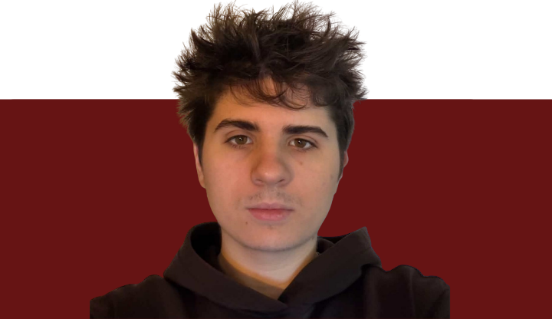
No Map? No Problem!

Third-year Journalism student Louis Paillier embraces the uncertainty of what comes next while exploring his interests in sports, writing, and cooking.
L a u r i e L e g a u l t
“It’s fun not knowing what I’m going to do next!” For 21-year-old Louis Paillier, uncertainty is part of what makes university—and his future beyond it—exciting. Unlike many students who experience the frightening uncertainty of what comes next after their academic degrees, Louis Paillier has a unique outlook on the ambiguity of his professional path.
Louis is half French, half Canadian, born in Toronto and lived abroad in the UK for three years; his multicultural upbringing makes him comfortable with change and variety. Louis is a 3rd-year journalism major with a minor in professional writing at Concordia, and has a specific interest in sports journalism.
LEARNING BY DOING
As a huge baseball fan, he once created an Instagram account dedicated to the Toronto Maple Leafs where he posted updates about the games and information about players.
Louis enjoyed the creative freedom and full authority of publication this account offered him. He reveals that a big challenge was comparing his account to bigger creators who generate higher audience engagement for, oftentimes, lower-quality content: “Sometimes I can post something that takes no effort, and it’ll blow up, or vice versa. The algorithm is the algorithm.”
While the account was able to gain immense popularity across the baseball fanbase, he later sold it to a new handler for $800.

Louis Paillier, BA 27
Despite his success in creating and managing content, Louis admitted he wasn't sure journalism was the right major for him. His initial interest in the program came from his love for writing. Louis believed that studying journalism would help him improve as a writer. Although he noticed improvement in his skills, his interest in the program began to dwindle, saying he found the industry too polarizing.
It was during a supper with his grandfather in France that Louis came to this realization. To do something he was passionate about—that is what Louis’ grandfather wanted him to remember.
FOLLOWING A DIFFERENT RECIPE
Outside of university, Louis works in a bakery. With a career change on the rise, he began wondering if culinary school would be his next option.
He enjoys being able to improve his baking skills with the chef’s guidance, and loves watching online food content from smaller creators.
For Louis Paillier, the path beyond Concordia isn't set in stone. Between journalism, content creation and a growing interest in baking, he's discovering that finding the right career can begin with exploring the possibilities because, “I know my parents will support me in everything”. This Concordia student may not have his future clearly mapped out, but for now the uncertainty isn’t a problem to solve—it is part of the adventure.

