Ali Kalkandelen

Date: 4/9/2018

CS-410

**CATV( Cable Television)**

Cable television is a system of delivering television programming to paying subscribers via radio frequency (RF) signals transmitted through coaxial cables or light pulses through fiber-optic cables. Cable television, introduced in the 1970s, offers a greater number of channels, while solving antenna reception problems. Even though it started in the 70s, Satellite Television with an antenna was though about even back in the 1940s. Using a direct feed to the television or decoder box, cable TV is the most widely used television reception medium. Understanding how cable television really works allows insight into how one cable leading into your home can carry so much information. About 70 Percent of households have cable TV



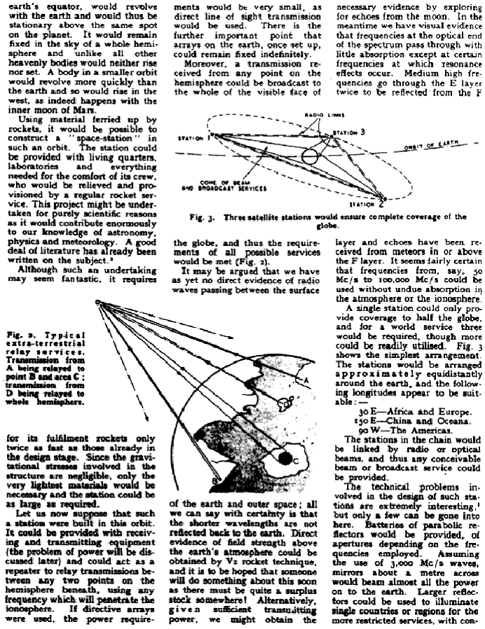

Even though the cable television didn’t come into play until the 1070s, television broadcasting through using satellites were imagined back in 1940s, when a science fiction author Artur C. Clarke imagined 3 satellites (which he calls extra-terrestrial relay services in geosynchronous orbit). In this orbit, satellites maintain the same footprint

In most cases the signal travels through distribution hubs and nodes (as many as 500, although this varies depending on the provider's available channel capacity) specific for a certain town or region before ending up in the homes of subscribers. The signal coming from the coaxial cable is then transferred to cable boxes and translated to the connected television. Many channels can be transmitted through one coaxial cable by a technique called [frequency division multiplexing](https://en.wikipedia.org/wiki/Frequency_division_multiplexing) in which each channel receives a different frequency, allowing the subscriber to switch between channels. The cable boxes are also encrypted and allow only frequencies of the channels subscribed to get through to the end user.

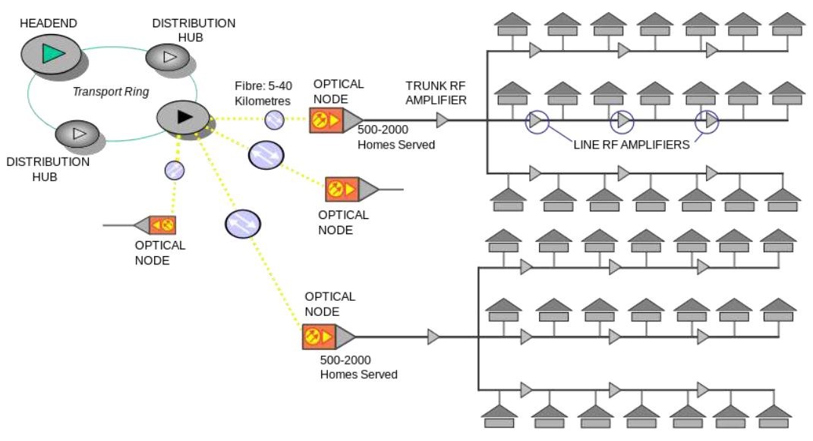

By giving each channel a different frequency "slot" on the cable, the separate television signals do not interfere. At the subscriber's residence, either the subscriber's television or a set-top box provided by the cable company translates the desired channel back to its original frequency (baseband), and it is displayed on-screen. Due to widespread cable theft in earlier analog systems, the signals are encrypted on modern digital cable systems, and the set-top box must be activated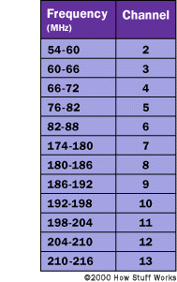 by an activation code sent by the cable company before it will function, which is only sent after the subscriber signs up.

There are also usually upstream channels on the cable, to send data from the customer box to the cable headend, for advanced features such as requesting pay-per-view shows, cable internet access, and cable telephone service. The downstream channels occupy a band of frequencies from approximately 50 MHz to 1 GHz, while the upstream channels occupy frequencies of 5 to 42 MHz Subscribers pay with a monthly fee. Subscribers can choose from several levels of service, with "premium" packages including more channels but costing a higher rate.

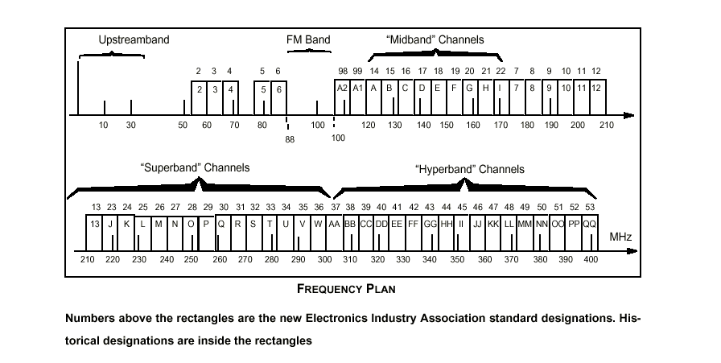

Cable channels are allowed bandwidth of 6 Megahertz, or MHz, per channel. Given that

Coaxial cable is capable of many times this, it can carry many channels into the home on a single

RG-6 coaxial feed. Some cable providers use a thicker, stiffer cable, called RG-11, to get high definition, or HD, cable service and broadband Internet into your home.

Compression

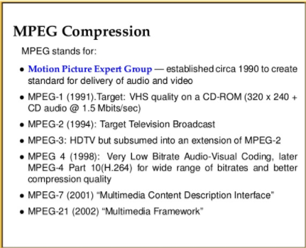MPEG-2 and MPEG-4 are the two compression schemes found in cable TV broadcasts. MPEG stands for Motion Picture Experts Group. This technology aims to eliminate much of the unneeded data on the channel, while not adversely affecting picture quality. HD is enabled via cable, thanks to MPEG compression schemes. In fact, many channels are digitally encoded, and are unlocked by using a cable box. This encoding allows one cable to carry all channels, not enquiring a second coaxial feed for premium channels.

**Distribution Boxes**

Cable companies use service redistribution boxes found in your neighborhood or yard to re-amplify the signals. Peering inside, you would see multiple coaxial cables connected to what appears to be a large splitter, which in turn is connected to a silver or black box. This allows the cable feed to be retransmitted for many miles without significant degradation. Fiber-optic cabling allows more data from the service provider, which then converts to coaxial cables leading into your home or business.

The Future of Cable television

Generally, the penetration of live multi-channel pay-TV services will decline from 85% of US households in 2017 to 79% in 2030. While statistically a loss of only 7%, it nonetheless illustrates the ongoing secular decline of a once healthy market space. TDG predicts that, by 2030, roughly 30 million US households will live without an MVPD service of any kind, be it virtual or legacy.

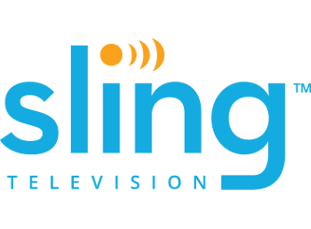 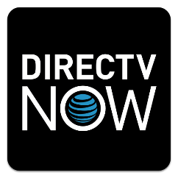 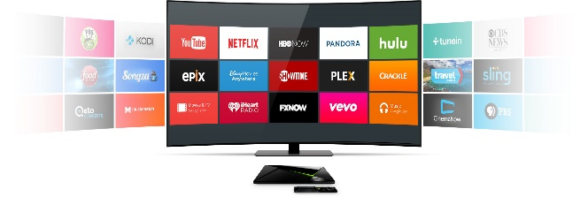

References:

<https://en.wikipedia.org/wiki/Cable_television>

<https://electronics.howstuffworks.com/cable-tv.htm>

<https://itstillworks.com/cable-television-works-tutorial-17251.html>

<https://avc.com/2012/02/clearqam-what-it-is-and-why-it-matters/>

<http://jhr.uwpress.org/content/early/2017/10/02/jhr.54.2.0316.7819R1.abstract>