2.1. Experiment Procedure
Construct the circuit shown in Figure 2.1 according to the following steps: R1=R2=R3=1K, E=5V. Run the circuit and determine the Vo (Output Voltage) values ​​according to the input values ​​in Table.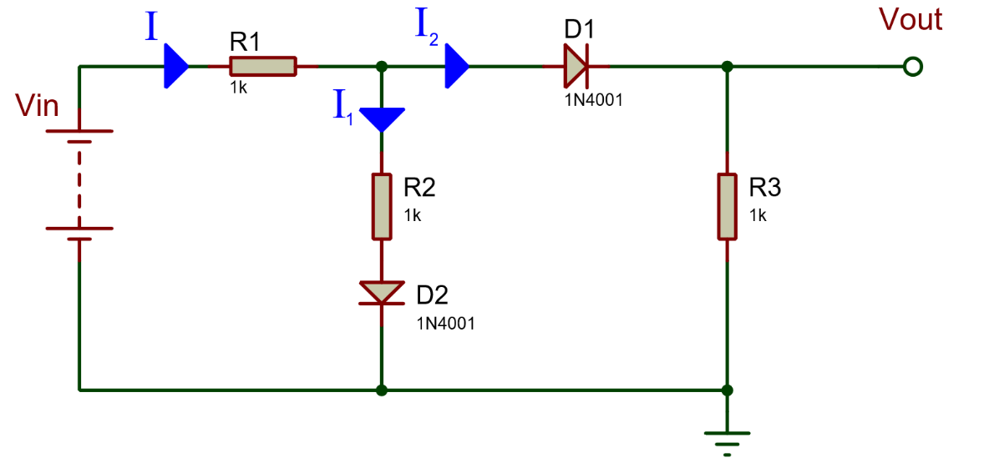
Figure 2.1

Table 2.1
V_{in} | V_{o}
1 V
2 V
3 V
4 V
5 V

Construct the circuit shown in Figure 2.2 according to the following steps: R1=R2=R3=1K, E=5V. Run the circuit and determine the Vo (Output Voltage) values ​​according to the input values ​​in Table 2.2.
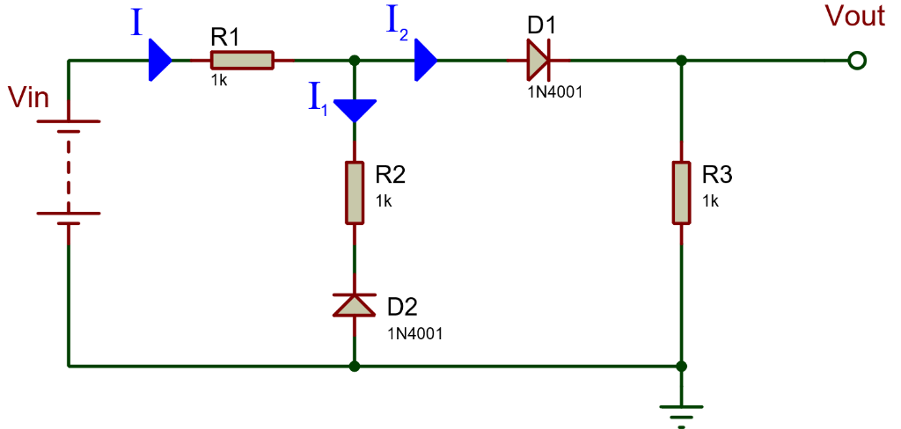
Figure 2.2

Table 2.2
V_{in} | V_{o}
1 V
2 V
3 V
4 V
5 V

