ASSIGNMENT-4
NAME: Muhammad Ali
REG NO: 8282

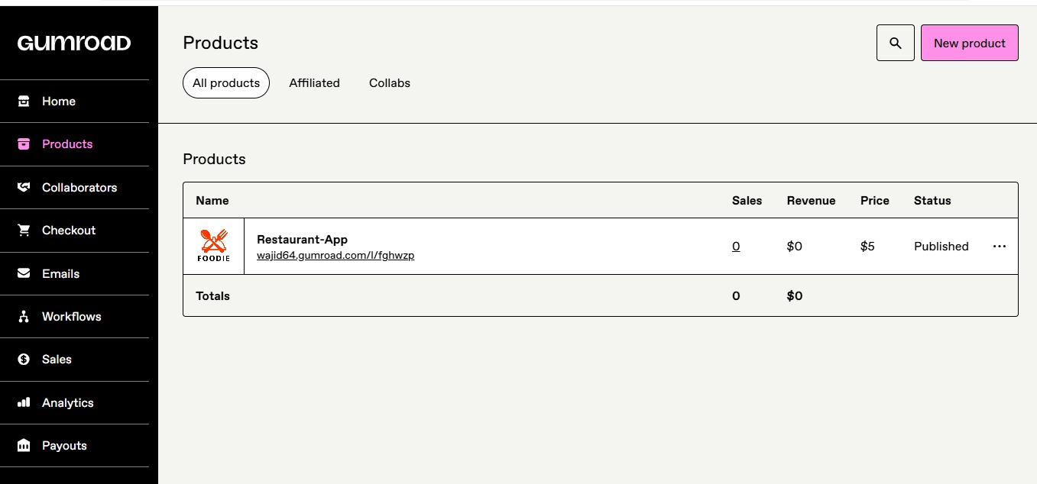
Link:
https://wajid64.gumroad.com/l/fghwzp

