

12/12/2024

Submitted By: Ali Khan & Muhammad Atif

Supervised By: Mr. Rizwan Abro

Department Computer Science

FINAL YEAR PROJECT

PROPOSAL

CCC

ADVOCATE NOW

**Table of Contents**

1. **Abstract ......................................................................... 1**
2. **Introduction & Background ............................................. 2**
3. **Problem Identification .................................................... 6**3.1 Limited Access to Legal Professionals ............................. 7  
   3.2 Low Visibility for Lawyers ................................................ 8  
   3.3 Insufficient Legal Awareness ........................................... 9  
   3.4 Lack of Virtual Consultation Platforms ............................ 10  
   3.5 Unavailability of Secure Payment Solutions ..................... 11
4. **Targeted Users ................................................................ 12**4.1 Individual Users ............................................................. 13  
   4.2 Lawyers and Legal Professionals ..................................... 14  
   4.3 Organizations and Firms ................................................. 15
5. **Literature Review ............................................................ 16**
6. **Project Goals & Objectives .............................................. 20**6.1 Develop Cross-Platform Mobile App ................................ 21  
   6.2 Lawyer Search & Profile Viewing ..................................... 22  
   6.3 Video Consultation & Appointment Scheduling ............... 23  
   6.4 Secure Payment Integration ............................................ 24  
   6.5 Backend Support for Data Management .......................... 25
7. **Technical Approach & Methodology .................................. 26**7.1 Technologies and Tools ................................................... 27
   * Flutter ....................................................................... 28
   * Firebase/Supabase .................................................... 29
   * APIs (Payment and Video Integration) .......................... 30
   * Cloud Services ........................................................... 31  
     7.2 Methodology Steps ............................................... 32
   * Requirement Gathering .............................................. 33
   * Design & Development ............................................... 34
   * Testing ....................................................................... 35
   * Deployment .............................................................. 36  
     7.3 System Architecture ............................................. 37  
     7.4 Security Measures ................................................ 38
8. **Activity Diagram ............................................................ 39**
9. **Timetable ...................................................................... 40**
10. **Cost Estimation ............................................................. 41**
11. **Recommendations ........................................................ 42**
12. **References .................................................................... 43**

**1. Abstract**

"Advocate Now" is a mobile application that eliminates the struggle of locating qualified lawyers by allowing users to schedule legal consultations with ease and speed. The app is intended to improve the situation of the clients, offering them a quick solution to search for the best lawyers who suit them in all aspects and allowing them to schedule meetings without leaving the house because they are rating and experience-based interviews instead of physically going to the lawyer's office.

Clients have the option to register using their email address, making sign up on the app an easy task. After registering, users seek for lawyers based on different parameters: specialty and current time. Each lawyer has their profile depicting their qualifications, what they practice, fees, and experience.

In placing a consultation order through ‘Advocate Now’, things cannot get any simpler. The client can choose communication method, be it face to face, video or through a phone call. Payments are made automatically in the application, and the invoices and reminders keep the client well informed about the state of his or her appointment.

**2. Introduction & Background**

Access to legal services is crucial to citizens but many of the citizens of Pakistan cannot avail themselves of experienced legal consultants. Compounding this is the fact that legal services are frequently centralized around urban centres, making it hard for rural populations to access timely legal counsel. On top of that, there is no single digital platform in Pakistan where individuals can find legal professionals with specialized knowledge, book appointments or consult virtually.

Advocate Now is a mobile solution which is meant to fulfil this gap by allowing users to avail quick access to a network of qualified lawyers. The app will allow users to search for lawyers by specialty and experience, check profiles to determine qualifications, and schedule video call consultations. The platform will also integrate secure payment system that will make the process of consultation easier, and it will be a convenient process. It serves our mission to give the public increased access to online tools and options for legal resources while also allowing lawyers to connect with individuals seeking legal assistance.

**3. Problem Identification**

3.1 **Limited Access to Legal Professionals**: Individuals in rural and underserved areas often find it difficult to access experienced lawyers, which delays resolution of their legal issues.  
3.2 **Low Lawyer Visibility**: Many qualified lawyers lack a digital platform to market their services effectively, limiting their reach to potential clients.  
3.3 **Lack of Legal Awareness**: A considerable portion of the population lacks the foundational legal knowledge needed to recognize when professional legal advice is necessary.  
3.4 **Absence of Digital Consultation Options**: While digital transformations have influenced other sectors, legal consultations in Pakistan still heavily rely on in-person interactions. Few platforms offer virtual consultations with integrated payment and scheduling features.

By providing a centralized platform for lawyer search and consultation, *Advocate Now* aims to address each of these challenges.

**4. Target Users**

4.1 **General Public:** Individuals seeking legal advice for personal or business matters who need accessible, reliable, and convenient options for finding a lawyer.4.2 **Legal Professionals:** Lawyers looking to increase their visibility and accessibility to a broader client base, especially by offering virtual consultations.  
4.3 **Corporate Clients:** Businesses and organizations that require regular legal consultation services.4.4 **Educational Institutions:** Law students or institutions that may benefit from connecting with legal professionals for mentorship or consultation.

**5. Literature Review**

Then there are many legal platforms around the world which allow users to access legal services online by creating a profile, making virtual appointments, with payments integrated into the platform. Examples include LegalZoom and Rocket Lawyer, which have created wider access to legal services across the U.S. Most available studies show that having user-friendly interfaces, open profiles, and real time communication features, increases customer satisfaction. But those kinds of platforms are not prevalent in Pakistan and the process of digital transformation in legal services in the country is already in its infancy stages. Based on user-friendly access to profiles with transparency to create instant video conferencing, *Advocate Now* aims to introduce the benefits of digital legal services to Pakistan.

**6. Project Goals & Objectives**

The core goal of *Advocate Now* is to create a mobile platform that makes legal services more accessible for individuals across Pakistan. Specific objectives include:

6.1 **Develop a Cross-Platform Mobile Application**: Design and implement the Advocate Now app using Flutter to support both Android and iOS users.  
6.2 **Build a Searchable Directory of Lawyers**: Allow users to search for lawyers based on specialty, location, and years of experience to find the best fit for their needs.  
6.3 **Implement Video Consultation Scheduling**: Enable users to book consultations directly through the app and conduct virtual meetings.  
6.4 **Integrate Secure Payment Processing**: Provide an in-app payment system for seamless transaction processing for consultations.  
6.6 **User Testing and Feedback Integration**: Regularly incorporate feedback from users and lawyers to refine app functionality and usability.

**7. Technical Approach & Methodology**

7.1 **Requirement Gathering**  
    Conduct interviews and surveys with potential users (lawyers and clients) to understand specific needs and pain points. This feedback will inform the design and functionality of Advocate Now.

7.2 **Design & Development**  
    7.2.1 **Frontend Development**: Use Flutter to create a user-friendly, responsive, and intuitive interface for Android and iOS platforms. The UI will focus on accessibility and ease of use.  
    7.2.2 **Backend Development**: Implement a backend using Firebase/Supabase to support authentication, data storage, and real-time data management. Firebase also offers scalability and data security.  
    7.2.3 **Payment Integration**: Integrate a secure payment API to handle financial transactions safely and efficiently.  
    7.2.4 **Video Conferencing API**: Incorporate a video calling API (e.g., Twilio or zoom) to enable live consultations between lawyers and clients.

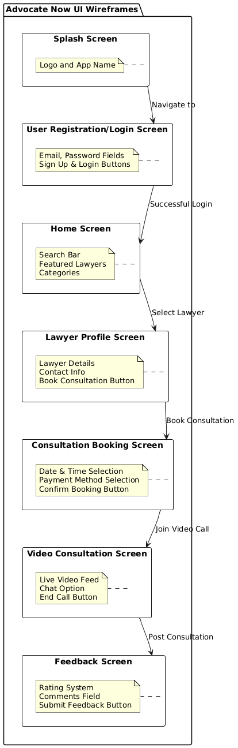

7.3 **Testing**  
    7.3.1 **Unit Testing**: Conduct unit tests to verify that each feature functions as expected.  
    7.3.2 **Integration Testing**: Ensure that the app components work seamlessly together, focusing on the registration, search, booking, and payment features.  
    7.3.3 **User Testing**: Engage a group of potential users (both lawyers and clients) in beta testing, gathering feedback to improve usability and functionality.

7.4 **Deployment**  
    Deploy the Advocate Now app on app stores for both Android and iOS. Monitor user engagement and gather feedback post-launch for continuous improvement.

**8. Activity Diagram**

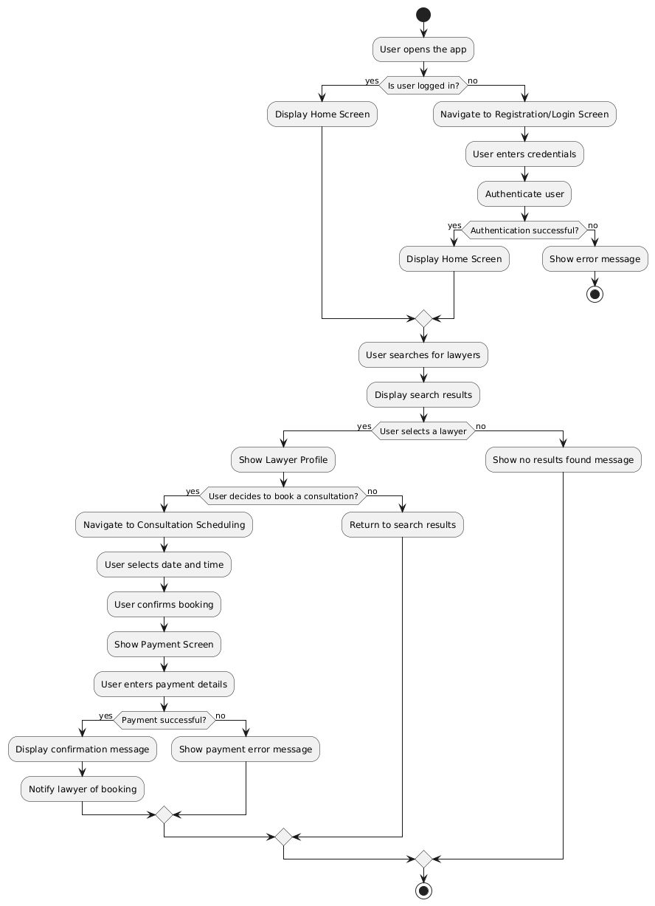

**9. Technology Used**

7.1 **Flutter**: To enable cross-platform mobile app development, making the app accessible on Android and iOS.  
7.2 **Firebase/Supabase**: For backend support, including authentication, database management, and real-time updates.  
7.3 **Twilio/Jitsi Meet (or other video conferencing APIs)**: To enable secure video calls for consultations.  
7.4 **Payment API (e.g., Easypaisa and Jazzcash)**: For secure in-app transactions.  
7.5 **Cloud Storage (Firebase)**: For storing and managing user and app data securely.

**10. Timetable**

| **Phase** | **Tas** | **Duration** |
| --- | --- | --- |
| Requirement Gathering | User and Lawyer Interviews, Surveys | 1 Month |
| Design & Development | Frontend & Backend Development | 6 Months |
| Testing | Unit, Integration, and User Testing | 15 days |
| Deployment & Feedback | App Launch, Post-Launch Support | 3 Month |

**11. Cost Analysis**

| **Item** | **Type** | **Quantity** | **Per Unit Cost (PKR)** | **Total Cost (PKR)** |
| --- | --- | --- | --- | --- |
| Emulator (Testing) | Testing Device | 1 | 90,000 | 40,000 |
| Miscellaneous | Miscellaneous | - | 15,000 | 15,000 |
| **Total Estimated Cost** |  |  |  | 55,000 |

**12. Recommendations**

*Advocate Now* is expected to transform legal accessibility by providing a digital platform that addresses the unique needs of Pakistani clients and lawyers. Future enhancements could include features like document uploading for pre-consultation, case tracking, and user feedback mechanisms to continuously improve the service quality**.**

**13. References**

13.1 **Digital Legal Services in Emerging Markets:** Research on the growth of mobile legal solutions.  
13.2 **Firebase Documentation:** Comprehensive guidelines on Firebase features and security.  
13.3 **Flutter Documentation**: Overview of cross-platform development using Flutter.13.4 **Twilio/Jitsi Meet Documentation**: Integration of video conferencing in mobile applications.