***Documentation***

**1. Purpose of the application** –

*1.1 Design of the application:*

* A 3d Unity Ball game.
* Game is designed to pick up the spinning game objects on the screen.
* With every game object that it collides with the count goes up by 5 points.
* When all the game objects have been collected the WIN TEXT will show YOU WIN!
* The game is very easy, I concentrated on getting the MYO to connect to the game then add any other features.
* 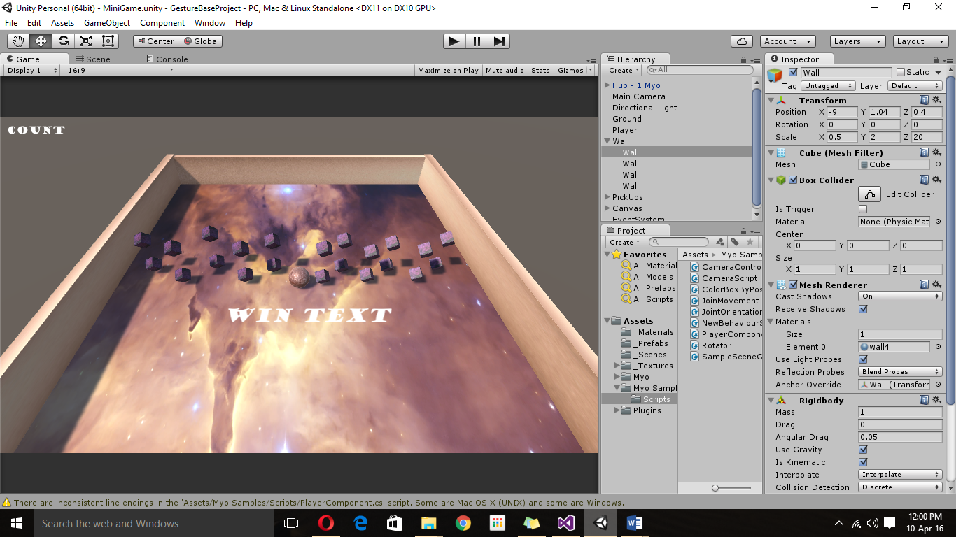This project was more of a research process for me as I used the MYO armband for the first time.

*1.2 Experimentation process:*

* First few weeks was just me experimenting with the MYO armband.
* I downloaded the Sdk and I played around with the features trying to understand the purpose of each script.
* The armband is very challenging to use. The gestures have to be very clearly defined in order for the armband to function properly.
* It also gets warmed up really fast, this locks the armband.
* In the Sdk example there are two parts to a stick which does all the movements and the box which shows the gesture movements working.
* In my project I first created the simple game, then I added the MYO Sdk, to see that the armband connects to the project I added a few color materials and checked. If you move wrist to the right change to a different color, if to the left a different color and if double tap a different color.
* Also because it’s a new technology there isn’t many resources that can help if you are stuck.

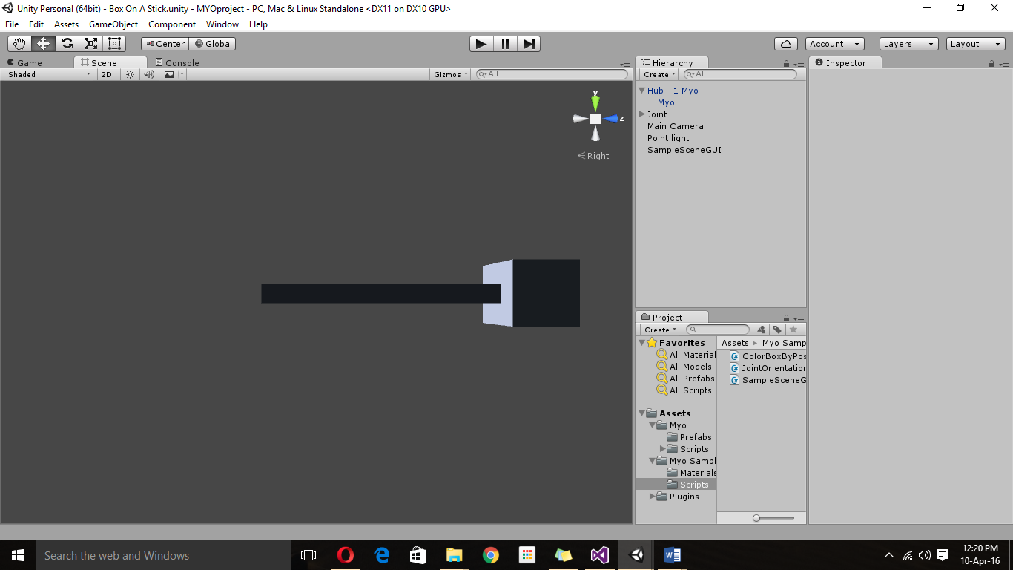

*1.3 Testing gestures:*

* There are many gestures available for phones and touch devices, also for Kinect but the MYO only uses and recognizes a few of those gestures.
* The MYO Sdk comes with a few different scripts that show and also explain how to use those gestures.

**2. Gestures identified as appropriate for this application –**

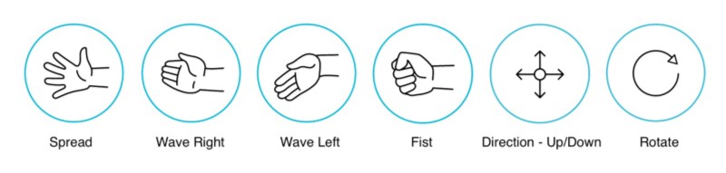

* These are some of the gestures that the MYO armband uses.
* In my project I am using the Wave left, Wave right and the double tap.
* I am using the wave left the wave fright and the double tap gestures to change the color of the ball.
* The ball will be moving with the hand, as the hand moves the ball moves across the screen.
* Because of the limited time I had with the MYO there was only so much I could do. Perhaps if I had the MYO for a longer time I could have implemented some other gesture features.

**3. Hardware used in creating the application –**

*3.1 Choosing the hardware I would use:*

There was a wide range of hardware to choose from. But in a previous class assessment we had to choose a few of these hardware and analyze them and compare them. Therefore I used that knowledge accumulated to choose the hardware I wanted to use.

*3.1.1 Kinect*

* An RGB camera that stores three channel data in a 1280x960 resolution. This makes capturing a color image possible.
* An infrared (IR) emitter and an IR depth sensor. The emitter emits infrared light beams and the depth sensor reads the IR beams reflected back to the sensor. The reflected beams are converted into depth information measuring the distance between an object and the sensor. This makes capturing a depth image possible.
* A multi-array microphone, which contains four microphones for capturing sound. Because there are four microphones, it is possible to record audio as well as find the location of the sound source and the direction of the audio wave.
* A 3-axis accelerometer configured for a 2G range, where G is the acceleration due to gravity. It is possible to use the accelerometer to determine the current orientation of the Kinect.

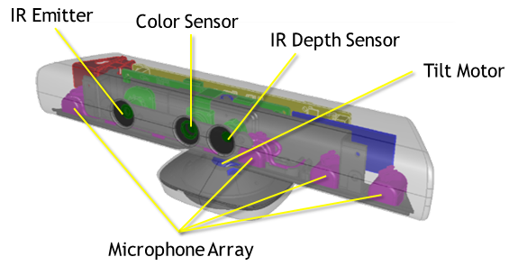

*3.1.2 ASUS Xtion PRO*

* The world’s first and exclusive professional PC motion sensing software development solution.
* OPNI NITE middleware compatible SDK makes the motion-sensing applications and games development easily
* Easily selling developer’s applications on the upcoming ASUS@vibe online entertainment content store.

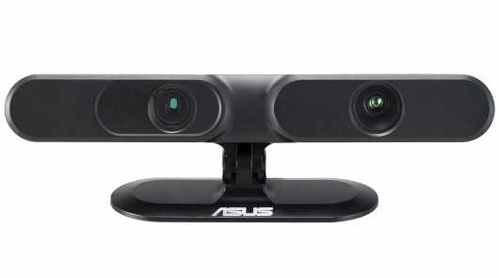

*3.1.3 MYO Armband*

* The MYO armband is a virtual instrument.
* To read the muscle activity in your forearm, Myo wraps it in eight different blocks, each of which contains a medical-grade EMG sensor. The armband also uses a three-axis gyroscope, three-axis accelerometer, and three-axis magnetometer to sense motion in any direction.
* Muscle activity and motion readings are handled by an onboard ARM Cortex M4 Processor, which communicates with your devices via Bluetooth. For devices that don’t have Bluetooth functionality built in, Myo also comes with a Bluetooth dongle that plugs into any USB port.
* This is the newest technology from the ones I came in contact with.
* Due to the research I did on this armband I got really interested in figuring out how to work with it.

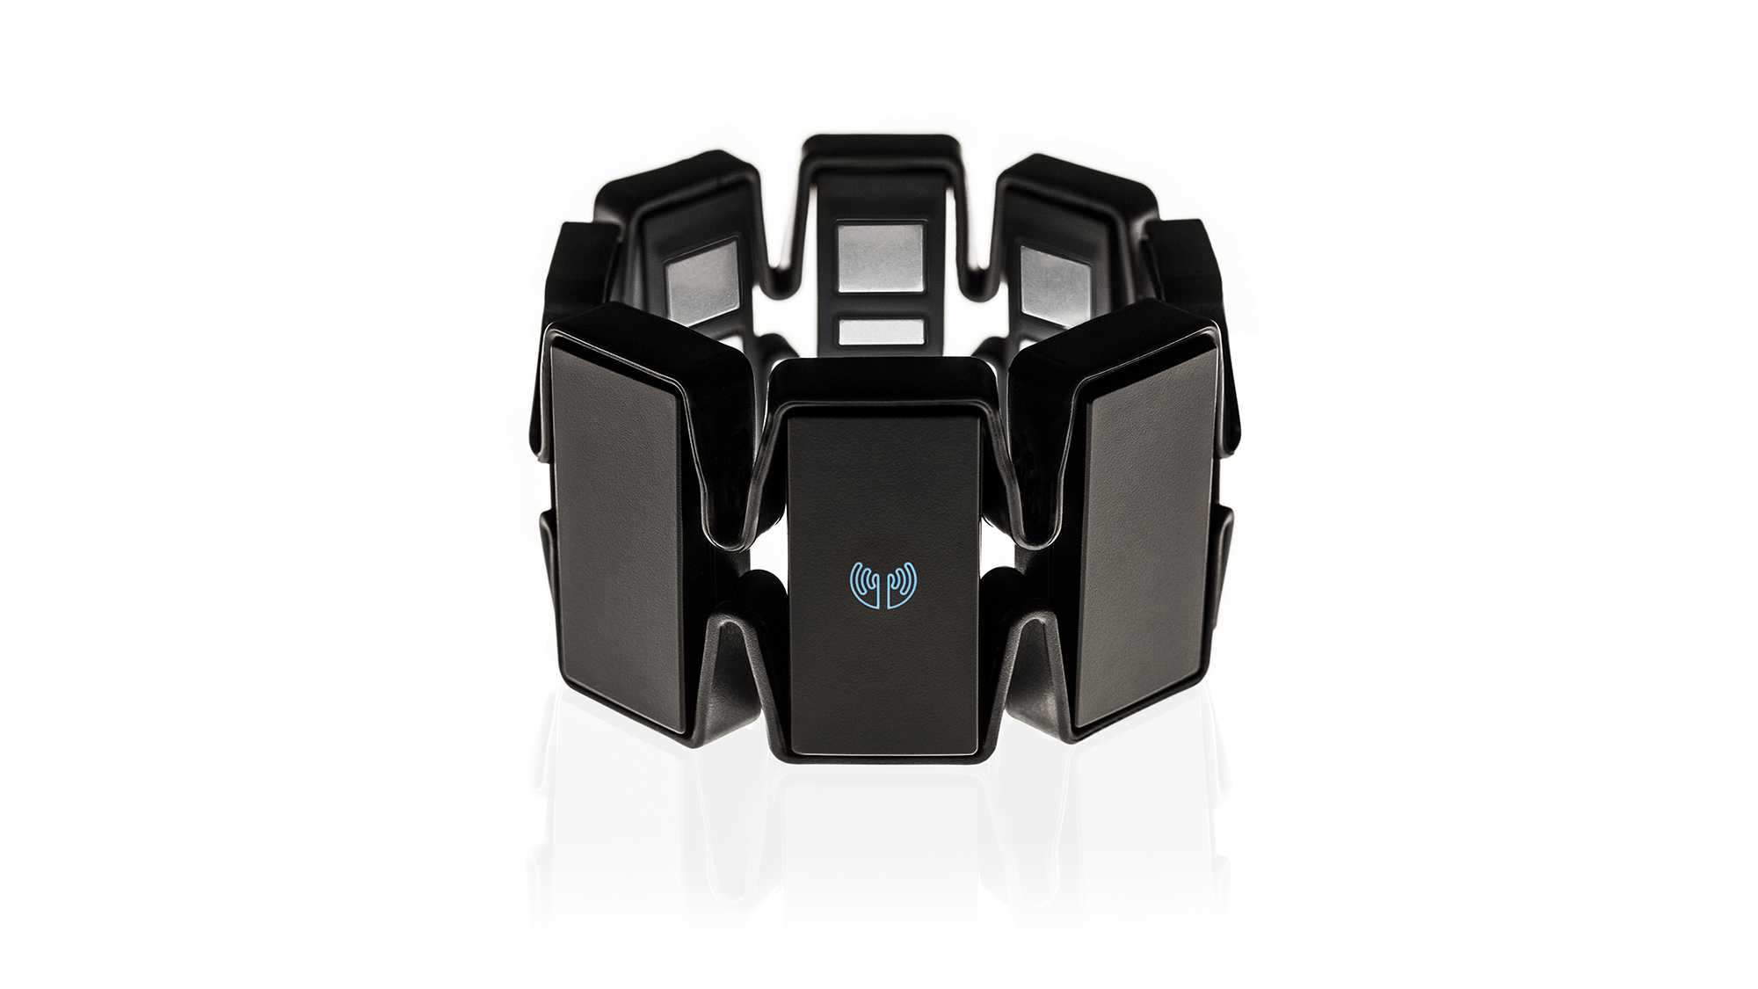

*3.2 My Final choice of hardware:*

* Finally after seeing which hardware interested me the most.
* I choose to use the MYO armband.
* I choose this because I thought it will challenge me to get the best result for this module.
* Even though the Myo had a few disadvantage, for example:

1. There was a limited amount of MYO armbands.
2. As I never used it before it took more research.
3. Time consuming.
4. Since its new there wasn’t a lot of help on the internet in how to solve problems.

**4. Architecture for the solution –**

There isn’t a particular architecture or structure to this. It’s created in unity and it only connects to the MYO armband. There isn’t any connection to the internet or one drive, doesn’t connect to any database. Just the basic hierarchy that is displayed in unity. Also in the Assets folder there are folders within folders to make the project tidy.

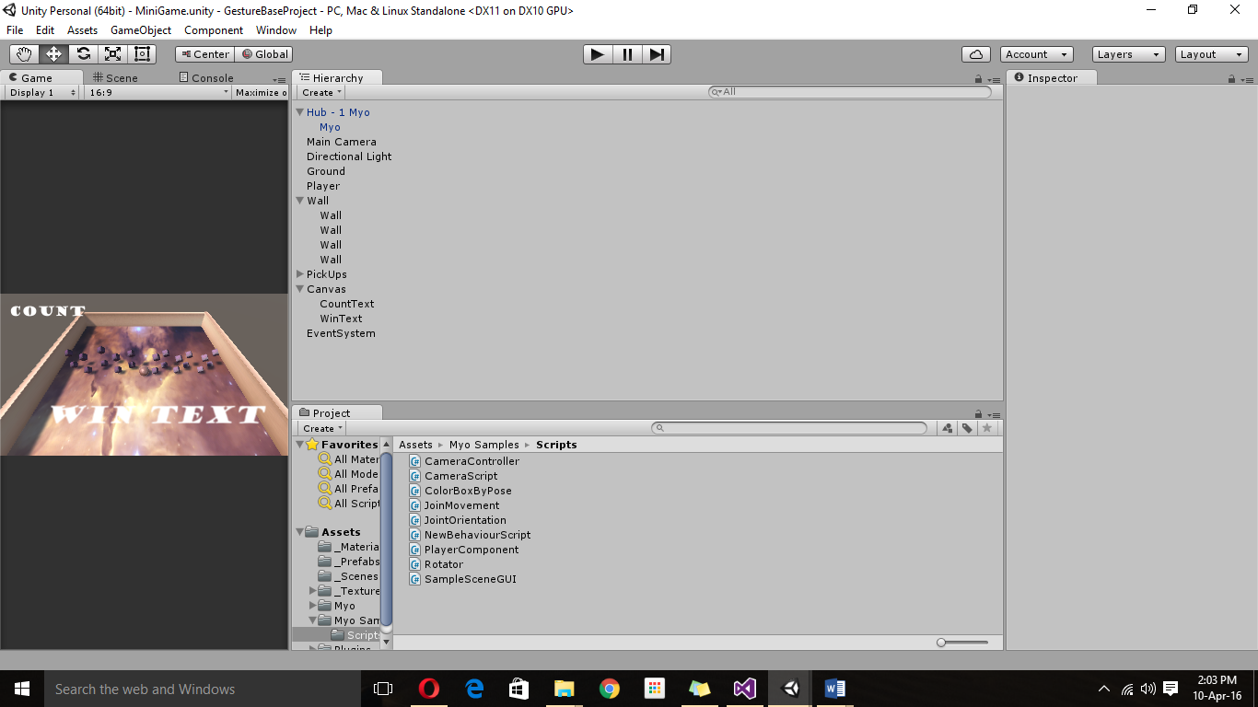

**5. Problems faced –**

* I was in supposed to be in a group for this project but my team member decided to his own way two weeks before the deadline.
* I tried my best to gather all the knowledge I had with using unity and all the research I did on the MYO Armband to create this.
* Also I didn’t have the MYO for all this time due to other classmates wanting to use it.
* Those two weeks that I had I spent most of the time connecting the MYO to the unity game. It was a real challenge.
* Due to all of these unexpected turn of events, my project is not fully finished. The MYO connects, the gestures work on the project but I couldn’t get to fix my colliders and my boundaries and therefor the ball can go through the walls I have created.

**6. Conclusions & Recommendations –**

*6.1What you have learned:*

* With the completion of this project I have learned how to work with Unity better, this enhancing my knowledge and helping me in the final project as well.
* I have learned how to deal with unexpected events and still have a finished product at the end. This will definitely help me in the future when I will work in the industry.
* Also getting a time limit helped me put into perspective everything I had to do in the time given. Therefore I have achieved better time management skills.
* All things are possible by doing a lot of research.

*6.2 Research:*

Here are some of the sites I researched in order to do this project:

* *file:///C:/Users/ligia/Downloads/questions%20from%20class%20(2).pdf* *–this is the assignment I placed on Moodle where my research about which hardware to use was done.*
* [*https://learnonline.gmit.ie/course/view.php?id=1519*](https://learnonline.gmit.ie/course/view.php?id=1519) *–this is a link of the class notes we got to help us with the project.*
* [*https://www.myo.com*](https://www.myo.com) *– getting started with the MYO*
* [*https://support.getmyo.com/hc/en-us*](https://support.getmyo.com/hc/en-us) *-MYO support*
* [*https://en.wikipedia.org/wiki/Kinect*](https://en.wikipedia.org/wiki/Kinect)
* [*http://docs.unity3d.com/ScriptReference/Collider.html*](http://docs.unity3d.com/ScriptReference/Collider.html)
* [*http://docs.unity3d.com/ScriptReference/Collider.html*](http://docs.unity3d.com/ScriptReference/Collider.html)
* [*https://developer.thalmic.com/docs/api_reference/platform/the-sdk.html*](https://developer.thalmic.com/docs/api_reference/platform/the-sdk.html)

*6.3 Recommendations:*

* If I was to do the project again I would from the start do the project alone so I could manage everything better, and therefore have more than two weeks to do the project.
* This is the only thing I would change in this project.