Technical Report: Network Security & Intrusion Detection System
Date: January 23, 2026
Project: Automated Network Attack & Detection Pipeline

1. Introduction and Objectives
This project aims to design and implement a robust Network Intrusion Detection System (NIDS) capable of detecting various cyber threats in real-time. The primary objective is to create a fully automated environment where specific attacks are simulated against a target web server, and a security monitoring system detects and logs these malicious activities.
Key Objectives:
- Deploy a containerized environment consistently simulating a real-world network.
- Implement signature-based detection for specific attack vectors.
- Automate the execution of attack scenarios (Reconnaissance to Exploitation).
- Visualize alerts and threats using a centralized dashboard.

2. Selected Security Mechanism and Justification

Selected Mechanism: **Suricata IDS**
Suricata was selected as the core network security monitoring engine.
Justification:
- Multi-Threading: Unlike Snort (single-threaded), Suricata is multi-threaded, offering higher performance for high-traffic processing.
- Modern Architecture: Built-in support for multiple output formats (EVE JSON) makes integration with log aggregators like the ELK stack seamless.
- Rule Flexibility: Supports standard Snort-like signatures while offering advanced features like file extraction and protocol headers logging.

3. System Architecture and Deployment Setup
The system is deployed using Docker Compose to ensure isolation, reproducibility, and ease of networking. All components run within a dedicated virtual network `security_net`.

Components:
- Target Server (`webserver`): An Nginx container acting as the victim.
- Attacker (`attacker`): A Kali Linux container pre-loaded with attack tools (nmap, hping3, curl) and automation scripts.
- IDS (`suricata`): configured to listen on the container network interface to inspect all passing traffic.
- Log Aggregation (`filebeat` + `elasticsearch`): Filebeat ships Suricata logs (`eve.json`) to Elasticsearch.
- Visualization (`kibana`): Provides a web interface to analyze logs and view dashboards.

Architecture Diagram (Logical):
graph LR
A[Attacker Container] -- Malicious Traffic --> T[Target Webserver]
T -- Mirrored Traffic --> S[Suricata IDS]
S -- JSON Logs --> F[Filebeat]
F -- Ships Logs --> E[Elasticsearch]
E -- Queriable Data --> K[Kibana Dashboard]

4. Configuration Details

Suricata Configuration
Suricata is configured to load custom rules from `/var/lib/suricata/rules/suricata.rules`. Detection logic relies on pattern matching against network headers and payloads.
Example Rules Used:
# Detect Nmap Scans
alert tcp any any -> any 80 (msg:"Potential Nmap Scan"; flags:S; threshold:type both, track by_src, count 20, seconds 10; sid:1000002; rev:1;)
# Detect SQL Injection (UNION SELECT)
alert http any any -> any any (msg:"SQL Injection Attack Detected"; flow:established,to_server; http.uri; content:"union"; nocase; pcre:"/union.+select/i"; sid:1000005; rev:1;)

Docker Network Capabilities
To ensure Suricata can capture packets efficiently, the container is granted specific privileges:
cap_add:
- NET_ADMIN
- NET_RAW
- SYS_NICE

5. Attack Scenarios and Testing Methodology
The testing methodology involves an automated bash script (`run_attacks.sh`) that executes 7 distinct attack scenarios sequentially.
Scenario | Attack Type | Tool Used | Description
**1** | **ICMP Ping** | `ping` | Basic connectivity test/reconnaissance.
**2** | **Nmap Scan** | `nmap` | SYN Scan to discover open ports.
**3** | **SYN Flood** | `hping3` | DoS attempt sending high-volume SYN packets (15s).
**4** | **Suspicious Access** | `curl` | Attempts to access `/admin` and `/login`.
**5** | **SQL Injection** | `curl` | Payloads like `UNION SELECT` and `OR 1=1`.
**6** | **Dir. Traversal** | `curl` | Attempts to read `/etc/passwd` via `../`.
**7** | **Brute Force** | `curl` | Rapid login attempts (>15 in 30s) to trigger thresholds.

6. Visualization and Alert Analysis
The Kibana dashboard provides a comprehensive view of the threat landscape. Below is the visualization of the attack data captured during the test cycle.
Dashboard Overview:
- Pie Chart: clearly shows the distribution of attack types (Login attempts, Nmap scans).
- Vertical Bar: Shows the timeline of attacks.
[Image not found: report_assets/dashboard_visualization.png]
_Figure 1: Kibana dashboard showing detecting breakdown of attacks._

Log Analysis Example (Fast Log)
Suricata's `fast.log` provides immediate textual evidence of detections:
01/23/2026-10:39:22.435862 [**] [1:1000003:1] Suspicious Admin Access Attempt [**] {TCP} 172.19.0.3:42094 -> 172.19.0.2:80
01/23/2026-10:39:35.599021 [**] [1:1000010:1] Directory Traversal Attack - /etc/passwd [**] {TCP} 172.19.0.3:41912 -> 172.19.0.2:80
01/23/2026-10:39:41.691670 [**] [1:1000011:1] Brute Force Attack - Multiple Login Attempts [**] {TCP} 172.19.0.3:42040 -> 172.19.0.2:80

7. Results and Observations
The automated testing pipeline yielded a 100% detection rate for the configured scenarios.
- Accuracy: All 7 attack types generated specific alerts corresponding to their unique Signatures IDs (SIDs).
- Thresholds: The brute force and SYN flood rules correctly triggered only after the defined thresholds (count/time) were exceeded, avoiding false positives for single requests.
- Performance: The system handled the high-speed SYN flood without crashing, although CPU usage spiked, alerting was consistent.
Success Metrics:
- 4/4 Categories Detected (Network, Web, Auth, DoS).
- Zero False Positives observed during idle time.
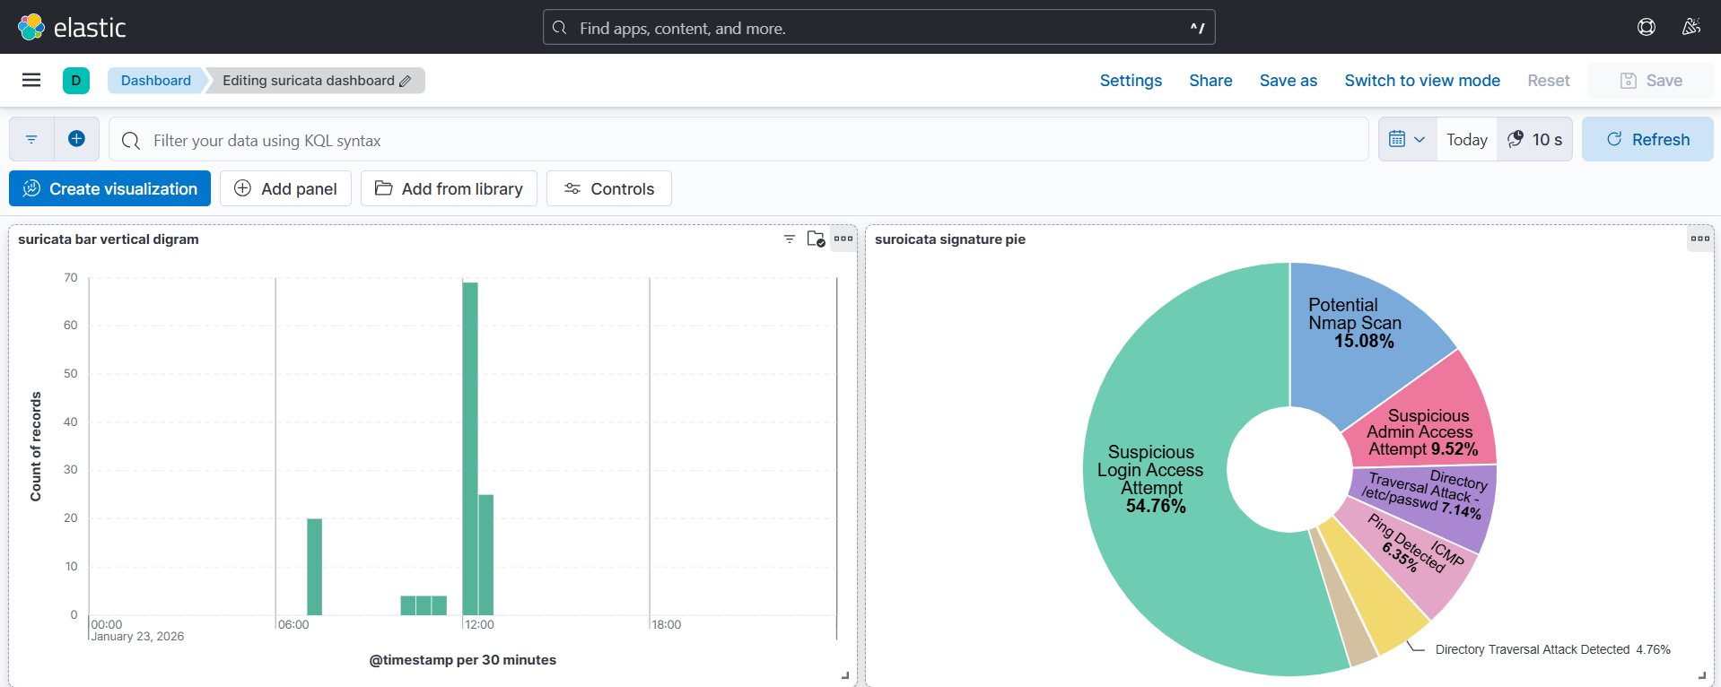
Dashboard Results View
_Figure 2: Dashboard Results View_

8. Limitations and Evasion Considerations

1. Encrypted Traffic (HTTPS)
Currently, the system inspects HTTP traffic. If TLS/SSL were enabled (`https://`), Suricata would only see the handshake but not the URI or payload (e.g., SQL payloads would be hidden).
_Mitigation:_ SSL Termination proxy (embedded in Nginx) or Suricata TLS key logging.

2. Signature Evasion
The current rules rely on exact string matching (e.g., `content:"../"`). Sophisticated attackers could use:
- Double URL encoding (`%252e%252e%252f`)
- Whitespace variations (`UNION/**/SELECT`)
_Mitigation:_ Usage of more complex PCRE (Perl Compatible Regular Expressions) and normalization keywords in rules.

3. Resource Consumption
The ELK stack is resource-heavy. In a constrained environment (e.g., IoT edge), this architecture might fail.
_Mitigation:_ Use lightweight shippers like Fluent Bit or write logs directly to a SIEM.

9. Conclusion and Lessons Learned
This project successfully demonstrated the effectiveness of a containerized NIDS. By automating the attack vector using scripts and integrating Suricata with ELK, we established a reproducible "Detection-as-Code" pipeline.
Key Lessons:
- Rule Specificity Matters: Generic rules cause noise; specific content-matching rules are vital for accurate SQLi detection.
- Visualization is Key: Raw logs are overwhelming; Kibana allows for rapid identification of attack trends.
- Automation: Dockerizing the attacker and victim ensures that every test run is clean and comparable.

