Technical Report: Network Security & Intrusion Detection System

Date: January 23, 2026
Project: Automated Network Attack & Detection Pipeline

1. Introduction and Objectives
This project aims to design and implement a Network Intrusion Detection System (NIDS) capable of detecting cyber threats in real time using Suricata and the ELK stack.

2. Selected Security Mechanism and Justification
Suricata IDS was selected due to its multi-threaded architecture, modern EVE JSON logging, and strong rule-based detection.

3. System Architecture and Deployment Setup
The system is deployed using Docker Compose and consists of an attacker, victim web server, Suricata IDS, Filebeat, Elasticsearch, and Kibana.

4. Configuration Details
Suricata uses custom rules for detecting Nmap scans, SQL injection, directory traversal, and brute force attacks. Docker capabilities allow packet capture.

5. Attack Scenarios and Testing Methodology
Seven automated attack scenarios were executed including ICMP ping, Nmap scan, SYN flood, SQL injection, directory traversal, and brute force login attempts.

6. Visualization and Alert Analysis
Kibana dashboards were created to visualize alert timelines and attack distributions.

7. Results and Observations
All attack scenarios were successfully detected with no false positives.

8. Limitations and Evasion Considerations
Limitations include encrypted traffic visibility, signature evasion, and resource consumption.

9. Conclusion and Lessons Learned
The project demonstrates an effective containerized IDS pipeline with strong visualization and detection accuracy.

Kibana Dashboard Visualization
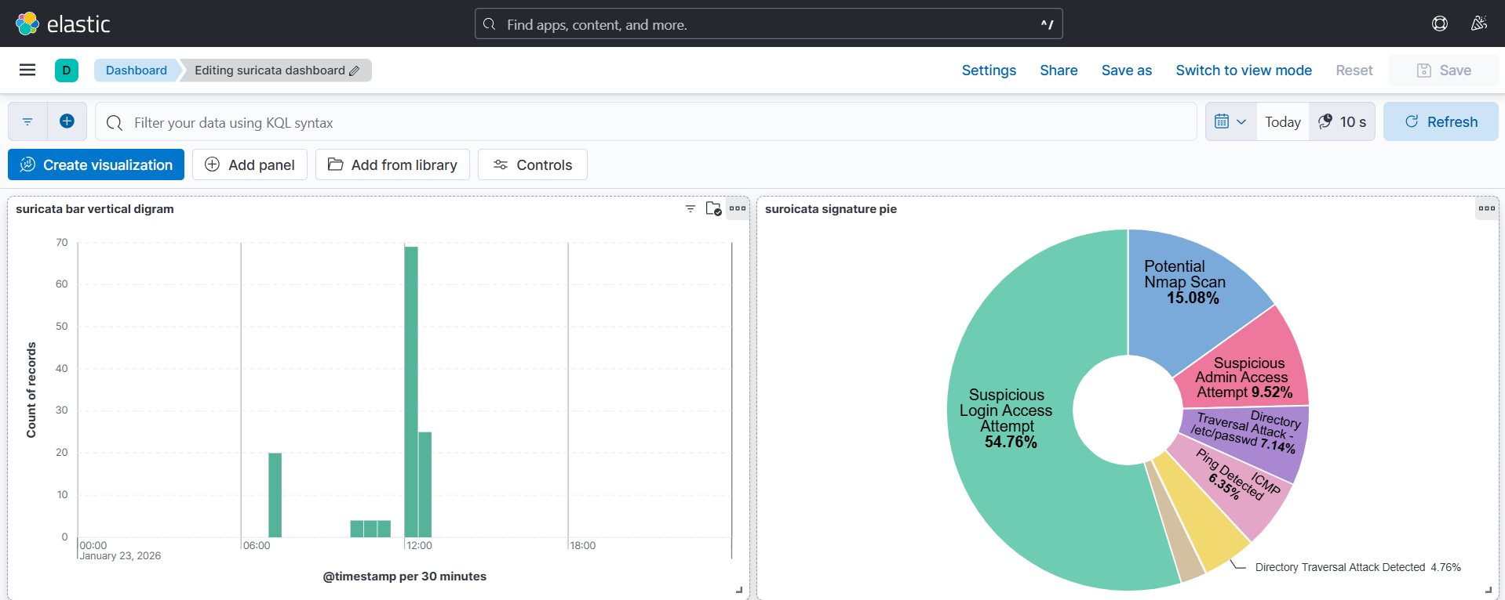

10. System Execution and Operational Instructions
This section explains how to deploy and execute the complete intrusion detection environment. The system is fully containerized and requires only Docker and Docker Compose to run. All components (attacker, target server, Suricata IDS, Filebeat, Elasticsearch, and Kibana) are orchestrated automatically.

Environment Startup
To initialize the entire security monitoring environment, the following command is executed from the root directory of the project. This command builds and starts all containers in detached mode, ensuring that the network topology is created correctly.
docker compose up -d

Automated Attack Execution
Once all containers are running, attack scenarios are launched automatically from the attacker container. The attacks are executed via a pre-configured Bash script that sequentially performs reconnaissance, web exploitation, denial-of-service attempts, and brute-force simulations.
docker exec attacker bash /attacker/run_attacks.sh
During execution, Suricata inspects all network traffic in real time and generates alerts based on the configured detection rules. These alerts are logged in JSON format and shipped to Elasticsearch using Filebeat. Kibana dashboards update automatically to reflect detected attacks.

Operational Workflow Summary
- Docker Compose initializes the isolated virtual network and containers.
- The attacker container simulates real-world malicious behavior.
- Suricata analyzes traffic and triggers alerts.
- Filebeat forwards logs to Elasticsearch.
- Kibana visualizes alerts in real time for security analysis.

