**Assignment_3.2**

Introduction: -

* Most of the times, RTL files are listed in a file, but we need to use the files through the EDA tools commands in another format.

Required: -

1. Create a tcl script named Ass3.2.tcl.
2. 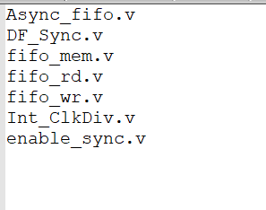You will find the rtl files are listed in **rtl.txt** file as follow
3. It is required to create a list of name **designs** and store the RTL file names as the list elements
4. Print the new created list "designs" to be as follow: -

{Async_fifo.v DF_Sync.v fifo_mem.v fifo_rd.v fifo_wr.v Int_ClkDiv.v enable_sync.v}