Technical documentation
Architecture Overview:
The solution uses a Hub-and-Spoke network architecture consisting of a central Hub Virtual Network and two spoke networks for Application and Management workloads. The Hub VNet provides centralised networking services, including Azure Bastion for secure administration and a Private Endpoint for private access to the Storage Account. The environment also utilises Azure platform services such as Azure Key Vault, Azure Monitor, Log Analytics Workspace and Recovery Services Vault to provide security, monitoring and backup capabilities across the platform.

Custom domain added in Entra ID:
A custom domain (alimalikcloud.uk) was configured within Microsoft Entra ID by creating the required TXT verification record in the Cloudflare DNS zone to verify domain ownership. This allows user and administrative accounts to utilise organisational email addresses rather than the default onmicrosoft.com domain, providing a more professional identity aligned with the organisation's branding.
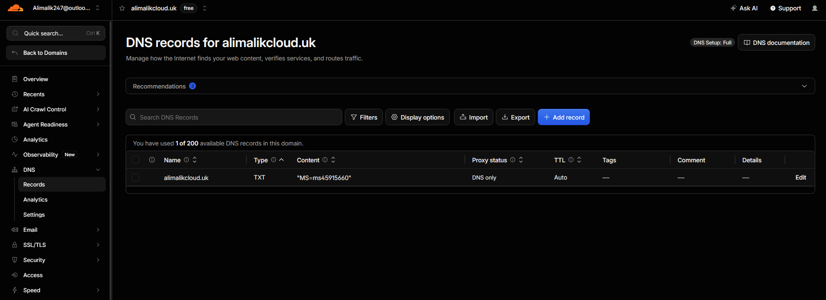

Entra ID users and groups:
Microsoft Entra ID was selected as the identity and access management platform for the environment. User accounts and security groups were created to represent the business departments defined within the project requirements. Users were assigned to their respective groups to support Role-Based Access Control (RBAC) and simplify permission management.
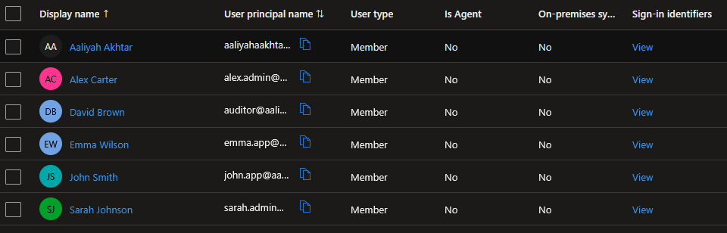
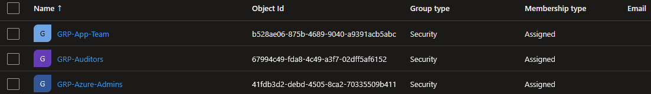

Azure policy – Allowed locations:
An Azure Policy was implemented at the subscription level to restrict resource deployments to approved United States Azure regions. This supports governance requirements, maintains deployment standards and helps enforce organisational compliance. The policy was validated by attempting to deploy a resource to a non-approved region, which was successfully denied.
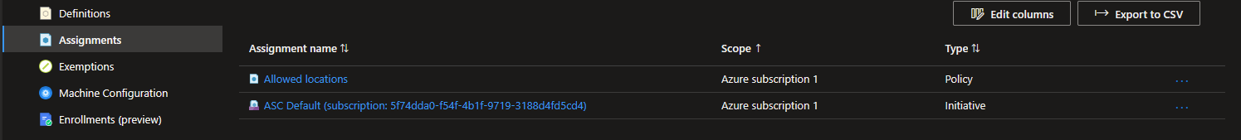

Resource groups:
Resource Groups were created to logically organise resources based on their function within the environment. This improves management, supports access control and simplifies administration throughout the Azure estate.
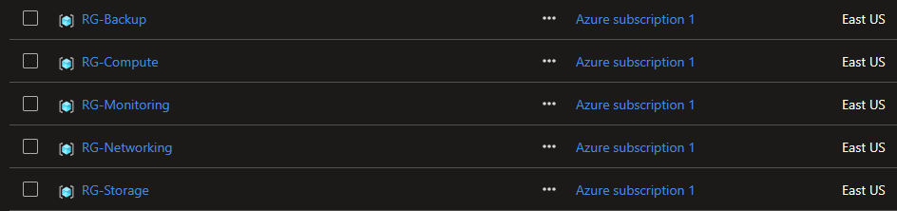

The Hub-VNet:
The Hub Virtual Network was deployed as the central networking component of the Hub-and-Spoke architecture. It hosts Azure Bastion for secure administration and a Private Endpoint for private access to the Azure Storage Account, providing centralised connectivity and secure access to network resources.
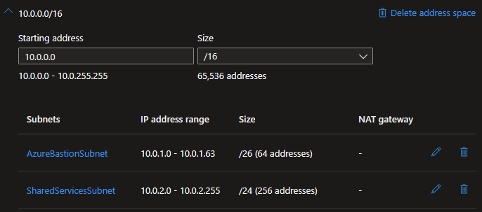

The Application Spoke VNet:
The Spoke-App virtual network was created to host business application workloads within the Hub-and-Spoke architecture. A dedicated address space and subnet were configured to provide network segmentation, support VNet Peering and enable the secure isolation of application resources.
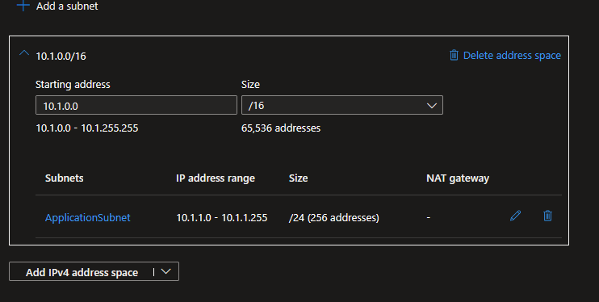

The management spoke VNet:
The Spoke-Mgmt virtual network was deployed to host management and infrastructure workloads within the Hub-and-Spoke architecture. A dedicated address space and subnet were configured to provide network segmentation, support VNet Peering and allow management resources to operate independently from application workloads.
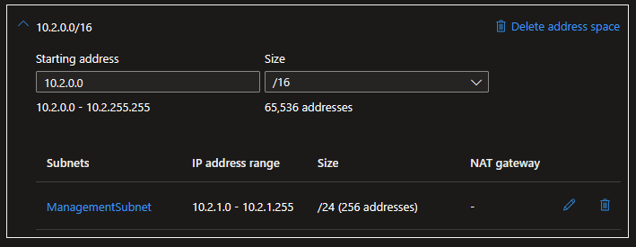

VNet peering (App spoke to Hub and Hub to app spoke):
VNet peering was configured between the Hub-VNet, Spoke-App VNet and Spoke-Mgmt VNet to establish private connectivity between the networks. This enables resources in each network to communicate securely over Azure's private backbone network while maintaining network segmentation and avoiding the need for public connectivity.
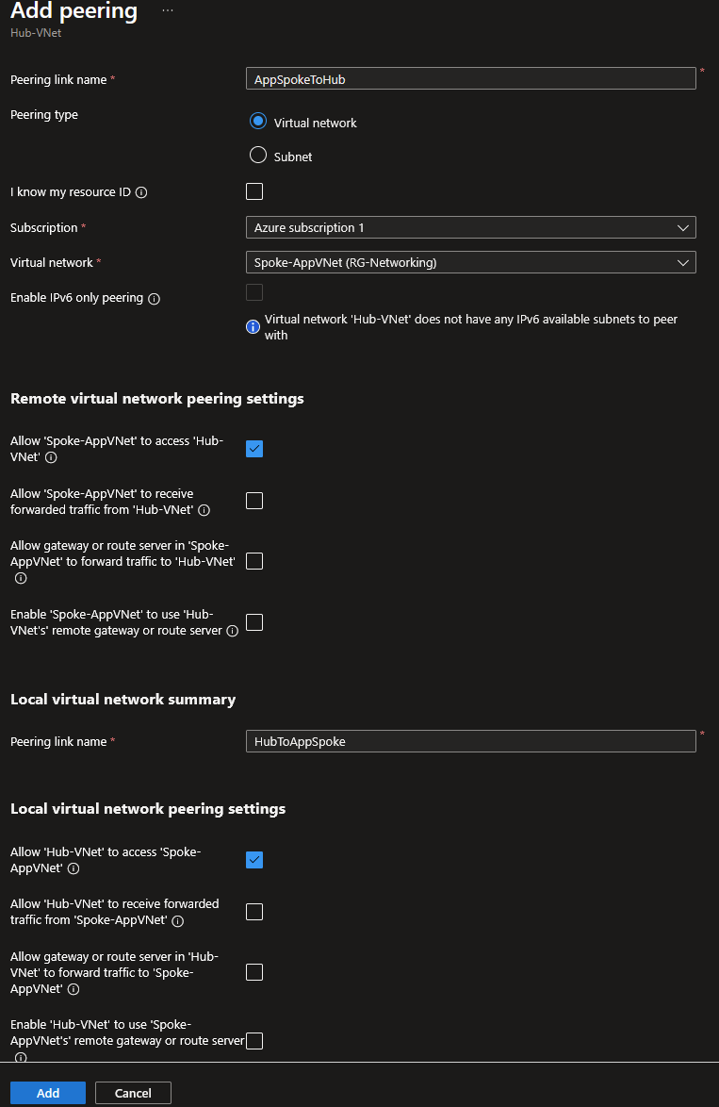

Bastion server:
Azure Bastion was deployed within the Hub VNet to provide secure administrative access to virtual machines hosted within the spoke networks. This enables RDP and SSH connectivity without exposing management ports or public IP addresses to the internet, improving the security posture of the environment.
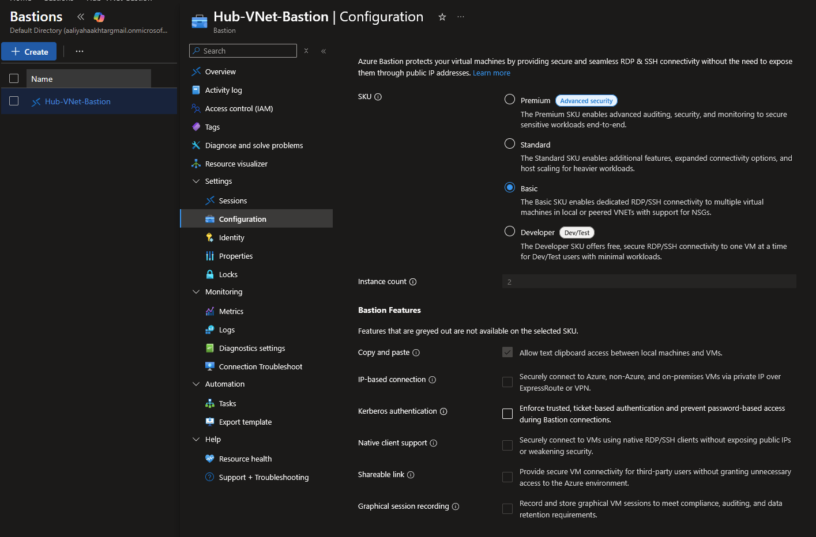

Network Security Groups (NSGs):
Network Security Groups (NSGs) were applied to the network interfaces of both virtual machines to provide traffic filtering and access control. Combined with Azure Bastion and the absence of public IP addresses, the NSGs help restrict unauthorised access and strengthen the overall security posture of the environment.

Application VM deployment:

APP-SRV01 was deployed within the Application Subnet of the Spoke-App VNet to represent a business application workload. The virtual machine was configured without a public IP address and is administered securely through Azure Bastion. Microsoft Entra login and a System Assigned Managed Identity were enabled to support identity-based administration and secure access to Azure services. Automatic patching, boot diagnostics and scheduled shutdown were configured to support security, operational management and cost optimisation.

Management VM deployment:

MGMT-LNX01 was deployed within the Management Subnet of the Spoke-Mgmt VNet to provide a dedicated management workload. The virtual machine was configured without a public IP address and is administered securely through Azure Bastion. Microsoft Entra login, a System Assigned Managed Identity and SSH key authentication were implemented to support secure administration and access to Azure services. Automatic updates, boot diagnostics and scheduled shutdown were configured to support operational management and cost optimisation.

Creating the Key Vault:

Azure Key Vault was deployed to provide a secure, centralised location for storing administrative credentials and SSH key material. The service integrates with Azure RBAC and Managed Identities, allowing workloads to securely retrieve secrets without storing credentials directly on virtual machines.

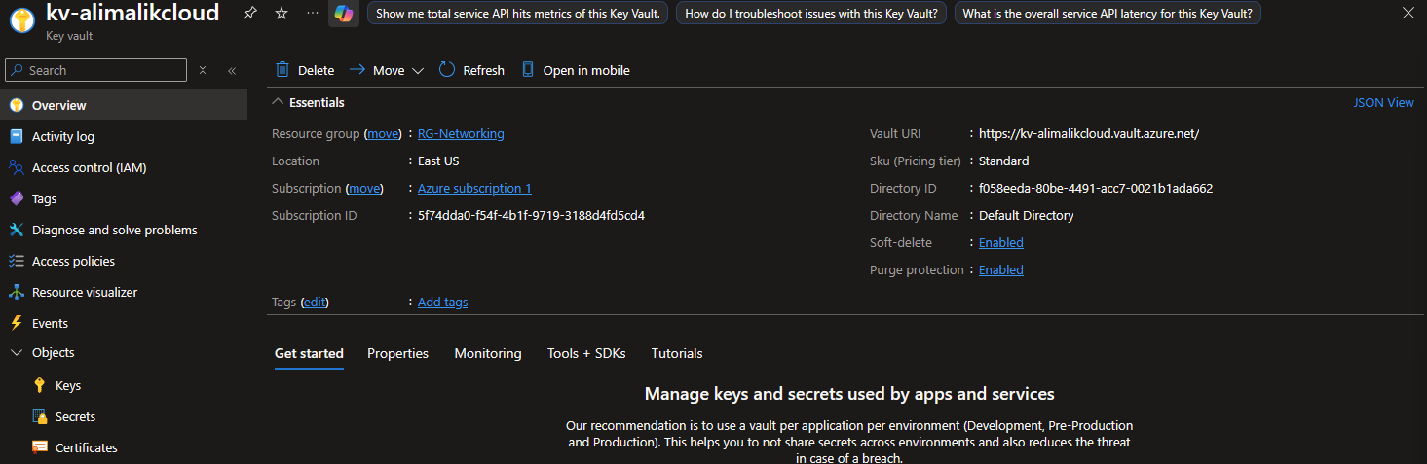

I uploaded the local admin password for the application workload vm and the private ssh key for the management workload VM into key vault, storing them securely as secretes.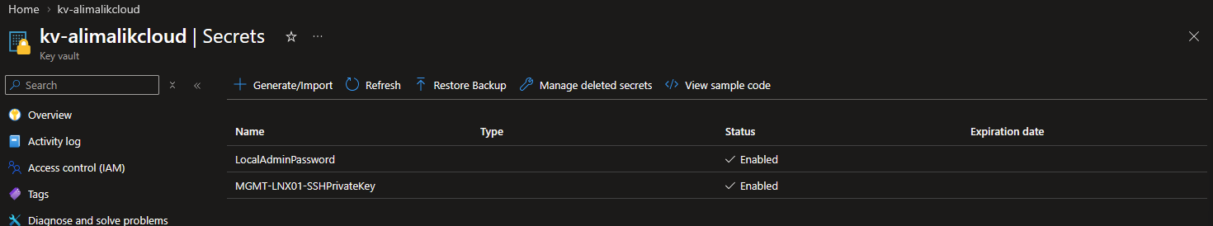

Configured the private endpoint to secure the storage account:
A Private Endpoint was deployed within the Hub VNet to provide private access to the Azure Storage Account. A Private DNS Zone was configured to enable automatic name resolution of the Storage Account's private IP address across the Hub-and-Spoke environment.
See the below configuration:
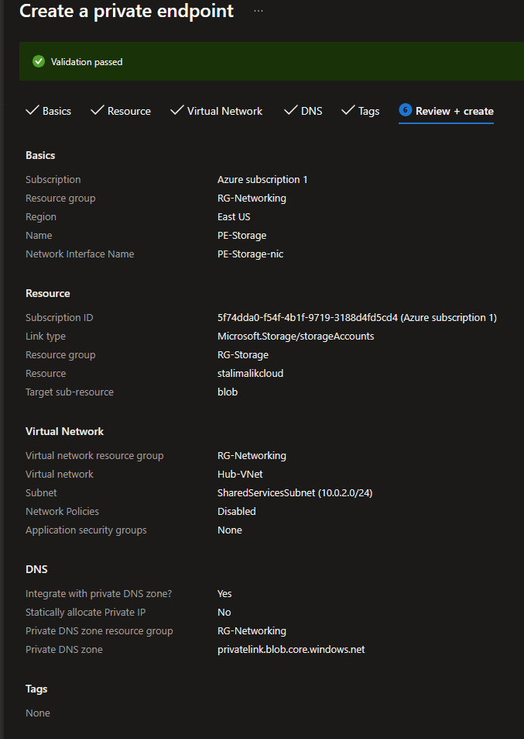
The private dns zone was created and contains an ‘A’ record mapping the storage account host name to the private endpoint. I then manually created the virtual network links linking the private dns zone to the application spoke vnet and the management spoke vnet.
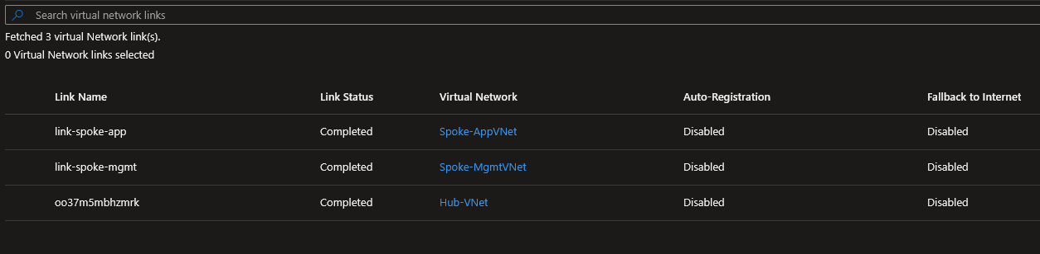

Recovery services vault (RSV):
RSV-AliMalikCloud was deployed to provide backup and recovery services for the environment. Locally Redundant Storage (LRS) was selected to support cost optimisation, while soft delete protection was enabled to improve resilience against accidental deletion. The vault protects both Windows and Linux workloads and supports business continuity requirements.

Back up policy:
APP-SRV01 was protected using Azure Backup and the Recovery Services Vault. An Enhanced backup policy was configured to create regular recovery points with a 30-day retention period. Application-consistent backups and future disk protection were enabled to support recoverability and business continuity requirements.
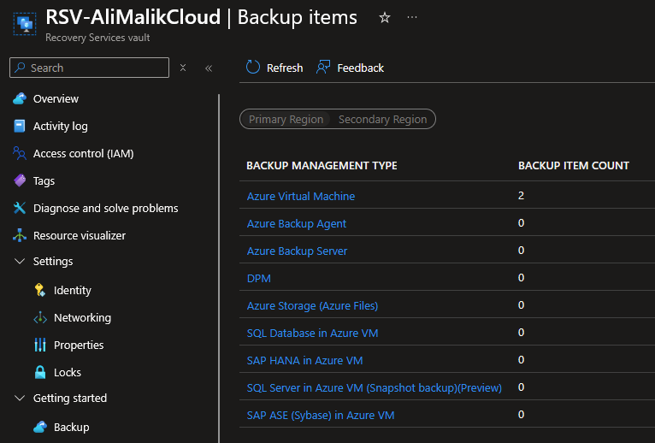

RBAC:
Azure RBAC was implemented using Microsoft Entra security groups to enforce the principle of least privilege. Administrative, audit and application support groups were assigned only the permissions required to perform their respective responsibilities, simplifying access management and improving security.

These are the following RBAC roles I have assigned.
Subscription scope:
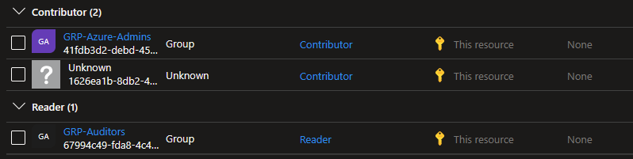

APP-SRV01 scope:
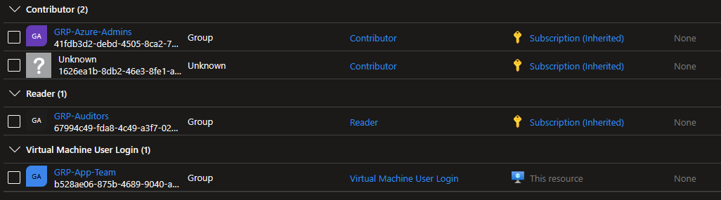

MGMT-LNX01 scope:
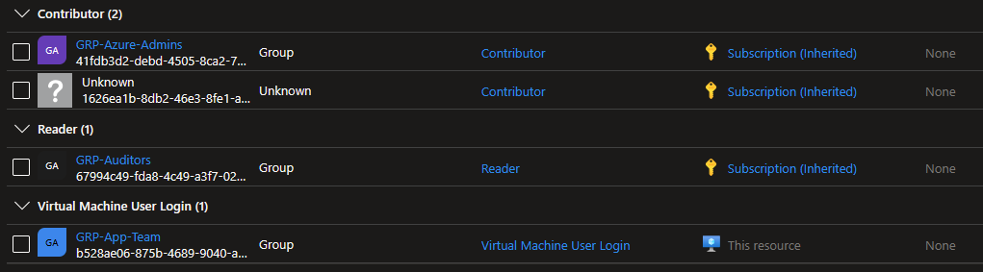

Key vault scope:
I granted key vault secretes user to the virtual machine managed identities.
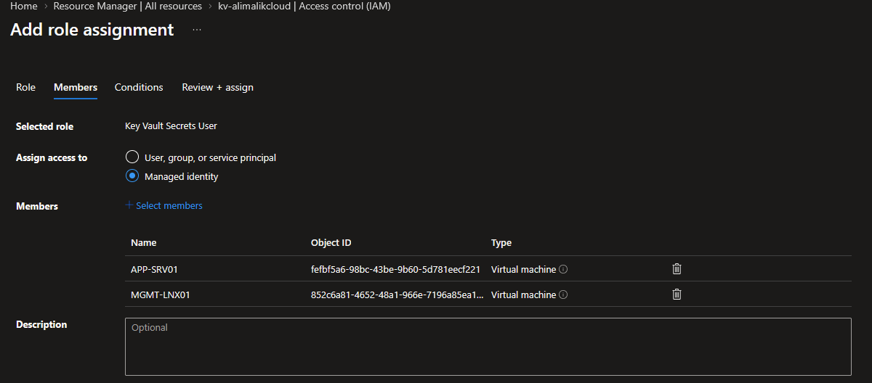

Storage account (stalimalikcloud):
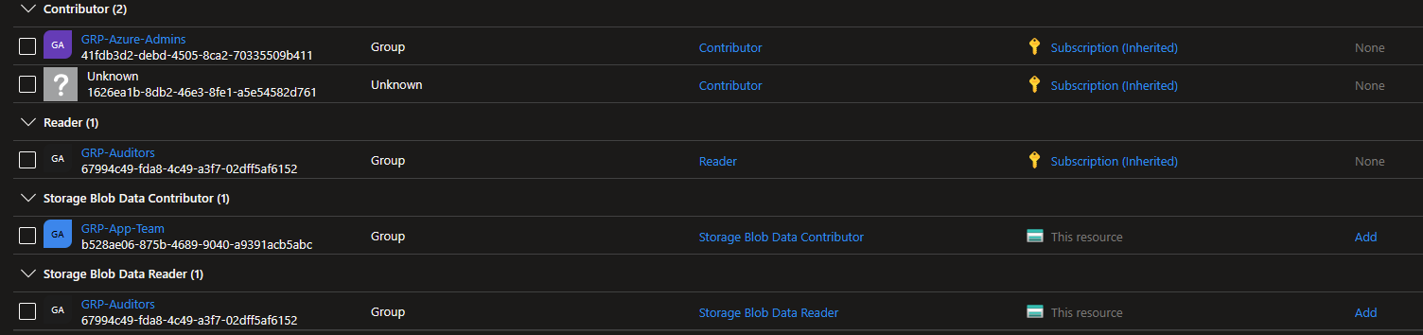

Managed identity:
System Assigned Managed Identities were enabled on both APP-SRV01 and MGMT-LNX01 to provide secure authentication to Azure services. The Key Vault Secrets User role was assigned to both identities, allowing secure access to Azure Key Vault without storing credentials directly on the virtual machines.

LAW and data collection rule:
A Data Collection Rule (DCR-AliMalikCloud) was implemented to collect performance telemetry from APP-SRV01 and MGMT-LNX01 and forward the data to LAW-AliMalikCloud. This provides centralised monitoring, log collection and operational visibility across the environment.
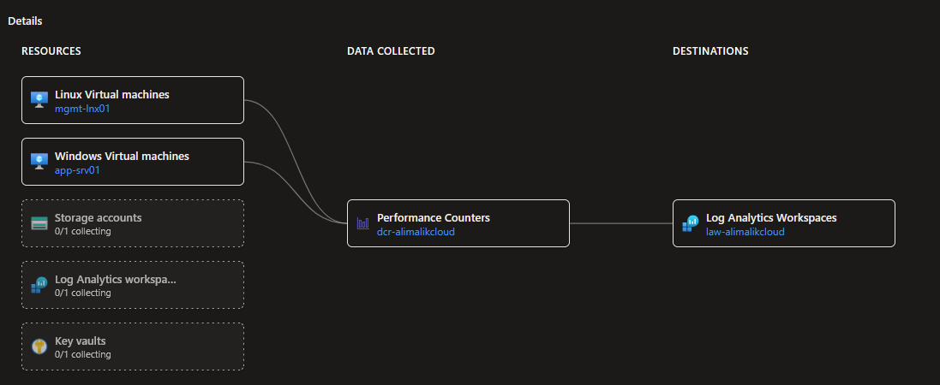

Monitoring alert rules:
A CPU utilisation alert was configured using Azure Monitor to provide proactive performance monitoring for APP-SRV01 and MGMT-LNX01. The alert triggers when CPU utilisation exceeds 80% and notifies the IT Operations team through the AG-IT-Operations Action Group, enabling early identification of performance issues.

Resource Naming Convention Section:
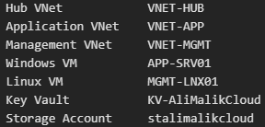
A consistent naming convention was used across all Azure resources to improve organisation, management and resource identification.

Cost management:
Centralised networking services provided through the Hub VNet reduce management overhead and support a scalable Hub-and-Spoke architecture.
- Auto shutdown enabled on both vm’s.
- No public Ips created and in use.
- LRS backup selected.
- Free-tier monitoring where possible.

Testing
VNet peering has been validated see the below screen shots.
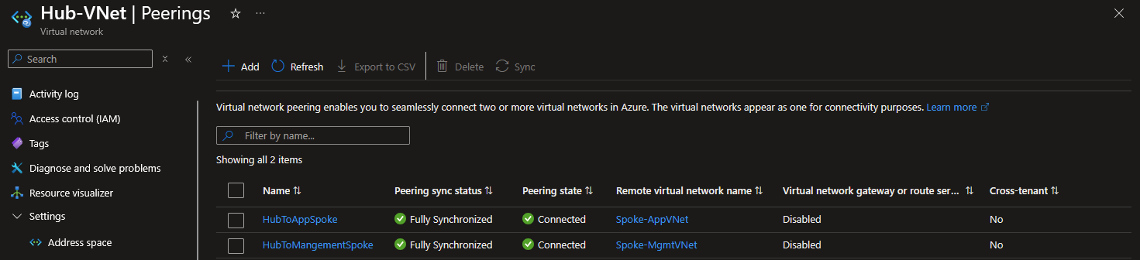See the below screenshots:
I enabled ICMP inbound on the application servers OS firewall:
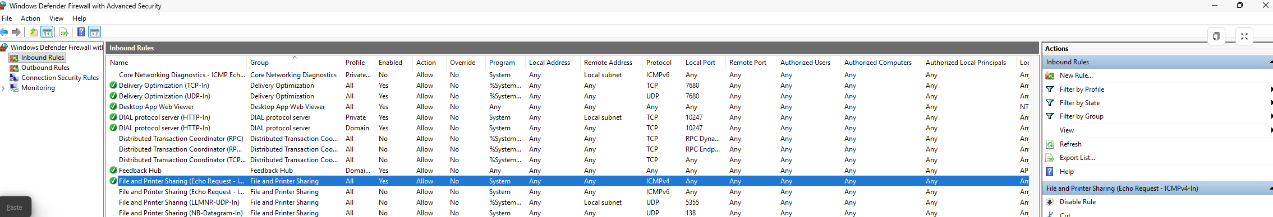

Bastion server:
VNet peering was validated through successful Azure Bastion access to both workload virtual machines. APP-SRV01 and MGMT-LNX01 were accessible from the Hub VNet without public IP addresses, confirming that routing and connectivity between the Hub and spoke virtual networks were functioning correctly.
APP-SRV01:
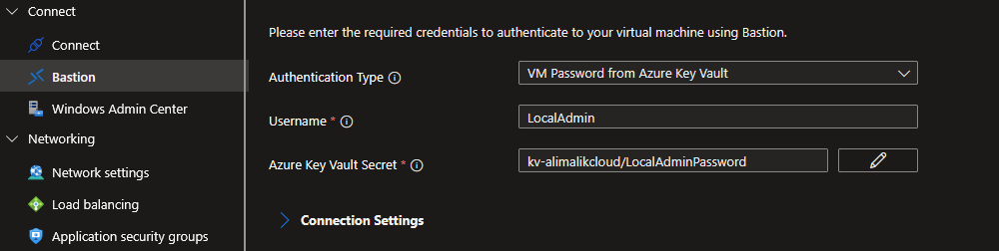#
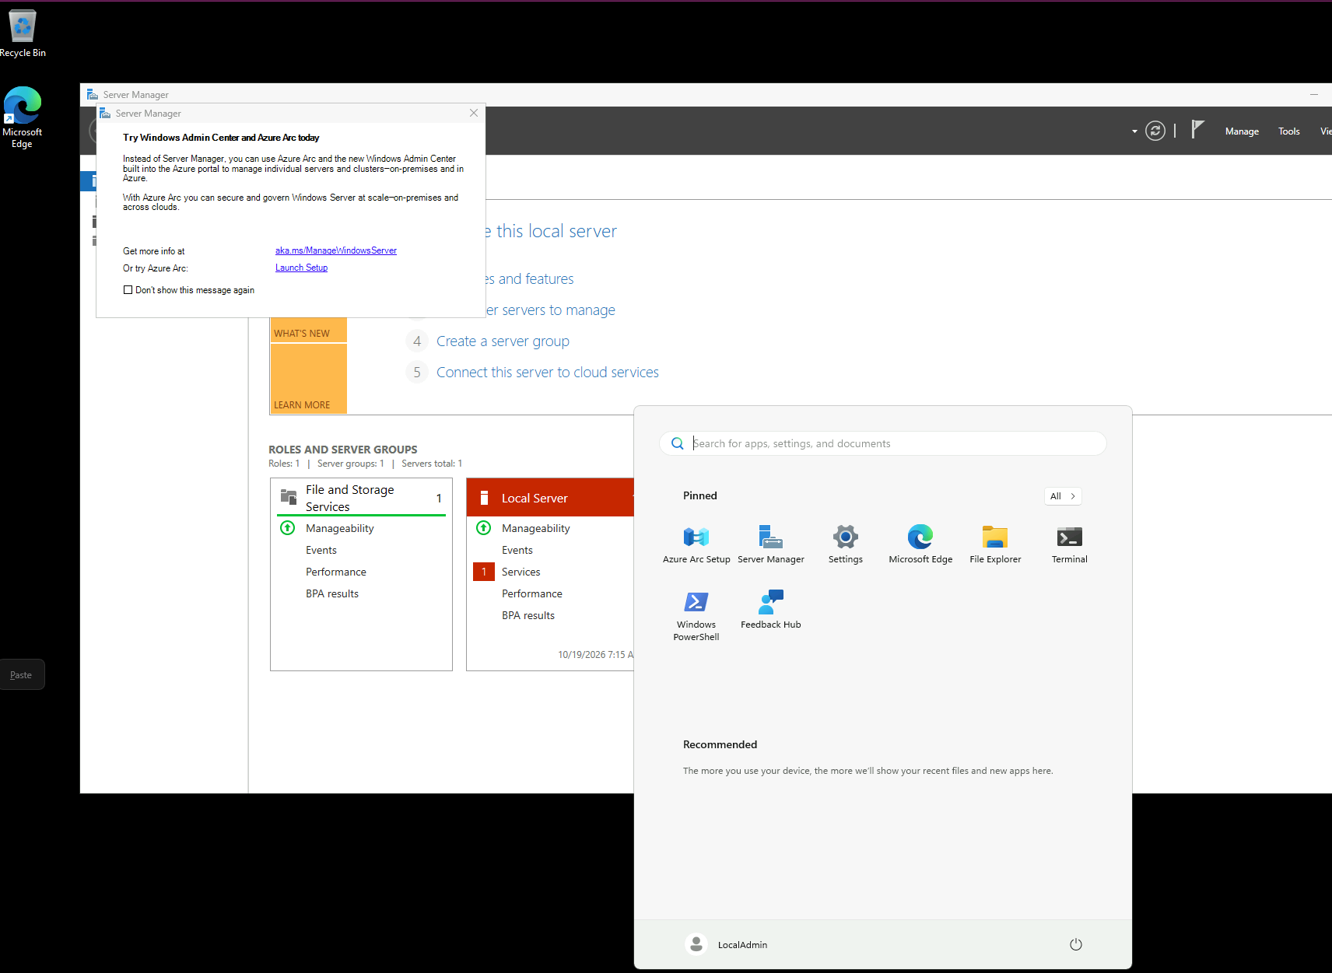

MGMT-LNX01
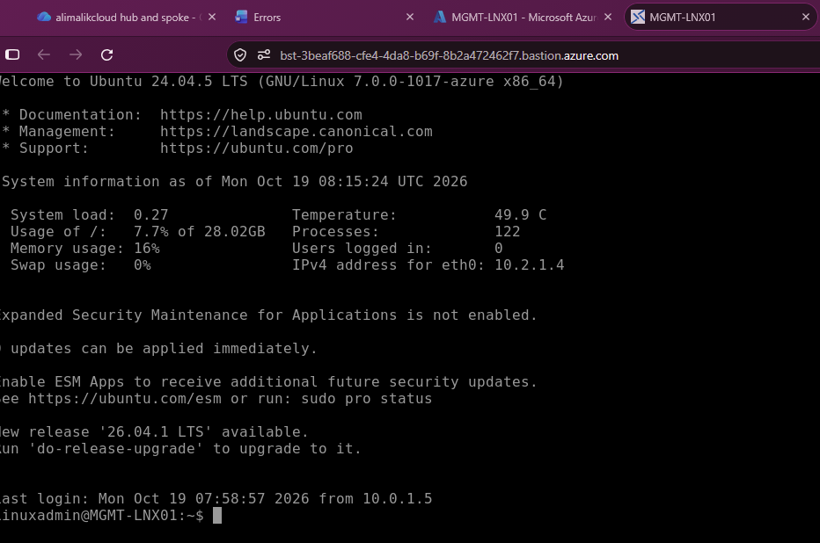
Successful login to the management VM using Azure Bastion.

Key vault:
This has been validated as i can use the scretes from the keyvault to login to the vm’s and the scretes are visble in the keyvault: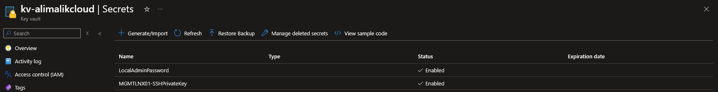

Private endpoint:
I ran nslookup stalimalikcloud.blob.core.windows.net, to valid if the storage account host name would be resolved to the private endpoint (private ip).
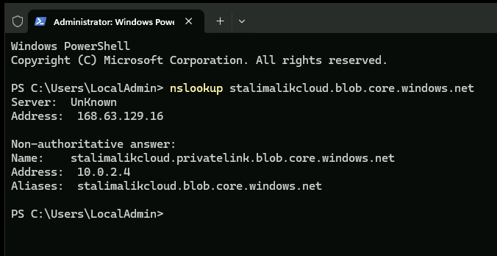

Backup:
I restored the APP-SRV01 vm, the restore was deployed back into the application subnet, see the below restore:

Restored completed successfully:

Conclusion:
This project successfully delivered a secure Azure Hub-and-Spoke environment for AliMalikCloud. The solution incorporates Microsoft Entra ID, Azure Policy, Azure Bastion, VNet Peering, Azure Key Vault, Private Endpoints, Azure Monitor, Log Analytics Workspace, Azure Backup and Recovery Services Vault. The implementation demonstrates key cloud engineering principles including security, governance, monitoring, business continuity and cost optimisation.

