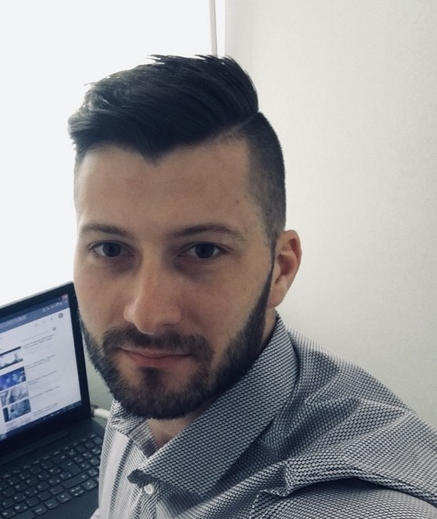HARIS KOVAČEVIĆ

POWER ELECTRONICS ENGINEER

# Gotlandweg 135, Soest, Germany

+386 (0) 70 673 696

[hariskovacevi@gmail.com](mailto:hariskovacevi@gmail.com) 29.1.1992. Kotor Varoš, BiH Married

**JOB EXPERIENCE**

8/2022 - today **Power Electronics Engineer**, AEconversion GmbH & Co. KG., Bad Sassendorf, Germany

* Software development for custom power electronics systems
* Control system design for Power electronics converters
* C programming and model based design

1/2021 – 8/2022 **Embedded System Engineer**, Emsiso d.o.o., Pesnica pri Mariboru, Slovenia

* Software development for home appliance and automotive devices
* Motor control system design for Washing Machine
* C programming and model based design

8/2018 – 1/2021 **Embedded System Engineer**, Mahle Electric Drives Slovenia d.o.o., Maribor,

Slovenia

* Software development for electrically driven auxiliaries in automotive industry (ECF, Watter and oil pumps)
* Motor control system design
* C and assembly programming

10/2017 - 8/2018 **Embedded System Engineer**, TECES, Technology center for electrical machines,

Maribor, Slovenia

* Software development for highly efficient solar micro inverter with advanced control and switching topology
* C and assembly programming

7/2016 - 9/2017 **Junior Software Developer**, GlobalLogic d.d., Zagreb, Croatia

* Software development for telecommunication industry
* Software development for smart house
* Java and C programming

11/2014 - 7/2016 **Senior technician**, Zagreb University of Applied Science, Zagreb, Croatia

* Maintenance and repair of laboratory equipment for measurement in electrical engineering
* Performing laboratory exercises for different subjects in electrical engineering

6/2014 - 10/2014 **Construction worker**, Zagrebački holding d.o.o., Zagreb, Croatia

* Road construction and maintenance

**EDUCATION**

10/2018 – 12/2022 **D. Sc. in Electrical engineering**, Faculty of Electrical Engineering and Computer

Science, Maribor

10/2013 – 5/2016 **M. Sc. in Electrical engineering**, Zagreb University of Applied Science 10/2010 – 10/2013 **B. Sc. in Electrical engineering**, Zagreb University of Applied Science

**SKILLS**

# C programming Java programming Unit testing MISRA

Git

Matlab / Simulink LTSpice

Power electronics Motor control PCB Design Hardware design MSOffice

**LANGUAGES**

Croatian - C2 English - B1 Slovenian - A2 German

**AWARDS AND CERTIFICATES**

|  |  |
| --- | --- |
| 10/2017 | **An English language exam at B1 level ( CERF )** |
| 11/2016 | **Zagreb University of Applied Science Award** |
| 6/2016 | **MIPRO Program Committee Award** |

**BIBLIOGRAPHY**

3/2022 **Single-Shunt Measurement of Three-Phase Currents for a Three-Level Inverter under the Low Modulation Index Operation**, MDPI Sensors, Original scientific article

3/2022 **Single-Shunt Three-Phase Current Measurement for a Three-Level Inverter Using a Modified Space-Vector Modulation**, MDPI Electronics, Original scientific article

6/2016 **Buck converter controlled by Arduino Uno**, MIPRO, Conference paper, Opatija, Croatia

**PASSIONS AND VOLUNTEERING**

A former member of Croatian karate national team; Black belt; 10 times Croatian karate champion; 7th in the World and Europe in 2013

Like to travel, reading books, watching movies, hiking and go to the gym