PROJECT REPORT
LeafScan
A desktop app that recognises plant leaf diseases
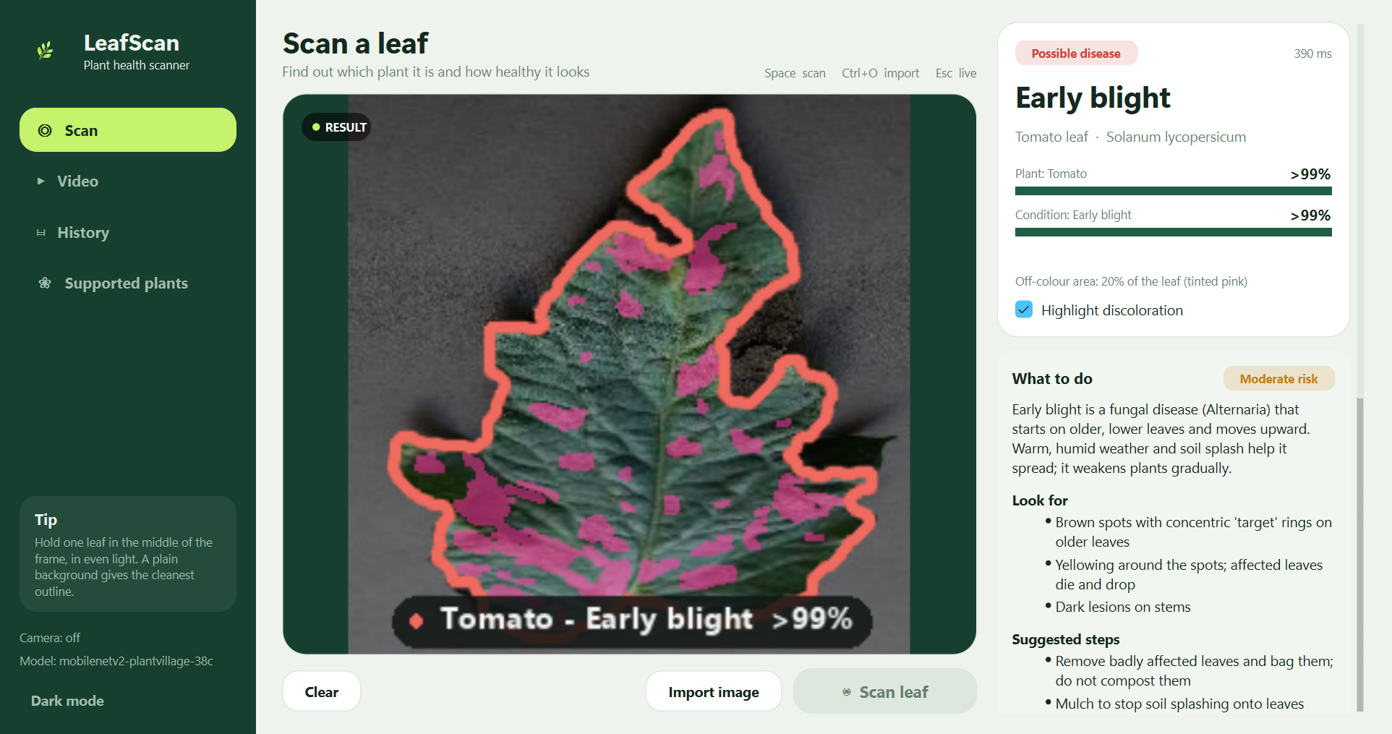
Made by
Hiba Anouar
Ali Mbarki
Rayan Ouarrad
Fadia Belaaliya
Hamza Mikdad
Academic year 2026 – 2027

Contents
1. Definition of the project 3
1.1 Objectives 3
2. Scope of the project 3
3. Technical part 4
3.1 Technologies used 4
3.2 How the app works 5
3.3 Organisation of the code 5
3.4 Installing and running 6
4. The application 6
4.1 Scanning a leaf 6
4.2 Video analysis 7
4.3 History 7
4.4 Advice and dark mode 8
5. Results 8
5.1 Testing 8
5.2 Accuracy 9
5.3 Speed and demo 9
6. Limitations and future work 9
6.1 Difficulties we faced 9
6.2 Limitations and next steps 9
7. Team organisation 10
8. Conclusion 10
References 10

1. Definition of the project
Plant diseases usually show up first on the leaves: spots, yellow areas, rings or mould. A farmer or a gardener who sees these signs often does not know what they mean, and there is not always an expert nearby to ask. We wanted to see if a normal laptop could help with this.
LeafScan is a desktop application that looks at a picture of a leaf and tells you which plant it is and if it looks healthy or sick. You can give it a photo, show the leaf to the webcam, or even give it a video of your plants. The app then gives some simple advice and keeps a history of the scans.
It is a proof of concept (PoC): the goal was to show that the idea works on a normal computer, not to build a finished product. This report presents the scope of the project, the technical part, the results we got, the limits we found and how we worked as a team.

1.1 Objectives
At the start of the project we fixed these goals:
- Take a leaf image from the webcam, a photo file or a video.
- Find the leaf in the image and draw its outline.
- Say which plant it is and which disease it has (or if it is healthy), with a confidence percentage.
- Say “Not sure” when the picture is not good enough, instead of giving a wrong answer.
- Show advice for the disease and keep a history of the scans with charts.
- Work offline, on a normal laptop, without freezing.

2. Scope of the project
To finish a working PoC in the time we had, we clearly decided what is part of the project and what is not:
Inside the scope | Outside the scope
Desktop app for Windows, written in Python | Mobile app or website
Photos, webcam and recorded videos | Drones, satellite or microscope images
The 14 plants and 38 classes of the model (table below) | Other plants, pests and nutrient problems
Using an already trained AI model | Training our own model from zero
Advice with sources, history of scans | Real medical-style diagnosis or treatment doses
Working offline on a normal laptop CPU | Servers, cloud or a graphics card

The plants and diseases are the ones the model was trained on. We kept the list in one file (labels.json) so the rest of the code never writes a plant name by hand.
Plant | Scientific name | What the app can detect
Apple | Malus domestica | Healthy, apple scab, black rot, cedar apple rust
Blueberry | Vaccinium spp. | Healthy only
Cherry | Prunus avium | Healthy, powdery mildew
Corn | Zea mays | Healthy, common rust, gray leaf spot, northern leaf blight
Grape | Vitis vinifera | Healthy, black rot, esca (black measles), leaf blight
Citrus (orange) | Citrus sinensis | Citrus greening (HLB)
Peach | Prunus persica | Healthy, bacterial spot
Bell pepper | Capsicum annuum | Healthy, bacterial spot
Potato | Solanum tuberosum | Healthy, early blight, late blight
Raspberry | Rubus idaeus | Healthy only
Soybean | Glycine max | Healthy only
Squash | Cucurbita spp. | Powdery mildew
Strawberry | Fragaria × ananassa | Healthy, leaf scorch
Tomato | Solanum lycopersicum | Healthy and 9 problems (early blight, late blight, leaf mold, mosaic virus, spider mites, …)

3. Technical part

3.1 Technologies used
We chose tools that are free, work offline and that we could learn quickly. The table below sums up what we used and why.
Technology | Used for | Why we chose it
Python 3.11 | The whole application | Easy to learn, lots of libraries for images and AI
PySide6 (Qt) | The interface: windows, buttons, pages | Looks like a real desktop app, free to use, supports threads
OpenCV | Webcam, reading photos and videos, finding the leaf, drawing outlines | The most used library for image processing, and it is fast
MobileNetV2 | The AI model that recognises the plant and the disease | Small (9 MB) and fast, already trained on plant leaves
ONNX Runtime | Running the AI model on the computer | Very light compared to PyTorch, no graphics card needed
NumPy | Working with images as arrays of numbers | Used by OpenCV and the model anyway
SQLite | Saving the history of scans | A database in one file, already included in Python
Matplotlib | Charts on the History page | Simple to put inside a Qt window
JSON files | List of plants and diseases, advice texts | Easy to read and change without touching the code
pytest | Automatic tests | The standard test tool in Python
Git | Sharing code and keeping versions | Everyone could work on their part safely

About the AI model: we did not train a model from zero. We first tried to train our own, but on our laptops it was very slow and the files were huge (around 5 GB with PyTorch). So we used a model that was already trained on the public PlantVillage dataset (about 54,000 leaf photos) and is shared on Hugging Face. It knows 14 plants (apple, tomato, potato, grape, corn, pepper and others) and 38 classes (healthy or a specific disease). With ONNX Runtime the app is now only about 550 MB.

3.2 How the app works
When the user gives an image to LeafScan, it goes through a few steps, one after the other:
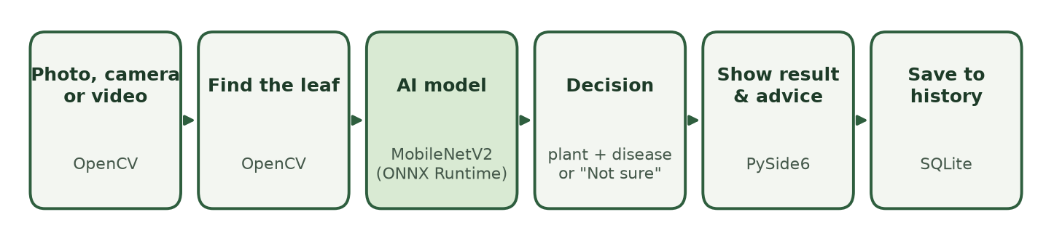
Figure 1 – The steps an image goes through in LeafScan
- Get the image. From a photo, the webcam or a video frame (OpenCV).
- Find the leaf. OpenCV looks at the colours to separate the green leaf from the background and draws its outline. If no leaf is found, the app says so and stops here.
- Recognise it. The leaf is cut out, resized to 224 × 224 pixels and given to the AI model, which gives a probability for each of the 38 classes.
- Decide. We first decide the plant, then the disease. If the model is not confident enough (below 55 % for the plant or 60 % for the disease), the app answers “Not sure”.
- Show and save. The result, the outline and the advice are shown, and the user can save the scan in the history.
To keep the window from freezing, the camera and the AI model run in separate threads (QThread in Qt). The interface only displays things and reacts to clicks.

3.3 Organisation of the code
We split the code into folders, one for each big job, which also matched how we split the work in the team:
Folder / file | What it contains
ui/ | All the pages and windows of the interface (scan, video, history, theme)
vision/ | Finding the leaf, finding several leaves in a video, drawing outlines
classify/ | Loading the AI model and preparing the image for it
storage/ | The SQLite database for the history
guidance/ | The advice cards for each disease, with their sources
pipeline.py | Connects all the steps together, from image to result
labels.json | The list of the 14 plants and 38 classes
tests/ | The automatic tests

3.4 Installing and running
The app runs on Windows with Python 3.11. To install it, we create a virtual environment and install the libraries from requirements.txt:
- python -m venv .venv
- .venv\Scripts\pip install -r requirements.txt
- Double-click “Start LeafScan.bat” to open the app (no terminal needed).
The AI model file (9 MB) is already in the models folder, so no internet is needed after installing. The first scan takes a second or two while the model loads, then each scan is fast.

4. The application
The app has a menu on the left with three pages, Scan, Video and History, plus a list of the supported plants and a dark mode. All the screenshots below were taken from our app.

4.1 Scanning a leaf
On the Scan page the user imports a photo (or presses Space with the webcam). The leaf is outlined, and the right panel shows the plant, the disease and two confidence bars. Pink areas show the parts of the leaf that are not a healthy green colour. Under the result there is a “What to do” card with symptoms, steps to take and prevention.
Figure 2 – A tomato leaf with early blight, detected with more than 99 % confidence
We made sure the app never shows “100 %”, because an AI is never completely sure. When the picture is blurry or dark, the app does not guess: it answers “Not sure” and shows its best guesses, as in Figure 3.
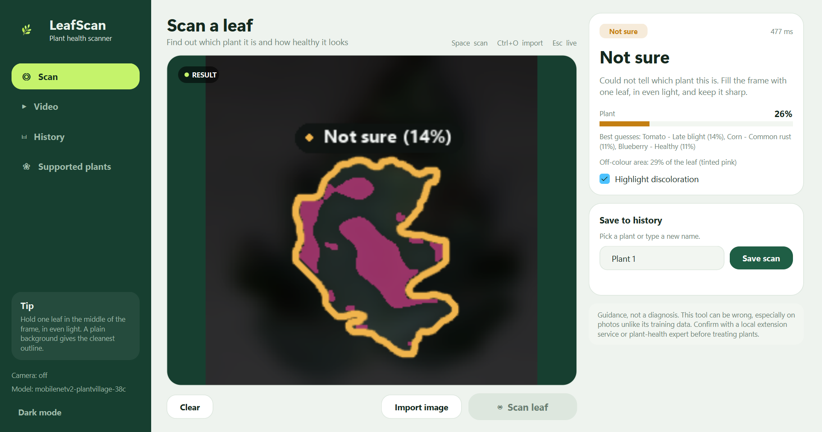
Figure 3 – A blurry and dark photo: the app answers “Not sure” instead of guessing

4.2 Video analysis
This was the last feature we added. The user opens a video of their plants and the app checks every leaf while the video plays. Each leaf gets an outline (red for a disease, green for healthy) and a label. About three times per second the frame is analysed, and the app follows each leaf from one frame to the next so the labels do not jump around. A disease is only reported after it is seen at least twice, to avoid false alarms. At the end it gives a verdict like “Illness detected” with the time where each problem was seen.
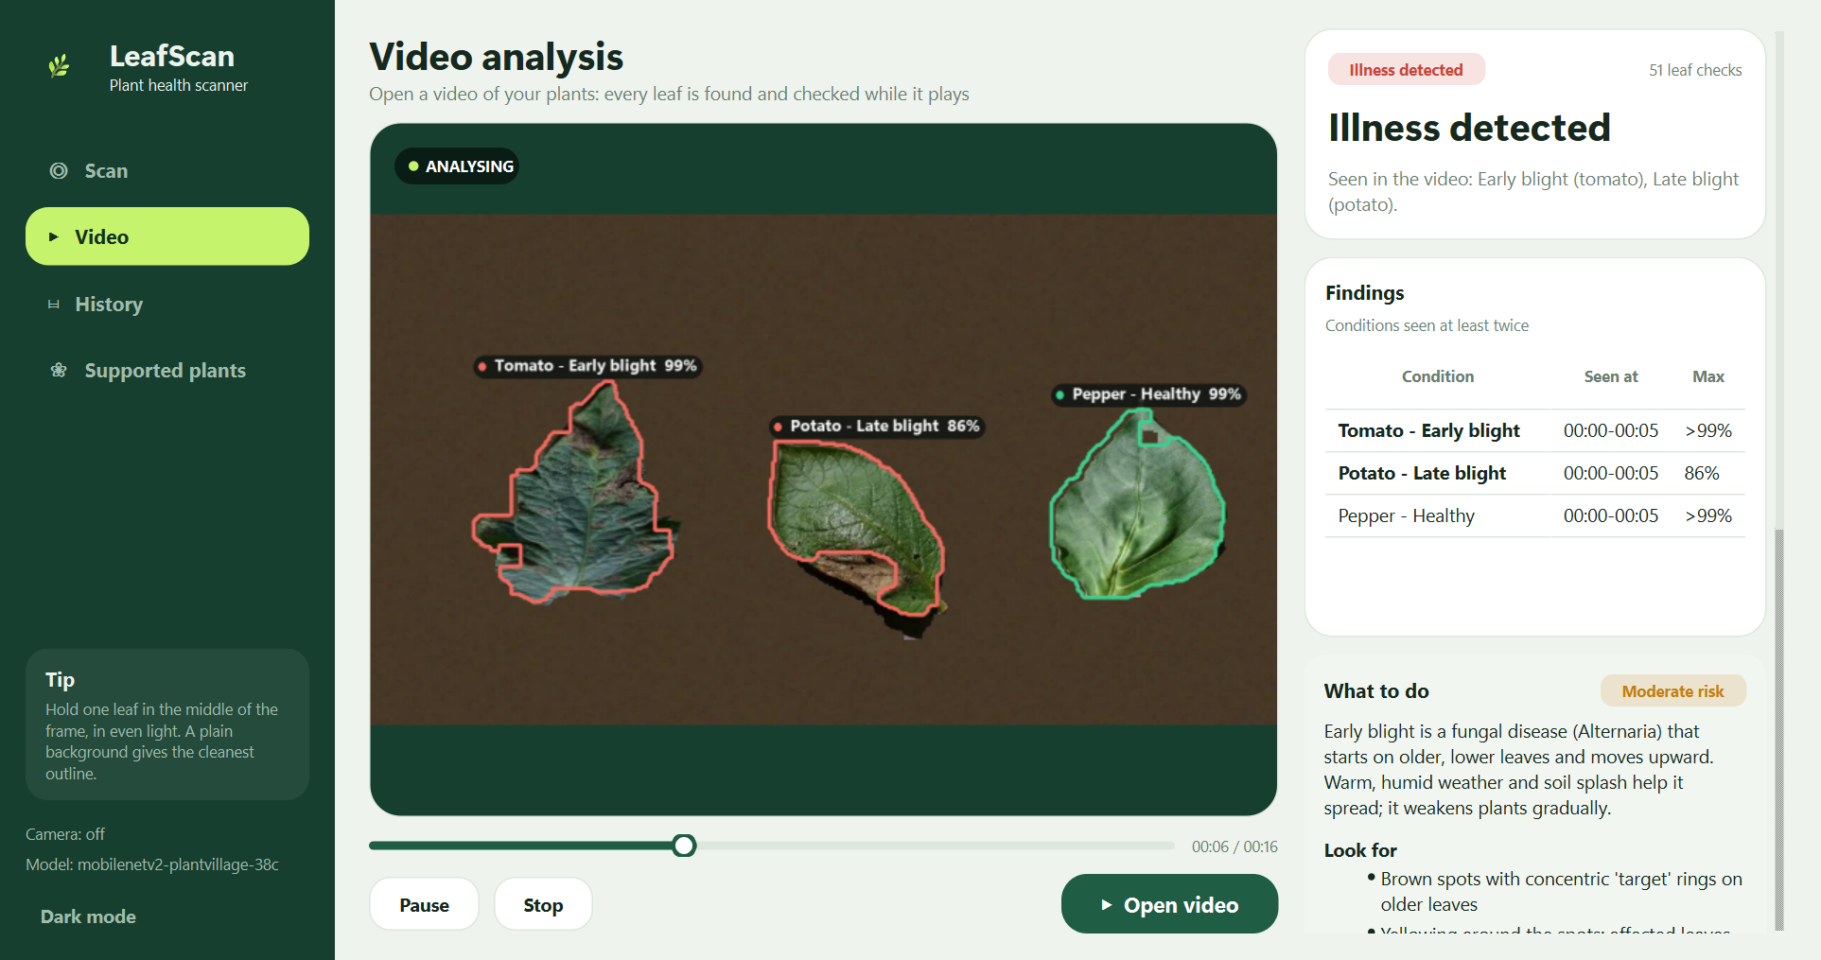
Figure 4 – Video analysis: three leaves found and labelled while the video plays

4.3 History
Every scan can be saved under a plant name, like “Tomato bed”. The History page shows the number of scans, two charts (scans over time and diseases per plant) and a table with a small picture of each scan. The user can filter by plant, open an old scan or delete it. Everything is saved locally in an SQLite database, and the images are saved as PNG files.
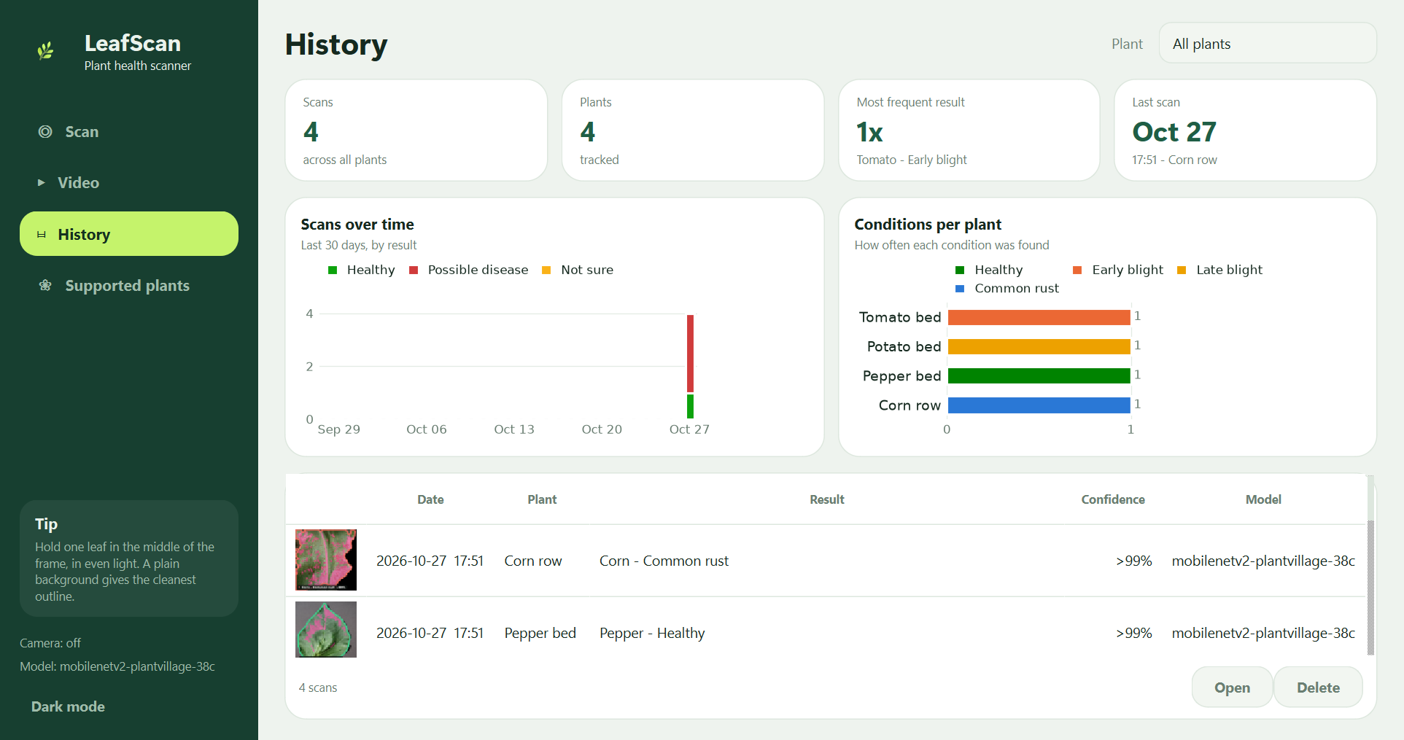
Figure 5 – The History page with charts and saved scans

4.4 Advice and dark mode
For each disease we wrote an advice card (what it is, what to look for, what to do, how to prevent it) based on university agriculture websites like UC IPM, the Royal Horticultural Society and NC State Extension. Each card has its sources, and the app always reminds the user that this is guidance, not a real diagnosis. The app also has a dark mode, which is remembered the next time the app opens.
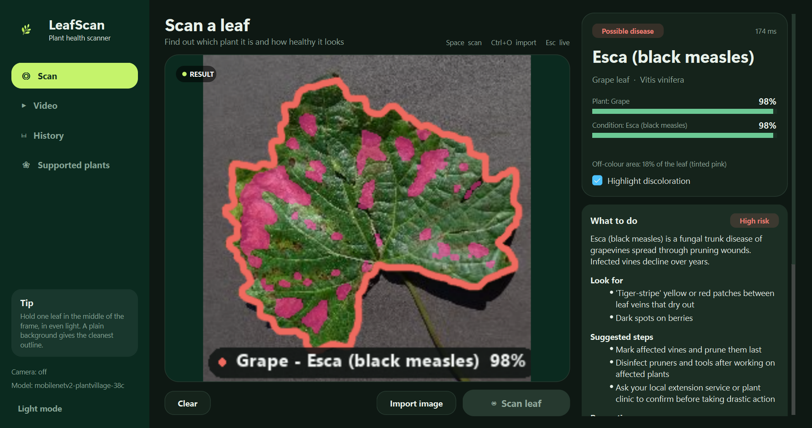
Figure 6 – Dark mode: a grape leaf with Esca, with the advice card

5. Results

5.1 Testing
We wrote 64 automatic tests with pytest (63 pass, 1 is skipped on purpose). They check the leaf detection on test images, the decision rules, saving and deleting in the database, that every disease has an advice card, and even the interface (it opens without a screen, imports a photo and saves it). We also tested what happens when things go wrong: no webcam, a broken model file or a file that is not an image. In each case the app shows a message instead of crashing.

5.2 Accuracy
We tested the model through our app on two kinds of photos:
Type of photos | Number | Plant correct | Disease correct
Lab photos (one leaf, plain background) | 1,411 | 97 % | 94 %
Real photos (in the field, messy background) | 962 | 64 % | 24 %

On clean photos the app works very well. On real-life photos it is much weaker, because the model only learned from studio photos. The good part is that in many of these cases the app answers “Not sure” instead of a wrong disease.

5.3 Speed and demo
What we measured | Result on a normal laptop (no graphics card)
AI model, one image | 20 to 50 milliseconds
Full scan (find leaf + model + drawing) | about 0.1 to 0.5 second
Video analysis | 3 checks per second, video plays at almost normal speed
Size of the installed app | about 550 MB (model: 9 MB)

In our demo the app correctly recognised tomato early blight, potato late blight, a healthy bell pepper, corn common rust, grape esca and apple cedar rust, and answered “Not sure” for a blurry, dark photo. In the test video it found and correctly labelled all three leaves. So the main objectives of the PoC were reached.

6. Limitations and future work

6.1 Difficulties we faced
- Wrong plant. At first the app often got the plant wrong. We fixed a lot of it by cutting the leaf out before giving it to the model, by checking the plant first and the disease second, and by also testing the mirror image of the leaf.
- Leaf not found. With a busy background (a desk, a hand) the leaf was sometimes not detected. We added more detection methods that are tried one after the other.
- Heavy app. Our first version with PyTorch was about 5 GB. Switching to ONNX Runtime and a ready model brought it down to about 550 MB.
- Freezing window. The camera and the model blocked the interface, so we moved them into separate threads.

6.2 Limitations and next steps
The main limit is that the model was trained on clean studio photos, so it is not reliable enough yet for real field photos. It also only knows 14 plants: a leaf from another plant will be shown as “Not sure” or confused with a known one. If we continue the project, we would like to:
- Train the model on real-life photos (for example the PlantDoc dataset) to improve field accuracy.
- Add an “unknown plant” answer and more plants.
- Make a mobile version, since the same model can run on a phone.

7. Team organisation
We divided the project into five parts so each member had a balanced share and could explain their part:
Member | Part of the project | Main technologies
Hiba Anouar | Interface and design, live demo | PySide6 / Qt, style sheets
Ali Mbarki | Camera, video and leaf detection | OpenCV
Rayan Ouarrad | AI model | MobileNetV2, ONNX Runtime, NumPy
Fadia Belaaliya | Processing steps and decision rules | Python, NumPy, Qt threads
Hamza Mikdad | History, charts, advice and tests | SQLite, Matplotlib, JSON, pytest

We worked in steps, and at the end of each step the app was working and saved in Git:
Step | What we did
1. Skeleton | Empty interface with fake results, so everyone could start on their part
2. AI model | Added the real model and the decision rules
3. Leaf detection | Finding and outlining the leaf with OpenCV
4. History and advice | Database, charts and advice cards
5. Testing | Error handling and automatic tests
6. Improvements | Lighter app (ONNX), new design, video analysis

We used Git to share the code and met regularly to connect the parts together. Defining clear inputs and outputs for each part at the beginning helped a lot, because everyone could work at the same time.

8. Conclusion
LeafScan shows that a normal laptop, without internet, can recognise a plant and its disease from a leaf in less than a second, find leaves in a video, give advice and keep a history. The proof of concept reaches its goals on clean photos (97 % for the plant, 94 % for the disease). The tests on real photos also showed us clearly what to improve next: a model trained on real field pictures.
This project taught us a lot about image processing, using AI models, building a real interface and working as a team on the same code.

References
1. Sandler et al. (2018), MobileNetV2: Inverted Residuals and Linear Bottlenecks, CVPR.
2. Hughes & Salathé (2015), PlantVillage: an open access repository of images on plant health.
3. Pre-trained model: huggingface.co/linkanjarad/mobilenet_v2_1.0_224-plant-disease-identification
4. Documentation: opencv.org, onnxruntime.ai, doc.qt.io/qtforpython-6
5. Advice sources: UC Statewide IPM Program, Royal Horticultural Society, NC State Extension, Ohioline.

