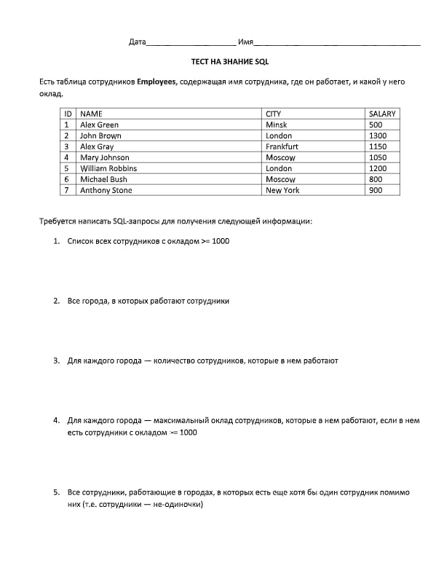

1. SELECT NAME FROM Employees  
   WHERE SALARY >=1000;
2. SELECT DISTINCT CITY FROM employees;
3. SELECT count(\*) FROM employees

GROUP BY CITY;

1. SELECT max(salary) FROM employees

GROUP BY CITY

HAVING SALARY >=1000;

1. SELECT NAME FROM employees

WHERE CITY in ( SELECT CITY FROM employees

GROUP BY city

HAVING count(\*) >1);