**Introduction**

Online shopping is becoming increasingly popular for variety of reasons.

There are certainly outside factors such as increasing gas prices, difficulty in getting to traditional stores and contribute to the increased interest in online shopping.

Consumers can get full information about the product with its reviews being passed by the existing users. If one wants to buy a product, he/she is no longer limited to asking the friends and families because there are many products reviews on the web which gives opinions of the existing users of the product.

Online shopping sites contain wide variety of goods both high quality and mild quality keeping in mind the level of people.

Our project is about online shopping, online shopping is one of the essential elements in the presence time due to the healthy situation (corona virus) around the world.

The visitor enters to the application and see the product. If he like some product he can go to the store and buy it. If he wants to buy online, he has to register then the orders will be delivered to his location.

When the client makes orders the closest available delivery man receive the orders then he go to the supplier, bring the orders and deliver it.

The user can be a client or supplier. The supplier can add, delete or modify the products that the client will buy it.

Any person can be access as a client or open a store as a supplier.

**Actors and Roles**

In this website, we are going to describe each actor acting in the system and its power.  
The actors are:   
1- The Visitor  
2- The Client  
3- The Supplier  
4- The Delivery Man  
5- The Controller   
6- The Administrator

**Visitor:** a visitor visits the website in order to browsing distribution to know the products that he wants to buy. Also, he can register to be a client or supplier.

**Client:** a client can browse the website. He can create new order (add item, delete item, modify item and confirm order), pay money with a credit card and ask for delivery.  
Also, he can select delivery man priorities and send a feedback to the administrator.

**The supplier:** a supplier can do the same task of the client plus he can open store, manipulate product (add, modify, delete and special offers) and browsing receive orders.

**The Delivery Man:** a delivery man has multi tasks: receive the orders from the client or the supplier and deliver it and he confirm receipt of money from the client.

**The controller:** a controller can manipulate data (add, modify and delete).

**The Administrator:** he is the main of the website he can manipulate all type of user(client, supplier, delivery man and controller) by create, delete, modify, block and unblock.  
Also, he can create a new report like:  
- Delivery man delivered orders.  
- Delivery amount special duration.  
- Most product demand.  
- Administrator or Supplier weekly incomes.

**Objectives**

**1- Increase job opportunities.**

Many assumed the growth of e-commerce meant a huge blow to the job market, especially in the world of retail. However, it actually wound up creating numerous employment opportunities in various sectors.

**2- Decrease the traffic jam and air pollution.**

Traditional retail involves traffic both from warehouses to stores and from consumers to stores. E-commerce cuts intermediate traffic by delivering goods directly from the warehouses to the consumers. Although plenty of evidence has shown that vans that are servicing e-commerce are a growing contributor to traffic and congestion, consumers are also making less shopping trips using vehicles.

**3- Increasing the number of loyal clients**

Customers are the core of all business strategies. Therefore, ensuring the great customer experience is of prime importance for the growth of the business. You need to meet your customers where they spend their time. More than 60% of consumers look for purchasing goods and services online. If you meet your customers where they are already active, the chances of them, interacting with your business increases two folds. You can increase the number of loyal customers by giving the best experience to your already existing customers as well as bring in newer customers.

**4- Boosting the efficiency of services**

With the continually evolving technology, you need to enhance the efficiency of your services. By choosing an online ecommerce platform to create an online store, you can efficiently reduce the cost of managing and selling online. You have various opportunities to boost the efficiency of your service that eventually enhances the revenue earned. By reducing the delivery time, you can witness happy customers getting back to your business two times faster. Another way is to provide your customers with automated services such as status update, invoice creating, chat support, etc. When you update your efficiency of delivering products or services to your customers, you are creating a strong online presence that helps you sell more.

**5- Save money**

* Make an online shopping list.
* Compare prices and visit deals websites.
* Get coupons online.
* Sign up for online reward programs.
* Leave items in your shopping cart.
* Create a budget for your online shopping.

**6- Making responsive ecommerce website**

With the increasing use of smartphones for shopping online, it has become more than mandatory for ecommerce businesses to go mobile. Apart from creating a native mobile app, like the one offered from Builder fly, you need to create a responsive ecommerce website. It is one of the major objectives of all leading ecommerce businesses. By responsive, it means to create a website that can be viewed from any devices of varying screen size, equally. Studies say that Google may next rank a website based on its mobile website. It means that any website that has a responsive design would be ranked on top of the website that does not have one. Making your ecommerce website responsive can help you optimize it. A mobile-friendly website earns more traffic than the rest.

**Problems**

1. Open stores that sell illegal products.
2. Open store with the same name to another store of another user.
3. Packaging for the products.
4. Delivering wrong products.
5. Boring experience.

**Solutions**

1. Allow the user to send feedback to the administrator for illegal issue then the administrator send warning to the owner of the store or block it or close it after investigation.
2. Choose material that is cost friendly yet sturdy enough for the packaging to stay intact till the last.
3. Double check order information.
4. Create rich, enjoyable adventures that resonate with today’s impatient shoppers. Integrating approaches and technologies that make shopping more interactive and engaging.

**Use case diagram**

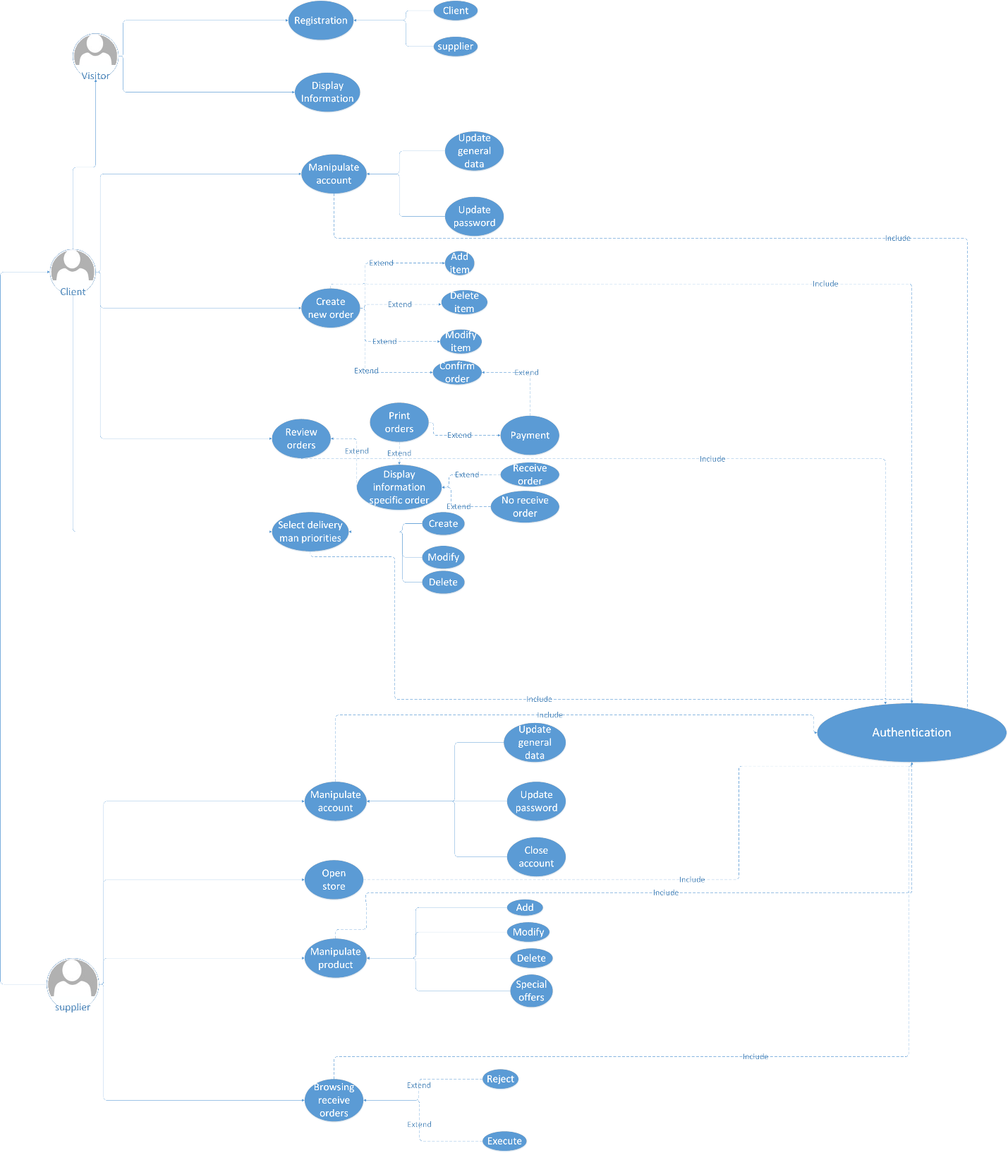

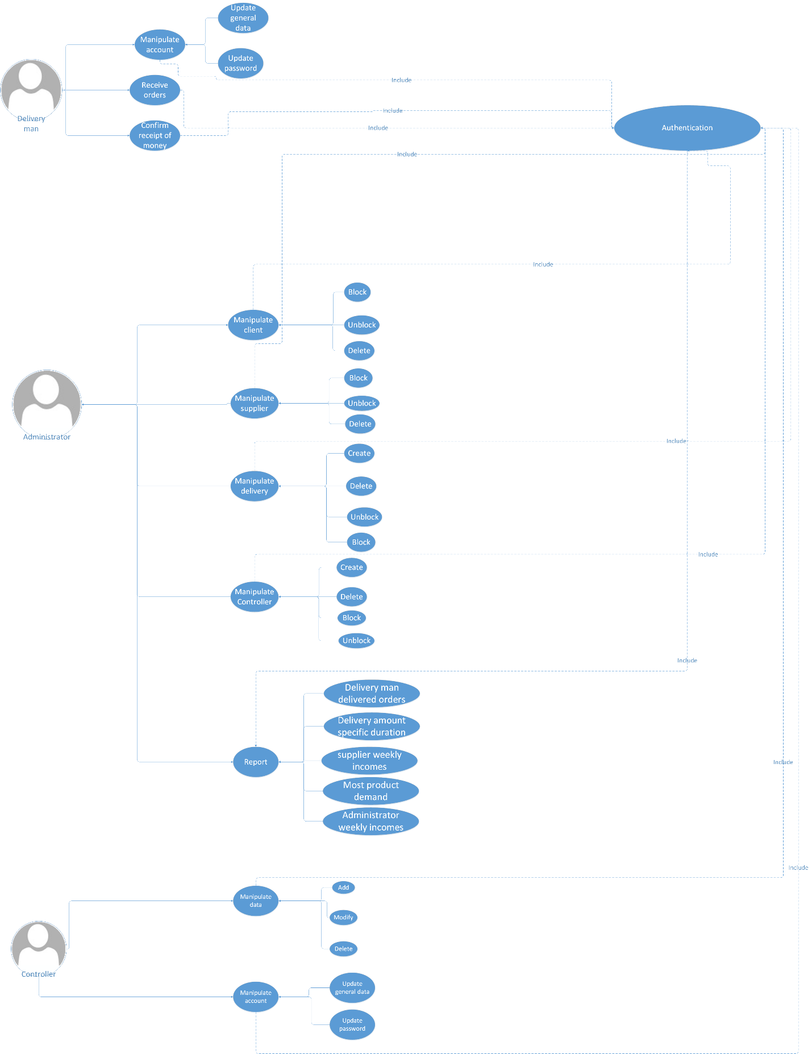

**Class diagram**

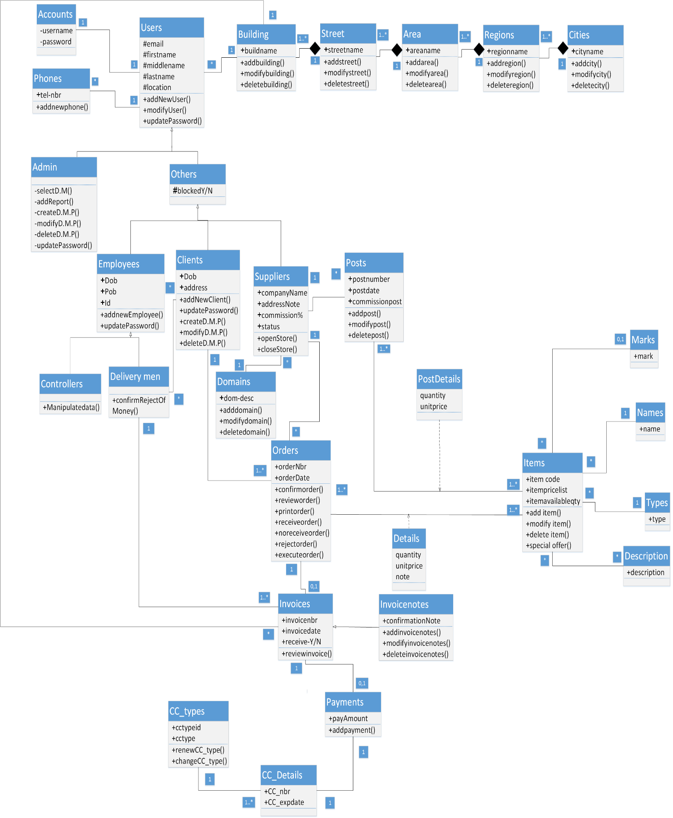

**Sequences login diagram**

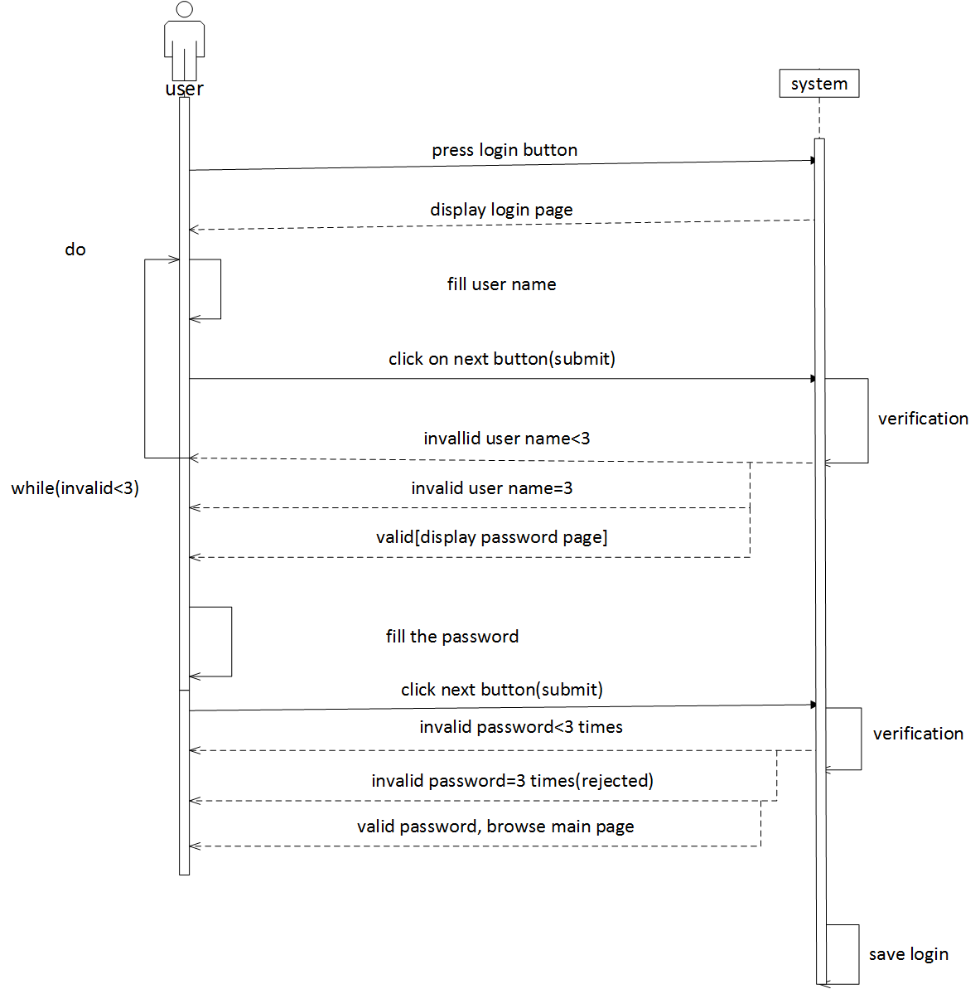

**Sequences registration diagram**

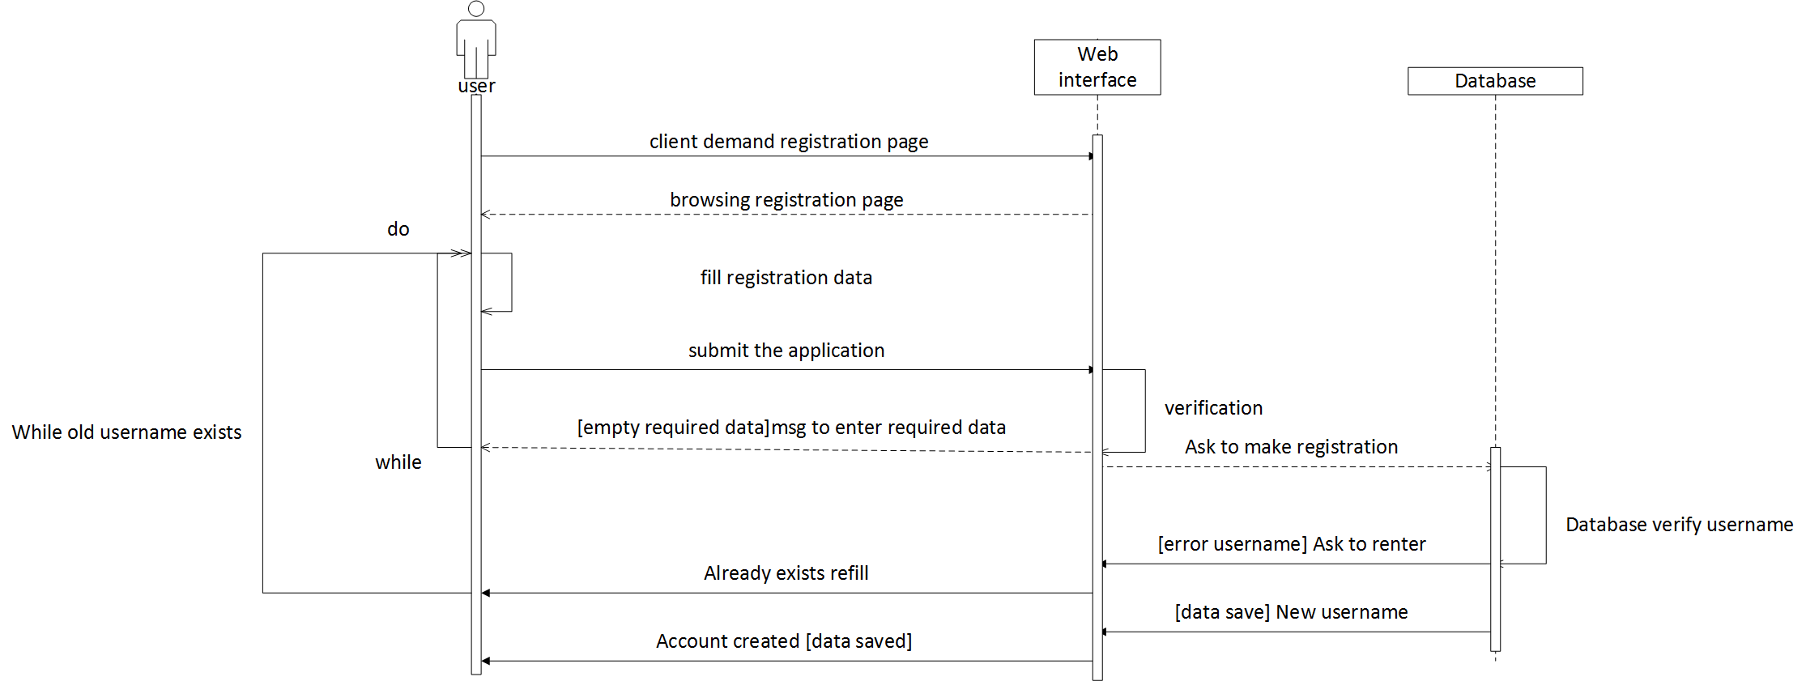

**Sequence post-product diagram**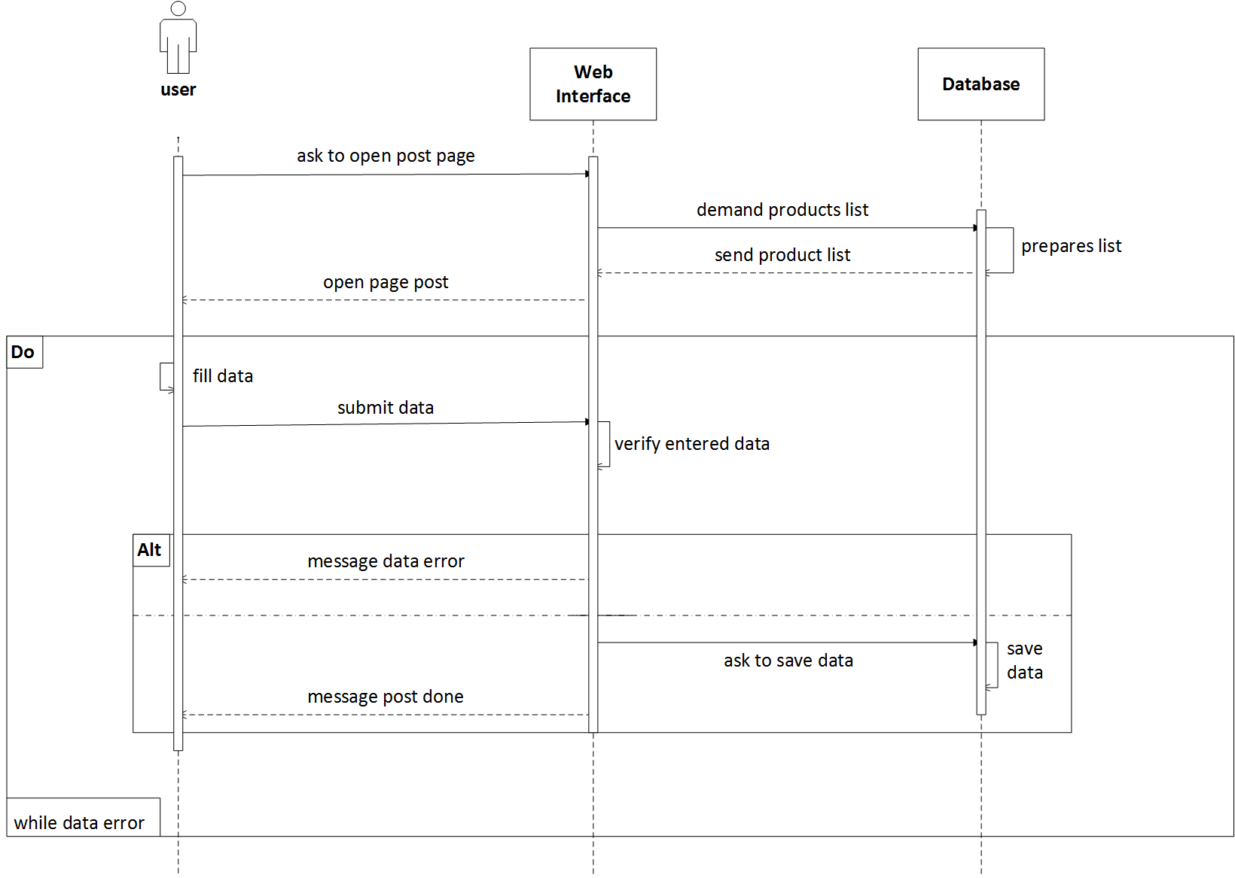

**Sequences request-order diagram**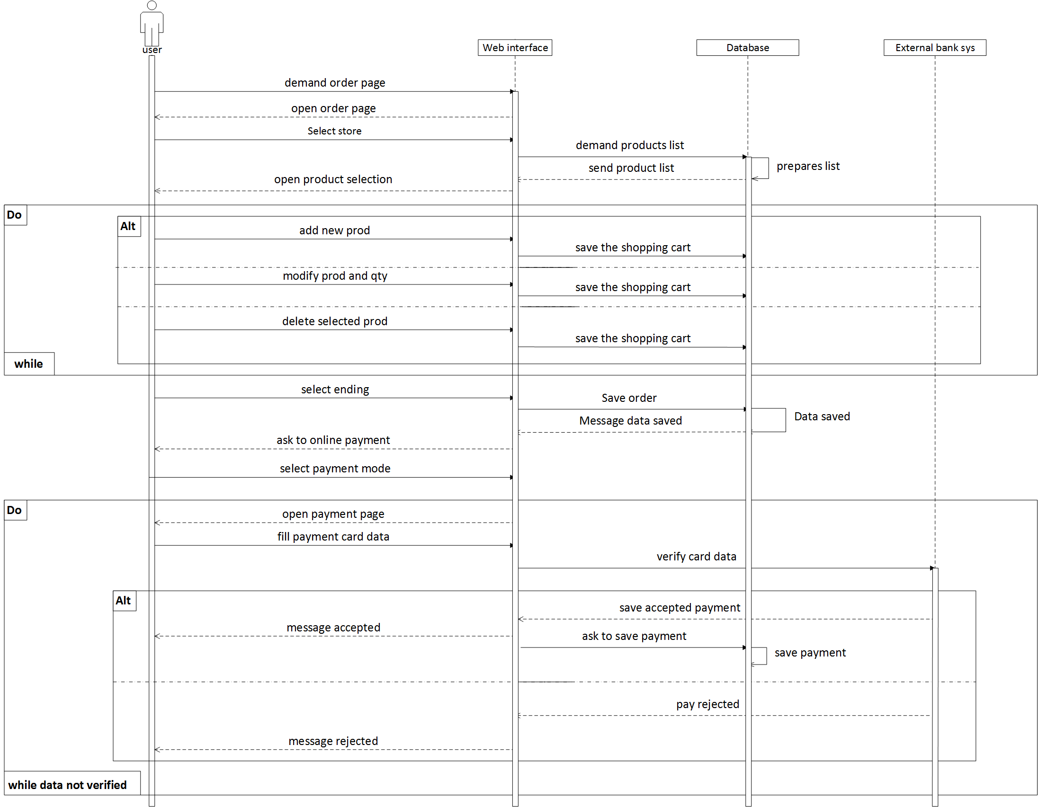

**Activity login diagram**

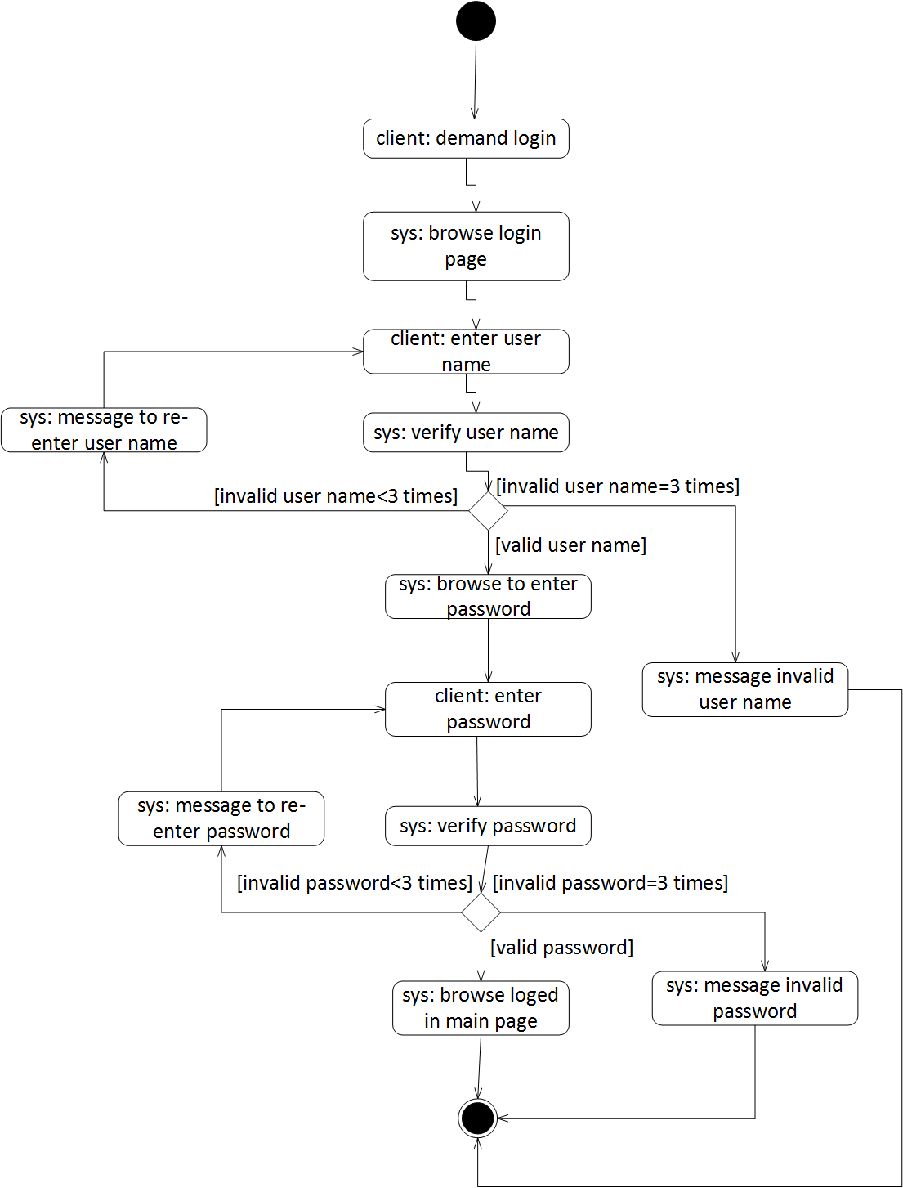

**Activity registration diagram**

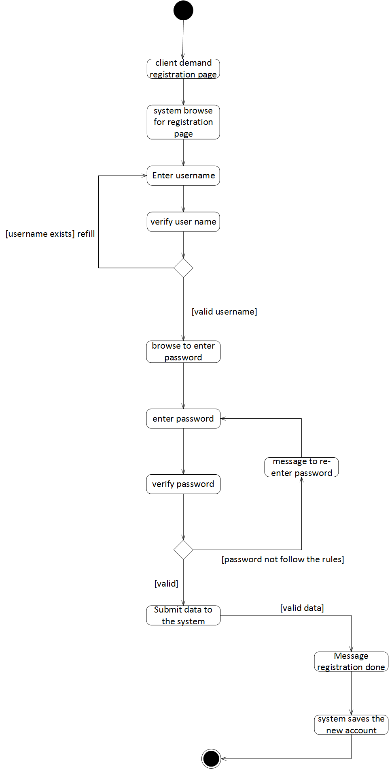

**Activity post-product diagram**

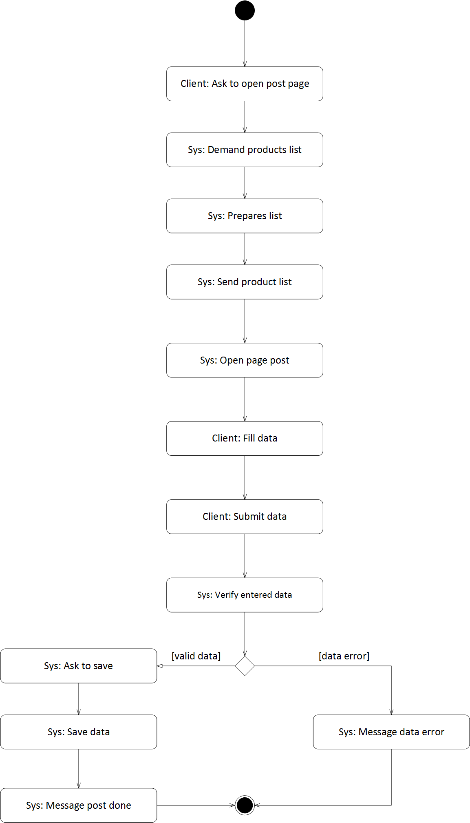

**Activity request-order diagram**