Presentation Questions

Course Title: Compiler Construction
Course Code: CS-462
Submitted To: Dr. Saliha Zahoor
Submitted By: Muhammad Ali Saagar (23021519-095)
Zain Ali Yousaf(23021519-122)
Aown Abbas (23021519-054)
Department: Computer Science
Class: BS-VI-23-C-Morning



Hafiz Hayat Campus

Q1. Lexical Analysis — Lexemes, Tokens & Role of RE/DFA/NFA
Part (a): Lexemes and Tokens
Given Program:
main()
{
int v,w,x,y,z;
z = w + x + y * v;
}

A lexeme is the actual string of characters. A token is the category/type of that lexeme. The attribute gives extra information (like the actual value).

Lexeme | Token | Attribute
main | IDENTIFIER | main
( | LPAREN | -
) | RPAREN | -
{ | LBRACE | -
int | KEYWORD | int
v | IDENTIFIER | v
, | COMMA | -
w | IDENTIFIER | w
, | COMMA | -
x | IDENTIFIER | x
, | COMMA | -
y | IDENTIFIER | y
, | COMMA | -
z | IDENTIFIER | z
; | SEMICOLON | -
z | IDENTIFIER | z
= | ASSIGN_OP | =
w | IDENTIFIER | w
+ | ARITH_OP | +
x | IDENTIFIER | x
+ | ARITH_OP | +
y | IDENTIFIER | y
* | ARITH_OP | *
v | IDENTIFIER | v
; | SEMICOLON | -
} | RBRACE | -

Part (b): Role of RE, NFA, DFA in Lexical Analysis
Think of it as a pipeline: RE → NFA → DFA → Lexical Analyzer

1. Regular Expressions (RE): We use RE to define patterns for tokens. For example:
- Identifier: [a-zA-Z][a-zA-Z0-9]*
- Integer: [0-9]+
- Operator: + | - | * | /

2. NFA (Non-Deterministic Finite Automaton): Each RE is converted into an NFA. The NFA helps represent token patterns through states and transitions, making token recognition easier to design.
3. DFA (Deterministic Finite Automaton): The NFA is converted into a DFA because DFA is faster and more efficient for scanning input. During lexical analysis, the DFA reads the source code character by character and identifies tokens without backtracking.

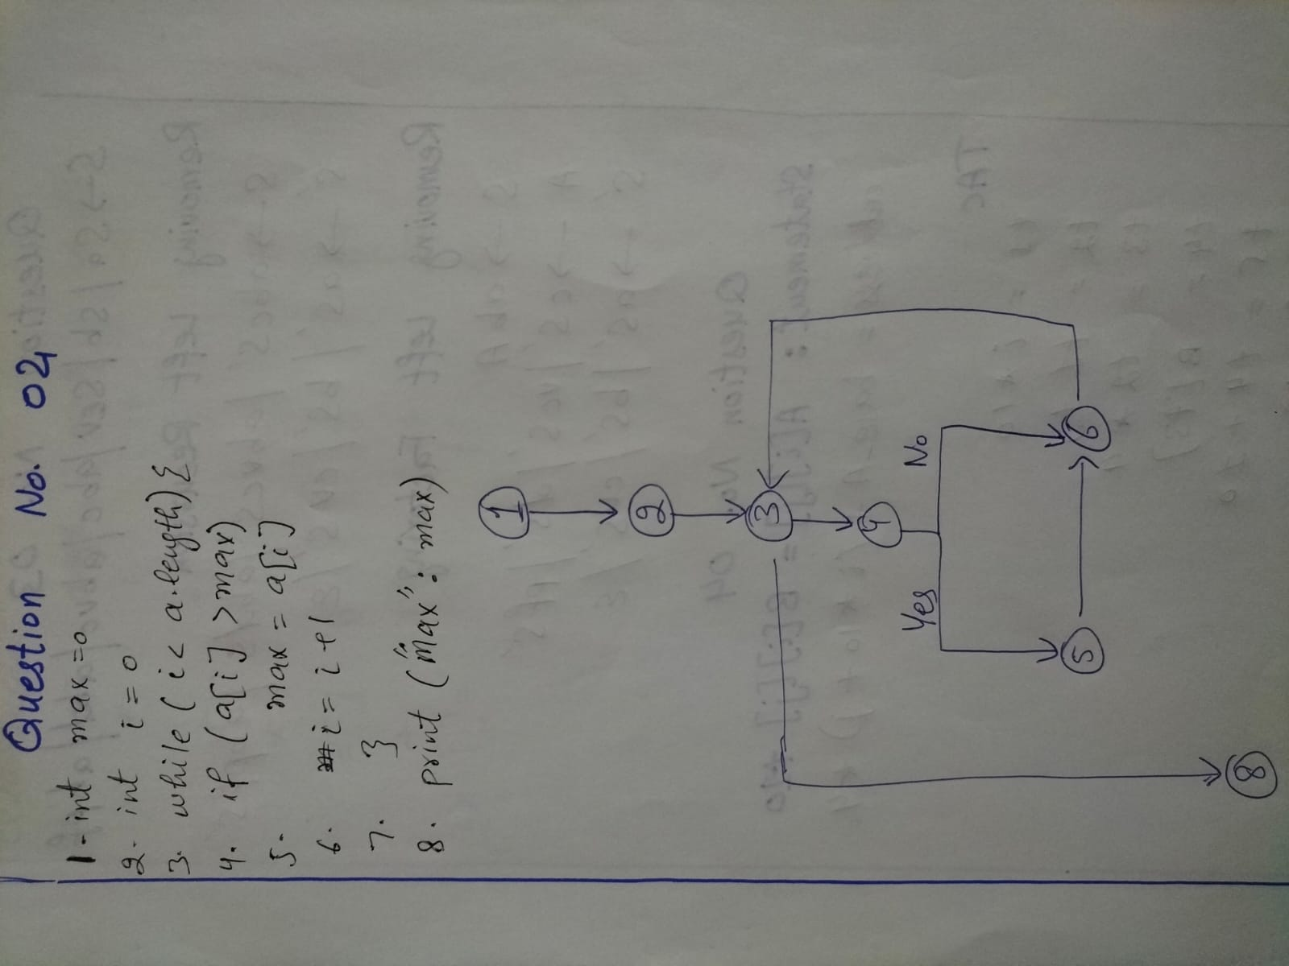

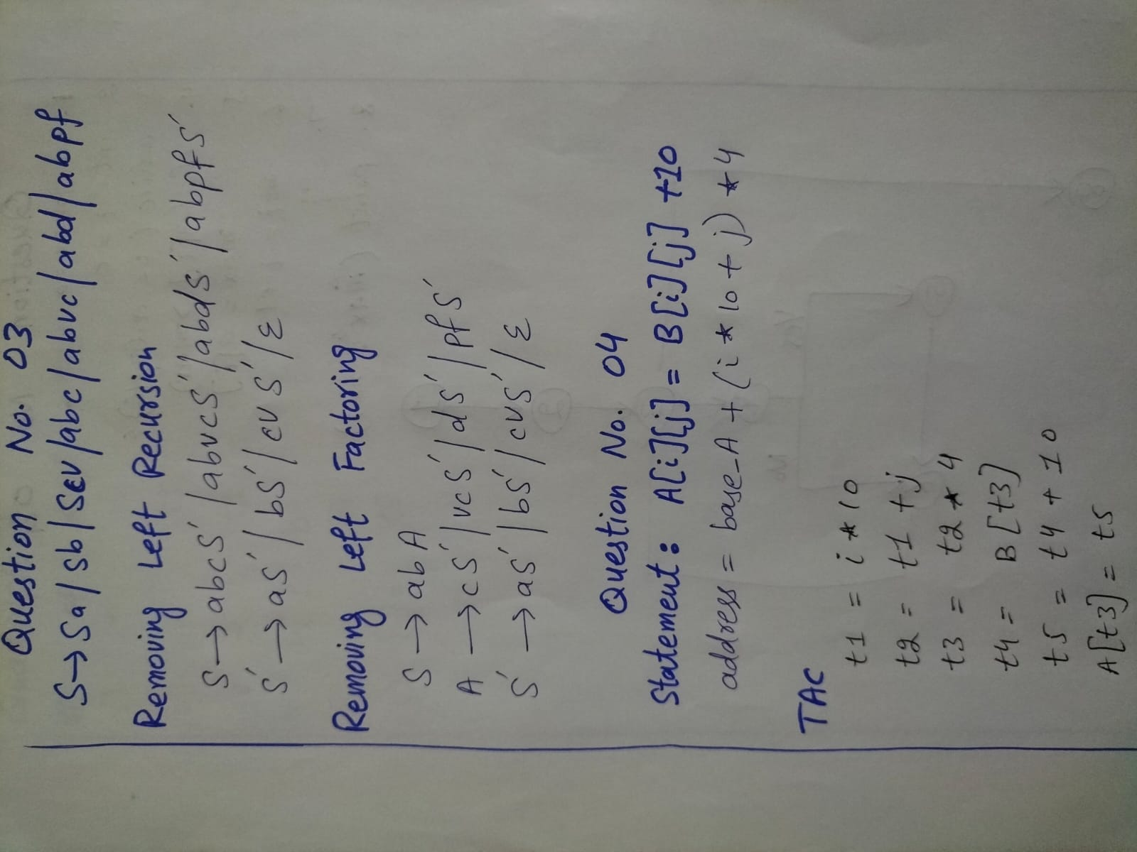

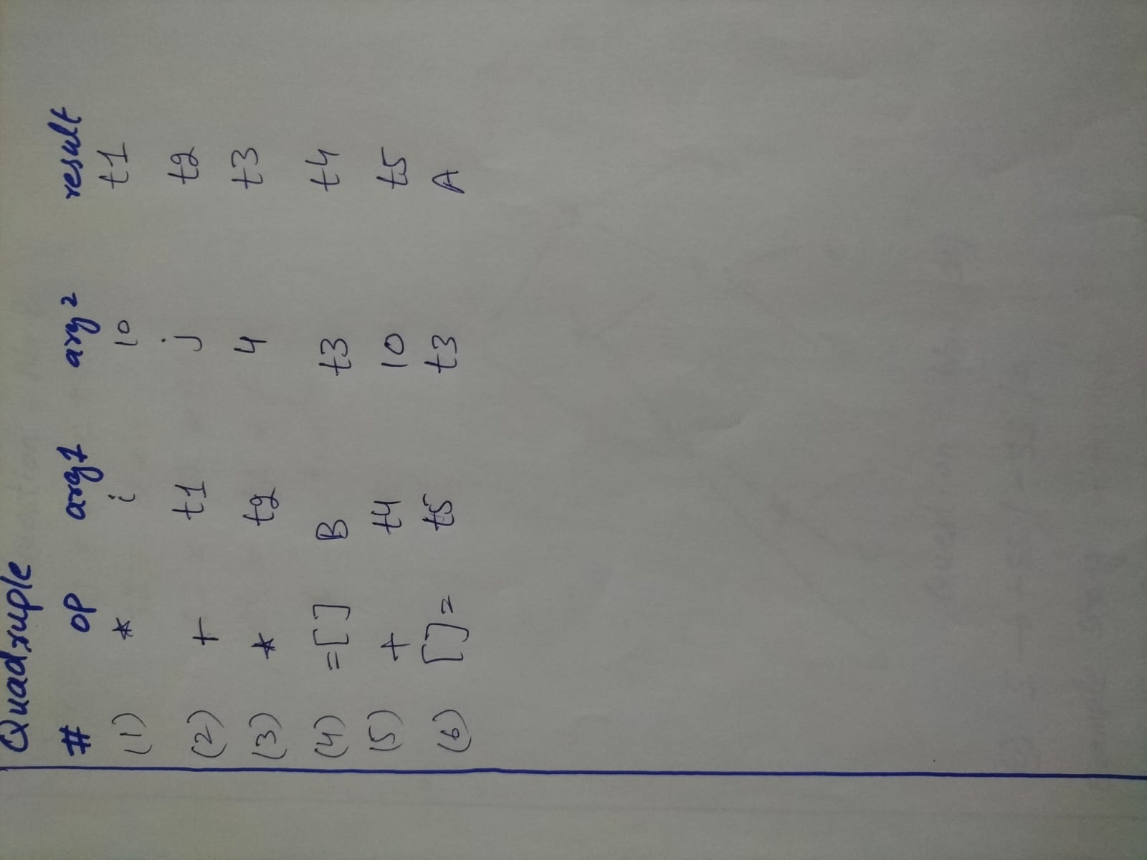

Q5. Role of Symbol Table
A Symbol Table is a data structure used by the compiler to store information about identifiers (variables, functions, etc.) found in the source code.

What does it store?
- Name of the identifier (e.g. x, max, main)
- Type (int, float, char, etc.)
- Scope (global, local)
- Memory address / offset
- For functions: number of parameters, return type

Example
int x = 5;
float y = 3.14;
void add(int a) { ... }

Name | Type | Scope | Value/Address
x | int | global | 5
y | float | global | 3.14
add | function | global | returns void
a | int | local (add) | parameter

Q6. Short Notes
a. Error Recovery Strategies in Parser
When a parser finds a syntax error, it needs to continue (not crash). Strategies:
- Panic Mode: Skip input tokens until a 'safe' token (like ; or }) is found. Simple but may skip valid code.
- Phrase Level Recovery: Make local corrections (insert/delete a token) to fix the error and continue.
- Error Productions: Add special grammar rules for common mistakes. The parser handles them without crashing.
- Global Correction: Find the minimum number of changes to make input valid. Very expensive, rarely used.

b. Operator Precedence Parsing
A bottom-up parsing technique where grammar rules are based on operator priorities (like * before +). The parser uses a precedence table to decide when to shift and when to reduce. Works well for expression grammars.
Example: 3 + 5 * 2 → * has higher precedence than +, so 5*2 is reduced first.

c. LEX
LEX is a tool that automatically generates a lexical analyzer (scanner) from a set of regular expression rules.
How it works: You write patterns and actions in a .l file → LEX generates C code → compile → run as scanner.

d. YACC (Yet Another Compiler Compiler)
YACC is a parser generator. You describe grammar rules with actions, and YACC generates a parser.
Works with LEX: LEX provides tokens → YACC parses them using grammar rules.

e. SDT and SDD
SDD (Syntax Directed Definition): Associates attributes and rules with grammar productions. Defines WHAT to compute but not exactly when.
SDT (Syntax Directed Translation): An SDD with program actions embedded inside grammar rules (translation schemes). Defines WHEN to compute.
Example SDD:
E → E1 + T { E.val = E1.val + T.val }
T → num { T.val = num.lexval }

Q.7 Shift-Reduce Conflicts & Parsing (a,(a,a))

Shift-Reduce Conflict: The parser can't decide whether to shift the next input token or reduce the current stack. Occurs due to ambiguous grammar.
Reduce-Reduce Conflict: The parser can reduce using two different grammar rules. Indicates ambiguity in grammar.

Grammar: S → (L) | a
L → L,S | S

S ⇒ (L) using S → (L)
⇒ (L,S) using L → L,S
⇒ (S,S) using L → S
⇒ (a,S) using S → a
⇒ (a,(L)) using S → (L)
⇒ (a,(L,S)) using L → L,S
⇒ (a,(S,S)) using L → S
⇒ (a,(a,S)) using S → a
⇒ (a,(a,a)) using S → a
Shift-Reduce Parse of (a, (a, a))
Stack | Input | Action
$ | (a,(a,a))$ | Shift (
$( | a,(a,a))$ | Shift a
$(a | ,(a,a))$ | Reduce S→a
$(S | ,(a,a))$ | Reduce L→S
$(L | ,(a,a))$ | Shift ,
$(L, | (a,a))$ | Shift (
$(L,( | a,a))$ | Shift a
$(L,(a | ,a))$ | Reduce S→a
$(L,(S | ,a))$ | Reduce L→S
$(L,(L | ,a))$ | Shift ,
$(L,(L, | a))$ | Shift a
$(L,(L,a | ))$ | Reduce S→a
$(L,(L,S | ))$ | Reduce L→L,S
$(L,(L | ))$ | Shift )
$(L,(L) | )$ | Reduce S→(L)
$(L,S | )$ | Reduce L→L,S
$(L | )$ | Shift )
$(L) | $ | Reduce S→(L)
$S | $ | ACCEPT

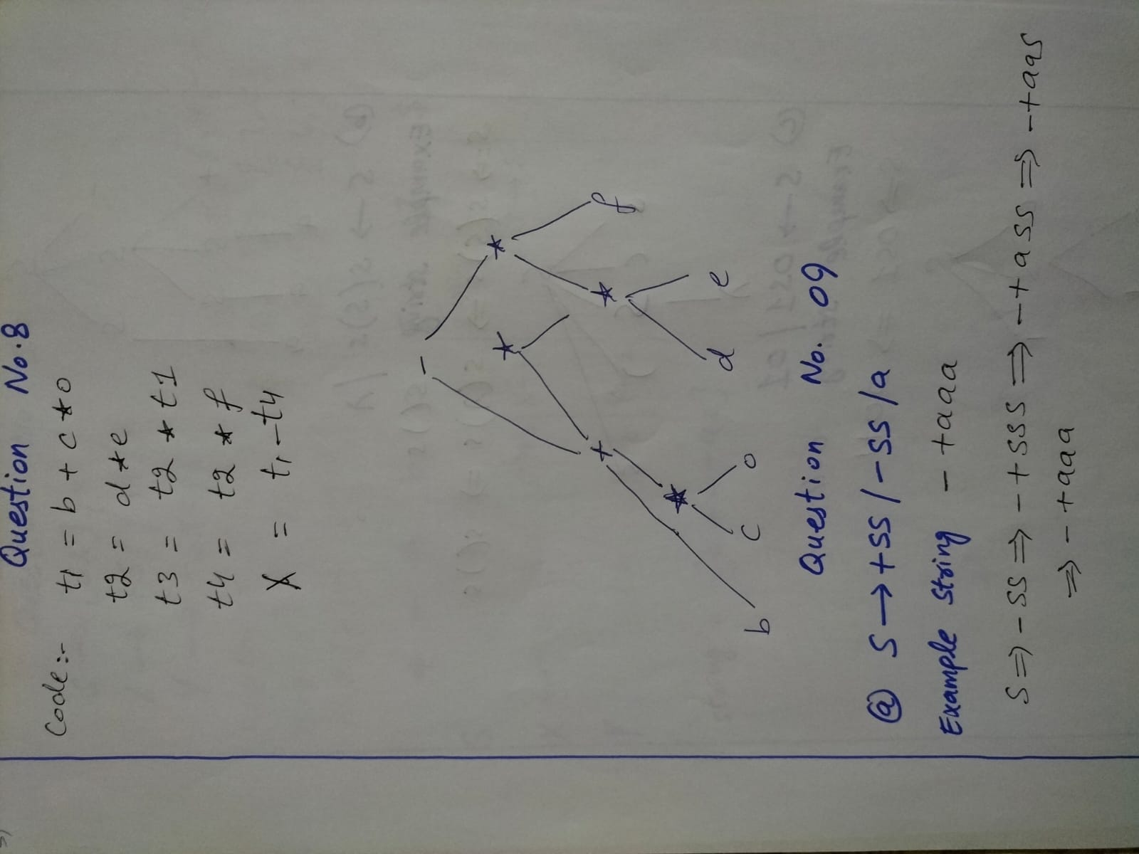

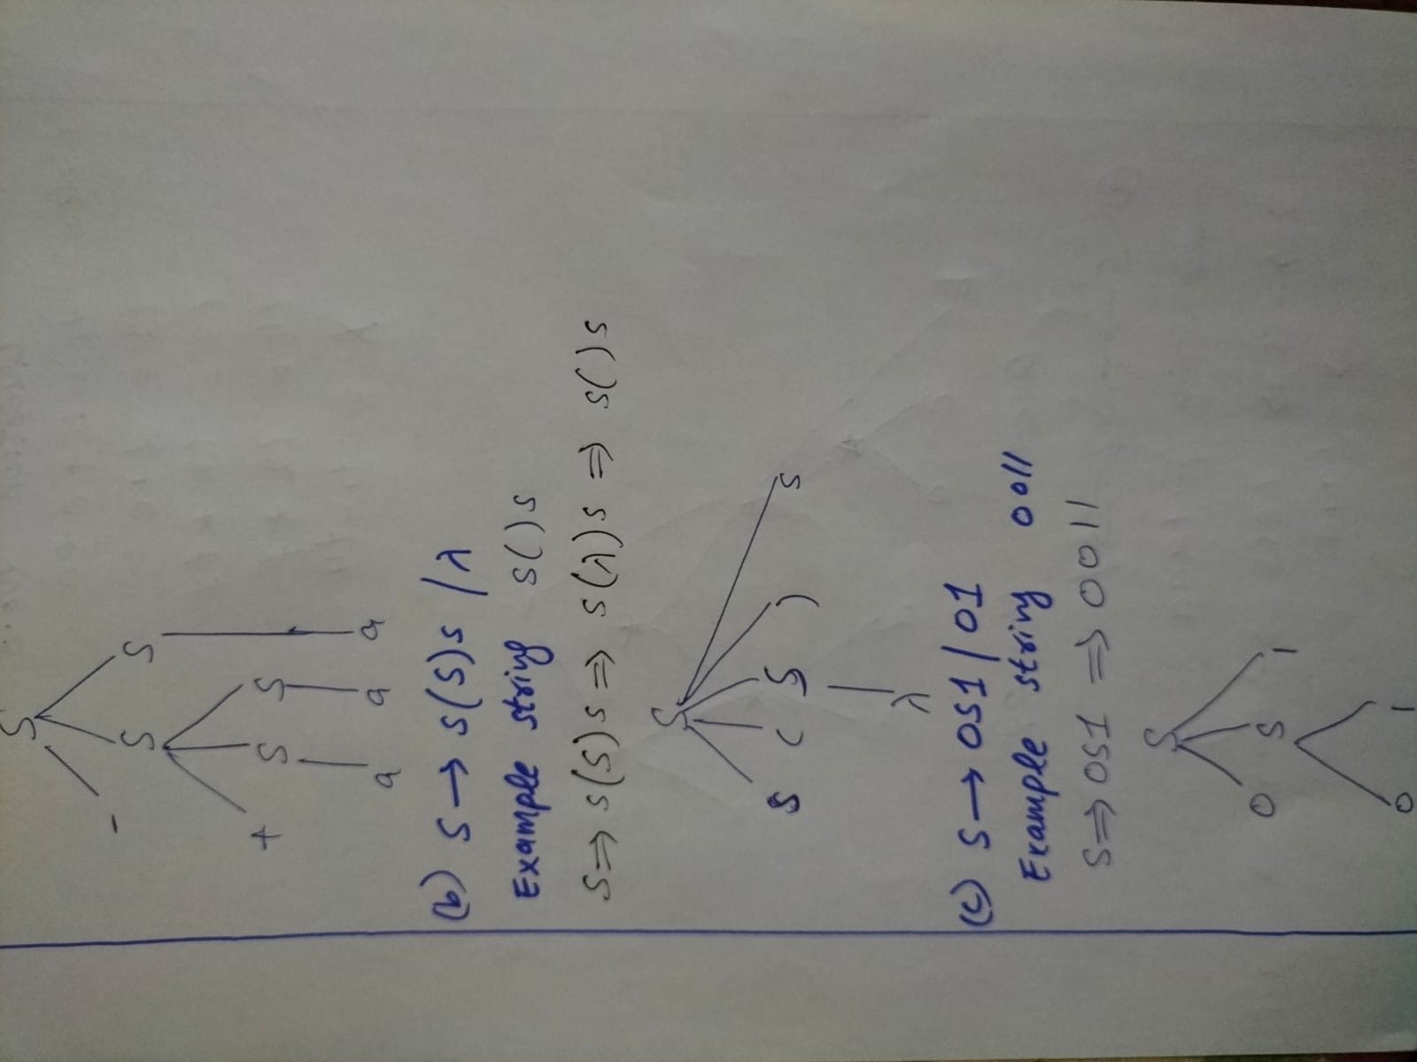

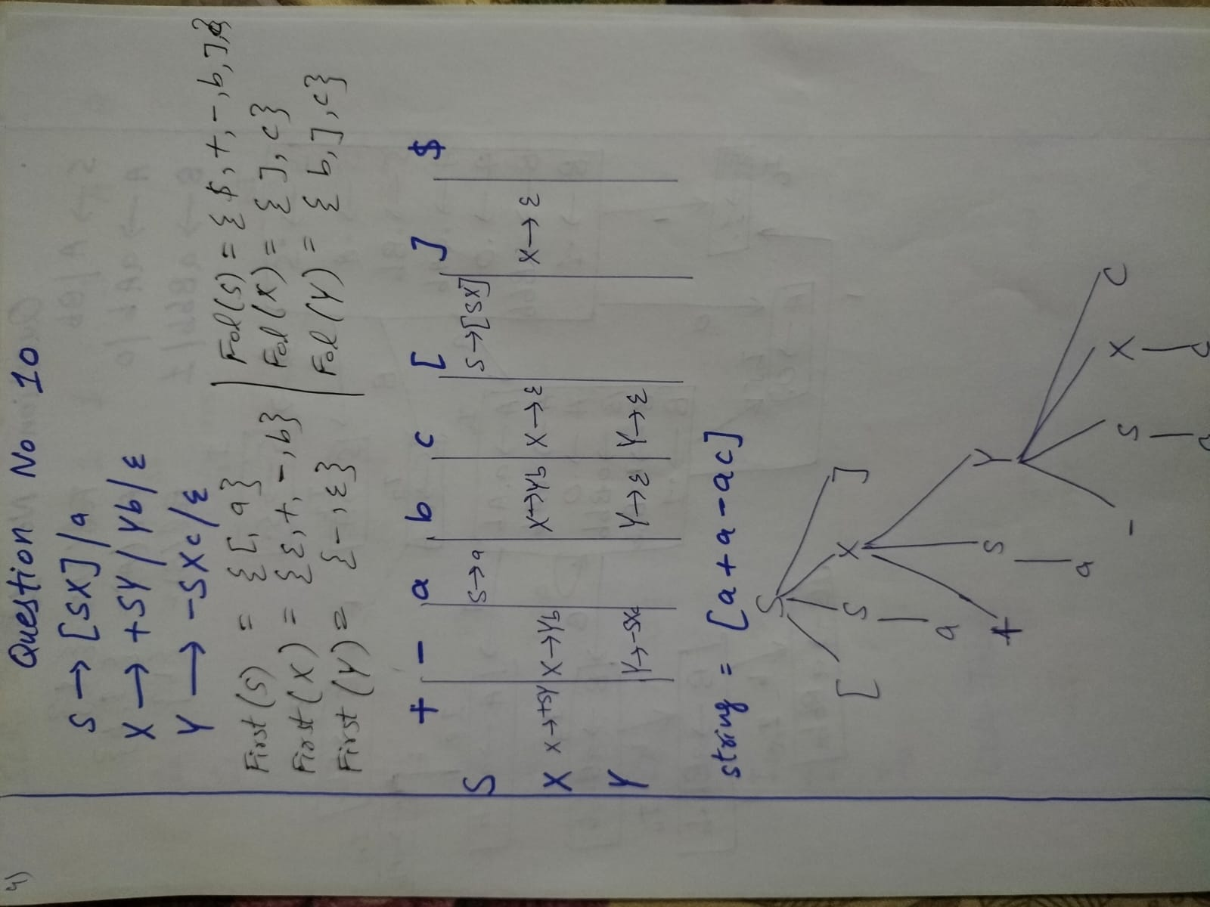

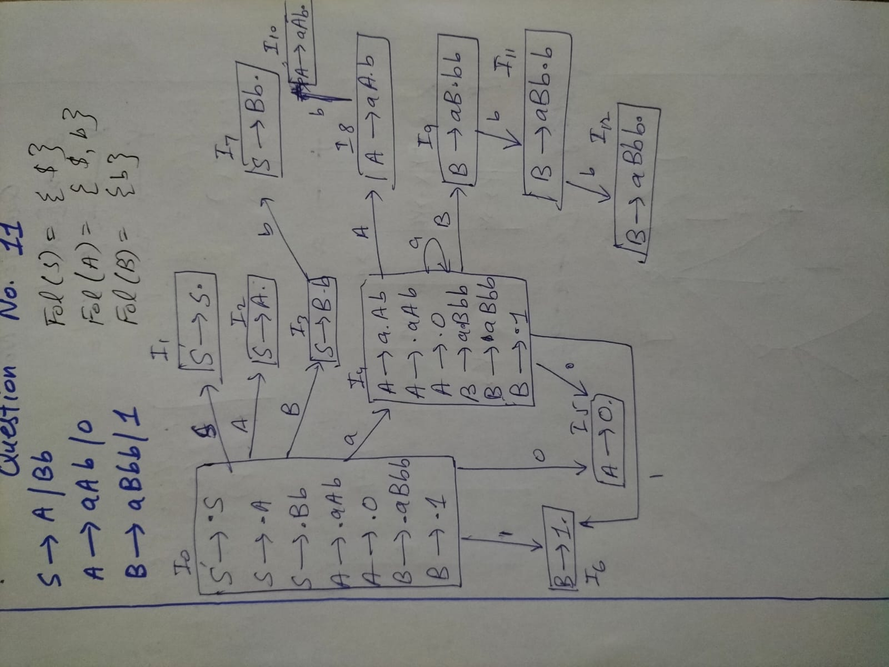

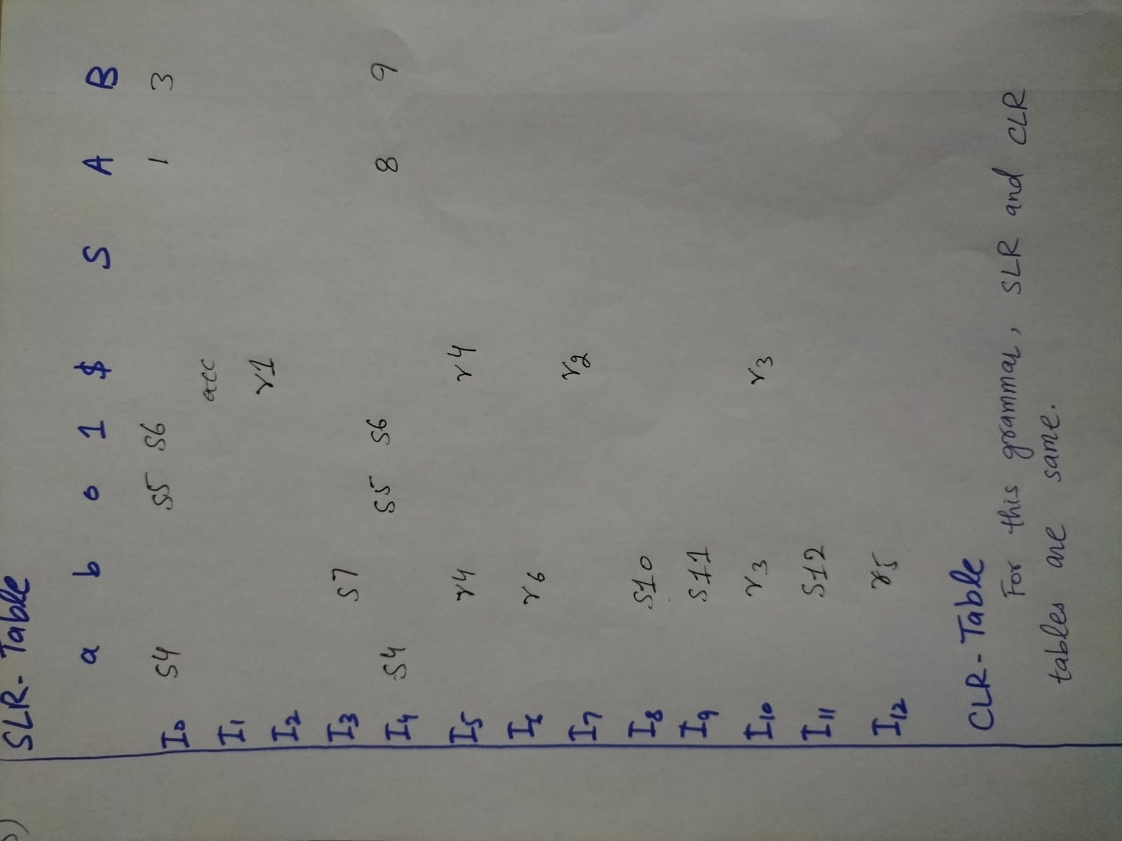

Q12. Switch Statement & Backpatching
Switch Statement Code Generation
A switch statement is translated using a jump table or a series of conditional branches.

Example:
switch (x) {
case 1: action1; break;
case 2: action2; break;
default: actionD;
}

Three Address Code:
t = x
if t == 1 goto L1
if t == 2 goto L2
goto Ldefault
L1: action1; goto Lend
L2: action2; goto Lend
Ldefault: actionD
Lend:

Backpatching
Backpatching is a technique used for generating code in a single pass. When a jump instruction is generated but the target address is not yet known, we leave the address blank (a 'hole'). Later, when the target is known, we 'backpatch' (fill in) all those blank addresses.

Example: if (x > 0) then ...
Step 1: Generate: if x > 0 goto ___ (hole at position 101)
Step 2: Process 'then' code
Step 3: Now we know target is line 105
Step 4: Backpatch: fill 101 with 'goto 105'

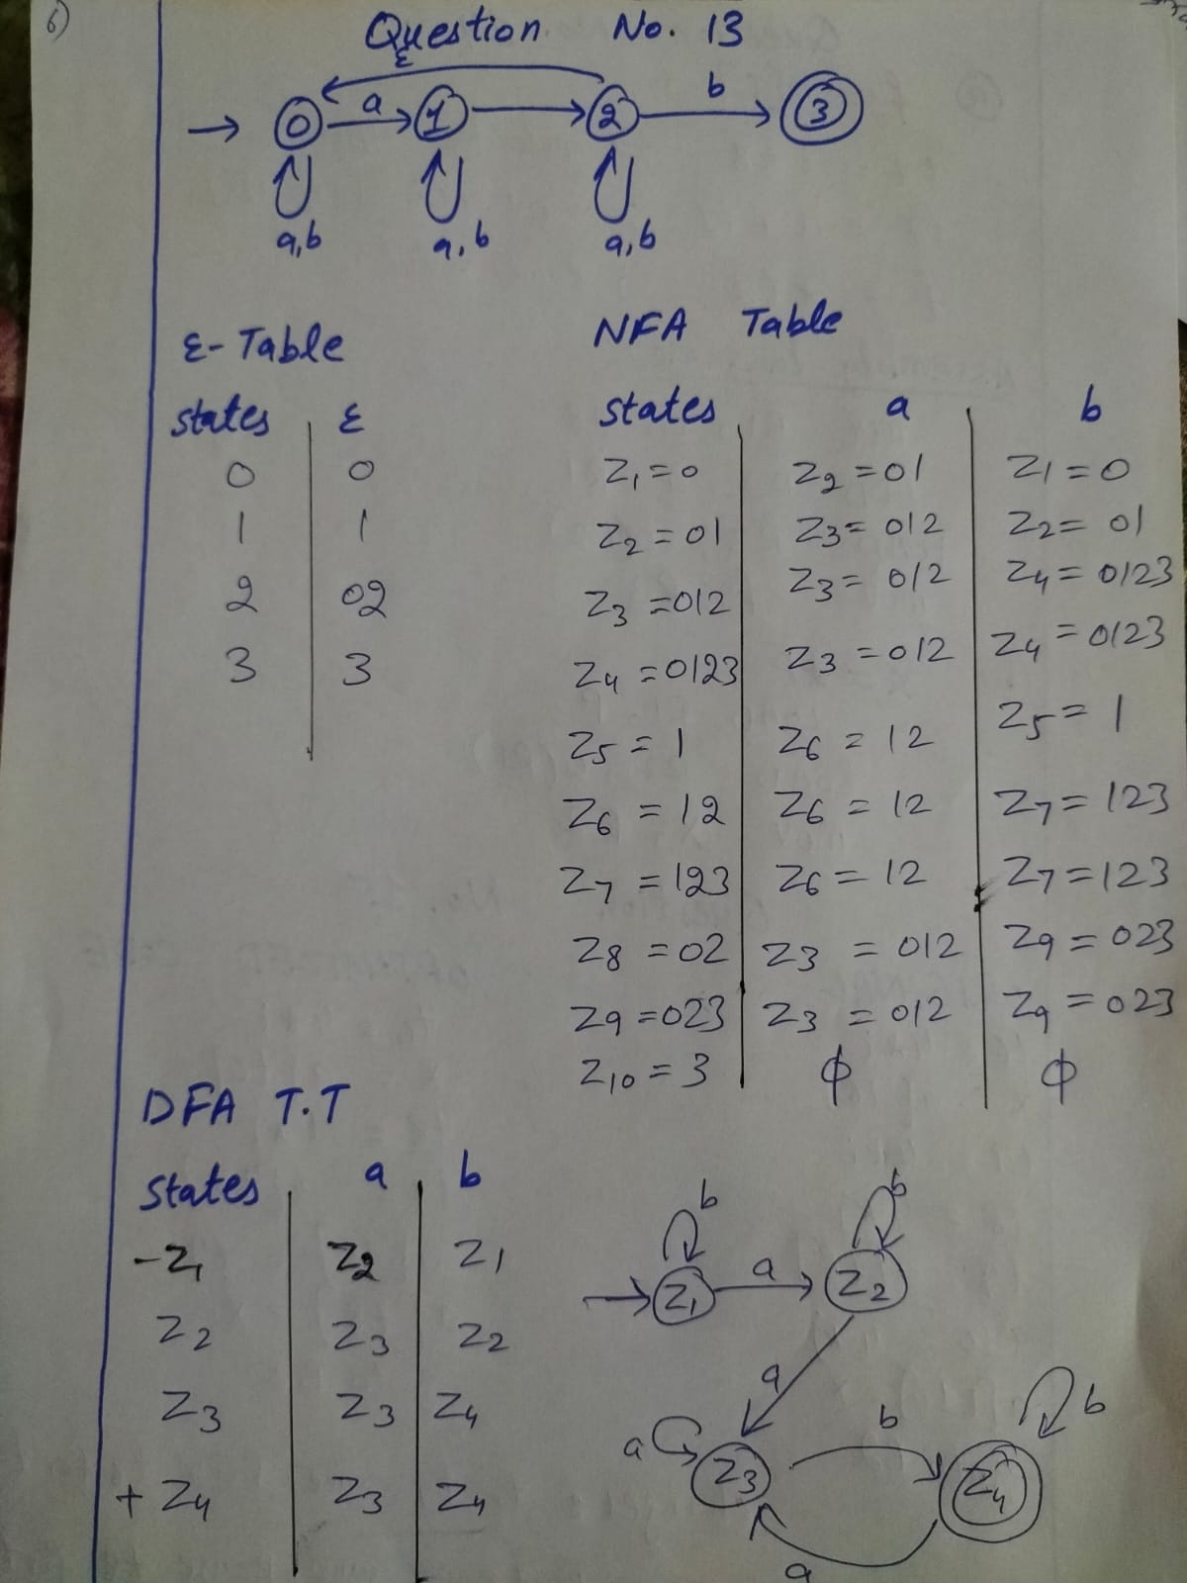

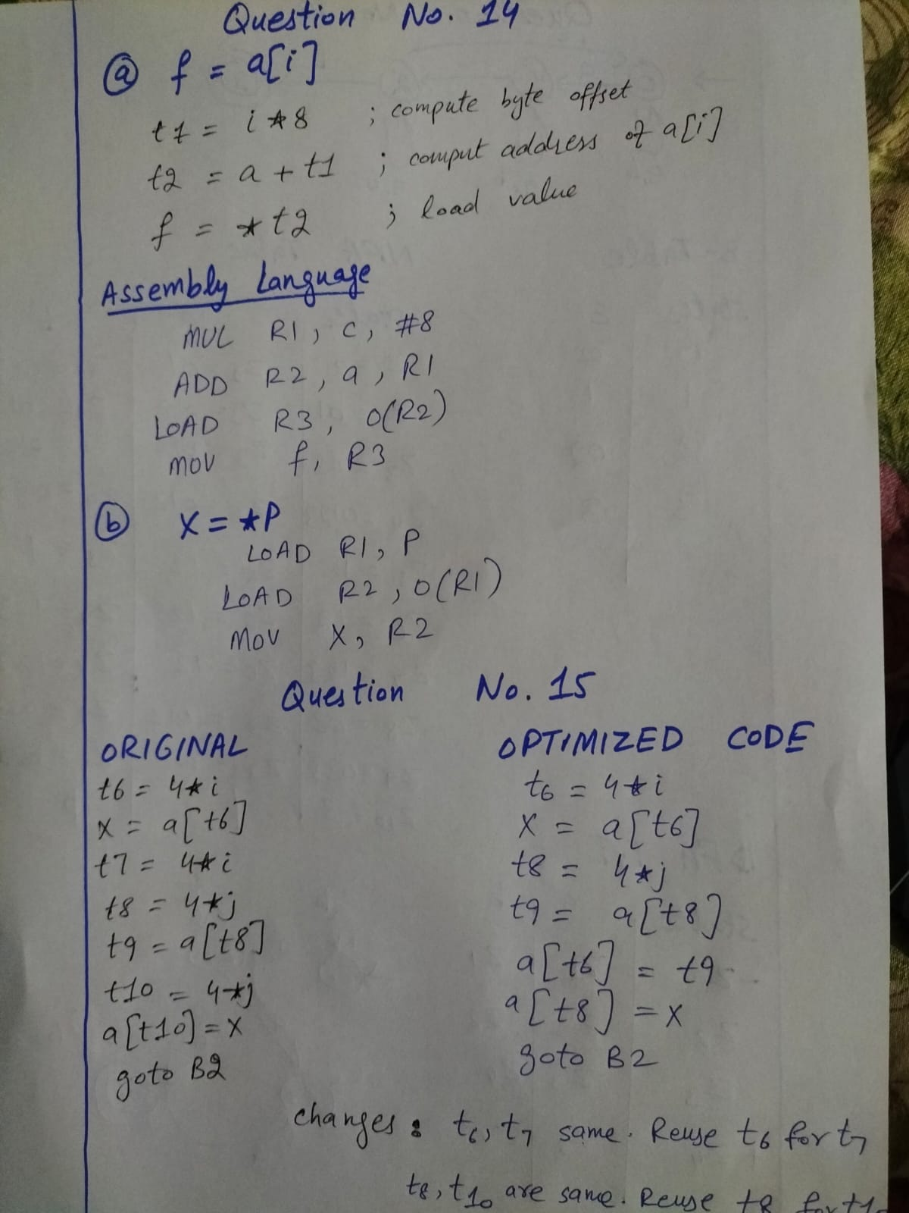

Q16. Python Program to Generate Quadruples

# Program to Generate Quadruples for Any Expression

expression = "a = b + m * d - o"

quadruples = []
temp_count = 1

# Operator precedence
precedence = {
'+': 1,
'-': 1,
'*': 2,
'/': 2
}

# Convert expression into tokens
tokens = expression.replace("=", " = ") \
.replace("+", " + ") \
.replace("-", " - ") \
.replace("*", " * ") \
.replace("/", " / ").split()

# Left and right side
left_side = tokens[0]
right_side = tokens[2:]

# Infix to Postfix Conversion
output = []
stack = []

for token in right_side:

if token.isalnum():
output.append(token)

elif token in precedence:

while (stack and stack[-1] in precedence and
precedence[stack[-1]] >= precedence[token]):
output.append(stack.pop())

stack.append(token)

while stack:
output.append(stack.pop())

# Generate Quadruples
eval_stack = []

for token in output:

if token.isalnum():
eval_stack.append(token)

else:
arg2 = eval_stack.pop()
arg1 = eval_stack.pop()

temp = "t" + str(temp_count)
temp_count += 1

quadruples.append([token, arg1, arg2, temp])

eval_stack.append(temp)

# Final Assignment
final_temp = eval_stack.pop()
quadruples.append(["=", final_temp, "-", left_side])

# Print Quadruples
print("Expression:", expression)

print("\nOp\tArg1\tArg2\tResult")

for q in quadruples:
print(q[0], "\t", q[1], "\t", q[2], "\t", q[3])

Q17. DFA Program for Strings Ending with 001

input_str = input("Enter binary string: ")

state = 0 # q0

trans = [
[1, 0], # q0: 0->q1, 1->q0
[2, 0], # q1: 0->q2, 1->q0
[2, 3], # q2: 0->q2, 1->q3
[1, 0] # q3: 0->q1, 1->q0
]

for ch in input_str:
c = int(ch)
state = trans[state][c]

if state == 3:
print("ACCEPTED (ends with 001)")
else:
print("REJECTED")

Q18. Program to Check:
- Left Recursive
- Ambiguous
- LL(1)

grammar = {
"S": ["Sb", "b"],
"A": ["aA", "a"]
}

# Program

left_recursive = False
ambiguous = False

print("Grammar:\n")

for nt, productions in grammar.items():
print(nt, "->", " | ".join(productions))

print("\nChecking Grammar...\n")

# Check Left Recursion

for nt, productions in grammar.items():

for prod in productions:

if prod.startswith(nt):

print(nt, "is Left Recursive")
left_recursive = True

# Check Ambiguity
# If two productions start with same symbol

for nt, productions in grammar.items():

first_symbols = []

for prod in productions:

if len(prod) > 0:
first_symbols.append(prod[0])

if len(first_symbols) != len(set(first_symbols)):

print(nt, "may be Ambiguous")
ambiguous = True

# ==================================================
# Final Result
# ==================================================

print()

if not left_recursive and not ambiguous:

print("Grammar is LL(1)")

else:

print("Grammar is NOT LL(1)")

Q19. FIRST and FOLLOW Program

grammar = {
"S": ["aAABb", "b"],
"A": ["c", "d" , "m"]
}

# FIRST and FOLLOW Program

FIRST = {}
FOLLOW = {}

# PRINT GRAMMAR

print("Grammar:\n")

for nt, productions in grammar.items():
print(nt, "->", " | ".join(productions))

# FIRST SETS

print("\nFIRST Sets:\n")

for nt, productions in grammar.items():

FIRST[nt] = set()

for prod in productions:

first_symbol = prod[0]

# If first symbol is terminal
if first_symbol not in grammar:
FIRST[nt].add(first_symbol)

# If first symbol is non-terminal
else:
FIRST[nt].update(FIRST.get(first_symbol, []))

print("FIRST(", nt, ") =", list(FIRST[nt]))

# FOLLOW SETS

print("\nFOLLOW Sets:\n")

# Initialize empty sets
for nt in grammar:
FOLLOW[nt] = set()

# Start symbol gets $
start_symbol = list(grammar.keys())[0]
FOLLOW[start_symbol].add("$")

# Find FOLLOW
for nt, productions in grammar.items():

for prod in productions:

for i in range(len(prod)):

symbol = prod[i]

# If symbol is Non-Terminal
if symbol in grammar:

# If next symbol exists
if i + 1 < len(prod):

next_symbol = prod[i + 1]

# Next symbol is terminal
if next_symbol not in grammar:
FOLLOW[symbol].add(next_symbol)

# Next symbol is non-terminal
else:
FOLLOW[symbol].update(FIRST[next_symbol])

# If symbol is last
else:
FOLLOW[symbol].update(FOLLOW[nt])

# Print FOLLOW sets
for nt in grammar:
print("FOLLOW(", nt, ") =", list(FOLLOW[nt]))

Q20. Remove Left Recursion and Left Factoring

grammar = {
"S": ["Sa", "Sjdie", "abc", "abd"],
"A": ["Ac", "d", "Awae"]
}

print("Original Grammar:\n")

for nt, productions in grammar.items():
print(nt, "->", " | ".join(productions))

# Remove Left Recursion

new_grammar = {}

for nt, productions in grammar.items():

alpha = []
beta = []

for prod in productions:

if prod.startswith(nt):
alpha.append(prod[len(nt):])

else:
beta.append(prod)

# If left recursion exists
if alpha:

new_nt = nt + "'"

new_grammar[nt] = []
new_grammar[new_nt] = []

for b in beta:
new_grammar[nt].append(b + new_nt)

for a in alpha:
new_grammar[new_nt].append(a + new_nt)

new_grammar[new_nt].append("e")

else:
new_grammar[nt] = productions

print("\nAfter Removing Left Recursion:\n")

for nt, productions in new_grammar.items():
print(nt, "->", " | ".join(productions))

# Left Factoring

factored_grammar = {}

for nt, productions in new_grammar.items():

prefix_map = {}

for prod in productions:

prefix = prod[0]

if prefix not in prefix_map:
prefix_map[prefix] = []

prefix_map[prefix].append(prod)

changed = False

for prefix, group in prefix_map.items():

if len(group) > 1:

changed = True

new_nt = nt + "F"

factored_grammar[nt] = [prefix + new_nt]

factored_grammar[new_nt] = []

for item in group:
factored_grammar[new_nt].append(item[1:])

if not changed:
factored_grammar[nt] = productions

print("\nAfter Left Factoring:\n")

for nt, productions in factored_grammar.items():
print(nt, "->", " | ".join(productions))

