Student ID & Name:

1. [50 points] Write the queries for the following considering the following Labelled Graph Property Model:

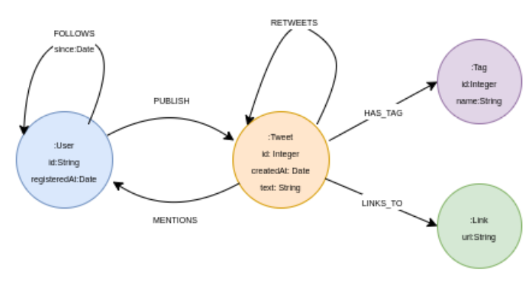

1.1. Return the number of tweets published by each user.

1.2. Return the number of followers for each user.

1.3. Return the top five users with respect to the number of tweets published by them.

1.4. Return the average number of hashtags used in a tweet.

1.5. Find the length of the shortest path between User A and User B (where A and B are IDs of the respective users) using the FOLLOWS relationship.

1.6. Find all paths between User A and User B of length up to 3 using the FOLLOWS relationship.

1.7. Generate a projection for analyzing the network of who is following whom.

1.8. Return the top five users followed by other users using gds.degree.stream() – you can refer to the projection generated in the above question.

1.9. Return the top five users following other users using gds.degree.stream().

1.10. Return the top five users having the highest PageRank value using gds.pageRank.stream().

2. Consider a projection where nodes are users and an edge represents a user has mentioned another user in a tweet. Answer the following questions for this network:

2.1. [20] We calculate a weakly connected algorithm which assigns all nodes a component id. On analysis, we found that there are three unique component ids. What have we learned from this information?

2.2. [20] After running a community detection algorithm on this projection, we obtain 10 different communities. The sizes of these communities are 60%, 15%, 5%, 5%, 3%, 2%, 1%, 1%, 1%, and 1%. How would you define a community for this network?

2.3. [10] If we list the top 10 nodes with the highest betweenness values, what characteristics might these nodes possess?