Complain Management System WEb APP

Submitted by: Ali Murtaza

Reg# NIM-BSCS-2019-39

**Instructer**: Mr. Ikram Ullah Khan Niazi

#### Introduction

The purpose of the project was to built a CRUD web application that will manage complains of students about Namal Mess, Hostel, Faculty and Study. I created a web app that solves this problem. Students can simply go to the app register themselves and make complains about their concerns. There is also a admin page, admin can view who has posted complain and the complains are forward to the respective authority.

#### Technology Used

To create this web app I used Flask as backend and Html templates as frontend. The database I used is MySQL using ORM technique with SQLalchemy and Flask-Marshmallow.

#### Basic Working Model

First of all MVC model is followed. Backend and frontend are separated. If frontend has to send some data to backend then frontend will send a ajax request to backend. And then frontend will get a response from backend. The data that is send from backend to frontend will be in JSON format. Session is also used so as to keep track of user which has logged in the app. Moreover, from CRUD( Create, Read, Update and Delete) operations without Update all of the operation have been used in the web application.

#### Functions of Website

Home:

In this page, user can select whether he/she wants signup or login

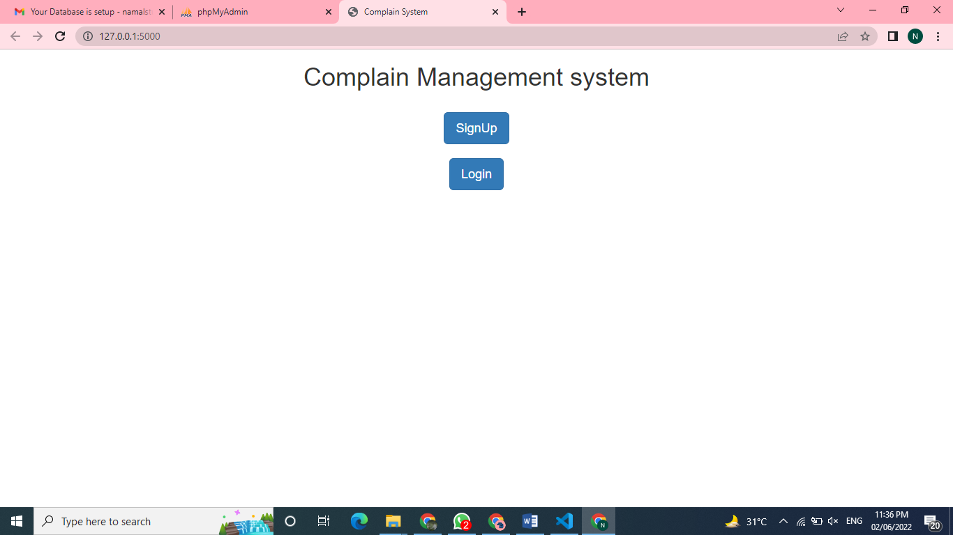

Sign Up:

Sign up form will be used to take input from user to register on app. User will enter its email and password. These will be send to sign up view on the backend using ajax POST request and backend will add these details in the database.

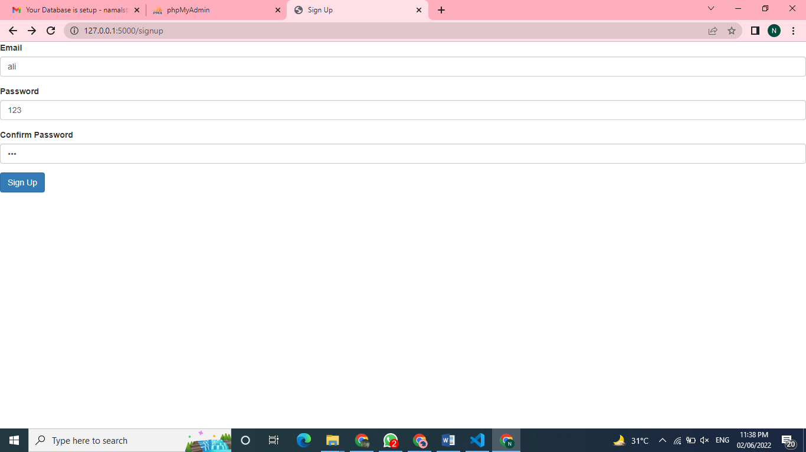

Log In

After sign up we have login functionality. User will enter email and password. This data will be sent to backend using ajax POST request. At backend, data will be fetched and checked if credentials are found in database then it will be redirected to dashboard.

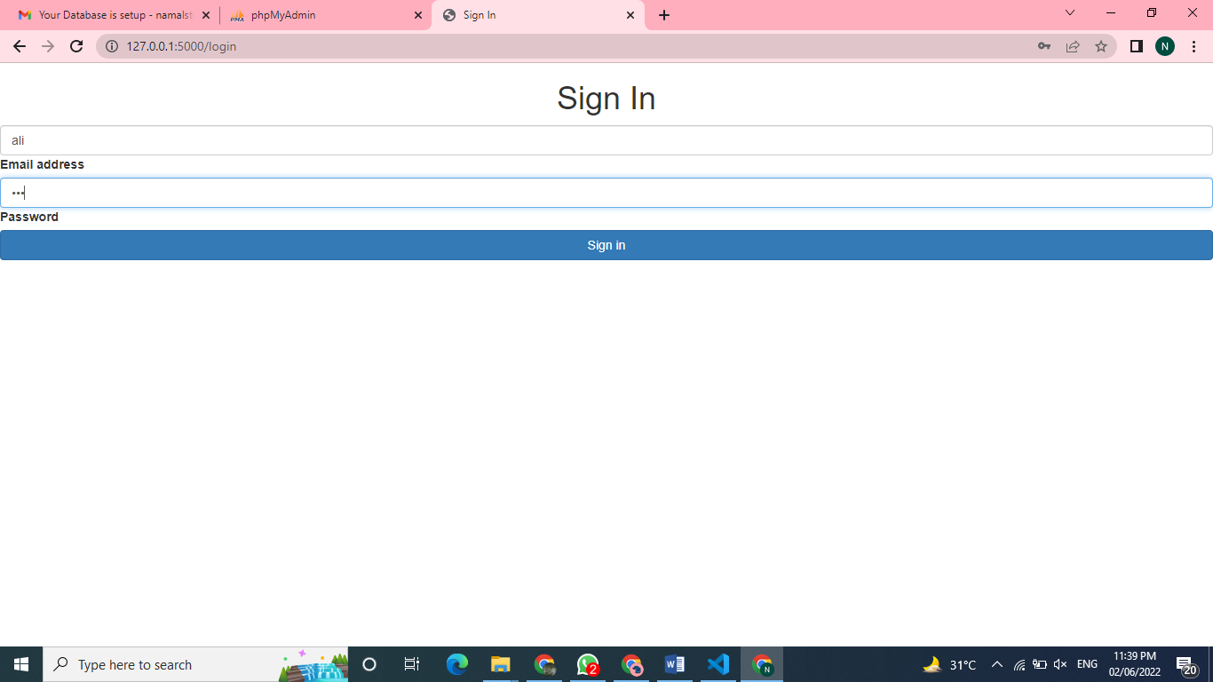

Submit Complain

In dashboard, there is form to submit complain user can enter its complain. Select category and send complain. All of the complain data will be sent from frontend except email. Email will be get from session of that user. All other data will be send to dashboard view using ajax POST request and data will be stored in database.

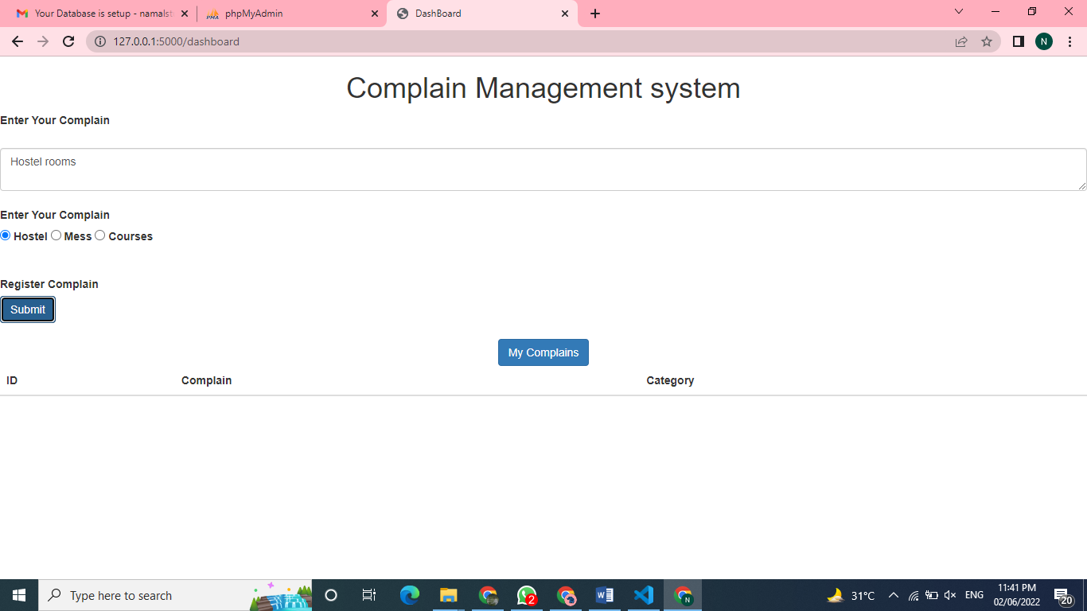

View Complains

There is button on dashboard named as My Complains. If we click on this button an ajax GET request will be sent to ‘dashboard/view’ then email will be get from session and all complains belonging to that user will be queried from database and returned to frontend in json.

Similarly there is a admin view complains as well. Admin can view all complains

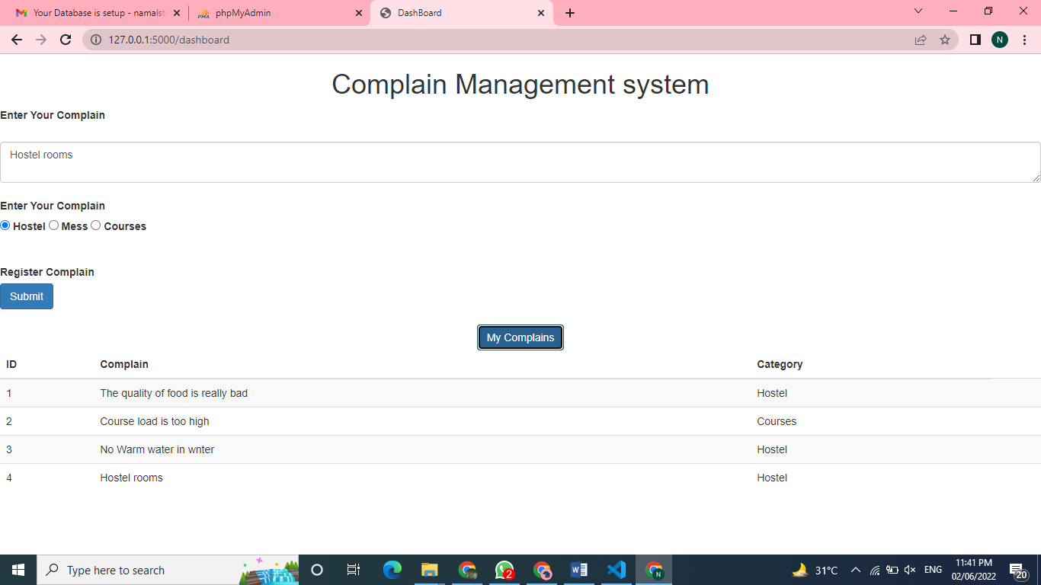

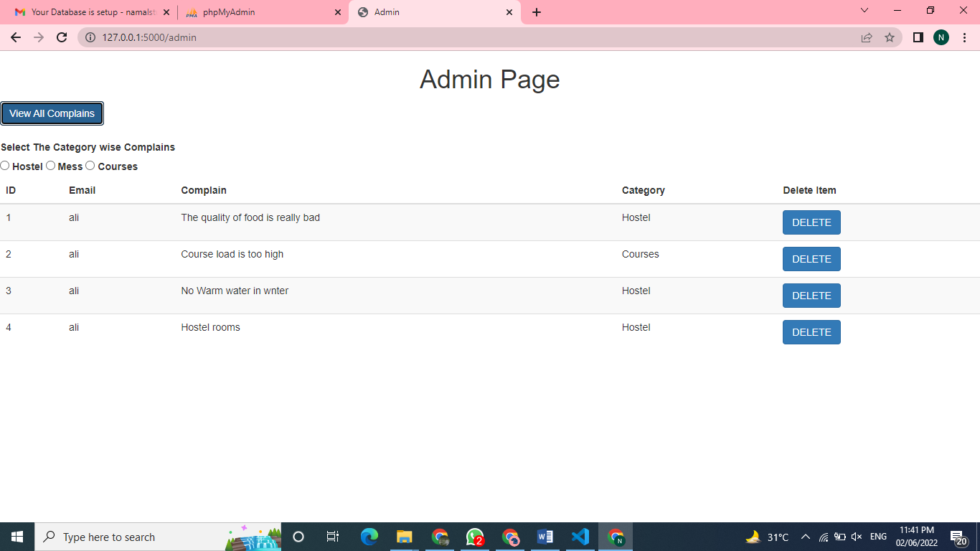

Delete Complains

In admin panel or view, he can delete complains. Admin can click delete button and ajax DELETE request will be sent to dashboard view with complain id. Then using id this that complain will be deleted from database. After successful response we send another ajax GET request to update complains after deletion of one.

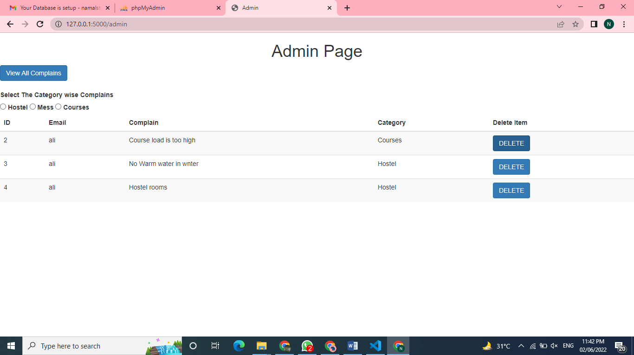

#### Conclusion and Future Work

This work is not up to the mark and according to the proposal. In future, I will try to enhance this app by using React as frontend and adding other features.