DELTA UNIVERSITY FOR SCIENCE AND TECHNOLOGY
Faculty of Artificial Intelligence
Dashboard Design & Data Visualization Assignment
Project Title: Global Video Game Sales Analytical Dashboard (1980 – 2020)

# | Student Full Name (الاسم بالكامل) | Student ID (الرقم الجامعي)
1 | Ali Naser Ali Mahmoud | 42510377
2
3
4
5

Interactive Streamlit Dashboard URL: https://dm-project-jp5blwxqhidypledawxdqc.streamlit.app/

1. Purpose of the Dashboard (الغرض من لوحة التحكم)
The primary objective of the Global Video Game Sales Analytical Dashboard is to transform raw historical sales data (spanning from 1980 to 2020) into clear, interactive, and actionable visual insights. The dashboard enables decision-makers, game developers, and publishers to track multi-decade industry growth trends, compare commercial performance across 12 distinct game genres, evaluate regional market correlations between North America and Europe, and analyze how ESRB age ratings impact sales distributions across major gaming platforms.
الهدف الرئيسي من لوحة التحكم التحليلية لمبيعات ألعاب الفيديو العالمية هو تحويل بيانات المبيعات التاريخية الخام (الممتدة من عام 1980 إلى 2020) إلى رؤى بصرية واضحة وتفاعلية تدعم اتخاذ القرار. تتيح اللوحة للمطورين والناشرين ومحللي البيانات تتبع اتجاهات النمو التاريخية للصناعة، ومقارنة الأداء التجاري عبر 12 تصنيفاً مختلفاً للألعاب (Genres)، ودراسة الارتباط التسويقي بين أكبر سوقين عالميين (أمريكا الشمالية وأوروبا)، وتحليل تأثير التصنيف العمري (ESRB Rating) على توزيع المبيعات عبر المنصات المشغلة الكبرى.

2. Dataset & Variables Description (وصف البيانات ومتغيراتها)
The analysis is based on the Global Video Game Sales Dataset (vgsales.csv), which records historical physical and tracked retail sales for video games achieving over 100,000 copies sold worldwide. Prior to visualization, the dataset underwent rigorous data preparation and cleaning: duplicate entries were removed, missing values in the 'Year' and 'Publisher' columns were handled, platform labels were standardized into 5 primary families (Nintendo, Playstation, Xbox, PC, and Others), and a logarithmic transformation (Global.Sales.Log) was computed to normalize right-skewed sales distributions.
Variable Name (المتغير) | Data Type (نوع البيانات) | Description (الوصف)
Rank & Name | Integer / Text | Overall global sales ranking and official title of the video game.
Platform & Platform.type | Categorical (Text) | Specific console/system (e.g., Wii, PS3, X360) and aggregated platform family (Nintendo, Playstation, Xbox, PC, Others).
Year | Temporal / Integer | Release year of the game title (cleaned range: 1980 to 2020).
Genre | Categorical (Text) | Primary gameplay classification across 12 categories (Action, Sports, Shooter, Role-Playing, Platform, etc.).
Publisher | Categorical (Text) | Company responsible for publishing and distributing the title.
NA_Sales & EU_Sales | Numeric (Float) | Regional sales volume in North America and Europe (measured in millions of units).
JP_Sales & Other_Sales | Numeric (Float) | Regional sales volume in Japan and the rest of the world (measured in millions of units).
Global_Sales & Global.Sales.Log | Numeric (Float) | Total worldwide sales in millions of units, alongside its log-transformed value for boxplot distribution analysis.
Rating.type | Categorical (Text) | ESRB age appropriateness classification: Everyone (E), Everyone 10+ (E10+), Teen (T), Mature (M), and Others.

3. Explanation of Each Visualization (شرح الرسوم البيانية ولوحة التحكم)
Below is the complete unified dashboard layout combining Key Performance Indicators (KPIs) and the four core analytical visualizations:
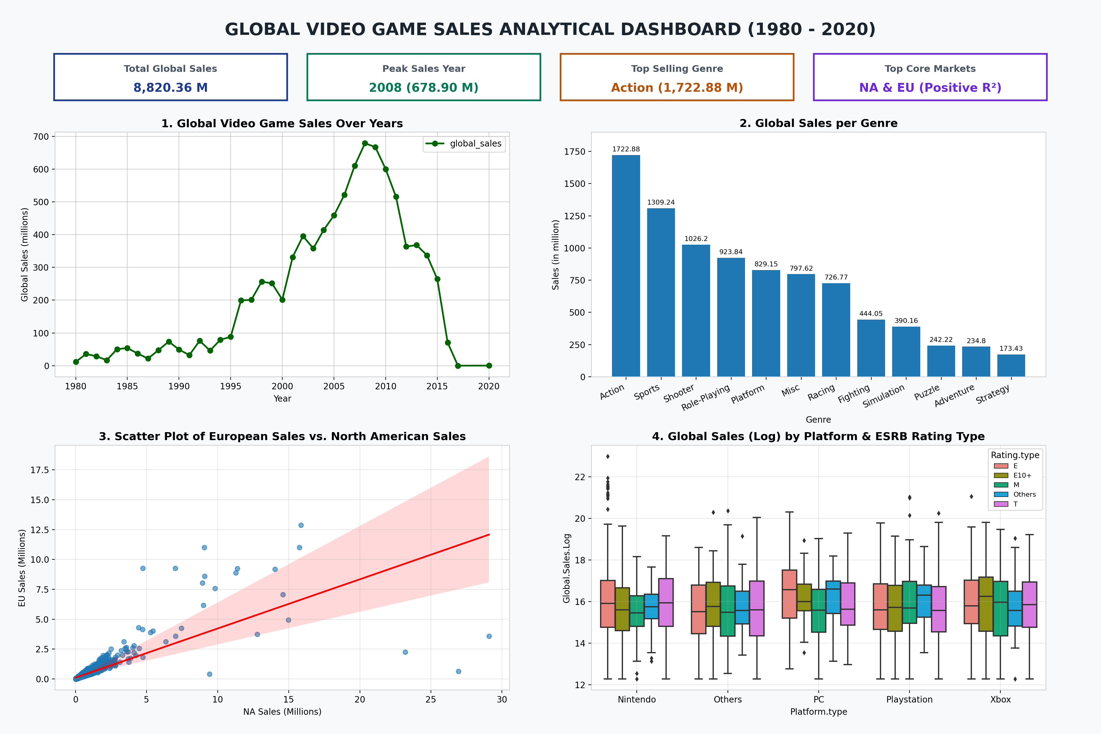

Visualization 1: Global Video Game Sales Over Years (Line Chart)
• What it shows: Tracks total worldwide video game unit sales (in millions) annually from 1980 through 2020.
• Why this chart type was chosen: A Line Chart is the gold standard for continuous time-series analysis, allowing immediate identification of long-term growth trajectories, market booms, and structural inflection points.
• الشرح بالعربية: يعرض الرسم الخطي تطور إجمالي المبيعات العالمية سنوياً من 1980 إلى 2020، وتم اختياره لأنه الأفضل لتتبع السلاسل الزمنية وكشف فترات الذروة والانحدار.
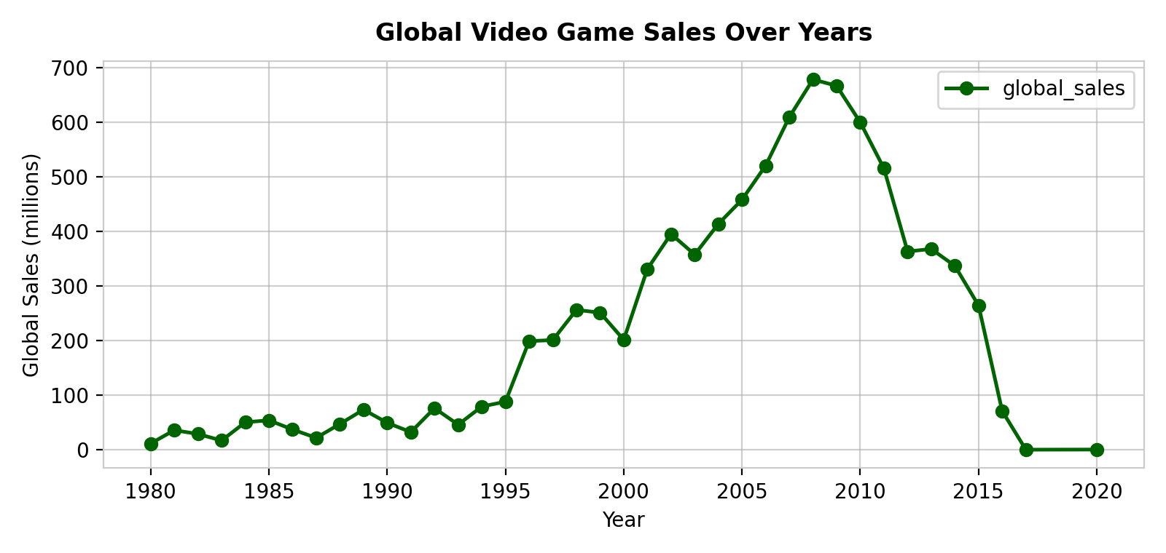

Visualization 2: Global Sales per Genre (Bar Chart)
• What it shows: Compares cumulative global sales across all 12 video game genres, sorted in descending order with exact data labels.
• Why this chart type was chosen: A vertical Bar Chart provides high visual clarity for categorical comparisons, making it effortless to rank top-performing genres against niche categories.
• الشرح بالعربية: يقارن مخطط الأعمدة بين إجمالي المبيعات لكل تصنيف من تصنيفات الألعاب الـ 12 مرتبة تنازلياً، وتم اختياره لدقته في المقارنة المباشرة بين الفئات المستقلة.
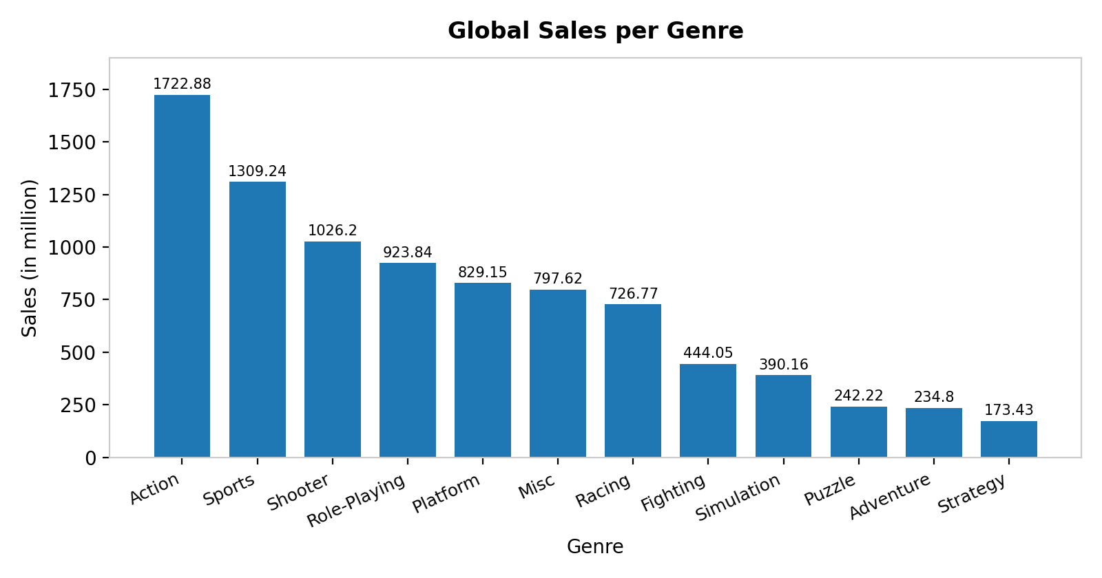

Visualization 3: European Sales vs. North American Sales with Trend Line (Scatter Plot)
• What it shows: Maps individual game titles by their North American sales (X-axis) against European sales (Y-axis), overlaid with a linear regression trend line and 95% confidence interval.
• Why this chart type was chosen: A Scatter Plot with a regression line is ideal for bivariate numeric analysis, directly revealing correlation strength, slope, and regional outliers.
• الشرح بالعربية: يوضح مخطط الانتشار مع خط الاتجاه العلاقة الارتباطية بين مبيعات أمريكا الشمالية وأوروبا، وتم اختياره لقياس قوة واتجاه العلاقة الطردية بين المتغيرين الرقميين.
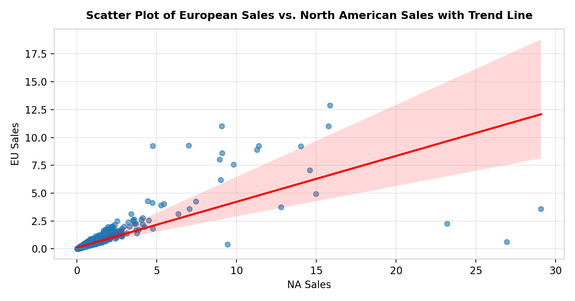

Visualization 4: Global Sales (Log) by Platform & Rating Type (Grouped Box Plot)
• What it shows: Displays the five-number statistical summary (median, quartiles Q1/Q3, whiskers, and outliers) of log-transformed global sales across major platform families subdivided by ESRB age rating (E, E10+, M, T, Others).
• Why this chart type was chosen: A Grouped Box Plot excels at multi-dimensional distribution analysis, exposing how audience demographics interact with hardware ecosystems without being distorted by extreme blockbuster outliers.
• الشرح بالعربية: يوضح مخطط الصندوق والعارضتين التوزيع الإحصائي للمبيعات اللوغاريتمية مقسماً حسب المنصة والتقييم العمري، وتم اختياره لإظهار الوسيط وتشتت البيانات والقيم المتطرفة بدقة.
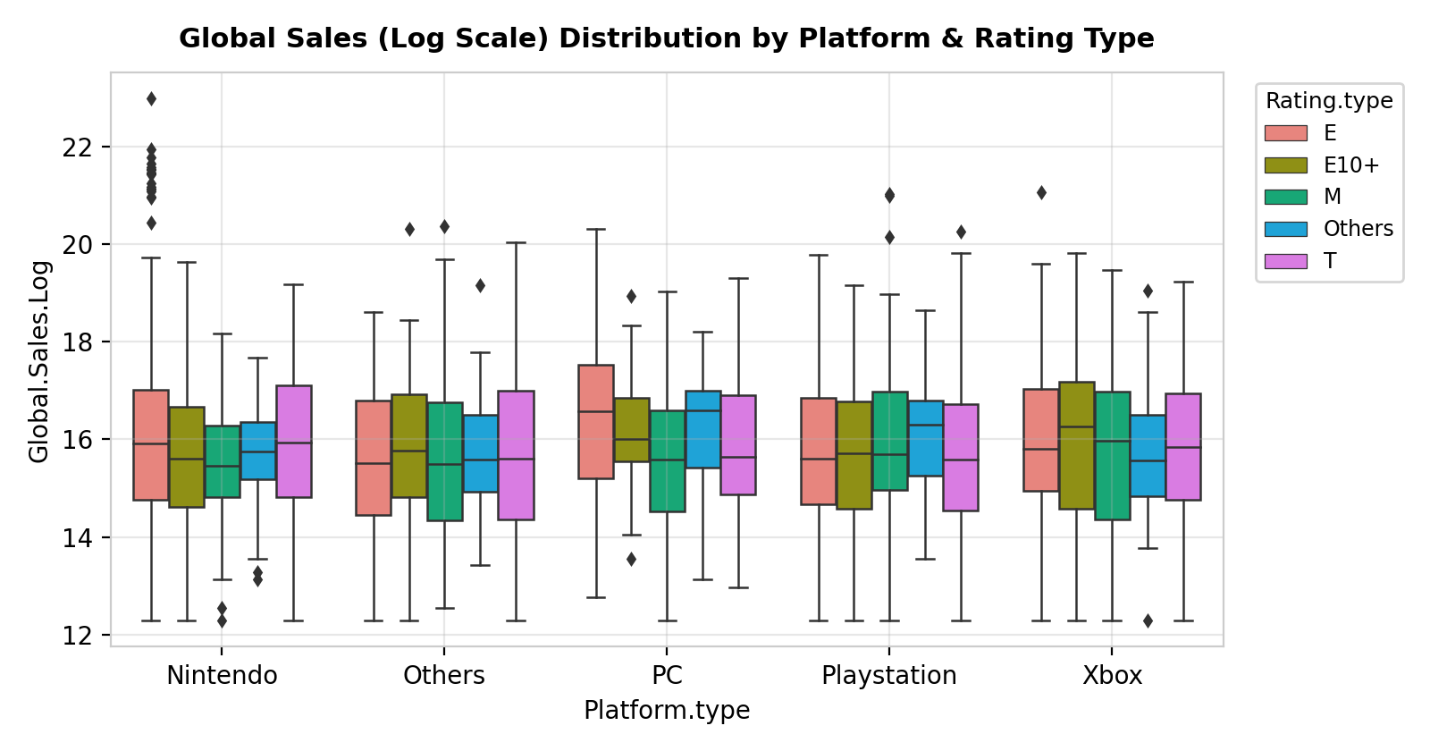

4. Main Findings & Insights (أبرز النتائج والرؤى المكتشفة)
1. The Golden Console Era Peak (2006–2010): Global video game sales remained below 100M units annually between 1980 and 1995, surged following the 3D console revolution in 1996, and reached an all-time historical peak in 2008 (678.90 million units) and 2009 (667.30 million units) driven by seventh-generation consoles (Nintendo Wii, PS3, Xbox 360). Post-2011 figures show a sharp decline in tracked physical retail copies due to the industry's structural shift toward digital downloads, free-to-play models, and mobile gaming.
2. Dominance of Action, Sports, and Shooter Genres: The Action genre leads global revenue by a substantial margin at 1,722.88 million units (19.5% of total sales), followed by Sports (1,309.24 million) and Shooter (1,026.20 million). Collectively, these top three genres capture 46.0% of all historical sales, whereas Strategy (173.43 million), Adventure (234.80 million), and Puzzle (242.22 million) represent specialized niche markets.
3. Strong Positive Cross-Atlantic Correlation (NA vs. EU): The regression trend line demonstrates a strong positive linear relationship between North American and European sales (EU sales average roughly 42% to 48% of NA volume). Blockbuster titles that succeed in North America reliably achieve high commercial traction in Europe, validating unified Western marketing campaigns.
4. Platform-Specific Demographic Alignment: The grouped box plot reveals distinct audience segmentation across hardware ecosystems: Nintendo achieves its highest median sales and upper outliers in family-friendly 'Everyone (E)' titles, whereas PlayStation and Xbox exhibit superior median performance in 'Mature (M)' and 'Teen (T)' titles. Meanwhile, PC sales show a lower physical retail median due to early adoption of digital distribution platforms like Steam.

5. Conclusions & Recommendations (الخلاصة والتوصيات)
In conclusion, the Global Video Game Sales Dashboard demonstrates that commercial success in the gaming industry is heavily governed by genre selection, hardware-demographic alignment, and synchronized Western regional releases. Based on the empirical insights extracted from the dashboard, we propose three strategic recommendations for game publishers and investors:
1. Portfolio Prioritization: Allocate flagship development budgets toward Action, Sports, and Shooter titles, or hybridize RPG mechanics with action gameplay to maximize addressable market size.
2. Targeted Platform Releases: Align ESRB age ratings with platform strengths—prioritize 'E' and 'E10+' family titles for Nintendo hardware while targeting 'M' and 'T' core experiences toward PlayStation and Xbox ecosystems.
3. Unified NA/EU Launch Strategies: Leverage the strong positive correlation between North American and European markets by executing simultaneous cross-Atlantic launches and shared localization pipelines.
الخلاصة بالعربية: تؤكد نتائج لوحة التحكم أن النجاح التجاري في صناعة الألعاب يعتمد بشكل مباشر على مواءمة تصنيف اللعبة وفئتها العمرية مع المنصة المستهدفة. ونوصي شركات التطوير بالتركيز على فئات الأكشن والرياضة والتصويب لتحقيق أعلى العوائد، وتوجيه الألعاب العائلية (E) لمنصات نينتندو وألعاب البالغين (M) لمنصتي بلايستيشن وإكس بوكس، مع توحيد الحملات التسويقية في أمريكا الشمالية وأوروبا نظراً للارتباط الطردي القوي بين السوقين.

