**گزارش سوال دوم آزمایش های کامپیوتری**

در این آزمایش ما با 2 دیتاست مواجه هستیم که باید به کمک دیتاست train به برنامه ی خود بیاموزیم که چگونه دیتاست دوم که همان دیتاست test هست را مورد تحلیل و بررسی قرار دهد.

دیتاست ها شامل امتیازی است که تعدادی از افراد به 1593 خبر داده اند و نوعی علاقه خود به آن نوع خبر را نشان داده اند و در آخر با توجه به تمام امتیاز های هر شخص به خبر ها، شخص در یکی از دو گروه مورد نظر ما قرار میگیرد.

ما با تحلیل دیتاست test میخواهیم نشان دهیم که هر شخص به کدام گروه تعلق دارد. برای این منظور باید از نتایج مشابه در دیتاست train کمک بگیریم.

برای حل این سوال ما احتمال اینکه هر فرد با توجه به امتیاز هایی که به خبر ها داده است به کدام

گروه تعلق دارد را محاسبه میکنیم و گروهی را که احتمال آن بیشتر شد را به آن فرد نسبت میدهیم.

برای محاسبه ما باید از قانون بیز استفاده کنیم.

با توجه به کدی که من طراحی کردم و نتایجی که بدست آوردم و مقایسه نتایج با نتایج پیشبینی شده میتوان گفت که این آزمایش دارای دقت 66 درصد بوده است. به طوری که 264 خروجی با مقدار پیشبینی شده یکسان بوده و 136 خروجی اشتباه بدست آمده اند.

نتایج کامل بدست آمده از خروجی برنامه به صورت زیر است که به علت طولانی بودن زمان اجرا، آن ها را در این سند آورده ام که میتوانید در صفحات بعد آن ها را مشاهده کنید.

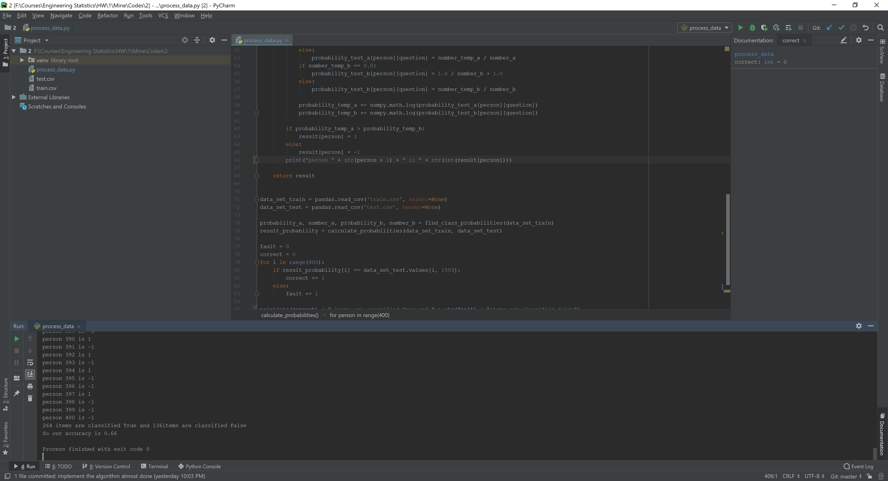

person 1 is 1

person 2 is 1

person 3 is -1

person 4 is -1

person 5 is -1

person 6 is 1

person 7 is -1

person 8 is 1

person 9 is -1

person 10 is 1

person 11 is 1

person 12 is -1

person 13 is 1

person 14 is -1

person 15 is -1

person 16 is 1

person 17 is -1

person 18 is 1

person 19 is 1

person 20 is -1

person 21 is 1

person 22 is -1

person 23 is -1

person 24 is 1

person 25 is -1

person 26 is -1

person 27 is -1

person 28 is 1

person 29 is 1

person 30 is -1

person 31 is -1

person 32 is 1

person 33 is -1

person 34 is -1

person 35 is -1

person 36 is -1

person 37 is -1

person 38 is -1

person 39 is 1

person 40 is -1

person 41 is -1

person 42 is -1

person 43 is -1

person 44 is 1

person 45 is -1

person 46 is -1

person 47 is -1

person 48 is -1

person 49 is -1

person 50 is 1

person 51 is -1

person 52 is -1

person 53 is -1

person 54 is 1

person 55 is -1

person 56 is -1

person 57 is -1

person 58 is -1

person 59 is -1

person 60 is 1

person 61 is -1

person 62 is -1

person 63 is -1

person 64 is -1

person 65 is -1

person 66 is -1

person 67 is 1

person 68 is -1

person 69 is 1

person 70 is -1

person 71 is 1

person 72 is -1

person 73 is -1

person 74 is -1

person 75 is -1

person 76 is 1

person 77 is -1

person 78 is -1

person 79 is -1

person 80 is 1

person 81 is -1

person 82 is 1

person 83 is 1

person 84 is 1

person 85 is -1

person 86 is -1

person 87 is -1

person 88 is -1

person 89 is -1

person 90 is -1

person 91 is 1

person 92 is 1

person 93 is -1

person 94 is 1

person 95 is -1

person 96 is -1

person 97 is -1

person 98 is 1

person 99 is -1

person 100 is -1

person 101 is -1

person 102 is 1

person 103 is 1

person 104 is 1

person 105 is -1

person 106 is -1

person 107 is 1

person 108 is -1

person 109 is 1

person 110 is 1

person 111 is 1

person 112 is -1

person 113 is -1

person 114 is -1

person 115 is -1

person 116 is -1

person 117 is -1

person 118 is 1

person 119 is -1

person 120 is -1

person 121 is -1

person 122 is -1

person 123 is -1

person 124 is 1

person 125 is -1

person 126 is -1

person 127 is -1

person 128 is 1

person 129 is 1

person 130 is 1

person 131 is -1

person 132 is -1

person 133 is 1

person 134 is 1

person 135 is -1

person 136 is 1

person 137 is -1

person 138 is 1

person 139 is 1

person 140 is -1

person 141 is 1

person 142 is -1

person 143 is -1

person 144 is -1

person 145 is 1

person 146 is 1

person 147 is -1

person 148 is 1

person 149 is -1

person 150 is -1

person 151 is -1

person 152 is -1

person 153 is -1

person 154 is 1

person 155 is -1

person 156 is -1

person 157 is -1

person 158 is 1

person 159 is -1

person 160 is -1

person 161 is -1

person 162 is -1

person 163 is -1

person 164 is -1

person 165 is 1

person 166 is 1

person 167 is -1

person 168 is -1

person 169 is -1

person 170 is -1

person 171 is -1

person 172 is 1

person 173 is -1

person 174 is -1

person 175 is -1

person 176 is -1

person 177 is -1

person 178 is 1

person 179 is -1

person 180 is 1

person 181 is -1

person 182 is 1

person 183 is -1

person 184 is -1

person 185 is -1

person 186 is 1

person 187 is -1

person 188 is -1

person 189 is -1

person 190 is -1

person 191 is 1

person 192 is -1

person 193 is 1

person 194 is -1

person 195 is 1

person 196 is 1

person 197 is -1

person 198 is -1

person 199 is -1

person 200 is -1

person 201 is -1

person 202 is -1

person 203 is -1

person 204 is -1

person 205 is -1

person 206 is -1

person 207 is 1

person 208 is 1

person 209 is -1

person 210 is 1

person 211 is -1

person 212 is -1

person 213 is -1

person 214 is -1

person 215 is -1

person 216 is 1

person 217 is 1

person 218 is 1

person 219 is 1

person 220 is -1

person 221 is -1

person 222 is -1

person 223 is -1

person 224 is 1

person 225 is 1

person 226 is -1

person 227 is -1

person 228 is 1

person 229 is 1

person 230 is -1

person 231 is -1

person 232 is -1

person 233 is -1

person 234 is -1

person 235 is -1

person 236 is -1

person 237 is -1

person 238 is -1

person 239 is 1

person 240 is -1

person 241 is 1

person 242 is -1

person 243 is -1

person 244 is -1

person 245 is -1

person 246 is -1

person 247 is -1

person 248 is -1

person 249 is 1

person 250 is -1

person 251 is -1

person 252 is -1

person 253 is -1

person 254 is -1

person 255 is -1

person 256 is -1

person 257 is -1

person 258 is 1

person 259 is -1

person 260 is -1

person 261 is -1

person 262 is 1

person 263 is -1

person 264 is -1

person 265 is -1

person 266 is 1

person 267 is 1

person 268 is -1

person 269 is -1

person 270 is -1

person 271 is -1

person 272 is -1

person 273 is -1

person 274 is -1

person 275 is 1

person 276 is 1

person 277 is -1

person 278 is -1

person 279 is -1

person 280 is -1

person 281 is 1

person 282 is -1

person 283 is -1

person 284 is 1

person 285 is -1

person 286 is 1

person 287 is -1

person 288 is -1

person 289 is -1

person 290 is -1

person 291 is 1

person 292 is -1

person 293 is -1

person 294 is -1

person 295 is -1

person 296 is -1

person 297 is 1

person 298 is 1

person 299 is -1

person 300 is -1

person 301 is -1

person 302 is -1

person 303 is 1

person 304 is -1

person 305 is -1

person 306 is -1

person 307 is -1

person 308 is -1

person 309 is -1

person 310 is -1

person 311 is -1

person 312 is 1

person 313 is -1

person 314 is 1

person 315 is -1

person 316 is -1

person 317 is -1

person 318 is -1

person 319 is -1

person 320 is -1

person 321 is -1

person 322 is -1

person 323 is 1

person 324 is -1

person 325 is 1

person 326 is -1

person 327 is 1

person 328 is -1

person 329 is 1

person 330 is -1

person 331 is -1

person 332 is 1

person 333 is -1

person 334 is -1

person 335 is 1

person 336 is -1

person 337 is -1

person 338 is -1

person 339 is -1

person 340 is -1

person 341 is 1

person 342 is -1

person 343 is -1

person 344 is 1

person 345 is 1

person 346 is -1

person 347 is -1

person 348 is -1

person 349 is 1

person 350 is -1

person 351 is 1

person 352 is -1

person 353 is 1

person 354 is 1

person 355 is -1

person 356 is -1

person 357 is -1

person 358 is -1

person 359 is -1

person 360 is -1

person 361 is -1

person 362 is -1

person 363 is 1

person 364 is -1

person 365 is -1

person 366 is -1

person 367 is -1

person 368 is -1

person 369 is -1

person 370 is -1

person 371 is -1

person 372 is 1

person 373 is -1

person 374 is 1

person 375 is -1

person 376 is -1

person 377 is -1

person 378 is 1

person 379 is -1

person 380 is -1

person 381 is -1

person 382 is -1

person 383 is -1

person 384 is 1

person 385 is 1

person 386 is -1

person 387 is -1

person 388 is -1

person 389 is -1

person 390 is 1

person 391 is -1

person 392 is 1

person 393 is -1

person 394 is 1

person 395 is -1

person 396 is -1

person 397 is 1

person 398 is -1

person 399 is -1

person 400 is -1

**264 items are classified True and 136 items are classified False**

**So our accuracy is 0.66**