**T.C.**

**BAHÇEŞEHİR UNIVERSITY**

**FACULTY OF ENGINEERING AND NATURAL SCIENCES**

**SEN3006 Software Architecture**

**Branch Tracker**

**Muhammed Emre Durmaz - 1731638 – Software Engineering**

**Orhancan Subaşı - 1603054 – Software Engineering**

**Ali Berkay Aslıoğlu – 1604623 – Software Engineering**

**Project Overview**

**Running the project**

1. **Import Database:** Mongodb must be installed. You can perform transactions through Mongodb compass.Create a db named “BranchTracker”. Create collections named “dailysales” and “users” and import json data in the project.
2. **Run Backend Project:** Nodejs must be installed. Run the "npm install" command once on the server folder. Then "npm run start" every time the project is run.
3. **Run Frontend Project:** Nodejs must be installed. Run the "npm install" command once on the server folder. Then "npm run start" every time the project is run.

**Admin Main Page**

The turnovers with which the region managers entered for their regions are displayed. Regions without turnover entry are black.

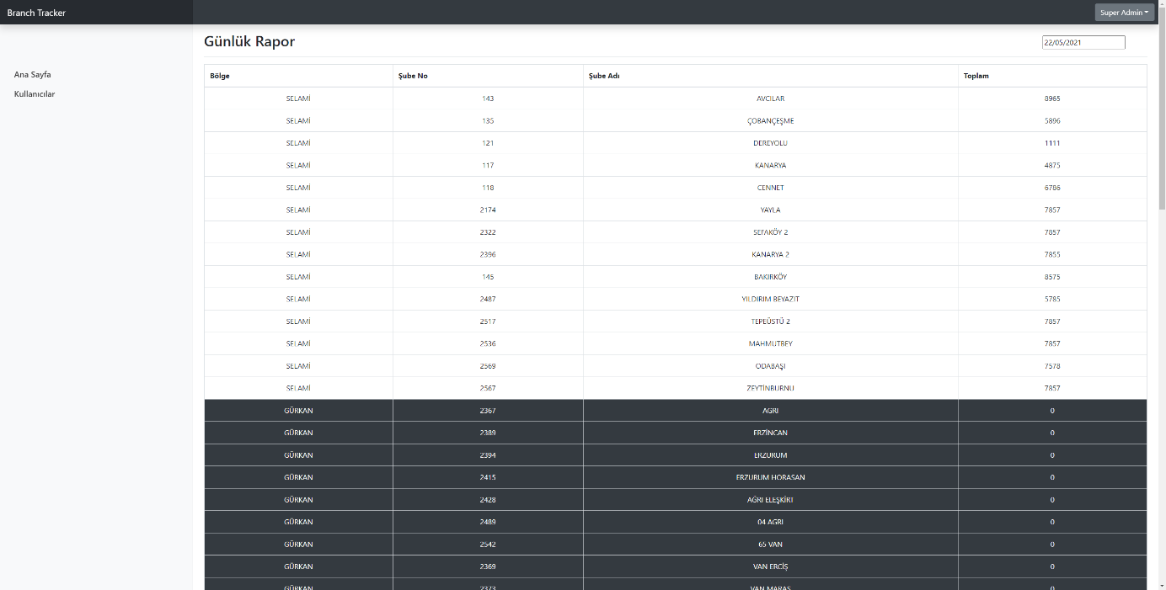

**Admin Users Page**

The system administrator can add or delete a new regional officer and branches affiliated with this regional officer.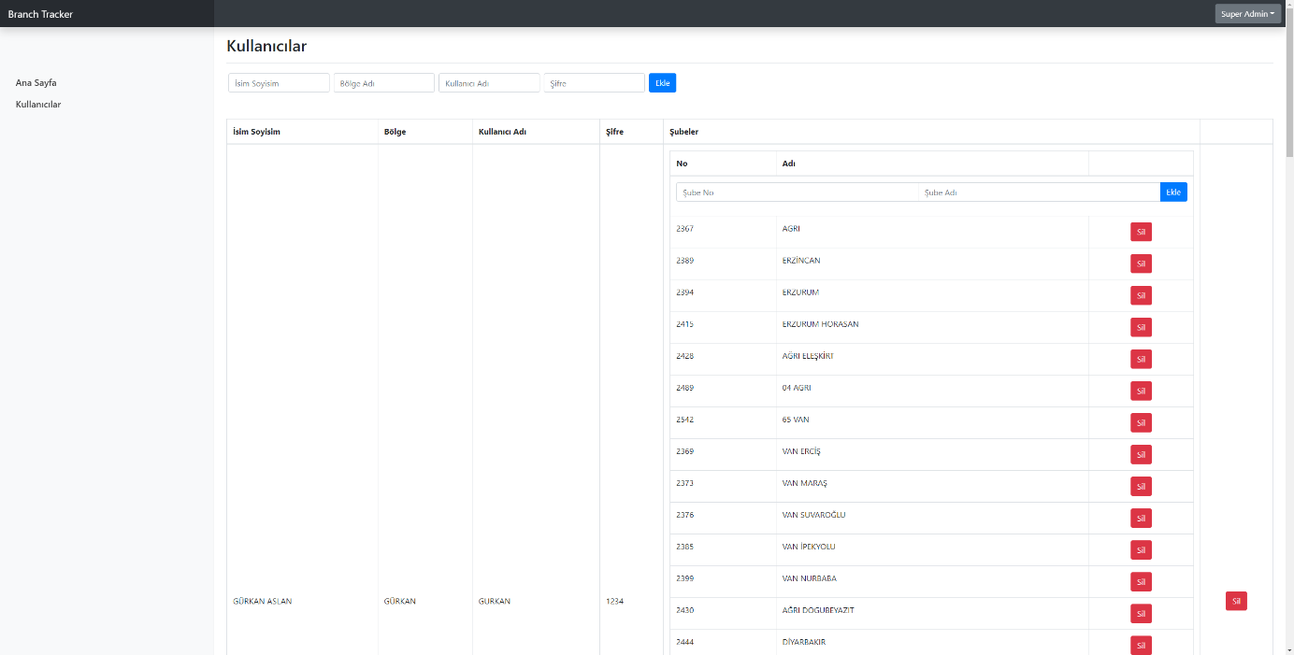

**Regional Manager Page**

The regional officer can enter their daily turnover. The turnovers are recorded within that day.

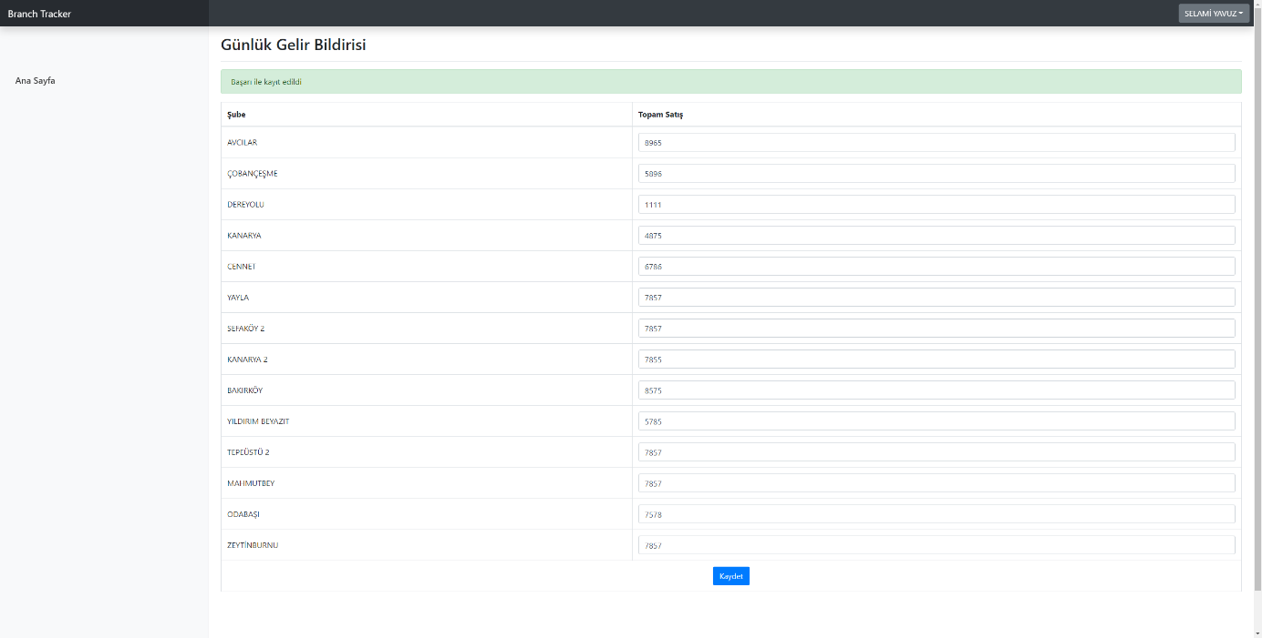

**Diagrams**

1. **Software Architecture Diagram**

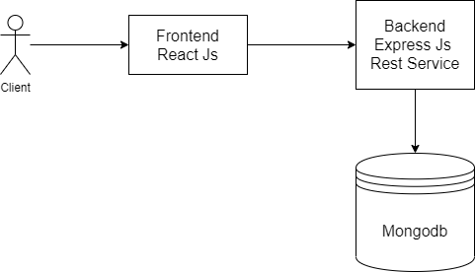

1. **Use Case Diagram**

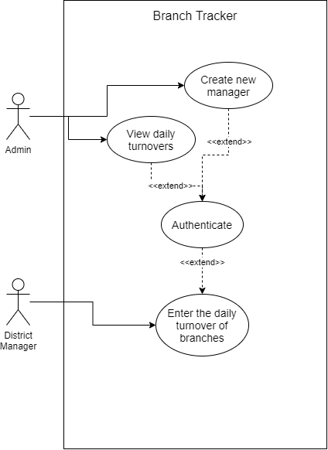

1. **Sequence Diagram**

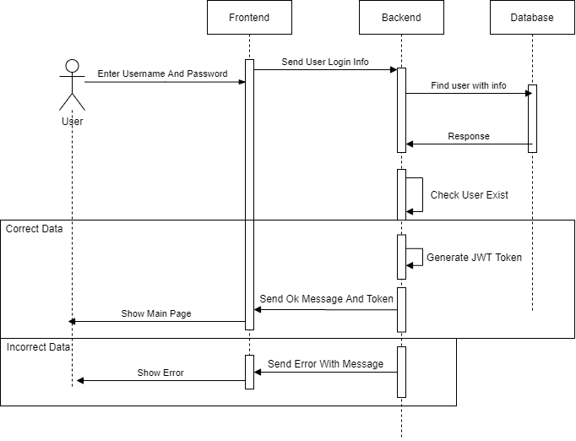

1. **Class Diagram**

