**Tailor Management System**

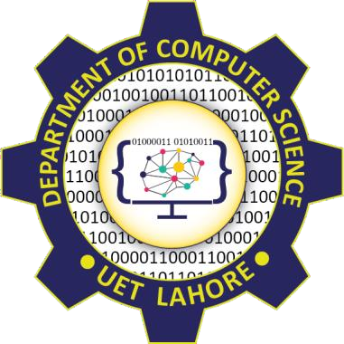

Session: 2023 – 2027

# Submitted by:

Muhammad Ali Raza ( 2023-CS-801 )

# Submitted To:

Prof. Talha Mubashir

Department of Computer Science

**University of Engineering and Technology Lahore Pakistan(Fsd)**

# Tailor Management System Documentation

## **Introduction**

The Tailor Management System is a Windows Forms application designed to streamline and manage the operations of a tailoring business. The system facilitates the management of customer information, product details, and cloth inventory, ensuring efficient and accurate business operations. The key functionalities of the system include adding, deleting, updating, and viewing details of customers, products, and cloth inventory.

## **Key Functionalities**

### **Customer Management**

* **Add Customer**: Allows the user to add new customer details including name, contact information, and address.
* **Delete Customer**: Enables the removal of customer records from the system.
* **Update Customer**: Facilitates the modification of existing customer information.
* **View Customer**: Provides a detailed view of all customer records stored in the system.

### **Product Management**

* **Add Product**: Allows the user to add new product details including product name, type, and price.
* **Delete Product**: Enables the removal of product records from the system.
* **Update Product**: Facilitates the modification of existing product information.
* **View Product**: Provides a detailed view of all product records stored in the system.

### **Cloth Inventory Management**

* **Add Cloth**: Allows the user to add new cloth details including cloth type, quantity, and price.
* **Delete Cloth**: Enables the removal of cloth records from the system.
* **Update Cloth**: Facilitates the modification of existing cloth information.
* **View Cloth**: Provides a detailed view of all cloth inventory records stored in the system.

## **Objectives**

1. **Streamline Customer Management**: Efficiently manage customer details to provide personalized service and improve customer satisfaction.
2. **Product Management**: Maintain detailed records of products available for tailoring, including prices and types.
3. **Cloth Inventory Management**: Keep track of cloth inventory levels to ensure the availability of materials for order fulfillment.
4. **Order Tracking**: Monitor the status of each order to ensure timely delivery and maintain customer trust.

**Wire Frames of Application**

Following are Wire Frames of my Project

* Sign In / Sign Up

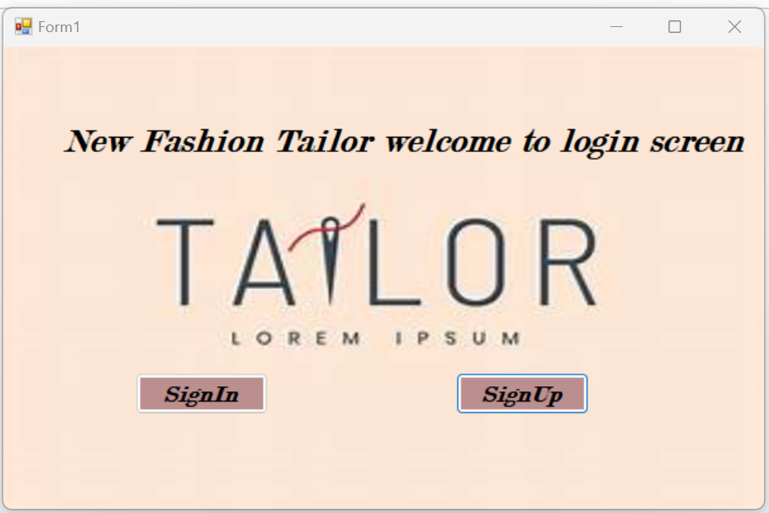

* Sign In

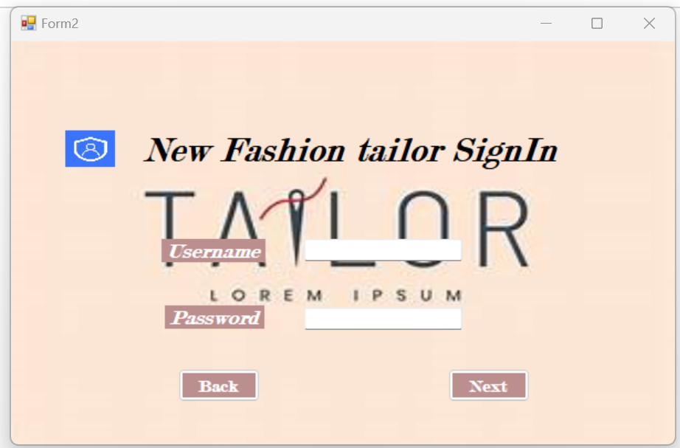

* 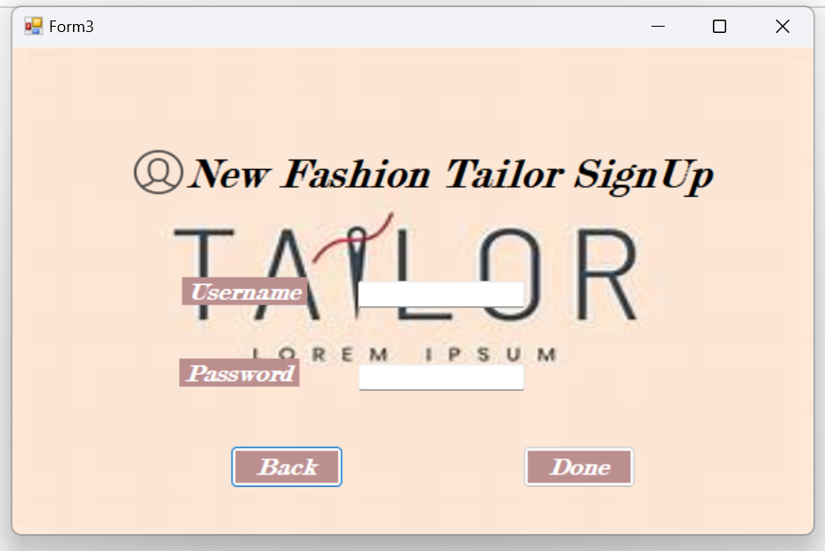Sign Up
* Dais Board

