**FAA DI Analysis Program Manual**

**Assumptions:**

These are rules adopted due to the design constraints of the program. Currently, these are the assumptions that the program operates under:

* The name of each file begins with a 4-letter descriptor followed by an underscore, date, underscore, time, and frequency. This constraint will be removed in a future update.

Example:

“TEST_08_20_18_16_15_41_200kHz.dix”

If this is not the case, please use a bulk rename utility to rename all your files this way before proceeding. The date and time is necessary to maintain proper order between the files.

* Currently, the program operates with 3 files, all 3 of these must available in the default MATLAB folder for proper function. These files are as listed:

“distinguishable_colors.m”

“FAA_Analysis.m”

“FAA_DI_Analysis_Main.m”

The program can only be operated from the Main “FAA_DI_Analysis_Main.m” file.

The latest version of these files will be available in the GitHub repository.

**Parameters:**

These are a mixture of constraints and instructions used to define the operations of the program upon execution. These parameters can be found and edited

Each of these parameters, and their function is listed below:

Frequencies

The different frequencies that need to be plotted from the .dix files must be defined in the parameters. For example:

Frequencies = [200]; This will plot DI from only 200kHz

Frequencies = [200 250 300 350];

Similarly, this will plot DI from the 4 listed frequencies in order.

Plot_All

If plot All is set to 1, this will plot all available unique paths from the defined frequencies in the .dix files. If plot All is set to 0, the program will plot only paths from the “selectpath” parameters. For this to function properly, please ensure that the parameter “elim” is set equal to “[]”.

Elim

Elim is used exclusively for times when Plot_All is set to 1, and some sensors need to be filtered out of the plotted results. Example:

Elim = [1 3 5];

This will filter out and eliminate all paths with sensors numbered 1, 3, and 5 from the plotted results.

This is useful for isolating some paths from others in bulk without having to select them 1 by 1 using “selectpath”.

selectpath

Everytime the program is run with .dix files, an excel file with the dix filenames and the unique paths within them is generated. Each path in this excel file is assigned an index number, which allows the program to call the path one by one and plot them.

If the .dix filename is “TEST_08_20_18_16_15_41_200kHz.dix”, then the excel filename with be “TEST_Unique_Paths.xlsx” accordingly. This is what the excel file looks like:

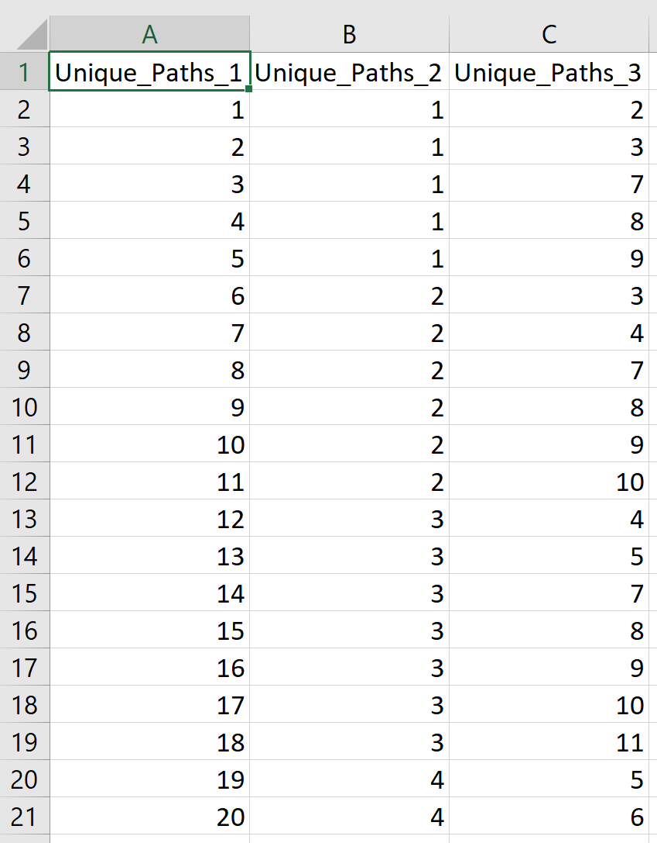

Here, column A is the index number. Column B is the actuator, and Column C is the sensor.

Thus, if path 1-2 needed to be plotted, selectpath would be set to 1.

Final example:

Let’s say 3 different paths, 1-2, 2-10, and 4-5 from the 300kHz frequency needed to be extracted from the .dix files.

The parameters would then look like this:

Frequencies = [300]; Only the frequency 300 is defined.

Plot_All = 0;

This is set to 0 because all paths are not being plotted, only the defined plots need to be plotted.

Elim = [];

Elim is empty because it is used exclusively for cases where Plot_All is set to 1.

Selectpath = [1 11 19];

The indexes for the paths 1-2, 2-10, and 4-5 were taken from the autogenerated xlsx file.

These parameters would then generate the desired DI results.

The last parameter is the File prefix. This is just the first 4 letters of the previously renamed .dix files, which is used for sorting, and identifying the necessary files.

For a .dix file named “TEST_08_20_18_16_15_41_200kHz.dix”, the file prefix would be “TEST_”. Do not forget to add the underscore, not including it may result in errors.