Probes : [

{

"Name": "PacktHealthProbe",

"Etag": "W/\"d24289bb-bfca-4e93-8a7b-4432f5347ef2\"",

"Id": "/subscriptions/7753245a-a8af-48a8-b2c8-68c85134798e/resourceGroups/PacktLoadBalancer/providers/Microsoft.Network/loadBalancers/PacktLoadBalancer/probes/PacktHealthProbe",

"Protocol": "Tcp",

"Port": 80,

"IntervalInSeconds": 5,

"NumberOfProbes": 2,

"ProvisioningState": "Succeeded",

"LoadBalancingRules": []

$azlb | Add-AzLoadBalancerRuleConfig -Name $LBRuleName -FrontendIpConfigurationId $LBFrontendIPConfiguration -Protocol "Tcp" -FrontendPort 3350 -BackendPort 3350 - EnableFloatingIP



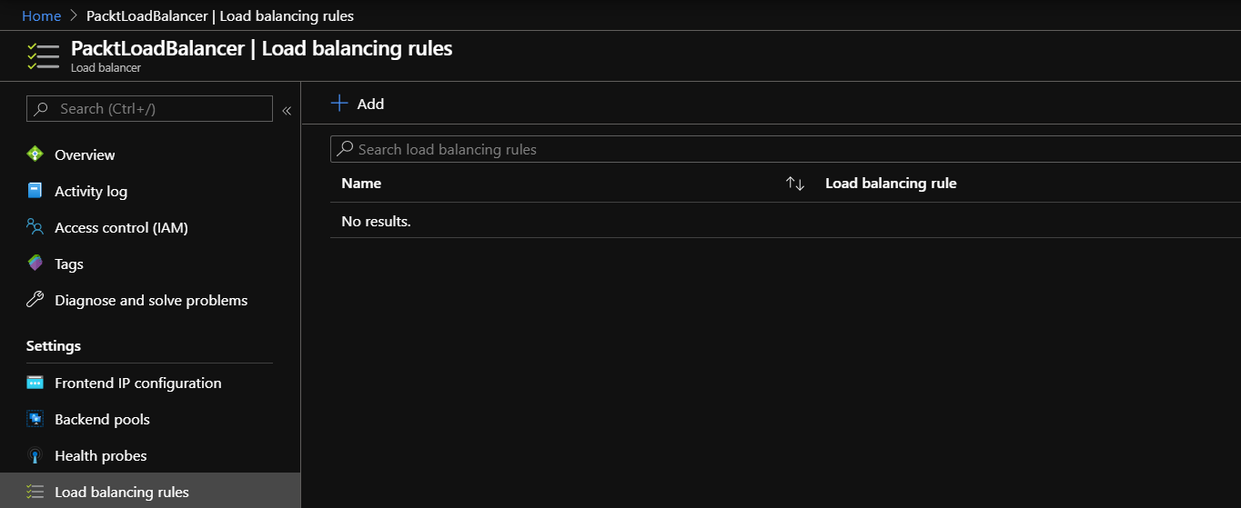

$azlb | Set-AzLoadBalancerRuleConfig -Name "$($LBRuleName)" -FrontendIPConfiguration $LBFrontendIPConfiguration -Protocol "Tcp" -FrontendPort 3350 -BackendPort 3350 -Verbose

LoadBalancingRules : [

{

"Name": "NewRule",

"Protocol": "Tcp",

"FrontendPort": 3350,

"BackendPort": 3350,

"IdleTimeoutInMinutes": 4,

"EnableFloatingIP": false,

"EnableTcpReset": false,

"DisableOutboundSNAT": false,

"FrontendIPConfiguration": {

"Id": "/subscriptions/7753245a-a8af-48a8-b2c8-68c85134798e/resourceGroups/PacktLoadBalancer/providers/Microsoft.Network/loadBalancers/PacktLoadBalancer/frontendIPConfigurations/NewFrontend"

(Provisioning state: Successful)