1. Between Monday to Thursday check if new node image is available using below commands

To check latest node image available

az aks nodepool get-upgrades --nodepool-name npsystem --cluster-name aks-vyajhwtrez6ou --resource-group daf-lan2-d-euwe-rsg-aks --query latestNodeImageVersion

To check current node image version

az aks nodepool show --resource-group daf-lan2-d-euwe-rsg-aks --cluster-name aks-vyajhwtrez6ou --name npsystem --query nodeImageVersion

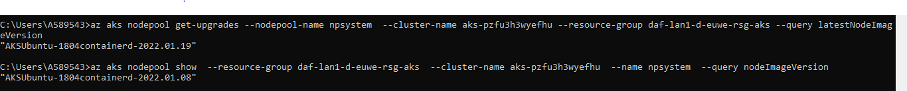

1. If new node image is available, then raise a change for the upgrade and schedule it on Friday between 6:00 PM to 9:00 PM.
2. Before change, Check quota usage of the cores of the subscription.

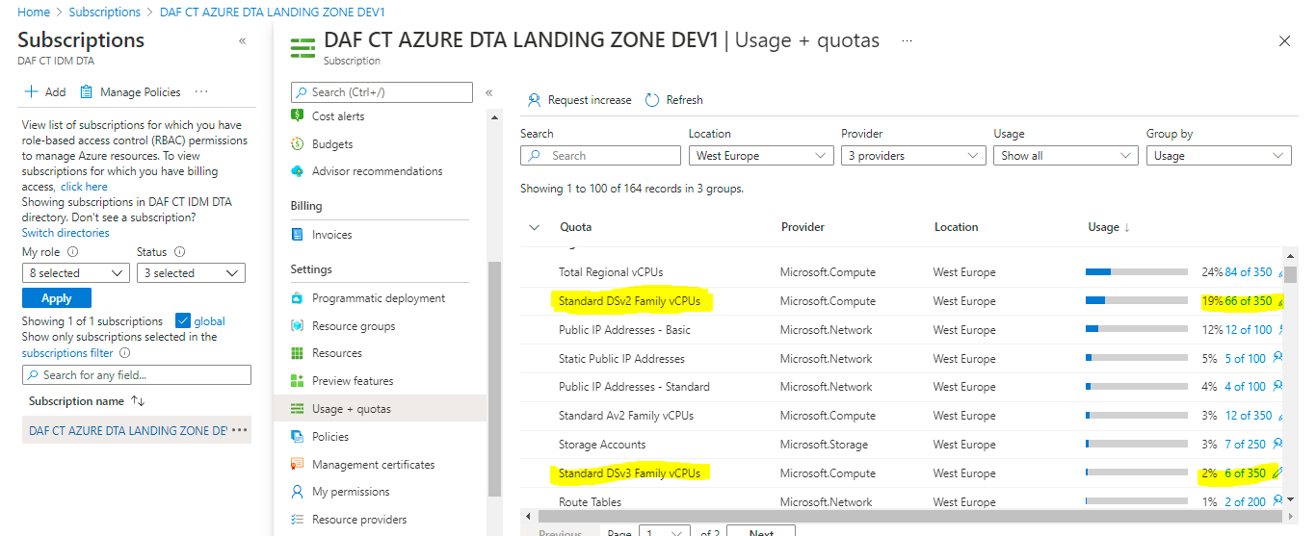

1. If cores are not available request the quota increase

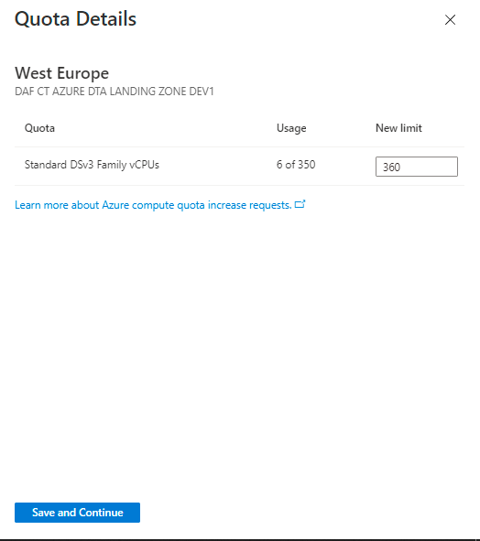

1. Before starting the upgrade send email to all teams to notify the start of the upgrade
2. At the time of execution, Login to Devops portal and select daf-ct-dta-infra project

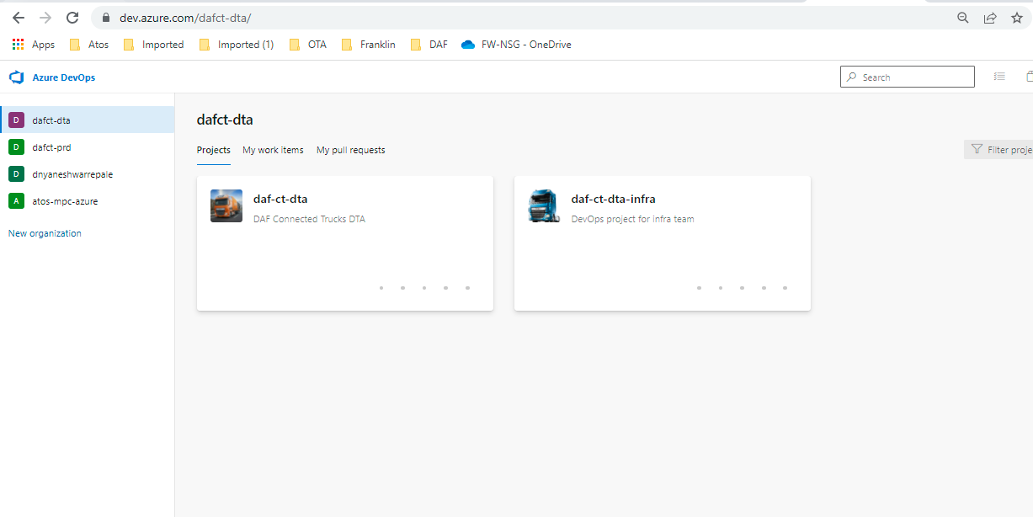

1. In Pipelines select Releases. Select Weekly Node Image Upgrade Pipeline and Select Create Release

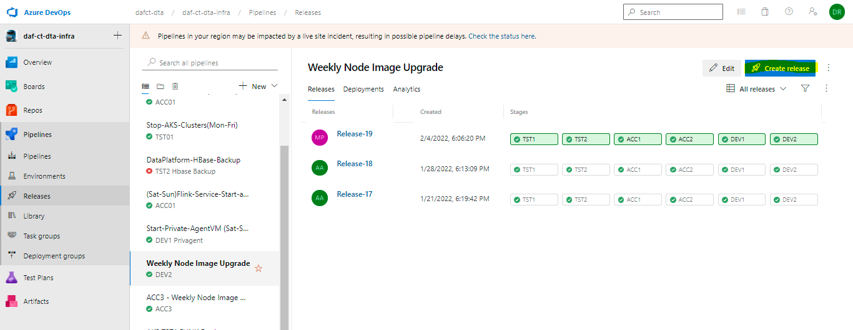

1. New window will pop up. Select create in that window.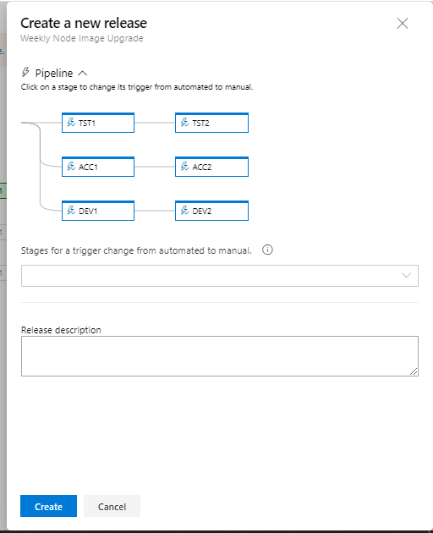
2. Monitor the pipeline execution in DevOps portal

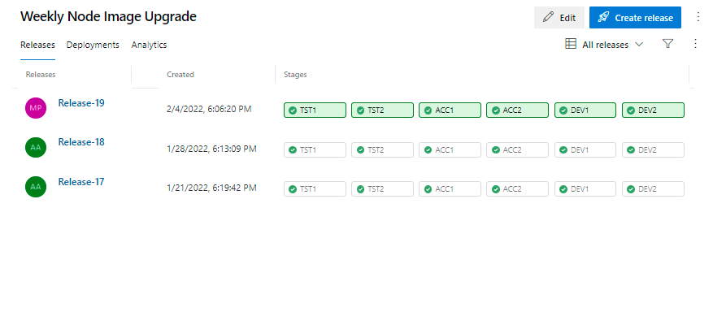

1. . Login to Azure portal and check the node and workload status as below during upgrade and post upgrade.

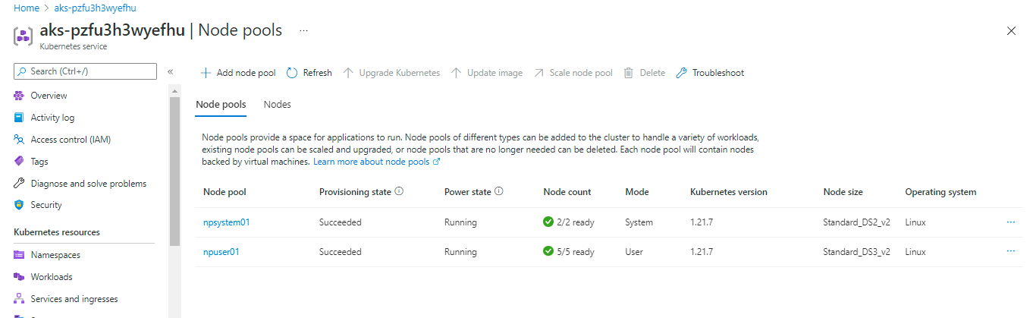

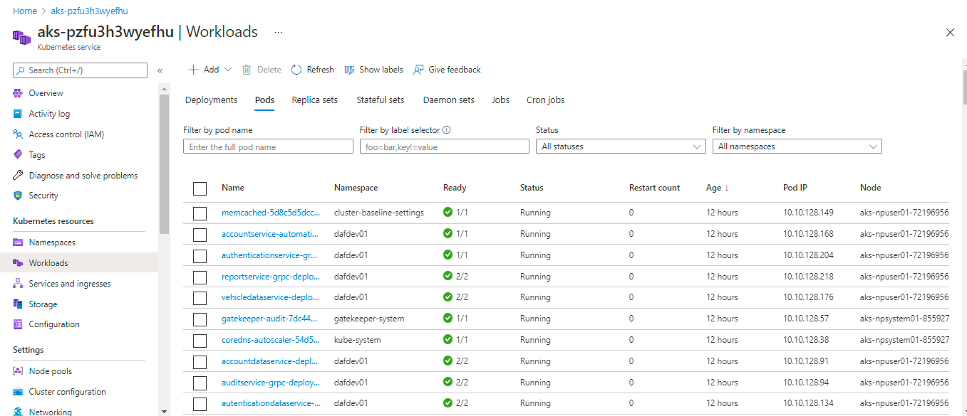

1. Post upgrade send email to all teams to notify the upgrade completion