**OOP Lab 02**

**Name: Ali Rooman**

**Roll No: 24K-0792**

**Task 1**

|  |
| --- |
| #include <iostream>  #include <string>  using *namespace* std;  *struct* Book {      string title;      string author;  *int* year;  };  *int* main() {  *int* n;      cout<<"Enter the number of books you want to enter data: ";      cin>>n;      cin.ignore();      Book *\**b = new Book[n];      for (*int* i=0;i<n;i++){          cout<<"\nEnter details for book "<<i+1<<":\n";          cout<<"Title:";          getline(cin, b[i].title);          cout<<"Author: ";          getline(cin, b[i].author);          cout<<"Year: ";          cin>>b[i].year;          cin.ignore();      }  *int* specificYear = 2000, found = 0;      cout<<"\nBook Details published after 2000:\n";      for (*int* i=0;i<n;i++) {          if(b[i].year>=specificYear){          found = 1;          cout<<"Title: "<<b[i].title<<", Author: "<<b[i].author<<", Year: "<<b[i].year<<endl;          }      }      if (!found) {          cout<<"No books found published after 2000.\n";      }      delete[] b;      return 0;  } |

Output

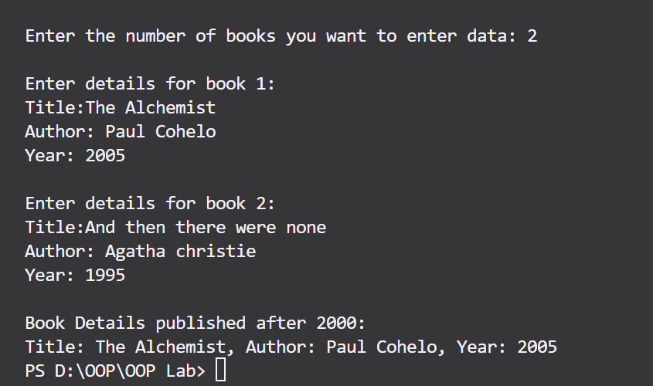

**Task 2**

|  |
| --- |
| #include <iostream>  #include <string>  using *namespace* std;  *void* addition(*int* *\*\*mat1*,*int* *\*\*mat2*,*int* *\*\*sum*,*int* *m*,*int* *n*) {      for (*int* i=0;i<m;i++){          for (*int* j=0;j<n;j++){              sum[i][j] = mat1[i][j] + mat2[i][j];          }      }  }  *void* subtraction(*int* *\*\*mat1*,*int* *\*\*mat2*,*int* *\*\*diff*,*int* *m*,*int* *n*) {      for (*int* i=0;i<m;i++){          for (*int* j=0;j<n;j++){              diff[i][j] = mat1[i][j] - mat2[i][j];          }      }  }  *void* display(*int* *\*\*matrix*,*int* *m*,*int* *n*){      for (*int* i=0;i<m;i++){          for (*int* j=0;j<n;j++){              cout<<matrix[i][j]<<" ";          }          cout<<"\n";      }  }  *int* main() {    *int* m,n;      cout<<"Enter the no of rows of matrices: ";      cin>>m;      cout<<"\nEnter the no of Columns of matrices: ";      cin>>n;    *int* *\*\**mat1 = new *int*\*[m];  *int* *\*\**mat2 = new *int*\*[m];      for (*int* i = 0; i < m; i++) {          mat1[i] = new *int*[n];          mat2[i] = new *int*[n];      }      cout<<"Enter elements of matrix 1:\n";      for (*int* i=0;i<m;i++) {          for (*int* j=0;j<n;j++) {              cout<<"\nEnter "<<i+1<<","<<j+1<<" element: ";              cin>>mat1[i][j];            }      }      cout<<"Enter elements of matrix 2:\n";      for (*int* i=0;i<m;i++) {          for (*int* j=0;j<n;j++) {              cout<<"\nEnter "<<i+1<<","<<j+1<<" element: ";              cin>>mat2[i][j];          }      }    *int* *\*\**sum = new *int*\*[m];  *int* *\*\**diff = new *int*\*[m];      for (*int* i=0;i<m;i++){          sum[i] = new *int*[n];          diff[i] = new *int*[n];      }      addition(mat1,mat2,sum,m,n);      subtraction(mat1,mat2,diff,m,n);      cout<<"The sum of the matrices is: "<<endl;      display(sum,m,n);      cout<<"\nThe difference of the matrices is: "<<endl;      display(diff,m,n);      for (*int* i = 0; i < m; i++) {          delete[] mat1[i];          delete[] mat2[i];          delete[] sum[i];          delete[] diff[i];      }      delete[] mat1;      delete[] mat2;      delete[] sum;      delete[] diff;      return 0;  } |

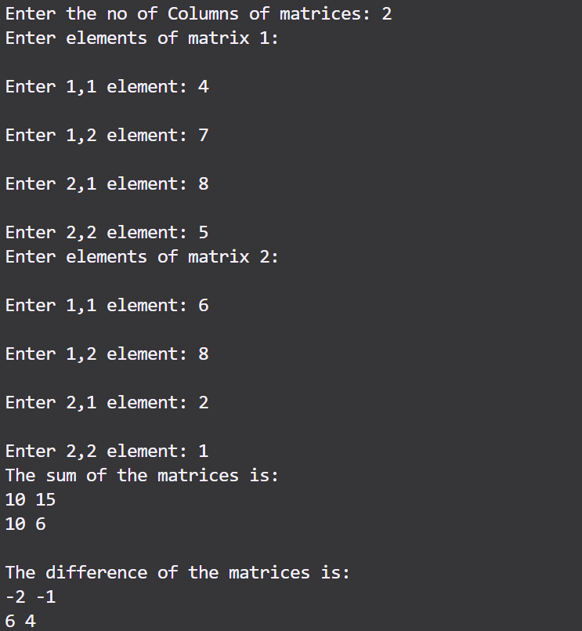Output

**Task 3**

|  |
| --- |
| #include <iostream>  #include <string>  using *namespace* std;  *struct* Employee {      string name;  *float* hoursWorked;  *float* hourlyRate;  };  *int* main() {  *int* n;      cout<<"Enter the number of employees you want to add: ";      cin>>n;      cin.ignore();      Employee *\**emp = new Employee[n];  *float\** Salaries = new *float*[n];      for (*int* i=0;i<n;i++){          cout<<"\nEnter details for employee "<<i+1<<"\n";          cout<<"Enter Name: ";          getline(cin,emp[i].name);          cout<<"Enter hours workked: ";          cin>>emp[i].hoursWorked;          cout<<"Enter hourly rate: ";          cin>>emp[i].hourlyRate;          cin.ignore();          Salaries[i] = emp[i].hourlyRate*emp[i].hoursWorked;      }      cout<<"\nTotal Salaries for employees";      for (*int* i=0;i<n;i++){          cout<<"\nFor employee "<<emp[i].name<<" Salary is: "<<Salaries[i];      }      delete [] emp;      delete [] Salaries;      return 0;  } |

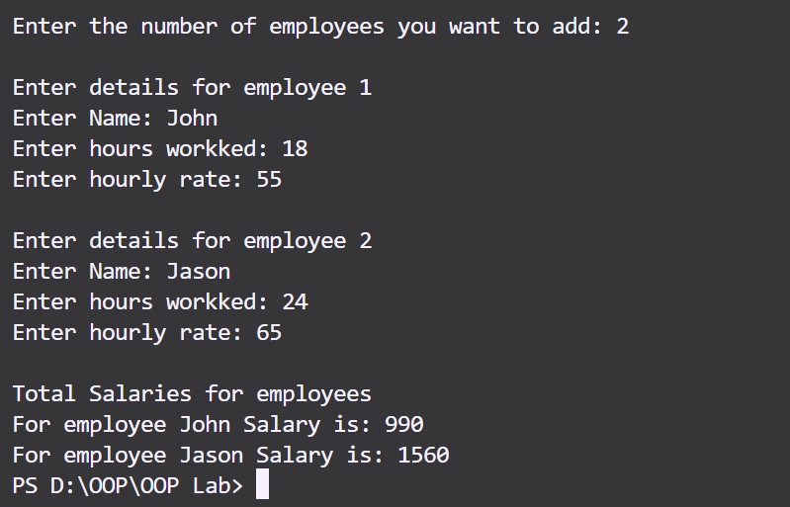Output

**Task 4**

|  |
| --- |
| #include <iostream>  #include <string>  using *namespace* std;  string sort(*const* string*&* *str*) {      string result;      for (*int* i=0;i<str.length();i++) {          if (isalpha(str[i]))              result+=str[i];      }  *int* n = result.length();      for (*int* i=0;i<n-1;i++) {          for (*int* j=0;j<n-i-1;j++) {              if (result[j]>result[j+1]) {  *char* temp = result[j];                  result[j] = result[j+1];                  result[j+1] = temp;              }          }      }      return result;  }  *int* main() {  *int* n;      cout<<"Enter the number of strings you want to write: ";      cin>>n;      cin.ignore();      string *\**str = new string[n];      string *\**result = new string[n];      for (*int* i=0;i<n;i++){          cout<<"Enter string "<<i+1<<": ";          getline(cin,str[i]);      }      for (*int* i=0;i<n;i++){          result[i] = sort(str[i]);      }      for (*int* i=0;i<n;i++){          cout<<"\nString "<<i+1<<": "<<result[i];      }      delete []str;      delete []result;      return 0;  } |

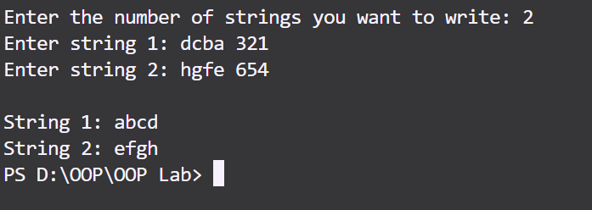Output

**Task 5**

|  |
| --- |
| #include <iostream>  #include <string>  using *namespace* std;  *int* main() {  *int* n,sum = 0;      cout<<"Enter the no of elements in array: ";      cin>>n;  *int* *\**arr = new *int*[n];      cout<<"Enter the element in the array\n";      for(*int* i=0;i<n;i++){          cout<<"Element "<<i+1<<": ";          cin>>*(arr+i);          sum+=*(arr+i);      }      cout<<"The sum of the array is: "<<sum;      delete []arr;      return 0;  } |

Output

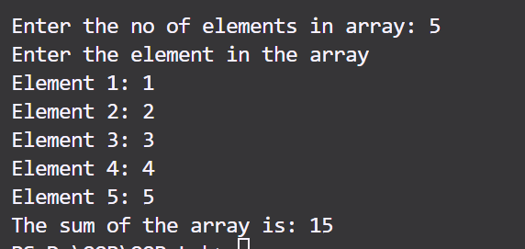

**Task 6**

|  |
| --- |
| #include <iostream>  using *namespace* std;  *struct* Student {      string name;  *int* rollNumber;  *float* marks[3];  };  *int* main() {  *int* n;      cout<<"Enter the number of students: ";      cin>>n;      Student*\** students = new Student[n];      for (*int* i=0;i<n;i++) {          cout<<"\nEnter details for student "<<i + 1<<":\n";          cout<<"Name: ";          cin.ignore();          getline(cin, students[i].name);          cout<<"Roll Number: ";          cin>>students[i].rollNumber;          cout<<"Enter marks for 3 subjects: \n";          for (*int* j = 0; j < 3; j++) {              cout<<"Subject "<<j+1<<": ";              cin>>students[i].marks[j];              }      }      cout<<"\nStudent Records:\n";      for (*int* i=0;i<n;i++) {  *float* sum = 0;          for (*int* j = 0; j < 3; j++) sum += students[i].marks[j];          cout<<"\nStudent "<<i + 1<<":\n";          cout<<"Name: "<<students[i].name<<"\n";          cout<<"Roll Number: "<<students[i].rollNumber<<"\n";          cout<<"Average Marks: "<<sum / 3<<"\n";      }      delete[] students;      return 0;  } |

Output

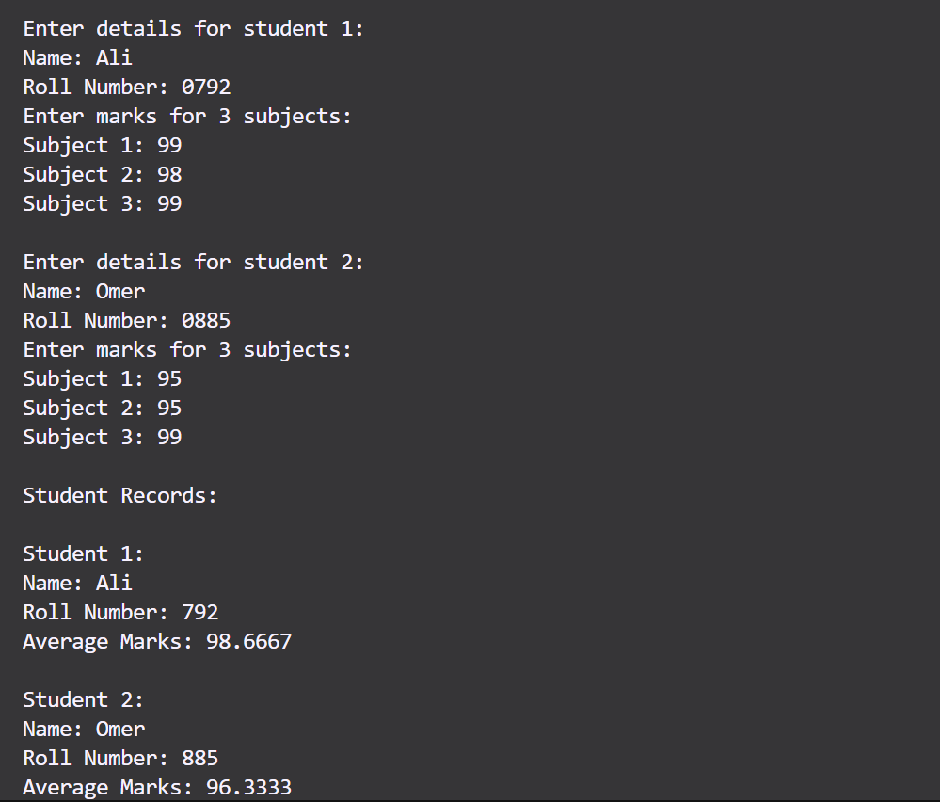

**Task 7**

|  |
| --- |
| #include <iostream>  using *namespace* std;  *void* multiplyMatrices(*int\*\** *mat1*, *int\*\** *mat2*, *int\*\** *result*, *int* *r1*, *int* *c1*, *int* *r2*, *int* *c2*) {      for(*int* i=0;i<r1;++i) {          for(*int* j=0;j<c2;++j) {              result[i][j]=0;              for(*int* k=0;k<c1;++k) {                  result[i][j]+=mat1[i][k]*mat2[k][j];              }          }      }  }  *int* main() {  *int* r1,c1,r2,c2;      cout<<"Enter rows and columns for first matrix \n";      cout<<"Enter Rows: ";      cin>>r1;      cout<<"Enter Columns: ";      cin>>c1;      cout<<"Enter rows and columns for second matrix \n";      cout<<"Enter Rows: ";      cin>>r2;      cout<<"Enter Columns: ";      cin>>c2;      if(c1!=r2) {          cout<<"Matrix multiplication not possible."<<endl;          return 1;      }  *int\*\** mat1=new *int*\*[r1];      for(*int* i=0;i<r1;++i) {          mat1[i]=new *int*[c1];      }  *int\*\** mat2=new *int*\*[r2];      for(*int* i=0;i<r2;++i) {          mat2[i]=new *int*[c2];      }  *int\*\** result=new *int*\*[r1];      for(*int* i=0;i<r1;++i) {          result[i]=new *int*[c2];      }      cout<<"Enter elements of first matrix:"<<endl;      for(*int* i=0;i<r1;++i) {          for(*int* j=0;j<c1;++j) {              cin>>mat1[i][j];          }      }      cout<<"Enter elements of second matrix:"<<endl;      for(*int* i=0;i<r2;++i) {          for(*int* j=0;j<c2;++j) {              cin>>mat2[i][j];          }      }      multiplyMatrices(mat1,mat2,result,r1,c1,r2,c2);      cout<<"Resultant matrix:"<<endl;      for(*int* i=0;i<r1;++i) {          for(*int* j=0;j<c2;++j) {              cout<<result[i][j]<<" ";          }          cout<<endl;      }      for(*int* i=0;i<r1;++i) {          delete[] mat1[i];      }      delete[] mat1;      for(*int* i=0;i<r2;++i) {          delete[] mat2[i];      }      delete[] mat2;      for(*int* i=0;i<r1;++i) {          delete[] result[i];      }      delete[] result;      return 0;  } |

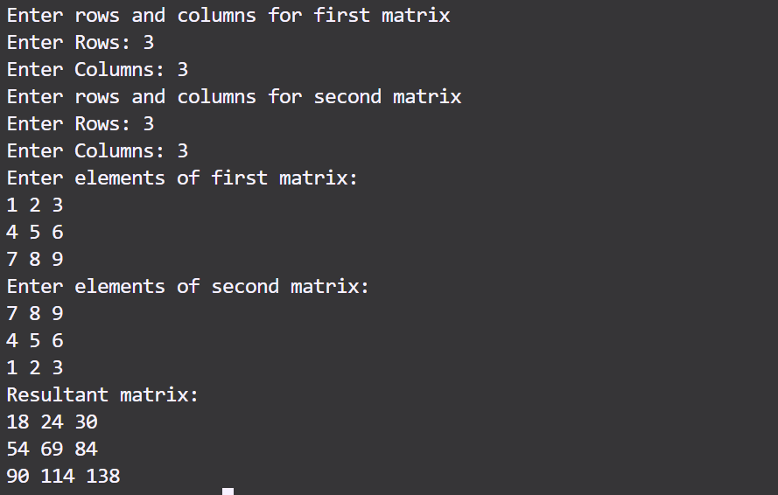Output

**Task 8**

|  |
| --- |
| #include <iostream>  using *namespace* std;  *int* main() {  *int* n;      cout<<"Enter size of array: ";      cin>>n;  *int\*\** arr=new *int*\*[n];      for(*int* i=0;i<n;i++) {          arr[i]=new *int*;          cout<<"Enter element "<<i+1<<": ";          cin>>*arr[i];      }      cout<<"\nArray elements: ";      for(*int* i=0;i<n;i++) {          cout<<*arr[i]<<" ";      }      cout<<endl;      for(*int* i=0;i<n;i++) {          delete arr[i];      }      delete[] arr;      return 0;  } |

Output

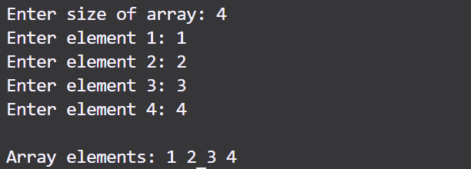

**Task 9**

|  |
| --- |
| #include <iostream>  using *namespace* std;  *struct* Product {  *int* productID;      string name;  *int* quantity;  *double* price;  };  *double* calculateTotalValue(Product*\** *products*, *int* *n*) {  *double* totalValue = 0;      for (*int* i = 0; i < n; i++) {      totalValue += products[i].quantity * products[i].price;      }      return totalValue;  }  *int* main() {  *int* n;      cout<<"Enter the number of products: "; cin>>n;      Product*\** products = new Product[n];      for (*int* i = 0; i < n; i++) {          cout<<"\nEnter details for Product "<<i+1<<":\n";          cout<<"Product ID: ";          cin>>products[i].productID;          cin.ignore();          cout<<"Name: ";          getline(cin, products[i].name);          cout<<"Quantity: ";          cin>>products[i].quantity;          cout<<"Price: ";          cin>>products[i].price;      }      cout<<"\nTotal Inventory Value: $"<<calculateTotalValue(products, n)<<endl;      delete[] products;      return 0;  } |

Output

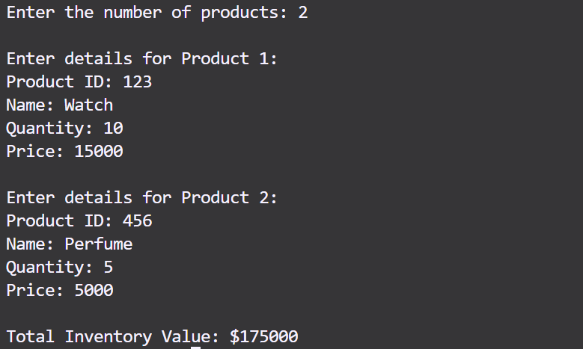

**Task 10**

|  |
| --- |
| #include <iostream>  using *namespace* std;  *int* main() {  *int* x, y, z;      cout<<"Enter the dimensions of the 3D array (x, y, z): ";      cin>>x>>y>>z;      cin.ignore();  *int\*\*\** array = new *int*\*\*[x];      for (*int* i=0;i<x;i++) {          array[i] = new *int*\*[y];          for (*int* j=0;j<y;j++) {              array[i][j] = new *int*[z];          }      }      cout<<"Enter elements of the 3D array:"<<endl;      for (*int* i=0;i<x;i++) {          for (*int* j=0;j<y;j++) {              for (*int* k=0;k<z;k++) {                  cout<<"Element at ("<<i<<", "<<j<<", "<<k<<"): ";                  cin>>array[i][j][k];                  cin.ignore();              }          }      }      cout<<"\nThe 3D array is:"<<endl;      for (*int* i=0;i<x;i++) {          cout<<"Layer "<<i+1<<":"<<endl;          for (*int* j=0;j<y;j++) {              for (*int* k=0;k<z;k++) {                  cout<<array[i][j][k]<<" ";              }              cout<<endl;          }          cout<<endl;      }      for (*int* i = 0; i < x; i++) {          for (*int* j = 0; j < y; j++) {              delete[] array[i][j];          }          delete[] array[i];      }      delete[] array;      return 0;  } |

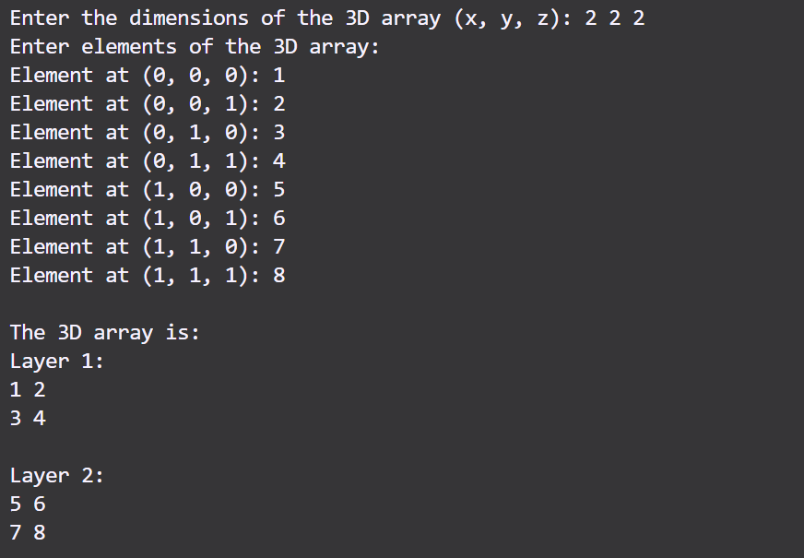Output