First of all, to understand the actual meaning of both Relative and Absolute Positioning we need to understand the Position terminology.

The position property specifies the type of positioning method used for an element. We currently have 5 types of positioning values:

1. Static
2. Relative
3. Fixed
4. Absolute
5. Sticky

An element with position: relative; is positioned relative to its normal position.

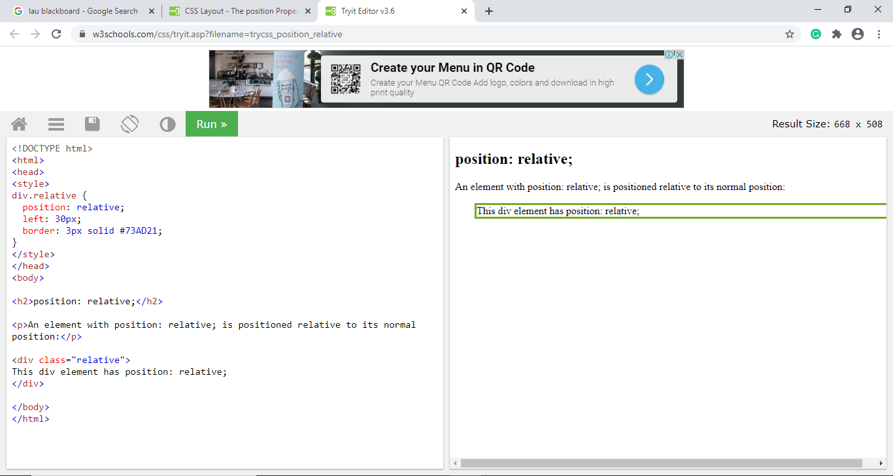

An element with position: absolute; is positioned relative to the nearest positioned ancestor (instead of positioned relative to the viewport.

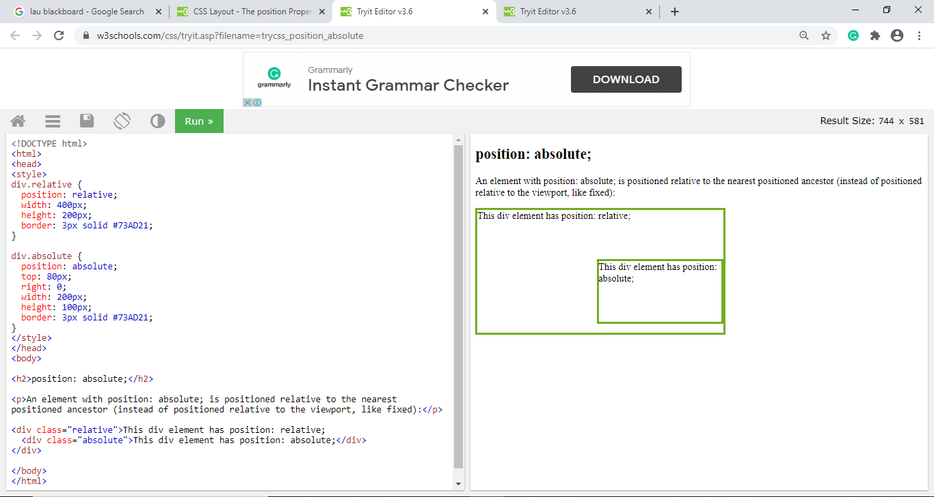

The difference between Padding and Margin is that margin is the space around an element and padding refers to the space between an element and the content inside it.

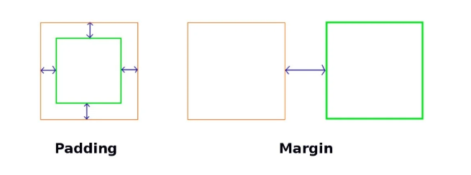

The margin falls outside two adjacent elements. Each side of the element has a margin size you can change individually. In creating the gap, the margin pushes adjacent elements away.

On the other hand, padding is placed inside the border of an element. To create the gap, the padding either grows the element’s size or shrinks the content inside. By default, the size of the element increases.

Margin and padding are always parts of an element, even if there’s no visible border.

As I understood it that each element has a specific border to it, the distance between the content and the inner border is the padding and the distance between the page displayed and the outer border of the element is the margin.

