**Linux**

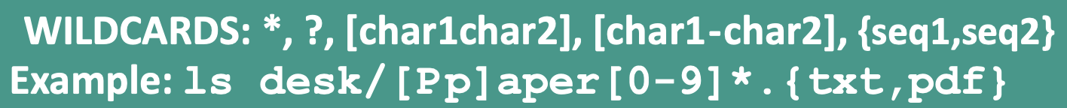

chown user:group path/to/file_or_directory

chown -R user path/to/directory

chgrp group path/to/file_or_directory

chgrp -R group path/to/directory

my_files=(/path/to/files/*.csv)

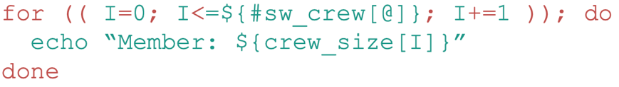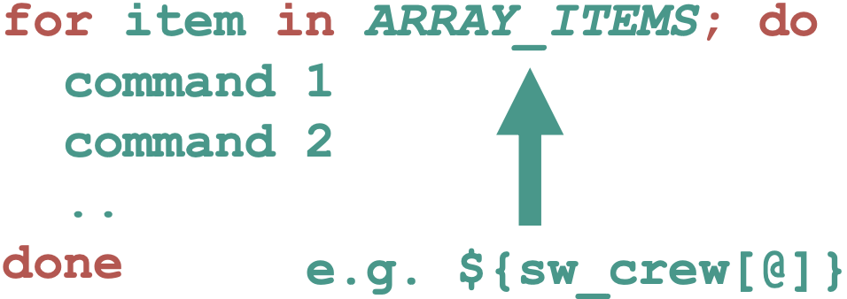

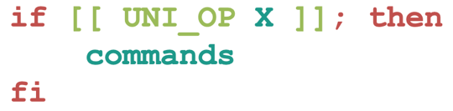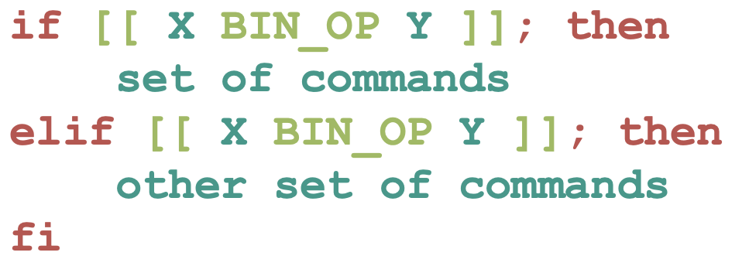

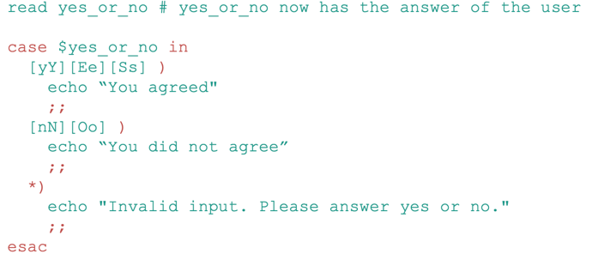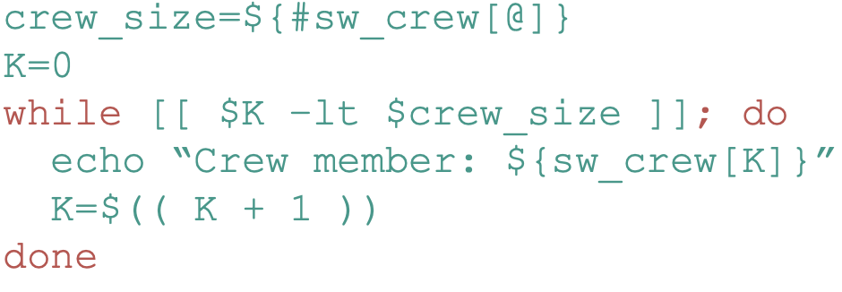

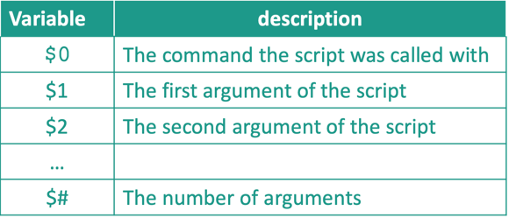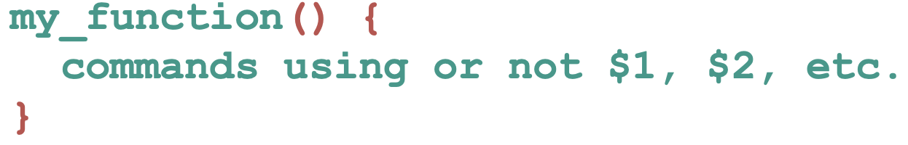

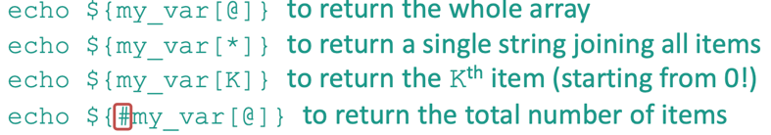

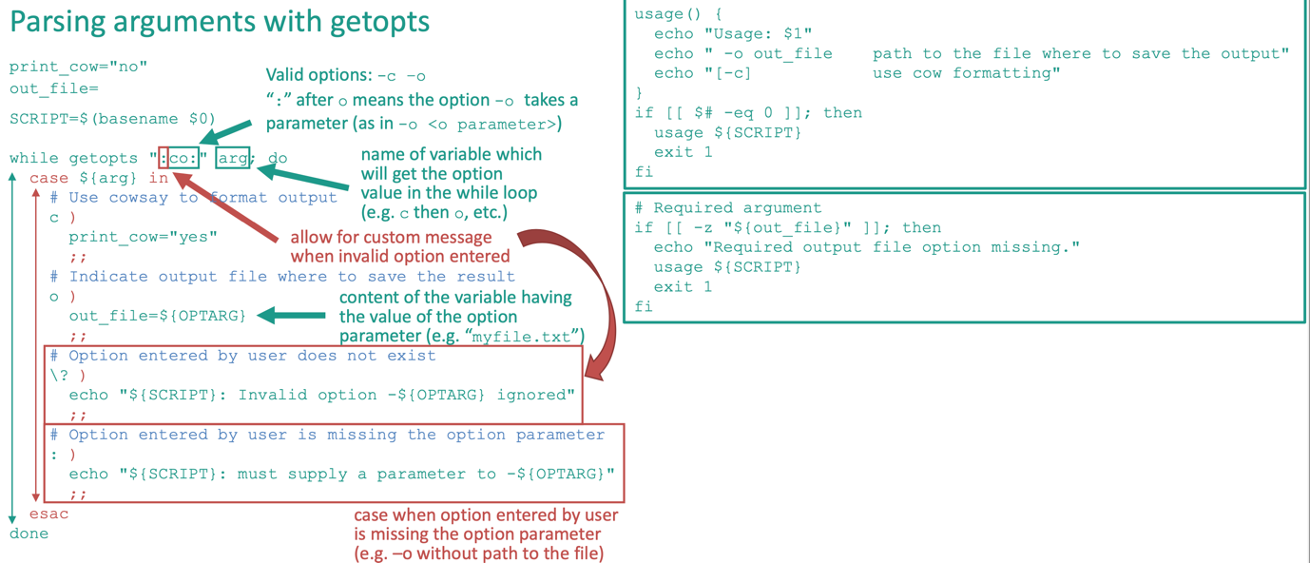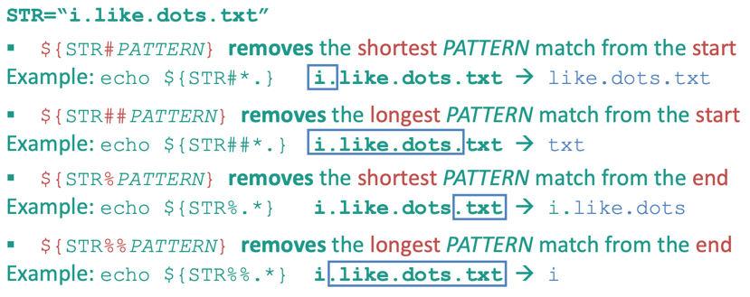

IP + Port = Socket (52.212.137.39:8080)

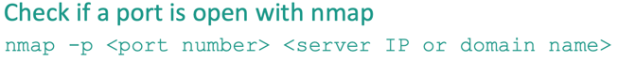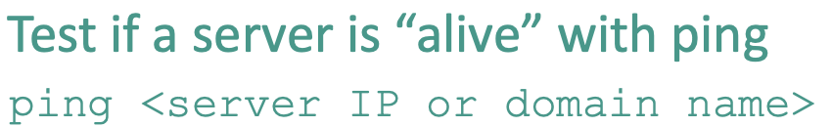

ssh-keygen -t rsa -b 4096

ssh-copy-id username@remote_host

**Git**

* man git-command (e.g. man git-commit)
* git init
* git add .
* git commit -m “message”
* commit includes checksum, previous checksum, message, author, and date
* git status
* git log (--oneline OR –summary)
* git show
* git diff OldCommit NewCommit
* git difftool OldCommit NewCommit
* gitk
* git config --global user.name “NAME”
* git config --global user.email “email”

*Branches*

* git branch topic
* git checkout topic
* git branch topic <COMMIT-id> 🡪 creates the topic branch at COMMIT-id
* branch is a pointer to a commit
* HEAD is a pointer to the active branch
* git branch -v 🡪 lists all the branches
* git branch -d topic 🡪 deletes the branch
* git branch -M main 🡪 renames the branch

*Remote*

* git remote add origin [git@github.com:<user>/<repo>.git](mailto:git@github.com:%3cuser%3e/%3crepo%3e.git)
* git clone
* git push -u origin main
* git pull origin main (same as: git fetch origin main + git merge origin/main)
* git branch -avv (shows all local and remote branches)
* git branch -u origin/main (restores the remote tracking in the now github repo)

*Merge*

* If main branch is paused:
  + git checkout main
  + git merge topic (we can use --no-ff here to keep the history)
* If 3 way:
  + git checkout topic
  + git rebase main
  + git checkout main
  + git merge topic --no-ff
* If 3 way:
* git checkout main
* git cherry-pick <commit-id> (or <commit-id1>~..<commit-id2>)
* first commit-id is ignored.
* ~ means one before

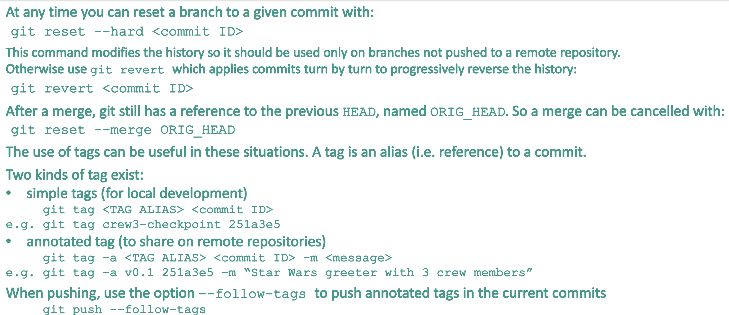

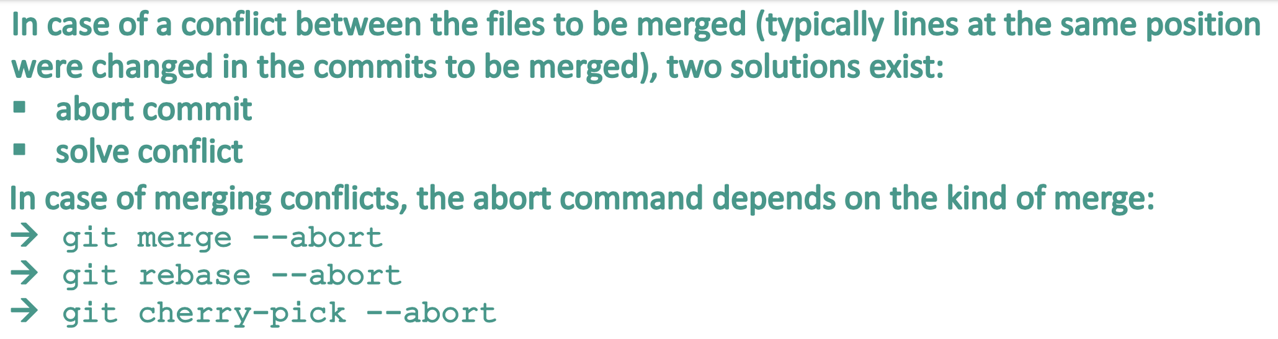

If we want to solve the conflict, we can use “git mergetool”

**Python**

def comment_grade(grade: int, mode: str = 'normal') -> str :

“””

Provide a feedback according to the grade value

Parameters

----------

grade

The grade obtained by the student (out of 10)

mode

The feedback mode, either "normal" (default) or "positive_reinforcement"

Returns

-------

comment

The grade feedback

Examples

-------------

>>> comment_grade(6)

‘Grade high enough’

“””

If1 grade >= 0 and grade < 5:

return('Grade too low')

elif1 grade > 5 and grade <= 10:

if2 mode == 'normal':

return('Grade high enough')

elif2 mode == 'positive_reinforcement':

return('Well done, keep going!')

else2:

raise ValueError('The mode should be "normal" or "positive_reinforcement"')

else1:

assert (grade < 0 or grade > 10), 'INTERNAL BUG: grade is not less than 0 or greater than 10'

raise ValueError('EXTERNAL ERROR: The grade entered should be between 0 and 10')

* os.getcwd()
* sys.path
* os.__file__
* if __name__==”__main__”: (if executed from *command line*)
* import importlib; importlib.reload(numpy)
* def test_grade():

assert comment_grade(0, “normal”) == ”Grade too low”

* pytest --doctest-modules file.py
* class Student:

def __init__(self, first_name, last_name, grade=None):

self.first_name=first_name

self.last_name=last_name

self.grade=grade

def get_name():

return self.first_name + “ “ + self.last_name

* docstring for the class has Attributes and Methods
* student1 = Student(Ali, Saadat, 20)
* 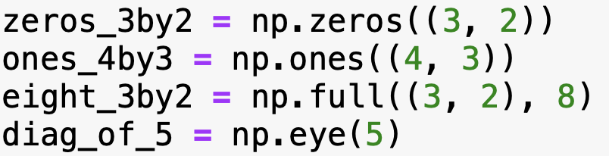
* Reading files:
  + home_path=os.path.expanduser(‘~’)
  + file_path=os.path.join(home_path, “Documents”, “data”, “file.csv”)
  + with open(file_path, ‘r’) as file_handler:

file_content=file_handler.read()

* all_files=sort(glob.glob(“~/data/*.csv”))
* patient_files=[f for f in all_files if not “small” in f]
* np.loadtext(fname=”/path/to/file”, delimeter=’,’)
* 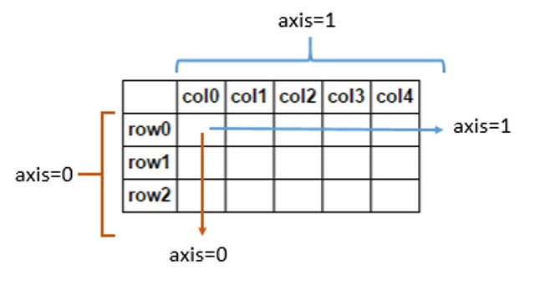
* df = pd.readcsv(“/path/to/file”)
  + df.describe()
  + df.head(5)
  + df.shape
  + df.dtypes
  + df.isna().sum()
  + df[ df[‘year]>=2000 ]
  + df.dropna()
  + df[‘country’].value_counts()
  + top10 = list(df[‘country’].value_counts().nlargest(10).index)

top10_mask=df[‘country’].isin(top10)

df[top10_mask]

* + df[‘country’].value_counts().nlargest(10).plot(kind=’bar’)
* sns
  + sns.boxplot(df[‘year’])
  + sns.histplot(df[‘year’])
  + sns.kdeplot(df[‘year’], df[‘price’])
  + sns.scatterplot(x=’year’, y=’price’, data=df)
  + sns.countplot(y=’country’, data=df)
  + sns.violinplot(x=”price”, y=”country”, data=df)
  + with sns.plotting_context("notebook", font_scale=1.2):

g = sns.catplot(x="model", y="val", hue="stage", col="scorer",

data=train_test_results_df, kind="bar", sharey=False)

**ML**

Train_test_split

* from sklearn.model_selection import train_test_split

X_train, X_test, y_train, y_test = train_test_split(X, y, test_size=0.4, random_state=42)

LinearRegression, MSE, R2

* from sklearn.linear_model import LinearRegression

from sklearn.metrics import mean_squared_error, r2_score

lm = LinearRegression()

lm.fit(X_train, y_train)

y_pred = lm.predict(X_train)

R2_train = r2_score(y_train, y_pred)

MSE_train = mean_squared_error(y_train, y_pred)

Pipeline

* from sklearn.preprocessing import PolynomialFeatures

from sklearn.pipeline import Pipeline

lm_deg5 = Pipeline([('poly_transformer', PolynomialFeatures(degree=5)),

('lm', LinearRegression())])

lm_deg5.fit(X_train, y_train)

lm_deg5['lm'].coef_

y_pred = lm_deg5.predict(X_train)

CrossValidation

* from sklearn.model_selection import KFold

ml_models = {'lm': LinearRegression(),

'lm_deg2': Pipeline([('poly_transformer', PolynomialFeatures(degree=2)),

('lm', LinearRegression())]),

'lm_deg5': Pipeline([('poly_transformer', PolynomialFeatures(degree=5)),

('lm', LinearRegression())])}

kf_results = []

kfs = KFold(n_splits=10, shuffle=True, random_state=42)

for i_f, (ix_train, ix_test) in enumerate(kfs.split(X_train)):

# Loop over models

for mod_name, mod in ml_models.items():

# Define training and testing folds

X_training_folds = X_train.iloc[ix_train]

y_training_folds = y_train.iloc[ix_train]

X_test_fold = X_train.iloc[ix_test]

y_test_fold = y_train.iloc[ix_test]

# Fit the model on the training folds

mod.fit(X_training_folds, y_training_folds)

# Test on both the training and testing folds to check for over-/under-fitting

y_pred_train = mod.predict(X_training_folds)

y_pred_test = mod.predict(X_test_fold)

# R2

kf_results.append({'model': mod_name, 'fold': i_f, 'stage': 'train', 'scorer': 'r2',

CrossValidation automated

* from sklearn.model_selection import cross_val_score

from sklearn.metrics import fbeta_score, make_scorer

mse_scorer = make_scorer(mean_squared_error, greater_is_better=False)

cv_test_scores = {}

for mod_name in ml_models.keys():

cv_test_scores[mod_name] = cross_val_score(ml_models[mod_name], X_train, y_train,

cv=kfs, scoring=mse_scorer, n_jobs=-1)

cv_test_scores_df = pd.DataFrame(cv_test_scores)

CrossValidation aturomated2

* from sklearn.model_selection import cross_validate

cv_scores = {}

for mod_name in ml_models.keys():

cv_scores[mod_name] = cross_validate(ml_models[mod_name], X_train, y_train, cv=kfs,

scoring=['r2', 'neg_mean_squared_error'],

return_train_score=True, n_jobs=-1)

def crossval_to_df(cv_dict):

crossval_results = []

for model in cv_dict.keys():

for scorer in cv_dict[model].keys():

if scorer.startswith('train_'):

score = scorer.replace('train_', '')

for i_val, val in enumerate(cv_dict[model][scorer]):

crossval_results.append({'model': model, 'fold': i_val, 'stage': 'train',

'scorer': score, 'val': val})

elif scorer.startswith('test_'):

score = scorer.replace('test_', '')

for i_val, val in enumerate(cv_dict[model][scorer]):

crossval_results.append({'model': model, 'fold': i_val, 'stage': 'test',

'scorer': score, 'val': val})

return pd.DataFrame(crossval_results)

crossval_df = crossval_to_df(cv_scores)

Transform Label and Features

* from sklearn.preprocessing import LabelEncoder, OrdinalEncoder, OneHotEncoder, StandardScaler

from sklearn.compose import make_column_transformer

y_num = LabelEncoder().fit_transform(y_cat)

cols_ordinal = ["smoking_status"]

cols_non_ordinal = ["gender", "ever_married", "work_type", "Residence_type"]

cols_continuous = ["age", "avg_glucose_level", "bmi"]

preprocessor = make_column_transformer(

(OrdinalEncoder(categories=[['never smoked', 'formerly smoked', 'smokes']]), cols_ordinal),

(OneHotEncoder(drop='if_binary', sparse=False), cols_non_ordinal),

(StandardScaler(), cols_continuous),

remainder='passthrough',

verbose_feature_names_out=False

)

X_final = pd.DataFrame(data=preprocessor.fit_transform(X),

columns=preprocessor.get_feature_names_out())

Logistic Regression

* from sklearn.linear_model import LogisticRegression

lr = LogisticRegression(penalty='none', class_weight='balanced', max_iter=1000)

lr.fit(X_train, y_train)

Confusion Matrix

* from sklearn.metrics import accuracy_score, confusion_matrix, ConfusionMatrixDisplay

y_pred_train = lr.predict(X_train)

accuracy_score(y_train, y_pred_train)

confusion_matrix(y_train, y_pred_train)

ConfusionMatrixDisplay.from_estimator(lr, X_train, y_train, display_labels=label_encoder.classes_,

normalize='true')

lr_coefs_df = pd.DataFrame({'coefs': np.std(X_train, 0)*lr.coef_[0]},

index=X.columns)

plt.figure(figsize=(6,6))

sns.barplot(x='coefs', y=lr_coefs_df.index, data=lr_coefs_df)

PCA

* from sklearn.datasets import load_digits

from sklearn.decomposition import PCA

digits = load_digits()

pca = PCA(n_components=2)

projected_digits = pca.fit_transform(digits.data)

pca = PCA().fit(digits.data)

plt.plot(np.cumsum(pca.explained_variance_ratio_))

Kmeans

* from sklearn.cluster import KMeans

from sklearn.preprocessing import scale

X = scale(digits.data)

y = digits.target

X_pca = PCA(n_components=2).fit_transform(X)

kmeans = KMeans(n_clusters=n_digits)

kmeans.fit(X_pca)

silhouette

* from sklearn.metrics import silhouette_samples, silhouette_score

clusterer = KMeans(n_clusters=n_clusters, random_state=10)

cluster_labels = clusterer.fit_predict(X_pca)

silhouette_avg = silhouette_score(X_pca, cluster_labels)

sample_silhouette_values = silhouette_samples(X_pca, cluster_labels)