Contents

**Task # 01** 2

**A Deep Learning Model for Classifying Forest and Mountain Images** 2

**I. Abstract:** 2

**II. Introduction:** 2

**III. Literature Review:** 3

**IV. Problem Statement:** 3

**V. Data:** 4

**VI. Methods:** 4

**VII. Result Evaluation:** 5

**VIII. Conclusion:** 6

**References:** 7

# 

# **Task # 01**

# **A Deep Learning Model for Classifying Forest and Mountain Images**

**Ali Asad Usman**

**I. Abstract:**

This project explores the application of deep learning methods to solve a binary image classification problem using the Intel Image Classification Dataset. The goal is to classify images into one of two categories: forests or mountains. To achieve this, the Convolutional Neural Network (CNN) is being used, a powerful tool in the field of computer vision. The dataset comprises a diverse collection of images representing various environmental settings, but for this study, only the "forest" and "mountain" classes were considered. A straightforward CNN architecture was designed, trained, and evaluated using metrics such as accuracy, precision, recall, and F1-score. The model achieved notable accuracy, demonstrating the effectiveness of CNNs in solving image classification tasks even with a simple setup. This project underscores how deep learning can simplify and enhance traditional approaches to classification problems in real-world applications.

**II. Introduction:**

Deep learning has revolutionized several domains by addressing complex challenges that were once difficult to solve with traditional methods. Fields such as computer vision, natural language processing, and speech recognition have particularly benefited from deep learning. Image classification, one of the most important tasks in computer vision, involves automatically identifying the category of objects or scenes in a given image.

Traditional image classification approaches relied heavily on manually extracting features from images, which was both time-consuming and prone to error. Deep learning, especially through Convolutional Neural Networks (CNNs), has transformed this process. CNNs automatically learn and extract hierarchical features from raw image data, significantly reducing the need for human intervention while improving accuracy and efficiency.

In this project, we focus on applying CNNs to a binary image classification task. The challenge is to classify images as either "forest" or "mountain" scenes, a task that has numerous real-world applications, such as environmental monitoring, resource management, and tourism. By leveraging CNNs, this study aim to highlight their ability to process and interpret visual data with high accuracy, even in scenarios where the dataset is limited in size or complexity.

**III. Literature Review:**

Over the years, significant advancements in deep learning have paved the way for state-of-the-art performance in image classification tasks. One of the earliest milestones in this field was the development of AlexNet by (Krizhevsky et al., 2012). This deep learning model was revolutionary, outperforming traditional computer vision techniques by a large margin. AlexNet introduced the concept of using deep convolutional layers to capture intricate patterns in images and employed dropout layers to mitigate overfitting, making it highly effective for classification tasks.

Building on this foundation, (Simonyan and Zisserman, 2014) introduced VGGNet. VGGNet demonstrated the power of deeper architectures, where increasing the number of layers allowed the network to learn finer details and features from images. The success of VGGNet and AlexNet inspired the development of more sophisticated architectures, such as ResNet and Inception, which further advanced the field.

For this project, however, we adopted a simpler CNN architecture due to the relatively small size and limited scope of the dataset. While less complex than models like AlexNet or VGGNet, our approach effectively distinguished between "forest" and "mountain" images. This supports findings from previous research that even lightweight models can achieve high accuracy with proper preprocessing and data augmentation. Data augmentation, in particular, played a crucial role in diversifying the training dataset and improving the model's ability to generalize to unseen images.

## **IV. Problem Statement:**

The primary aim of this project is to develop a deep learning model capable of accurately classifying images into one of two categories: forests or mountains. This classification task is not only a technical challenge but also has significant practical applications. For example: Geographic Surveys: Automating the process of identifying landscapes can save time and resources. Environmental Monitoring: Understanding the distribution of forests and mountains can aid in conservation and planning efforts. Tourism: Classifying landscapes can help promote destinations based on their natural beauty. Resource Management: Identifying specific landscapes can assist in better management of natural resources. Given these applications, solving this binary classification problem contributes to advancing tools and technologies that can automate and enhance decision-making processes in various fields.

**V. Data:**

The dataset used in this project is the **Intel Image Classification Dataset**. It contains thousands of images categorized into six classes: buildings, forest, glacier, mountain, sea, and street. For this study, we focused exclusively on the "forest" and "mountain" categories, transforming the task into a binary classification problem. The dataset is already pre-split into training and testing sets, which simplifies the implementation process.

To prepare the data for analysis, the following preprocessing steps were undertaken:

***Resizing:*** All images were resized to a uniform size of 128x128 pixels. This resizing ensures that the model receives consistent input dimensions, which is crucial for efficient training and testing. Additionally, resizing reduces computational requirements by standardizing the image size.

***Normalization:*** The pixel values of the images were scaled to fall within the range [0, 1] by dividing each pixel value by 255. Normalization ensures that the input data has a uniform scale, which helps the model converge faster during training.

***Data Augmentation:*** To improve the model's ability to generalize, we applied various data augmentation techniques, including: Random rotations to simulate different perspectives. Zooming to highlight smaller regions of the image. Horizontal flipping to create mirrored versions of the original images.

These techniques artificially expanded the training dataset, enhancing its diversity and helping the model learn more robust features.

**VI. Methods:**

To solve the binary classification problem, we designed a CNN architecture tailored to the dataset's characteristics. The methodology consisted of the following steps:

***Data Preprocessing:*** The dataset was filtered to include only the "forest" and "mountain" categories. Preprocessed images underwent resizing, normalization, and data augmentation to ensure consistency and improve generalization.

***Model Architecture:*** The CNN was designed with the following components:

* ***Convolutional Layers:*** Two convolutional layers were used to extract spatial features from the images.
* ***Max-Pooling Layers:*** These layers reduced the spatial dimensions of feature maps, helping the model focus on the most relevant features.
* ***Fully Connected Layers:*** After flattening the feature maps, fully connected layers were added to integrate the features and make predictions.
* ***Dropout Layers:*** Dropout was used to randomly deactivate neurons during training, reducing the risk of overfitting.
* ***Output Layer:*** The output layer consisted of a single unit with a sigmoid activation function, suitable for binary classification tasks.

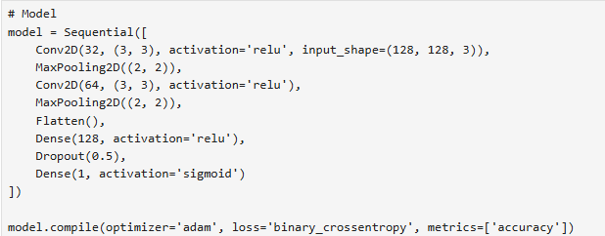

Figure : Model Architecture

***Training:*** The model was trained using the Adam optimizer and binary cross-entropy loss function. Early stopping was employed to halt training when the validation loss stopped improving, preventing overfitting and ensuring the best possible model performance.

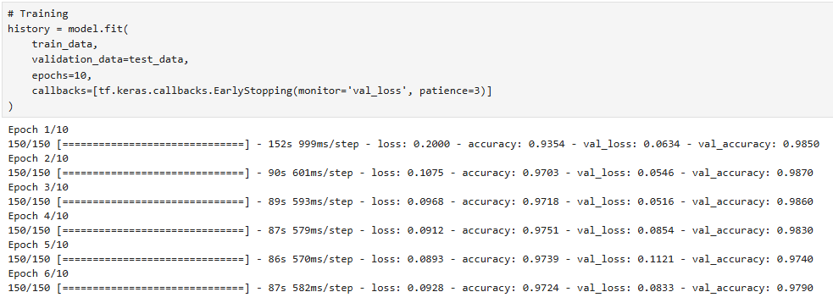

Figure : Model Training

***Evaluation:*** The model's performance was assessed on the test dataset using metrics such as accuracy, precision, recall, and F1-score. Additionally, a confusion matrix was analyzed to understand the classification errors and gain deeper insights into the model's behavior as shown in Figure 1.

## **VII. Result Evaluation:**

*Overfitting and Mitigation Strategies:* Overfitting, where the model performs well on training data but poorly on unseen data, was addressed using the following strategies:

*Data Augmentation:* Diversifying the training data reduced the risk of memorizing specific features.

*Dropout Layers:* These layers randomly deactivated neurons during training, encouraging the model to learn generalized patterns.

*Early Stopping:* Training was stopped when validation loss stopped improving, ensuring that the model did not over-fit to the training data.

The model achieved the following results: for the forest landscape the accuracy: ~97%, precision: ~97%, recall: ~99%, F1-Score: ~98% while for the mountains the accuracy is ~98%, precision is ~99%, recall is for 97%, F1-score is ~98% as shown in Figure 3.

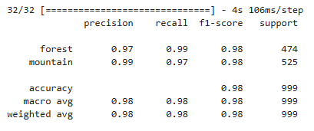

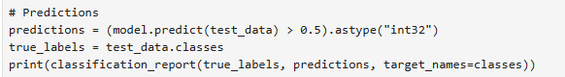

Figure : Performance Evaluation Matrix

These metrics indicate a balanced performance, with the model correctly identifying a high percentage of both classes. The confusion matrix showed minimal misclassifications, reflecting the model's strong generalization ability as shown in Figure 4.

*Comparison with Pre-Trained Models:*

While we considered pre-trained models like MobileNetV2, which are trained on large-scale datasets, our custom CNN performed adequately for the task. For future improvements, integrating transfer learning with a pre-trained model could further enhance accuracy, especially on smaller datasets.

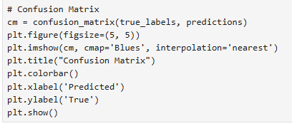

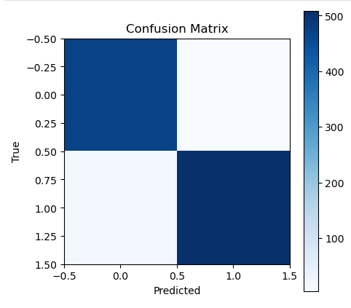

Figure : Confusion Matrix

**VIII. Conclusion:**

This project successfully demonstrated the potential of deep learning for binary image classification. By employing a CNN, we achieved high accuracy in distinguishing between forest and mountain images. Techniques like data augmentation, dropout, and early stopping were instrumental in improving the model's performance and preventing overfitting.

In future work, more complex architectures or pre-trained models could be explored to further enhance accuracy. Additionally, expanding the classification task to include other environmental categories could lead to the development of a comprehensive natural landscape classification system, benefiting various industries.

## **References:**

Krizhevsky, A., Sutskever, I., & Hinton, G. E. (2012). ImageNet classification with deep convolutional neural networks. Advances in Neural Information Processing Systems, 25, 1097–1105. https://doi.org/10.1145/3065386

Simonyan, K., & Zisserman, A. (2015). Very deep convolutional networks for large-scale image recognition. Proceedings of the International Conference on Learning Representations (ICLR). <https://arxiv.org/abs/1409.1556>.