Impella RP in High-Risk Pulmonary Embolism With Cardiogenic Shock
  - National Inpatient Sample (NIS), 2017–2022
Ali Salman

Study overview
This report reproduces the primary, survey-weighted analysis of Impella RP use among adults hospitalized with high-risk pulmonary embolism (PE) and cardiogenic shock in the National Inpatient Sample (NIS), 2017–2022. The primary analytic approach uses propensity score inverse probability of treatment weighting (IPTW) to address measured confounding while retaining the NIS complex survey design.

Data source and study period
We used the Healthcare Cost and Utilization Project (HCUP) National Inpatient Sample (NIS), 2017–2022, a stratified, nationally representative sample of U.S. hospital discharges. All analyses accounted for the NIS complex survey design (hospital clustering, stratification, and discharge weights).

Study population
We included discharges meeting all of the following: - Age ≥ 18 years - Pulmonary embolism present (ICD-10-CM diagnosis codes: I26.01, I26.02, I26.04, I26.09, I26.90, I26.92, I26.93, I26.94, I26.96, I26.99) - Cardiogenic shock present (ICD-10-CM: R57.0)

Exposure
Impella RP use was defined by ICD-10-PCS procedure codes 02HA3RZ or 5A0221D during the index hospitalization.

Covariates
Covariates were prespecified based on clinical relevance and availability in NIS: - Demographics: age, sex, race (collapsed category), primary payer (collapsed category), ZIP-code income quartile - Hospital factors: region, bed size, location/teaching status - Transfer status: transfer-in, transfer-out - Clinical factors: right ventricular failure, left ventricular failure, Charlson comorbidity index, and year of admission
Race and payer were collapsed for analytic stability (Native American → “Other”; Self-pay and No charge → “Other”).

Outcomes
Prespecified in-hospital outcomes were: - In-hospital mortality - Major bleeding and/or transfusion (intracranial hemorrhage diagnosis codes I60–I62 and/or blood product transfusion procedures; see Appendix) - Acute kidney injury (ICD-10-CM: N17.) - Length of stay (LOS), days - Inflation-adjusted total cost, in 2022 U.S. dollars, computed from total charges using the HCUP cost-to-charge ratio and adjusted using annual Consumer Price Index ratios

Statistical analysis
We report survey-weighted descriptive statistics and compare groups by Impella RP status.

Primary approach: propensity score IPTW
Primary associations were estimated using propensity score IPTW to create a weighted pseudo-population in which measured baseline covariates were balanced between treatment groups. IPTW weights were estimated for the average treatment effect on the treated (ATT). Conceptually, the ATT answers:
Among hospitalizations that received Impella RP, what would outcomes have been if they had not received Impella RP?
To preserve national representativeness and account for the NIS complex survey design, we combined weights as:
Final analysis weight = (NIS discharge weight) × (IPTW)
We assessed covariate balance using standardized mean differences (SMDs) before and after weighting and visualized balance with a Love plot.

Outcome models (IPTW-weighted)
Outcome models were fit using the IPTW-weighted survey design: - Binary outcomes: survey-weighted generalized linear models with quasibinomial family; reported as odds ratios (OR) with 95% confidence intervals (CI) - LOS and total cost: survey-weighted Gaussian models of log(1 + outcome); exponentiated coefficients are reported as ratios (exp[β]) with 95% CI

Baseline characteristics
Characteristic | Overall N = 53,355¹ | No N = 51,965¹ | Yes N = 1,390¹ | p-value²
Age, y | 63 (16) | 63 (16) | 60 (15) | 0.007
Sex |  |  |  | <0.001
Female | 24,050 (45%) | 23,555 (45%) | 495 (36%)
Male | 29,305 (55%) | 28,410 (55%) | 895 (64%)
Race |  |  |  | 0.005
Asian or Pacific Islander | 1,090 (2.1%) | 1,060 (2.1%) | 30 (2.3%)
Black | 11,385 (22%) | 11,170 (22%) | 215 (16%)
Hispanic | 4,270 (8.3%) | 4,220 (8.4%) | 50 (3.8%)
Other | 1,985 (3.9%) | 1,920 (3.8%) | 65 (5.0%)
White | 32,665 (64%) | 31,715 (63%) | 950 (73%)
Insurance payer |  |  |  | <0.001
Medicaid | 9,200 (17%) | 9,035 (17%) | 165 (12%)
Medicare | 27,455 (52%) | 26,830 (52%) | 625 (45%)
Other | 3,885 (7.3%) | 3,770 (7.3%) | 115 (8.3%)
Private | 12,730 (24%) | 12,245 (24%) | 485 (35%)
Income quartile |  |  |  | 0.8
Q1 | 16,205 (31%) | 15,815 (31%) | 390 (28%)
Q2 | 13,850 (27%) | 13,475 (27%) | 375 (27%)
Q3 | 12,260 (23%) | 11,910 (23%) | 350 (25%)
Q4 | 9,895 (19%) | 9,635 (19%) | 260 (19%)
Hospital region |  |  |  | 0.7
Midwest | 12,345 (23%) | 12,050 (23%) | 295 (21%)
Northeast | 8,635 (16%) | 8,420 (16%) | 215 (15%)
South | 20,280 (38%) | 19,710 (38%) | 570 (41%)
West | 12,095 (23%) | 11,785 (23%) | 310 (22%)
Hospital bedsize |  |  |  | 0.3
Large | 33,640 (63%) | 32,710 (63%) | 930 (67%)
Medium | 12,715 (24%) | 12,395 (24%) | 320 (23%)
Small | 7,000 (13%) | 6,860 (13%) | 140 (10%)
Hospital location/teaching status |  |  |  | 0.3
Rural | 1,985 (3.7%) | 1,940 (3.7%) | 45 (3.2%)
Urban, non-teaching | 6,500 (12%) | 6,370 (12%) | 130 (9.4%)
Urban, teaching | 44,870 (84%) | 43,655 (84%) | 1,215 (87%)
No. of comorbidities |  |  |  | 0.071
No comorbidities | 4,500 (8.4%) | 4,430 (8.5%) | 70 (5.0%)
One comorbidity | 10,520 (20%) | 10,270 (20%) | 250 (18%)
Two or more comorbidities | 38,335 (72%) | 37,265 (72%) | 1,070 (77%)
¹Mean (SD); n (%)
²Design-based KruskalWallis test; Pearson's X^2: Rao & Scott adjustment

Unadjusted outcomes
Characteristic | Overall N = 53,355¹ | No N = 51,965¹ | Yes N = 1,390¹ | p-value²
In-hospital mortality | 20,165 (38%) | 19,555 (38%) | 610 (44%) | 0.033
Length of stay (days) | 9 (4, 19) | 9 (4, 18) | 14 (4, 27) | <0.001
Inflation-adjusted total cost ($) | 45,310 (23,695, 93,410) | 44,059 (23,240, 90,785) | 122,986 (70,352, 211,158) | <0.001
Major bleeding and/or transfusion | 9,030 (17%) | 8,710 (17%) | 320 (23%) | 0.006
Acute kidney injury | 35,500 (67%) | 34,440 (66%) | 1,060 (76%) | <0.001
¹n (%); Median (Q1, Q3)
²Pearson's X^2: Rao & Scott adjustment; Design-based KruskalWallis test

Propensity score IPTW
n treated_n att_min att_p99 att_max
1 10671 278 3.230975e-08 1 1

Covariate balance diagnostics
We assessed balance using standardized mean differences (SMDs) before and after ATT weighting (target absolute SMD < 0.10).
Balance Measures
Type Diff.Un Diff.Adj M.Threshold
prop.score Distance 0.6400 0.0417 Balanced, <0.1
AGE Contin. -0.1515 0.0010 Balanced, <0.1
FEMALE_Male Binary 0.0972 0.0008 Balanced, <0.1
RACE_alt_Asian or Pacific Islander Binary 0.0017 0.0002 Balanced, <0.1
RACE_alt_Black Binary -0.0589 -0.0004 Balanced, <0.1
RACE_alt_Hispanic Binary -0.0461 0.0001 Balanced, <0.1
RACE_alt_Other Binary 0.0113 0.0011 Balanced, <0.1
RACE_alt_White Binary 0.0920 -0.0010 Balanced, <0.1
RACE_alt:<NA> Binary 0.0214 0.0010 Balanced, <0.1
PAY1_alt_Medicaid Binary -0.0554 -0.0003 Balanced, <0.1
PAY1_alt_Medicare Binary -0.0675 0.0000 Balanced, <0.1
PAY1_alt_Other Binary 0.0101 -0.0004 Balanced, <0.1
PAY1_alt_Private Binary 0.1129 0.0008 Balanced, <0.1
PAY1_alt:<NA> Binary -0.0016 -0.0000 Balanced, <0.1
ZIPINC_QRTL_Q1 Binary -0.0275 0.0006 Balanced, <0.1
ZIPINC_QRTL_Q2 Binary 0.0077 -0.0008 Balanced, <0.1
ZIPINC_QRTL_Q3 Binary 0.0203 0.0014 Balanced, <0.1
ZIPINC_QRTL_Q4 Binary -0.0004 -0.0012 Balanced, <0.1
ZIPINC_QRTL:<NA> Binary -0.0110 -0.0001 Balanced, <0.1
HOSP_REGION_Midwest Binary -0.0197 -0.0000 Balanced, <0.1
HOSP_REGION_Northeast Binary -0.0074 0.0009 Balanced, <0.1
HOSP_REGION_South Binary 0.0308 -0.0004 Balanced, <0.1
HOSP_REGION_West Binary -0.0038 -0.0005 Balanced, <0.1
HOSP_BEDSIZE_Large Binary 0.0396 -0.0002 Balanced, <0.1
HOSP_BEDSIZE_Medium Binary -0.0083 -0.0006 Balanced, <0.1
HOSP_BEDSIZE_Small Binary -0.0313 0.0008 Balanced, <0.1
HOSP_LOCTEACH_Rural Binary -0.0050 0.0001 Balanced, <0.1
HOSP_LOCTEACH_Urban, non-teaching Binary -0.0291 -0.0002 Balanced, <0.1
HOSP_LOCTEACH_Urban, teaching Binary 0.0340 0.0000 Balanced, <0.1
TRAN_IN_No transfer Binary -0.1186 -0.0013 Balanced, <0.1
TRAN_IN_Transferred from acute-care Binary 0.1317 0.0016 Balanced, <0.1
TRAN_IN_Transferred from other Binary -0.0131 -0.0003 Balanced, <0.1
TRAN_IN:<NA> Binary 0.0024 0.0003 Balanced, <0.1
TRAN_OUT_No transfer Binary -0.0051 -0.0011 Balanced, <0.1
TRAN_OUT_Transferred to acute-care Binary 0.0099 0.0003 Balanced, <0.1
TRAN_OUT_Transferred to other Binary -0.0048 0.0008 Balanced, <0.1
TRAN_OUT:<NA> Binary -0.0003 -0.0000 Balanced, <0.1
RV_Failure_Yes Binary -0.0044 -0.0013 Balanced, <0.1
LV_Failure_Yes Binary 0.2093 0.0011 Balanced, <0.1
charlindex Contin. 0.0636 0.0020 Balanced, <0.1
YEAR_2017.000 Binary -0.0282 0.0004 Balanced, <0.1
YEAR_2018.000 Binary 0.0449 0.0002 Balanced, <0.1
YEAR_2019.000 Binary 0.0130 -0.0005 Balanced, <0.1
YEAR_2020.000 Binary -0.0047 -0.0002 Balanced, <0.1
YEAR_2021.000 Binary -0.0375 -0.0003 Balanced, <0.1
YEAR_2022.000 Binary 0.0125 0.0004 Balanced, <0.1
Balance tally for mean differences
count
Balanced, <0.1 46
Not Balanced, >0.1 0
Variable with the greatest mean difference
Variable Diff.Adj M.Threshold
charlindex 0.002 Balanced, <0.1
Effective sample sizes
No Yes
Unadjusted 10393. 278
Adjusted 6486.55 278
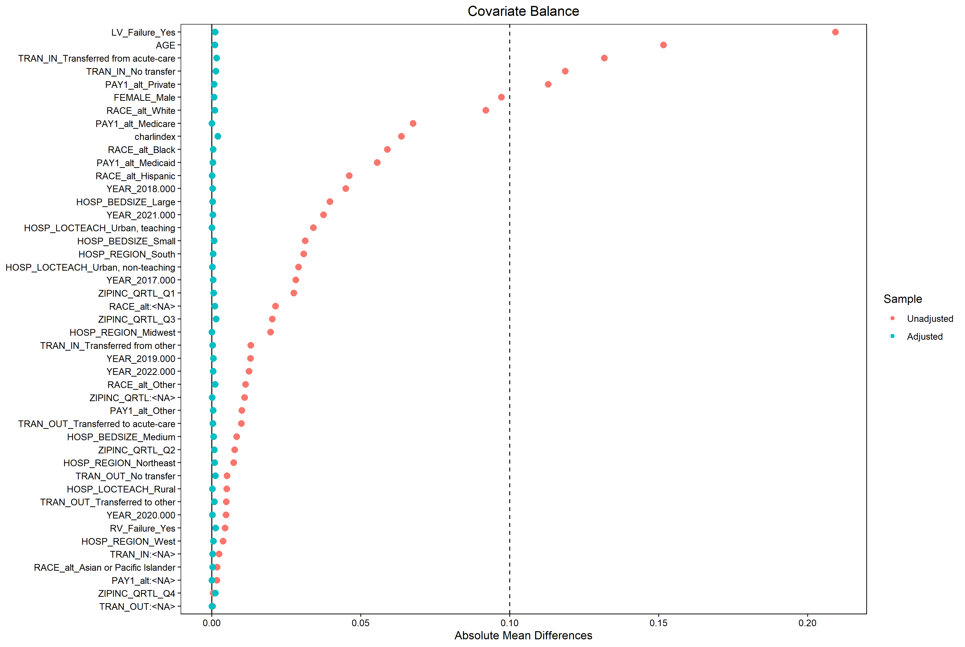

IPTW-weighted descriptive tables
Characteristic | Overall N = 2,779¹ | No N = 1,389¹ | Yes N = 1,390¹
Age, y | 60 (16) | 60 (16) | 60 (15)
Sex
Female | 991 (36%) | 496 (36%) | 495 (36%)
Male | 1,788 (64%) | 893 (64%) | 895 (64%)
Race
Asian or Pacific Islander | 60 (2.3%) | 30 (2.3%) | 30 (2.3%)
Black | 431 (16%) | 216 (16%) | 215 (16%)
Hispanic | 100 (3.8%) | 50 (3.8%) | 50 (3.8%)
Other | 129 (4.9%) | 64 (4.9%) | 65 (5.0%)
White | 1,901 (73%) | 951 (73%) | 950 (73%)
Insurance payer
Medicaid | 330 (12%) | 165 (12%) | 165 (12%)
Medicare | 1,249 (45%) | 624 (45%) | 625 (45%)
Other | 230 (8.3%) | 115 (8.3%) | 115 (8.3%)
Private | 968 (35%) | 483 (35%) | 485 (35%)
Income quartile
Q1 | 779 (28%) | 389 (28%) | 390 (28%)
Q2 | 751 (27%) | 376 (27%) | 375 (27%)
Q3 | 698 (25%) | 348 (25%) | 350 (25%)
Q4 | 521 (19%) | 261 (19%) | 260 (19%)
Hospital region
Midwest | 590 (21%) | 295 (21%) | 295 (21%)
Northeast | 428 (15%) | 213 (15%) | 215 (15%)
South | 1,140 (41%) | 570 (41%) | 570 (41%)
West | 620 (22%) | 310 (22%) | 310 (22%)
Hospital bedsize
Large | 1,859 (67%) | 929 (67%) | 930 (67%)
Medium | 640 (23%) | 320 (23%) | 320 (23%)
Small | 279 (10%) | 139 (10.0%) | 140 (10%)
Hospital location/teaching status
Rural | 90 (3.2%) | 45 (3.2%) | 45 (3.2%)
Urban, non-teaching | 260 (9.4%) | 130 (9.4%) | 130 (9.4%)
Urban, teaching | 2,429 (87%) | 1,214 (87%) | 1,215 (87%)
Transfer in
No transfer | 1,671 (61%) | 836 (61%) | 835 (61%)
Transferred from acute-care | 987 (36%) | 492 (36%) | 495 (36%)
Transferred from other | 100 (3.6%) | 50 (3.7%) | 50 (3.6%)
Transfer out
No transfer | 1,881 (68%) | 941 (68%) | 940 (68%)
Transferred to acute-care | 179 (6.5%) | 89 (6.4%) | 90 (6.5%)
Transferred to other | 718 (26%) | 358 (26%) | 360 (26%)
Right ventricular failure | 292 (10%) | 147 (11%) | 145 (10%)
Left ventricular failure | 1,827 (66%) | 912 (66%) | 915 (66%)
Charlson comorbidity index | 3.29 (2.30) | 3.28 (2.32) | 3.29 (2.28)
Year
2017.000 | 239 (8.6%) | 119 (8.6%) | 120 (8.6%)
2018.000 | 509 (18%) | 254 (18%) | 255 (18%)
2019.000 | 470 (17%) | 235 (17%) | 235 (17%)
2020.000 | 460 (17%) | 230 (17%) | 230 (17%)
2021.000 | 480 (17%) | 240 (17%) | 240 (17%)
2022.000 | 619 (22%) | 309 (22%) | 310 (22%)
¹Mean (SD); n (%)

IPTW-weighted outcome models

In-hospital mortality
Characteristic | OR | 95% CI | p-value
Impella RP
No | — | —
Yes | 1.59 | 1.25, 2.02 | <0.001
Abbreviations: CI = Confidence Interval, OR = Odds Ratio

Major bleeding and/or transfusion
Characteristic | OR | 95% CI | p-value
Impella RP
No | — | —
Yes | 1.54 | 1.15, 2.06 | 0.004
Abbreviations: CI = Confidence Interval, OR = Odds Ratio

Acute kidney injury
Characteristic | OR | 95% CI | p-value
Impella RP
No | — | —
Yes | 1.48 | 1.12, 1.96 | 0.006
Abbreviations: CI = Confidence Interval, OR = Odds Ratio

Length of stay (LOS)
Characteristic | exp(Beta) | 95% CI | p-value
Impella RP
No | — | —
Yes | 1.19 | 1.04, 1.37 | 0.014
Abbreviation: CI = Confidence Interval

Inflation-adjusted total cost
Characteristic | exp(Beta) | 95% CI | p-value
Impella RP
No | — | —
Yes | 2.56 | 2.31, 2.84 | <0.001
Abbreviation: CI = Confidence Interval

Appendix: code groupings used to define study variables
The following code groupings were used to derive study variables from discharge diagnosis and procedure fields:
- Pulmonary embolism: ICD-10-CM I26.01, I26.02, I26.04, I26.09, I26.90, I26.92, I26.93, I26.94, I26.96, I26.99
- Cardiogenic shock: ICD-10-CM R57.0
- Right ventricular failure: ICD-10-CM I50.810–I50.813 and I27.81
- Left ventricular failure: ICD-10-CM I50.1, I50.20–I50.23, I50.30–I50.33, I50.40–I50.43
- Impella RP: ICD-10-PCS 02HA3RZ or 5A0221D
- Acute kidney injury: ICD-10-CM N17.
- Major bleeding and/or transfusion: intracranial hemorrhage ICD-10-CM I60–I62 and/or blood product transfusion ICD-10-PCS procedure codes (see project code list)

