ARBITER supplementary methods and results
This supplement follows seven questions: how to reproduce the evaluation; how domain ratings agree; how the conditional primary endpoint behaves; which signalling answers differ; how derived Overall and missingness are handled; what procedural checks and computation establish; and how the system relates to prior work. Estimates are generated from the accompanying analysis exports.
Reproduce the evaluation: eMethods, eTable 1; full prompts and AVATAR trace at the end.
Interpret domain agreement: eTables 2–8 and 2A/8A; eFigures 1 and 3.
Read the conditional primary result: eTables 9–12 and 12A.
Inspect signalling and rule diagnostics: eTables 13–15 and 13A–13C/14A–14B; eFigures 2, 4 and 5.
Separate derived Overall and observed missingness: eTables 16–17.
Distinguish process checks from computational burden: eTables 18–22.
Locate prior work and reporting statements: eTable 23 and the separate TRIPOD-LLM/GRRAS map.

Contents and stable display locators
1. Reproducibility and methods 7
eTable 1. Benchmark trials 7
2. Full domain agreement evidence 9
eTable 2. Full independent agreement and paired contrasts 9
eTable 2A. Unweighted agreement with each expert 22
eTable 3. Category distributions 25
eTable 4. Expert reliability 27
eTable 5. Confusion matrices against each independent expert 28
eTable 6. Published label agreement 40
eTable 7. Unweighted agreement with published labels 42
eTable 8. Exploratory binary agreement against each expert 43
eTable 8A. Paired binary differences 49
3. Primary endpoint and supporting analyses 51
eTable 9. Primary endpoint sensitivities and post hoc strata 51
eTable 10. Forced choice on disputed cells 53
eTable 11. Direction of disagreement against independent experts 54
eTable 12. Revised ratings and retained or changed answers 56
eTable 12A. Retained and changed signalling answers 57
4. Signalling diagnostics and rules-only recomputation 58
eTable 13. Full signalling question agreement 58
eTable 13A. Five-level disagreement types 65
eTable 13B. Paired signalling differences 66
eTable 13C. Signalling comparison eligibility 69
eTable 14. Rules only recomputation 74
eTable 14A. Independent agreement after rules only recomputation 75
eTable 14B. Cells changed by rules only recomputation 81
eTable 15. Invalid answer path sensitivity 83
5. Derived Overall and missingness 84
eTable 16. Derived Overall agreement and paired contrasts 84
eTable 17. Derived Overall validation differences 87
6. Process and resources 89
eTable 18. Rule consistency and audit 89
eTable 19. Evidence binding 97
eTable 20. Time cost and token use 98
eTable 21. API cost estimates and reconstruction bounds 99
eTable 22. Token reconciliation 101
7. Prior work and reporting 104
eTable 23. Prior work evidence ledger 104
eFigure 1. Absolute agreement by domain and derived Overall 105
eFigure 2. Collapsed question-level paired differences (D1 panel) 106
eFigure 2. Collapsed question-level paired differences (D2 panel) 107
eFigure 2. Collapsed question-level paired differences (D3 panel) 108
eFigure 2. Collapsed question-level paired differences (D4 panel) 109
eFigure 2. Collapsed question-level paired differences (D5 panel) 110
eFigure 3. Published label agreement across reviews 111
eFigure 4. Domain-level signalling agreement 112
eFigure 5. All signalling question paired differences (D1 panel) 113
eFigure 5. All signalling question paired differences (D2 panel) 114
eFigure 5. All signalling question paired differences (D3 panel) 115
eFigure 5. All signalling question paired differences (D4 panel) 116
eFigure 5. All signalling question paired differences (D5 panel) 117
AVATAR complete trace 118
Prompt templates and run provenance 141

Algorithms and validation
The official 22 August 2019 RoB 2 algorithms were implemented for D1 randomisation, D2 deviations (effect of assignment), D3 missing outcome data, D4 outcome measurement and D5 selection of the reported result. Numbered questions map to the 22 exported signalling questions. Required NA or missing answers make a nonempty path invalid; absent labels or wholly absent answer sets are not evaluable. Overall is the worst domain judgment, with High permitted when at least two domains have Some concerns. The guidance was cross-checked with ARBITER 1.0.0 source (commit 2f549ae). Unit tests cover the decision paths and required-answer checks. Bundle proposals reproduce 510/510 domain outputs; no overrides were recorded. All required active answers in the ARBITER domain histories are present. Unassisted invalid-path sensitivity recursively resolves required invalid answers as N/PN, then NI; off-path answers are not imputed.
API list-price reconstruction
Costs are frozen-rate API list-price equivalents, not expenditure. USD rates per million tokens are: Sonnet input 2.00, 1-hour cache write 4.00, 5-minute write 2.50, cache read 0.10, output 10.00; Rates were frozen from the provider pricing documentation on 18 October 2026. Main-thread assistant events are deduplicated by message identity within turn; synthetic zero-usage events are excluded. Thinking tokens are included in output. Side calls are total recorded model usage minus terminal usage. One-hour side-call cache writes are primary; five-minute writes are a sensitivity. Reconstruction bounds coincide. Routing was global, with no geography multiplier. For each trial, equivalent US$ = (2 × input + 4 × 1-hour cache writes + 2.5 × 5-minute cache writes + 0.1 × cache reads + 10 × output tokens) / 1,000,000, summed over recorded model calls. Runs used a subscription; these equivalents are not subscription expenditure. Harness costs are unusable: unrecognized model and unknown cost basis; retained only as supplementary diagnostics.
Evidence binding and verification
Each distinct evidence identity cited in bases or counterevidence by current active answers is counted once per bundle; superseded histories are excluded. Visual records (figure kind or render field) take precedence over text spans. Text spans (narrative kind or quote/start/end fields) require a nonblank quote and source version, source identity matching a captured bundle source, finite page/start/end, and start less than end. Quotes are server-extracted spans cited by handle. Visual binding requires render source matching the record and a captured source, positive integer page, nonblank PNG hash, four finite region coordinates in [0,1] with ordered corners, and nonblank transcription. Images are server-rendered and hash-bound; transcriptions are model-written and are not machine-checked against the image. Unknown or missing records are other and unbound in the overall denominator. Empty bundles contribute no cited records. Trials using visual evidence use all 102 trials as denominator. These are structural checks, without PDF re-extraction or a judgment of whether a passage supports an answer. Bundle verification does not establish clinical correctness or completion. Unassisted evidence traces are not available.

Inference
Frequency percentages and percentage confidence limits use whole numbers for denominators below 100 and one decimal otherwise. Paired percentage-point effects retain one decimal and ordinal coefficients two decimals. All analytical values retain full stored precision. Intervals use 10,000 percentile bootstrap replicates, seed 20261018. Trials are sampled with replacement within the 16 fixed reviews, retaining paired arms and all domain ratings. These intervals do not sample new reviews, experts or model runs. Supporting analyses are secondary or exploratory; no P values or multiplicity adjustments are used.
Blinded expert assessment
Two blinded human experts independently rated every trial domain, without AI, and froze their ratings and signalling answers before viewing labels. They then made a forced choice among three labels shown in random order without rationales, followed by a revised rating. Choice is scored by label; ties credit every matching source. Concordant cells are excluded from preference summaries. The primary estimate uses arm disagreements with equal choices. Revised ratings are descriptive.
Independent reference and Overall
Agreement is evaluated against each independent rating, the arithmetic mean of the two expert-specific estimates, and the agreed reference. Derived Overall is the worst independent domain rating; optional escalation is not imposed. The workbook validation separately records every difference in all available columns. Published Overall is compared only on observed labels (n = 81); 21 trials had no observed Published Overall label and are excluded, never counted as disagreements. ARBITER and Unassisted use all trials (n = 102) and the same observed subset (n = 81). Every paired Overall contrast involving Published uses that subset (n = 81). Agreed-reference denominators are restricted further to equal expert ratings and printed on each row.

Signalling question mapping and eligibility
The ARBITER semantic question identifiers map one-to-one to the official numbered questions (see Signalling question mapping and eligibility); Unassisted numeric identifiers already match the experts. Comparisons require explicit answers to the same question and component on both sides. Scalar answers are never broadcast across components. NA, inactive questions, missing answers, unmatched components and unresolved strings are not evaluable and are counted separately. Five-level matching distinguishes Y, PY, N, PN and NI. Collapsed matching combines Y/PY and N/PN; NI remains separate. Paired differences retain only components evaluable in both arms.
Input parity and label targets
Both arms received identical supplied trial documents, including available ancillary records. Assessment prompts specified outcome, time point, contrast and printed result. Published assessment targets can be broad, inferred or mismatched. No target-matching subset, filter, stratum or sensitivity is used.
Interpretive limits
The formal primary endpoint is conditional on arm disagreement and equal expert choices. Independent comparisons cover all 510 domain cells against each expert separately. Derived Overall, direction, rules-only recomputation, severity strata and binary analyses are exploratory. Only two experts contributed; experts could consult sources beyond the arms’ inputs. Label exposure may anchor subsequent choices and revised ratings. One run per arm, possible training exposure and unassessed semantic evidence support limit interpretation. Published labels may refer to broad or different assessment targets; all 510 domain cells remain in Published-reference comparisons. The De Waal registry input belongs to another trial.

1. Reproducibility and methods
The methods above specify software, inputs, expert sequence, eligibility and inference. The benchmark table identifies the review populations. Complete prompts and the worked trace follow the results.
eTable 1. Benchmark trials
Specialty | Journal and year | Topic | Trials | Published D1–D5 labels (Low/SC/High) | Overall given
General medicine | JAMA 2026 | SGLT2 inhibitors and kidney outcomes across eGFR and albuminuria | 7 | 35 / 0 / 0 | No
General medicine | Lancet 2025 | Clopidogrel vs aspirin for secondary prevention of coronary artery disease | 7 | 32 / 3 / 0 | Yes
Cardiology | J Am Coll Cardiol 2025 | Early aortic valve replacement vs surveillance in asymptomatic severe aortic stenosis | 2 | 10 / 0 / 0 | Yes
Endocrinology | Lancet Diabetes Endocrinol 2025 | GLP-1 receptor agonists and kidney and cardiovascular outcomes | 7 | 35 / 0 / 0 | Yes
Gastroenterology | Gastroenterology 2025 | GLP-1 receptor agonists and gastrointestinal adverse events | 7 | 31 / 4 / 0 | Yes
Infectious diseases | Clin Infect Dis 2025 | Safety of high-dose rifampin in tuberculosis treatment | 6 | 30 / 0 / 0 | Yes
Nephrology | Clin J Am Soc Nephrol 2025 | Therapies for proteinuria and eGFR decline in IgA nephropathy | 7 | 30 / 5 / 0 | No
Neurology | Lancet Neurol 2025 | Pharmacotherapy and non-invasive neuromodulation for neuropathic pain | 7 | 24 / 7 / 4 | Yes
Obstetrics and gynaecology | Hum Reprod Update 2026 | Preconception lifestyle interventions for women | 7 | 23 / 10 / 2 | Yes
Counts summarize five Published domain labels per trial. Overall given denotes label availability. SC, Some concerns. ACL, anterior cruciate ligament; CDK4/6, cyclin-dependent kinases 4 and 6; eGFR, estimated glomerular filtration rate; GLP-1, glucagon-like peptide-1; HER2, human epidermal growth factor receptor 2; HR, hormone receptor; IgA, immunoglobulin A; SGLT2, sodium-glucose cotransporter 2.

eTable 1. Benchmark trials (continued 2)
Specialty | Journal and year | Topic | Trials | Published D1–D5 labels (Low/SC/High) | Overall given
Oncology | Lancet Oncol 2026 | CDK4/6 inhibitors plus endocrine therapy in HR-positive, HER2-negative advanced breast cancer | 7 | 35 / 0 / 0 | Yes
Orthopaedics | Am J Sports Med 2025 | Lateral extra-articular procedure added to primary ACL reconstruction | 5 | 20 / 3 / 2 | Yes
Paediatrics | JAMA Pediatr 2025 | Active treatment vs expectant management of patent ductus arteriosus in preterm infants | 7 | 29 / 6 / 0 | Yes
Psychiatry | Lancet Psychiatry 2026 | Cannabinoids for mental and substance use disorders | 5 | 19 / 6 / 0 | Yes
Pulmonary and critical care | Lancet Respir Med 2025 | Preoxygenation strategies for intubation in critically ill patients | 7 | 32 / 0 / 3 | No
Rheumatology | Lancet Rheumatol 2025 | Long-term effectiveness of non-surgical interventions for chronic low back pain | 7 | 12 / 23 / 0 | Yes
Surgery and anaesthesia | Br J Anaesth 2025 | Home-based prehabilitation before surgery | 7 | 30 / 2 / 3 | Yes
Total |  |  | 102 | 427 / 69 / 14 | 81 / 102
Counts summarize five Published domain labels per trial. Overall given denotes label availability. SC, Some concerns. ACL, anterior cruciate ligament; CDK4/6, cyclin-dependent kinases 4 and 6; eGFR, estimated glomerular filtration rate; GLP-1, glucagon-like peptide-1; HER2, human epidermal growth factor receptor 2; HR, hormone receptor; IgA, immunoglobulin A; SGLT2, sodium-glucose cotransporter 2.

2. Full domain agreement evidence
Separate expert references remain visible. Exact agreement and ordinal coefficients describe different aspects of agreement. Paired contrasts carry shared trial weights; expert agreement is context, not a performance ceiling.
eTable 2. Full independent agreement and paired contrasts
Reference | Domain | Source | N | Exact agreement (95% CI) | Weighted κ (95% CI)
Expert 1 | D1–D5 | ARBITER | 510 | 371/510 (72.7%; 69.8–75.5) | 0.51 (0.45–0.56)
Expert 1 | D1–D5 | Unassisted | 510 | 332/510 (65.1%; 62.2–68.0) | 0.35 (0.29–0.40)
Expert 1 | D1–D5 | Published | 510 | 301/510 (59.0%; 55.9–62.2) | 0.21 (0.16–0.26)
Expert 1 | D1–D5 | ARBITER minus Unassisted | 510 | 7.6 pp (5.1–10.2) | 0.16 (0.10–0.22)
Expert 1 | D1–D5 | ARBITER minus Published | 510 | 13.7 pp (10.6–16.9) | 0.30 (0.23–0.37)
Expert 1 | D1–D5 | Unassisted minus Published | 510 | 6.1 pp (2.9–9.0) | 0.14 (0.06–0.21)
Expert 1 | D1 | ARBITER | 102 | 94/102 (92.2%; 87.3–96.1) | 0.82 (0.69–0.92)
Expert 1 | D1 | Unassisted | 102 | 94/102 (92.2%; 87.3–96.1) | 0.79 (0.65–0.90)
Expert 1 | D1 | Published | 102 | 80/102 (78.4%; 71.6–84.3) | 0.41 (0.23–0.57)
Expert 1 | D1 | ARBITER minus Unassisted | 102 | 0.0 pp (−3.9 to 3.9) | 0.03 (−0.09 to 0.16)
Expert 1 | D1 | ARBITER minus Published | 102 | 13.7 pp (6.9–19.6) | 0.41 (0.21–0.61)
Expert 1 | D1 | Unassisted minus Published | 102 | 13.7 pp (6.9–20.6) | 0.38 (0.17–0.59)
D1–D5 pools 510 cells per expert; individual domains have 102. The agreed reference includes 388 pooled cells; domain-specific denominators are printed. Exact agreement is a percentage; paired differences subtract the second named source from the first, in percentage points for exact agreement and coefficient units for κ. κ is linearly weighted. Expert means average the two expert-specific estimates. CI, 95% confidence interval; 10,000 percentile bootstrap replicates, trials resampled within meta-analysis; seed 20261018.

eTable 2. Full independent agreement and paired contrasts (continued 2)
Reference | Domain | Source | N | Exact agreement (95% CI) | Weighted κ (95% CI)
Expert 1 | D2 | ARBITER | 102 | 73/102 (71.6%; 63.7–79.4) | 0.39 (0.24–0.53)
Expert 1 | D2 | Unassisted | 102 | 66/102 (64.7%; 57.8–71.6) | 0.19 (0.03–0.34)
Expert 1 | D2 | Published | 102 | 63/102 (61.8%; 52.9–70.6) | 0.11 (−0.03 to 0.26)
Expert 1 | D2 | ARBITER minus Unassisted | 102 | 6.9 pp (1.0–12.7) | 0.20 (0.04–0.37)
Expert 1 | D2 | ARBITER minus Published | 102 | 9.8 pp (2.0–17.6) | 0.28 (0.05–0.50)
Expert 1 | D2 | Unassisted minus Published | 102 | 2.9 pp (−4.9 to 10.8) | 0.08 (−0.12 to 0.28)
Expert 1 | D3 | ARBITER | 102 | 43/102 (42.2%; 34.3–49.0) | 0.28 (0.21–0.36)
Expert 1 | D3 | Unassisted | 102 | 37/102 (36.3%; 28.4–44.1) | 0.19 (0.11–0.28)
Expert 1 | D3 | Published | 102 | 36/102 (35.3%; 28.4–42.2) | 0.14 (0.09–0.20)
Expert 1 | D3 | ARBITER minus Unassisted | 102 | 5.9 pp (0.0–11.8) | 0.09 (0.02–0.16)
Expert 1 | D3 | ARBITER minus Published | 102 | 6.9 pp (0.0–13.7) | 0.14 (0.06–0.22)
Expert 1 | D3 | Unassisted minus Published | 102 | 1.0 pp (−6.9 to 8.8) | 0.05 (−0.05 to 0.15)
D1–D5 pools 510 cells per expert; individual domains have 102. The agreed reference includes 388 pooled cells; domain-specific denominators are printed. Exact agreement is a percentage; paired differences subtract the second named source from the first, in percentage points for exact agreement and coefficient units for κ. κ is linearly weighted. Expert means average the two expert-specific estimates. CI, 95% confidence interval; 10,000 percentile bootstrap replicates, trials resampled within meta-analysis; seed 20261018.

eTable 2. Full independent agreement and paired contrasts (continued 3)
Reference | Domain | Source | N | Exact agreement (95% CI) | Weighted κ (95% CI)
Expert 1 | D4 | ARBITER | 102 | 86/102 (84.3%; 78.4–90.2) | 0.53 (0.35–0.70)
Expert 1 | D4 | Unassisted | 102 | 80/102 (78.4%; 71.6–85.3) | 0.37 (0.19–0.52)
Expert 1 | D4 | Published | 102 | 78/102 (76.5%; 69.6–83.3) | 0.23 (0.06–0.38)
Expert 1 | D4 | ARBITER minus Unassisted | 102 | 5.9 pp (1.0–10.8) | 0.17 (0.00–0.34)
Expert 1 | D4 | ARBITER minus Published | 102 | 7.8 pp (2.9–12.7) | 0.31 (0.15–0.47)
Expert 1 | D4 | Unassisted minus Published | 102 | 2.0 pp (−3.9 to 7.8) | 0.14 (−0.06 to 0.33)
Expert 1 | D5 | ARBITER | 102 | 75/102 (73.5%; 66.7–80.4) | 0.48 (0.37–0.59)
Expert 1 | D5 | Unassisted | 102 | 55/102 (53.9%; 46.1–61.8) | 0.25 (0.17–0.34)
Expert 1 | D5 | Published | 102 | 44/102 (43.1%; 37.3–49.0) | 0.16 (0.11–0.21)
Expert 1 | D5 | ARBITER minus Unassisted | 102 | 19.6 pp (11.8–27.5) | 0.23 (0.14–0.32)
Expert 1 | D5 | ARBITER minus Published | 102 | 30.4 pp (22.5–38.2) | 0.32 (0.22–0.43)
Expert 1 | D5 | Unassisted minus Published | 102 | 10.8 pp (2.9–18.6) | 0.10 (0.02–0.18)
D1–D5 pools 510 cells per expert; individual domains have 102. The agreed reference includes 388 pooled cells; domain-specific denominators are printed. Exact agreement is a percentage; paired differences subtract the second named source from the first, in percentage points for exact agreement and coefficient units for κ. κ is linearly weighted. Expert means average the two expert-specific estimates. CI, 95% confidence interval; 10,000 percentile bootstrap replicates, trials resampled within meta-analysis; seed 20261018.

eTable 2. Full independent agreement and paired contrasts (continued 4)
Reference | Domain | Source | N | Exact agreement (95% CI) | Weighted κ (95% CI)
Expert 2 | D1–D5 | ARBITER | 510 | 433/510 (84.9%; 82.2–87.5) | 0.69 (0.63–0.75)
Expert 2 | D1–D5 | Unassisted | 510 | 400/510 (78.4%; 75.1–81.6) | 0.53 (0.45–0.60)
Expert 2 | D1–D5 | Published | 510 | 362/510 (71.0%; 67.5–74.5) | 0.29 (0.22–0.35)
Expert 2 | D1–D5 | ARBITER minus Unassisted | 510 | 6.5 pp (3.5–9.4) | 0.16 (0.09–0.23)
Expert 2 | D1–D5 | ARBITER minus Published | 510 | 13.9 pp (10.8–17.1) | 0.40 (0.33–0.47)
Expert 2 | D1–D5 | Unassisted minus Published | 510 | 7.5 pp (4.1–10.6) | 0.24 (0.15–0.33)
Expert 2 | D1 | ARBITER | 102 | 97/102 (95.1%; 91.2–99.0) | 0.86 (0.72–0.96)
Expert 2 | D1 | Unassisted | 102 | 93/102 (91.2%; 85.3–96.1) | 0.73 (0.56–0.87)
Expert 2 | D1 | Published | 102 | 81/102 (79.4%; 72.5–85.3) | 0.38 (0.19–0.55)
Expert 2 | D1 | ARBITER minus Unassisted | 102 | 3.9 pp (1.0–7.8) | 0.13 (0.02–0.25)
Expert 2 | D1 | ARBITER minus Published | 102 | 15.7 pp (8.8–22.5) | 0.48 (0.28–0.68)
Expert 2 | D1 | Unassisted minus Published | 102 | 11.8 pp (4.9–18.6) | 0.35 (0.14–0.57)
D1–D5 pools 510 cells per expert; individual domains have 102. The agreed reference includes 388 pooled cells; domain-specific denominators are printed. Exact agreement is a percentage; paired differences subtract the second named source from the first, in percentage points for exact agreement and coefficient units for κ. κ is linearly weighted. Expert means average the two expert-specific estimates. CI, 95% confidence interval; 10,000 percentile bootstrap replicates, trials resampled within meta-analysis; seed 20261018.

eTable 2. Full independent agreement and paired contrasts (continued 5)
Reference | Domain | Source | N | Exact agreement (95% CI) | Weighted κ (95% CI)
Expert 2 | D2 | ARBITER | 102 | 84/102 (82.4%; 75.5–89.2) | 0.47 (0.25–0.65)
Expert 2 | D2 | Unassisted | 102 | 81/102 (79.4%; 73.5–85.3) | 0.36 (0.13–0.56)
Expert 2 | D2 | Published | 102 | 76/102 (74.5%; 67.6–81.4) | 0.09 (−0.07 to 0.25)
Expert 2 | D2 | ARBITER minus Unassisted | 102 | 2.9 pp (−3.9 to 9.8) | 0.10 (−0.07 to 0.29)
Expert 2 | D2 | ARBITER minus Published | 102 | 7.8 pp (−1.0 to 16.7) | 0.37 (0.10–0.62)
Expert 2 | D2 | Unassisted minus Published | 102 | 4.9 pp (−2.9 to 13.7) | 0.27 (0.02–0.51)
Expert 2 | D3 | ARBITER | 102 | 80/102 (78.4%; 71.6–84.3) | 0.70 (0.59–0.79)
Expert 2 | D3 | Unassisted | 102 | 70/102 (68.6%; 61.8–75.5) | 0.51 (0.38–0.63)
Expert 2 | D3 | Published | 102 | 64/102 (62.7%; 55.9–69.6) | 0.30 (0.19–0.41)
Expert 2 | D3 | ARBITER minus Unassisted | 102 | 9.8 pp (2.9–16.7) | 0.18 (0.07–0.30)
Expert 2 | D3 | ARBITER minus Published | 102 | 15.7 pp (8.8–22.5) | 0.40 (0.27–0.51)
Expert 2 | D3 | Unassisted minus Published | 102 | 5.9 pp (−2.0 to 13.7) | 0.22 (0.03–0.39)
D1–D5 pools 510 cells per expert; individual domains have 102. The agreed reference includes 388 pooled cells; domain-specific denominators are printed. Exact agreement is a percentage; paired differences subtract the second named source from the first, in percentage points for exact agreement and coefficient units for κ. κ is linearly weighted. Expert means average the two expert-specific estimates. CI, 95% confidence interval; 10,000 percentile bootstrap replicates, trials resampled within meta-analysis; seed 20261018.

eTable 2. Full independent agreement and paired contrasts (continued 6)
Reference | Domain | Source | N | Exact agreement (95% CI) | Weighted κ (95% CI)
Expert 2 | D4 | ARBITER | 102 | 88/102 (86.3%; 80.4–92.2) | 0.61 (0.45–0.75)
Expert 2 | D4 | Unassisted | 102 | 84/102 (82.4%; 75.5–88.2) | 0.49 (0.32–0.64)
Expert 2 | D4 | Published | 102 | 80/102 (78.4%; 71.6–85.3) | 0.30 (0.14–0.45)
Expert 2 | D4 | ARBITER minus Unassisted | 102 | 3.9 pp (−1.0 to 8.8) | 0.12 (−0.05 to 0.30)
Expert 2 | D4 | ARBITER minus Published | 102 | 7.8 pp (2.9–12.7) | 0.31 (0.15–0.47)
Expert 2 | D4 | Unassisted minus Published | 102 | 3.9 pp (−1.0 to 8.8) | 0.20 (0.00–0.37)
Expert 2 | D5 | ARBITER | 102 | 84/102 (82.4%; 75.5–89.2) | 0.66 (0.53–0.78)
Expert 2 | D5 | Unassisted | 102 | 72/102 (70.6%; 61.8–78.4) | 0.47 (0.33–0.61)
Expert 2 | D5 | Published | 102 | 61/102 (59.8%; 52.9–66.7) | 0.26 (0.14–0.38)
Expert 2 | D5 | ARBITER minus Unassisted | 102 | 11.8 pp (2.9–20.6) | 0.19 (0.03–0.35)
Expert 2 | D5 | ARBITER minus Published | 102 | 22.5 pp (13.7–31.4) | 0.40 (0.23–0.56)
Expert 2 | D5 | Unassisted minus Published | 102 | 10.8 pp (2.9–18.6) | 0.21 (0.06–0.36)
D1–D5 pools 510 cells per expert; individual domains have 102. The agreed reference includes 388 pooled cells; domain-specific denominators are printed. Exact agreement is a percentage; paired differences subtract the second named source from the first, in percentage points for exact agreement and coefficient units for κ. κ is linearly weighted. Expert means average the two expert-specific estimates. CI, 95% confidence interval; 10,000 percentile bootstrap replicates, trials resampled within meta-analysis; seed 20261018.

eTable 2. Full independent agreement and paired contrasts (continued 7)
Reference | Domain | Source | N | Exact agreement (95% CI) | Weighted κ (95% CI)
Mean of experts | D1–D5 | ARBITER | 510 | 78.8% (76.4–81.1) | 0.60 (0.55–0.65)
Mean of experts | D1–D5 | Unassisted | 510 | 71.8% (69.1–74.4) | 0.44 (0.37–0.50)
Mean of experts | D1–D5 | Published | 510 | 65.0% (62.1–67.9) | 0.25 (0.20–0.30)
Mean of experts | D1–D5 | ARBITER minus Unassisted | 510 | 7.1 pp (4.8–9.4) | 0.16 (0.11–0.22)
Mean of experts | D1–D5 | ARBITER minus Published | 510 | 13.8 pp (11.2–16.5) | 0.35 (0.29–0.41)
Mean of experts | D1–D5 | Unassisted minus Published | 510 | 6.8 pp (4.0–9.6) | 0.19 (0.11–0.27)
Mean of experts | D1 | ARBITER | 102 | 93.6% (90.7–96.6) | 0.84 (0.74–0.91)
Mean of experts | D1 | Unassisted | 102 | 91.7% (87.7–95.1) | 0.76 (0.64–0.86)
Mean of experts | D1 | Published | 102 | 78.9% (73.5–84.3) | 0.39 (0.23–0.54)
Mean of experts | D1 | ARBITER minus Unassisted | 102 | 2.0 pp (0.0–4.9) | 0.08 (−0.01 to 0.19)
Mean of experts | D1 | ARBITER minus Published | 102 | 14.7 pp (9.8–19.6) | 0.44 (0.28–0.62)
Mean of experts | D1 | Unassisted minus Published | 102 | 12.7 pp (7.8–18.6) | 0.36 (0.19–0.55)
D1–D5 pools 510 cells per expert; individual domains have 102. The agreed reference includes 388 pooled cells; domain-specific denominators are printed. Exact agreement is a percentage; paired differences subtract the second named source from the first, in percentage points for exact agreement and coefficient units for κ. κ is linearly weighted. Expert means average the two expert-specific estimates. CI, 95% confidence interval; 10,000 percentile bootstrap replicates, trials resampled within meta-analysis; seed 20261018.

eTable 2. Full independent agreement and paired contrasts (continued 8)
Reference | Domain | Source | N | Exact agreement (95% CI) | Weighted κ (95% CI)
Mean of experts | D2 | ARBITER | 102 | 77.0% (70.1–83.3) | 0.43 (0.26–0.58)
Mean of experts | D2 | Unassisted | 102 | 72.1% (66.2–77.5) | 0.28 (0.09–0.44)
Mean of experts | D2 | Published | 102 | 68.1% (61.3–75.0) | 0.10 (−0.03 to 0.22)
Mean of experts | D2 | ARBITER minus Unassisted | 102 | 4.9 pp (0.0–9.8) | 0.15 (0.03–0.30)
Mean of experts | D2 | ARBITER minus Published | 102 | 8.8 pp (1.5–15.7) | 0.33 (0.11–0.53)
Mean of experts | D2 | Unassisted minus Published | 102 | 3.9 pp (−3.4 to 11.3) | 0.17 (−0.03 to 0.37)
Mean of experts | D3 | ARBITER | 102 | 60.3% (54.4–66.2) | 0.49 (0.41–0.56)
Mean of experts | D3 | Unassisted | 102 | 52.5% (46.1–58.8) | 0.35 (0.25–0.45)
Mean of experts | D3 | Published | 102 | 49.0% (43.1–54.9) | 0.22 (0.15–0.30)
Mean of experts | D3 | ARBITER minus Unassisted | 102 | 7.8 pp (2.9–13.2) | 0.14 (0.06–0.22)
Mean of experts | D3 | ARBITER minus Published | 102 | 11.3 pp (5.4–17.2) | 0.27 (0.17–0.36)
Mean of experts | D3 | Unassisted minus Published | 102 | 3.4 pp (−3.4 to 10.3) | 0.13 (0.00–0.26)
D1–D5 pools 510 cells per expert; individual domains have 102. The agreed reference includes 388 pooled cells; domain-specific denominators are printed. Exact agreement is a percentage; paired differences subtract the second named source from the first, in percentage points for exact agreement and coefficient units for κ. κ is linearly weighted. Expert means average the two expert-specific estimates. CI, 95% confidence interval; 10,000 percentile bootstrap replicates, trials resampled within meta-analysis; seed 20261018.

eTable 2. Full independent agreement and paired contrasts (continued 9)
Reference | Domain | Source | N | Exact agreement (95% CI) | Weighted κ (95% CI)
Mean of experts | D4 | ARBITER | 102 | 85.3% (80.4–89.7) | 0.57 (0.42–0.70)
Mean of experts | D4 | Unassisted | 102 | 80.4% (75.0–85.3) | 0.43 (0.28–0.56)
Mean of experts | D4 | Published | 102 | 77.5% (71.1–83.3) | 0.26 (0.11–0.40)
Mean of experts | D4 | ARBITER minus Unassisted | 102 | 4.9 pp (0.5–9.8) | 0.14 (−0.02 to 0.31)
Mean of experts | D4 | ARBITER minus Published | 102 | 7.8 pp (3.4–12.7) | 0.31 (0.15–0.47)
Mean of experts | D4 | Unassisted minus Published | 102 | 2.9 pp (−2.5 to 7.8) | 0.17 (−0.02 to 0.34)
Mean of experts | D5 | ARBITER | 102 | 77.9% (72.1–83.3) | 0.57 (0.47–0.67)
Mean of experts | D5 | Unassisted | 102 | 62.3% (55.4–69.1) | 0.36 (0.26–0.46)
Mean of experts | D5 | Published | 102 | 51.5% (46.1–56.9) | 0.21 (0.14–0.28)
Mean of experts | D5 | ARBITER minus Unassisted | 102 | 15.7 pp (8.8–22.5) | 0.21 (0.11–0.31)
Mean of experts | D5 | ARBITER minus Published | 102 | 26.5 pp (19.1–33.8) | 0.36 (0.24–0.48)
Mean of experts | D5 | Unassisted minus Published | 102 | 10.8 pp (3.4–17.6) | 0.15 (0.05–0.26)
D1–D5 pools 510 cells per expert; individual domains have 102. The agreed reference includes 388 pooled cells; domain-specific denominators are printed. Exact agreement is a percentage; paired differences subtract the second named source from the first, in percentage points for exact agreement and coefficient units for κ. κ is linearly weighted. Expert means average the two expert-specific estimates. CI, 95% confidence interval; 10,000 percentile bootstrap replicates, trials resampled within meta-analysis; seed 20261018.

eTable 2. Full independent agreement and paired contrasts (continued 10)
Reference | Domain | Source | N | Exact agreement (95% CI) | Weighted κ (95% CI)
Agreed reference | D1–D5 | ARBITER | 388 | 349/388 (89.9%; 87.2–92.5) | 0.79 (0.73–0.85)
Agreed reference | D1–D5 | Unassisted | 388 | 313/388 (80.7%; 77.6–83.7) | 0.57 (0.49–0.65)
Agreed reference | D1–D5 | Published | 388 | 281/388 (72.4%; 68.9–76.1) | 0.32 (0.24–0.39)
Agreed reference | D1–D5 | ARBITER minus Unassisted | 388 | 9.3 pp (6.3–12.2) | 0.22 (0.15–0.30)
Agreed reference | D1–D5 | ARBITER minus Published | 388 | 17.5 pp (14.1–20.9) | 0.48 (0.40–0.56)
Agreed reference | D1–D5 | Unassisted minus Published | 388 | 8.2 pp (4.8–11.7) | 0.26 (0.15–0.36)
Agreed reference | D1 | ARBITER | 89 | 89/89 (100%; 100–100) | 1.00 (1.00–1.00)
Agreed reference | D1 | Unassisted | 89 | 87/89 (98%; 95–100) | 0.91 (0.79–1.00)
Agreed reference | D1 | Published | 89 | 74/89 (83%; 77–89) | 0.46 (0.25–0.63)
Agreed reference | D1 | ARBITER minus Unassisted | 89 | 2.2 pp (0.0–5.5) | 0.09 (0.00–0.21)
Agreed reference | D1 | ARBITER minus Published | 89 | 16.9 pp (11.2–22.8) | 0.54 (0.37–0.75)
Agreed reference | D1 | Unassisted minus Published | 89 | 14.6 pp (8.8–20.7) | 0.46 (0.26–0.68)
D1–D5 pools 510 cells per expert; individual domains have 102. The agreed reference includes 388 pooled cells; domain-specific denominators are printed. Exact agreement is a percentage; paired differences subtract the second named source from the first, in percentage points for exact agreement and coefficient units for κ. κ is linearly weighted. Expert means average the two expert-specific estimates. CI, 95% confidence interval; 10,000 percentile bootstrap replicates, trials resampled within meta-analysis; seed 20261018.

eTable 2. Full independent agreement and paired contrasts (continued 11)
Reference | Domain | Source | N | Exact agreement (95% CI) | Weighted κ (95% CI)
Agreed reference | D2 | ARBITER | 81 | 71/81 (88%; 81–94) | 0.52 (0.22–0.75)
Agreed reference | D2 | Unassisted | 81 | 65/81 (80%; 73–87) | 0.31 (0.00–0.55)
Agreed reference | D2 | Published | 81 | 61/81 (75%; 67–83) | 0.04 (−0.12 to 0.22)
Agreed reference | D2 | ARBITER minus Unassisted | 81 | 7.4 pp (1.3–13.3) | 0.22 (0.02–0.45)
Agreed reference | D2 | ARBITER minus Published | 81 | 12.3 pp (3.8–20.8) | 0.48 (0.14–0.76)
Agreed reference | D2 | Unassisted minus Published | 81 | 4.9 pp (−4.1 to 14.5) | 0.26 (−0.06 to 0.55)
Agreed reference | D3 | ARBITER | 54 | 42/54 (78%; 69–87) | 0.73 (0.61–0.84)
Agreed reference | D3 | Unassisted | 54 | 35/54 (65%; 54–76) | 0.52 (0.35–0.68)
Agreed reference | D3 | Published | 54 | 32/54 (59%; 49–70) | 0.30 (0.17–0.46)
Agreed reference | D3 | ARBITER minus Unassisted | 54 | 13.0 pp (3.7–22.6) | 0.21 (0.08–0.37)
Agreed reference | D3 | ARBITER minus Published | 54 | 18.5 pp (7.8–29.1) | 0.43 (0.28–0.57)
Agreed reference | D3 | Unassisted minus Published | 54 | 5.6 pp (−7.0 to 18.2) | 0.22 (−0.02 to 0.44)
D1–D5 pools 510 cells per expert; individual domains have 102. The agreed reference includes 388 pooled cells; domain-specific denominators are printed. Exact agreement is a percentage; paired differences subtract the second named source from the first, in percentage points for exact agreement and coefficient units for κ. κ is linearly weighted. Expert means average the two expert-specific estimates. CI, 95% confidence interval; 10,000 percentile bootstrap replicates, trials resampled within meta-analysis; seed 20261018.

eTable 2. Full independent agreement and paired contrasts (continued 12)
Reference | Domain | Source | N | Exact agreement (95% CI) | Weighted κ (95% CI)
Agreed reference | D4 | ARBITER | 85 | 79/85 (93%; 88–98) | 0.74 (0.53–0.90)
Agreed reference | D4 | Unassisted | 85 | 74/85 (87%; 81–93) | 0.48 (0.24–0.68)
Agreed reference | D4 | Published | 85 | 72/85 (85%; 78–91) | 0.37 (0.14–0.58)
Agreed reference | D4 | ARBITER minus Unassisted | 85 | 5.9 pp (1.1–11.5) | 0.26 (0.02–0.52)
Agreed reference | D4 | ARBITER minus Published | 85 | 8.2 pp (3.4–14.0) | 0.37 (0.15–0.59)
Agreed reference | D4 | Unassisted minus Published | 85 | 2.4 pp (−3.6 to 8.2) | 0.11 (−0.18 to 0.38)
Agreed reference | D5 | ARBITER | 79 | 68/79 (86%; 79–93) | 0.72 (0.58–0.85)
Agreed reference | D5 | Unassisted | 79 | 52/79 (66%; 57–75) | 0.40 (0.28–0.54)
Agreed reference | D5 | Published | 79 | 42/79 (53%; 46–60) | 0.23 (0.16–0.31)
Agreed reference | D5 | ARBITER minus Unassisted | 79 | 20.3 pp (11.9–28.6) | 0.32 (0.19–0.44)
Agreed reference | D5 | ARBITER minus Published | 79 | 32.9 pp (23.8–41.9) | 0.48 (0.34–0.63)
Agreed reference | D5 | Unassisted minus Published | 79 | 12.7 pp (3.7–21.5) | 0.16 (0.04–0.30)
Expert-to-expert | D1–D5 | Expert 2 | 510 | 388/510 (76.1%; 73.1–78.8) | 0.59 (0.54–0.64)
Expert-to-expert | D1 | Expert 2 | 102 | 89/102 (87.3%; 81.4–93.1) | 0.70 (0.53–0.83)
Expert-to-expert | D2 | Expert 2 | 102 | 81/102 (79.4%; 71.6–86.3) | 0.48 (0.32–0.64)
Expert-to-expert | D3 | Expert 2 | 102 | 54/102 (52.9%; 46.1–60.8) | 0.43 (0.35–0.52)
Expert-to-expert | D4 | Expert 2 | 102 | 85/102 (83.3%; 77.5–89.2) | 0.62 (0.47–0.75)
D1–D5 pools 510 cells per expert; individual domains have 102. The agreed reference includes 388 pooled cells; domain-specific denominators are printed. Exact agreement is a percentage; paired differences subtract the second named source from the first, in percentage points for exact agreement and coefficient units for κ. κ is linearly weighted. Expert means average the two expert-specific estimates. CI, 95% confidence interval; 10,000 percentile bootstrap replicates, trials resampled within meta-analysis; seed 20261018.

eTable 2. Full independent agreement and paired contrasts (continued 13)
Reference | Domain | Source | N | Exact agreement (95% CI) | Weighted κ (95% CI)
Expert-to-expert | D5 | Expert 2 | 102 | 79/102 (77.5%; 70.6–84.3) | 0.55 (0.44–0.67)
D1–D5 pools 510 cells per expert; individual domains have 102. The agreed reference includes 388 pooled cells; domain-specific denominators are printed. Exact agreement is a percentage; paired differences subtract the second named source from the first, in percentage points for exact agreement and coefficient units for κ. κ is linearly weighted. Expert means average the two expert-specific estimates. CI, 95% confidence interval; 10,000 percentile bootstrap replicates, trials resampled within meta-analysis; seed 20261018.

eTable 2A. Unweighted agreement with each expert
Expert | Source | Domain | Metric | N | Value
1 | ARBITER | D1 | Unweighted κ | 102 | 0.79 (0.65–0.90)
1 | Unassisted | D1 | Unweighted κ | 102 | 0.79 (0.65–0.90)
1 | Published | D1 | Unweighted κ | 102 | 0.41 (0.23–0.56)
1 | ARBITER | D2 | Unweighted κ | 102 | 0.31 (0.17–0.45)
1 | Unassisted | D2 | Unweighted κ | 102 | 0.13 (0.00–0.26)
1 | Published | D2 | Unweighted κ | 102 | 0.02 (−0.08 to 0.13)
1 | ARBITER | D3 | Unweighted κ | 102 | 0.18 (0.10–0.26)
1 | Unassisted | D3 | Unweighted κ | 102 | 0.10 (0.02–0.18)
1 | Published | D3 | Unweighted κ | 102 | 0.10 (0.04–0.16)
1 | ARBITER | D4 | Unweighted κ | 102 | 0.50 (0.32–0.68)
1 | Unassisted | D4 | Unweighted κ | 102 | 0.28 (0.13–0.43)
1 | Published | D4 | Unweighted κ | 102 | 0.20 (0.03–0.37)
1 | ARBITER | D5 | Unweighted κ | 102 | 0.48 (0.37–0.59)
1 | Unassisted | D5 | Unweighted κ | 102 | 0.25 (0.17–0.34)
1 | Published | D5 | Unweighted κ | 102 | 0.15 (0.10–0.20)
1 | ARBITER | Overall (all) | Unweighted κ | 102 | 0.13 (0.03–0.22)
1 | Unassisted | Overall (all) | Unweighted κ | 102 | 0.06 (−0.01 to 0.14)
Unweighted Cohen κ against each independent expert; each domain has 102 cells. Overall (all) uses 102 trials for ARBITER and Unassisted. Overall (observed) uses the common 81 trials with Published labels for every source, excluding 21 missing Published labels. N is printed by row. CI, 95% confidence interval; 10,000 percentile bootstrap replicates, trials resampled within meta-analysis; seed 20261018.

eTable 2A. Unweighted agreement with each expert (continued 2)
Expert | Source | Domain | Metric | N | Value
1 | ARBITER | Overall (observed) | Unweighted κ | 81 | 0.12 (0.02–0.23)
1 | Unassisted | Overall (observed) | Unweighted κ | 81 | 0.05 (−0.02 to 0.13)
1 | Published | Overall (observed) | Unweighted κ | 81 | 0.07 (−0.01 to 0.16)
2 | ARBITER | D1 | Unweighted κ | 102 | 0.85 (0.73–0.97)
2 | Unassisted | D1 | Unweighted κ | 102 | 0.74 (0.59–0.87)
2 | Published | D1 | Unweighted κ | 102 | 0.38 (0.20–0.54)
2 | ARBITER | D2 | Unweighted κ | 102 | 0.42 (0.22–0.60)
2 | Unassisted | D2 | Unweighted κ | 102 | 0.30 (0.10–0.49)
2 | Published | D2 | Unweighted κ | 102 | 0.06 (−0.09 to 0.22)
2 | ARBITER | D3 | Unweighted κ | 102 | 0.61 (0.50–0.72)
2 | Unassisted | D3 | Unweighted κ | 102 | 0.41 (0.29–0.53)
2 | Published | D3 | Unweighted κ | 102 | 0.27 (0.18–0.38)
2 | ARBITER | D4 | Unweighted κ | 102 | 0.56 (0.39–0.71)
2 | Unassisted | D4 | Unweighted κ | 102 | 0.39 (0.24–0.54)
2 | Published | D4 | Unweighted κ | 102 | 0.24 (0.08–0.42)
Unweighted Cohen κ against each independent expert; each domain has 102 cells. Overall (all) uses 102 trials for ARBITER and Unassisted. Overall (observed) uses the common 81 trials with Published labels for every source, excluding 21 missing Published labels. N is printed by row. CI, 95% confidence interval; 10,000 percentile bootstrap replicates, trials resampled within meta-analysis; seed 20261018.

eTable 2A. Unweighted agreement with each expert (continued 3)
Expert | Source | Domain | Metric | N | Value
2 | ARBITER | D5 | Unweighted κ | 102 | 0.65 (0.52–0.78)
2 | Unassisted | D5 | Unweighted κ | 102 | 0.45 (0.31–0.59)
2 | Published | D5 | Unweighted κ | 102 | 0.26 (0.15–0.36)
2 | ARBITER | Overall (all) | Unweighted κ | 102 | 0.54 (0.42–0.66)
2 | Unassisted | Overall (all) | Unweighted κ | 102 | 0.36 (0.26–0.47)
2 | ARBITER | Overall (observed) | Unweighted κ | 81 | 0.59 (0.46–0.72)
2 | Unassisted | Overall (observed) | Unweighted κ | 81 | 0.39 (0.27–0.51)
2 | Published | Overall (observed) | Unweighted κ | 81 | 0.31 (0.19–0.43)
Unweighted Cohen κ against each independent expert; each domain has 102 cells. Overall (all) uses 102 trials for ARBITER and Unassisted. Overall (observed) uses the common 81 trials with Published labels for every source, excluding 21 missing Published labels. N is printed by row. CI, 95% confidence interval; 10,000 percentile bootstrap replicates, trials resampled within meta-analysis; seed 20261018.

eTable 3. Category distributions
Source | Population | Label | Count | N | Share
Published | D1–D5 | Low | 427 | 510 | 427/510 (83.7%)
Published | D1–D5 | Some concerns | 69 | 510 | 69/510 (13.5%)
Published | D1–D5 | High | 14 | 510 | 14/510 (2.7%)
Published | Overall | Low | 42 | 81 | 42/81 (52%)
Published | Overall | Some concerns | 22 | 81 | 22/81 (27%)
Published | Overall | High | 17 | 81 | 17/81 (21%)
ARBITER | D1–D5 | Low | 375 | 510 | 375/510 (73.5%)
ARBITER | D1–D5 | Some concerns | 114 | 510 | 114/510 (22.4%)
ARBITER | D1–D5 | High | 21 | 510 | 21/510 (4.1%)
ARBITER | Overall | Low | 40 | 102 | 40/102 (39.2%)
ARBITER | Overall | Some concerns | 44 | 102 | 44/102 (43.1%)
ARBITER | Overall | High | 18 | 102 | 18/102 (17.6%)
Unassisted | D1–D5 | Low | 407 | 510 | 407/510 (79.8%)
Unassisted | D1–D5 | Some concerns | 80 | 510 | 80/510 (15.7%)
Unassisted | D1–D5 | High | 23 | 510 | 23/510 (4.5%)
Unassisted | Overall | Low | 61 | 102 | 61/102 (59.8%)
Unassisted | Overall | Some concerns | 25 | 102 | 25/102 (24.5%)
Counts partition Low, Some concerns and High for each source. Domains pool 510 cells. Derived Overall uses 102 trials for the arms and experts, and 81 observed Published labels; 21 missing Published labels are excluded.

eTable 3. Category distributions (continued 2)
Source | Population | Label | Count | N | Share
Unassisted | Overall | High | 16 | 102 | 16/102 (15.7%)
Expert 1 | D1–D5 | Low | 277 | 510 | 277/510 (54.3%)
Expert 1 | D1–D5 | Some concerns | 163 | 510 | 163/510 (32.0%)
Expert 1 | D1–D5 | High | 70 | 510 | 70/510 (13.7%)
Expert 1 | Overall | Low | 5 | 102 | 5/102 (4.9%)
Expert 1 | Overall | Some concerns | 42 | 102 | 42/102 (41.2%)
Expert 1 | Overall | High | 55 | 102 | 55/102 (53.9%)
Expert 2 | D1–D5 | Low | 346 | 510 | 346/510 (67.8%)
Expert 2 | D1–D5 | Some concerns | 131 | 510 | 131/510 (25.7%)
Expert 2 | D1–D5 | High | 33 | 510 | 33/510 (6.5%)
Expert 2 | Overall | Low | 24 | 102 | 24/102 (23.5%)
Expert 2 | Overall | Some concerns | 52 | 102 | 52/102 (51.0%)
Expert 2 | Overall | High | 26 | 102 | 26/102 (25.5%)
Counts partition Low, Some concerns and High for each source. Domains pool 510 cells. Derived Overall uses 102 trials for the arms and experts, and 81 observed Published labels; 21 missing Published labels are excluded.

eTable 4. Expert reliability
Domain | Metric | Count | N | Value
D1–D5 | Exact agreement | 388 | 510 | 388/510 (76.1%; 73.1–78.8)
D1–D5 | Weighted κ | — | 510 | 0.59 (0.54–0.64)
D1 | Exact agreement | 89 | 102 | 89/102 (87.3%; 81.4–93.1)
D1 | Weighted κ | — | 102 | 0.70 (0.53–0.83)
D2 | Exact agreement | 81 | 102 | 81/102 (79.4%; 71.6–86.3)
D2 | Weighted κ | — | 102 | 0.48 (0.32–0.64)
D3 | Exact agreement | 54 | 102 | 54/102 (52.9%; 46.1–60.8)
D3 | Weighted κ | — | 102 | 0.43 (0.35–0.52)
D4 | Exact agreement | 85 | 102 | 85/102 (83.3%; 77.5–89.2)
D4 | Weighted κ | — | 102 | 0.62 (0.47–0.75)
D5 | Exact agreement | 79 | 102 | 79/102 (77.5%; 70.6–84.3)
D5 | Weighted κ | — | 102 | 0.55 (0.44–0.67)
Expert 1 versus Expert 2. Pooled D1–D5: 510 cells; each domain: 102. Exact agreement is the percentage of equal labels; κ is linearly weighted. CI, 95% confidence interval; 10,000 percentile bootstrap replicates, trials resampled within meta-analysis; seed 20261018.

eTable 5. Confusion matrices against each independent expert
Expert |  |  |  | Source prediction (cell counts)
Expert | Source | Domain | Reference | Low | Some concerns | High | Missing | N
1 | ARBITER | D1 | Low | 75 | 0 | 0 | 0 | 102
1 | ARBITER | D1 | Some concerns | 8 | 15 | 0 | 0 | 102
1 | ARBITER | D1 | High | 0 | 0 | 4 | 0 | 102
1 | Unassisted | D1 | Low | 75 | 0 | 0 | 0 | 102
1 | Unassisted | D1 | Some concerns | 6 | 17 | 0 | 0 | 102
1 | Unassisted | D1 | High | 1 | 1 | 2 | 0 | 102
1 | Published | D1 | Low | 70 | 4 | 1 | 0 | 102
1 | Published | D1 | Some concerns | 11 | 9 | 3 | 0 | 102
1 | Published | D1 | High | 3 | 0 | 1 | 0 | 102
Rows are independent-expert categories; columns are source predictions; entries are cell counts. N is the total across all three reference rows in each expert/source/domain matrix, not a row total. Each domain has 102 cells. Overall uses 102 trials for the arms and 81 observed Published labels.

eTable 5. Confusion matrices against each independent expert (continued 2)
Expert |  |  |  | Source prediction (cell counts)
Expert | Source | Domain | Reference | Low | Some concerns | High | Missing | N
1 | ARBITER | D2 | Low | 67 | 3 | 1 | 0 | 102
1 | ARBITER | D2 | Some concerns | 10 | 4 | 1 | 0 | 102
1 | ARBITER | D2 | High | 5 | 9 | 2 | 0 | 102
1 | Unassisted | D2 | Low | 62 | 7 | 2 | 0 | 102
1 | Unassisted | D2 | Some concerns | 12 | 2 | 1 | 0 | 102
1 | Unassisted | D2 | High | 9 | 5 | 2 | 0 | 102
1 | Published | D2 | Low | 62 | 9 | 0 | 0 | 102
1 | Published | D2 | Some concerns | 15 | 0 | 0 | 0 | 102
1 | Published | D2 | High | 9 | 6 | 1 | 0 | 102
Rows are independent-expert categories; columns are source predictions; entries are cell counts. N is the total across all three reference rows in each expert/source/domain matrix, not a row total. Each domain has 102 cells. Overall uses 102 trials for the arms and 81 observed Published labels.

eTable 5. Confusion matrices against each independent expert (continued 3)
Expert |  |  |  | Source prediction (cell counts)
Expert | Source | Domain | Reference | Low | Some concerns | High | Missing | N
1 | ARBITER | D3 | Low | 27 | 1 | 0 | 0 | 102
1 | ARBITER | D3 | Some concerns | 24 | 4 | 0 | 0 | 102
1 | ARBITER | D3 | High | 17 | 17 | 12 | 0 | 102
1 | Unassisted | D3 | Low | 26 | 2 | 0 | 0 | 102
1 | Unassisted | D3 | Some concerns | 28 | 0 | 0 | 0 | 102
1 | Unassisted | D3 | High | 24 | 11 | 11 | 0 | 102
1 | Published | D3 | Low | 28 | 0 | 0 | 0 | 102
1 | Published | D3 | Some concerns | 25 | 3 | 0 | 0 | 102
1 | Published | D3 | High | 30 | 11 | 5 | 0 | 102
Rows are independent-expert categories; columns are source predictions; entries are cell counts. N is the total across all three reference rows in each expert/source/domain matrix, not a row total. Each domain has 102 cells. Overall uses 102 trials for the arms and 81 observed Published labels.

eTable 5. Confusion matrices against each independent expert (continued 4)
Expert |  |  |  | Source prediction (cell counts)
Expert | Source | Domain | Reference | Low | Some concerns | High | Missing | N
1 | ARBITER | D4 | Low | 76 | 1 | 0 | 0 | 102
1 | ARBITER | D4 | Some concerns | 12 | 9 | 0 | 0 | 102
1 | ARBITER | D4 | High | 1 | 2 | 1 | 0 | 102
1 | Unassisted | D4 | Low | 76 | 1 | 0 | 0 | 102
1 | Unassisted | D4 | Some concerns | 16 | 3 | 2 | 0 | 102
1 | Unassisted | D4 | High | 1 | 2 | 1 | 0 | 102
1 | Published | D4 | Low | 74 | 3 | 0 | 0 | 102
1 | Published | D4 | Some concerns | 17 | 4 | 0 | 0 | 102
1 | Published | D4 | High | 2 | 2 | 0 | 0 | 102
Rows are independent-expert categories; columns are source predictions; entries are cell counts. N is the total across all three reference rows in each expert/source/domain matrix, not a row total. Each domain has 102 cells. Overall uses 102 trials for the arms and 81 observed Published labels.

eTable 5. Confusion matrices against each independent expert (continued 5)
Expert |  |  |  | Source prediction (cell counts)
Expert | Source | Domain | Reference | Low | Some concerns | High | Missing | N
1 | ARBITER | D5 | Low | 26 | 0 | 0 | 0 | 102
1 | ARBITER | D5 | Some concerns | 27 | 49 | 0 | 0 | 102
1 | ARBITER | D5 | High | 0 | 0 | 0 | 0 | 102
1 | Unassisted | D5 | Low | 26 | 0 | 0 | 0 | 102
1 | Unassisted | D5 | Some concerns | 45 | 29 | 2 | 0 | 102
1 | Unassisted | D5 | High | 0 | 0 | 0 | 0 | 102
1 | Published | D5 | Low | 26 | 0 | 0 | 0 | 102
1 | Published | D5 | Some concerns | 55 | 18 | 3 | 0 | 102
1 | Published | D5 | High | 0 | 0 | 0 | 0 | 102
Rows are independent-expert categories; columns are source predictions; entries are cell counts. N is the total across all three reference rows in each expert/source/domain matrix, not a row total. Each domain has 102 cells. Overall uses 102 trials for the arms and 81 observed Published labels.

eTable 5. Confusion matrices against each independent expert (continued 6)
Expert |  |  |  | Source prediction (cell counts)
Expert | Source | Domain | Reference | Low | Some concerns | High | Missing | N
1 | ARBITER | Overall | Low | 5 | 0 | 0 | 0 | 102
1 | ARBITER | Overall | Some concerns | 24 | 17 | 1 | 0 | 102
1 | ARBITER | Overall | High | 11 | 27 | 17 | 0 | 102
1 | Unassisted | Overall | Low | 5 | 0 | 0 | 0 | 102
1 | Unassisted | Overall | Some concerns | 34 | 7 | 1 | 0 | 102
1 | Unassisted | Overall | High | 22 | 18 | 15 | 0 | 102
1 | Published | Overall | Low | 2 | 0 | 0 | 0 | 81
1 | Published | Overall | Some concerns | 19 | 8 | 3 | 0 | 81
1 | Published | Overall | High | 21 | 14 | 14 | 0 | 81
Rows are independent-expert categories; columns are source predictions; entries are cell counts. N is the total across all three reference rows in each expert/source/domain matrix, not a row total. Each domain has 102 cells. Overall uses 102 trials for the arms and 81 observed Published labels.

eTable 5. Confusion matrices against each independent expert (continued 7)
Expert |  |  |  | Source prediction (cell counts)
Expert | Source | Domain | Reference | Low | Some concerns | High | Missing | N
2 | ARBITER | D1 | Low | 79 | 1 | 0 | 0 | 102
2 | ARBITER | D1 | Some concerns | 3 | 14 | 0 | 0 | 102
2 | ARBITER | D1 | High | 1 | 0 | 4 | 0 | 102
2 | Unassisted | D1 | Low | 77 | 3 | 0 | 0 | 102
2 | Unassisted | D1 | Some concerns | 3 | 14 | 0 | 0 | 102
2 | Unassisted | D1 | High | 2 | 1 | 2 | 0 | 102
2 | Published | D1 | Low | 73 | 6 | 1 | 0 | 102
2 | Published | D1 | Some concerns | 7 | 7 | 3 | 0 | 102
2 | Published | D1 | High | 4 | 0 | 1 | 0 | 102
Rows are independent-expert categories; columns are source predictions; entries are cell counts. N is the total across all three reference rows in each expert/source/domain matrix, not a row total. Each domain has 102 cells. Overall uses 102 trials for the arms and 81 observed Published labels.

eTable 5. Confusion matrices against each independent expert (continued 8)
Expert |  |  |  | Source prediction (cell counts)
Expert | Source | Domain | Reference | Low | Some concerns | High | Missing | N
2 | ARBITER | D2 | Low | 76 | 9 | 1 | 0 | 102
2 | ARBITER | D2 | Some concerns | 5 | 6 | 1 | 0 | 102
2 | ARBITER | D2 | High | 1 | 1 | 2 | 0 | 102
2 | Unassisted | D2 | Low | 75 | 10 | 1 | 0 | 102
2 | Unassisted | D2 | Some concerns | 6 | 4 | 2 | 0 | 102
2 | Unassisted | D2 | High | 2 | 0 | 2 | 0 | 102
2 | Published | D2 | Low | 74 | 11 | 1 | 0 | 102
2 | Published | D2 | Some concerns | 10 | 2 | 0 | 0 | 102
2 | Published | D2 | High | 2 | 2 | 0 | 0 | 102
Rows are independent-expert categories; columns are source predictions; entries are cell counts. N is the total across all three reference rows in each expert/source/domain matrix, not a row total. Each domain has 102 cells. Overall uses 102 trials for the arms and 81 observed Published labels.

eTable 5. Confusion matrices against each independent expert (continued 9)
Expert |  |  |  | Source prediction (cell counts)
Expert | Source | Domain | Reference | Low | Some concerns | High | Missing | N
2 | ARBITER | D3 | Low | 54 | 1 | 0 | 0 | 102
2 | ARBITER | D3 | Some concerns | 13 | 15 | 1 | 0 | 102
2 | ARBITER | D3 | High | 1 | 6 | 11 | 0 | 102
2 | Unassisted | D3 | Low | 54 | 1 | 0 | 0 | 102
2 | Unassisted | D3 | Some concerns | 20 | 7 | 2 | 0 | 102
2 | Unassisted | D3 | High | 4 | 5 | 9 | 0 | 102
2 | Published | D3 | Low | 54 | 0 | 1 | 0 | 102
2 | Published | D3 | Some concerns | 19 | 8 | 2 | 0 | 102
2 | Published | D3 | High | 10 | 6 | 2 | 0 | 102
Rows are independent-expert categories; columns are source predictions; entries are cell counts. N is the total across all three reference rows in each expert/source/domain matrix, not a row total. Each domain has 102 cells. Overall uses 102 trials for the arms and 81 observed Published labels.

eTable 5. Confusion matrices against each independent expert (continued 10)
Expert |  |  |  | Source prediction (cell counts)
Expert | Source | Domain | Reference | Low | Some concerns | High | Missing | N
2 | ARBITER | D4 | Low | 78 | 0 | 0 | 0 | 102
2 | ARBITER | D4 | Some concerns | 11 | 9 | 0 | 0 | 102
2 | ARBITER | D4 | High | 0 | 3 | 1 | 0 | 102
2 | Unassisted | D4 | Low | 78 | 0 | 0 | 0 | 102
2 | Unassisted | D4 | Some concerns | 15 | 4 | 1 | 0 | 102
2 | Unassisted | D4 | High | 0 | 2 | 2 | 0 | 102
2 | Published | D4 | Low | 76 | 2 | 0 | 0 | 102
2 | Published | D4 | Some concerns | 16 | 4 | 0 | 0 | 102
2 | Published | D4 | High | 1 | 3 | 0 | 0 | 102
Rows are independent-expert categories; columns are source predictions; entries are cell counts. N is the total across all three reference rows in each expert/source/domain matrix, not a row total. Each domain has 102 cells. Overall uses 102 trials for the arms and 81 observed Published labels.

eTable 5. Confusion matrices against each independent expert (continued 11)
Expert |  |  |  | Source prediction (cell counts)
Expert | Source | Domain | Reference | Low | Some concerns | High | Missing | N
2 | ARBITER | D5 | Low | 42 | 5 | 0 | 0 | 102
2 | ARBITER | D5 | Some concerns | 11 | 42 | 0 | 0 | 102
2 | ARBITER | D5 | High | 0 | 2 | 0 | 0 | 102
2 | Unassisted | D5 | Low | 45 | 2 | 0 | 0 | 102
2 | Unassisted | D5 | Some concerns | 26 | 26 | 1 | 0 | 102
2 | Unassisted | D5 | High | 0 | 1 | 1 | 0 | 102
2 | Published | D5 | Low | 44 | 2 | 1 | 0 | 102
2 | Published | D5 | Some concerns | 36 | 16 | 1 | 0 | 102
2 | Published | D5 | High | 1 | 0 | 1 | 0 | 102
Rows are independent-expert categories; columns are source predictions; entries are cell counts. N is the total across all three reference rows in each expert/source/domain matrix, not a row total. Each domain has 102 cells. Overall uses 102 trials for the arms and 81 observed Published labels.

eTable 5. Confusion matrices against each independent expert (continued 12)
Expert |  |  |  | Source prediction (cell counts)
Expert | Source | Domain | Reference | Low | Some concerns | High | Missing | N
2 | ARBITER | Overall | Low | 23 | 1 | 0 | 0 | 102
2 | ARBITER | Overall | Some concerns | 17 | 33 | 2 | 0 | 102
2 | ARBITER | Overall | High | 0 | 10 | 16 | 0 | 102
2 | Unassisted | Overall | Low | 24 | 0 | 0 | 0 | 102
2 | Unassisted | Overall | Some concerns | 33 | 18 | 1 | 0 | 102
2 | Unassisted | Overall | High | 4 | 7 | 15 | 0 | 102
2 | Published | Overall | Low | 16 | 0 | 0 | 0 | 81
2 | Published | Overall | Some concerns | 20 | 15 | 6 | 0 | 81
2 | Published | Overall | High | 6 | 7 | 11 | 0 | 81
Rows are independent-expert categories; columns are source predictions; entries are cell counts. N is the total across all three reference rows in each expert/source/domain matrix, not a row total. Each domain has 102 cells. Overall uses 102 trials for the arms and 81 observed Published labels.

eTable 6. Published label agreement
Source | Domain | Weighted κ | AC2 | Exact agreement | Sensitivity | Specificity
ARBITER (Sonnet 5.5) | D1–D5 | 0.34 (0.26–0.42) | 0.81 (0.78–0.84) | 386/510 (75.7%; 72.4–79.0) | 55/83 (66%; 57–75) | 347/427 (81.3%; 77.7–84.7)
Unassisted (Sonnet 5.5) | D1–D5 | 0.28 (0.21–0.35) | 0.82 (0.79–0.85) | 395/510 (77.5%; 74.1–80.8) | 42/83 (51%; 40–60) | 366/427 (85.7%; 82.1–89.3)
All-Low rule | D1–D5 | — | — | 427/510 (83.7%; 81.0–86.5) | — | 427/427 (100.0%; 100.0–100.0)
ARBITER (Sonnet 5.5) | D1 | 0.38 (0.19–0.55) | 0.84 (0.78–0.89) | 82/102 (80.4%; 74.5–86.3) | 10/18 (56%; 35–78) | 75/84 (89%; 83–95)
Unassisted (Sonnet 5.5) | D1 | 0.39 (0.21–0.55) | 0.85 (0.79–0.90) | 82/102 (80.4%; 74.5–86.3) | 11/18 (61%; 40–82) | 75/84 (89%; 83–95)
All-Low rule | D1 | — | — | 84/102 (82.4%; 76.5–88.2) | — | 84/84 (100%; 100–100)
ARBITER (Sonnet 5.5) | D2 | −0.01 (−0.15 to 0.14) | 0.77 (0.69–0.84) | 71/102 (69.6%; 61.8–77.5) | 3/16 (19%; 0–38) | 69/86 (80%; 73–87)
Unassisted (Sonnet 5.5) | D2 | 0.06 (−0.10 to 0.21) | 0.79 (0.72–0.85) | 73/102 (71.6%; 64.7–78.4) | 4/16 (25%; 7–45) | 71/86 (83%; 76–89)
All-Low rule | D2 | — | — | 86/102 (84.3%; 78.4–90.2) | — | 86/86 (100%; 100–100)
ARBITER (Sonnet 5.5) | D3 | 0.43 (0.29–0.57) | 0.76 (0.68–0.84) | 75/102 (73.5%; 66.7–80.4) | 17/19 (89%; 74–100) | 66/83 (80%; 73–86)
Unassisted (Sonnet 5.5) | D3 | 0.29 (0.13–0.44) | 0.76 (0.67–0.83) | 77/102 (75.5%; 68.6–82.4) | 11/19 (58%; 39–76) | 70/83 (84%; 78–91)
All-Low rule | D3 | — | — | 83/102 (81.4%; 76.5–86.3) | — | 83/83 (100%; 100–100)
Published is the reference. Cohen κ is linearly weighted; AC2 is Gwet AC2. Some concerns or High is positive. Sensitivity uses Published-positive cells; specificity uses Published-Low cells. Exact agreement and binary metrics are n/N (%), with percentage CI bounds. Pooled domains: 510; each domain: 102; Overall: 81 observed labels. All-Low reports agreement and specificity only by reporting convention; — denotes an omitted or not-applicable coefficient. CI, 95% confidence interval; 10,000 percentile bootstrap replicates, trials resampled within meta-analysis; seed 20261018.

eTable 6. Published label agreement (continued 2)
Source | Domain | Weighted κ | AC2 | Exact agreement | Sensitivity | Specificity
ARBITER (Sonnet 5.5) | D4 | 0.57 (0.33–0.78) | 0.95 (0.91–0.98) | 93/102 (91.2%; 86.3–96.1) | 7/9 (78%; 50–100) | 87/93 (94%; 89–98)
Unassisted (Sonnet 5.5) | D4 | 0.43 (0.22–0.61) | 0.94 (0.90–0.97) | 91/102 (89.2%; 83.3–94.1) | 5/9 (56%; 29–86) | 89/93 (96%; 92–99)
All-Low rule | D4 | — | — | 93/102 (91.2%; 86.3–96.1) | — | 93/93 (100%; 100–100)
ARBITER (Sonnet 5.5) | D5 | 0.30 (0.20–0.41) | 0.71 (0.64–0.77) | 65/102 (63.7%; 56.9–71.6) | 18/21 (86%; 75–95) | 50/81 (62%; 53–70)
Unassisted (Sonnet 5.5) | D5 | 0.25 (0.07–0.43) | 0.76 (0.69–0.83) | 72/102 (70.6%; 63.7–78.4) | 11/21 (52%; 35–71) | 61/81 (75%; 68–83)
All-Low rule | D5 | — | — | 81/102 (79.4%; 74.5–84.3) | — | 81/81 (100%; 100–100)
ARBITER (Sonnet 5.5) | Overall | 0.44 (0.32–0.56) | 0.50 (0.39–0.60) | 47/81 (58%; 49–67) | 36/39 (92%; 84–100) | 23/42 (55%; 44–67)
Unassisted (Sonnet 5.5) | Overall | 0.42 (0.27–0.56) | 0.53 (0.43–0.64) | 48/81 (59%; 51–68) | 25/39 (64%; 50–78) | 32/42 (76%; 66–87)
All-Low rule | Overall | — | — | 42/81 (52%; 44–59) | — | 42/42 (100%; 100–100)
Published is the reference. Cohen κ is linearly weighted; AC2 is Gwet AC2. Some concerns or High is positive. Sensitivity uses Published-positive cells; specificity uses Published-Low cells. Exact agreement and binary metrics are n/N (%), with percentage CI bounds. Pooled domains: 510; each domain: 102; Overall: 81 observed labels. All-Low reports agreement and specificity only by reporting convention; — denotes an omitted or not-applicable coefficient. CI, 95% confidence interval; 10,000 percentile bootstrap replicates, trials resampled within meta-analysis; seed 20261018.

eTable 7. Unweighted agreement with published labels
Source | Domain | Unweighted κ | Exact agreement
ARBITER (Sonnet 5.5) | D1 | 0.37 (0.18–0.53) | 82/102 (80.4%; 74.5–86.3)
Unassisted (Sonnet 5.5) | D1 | 0.38 (0.20–0.54) | 82/102 (80.4%; 74.5–86.3)
ARBITER (Sonnet 5.5) | D2 | −0.02 (−0.16 to 0.14) | 71/102 (69.6%; 61.8–77.5)
Unassisted (Sonnet 5.5) | D2 | 0.03 (−0.11 to 0.19) | 73/102 (71.6%; 64.7–78.4)
ARBITER (Sonnet 5.5) | D3 | 0.37 (0.23–0.51) | 75/102 (73.5%; 66.7–80.4)
Unassisted (Sonnet 5.5) | D3 | 0.31 (0.15–0.46) | 77/102 (75.5%; 68.6–82.4)
ARBITER (Sonnet 5.5) | D4 | 0.55 (0.30–0.77) | 93/102 (91.2%; 86.3–96.1)
Unassisted (Sonnet 5.5) | D4 | 0.34 (0.13–0.55) | 91/102 (89.2%; 83.3–94.1)
ARBITER (Sonnet 5.5) | D5 | 0.28 (0.18–0.39) | 65/102 (63.7%; 56.9–71.6)
Unassisted (Sonnet 5.5) | D5 | 0.26 (0.09–0.42) | 72/102 (70.6%; 63.7–78.4)
ARBITER (Sonnet 5.5) | Overall | 0.37 (0.24–0.49) | 47/81 (58%; 49–67)
Unassisted (Sonnet 5.5) | Overall | 0.32 (0.17–0.47) | 48/81 (59%; 51–68)
Published is the reference. κ is unweighted; exact agreement is n/N (%) with percentage CI bounds. Each domain has 102 cells; Overall uses 81 observed Published labels, excluding 21 missing labels. CI, 95% confidence interval; 10,000 percentile bootstrap replicates, trials resampled within meta-analysis; seed 20261018.

eTable 8. Exploratory binary agreement against each expert
Expert | Source | Domain | Metric | Count | N | Value
1 | ARBITER | D1–D5 | Sensitivity | 129 | 233 | 129/233 (55.4%; 49.6–60.8)
1 | ARBITER | D1–D5 | Specificity | 271 | 277 | 271/277 (97.8%; 96.1–99.3)
1 | Unassisted | D1–D5 | Sensitivity | 91 | 233 | 91/233 (39.1%; 32.7–45.0)
1 | Unassisted | D1–D5 | Specificity | 265 | 277 | 265/277 (95.7%; 93.6–97.6)
1 | Published | D1–D5 | Sensitivity | 66 | 233 | 66/233 (28.3%; 23.3–33.3)
1 | Published | D1–D5 | Specificity | 260 | 277 | 260/277 (93.9%; 91.4–96.2)
1 | ARBITER | D1 | Sensitivity | 19 | 27 | 19/27 (70%; 55–85)
1 | ARBITER | D1 | Specificity | 75 | 75 | 75/75 (100%; 100–100)
1 | Unassisted | D1 | Sensitivity | 20 | 27 | 20/27 (74%; 60–88)
1 | Unassisted | D1 | Specificity | 75 | 75 | 75/75 (100%; 100–100)
1 | Published | D1 | Sensitivity | 13 | 27 | 13/27 (48%; 31–67)
1 | Published | D1 | Specificity | 70 | 75 | 70/75 (93%; 88–98)
Exploratory. Some concerns or High is positive. Sensitivity denominators are expert-positive cells; specificity denominators are expert-Low cells. D1–D5 pools 510 cells; each domain has 102. Paired ARBITER minus comparator differences are percentage points. CI, 95% confidence interval; 10,000 percentile bootstrap replicates, trials resampled within meta-analysis; seed 20261018.

eTable 8. Exploratory binary agreement against each expert (continued 2)
Expert | Source | Domain | Metric | Count | N | Value
1 | ARBITER | D2 | Sensitivity | 16 | 31 | 16/31 (52%; 35–68)
1 | ARBITER | D2 | Specificity | 67 | 71 | 67/71 (94%; 89–99)
1 | Unassisted | D2 | Sensitivity | 10 | 31 | 10/31 (32%; 19–47)
1 | Unassisted | D2 | Specificity | 62 | 71 | 62/71 (87%; 81–94)
1 | Published | D2 | Sensitivity | 7 | 31 | 7/31 (23%; 10–37)
1 | Published | D2 | Specificity | 62 | 71 | 62/71 (87%; 81–93)
1 | ARBITER | D3 | Sensitivity | 33 | 74 | 33/74 (45%; 36–53)
1 | ARBITER | D3 | Specificity | 27 | 28 | 27/28 (96%; 89–100)
1 | Unassisted | D3 | Sensitivity | 22 | 74 | 22/74 (30%; 22–38)
1 | Unassisted | D3 | Specificity | 26 | 28 | 26/28 (93%; 83–100)
1 | Published | D3 | Sensitivity | 19 | 74 | 19/74 (26%; 19–32)
1 | Published | D3 | Specificity | 28 | 28 | 28/28 (100%; 100–100)
Exploratory. Some concerns or High is positive. Sensitivity denominators are expert-positive cells; specificity denominators are expert-Low cells. D1–D5 pools 510 cells; each domain has 102. Paired ARBITER minus comparator differences are percentage points. CI, 95% confidence interval; 10,000 percentile bootstrap replicates, trials resampled within meta-analysis; seed 20261018.

eTable 8. Exploratory binary agreement against each expert (continued 3)
Expert | Source | Domain | Metric | Count | N | Value
1 | ARBITER | D4 | Sensitivity | 12 | 25 | 12/25 (48%; 30–65)
1 | ARBITER | D4 | Specificity | 76 | 77 | 76/77 (99%; 96–100)
1 | Unassisted | D4 | Sensitivity | 8 | 25 | 8/25 (32%; 17–47)
1 | Unassisted | D4 | Specificity | 76 | 77 | 76/77 (99%; 96–100)
1 | Published | D4 | Sensitivity | 6 | 25 | 6/25 (24%; 10–38)
1 | Published | D4 | Specificity | 74 | 77 | 74/77 (96%; 92–100)
1 | ARBITER | D5 | Sensitivity | 49 | 76 | 49/76 (64%; 55–74)
1 | ARBITER | D5 | Specificity | 26 | 26 | 26/26 (100%; 100–100)
1 | Unassisted | D5 | Sensitivity | 31 | 76 | 31/76 (41%; 31–51)
1 | Unassisted | D5 | Specificity | 26 | 26 | 26/26 (100%; 100–100)
1 | Published | D5 | Sensitivity | 21 | 76 | 21/76 (28%; 21–34)
1 | Published | D5 | Specificity | 26 | 26 | 26/26 (100%; 100–100)
Exploratory. Some concerns or High is positive. Sensitivity denominators are expert-positive cells; specificity denominators are expert-Low cells. D1–D5 pools 510 cells; each domain has 102. Paired ARBITER minus comparator differences are percentage points. CI, 95% confidence interval; 10,000 percentile bootstrap replicates, trials resampled within meta-analysis; seed 20261018.

eTable 8. Exploratory binary agreement against each expert (continued 4)
Expert | Source | Domain | Metric | Count | N | Value
2 | ARBITER | D1–D5 | Sensitivity | 118 | 164 | 118/164 (72.0%; 65.4–78.2)
2 | ARBITER | D1–D5 | Specificity | 329 | 346 | 329/346 (95.1%; 93.0–97.1)
2 | Unassisted | D1–D5 | Sensitivity | 86 | 164 | 86/164 (52.4%; 44.1–60.5)
2 | Unassisted | D1–D5 | Specificity | 329 | 346 | 329/346 (95.1%; 92.8–97.2)
2 | Published | D1–D5 | Sensitivity | 58 | 164 | 58/164 (35.4%; 29.4–41.3)
2 | Published | D1–D5 | Specificity | 321 | 346 | 321/346 (92.8%; 90.2–95.1)
2 | ARBITER | D1 | Sensitivity | 18 | 22 | 18/22 (82%; 67–95)
2 | ARBITER | D1 | Specificity | 79 | 80 | 79/80 (99%; 96–100)
2 | Unassisted | D1 | Sensitivity | 17 | 22 | 17/22 (77%; 62–92)
2 | Unassisted | D1 | Specificity | 77 | 80 | 77/80 (96%; 92–100)
2 | Published | D1 | Sensitivity | 11 | 22 | 11/22 (50%; 30–71)
2 | Published | D1 | Specificity | 73 | 80 | 73/80 (91%; 85–96)
Exploratory. Some concerns or High is positive. Sensitivity denominators are expert-positive cells; specificity denominators are expert-Low cells. D1–D5 pools 510 cells; each domain has 102. Paired ARBITER minus comparator differences are percentage points. CI, 95% confidence interval; 10,000 percentile bootstrap replicates, trials resampled within meta-analysis; seed 20261018.

eTable 8. Exploratory binary agreement against each expert (continued 5)
Expert | Source | Domain | Metric | Count | N | Value
2 | ARBITER | D2 | Sensitivity | 10 | 16 | 10/16 (62%; 40–83)
2 | ARBITER | D2 | Specificity | 76 | 86 | 76/86 (88%; 82–94)
2 | Unassisted | D2 | Sensitivity | 8 | 16 | 8/16 (50%; 27–73)
2 | Unassisted | D2 | Specificity | 75 | 86 | 75/86 (87%; 82–93)
2 | Published | D2 | Sensitivity | 4 | 16 | 4/16 (25%; 7–45)
2 | Published | D2 | Specificity | 74 | 86 | 74/86 (86%; 80–92)
2 | ARBITER | D3 | Sensitivity | 33 | 47 | 33/47 (70%; 59–81)
2 | ARBITER | D3 | Specificity | 54 | 55 | 54/55 (98%; 94–100)
2 | Unassisted | D3 | Sensitivity | 23 | 47 | 23/47 (49%; 37–61)
2 | Unassisted | D3 | Specificity | 54 | 55 | 54/55 (98%; 94–100)
2 | Published | D3 | Sensitivity | 18 | 47 | 18/47 (38%; 29–48)
2 | Published | D3 | Specificity | 54 | 55 | 54/55 (98%; 94–100)
Exploratory. Some concerns or High is positive. Sensitivity denominators are expert-positive cells; specificity denominators are expert-Low cells. D1–D5 pools 510 cells; each domain has 102. Paired ARBITER minus comparator differences are percentage points. CI, 95% confidence interval; 10,000 percentile bootstrap replicates, trials resampled within meta-analysis; seed 20261018.

eTable 8. Exploratory binary agreement against each expert (continued 6)
Expert | Source | Domain | Metric | Count | N | Value
2 | ARBITER | D4 | Sensitivity | 13 | 24 | 13/24 (54%; 36–72)
2 | ARBITER | D4 | Specificity | 78 | 78 | 78/78 (100%; 100–100)
2 | Unassisted | D4 | Sensitivity | 9 | 24 | 9/24 (38%; 22–54)
2 | Unassisted | D4 | Specificity | 78 | 78 | 78/78 (100%; 100–100)
2 | Published | D4 | Sensitivity | 7 | 24 | 7/24 (29%; 14–45)
2 | Published | D4 | Specificity | 76 | 78 | 76/78 (97%; 94–100)
2 | ARBITER | D5 | Sensitivity | 44 | 55 | 44/55 (80%; 70–89)
2 | ARBITER | D5 | Specificity | 42 | 47 | 42/47 (89%; 81–98)
2 | Unassisted | D5 | Sensitivity | 29 | 55 | 29/55 (53%; 41–65)
2 | Unassisted | D5 | Specificity | 45 | 47 | 45/47 (96%; 90–100)
2 | Published | D5 | Sensitivity | 18 | 55 | 18/55 (33%; 25–41)
2 | Published | D5 | Specificity | 44 | 47 | 44/47 (94%; 87–100)
Exploratory. Some concerns or High is positive. Sensitivity denominators are expert-positive cells; specificity denominators are expert-Low cells. D1–D5 pools 510 cells; each domain has 102. Paired ARBITER minus comparator differences are percentage points. CI, 95% confidence interval; 10,000 percentile bootstrap replicates, trials resampled within meta-analysis; seed 20261018.

eTable 8A. Paired binary differences
Expert | Comparison | Domain | Metric | N | Value
1 | ARBITER minus Unassisted | D1–D5 | Sensitivity | 233 | 16.3 pp (10.6–22.1)
1 | ARBITER minus Unassisted | D1–D5 | Specificity | 277 | 2.2 pp (0.7–3.9)
1 | ARBITER minus Unassisted | D1 | Sensitivity | 27 | −3.7 pp (−15.4 to 7.7)
1 | ARBITER minus Unassisted | D1 | Specificity | 75 | 0.0 pp (0.0–0.0)
1 | ARBITER minus Unassisted | D2 | Sensitivity | 31 | 19.4 pp (−3.2 to 40.6)
1 | ARBITER minus Unassisted | D2 | Specificity | 71 | 7.0 pp (1.6–12.7)
1 | ARBITER minus Unassisted | D3 | Sensitivity | 74 | 14.9 pp (7.9–22.4)
1 | ARBITER minus Unassisted | D3 | Specificity | 28 | 3.6 pp (0.0–11.5)
1 | ARBITER minus Unassisted | D4 | Sensitivity | 25 | 16.0 pp (−3.6 to 34.8)
1 | ARBITER minus Unassisted | D4 | Specificity | 77 | 0.0 pp (0.0–0.0)
1 | ARBITER minus Unassisted | D5 | Sensitivity | 76 | 23.7 pp (13.5–33.3)
1 | ARBITER minus Unassisted | D5 | Specificity | 26 | 0.0 pp (0.0–0.0)
2 | ARBITER minus Unassisted | D1–D5 | Sensitivity | 164 | 19.5 pp (12.8–26.4)
2 | ARBITER minus Unassisted | D1–D5 | Specificity | 346 | 0.0 pp (−2.5 to 2.6)
2 | ARBITER minus Unassisted | D1 | Sensitivity | 22 | 4.5 pp (0.0–13.6)
2 | ARBITER minus Unassisted | D1 | Specificity | 80 | 2.5 pp (0.0–6.1)
Exploratory. Some concerns or High is positive. Sensitivity denominators are expert-positive cells; specificity denominators are expert-Low cells. D1–D5 pools 510 cells; each domain has 102. Paired ARBITER minus comparator differences are percentage points. CI, 95% confidence interval; 10,000 percentile bootstrap replicates, trials resampled within meta-analysis; seed 20261018.

eTable 8A. Paired binary differences (continued 2)
Expert | Comparison | Domain | Metric | N | Value
2 | ARBITER minus Unassisted | D2 | Sensitivity | 16 | 12.5 pp (−14.3 to 40.0)
2 | ARBITER minus Unassisted | D2 | Specificity | 86 | 1.2 pp (−6.1 to 8.1)
2 | ARBITER minus Unassisted | D3 | Sensitivity | 47 | 21.3 pp (10.9–32.7)
2 | ARBITER minus Unassisted | D3 | Specificity | 55 | 0.0 pp (−4.8 to 5.1)
2 | ARBITER minus Unassisted | D4 | Sensitivity | 24 | 16.7 pp (−3.8 to 36.0)
2 | ARBITER minus Unassisted | D4 | Specificity | 78 | 0.0 pp (0.0–0.0)
2 | ARBITER minus Unassisted | D5 | Sensitivity | 55 | 27.3 pp (16.1–38.5)
2 | ARBITER minus Unassisted | D5 | Specificity | 47 | −6.4 pp (−16.7 to 4.3)
Exploratory. Some concerns or High is positive. Sensitivity denominators are expert-positive cells; specificity denominators are expert-Low cells. D1–D5 pools 510 cells; each domain has 102. Paired ARBITER minus comparator differences are percentage points. CI, 95% confidence interval; 10,000 percentile bootstrap replicates, trials resampled within meta-analysis; seed 20261018.

3. Primary endpoint and supporting analyses
The formal primary endpoint conditions on arm disagreement and agreed choices. Subsequent ratings and severity strata are supporting descriptive analyses.
eTable 9. Primary endpoint sensitivities and post hoc strata
Analysis | Metric | Count | N | Value
Both experts agreed | ARBITER | 53 | 60 | 53/60 (88%; 80–96)
Both experts agreed | Unassisted | 7 | 60 | 7/60 (12%; 4–20)
Both experts agreed | Neither | 0 | 60 | 0/60 (0%; 0–0)
Expert 1 | ARBITER | 63 | 80 | 63/80 (79%; 70–87)
Expert 1 | Unassisted | 13 | 80 | 13/80 (16%; 8–25)
Expert 1 | Neither | 4 | 80 | 4/80 (5%; 1–9)
Expert 2 | ARBITER | 61 | 80 | 61/80 (76%; 68–85)
Expert 2 | Unassisted | 19 | 80 | 19/80 (24%; 15–32)
Expert 2 | Neither | 0 | 80 | 0/80 (0%; 0–0)
Counting split decisions against ARBITER | ARBITER | 53 | 80 | 53/80 (66%; 58–75)
Counting split decisions against ARBITER | Unassisted | 7 | 80 | 7/80 (9%; 3–15)
Counting split decisions against ARBITER | Assumed losses from split choices | 20 | 80 | 20/80 (25%; 18–32)
Post hoc: Stricter | ARBITER | 43 | 44 | 43/44 (98%; 93–100)
Post hoc: Stricter | Unassisted | 1 | 44 | 1/44 (2%; 0–7)
Post hoc: Stricter | Neither | 0 | 44 | 0/44 (0%; 0–0)
Post hoc: More lenient | ARBITER | 10 | 16 | 10/16 (62%; 42–83)
Post hoc: More lenient | Unassisted | 6 | 16 | 6/16 (38%; 17–58)
The formal primary row uses 60 agreed choices from 80 arm-discordant cells. Twenty split choices are counted against ARBITER by assumption only in the designated sensitivity. Expert-specific sensitivities use 80 cells. Stricter/more lenient describes ARBITER relative to Unassisted among the 60 agreed choices; these strata are exploratory. CI, 95% confidence interval; 10,000 percentile bootstrap replicates, trials resampled within meta-analysis; seed 20261018.

eTable 9. Primary endpoint sensitivities and post hoc strata (continued 2)
Analysis | Metric | Count | N | Value
Post hoc: More lenient | Neither | 0 | 16 | 0/16 (0%; 0–0)
The formal primary row uses 60 agreed choices from 80 arm-discordant cells. Twenty split choices are counted against ARBITER by assumption only in the designated sensitivity. Expert-specific sensitivities use 80 cells. Stricter/more lenient describes ARBITER relative to Unassisted among the 60 agreed choices; these strata are exploratory. CI, 95% confidence interval; 10,000 percentile bootstrap replicates, trials resampled within meta-analysis; seed 20261018.

eTable 10. Forced choice on disputed cells
Expert | Source | N | Count | Share
1 | Published | 154 | 38 | 38/154 (24.7%)
1 | ARBITER | 154 | 128 | 128/154 (83.1%)
1 | Unassisted | 154 | 78 | 78/154 (50.6%)
2 | Published | 154 | 41 | 41/154 (26.6%)
2 | ARBITER | 154 | 131 | 131/154 (85.1%)
2 | Unassisted | 154 | 89 | 89/154 (57.8%)
Disputed cells include disagreement of either arm with Published, distinct from the 80 arm-discordant cells. Choices are scored by label. When sources share the chosen label, each receives credit; counts overlap and need not sum to 154.

eTable 11. Direction of disagreement against independent experts
Expert | Source | Metric | Direction | Outcome | Count | N | Value
1 | ARBITER | Share | Stricter | Expert matches model | 64 | 88 | 64/88 (73%; 66–79)
1 | ARBITER | Share | Stricter | Expert matches Published | 5 | 88 | 5/88 (6%; 1–10)
1 | ARBITER | Share | Stricter | Expert matches neither | 19 | 88 | 19/88 (22%; 15–29)
2 | ARBITER | Share | Stricter | Expert matches model | 65 | 88 | 65/88 (74%; 67–81)
2 | ARBITER | Share | Stricter | Expert matches Published | 14 | 88 | 14/88 (16%; 10–22)
2 | ARBITER | Share | Stricter | Expert matches neither | 9 | 88 | 9/88 (10%; 5–15)
1 | ARBITER | Share | More lenient | Expert matches model | 22 | 36 | 22/36 (61%; 47–75)
1 | ARBITER | Share | More lenient | Expert matches Published | 11 | 36 | 11/36 (31%; 18–44)
1 | ARBITER | Share | More lenient | Expert matches neither | 3 | 36 | 3/36 (8%; 0–17)
2 | ARBITER | Share | More lenient | Expert matches model | 26 | 36 | 26/36 (72%; 58–86)
2 | ARBITER | Share | More lenient | Expert matches Published | 6 | 36 | 6/36 (17%; 7–28)
2 | ARBITER | Share | More lenient | Expert matches neither | 4 | 36 | 4/36 (11%; 3–21)
Exploratory. Direction compares the named source with Published. n counts those differing domain cells; outcomes partition independent expert matches to the source, Published or neither. CI, 95% confidence interval; 10,000 percentile bootstrap replicates, trials resampled within meta-analysis; seed 20261018.

eTable 11. Direction of disagreement against independent experts (continued 2)
Expert | Source | Metric | Direction | Outcome | Count | N | Value
1 | Unassisted | Share | Stricter | Expert matches model | 46 | 69 | 46/69 (67%; 57–75)
1 | Unassisted | Share | Stricter | Expert matches Published | 13 | 69 | 13/69 (19%; 12–27)
1 | Unassisted | Share | Stricter | Expert matches neither | 10 | 69 | 10/69 (14%; 7–23)
2 | Unassisted | Share | Stricter | Expert matches model | 43 | 69 | 43/69 (62%; 54–71)
2 | Unassisted | Share | Stricter | Expert matches Published | 17 | 69 | 17/69 (25%; 15–34)
2 | Unassisted | Share | Stricter | Expert matches neither | 9 | 69 | 9/69 (13%; 6–22)
1 | Unassisted | Share | More lenient | Expert matches model | 19 | 46 | 19/46 (41%; 29–54)
1 | Unassisted | Share | More lenient | Expert matches Published | 21 | 46 | 21/46 (46%; 33–59)
1 | Unassisted | Share | More lenient | Expert matches neither | 6 | 46 | 6/46 (13%; 6–21)
2 | Unassisted | Share | More lenient | Expert matches model | 26 | 46 | 26/46 (57%; 43–71)
2 | Unassisted | Share | More lenient | Expert matches Published | 14 | 46 | 14/46 (30%; 17–44)
2 | Unassisted | Share | More lenient | Expert matches neither | 6 | 46 | 6/46 (13%; 5–22)
Exploratory. Direction compares the named source with Published. n counts those differing domain cells; outcomes partition independent expert matches to the source, Published or neither. CI, 95% confidence interval; 10,000 percentile bootstrap replicates, trials resampled within meta-analysis; seed 20261018.

eTable 12. Revised ratings and retained or changed answers
Expert | Independent | Revised | Count | N | Share
1 | High | High | 50 | 510 | 50/510 (9.8%)
1 | High | Low | 4 | 510 | 4/510 (0.8%)
1 | High | Some concerns | 16 | 510 | 16/510 (3.1%)
1 | Low | Low | 273 | 510 | 273/510 (53.5%)
1 | Low | Some concerns | 4 | 510 | 4/510 (0.8%)
1 | Some concerns | Low | 10 | 510 | 10/510 (2.0%)
1 | Some concerns | Some concerns | 153 | 510 | 153/510 (30.0%)
2 | High | High | 27 | 510 | 27/510 (5.3%)
2 | High | Low | 2 | 510 | 2/510 (0.4%)
2 | High | Some concerns | 4 | 510 | 4/510 (0.8%)
2 | Low | High | 1 | 510 | 1/510 (0.2%)
2 | Low | Low | 335 | 510 | 335/510 (65.7%)
2 | Low | Some concerns | 10 | 510 | 10/510 (2.0%)
2 | Some concerns | Low | 11 | 510 | 11/510 (2.2%)
2 | Some concerns | Some concerns | 120 | 510 | 120/510 (23.5%)
Post-exposure ratings follow label presentation and are descriptive, not independent reference assessments. Counts and shares refer to the named workbook population.

eTable 12A. Retained and changed signalling answers
Expert | Change | Count | N | Share
1 | changed | 76 | 2,244 | 76/2244 (3.4%)
1 | mixed | 8 | 2,244 | 8/2244 (0.4%)
1 | retained | 2,160 | 2,244 | 2160/2244 (96.3%)
2 | changed | 53 | 2,244 | 53/2244 (2.4%)
2 | mixed | 1 | 2,244 | 1/2244 (0.0%)
2 | retained | 2,190 | 2,244 | 2190/2244 (97.6%)
Counts use original workbook question rows, including mixed component changes.

4. Signalling diagnostics and rules-only recomputation
Signalling diagnostics compare the same eligible question components. Collapsing answer levels changes the estimand. Rules-only recomputation retains recorded answers and invalid paths and cannot isolate a component effect.
eTable 13. Full signalling question agreement
Expert | Source | Group | Five-level exact | Collapsed exact
1 | ARBITER | Overall | 890/1,507 (59.1%; 56.7–61.4) | 1,212/1,507 (80.4%; 79.1–81.8)
1 | Unassisted | Overall | 685/1,417 (48.3%; 46.2–50.5) | 1,062/1,417 (74.9%; 73.4–76.5)
1 | ARBITER | D1 | 208/306 (68.0%; 63.4–72.2) | 266/306 (86.9%; 84.0–89.9)
1 | Unassisted | D1 | 187/303 (61.7%; 56.4–67.0) | 257/303 (84.8%; 81.2–88.3)
1 | ARBITER | D2 | 244/362 (67.4%; 62.2–72.4) | 306/362 (84.5%; 81.0–87.8)
1 | Unassisted | D2 | 201/353 (56.9%; 51.8–62.0) | 292/353 (82.7%; 79.2–86.0)
1 | ARBITER | D3 | 69/198 (34.8%; 29.2–40.3) | 139/198 (70.2%; 65.1–74.7)
1 | Unassisted | D3 | 73/168 (43.5%; 37.2–49.4) | 99/168 (58.9%; 51.9–65.3)
1 | ARBITER | D4 | 205/339 (60.5%; 55.8–65.1) | 319/339 (94.1%; 92.1–96.0)
1 | Unassisted | D4 | 153/292 (52.4%; 48.2–56.5) | 266/292 (91.1%; 88.4–93.7)
1 | ARBITER | D5 | 164/302 (54.3%; 50.2–58.5) | 182/302 (60.3%; 56.4–64.2)
1 | Unassisted | D5 | 71/301 (23.6%; 19.3–28.0) | 148/301 (49.2%; 45.0–53.5)
1 | ARBITER | 1.1 | 78/102 (76.5%; 68.6–83.3) | 95/102 (93.1%; 88.2–97.1)
1 | Unassisted | 1.1 | 73/101 (72.3%; 64.0–80.4) | 92/101 (91.1%; 85.9–96.0)
1 | ARBITER | 1.2 | 73/102 (71.6%; 63.7–79.4) | 94/102 (92.2%; 87.3–96.1)
1 | Unassisted | 1.2 | 60/101 (59.4%; 50.5–68.3) | 90/101 (89.1%; 83.2–94.1)
1 | ARBITER | 1.3 | 57/102 (55.9%; 48.0–63.7) | 77/102 (75.5%; 69.6–81.4)
1 | Unassisted | 1.3 | 54/101 (53.5%; 45.5–61.4) | 75/101 (74.3%; 68.0–80.2)
Absolute rates use source-specific eligible question components; paired differences use the shared eligible intersection (eTable 13B). Five-level distinguishes Y/PY/N/PN/NI; collapsed combines Y/PY and N/PN, with NI separate. Y, yes; PY, probably yes; N, no; PN, probably no; NI, no information. Numerators and denominators are printed in absolute-rate cells. — means no eligible source-specific question components. CI, 95% confidence interval; 10,000 percentile bootstrap replicates, trials resampled within meta-analysis; seed 20261018.

eTable 13. Full signalling question agreement (continued 2)
Expert | Source | Group | Five-level exact | Collapsed exact
1 | ARBITER | 2.1 | 72/102 (70.6%; 62.7–77.5) | 90/102 (88.2%; 82.4–93.1)
1 | Unassisted | 2.1 | 47/101 (46.5%; 38.0–55.0) | 89/101 (88.1%; 82.4–93.1)
1 | ARBITER | 2.2 | 75/102 (73.5%; 65.7–80.4) | 90/102 (88.2%; 83.3–93.1)
1 | Unassisted | 2.2 | 53/102 (52.0%; 44.1–59.8) | 88/102 (86.3%; 81.4–91.2)
1 | ARBITER | 2.3 | 36/46 (78%; 67–89) | 36/46 (78%; 67–89)
1 | Unassisted | 2.3 | 34/42 (81%; 70–91) | 34/42 (81%; 70–91)
1 | ARBITER | 2.4 | — | —
1 | Unassisted | 2.4 | — | —
1 | ARBITER | 2.5 | — | —
1 | Unassisted | 2.5 | — | —
1 | ARBITER | 2.6 | 56/100 (56.0%; 47.5–64.6) | 84/100 (84.0%; 77.8–89.9)
1 | Unassisted | 2.6 | 64/99 (65%; 57–72) | 77/99 (78%; 72–84)
1 | ARBITER | 2.7 | 5/12 (42%; 15–69) | 6/12 (50%; 25–77)
1 | Unassisted | 2.7 | 3/9 (33%; 0–62) | 4/9 (44%; 12–77)
Absolute rates use source-specific eligible question components; paired differences use the shared eligible intersection (eTable 13B). Five-level distinguishes Y/PY/N/PN/NI; collapsed combines Y/PY and N/PN, with NI separate. Y, yes; PY, probably yes; N, no; PN, probably no; NI, no information. Numerators and denominators are printed in absolute-rate cells. — means no eligible source-specific question components. CI, 95% confidence interval; 10,000 percentile bootstrap replicates, trials resampled within meta-analysis; seed 20261018.

eTable 13. Full signalling question agreement (continued 3)
Expert | Source | Group | Five-level exact | Collapsed exact
1 | ARBITER | 3.1 | 27/98 (28%; 20–35) | 59/98 (60%; 53–67)
1 | Unassisted | 3.1 | 39/97 (40%; 33–48) | 50/97 (52%; 44–59)
1 | ARBITER | 3.2 | 6/36 (17%; 6–29) | 34/36 (94%; 87–100)
1 | Unassisted | 3.2 | 17/31 (55%; 39–70) | 24/31 (77%; 63–91)
1 | ARBITER | 3.3 | 23/33 (70%; 55–83) | 32/33 (97%; 91–100)
1 | Unassisted | 3.3 | 9/21 (43%; 23–62) | 17/21 (81%; 64–95)
1 | ARBITER | 3.4 | 13/31 (42%; 26–59) | 14/31 (45%; 29–62)
1 | Unassisted | 3.4 | 8/19 (42%; 23–62) | 8/19 (42%; 23–62)
1 | ARBITER | 4.1 | 42/101 (41.6%; 33.3–49.5) | 101/101 (100.0%; 100.0–100.0)
1 | Unassisted | 4.1 | 82/101 (81.2%; 75.5–86.3) | 101/101 (100.0%; 100.0–100.0)
1 | ARBITER | 4.2 | 78/101 (77.2%; 71.7–82.4) | 101/101 (100.0%; 100.0–100.0)
1 | Unassisted | 4.2 | 29/101 (28.7%; 22.0–35.3) | 100/101 (99.0%; 97.0–100.0)
1 | ARBITER | 4.3 | 58/100 (58.0%; 49.5–66.7) | 83/100 (83.0%; 77.0–89.0)
1 | Unassisted | 4.3 | 35/68 (51%; 41–62) | 53/68 (78%; 70–86)
1 | ARBITER | 4.4 | 17/25 (68%; 50–85) | 24/25 (96%; 88–100)
1 | Unassisted | 4.4 | 5/16 (31%; 9–53) | 10/16 (62%; 42–82)
1 | ARBITER | 4.5 | 10/12 (83%; 60–100) | 10/12 (83%; 60–100)
1 | Unassisted | 4.5 | 2/6 (33%; 0–75) | 2/6 (33%; 0–75)
Absolute rates use source-specific eligible question components; paired differences use the shared eligible intersection (eTable 13B). Five-level distinguishes Y/PY/N/PN/NI; collapsed combines Y/PY and N/PN, with NI separate. Y, yes; PY, probably yes; N, no; PN, probably no; NI, no information. Numerators and denominators are printed in absolute-rate cells. — means no eligible source-specific question components. CI, 95% confidence interval; 10,000 percentile bootstrap replicates, trials resampled within meta-analysis; seed 20261018.

eTable 13. Full signalling question agreement (continued 4)
Expert | Source | Group | Five-level exact | Collapsed exact
1 | ARBITER | 5.1 | 65/101 (64.4%; 56.4–72.3) | 73/101 (72.3%; 65.3–79.0)
1 | Unassisted | 5.1 | 37/101 (36.6%; 28.4–45.1) | 54/101 (53.5%; 45.5–61.8)
1 | ARBITER | 5.2 | 56/100 (56.0%; 48.0–64.0) | 64/100 (64.0%; 56.6–71.3)
1 | Unassisted | 5.2 | 25/99 (25%; 18–32) | 57/99 (58%; 50–65)
1 | ARBITER | 5.3 | 43/101 (42.6%; 35.6–49.5) | 45/101 (44.6%; 37.6–51.5)
1 | Unassisted | 5.3 | 9/101 (8.9%; 4.0–14.1) | 37/101 (36.6%; 30.7–42.6)
2 | ARBITER | Overall | 997/1,501 (66.4%; 64.1–68.6) | 1,365/1,501 (90.9%; 89.5–92.3)
2 | Unassisted | Overall | 848/1,414 (60.0%; 57.5–62.6) | 1,236/1,414 (87.4%; 85.8–89.0)
2 | ARBITER | D1 | 235/306 (76.8%; 72.5–81.0) | 298/306 (97.4%; 95.8–98.7)
2 | Unassisted | D1 | 207/303 (68.3%; 63.1–73.3) | 283/303 (93.4%; 90.7–96.0)
2 | ARBITER | D2 | 272/360 (75.6%; 71.2–79.8) | 320/360 (88.9%; 85.4–92.0)
2 | Unassisted | D2 | 217/352 (61.6%; 57.0–66.5) | 310/352 (88.1%; 85.3–90.8)
2 | ARBITER | D3 | 104/194 (53.6%; 47.1–59.9) | 175/194 (90.2%; 86.5–93.7)
2 | Unassisted | D3 | 87/166 (52.4%; 45.3–59.0) | 133/166 (80.1%; 73.9–85.6)
2 | ARBITER | D4 | 198/340 (58.2%; 53.3–63.1) | 321/340 (94.4%; 92.4–96.4)
2 | Unassisted | D4 | 171/293 (58.4%; 53.3–63.3) | 271/293 (92.5%; 89.8–95.1)
2 | ARBITER | D5 | 188/301 (62.5%; 57.9–67.0) | 251/301 (83.4%; 79.6–87.0)
2 | Unassisted | D5 | 166/300 (55.3%; 49.2–61.6) | 239/300 (79.7%; 75.6–83.8)
Absolute rates use source-specific eligible question components; paired differences use the shared eligible intersection (eTable 13B). Five-level distinguishes Y/PY/N/PN/NI; collapsed combines Y/PY and N/PN, with NI separate. Y, yes; PY, probably yes; N, no; PN, probably no; NI, no information. Numerators and denominators are printed in absolute-rate cells. — means no eligible source-specific question components. CI, 95% confidence interval; 10,000 percentile bootstrap replicates, trials resampled within meta-analysis; seed 20261018.

eTable 13. Full signalling question agreement (continued 5)
Expert | Source | Group | Five-level exact | Collapsed exact
2 | ARBITER | 1.1 | 81/102 (79.4%; 71.6–86.3) | 99/102 (97.1%; 94.1–100.0)
2 | Unassisted | 1.1 | 73/101 (72.3%; 64.0–80.2) | 96/101 (95.0%; 91.1–98.0)
2 | ARBITER | 1.2 | 80/102 (78.4%; 70.6–85.3) | 99/102 (97.1%; 94.1–100.0)
2 | Unassisted | 1.2 | 61/101 (60.4%; 51.5–69.3) | 90/101 (89.1%; 83.3–94.1)
2 | ARBITER | 1.3 | 74/102 (72.5%; 64.7–80.4) | 100/102 (98.0%; 95.1–100.0)
2 | Unassisted | 1.3 | 73/101 (72.3%; 64.4–80.0) | 97/101 (96.0%; 92.2–99.0)
2 | ARBITER | 2.1 | 79/102 (77.5%; 70.6–84.3) | 92/102 (90.2%; 85.3–95.1)
2 | Unassisted | 2.1 | 53/101 (52.5%; 44.4–60.8) | 91/101 (90.1%; 85.1–94.9)
2 | ARBITER | 2.2 | 81/102 (79.4%; 72.5–85.3) | 93/102 (91.2%; 87.3–94.1)
2 | Unassisted | 2.2 | 52/102 (51.0%; 44.1–58.8) | 91/102 (89.2%; 85.3–92.2)
2 | ARBITER | 2.3 | 41/47 (87%; 78–96) | 41/47 (87%; 78–96)
2 | Unassisted | 2.3 | 38/42 (90%; 83–98) | 38/42 (90%; 83–98)
2 | ARBITER | 2.4 | — | —
2 | Unassisted | 2.4 | — | —
2 | ARBITER | 2.5 | — | —
2 | Unassisted | 2.5 | — | —
2 | ARBITER | 2.6 | 66/100 (66.0%; 58.2–73.7) | 86/100 (86.0%; 79.4–92.0)
2 | Unassisted | 2.6 | 70/99 (71%; 63–78) | 85/99 (86%; 80–91)
2 | ARBITER | 2.7 | 5/9 (56%; 22–88) | 8/9 (89%; 67–100)
2 | Unassisted | 2.7 | 4/8 (50%; 17–86) | 5/8 (62%; 25–100)
Absolute rates use source-specific eligible question components; paired differences use the shared eligible intersection (eTable 13B). Five-level distinguishes Y/PY/N/PN/NI; collapsed combines Y/PY and N/PN, with NI separate. Y, yes; PY, probably yes; N, no; PN, probably no; NI, no information. Numerators and denominators are printed in absolute-rate cells. — means no eligible source-specific question components. CI, 95% confidence interval; 10,000 percentile bootstrap replicates, trials resampled within meta-analysis; seed 20261018.

eTable 13. Full signalling question agreement (continued 6)
Expert | Source | Group | Five-level exact | Collapsed exact
2 | ARBITER | 3.1 | 52/96 (54%; 45–63) | 86/96 (90%; 84–95)
2 | Unassisted | 3.1 | 44/95 (46%; 38–55) | 75/95 (79%; 72–86)
2 | ARBITER | 3.2 | 8/35 (23%; 10–37) | 33/35 (94%; 86–100)
2 | Unassisted | 3.2 | 17/30 (57%; 41–71) | 24/30 (80%; 67–93)
2 | ARBITER | 3.3 | 22/32 (69%; 53–83) | 32/32 (100%; 100–100)
2 | Unassisted | 3.3 | 11/21 (52%; 31–73) | 18/21 (86%; 70–100)
2 | ARBITER | 3.4 | 22/31 (71%; 55–86) | 24/31 (77%; 63–91)
2 | Unassisted | 3.4 | 15/20 (75%; 55–92) | 16/20 (80%; 61–95)
2 | ARBITER | 4.1 | 50/102 (49.0%; 40.2–57.8) | 102/102 (100.0%; 100.0–100.0)
2 | Unassisted | 4.1 | 79/102 (77.5%; 70.6–84.3) | 102/102 (100.0%; 100.0–100.0)
2 | ARBITER | 4.2 | 60/102 (58.8%; 51.0–66.7) | 102/102 (100.0%; 100.0–100.0)
2 | Unassisted | 4.2 | 48/102 (47.1%; 39.2–55.9) | 101/102 (99.0%; 97.1–100.0)
2 | ARBITER | 4.3 | 63/99 (64%; 56–72) | 83/99 (84%; 78–90)
2 | Unassisted | 4.3 | 36/67 (54%; 43–64) | 56/67 (84%; 76–91)
2 | ARBITER | 4.4 | 15/25 (60%; 43–75) | 24/25 (96%; 88–100)
2 | Unassisted | 4.4 | 5/17 (29%; 11–50) | 9/17 (53%; 33–75)
2 | ARBITER | 4.5 | 10/12 (83%; 60–100) | 10/12 (83%; 60–100)
2 | Unassisted | 4.5 | 3/5 (60%; 0–100) | 3/5 (60%; 0–100)
Absolute rates use source-specific eligible question components; paired differences use the shared eligible intersection (eTable 13B). Five-level distinguishes Y/PY/N/PN/NI; collapsed combines Y/PY and N/PN, with NI separate. Y, yes; PY, probably yes; N, no; PN, probably no; NI, no information. Numerators and denominators are printed in absolute-rate cells. — means no eligible source-specific question components. CI, 95% confidence interval; 10,000 percentile bootstrap replicates, trials resampled within meta-analysis; seed 20261018.

eTable 13. Full signalling question agreement (continued 7)
Expert | Source | Group | Five-level exact | Collapsed exact
2 | ARBITER | 5.1 | 55/101 (54.5%; 46.0–63.4) | 72/101 (71.3%; 63.0–79.2)
2 | Unassisted | 5.1 | 49/101 (48.5%; 39.2–57.8) | 64/101 (63.4%; 54.9–71.7)
2 | ARBITER | 5.2 | 62/99 (63%; 55–70) | 92/99 (93%; 88–97)
2 | Unassisted | 5.2 | 59/98 (60%; 52–69) | 86/98 (88%; 82–94)
2 | ARBITER | 5.3 | 71/101 (70.3%; 62.7–77.5) | 87/101 (86.1%; 80.0–92.1)
2 | Unassisted | 5.3 | 58/101 (57.4%; 48.5–66.3) | 89/101 (88.1%; 82.2–94.0)
Absolute rates use source-specific eligible question components; paired differences use the shared eligible intersection (eTable 13B). Five-level distinguishes Y/PY/N/PN/NI; collapsed combines Y/PY and N/PN, with NI separate. Y, yes; PY, probably yes; N, no; PN, probably no; NI, no information. Numerators and denominators are printed in absolute-rate cells. — means no eligible source-specific question components. CI, 95% confidence interval; 10,000 percentile bootstrap replicates, trials resampled within meta-analysis; seed 20261018.

eTable 13A. Five-level disagreement types
Expert | Source | N | Five level disagreements | Within direction | Cross direction
1 | ARBITER | 1,507 | 617 | 322 | 295
1 | Unassisted | 1,417 | 732 | 377 | 355
2 | ARBITER | 1,501 | 504 | 368 | 136
2 | Unassisted | 1,414 | 566 | 388 | 178
All evaluable answers for each source and expert. Y, yes; PY, probably yes; N, no; PN, probably no; NI, no information. Within-direction: Y↔PY or N↔PN. Cross-direction: disagreements between Y/PY, N/PN or NI. The two counts partition five-level disagreements; the N column counts eligible components, including agreements.

eTable 13B. Paired signalling differences
Expert | Group | N | Five-level Δ, pp (95% CI) | Collapsed Δ, pp (95% CI)
1 | Overall | 1,407 | 11.0 (8.1–13.9) | 5.0 (3.6–6.4)
1 | D1 | 303 | 6.3 (0.3–12.0) | 2.0 (0.0–4.0)
1 | D2 | 348 | 10.1 (3.4–16.5) | 1.7 (−1.1 to 4.5)
1 | D3 | 165 | −10.3 (−17.2 to −3.2) | 8.5 (3.5–13.7)
1 | D4 | 290 | 8.6 (1.4–15.9) | 3.8 (1.4–6.2)
1 | D5 | 301 | 30.9 (24.8–36.7) | 11.3 (8.2–14.6)
1 | 1.1 | 101 | 5.0 (−5.1 to 14.9) | 2.0 (−1.0 to 5.9)
1 | 1.2 | 101 | 11.9 (2.0–22.5) | 3.0 (−2.0 to 8.0)
1 | 1.3 | 101 | 2.0 (−5.9 to 9.8) | 1.0 (0.0–3.0)
1 | 2.1 | 101 | 23.8 (12.0–35.0) | 0.0 (−2.0 to 2.9)
1 | 2.2 | 102 | 21.6 (11.8–31.4) | 2.0 (0.0–4.9)
1 | 2.3 | 41 | −2.4 (−14.3 to 9.3) | −2.4 (−14.3 to 9.3)
1 | 2.4 | 0 | — | —
1 | 2.5 | 0 | — | —
1 | 2.6 | 99 | −8.1 (−17.3 to 1.0) | 7.1 (0.0–14.1)
1 | 2.7 | 5 | −40.0 (−100.0 to 0.0) | −40.0 (−100.0 to 0.0)
1 | 3.1 | 97 | −12.4 (−22.6 to −2.1) | 8.2 (2.1–14.7)
1 | 3.2 | 28 | −42.9 (−63.6 to −19.2) | 7.1 (0.0–16.1)
1 | 3.3 | 21 | 33.3 (14.3–54.5) | 19.0 (4.5–36.4)
1 | 3.4 | 19 | 0.0 (−19.0 to 20.0) | 0.0 (−19.0 to 20.0)
ARBITER minus Unassisted in percentage points (pp); positive values favor ARBITER. n counts question components evaluable in both arms. Five-level distinguishes Y/PY/N/PN/NI; collapsed combines Y/PY and N/PN, with NI separate. Y, yes; PY, probably yes; N, no; PN, probably no; NI, no information. —: no eligible paired component. CI, 95% confidence interval; 10,000 percentile bootstrap replicates, trials resampled within meta-analysis; seed 20261018.

eTable 13B. Paired signalling differences (continued 2)
Expert | Group | N | Five-level Δ, pp (95% CI) | Collapsed Δ, pp (95% CI)
1 | 4.1 | 101 | −39.6 (−51.0 to −27.7) | 0.0 (0.0–0.0)
1 | 4.2 | 101 | 48.5 (37.6–58.8) | 1.0 (0.0–3.0)
1 | 4.3 | 68 | 10.3 (−3.3 to 24.2) | 4.4 (−1.5 to 10.1)
1 | 4.4 | 15 | 46.7 (13.3–76.9) | 33.3 (7.1–58.3)
1 | 4.5 | 5 | 40.0 (0.0–100.0) | 40.0 (0.0–100.0)
1 | 5.1 | 101 | 27.7 (16.8–38.2) | 18.8 (11.0–26.0)
1 | 5.2 | 99 | 31.3 (21.4–41.4) | 7.1 (3.0–12.1)
1 | 5.3 | 101 | 33.7 (26.3–41.2) | 7.9 (3.9–12.7)
2 | Overall | 1,407 | 6.6 (2.8–10.2) | 3.3 (1.9–4.7)
2 | D1 | 303 | 8.9 (3.3–14.5) | 4.0 (2.0–6.3)
2 | D2 | 349 | 13.8 (7.0–20.3) | 0.3 (−2.8 to 3.4)
2 | D3 | 164 | −1.2 (−9.9 to 8.3) | 7.9 (2.8–13.6)
2 | D4 | 291 | −0.3 (−9.4 to 8.6) | 3.1 (0.7–5.5)
2 | D5 | 300 | 7.0 (−1.3 to 15.1) | 3.7 (−0.3 to 7.4)
2 | 1.1 | 101 | 7.9 (−3.9 to 19.0) | 2.0 (−1.0 to 5.9)
2 | 1.2 | 101 | 17.8 (7.8–28.0) | 7.9 (3.0–12.9)
2 | 1.3 | 101 | 1.0 (−8.1 to 10.0) | 2.0 (0.0–5.0)
ARBITER minus Unassisted in percentage points (pp); positive values favor ARBITER. n counts question components evaluable in both arms. Five-level distinguishes Y/PY/N/PN/NI; collapsed combines Y/PY and N/PN, with NI separate. Y, yes; PY, probably yes; N, no; PN, probably no; NI, no information. —: no eligible paired component. CI, 95% confidence interval; 10,000 percentile bootstrap replicates, trials resampled within meta-analysis; seed 20261018.

eTable 13B. Paired signalling differences (continued 3)
Expert | Group | N | Five-level Δ, pp (95% CI) | Collapsed Δ, pp (95% CI)
2 | 2.1 | 101 | 24.8 (13.9–35.3) | 0.0 (−2.0 to 2.9)
2 | 2.2 | 102 | 28.4 (18.6–38.2) | 2.0 (0.0–4.9)
2 | 2.3 | 42 | −4.8 (−17.1 to 7.3) | −4.8 (−17.1 to 7.3)
2 | 2.4 | 0 | — | —
2 | 2.5 | 0 | — | —
2 | 2.6 | 99 | −4.0 (−14.3 to 6.1) | 1.0 (−6.2 to 8.2)
2 | 2.7 | 5 | 0.0 (−60.0 to 60.0) | 0.0 (−60.0 to 60.0)
2 | 3.1 | 95 | 8.4 (−4.1 to 20.7) | 10.5 (4.3–17.0)
2 | 3.2 | 28 | −35.7 (−59.3 to −9.7) | 7.1 (0.0–16.1)
2 | 3.3 | 21 | 14.3 (−4.5 to 33.3) | 14.3 (0.0–30.0)
2 | 3.4 | 20 | −15.0 (−38.1 to 10.0) | −10.0 (−31.8 to 12.5)
2 | 4.1 | 102 | −28.4 (−42.2 to −14.7) | 0.0 (0.0–0.0)
2 | 4.2 | 102 | 11.8 (−3.9 to 27.5) | 1.0 (0.0–2.9)
2 | 4.3 | 67 | 10.4 (−3.3 to 24.6) | 0.0 (−7.0 to 6.5)
2 | 4.4 | 16 | 50.0 (21.4–76.9) | 43.8 (23.1–65.0)
2 | 4.5 | 4 | 25.0 (0.0–100.0) | 25.0 (0.0–100.0)
2 | 5.1 | 101 | 5.9 (−5.9 to 17.8) | 7.9 (−1.0 to 16.0)
2 | 5.2 | 98 | 2.0 (−9.7 to 14.0) | 5.1 (0.0–10.3)
2 | 5.3 | 101 | 12.9 (1.0–25.5) | −2.0 (−7.8 to 4.0)
ARBITER minus Unassisted in percentage points (pp); positive values favor ARBITER. n counts question components evaluable in both arms. Five-level distinguishes Y/PY/N/PN/NI; collapsed combines Y/PY and N/PN, with NI separate. Y, yes; PY, probably yes; N, no; PN, probably no; NI, no information. —: no eligible paired component. CI, 95% confidence interval; 10,000 percentile bootstrap replicates, trials resampled within meta-analysis; seed 20261018.

eTable 13C. Signalling comparison eligibility
Expert | Source | Domain | Reason | Count
1 | ARBITER | D1 | Evaluable | 306
1 | Unassisted | D1 | Component not matched | 3
1 | Unassisted | D1 | Evaluable | 303
1 | ARBITER | D2 | Arm question inactive | 340
1 | ARBITER | D2 | Component not matched | 17
1 | ARBITER | D2 | Not applicable | 4
1 | ARBITER | D2 | Evaluable | 362
1 | Unassisted | D2 | Arm question inactive | 340
1 | Unassisted | D2 | Component not matched | 19
1 | Unassisted | D2 | Not applicable | 11
1 | Unassisted | D2 | Evaluable | 353
Counts are question components in the comparison frame, not trials. Evaluable requires the same explicit question/component on both sides. Exclusions are mutually exclusive recorded eligibility reasons. Paired contrasts use the intersection. See eMethods Signalling question mapping and eligibility.

eTable 13C. Signalling comparison eligibility (continued 2)
Expert | Source | Domain | Reason | Count
1 | ARBITER | D3 | Arm question inactive | 192
1 | ARBITER | D3 | Component not matched | 39
1 | ARBITER | D3 | Not applicable | 3
1 | ARBITER | D3 | Evaluable | 198
1 | Unassisted | D3 | Arm question inactive | 214
1 | Unassisted | D3 | Component not matched | 42
1 | Unassisted | D3 | Not applicable | 8
1 | Unassisted | D3 | Evaluable | 168
1 | ARBITER | D4 | Arm question inactive | 159
1 | ARBITER | D4 | Component not matched | 30
1 | ARBITER | D4 | Not applicable | 1
1 | ARBITER | D4 | Evaluable | 339
1 | Unassisted | D4 | Arm question inactive | 205
1 | Unassisted | D4 | Component not matched | 31
1 | Unassisted | D4 | Not applicable | 1
1 | Unassisted | D4 | Evaluable | 292
Counts are question components in the comparison frame, not trials. Evaluable requires the same explicit question/component on both sides. Exclusions are mutually exclusive recorded eligibility reasons. Paired contrasts use the intersection. See eMethods Signalling question mapping and eligibility.

eTable 13C. Signalling comparison eligibility (continued 3)
Expert | Source | Domain | Reason | Count
1 | ARBITER | D5 | Component not matched | 12
1 | ARBITER | D5 | Evaluable | 302
1 | Unassisted | D5 | Component not matched | 13
1 | Unassisted | D5 | Evaluable | 301
2 | ARBITER | D1 | Evaluable | 306
2 | Unassisted | D1 | Component not matched | 3
2 | Unassisted | D1 | Evaluable | 303
2 | ARBITER | D2 | Arm question inactive | 341
2 | ARBITER | D2 | Component not matched | 8
2 | ARBITER | D2 | Not applicable | 9
2 | ARBITER | D2 | Evaluable | 360
2 | Unassisted | D2 | Arm question inactive | 343
2 | Unassisted | D2 | Component not matched | 10
2 | Unassisted | D2 | Not applicable | 13
2 | Unassisted | D2 | Evaluable | 352
Counts are question components in the comparison frame, not trials. Evaluable requires the same explicit question/component on both sides. Exclusions are mutually exclusive recorded eligibility reasons. Paired contrasts use the intersection. See eMethods Signalling question mapping and eligibility.

eTable 13C. Signalling comparison eligibility (continued 4)
Expert | Source | Domain | Reason | Count
2 | ARBITER | D3 | Arm question inactive | 188
2 | ARBITER | D3 | Component not matched | 46
2 | ARBITER | D3 | Not applicable | 3
2 | ARBITER | D3 | Evaluable | 194
2 | Unassisted | D3 | Arm question inactive | 208
2 | Unassisted | D3 | Component not matched | 49
2 | Unassisted | D3 | Not applicable | 8
2 | Unassisted | D3 | Evaluable | 166
2 | ARBITER | D4 | Arm question inactive | 159
2 | ARBITER | D4 | Component not matched | 18
2 | ARBITER | D4 | Not applicable | 1
2 | ARBITER | D4 | Evaluable | 340
2 | Unassisted | D4 | Arm question inactive | 205
2 | Unassisted | D4 | Component not matched | 19
2 | Unassisted | D4 | Not applicable | 1
2 | Unassisted | D4 | Evaluable | 293
Counts are question components in the comparison frame, not trials. Evaluable requires the same explicit question/component on both sides. Exclusions are mutually exclusive recorded eligibility reasons. Paired contrasts use the intersection. See eMethods Signalling question mapping and eligibility.

eTable 13C. Signalling comparison eligibility (continued 5)
Expert | Source | Domain | Reason | Count
2 | ARBITER | D5 | Component not matched | 8
2 | ARBITER | D5 | Evaluable | 301
2 | Unassisted | D5 | Component not matched | 9
2 | Unassisted | D5 | Evaluable | 300
Counts are question components in the comparison frame, not trials. Evaluable requires the same explicit question/component on both sides. Exclusions are mutually exclusive recorded eligibility reasons. Paired contrasts use the intersection. See eMethods Signalling question mapping and eligibility.

eTable 14. Rules only recomputation
Analysis | Metric | Count | N | Value
Both experts agreed | ARBITER | 53 | 60 | 53/60 (88%; 80–96)
Both experts agreed | Unassisted | 8 | 60 | 8/60 (13%; 6–21)
Both experts agreed | Neither | 1 | 60 | 1/60 (2%; 0–5)
Expert 1 | ARBITER | 63 | 80 | 63/80 (79%; 70–87)
Expert 1 | Unassisted | 13 | 80 | 13/80 (16%; 10–23)
Expert 1 | Neither | 7 | 80 | 7/80 (9%; 4–14)
Expert 2 | ARBITER | 61 | 80 | 61/80 (76%; 68–85)
Expert 2 | Unassisted | 19 | 80 | 19/80 (24%; 16–32)
Expert 2 | Neither | 2 | 80 | 2/80 (2%; 0–6)
Counting split decisions against ARBITER | ARBITER | 53 | 80 | 53/80 (66%; 58–75)
Counting split decisions against ARBITER | Unassisted | 8 | 80 | 8/80 (10%; 5–16)
Counting split decisions against ARBITER | Neither or assumed split losses | 21 | 80 | 21/80 (26%; 19–34)
Rules-only repair retains recorded answers, missingness and original endpoint eligibility. Equal-choice n=60; expert-specific and split sensitivity n=80. Label ties credit both arms, so source-match counts can overlap. Neither or assumed split losses (21) comprises one neither result plus 20 split choices counted against ARBITER by assumption. CI, 95% confidence interval; 10,000 percentile bootstrap replicates, trials resampled within meta-analysis; seed 20261018.

eTable 14A. Independent agreement after rules only recomputation
Reference | Domain | Source | N | Exact agreement (95% CI) | Weighted κ (95% CI)
Expert 1 | D1–D5 | ARBITER | 510 | 371/510 (72.7%; 69.8–75.5) | 0.51 (0.45–0.56)
Expert 1 | D1–D5 | Unassisted | 510 | 324/510 (63.5%; 60.4–66.7) | 0.34 (0.28–0.40)
Expert 1 | D1–D5 | Published | 510 | 301/510 (59.0%; 55.9–62.2) | 0.21 (0.16–0.26)
Expert 1 | D1 | ARBITER | 102 | 94/102 (92.2%; 87.3–96.1) | 0.82 (0.69–0.92)
Expert 1 | D1 | Unassisted | 102 | 91/102 (89.2%; 83.3–94.1) | 0.71 (0.56–0.85)
Expert 1 | D1 | Published | 102 | 80/102 (78.4%; 71.6–84.3) | 0.41 (0.23–0.57)
Expert 1 | D2 | ARBITER | 102 | 73/102 (71.6%; 63.7–79.4) | 0.39 (0.24–0.53)
Expert 1 | D2 | Unassisted | 102 | 67/102 (65.7%; 58.8–72.5) | 0.22 (0.05–0.38)
Expert 1 | D2 | Published | 102 | 63/102 (61.8%; 52.9–70.6) | 0.11 (−0.03 to 0.26)
Expert 1 | D3 | ARBITER | 102 | 43/102 (42.2%; 34.3–49.0) | 0.28 (0.21–0.36)
Expert 1 | D3 | Unassisted | 102 | 40/102 (39.2%; 31.4–47.1) | 0.22 (0.14–0.31)
Expert 1 | D3 | Published | 102 | 36/102 (35.3%; 28.4–42.2) | 0.14 (0.09–0.20)
Expert 1 | D4 | ARBITER | 102 | 86/102 (84.3%; 78.4–90.2) | 0.53 (0.35–0.70)
Expert 1 | D4 | Unassisted | 102 | 79/102 (77.5%; 70.6–83.3) | 0.32 (0.17–0.46)
Expert 1 | D4 | Published | 102 | 78/102 (76.5%; 69.6–83.3) | 0.23 (0.06–0.38)
N is the denominator on each row. D1–D5: n = 510 per expert and n = 388 for the agreed reference; individual domains: n = 102 per expert, with agreed-reference n shown by row. Overall (all): n = 102 per expert for ARBITER and Unassisted. Overall (observed): n = 81 per expert for all three sources and every paired contrast involving Published; ARBITER and Unassisted are also reported on these same n = 81 trials. Twenty-one trials had no observed Published Overall label; these missing labels are excluded, never counted as disagreements. Agreed-reference Overall uses n = 52 among all trials and n = 42 among the observed-label subset, restricting each population to equal expert ratings. Expert-to-expert Overall: n = 102. Exact agreement is a percentage; paired differences are percentage points or coefficients. CI, 95% confidence interval; 10,000 percentile bootstrap replicates, trials resampled within meta-analysis; seed 20261018.

eTable 14A. Independent agreement after rules only recomputation (continued 2)
Reference | Domain | Source | N | Exact agreement (95% CI) | Weighted κ (95% CI)
Expert 1 | D5 | ARBITER | 102 | 75/102 (73.5%; 66.7–80.4) | 0.48 (0.37–0.59)
Expert 1 | D5 | Unassisted | 102 | 47/102 (46.1%; 38.2–53.9) | 0.22 (0.15–0.30)
Expert 1 | D5 | Published | 102 | 44/102 (43.1%; 37.3–49.0) | 0.16 (0.11–0.21)
Expert 1 | Overall (all) | ARBITER | 102 | 39/102 (38.2%; 30.4–46.1) | 0.22 (0.14–0.30)
Expert 1 | Overall (all) | Unassisted | 102 | 27/102 (26.5%; 18.6–34.3) | 0.15 (0.09–0.21)
Expert 1 | Overall (observed) | ARBITER | 81 | 32/81 (40%; 31–48) | 0.20 (0.11–0.29)
Expert 1 | Overall (observed) | Unassisted | 81 | 21/81 (26%; 17–35) | 0.13 (0.07–0.19)
Expert 1 | Overall (observed) | Published | 81 | 24/81 (30%; 22–37) | 0.11 (0.04–0.18)
Expert 2 | D1–D5 | ARBITER | 510 | 433/510 (84.9%; 82.2–87.5) | 0.69 (0.63–0.75)
Expert 2 | D1–D5 | Unassisted | 510 | 391/510 (76.7%; 73.3–79.8) | 0.50 (0.42–0.57)
Expert 2 | D1–D5 | Published | 510 | 362/510 (71.0%; 67.5–74.5) | 0.29 (0.22–0.35)
Expert 2 | D1 | ARBITER | 102 | 97/102 (95.1%; 91.2–99.0) | 0.86 (0.72–0.96)
Expert 2 | D1 | Unassisted | 102 | 89/102 (87.3%; 81.4–93.1) | 0.61 (0.43–0.78)
Expert 2 | D1 | Published | 102 | 81/102 (79.4%; 72.5–85.3) | 0.38 (0.19–0.55)
Expert 2 | D2 | ARBITER | 102 | 84/102 (82.4%; 75.5–89.2) | 0.47 (0.25–0.65)
Expert 2 | D2 | Unassisted | 102 | 81/102 (79.4%; 73.5–85.3) | 0.36 (0.14–0.54)
Expert 2 | D2 | Published | 102 | 76/102 (74.5%; 67.6–81.4) | 0.09 (−0.07 to 0.25)
N is the denominator on each row. D1–D5: n = 510 per expert and n = 388 for the agreed reference; individual domains: n = 102 per expert, with agreed-reference n shown by row. Overall (all): n = 102 per expert for ARBITER and Unassisted. Overall (observed): n = 81 per expert for all three sources and every paired contrast involving Published; ARBITER and Unassisted are also reported on these same n = 81 trials. Twenty-one trials had no observed Published Overall label; these missing labels are excluded, never counted as disagreements. Agreed-reference Overall uses n = 52 among all trials and n = 42 among the observed-label subset, restricting each population to equal expert ratings. Expert-to-expert Overall: n = 102. Exact agreement is a percentage; paired differences are percentage points or coefficients. CI, 95% confidence interval; 10,000 percentile bootstrap replicates, trials resampled within meta-analysis; seed 20261018.

eTable 14A. Independent agreement after rules only recomputation (continued 3)
Reference | Domain | Source | N | Exact agreement (95% CI) | Weighted κ (95% CI)
Expert 2 | D3 | ARBITER | 102 | 80/102 (78.4%; 71.6–84.3) | 0.70 (0.59–0.79)
Expert 2 | D3 | Unassisted | 102 | 71/102 (69.6%; 61.8–76.5) | 0.54 (0.40–0.66)
Expert 2 | D3 | Published | 102 | 64/102 (62.7%; 55.9–69.6) | 0.30 (0.19–0.41)
Expert 2 | D4 | ARBITER | 102 | 88/102 (86.3%; 80.4–92.2) | 0.61 (0.45–0.75)
Expert 2 | D4 | Unassisted | 102 | 82/102 (80.4%; 73.5–86.3) | 0.39 (0.20–0.56)
Expert 2 | D4 | Published | 102 | 80/102 (78.4%; 71.6–85.3) | 0.30 (0.14–0.45)
Expert 2 | D5 | ARBITER | 102 | 84/102 (82.4%; 75.5–89.2) | 0.66 (0.53–0.78)
Expert 2 | D5 | Unassisted | 102 | 68/102 (66.7%; 57.8–75.5) | 0.45 (0.32–0.58)
Expert 2 | D5 | Published | 102 | 61/102 (59.8%; 52.9–66.7) | 0.26 (0.14–0.38)
Expert 2 | Overall (all) | ARBITER | 102 | 72/102 (70.6%; 62.7–78.4) | 0.62 (0.51–0.72)
Expert 2 | Overall (all) | Unassisted | 102 | 57/102 (55.9%; 47.1–64.7) | 0.46 (0.35–0.56)
Expert 2 | Overall (observed) | ARBITER | 81 | 60/81 (74%; 65–83) | 0.66 (0.55–0.77)
Expert 2 | Overall (observed) | Unassisted | 81 | 46/81 (57%; 47–67) | 0.47 (0.36–0.58)
Expert 2 | Overall (observed) | Published | 81 | 42/81 (52%; 43–62) | 0.38 (0.26–0.50)
Mean of experts | D1–D5 | ARBITER | 510 | 78.8% (76.4–81.1) | 0.60 (0.55–0.65)
Mean of experts | D1–D5 | Unassisted | 510 | 70.1% (67.3–72.9) | 0.42 (0.36–0.48)
Mean of experts | D1–D5 | Published | 510 | 65.0% (62.1–67.9) | 0.25 (0.20–0.30)
N is the denominator on each row. D1–D5: n = 510 per expert and n = 388 for the agreed reference; individual domains: n = 102 per expert, with agreed-reference n shown by row. Overall (all): n = 102 per expert for ARBITER and Unassisted. Overall (observed): n = 81 per expert for all three sources and every paired contrast involving Published; ARBITER and Unassisted are also reported on these same n = 81 trials. Twenty-one trials had no observed Published Overall label; these missing labels are excluded, never counted as disagreements. Agreed-reference Overall uses n = 52 among all trials and n = 42 among the observed-label subset, restricting each population to equal expert ratings. Expert-to-expert Overall: n = 102. Exact agreement is a percentage; paired differences are percentage points or coefficients. CI, 95% confidence interval; 10,000 percentile bootstrap replicates, trials resampled within meta-analysis; seed 20261018.

eTable 14A. Independent agreement after rules only recomputation (continued 4)
Reference | Domain | Source | N | Exact agreement (95% CI) | Weighted κ (95% CI)
Mean of experts | D1 | ARBITER | 102 | 93.6% (90.7–96.6) | 0.84 (0.74–0.91)
Mean of experts | D1 | Unassisted | 102 | 88.2% (83.3–93.1) | 0.66 (0.51–0.80)
Mean of experts | D1 | Published | 102 | 78.9% (73.5–84.3) | 0.39 (0.23–0.54)
Mean of experts | D2 | ARBITER | 102 | 77.0% (70.1–83.3) | 0.43 (0.26–0.58)
Mean of experts | D2 | Unassisted | 102 | 72.5% (67.2–77.9) | 0.29 (0.11–0.45)
Mean of experts | D2 | Published | 102 | 68.1% (61.3–75.0) | 0.10 (−0.03 to 0.22)
Mean of experts | D3 | ARBITER | 102 | 60.3% (54.4–66.2) | 0.49 (0.41–0.56)
Mean of experts | D3 | Unassisted | 102 | 54.4% (48.0–60.8) | 0.38 (0.28–0.48)
Mean of experts | D3 | Published | 102 | 49.0% (43.1–54.9) | 0.22 (0.15–0.30)
Mean of experts | D4 | ARBITER | 102 | 85.3% (80.4–89.7) | 0.57 (0.42–0.70)
Mean of experts | D4 | Unassisted | 102 | 78.9% (73.5–84.3) | 0.35 (0.19–0.50)
Mean of experts | D4 | Published | 102 | 77.5% (71.1–83.3) | 0.26 (0.11–0.40)
Mean of experts | D5 | ARBITER | 102 | 77.9% (72.1–83.3) | 0.57 (0.47–0.67)
Mean of experts | D5 | Unassisted | 102 | 56.4% (49.0–63.7) | 0.33 (0.24–0.42)
Mean of experts | D5 | Published | 102 | 51.5% (46.1–56.9) | 0.21 (0.14–0.28)
Mean of experts | Overall (all) | ARBITER | 102 | 54.4% (47.5–60.8) | 0.42 (0.34–0.50)
Mean of experts | Overall (all) | Unassisted | 102 | 41.2% (34.3–48.0) | 0.30 (0.23–0.38)
N is the denominator on each row. D1–D5: n = 510 per expert and n = 388 for the agreed reference; individual domains: n = 102 per expert, with agreed-reference n shown by row. Overall (all): n = 102 per expert for ARBITER and Unassisted. Overall (observed): n = 81 per expert for all three sources and every paired contrast involving Published; ARBITER and Unassisted are also reported on these same n = 81 trials. Twenty-one trials had no observed Published Overall label; these missing labels are excluded, never counted as disagreements. Agreed-reference Overall uses n = 52 among all trials and n = 42 among the observed-label subset, restricting each population to equal expert ratings. Expert-to-expert Overall: n = 102. Exact agreement is a percentage; paired differences are percentage points or coefficients. CI, 95% confidence interval; 10,000 percentile bootstrap replicates, trials resampled within meta-analysis; seed 20261018.

eTable 14A. Independent agreement after rules only recomputation (continued 5)
Reference | Domain | Source | N | Exact agreement (95% CI) | Weighted κ (95% CI)
Mean of experts | Overall (observed) | ARBITER | 81 | 57% (49–64) | 0.43 (0.34–0.52)
Mean of experts | Overall (observed) | Unassisted | 81 | 41% (33–49) | 0.30 (0.22–0.38)
Mean of experts | Overall (observed) | Published | 81 | 41% (34–48) | 0.24 (0.16–0.33)
Agreed reference | D1–D5 | ARBITER | 388 | 349/388 (89.9%; 87.2–92.5) | 0.79 (0.73–0.85)
Agreed reference | D1–D5 | Unassisted | 388 | 307/388 (79.1%; 75.7–82.4) | 0.55 (0.47–0.63)
Agreed reference | D1–D5 | Published | 388 | 281/388 (72.4%; 68.9–76.1) | 0.32 (0.24–0.39)
Agreed reference | D1 | ARBITER | 89 | 89/89 (100%; 100–100) | 1.00 (1.00–1.00)
Agreed reference | D1 | Unassisted | 89 | 84/89 (94%; 90–99) | 0.80 (0.64–0.95)
Agreed reference | D1 | Published | 89 | 74/89 (83%; 77–89) | 0.46 (0.25–0.63)
Agreed reference | D2 | ARBITER | 81 | 71/81 (88%; 81–94) | 0.52 (0.22–0.75)
Agreed reference | D2 | Unassisted | 81 | 66/81 (81%; 75–88) | 0.32 (0.01–0.58)
Agreed reference | D2 | Published | 81 | 61/81 (75%; 67–83) | 0.04 (−0.12 to 0.22)
Agreed reference | D3 | ARBITER | 54 | 42/54 (78%; 69–87) | 0.73 (0.61–0.84)
Agreed reference | D3 | Unassisted | 54 | 37/54 (69%; 57–80) | 0.57 (0.39–0.73)
Agreed reference | D3 | Published | 54 | 32/54 (59%; 49–70) | 0.30 (0.17–0.46)
N is the denominator on each row. D1–D5: n = 510 per expert and n = 388 for the agreed reference; individual domains: n = 102 per expert, with agreed-reference n shown by row. Overall (all): n = 102 per expert for ARBITER and Unassisted. Overall (observed): n = 81 per expert for all three sources and every paired contrast involving Published; ARBITER and Unassisted are also reported on these same n = 81 trials. Twenty-one trials had no observed Published Overall label; these missing labels are excluded, never counted as disagreements. Agreed-reference Overall uses n = 52 among all trials and n = 42 among the observed-label subset, restricting each population to equal expert ratings. Expert-to-expert Overall: n = 102. Exact agreement is a percentage; paired differences are percentage points or coefficients. CI, 95% confidence interval; 10,000 percentile bootstrap replicates, trials resampled within meta-analysis; seed 20261018.

eTable 14A. Independent agreement after rules only recomputation (continued 6)
Reference | Domain | Source | N | Exact agreement (95% CI) | Weighted κ (95% CI)
Agreed reference | D4 | ARBITER | 85 | 79/85 (93%; 88–98) | 0.74 (0.53–0.90)
Agreed reference | D4 | Unassisted | 85 | 73/85 (86%; 80–92) | 0.43 (0.19–0.64)
Agreed reference | D4 | Published | 85 | 72/85 (85%; 78–91) | 0.37 (0.14–0.58)
Agreed reference | D5 | ARBITER | 79 | 68/79 (86%; 79–93) | 0.72 (0.58–0.85)
Agreed reference | D5 | Unassisted | 79 | 47/79 (59%; 50–69) | 0.36 (0.25–0.48)
Agreed reference | D5 | Published | 79 | 42/79 (53%; 46–60) | 0.23 (0.16–0.31)
Agreed reference | Overall (all) | ARBITER | 52 | 35/52 (67%; 55–79) | 0.58 (0.43–0.72)
Agreed reference | Overall (all) | Unassisted | 52 | 25/52 (48%; 35–60) | 0.39 (0.26–0.52)
Agreed reference | Overall (observed) | ARBITER | 42 | 30/42 (71%; 59–83) | 0.57 (0.37–0.74)
Agreed reference | Overall (observed) | Unassisted | 42 | 21/42 (50%; 35–64) | 0.37 (0.23–0.52)
Agreed reference | Overall (observed) | Published | 42 | 20/42 (48%; 34–61) | 0.25 (0.10–0.41)
N is the denominator on each row. D1–D5: n = 510 per expert and n = 388 for the agreed reference; individual domains: n = 102 per expert, with agreed-reference n shown by row. Overall (all): n = 102 per expert for ARBITER and Unassisted. Overall (observed): n = 81 per expert for all three sources and every paired contrast involving Published; ARBITER and Unassisted are also reported on these same n = 81 trials. Twenty-one trials had no observed Published Overall label; these missing labels are excluded, never counted as disagreements. Agreed-reference Overall uses n = 52 among all trials and n = 42 among the observed-label subset, restricting each population to equal expert ratings. Expert-to-expert Overall: n = 102. Exact agreement is a percentage; paired differences are percentage points or coefficients. CI, 95% confidence interval; 10,000 percentile bootstrap replicates, trials resampled within meta-analysis; seed 20261018.

eTable 14B. Cells changed by rules only recomputation
Slug | Domain | Original | Recomputed | Original arms differed | Experts chose the same label
an-2021 | D1 | Some concerns | High | No | Yes
chiba-2021 | D1 | Some concerns | Low | No | Yes
dian-2018 | D1 | Low | Some concerns | No | Yes
gupta-2024 | D1 | Low | High | No | Yes
sung-2020 | D1 | Low | Some concerns | No | Yes
castoldi-2020 | D2 | Some concerns | High | Yes | No
ibrahim-2017 | D2 | Some concerns | Low | No | No
stopdapt-3 | D2 | Some concerns | High | No | Yes
albert-2013 | D3 | Some concerns | High | Yes | No
ashar-2022 | D3 | Some concerns | High | Yes | Yes
levin-2016 | D3 | Some concerns | High | No | Yes
bendix-1996 | D4 | Some concerns | Low | No | Yes
boedt-2023 | D4 | Low | High | No | Yes
fulop-2021 | D4 | Some concerns | Low | No | Yes
Unassisted original and recomputed labels. Original arms differed and Experts chose the same label are fixed original-cell flags; the latter concerns forced-choice labels, not independent ratings. Original endpoint eligibility remains fixed. All 26 changes are shown.

eTable 14B. Cells changed by rules only recomputation (continued 2)
Slug | Domain | Original | Recomputed | Original arms differed | Experts chose the same label
abbasi-2012 | D5 | Some concerns | High | No | Yes
aboelfadl-2022 | D5 | Some concerns | High | No | Yes
attal-2021 | D5 | Some concerns | High | No | Yes
award-chn3-2023 | D5 | Low | Some concerns | No | Yes
baillard-2018 | D5 | Low | Some concerns | No | Yes
chiba-2021 | D5 | Some concerns | High | No | Yes
dian-2018 | D5 | Some concerns | High | No | Yes
envision | D5 | Some concerns | High | No | Yes
grant-2017 | D5 | Some concerns | High | No | Yes
jindani-2016 | D5 | Low | Some concerns | Yes | Yes
stopdapt-3 | D5 | Some concerns | High | Yes | No
sung-2020 | D5 | Some concerns | High | Yes | Yes
Unassisted original and recomputed labels. Original arms differed and Experts chose the same label are fixed original-cell flags; the latter concerns forced-choice labels, not independent ratings. Original endpoint eligibility remains fixed. All 26 changes are shown.

eTable 15. Invalid answer path sensitivity
Source | N | Original violations | Invalid paths | Additional violations | Domain | Resolution | Violations
Unassisted (Sonnet 5.5) | 509 | 26 | 39 | 3 | D1–D5 | N/PN | 29
Unassisted (Sonnet 5.5) | 509 | 26 | 39 | 36 | D1–D5 | NI | 62
Unassisted (Sonnet 5.5) | 101 | 5 | 0 | 0 | D1 | N/PN | 5
Unassisted (Sonnet 5.5) | 101 | 5 | 0 | 0 | D1 | NI | 5
Unassisted (Sonnet 5.5) | 102 | 3 | 4 | 1 | D2 | N/PN | 4
Unassisted (Sonnet 5.5) | 102 | 3 | 4 | 2 | D2 | NI | 5
Unassisted (Sonnet 5.5) | 102 | 3 | 2 | 2 | D3 | N/PN | 5
Unassisted (Sonnet 5.5) | 102 | 3 | 2 | 2 | D3 | NI | 5
Unassisted (Sonnet 5.5) | 102 | 3 | 32 | 0 | D4 | N/PN | 3
Unassisted (Sonnet 5.5) | 102 | 3 | 32 | 32 | D4 | NI | 35
Unassisted (Sonnet 5.5) | 102 | 12 | 1 | 0 | D5 | N/PN | 12
Unassisted (Sonnet 5.5) | 102 | 12 | 1 | 0 | D5 | NI | 12
Unassisted count summaries. Original contradictions are labels inconsistent with recorded answers; invalid paths omit required answers. Recursive replacement resolves required invalid answers as N/PN (No/Probably no) or NI (No information), without imputing off-path answers. Additional contradictions are newly exposed by replacement; final total is original plus additional (29 or 62 pooled).

5. Derived Overall and missingness
Overall is derived from five domains and is not an independent sixth domain. Expert comparisons cover 102 trials; every Published Overall comparison uses only 81 observed labels. Twenty-one missing labels are excluded.
eTable 16. Derived Overall agreement and paired contrasts
Reference | Domain | Source | N | Exact agreement (95% CI) | Weighted κ (95% CI)
Expert 1 | Overall (all) | ARBITER | 102 | 39/102 (38.2%; 30.4–46.1) | 0.22 (0.14–0.30)
Expert 1 | Overall (all) | Unassisted | 102 | 27/102 (26.5%; 18.6–34.3) | 0.15 (0.09–0.21)
Expert 1 | Overall (all) | ARBITER minus Unassisted | 102 | 11.8 pp (4.9–18.6) | 0.07 (0.01–0.13)
Expert 1 | Overall (observed) | ARBITER | 81 | 32/81 (40%; 31–48) | 0.20 (0.11–0.29)
Expert 1 | Overall (observed) | Unassisted | 81 | 21/81 (26%; 17–35) | 0.13 (0.07–0.19)
Expert 1 | Overall (observed) | Published | 81 | 24/81 (30%; 22–37) | 0.11 (0.04–0.18)
Expert 1 | Overall (observed) | ARBITER minus Unassisted | 81 | 13.6 pp (6.2–21.0) | 0.07 (0.01–0.13)
Expert 1 | Overall (observed) | ARBITER minus Published | 81 | 9.9 pp (−1.2 to 19.8) | 0.09 (0.00–0.18)
Expert 1 | Overall (observed) | Unassisted minus Published | 81 | −3.7 pp (−14.8 to 6.2) | 0.02 (−0.05 to 0.09)
Expert 2 | Overall (all) | ARBITER | 102 | 72/102 (70.6%; 62.7–78.4) | 0.62 (0.51–0.72)
Expert 2 | Overall (all) | Unassisted | 102 | 57/102 (55.9%; 47.1–64.7) | 0.46 (0.35–0.56)
Expert 2 | Overall (all) | ARBITER minus Unassisted | 102 | 14.7 pp (5.9–22.5) | 0.17 (0.07–0.26)
Derived Overall: all-label comparisons use 102 trials per expert for ARBITER and Unassisted; observed-label comparisons use the same 81 trials for all three sources and every paired contrast involving Published. Twenty-one missing Published labels are excluded. The agreed reference restricts to equal expert ratings: 52 trials for all-label comparisons and 42 for observed-label comparisons. Expert-to-expert Overall uses 102 trials. N is printed by row. Exact agreement is a percentage; paired differences subtract the second named source from the first, in percentage points for exact agreement and coefficient units for κ. κ is linearly weighted. Expert means average the two expert-specific estimates. CI, 95% confidence interval; 10,000 percentile bootstrap replicates, trials resampled within meta-analysis; seed 20261018.

eTable 16. Derived Overall agreement and paired contrasts (continued 2)
Reference | Domain | Source | N | Exact agreement (95% CI) | Weighted κ (95% CI)
Expert 2 | Overall (observed) | ARBITER | 81 | 60/81 (74%; 65–83) | 0.66 (0.55–0.77)
Expert 2 | Overall (observed) | Unassisted | 81 | 46/81 (57%; 47–67) | 0.47 (0.36–0.58)
Expert 2 | Overall (observed) | Published | 81 | 42/81 (52%; 43–62) | 0.38 (0.26–0.50)
Expert 2 | Overall (observed) | ARBITER minus Unassisted | 81 | 17.3 pp (8.6–25.9) | 0.19 (0.09–0.29)
Expert 2 | Overall (observed) | ARBITER minus Published | 81 | 22.2 pp (11.1–33.3) | 0.29 (0.15–0.42)
Expert 2 | Overall (observed) | Unassisted minus Published | 81 | 4.9 pp (−7.4 to 16.0) | 0.09 (−0.04 to 0.23)
Mean of experts | Overall (all) | ARBITER | 102 | 54.4% (47.5–60.8) | 0.42 (0.34–0.50)
Mean of experts | Overall (all) | Unassisted | 102 | 41.2% (34.3–48.0) | 0.30 (0.23–0.38)
Mean of experts | Overall (all) | ARBITER minus Unassisted | 102 | 13.2 pp (6.4–19.6) | 0.12 (0.05–0.19)
Mean of experts | Overall (observed) | ARBITER | 81 | 57% (49–64) | 0.43 (0.34–0.52)
Mean of experts | Overall (observed) | Unassisted | 81 | 41% (33–49) | 0.30 (0.22–0.38)
Mean of experts | Overall (observed) | Published | 81 | 41% (34–48) | 0.24 (0.16–0.33)
Mean of experts | Overall (observed) | ARBITER minus Unassisted | 81 | 15.4 pp (8.0–22.8) | 0.13 (0.06–0.20)
Mean of experts | Overall (observed) | ARBITER minus Published | 81 | 16.0 pp (6.8–25.3) | 0.19 (0.09–0.29)
Mean of experts | Overall (observed) | Unassisted minus Published | 81 | 0.6 pp (−9.3 to 10.5) | 0.06 (−0.04 to 0.15)
Derived Overall: all-label comparisons use 102 trials per expert for ARBITER and Unassisted; observed-label comparisons use the same 81 trials for all three sources and every paired contrast involving Published. Twenty-one missing Published labels are excluded. The agreed reference restricts to equal expert ratings: 52 trials for all-label comparisons and 42 for observed-label comparisons. Expert-to-expert Overall uses 102 trials. N is printed by row. Exact agreement is a percentage; paired differences subtract the second named source from the first, in percentage points for exact agreement and coefficient units for κ. κ is linearly weighted. Expert means average the two expert-specific estimates. CI, 95% confidence interval; 10,000 percentile bootstrap replicates, trials resampled within meta-analysis; seed 20261018.

eTable 16. Derived Overall agreement and paired contrasts (continued 3)
Reference | Domain | Source | N | Exact agreement (95% CI) | Weighted κ (95% CI)
Agreed reference | Overall (all) | ARBITER | 52 | 35/52 (67%; 55–79) | 0.58 (0.43–0.72)
Agreed reference | Overall (all) | Unassisted | 52 | 25/52 (48%; 35–60) | 0.39 (0.26–0.52)
Agreed reference | Overall (all) | ARBITER minus Unassisted | 52 | 19.2 pp (7.0–31.4) | 0.19 (0.06–0.31)
Agreed reference | Overall (observed) | ARBITER | 42 | 30/42 (71%; 59–83) | 0.57 (0.37–0.74)
Agreed reference | Overall (observed) | Unassisted | 42 | 21/42 (50%; 35–64) | 0.37 (0.23–0.52)
Agreed reference | Overall (observed) | Published | 42 | 20/42 (48%; 34–61) | 0.25 (0.10–0.41)
Agreed reference | Overall (observed) | ARBITER minus Unassisted | 42 | 21.4 pp (7.5–35.0) | 0.20 (0.04–0.34)
Agreed reference | Overall (observed) | ARBITER minus Published | 42 | 23.8 pp (7.0–40.0) | 0.32 (0.11–0.52)
Agreed reference | Overall (observed) | Unassisted minus Published | 42 | 2.4 pp (−16.3 to 19.6) | 0.12 (−0.05 to 0.29)
Expert-to-expert | Overall | Expert 2 | 102 | 52/102 (51.0%; 44.1–57.8) | 0.35 (0.26–0.44)
Derived Overall: all-label comparisons use 102 trials per expert for ARBITER and Unassisted; observed-label comparisons use the same 81 trials for all three sources and every paired contrast involving Published. Twenty-one missing Published labels are excluded. The agreed reference restricts to equal expert ratings: 52 trials for all-label comparisons and 42 for observed-label comparisons. Expert-to-expert Overall uses 102 trials. N is printed by row. Exact agreement is a percentage; paired differences subtract the second named source from the first, in percentage points for exact agreement and coefficient units for κ. κ is linearly weighted. Expert means average the two expert-specific estimates. CI, 95% confidence interval; 10,000 percentile bootstrap replicates, trials resampled within meta-analysis; seed 20261018.

eTable 17. Derived Overall validation differences
Slug | Column | Workbook | Calculated | Matches
abbasi-2012 | Published | High | Some concerns | No
aboelfadl-2022 | Published | High | Some concerns | No
albert-2013 | Published | High | Some concerns | No
ashar-2022 | Published | High | Some concerns | No
baillard-2006 | Published | — | High | No
baillard-2018 | Published | — | Low | No
barratt-2024 | Published | — | Low | No
bendix-1996 | Published | High | Some concerns | No
bendix-2000 | Published | High | Some concerns | No
canvas-program | Published | — | Low | No
chua-2022 | Published | — | High | No
dapa-hf | Published | — | Low | No
declare-timi-58 | Published | — | Low | No
deliver | Published | — | Low | No
empa-reg-outcome | Published | — | Low | No
emperor-preserved | Published | — | Low | No
emperor-reduced | Published | — | Low | No
All 29 differences from 612 column–trial checks are retained: 21 absent Published Overall labels, seven permitted High escalations and one Published Low versus derived Some concerns. Missing labels are excluded in agreement comparisons.

eTable 17. Derived Overall validation differences (continued 2)
Slug | Column | Workbook | Calculated | Matches
envision | Published | — | Low | No
frat-2019 | Published | — | Low | No
fulop-2021 | ARBITER | High | Some concerns | No
guitton-2019 | Published | — | Low | No
gupta-2024 | Published | Low | Some concerns | No
jaber-2016 | Published | — | Low | No
lv-2023 | Published | — | Some concerns | No
nefigard | Published | — | Low | No
rosen-2021 | Published | — | High | No
sanctuary | Published | — | Low | No
stop-igan | Published | — | Some concerns | No
testing | Published | — | Some concerns | No
All 29 differences from 612 column–trial checks are retained: 21 absent Published Overall labels, seven permitted High escalations and one Published Low versus derived Some concerns. Missing labels are excluded in agreement comparisons.

6. Process and resources
Rule conformance, structural record checks and computational burden answer separate questions. Source occurrence does not establish semantic support. Human workload and cost-effectiveness were not measured.
eTable 18. Rule consistency and audit
Source | Domain | Status | Count | N
ARBITER (Sonnet 5.5) | D1–D5 | Consistent | 510 | 510
ARBITER (Sonnet 5.5) | D1–D5 | Proposed agreement | 510 | 510
ARBITER (Sonnet 5.5) | D1–D5 | Recorded override | 0 | 510
ARBITER (Sonnet 5.5) | D1–D5 | Rating contradicts its own answers | 0 | 510
ARBITER (Sonnet 5.5) | D1–D5 | Required question skipped | 0 | 510
ARBITER (Sonnet 5.5) | D1–D5 | Any rule break | 0 | 510
Unassisted (Sonnet 5.5) | D1–D5 | Consistent | 444 | 509
Unassisted (Sonnet 5.5) | D1–D5 | Rating contradicts its own answers | 26 | 509
Unassisted (Sonnet 5.5) | D1–D5 | Required question skipped | 39 | 509
Unassisted (Sonnet 5.5) | D1–D5 | Any rule break | 65 | 509
Counts use the named evaluable ratings. Audit rows count active answers, distinct evidence records or bundles, as named. — means unavailable or not measured for the comparator, not zero. Structural binding and source occurrence do not establish semantic evidence support.

eTable 18. Rule consistency and audit (continued 2)
Source | Domain | Status | Count | N
ARBITER (Sonnet 5.5) | D1 | Consistent | 102 | 102
ARBITER (Sonnet 5.5) | D1 | Proposed agreement | 102 | 102
ARBITER (Sonnet 5.5) | D1 | Recorded override | 0 | 102
ARBITER (Sonnet 5.5) | D1 | Rating contradicts its own answers | 0 | 102
ARBITER (Sonnet 5.5) | D1 | Required question skipped | 0 | 102
ARBITER (Sonnet 5.5) | D1 | Any rule break | 0 | 102
Unassisted (Sonnet 5.5) | D1 | Consistent | 96 | 101
Unassisted (Sonnet 5.5) | D1 | Rating contradicts its own answers | 5 | 101
Unassisted (Sonnet 5.5) | D1 | Required question skipped | 0 | 101
Unassisted (Sonnet 5.5) | D1 | Any rule break | 5 | 101
Counts use the named evaluable ratings. Audit rows count active answers, distinct evidence records or bundles, as named. — means unavailable or not measured for the comparator, not zero. Structural binding and source occurrence do not establish semantic evidence support.

eTable 18. Rule consistency and audit (continued 3)
Source | Domain | Status | Count | N
ARBITER (Sonnet 5.5) | D2 | Consistent | 102 | 102
ARBITER (Sonnet 5.5) | D2 | Proposed agreement | 102 | 102
ARBITER (Sonnet 5.5) | D2 | Recorded override | 0 | 102
ARBITER (Sonnet 5.5) | D2 | Rating contradicts its own answers | 0 | 102
ARBITER (Sonnet 5.5) | D2 | Required question skipped | 0 | 102
ARBITER (Sonnet 5.5) | D2 | Any rule break | 0 | 102
Unassisted (Sonnet 5.5) | D2 | Consistent | 95 | 102
Unassisted (Sonnet 5.5) | D2 | Rating contradicts its own answers | 3 | 102
Unassisted (Sonnet 5.5) | D2 | Required question skipped | 4 | 102
Unassisted (Sonnet 5.5) | D2 | Any rule break | 7 | 102
Counts use the named evaluable ratings. Audit rows count active answers, distinct evidence records or bundles, as named. — means unavailable or not measured for the comparator, not zero. Structural binding and source occurrence do not establish semantic evidence support.

eTable 18. Rule consistency and audit (continued 4)
Source | Domain | Status | Count | N
ARBITER (Sonnet 5.5) | D3 | Consistent | 102 | 102
ARBITER (Sonnet 5.5) | D3 | Proposed agreement | 102 | 102
ARBITER (Sonnet 5.5) | D3 | Recorded override | 0 | 102
ARBITER (Sonnet 5.5) | D3 | Rating contradicts its own answers | 0 | 102
ARBITER (Sonnet 5.5) | D3 | Required question skipped | 0 | 102
ARBITER (Sonnet 5.5) | D3 | Any rule break | 0 | 102
Unassisted (Sonnet 5.5) | D3 | Consistent | 97 | 102
Unassisted (Sonnet 5.5) | D3 | Rating contradicts its own answers | 3 | 102
Unassisted (Sonnet 5.5) | D3 | Required question skipped | 2 | 102
Unassisted (Sonnet 5.5) | D3 | Any rule break | 5 | 102
Counts use the named evaluable ratings. Audit rows count active answers, distinct evidence records or bundles, as named. — means unavailable or not measured for the comparator, not zero. Structural binding and source occurrence do not establish semantic evidence support.

eTable 18. Rule consistency and audit (continued 5)
Source | Domain | Status | Count | N
ARBITER (Sonnet 5.5) | D4 | Consistent | 102 | 102
ARBITER (Sonnet 5.5) | D4 | Proposed agreement | 102 | 102
ARBITER (Sonnet 5.5) | D4 | Recorded override | 0 | 102
ARBITER (Sonnet 5.5) | D4 | Rating contradicts its own answers | 0 | 102
ARBITER (Sonnet 5.5) | D4 | Required question skipped | 0 | 102
ARBITER (Sonnet 5.5) | D4 | Any rule break | 0 | 102
Unassisted (Sonnet 5.5) | D4 | Consistent | 67 | 102
Unassisted (Sonnet 5.5) | D4 | Rating contradicts its own answers | 3 | 102
Unassisted (Sonnet 5.5) | D4 | Required question skipped | 32 | 102
Unassisted (Sonnet 5.5) | D4 | Any rule break | 35 | 102
Counts use the named evaluable ratings. Audit rows count active answers, distinct evidence records or bundles, as named. — means unavailable or not measured for the comparator, not zero. Structural binding and source occurrence do not establish semantic evidence support.

eTable 18. Rule consistency and audit (continued 6)
Source | Domain | Status | Count | N
ARBITER (Sonnet 5.5) | D5 | Consistent | 102 | 102
ARBITER (Sonnet 5.5) | D5 | Proposed agreement | 102 | 102
ARBITER (Sonnet 5.5) | D5 | Recorded override | 0 | 102
ARBITER (Sonnet 5.5) | D5 | Rating contradicts its own answers | 0 | 102
ARBITER (Sonnet 5.5) | D5 | Required question skipped | 0 | 102
ARBITER (Sonnet 5.5) | D5 | Any rule break | 0 | 102
Unassisted (Sonnet 5.5) | D5 | Consistent | 89 | 102
Unassisted (Sonnet 5.5) | D5 | Rating contradicts its own answers | 12 | 102
Unassisted (Sonnet 5.5) | D5 | Required question skipped | 1 | 102
Unassisted (Sonnet 5.5) | D5 | Any rule break | 13 | 102
Counts use the named evaluable ratings. Audit rows count active answers, distinct evidence records or bundles, as named. — means unavailable or not measured for the comparator, not zero. Structural binding and source occurrence do not establish semantic evidence support.

eTable 18. Rule consistency and audit (continued 7)
Source | Domain | Status | Count | N
ARBITER (Sonnet 5.5) | Overall | Consistent | 101 | 102
ARBITER (Sonnet 5.5) | Overall | Permitted escalation | 1 | 102
ARBITER (Sonnet 5.5) | Overall | Rating contradicts its own answers | 0 | 102
Unassisted (Sonnet 5.5) | Overall | Consistent | 102 | 102
Unassisted (Sonnet 5.5) | Overall | Permitted escalation | 0 | 102
Unassisted (Sonnet 5.5) | Overall | Rating contradicts its own answers | 0 | 102
Published | Overall | Consistent | 74 | 81
Published | Overall | Permitted escalation | 6 | 81
Published | Overall | Rating contradicts its own answers | 1 | 81
Counts use the named evaluable ratings. Audit rows count active answers, distinct evidence records or bundles, as named. — means unavailable or not measured for the comparator, not zero. Structural binding and source occurrence do not establish semantic evidence support.

eTable 18. Rule consistency and audit (continued 8)
Source | Domain | Status | Count | N
ARBITER (Sonnet 5.5) | Audit | Evidence coverage | 1,538 | 1,538
ARBITER (Sonnet 5.5) | Audit | Bundle verification | 102 | 102
ARBITER (Sonnet 5.5) | Audit | Structural evidence binding (overall) | 1,421 | 1,421
ARBITER (Sonnet 5.5) | Audit | Text-span evidence binding | 1,407 | 1,407
ARBITER (Sonnet 5.5) | Audit | Visual evidence binding | 14 | 14
ARBITER (Sonnet 5.5) | Audit | Other evidence records | 0 | 1,421
ARBITER (Sonnet 5.5) | Audit | Trials using visual evidence | 8 | 102
Unassisted (Sonnet 5.5) | Audit | Evidence coverage | — | —
Unassisted (Sonnet 5.5) | Audit | Bundle verification | — | —
Counts use the named evaluable ratings. Audit rows count active answers, distinct evidence records or bundles, as named. — means unavailable or not measured for the comparator, not zero. Structural binding and source occurrence do not establish semantic evidence support.

eTable 19. Evidence binding
Source | Metric | Count | N | Proportion (95% CI)
ARBITER (Sonnet 5.5) | Evidence coverage | 1,538 | 1,538 | 1,538/1,538 (100.0%; 100.0–100.0)
ARBITER (Sonnet 5.5) | Bundle verification | 102 | 102 | 102/102 (100.0%; 100.0–100.0)
ARBITER (Sonnet 5.5) | Structural evidence binding (overall) | 1,421 | 1,421 | 1,421/1,421 (100.0%; 100.0–100.0)
ARBITER (Sonnet 5.5) | Text-span evidence binding | 1,407 | 1,407 | 1,407/1,407 (100.0%; 100.0–100.0)
ARBITER (Sonnet 5.5) | Visual evidence binding | 14 | 14 | 14/14 (100%; 100–100)
ARBITER (Sonnet 5.5) | Other evidence records | 0 | 1,421 | 0/1,421 (0.0%; 0.0–0.0)
ARBITER (Sonnet 5.5) | Trials using visual evidence | 8 | 102 | 8/102 (7.8%; 2.9–12.7)
Unassisted (Sonnet 5.5) | Evidence coverage | — | — | —
Unassisted (Sonnet 5.5) | Bundle verification | — | — | —
Rows name distinct objects: active answers, text spans, image records or bundles. Values are proportions (95% CI). — means unavailable or not measured for the comparator, not zero. Structural checks do not establish that evidence supports an answer. CI, 95% confidence interval; 10,000 percentile bootstrap replicates, trials resampled within meta-analysis; seed 20261018.

eTable 20. Time cost and token use
Metric | ARBITER (Sonnet 5.5) | Unassisted (Sonnet 5.5) | Paired mean difference (95% CI)
System runtime (min/trial) | 7.6 (6.1–10.5) | 0.5 (0.4–0.5) | 11.0 (8.4–14.1)
API list-price equivalent (US$/trial) | 3.78 (3.46–4.10) | 0.09 (0.07–0.13) | 3.68 (3.61–3.75)
Input tokens (count/trial) | 96 (86–104) | 6 (6–6) | 90 (88–92)
Cache creation tokens (millions/trial) | 0.49 (0.46–0.54) | 0.02 (0.01–0.03) | 0.48 (0.47–0.49)
Cache read tokens (millions/trial) | 4.96 (4.48–5.59) | 0.02 (0.02–0.02) | 4.99 (4.87–5.12)
Output tokens (thousands/trial) | 21.4 (18.9–24.3) | 2.4 (1.9–2.9) | 19.5 (18.8–20.1)
Thinking tokens (thousands/trial) | 3.5 (2.6–4.2) | 1.0 (0.7–1.3) | 2.5 (2.3–2.7)
Agent steps/trial | 60.0 (54.0–71.8) | 4.0 (4.0–5.0) | 58.6 (56.9–60.3)
Continue prompts/trial | 0.0 (0.0–0.0) | 0.0 (0.0–0.0) | 0.0 (0.0–0.0)
Turns/trial | 2.0 (2.0–2.0) | 1.0 (1.0–1.0) | 1.0 (1.0–1.0)
Source summaries are medians (IQR); paired ARBITER minus Unassisted contrasts are mean differences (95% CI). Runtime is wall-clock minutes per trial; costs are frozen-rate API list-price equivalents in US$/trial across 102 paired trials, not invoices or human time. CI, 95% confidence interval; 10,000 percentile bootstrap replicates, trials resampled within meta-analysis; seed 20261018.

eTable 21. API cost estimates and reconstruction bounds
Source | Measure | API list-price equivalent (US$)
ARBITER (Sonnet 5.5) | Point Total | 386.07
ARBITER (Sonnet 5.5) | Point Median | 3.78
ARBITER (Sonnet 5.5) | Lower Total | 386.07
ARBITER (Sonnet 5.5) | Lower Median | 3.78
ARBITER (Sonnet 5.5) | Upper Total | 386.07
ARBITER (Sonnet 5.5) | Upper Median | 3.78
ARBITER (Sonnet 5.5) | Harness Total | 1140.34
ARBITER (Sonnet 5.5) | Harness Median | 11.11
ARBITER (Sonnet 5.5) | Side 5m Point Total | 365.88
ARBITER (Sonnet 5.5) | Side 5m Point Median | 3.58
ARBITER (Sonnet 5.5) | Side 5m Lower Total | 365.88
ARBITER (Sonnet 5.5) | Side 5m Lower Median | 3.58
ARBITER (Sonnet 5.5) | Side 5m Upper Total | 365.88
ARBITER (Sonnet 5.5) | Side 5m Upper Median | 3.58
Unassisted (Sonnet 5.5) | Point Total | 10.49
Unassisted (Sonnet 5.5) | Point Median | 0.09
Unassisted (Sonnet 5.5) | Lower Total | 10.49
All values are API list-price equivalents in US$. Totals cover 102 trials per arm; medians are per trial. Point is reconstructed recorded usage; lower/upper are reconstruction bounds, not confidence limits. Primary side-call cache writes assume one hour; Side 5m is the five-minute sensitivity. Harness figures are unusable diagnostic records: unrecognized model and unknown cost basis. Runs used a subscription; equivalents are not expenditure.

eTable 21. API cost estimates and reconstruction bounds (continued 2)
Source | Measure | API list-price equivalent (US$)
Unassisted (Sonnet 5.5) | Lower Median | 0.09
Unassisted (Sonnet 5.5) | Upper Total | 10.49
Unassisted (Sonnet 5.5) | Upper Median | 0.09
Unassisted (Sonnet 5.5) | Harness Total | 27.12
Unassisted (Sonnet 5.5) | Harness Median | 0.24
Unassisted (Sonnet 5.5) | Side 5m Point Total | 10.49
Unassisted (Sonnet 5.5) | Side 5m Point Median | 0.09
Unassisted (Sonnet 5.5) | Side 5m Lower Total | 10.49
Unassisted (Sonnet 5.5) | Side 5m Lower Median | 0.09
Unassisted (Sonnet 5.5) | Side 5m Upper Total | 10.49
Unassisted (Sonnet 5.5) | Side 5m Upper Median | 0.09
All values are API list-price equivalents in US$. Totals cover 102 trials per arm; medians are per trial. Point is reconstructed recorded usage; lower/upper are reconstruction bounds, not confidence limits. Primary side-call cache writes assume one hour; Side 5m is the five-minute sensitivity. Harness figures are unusable diagnostic records: unrecognized model and unknown cost basis. Runs used a subscription; equivalents are not expenditure.

eTable 22. Token reconciliation
Source | Measure | Value | Unit
ARBITER (Sonnet 5.5) | Request Input | 9,794 | Tokens
ARBITER (Sonnet 5.5) | Request One-Hour Cache Writes | 50,698,919 | Tokens
ARBITER (Sonnet 5.5) | Request Five-Minute Cache Writes | 0 | Tokens
ARBITER (Sonnet 5.5) | Request Read | 512,761,030 | Tokens
ARBITER (Sonnet 5.5) | Result Input | 9,794 | Tokens
ARBITER (Sonnet 5.5) | Result One-Hour Cache Writes | 50,695,878 | Tokens
ARBITER (Sonnet 5.5) | Result Five-Minute Cache Writes | 0 | Tokens
ARBITER (Sonnet 5.5) | Result Read | 512,867,801 | Tokens
ARBITER (Sonnet 5.5) | Result Output | 2,237,043 | Tokens
ARBITER (Sonnet 5.5) | Side Input | 5,777,447 | Tokens
ARBITER (Sonnet 5.5) | Side One-Hour Cache Writes | 13,464,429 | Tokens
ARBITER (Sonnet 5.5) | Side Five-Minute Cache Writes | 0 | Tokens
ARBITER (Sonnet 5.5) | Side Read | 203,137,779 | Tokens
ARBITER (Sonnet 5.5) | Side Output | 2,388,538 | Tokens
ARBITER (Sonnet 5.5) | Gap Input | 0 | Tokens
ARBITER (Sonnet 5.5) | Gap One-Hour Cache Writes | −3,041 | Tokens
ARBITER (Sonnet 5.5) | Gap Five-Minute Cache Writes | 0 | Tokens
Input means uncached input tokens; Read means cached input tokens; Output includes generated and thinking tokens. Token totals and request/event/turn counts are distinguished by Unit. Request: deduplicated main-thread request counters; Result: terminal usage counters; Side: total recorded model usage minus terminal usage. Gap = Result minus Request, so negative gaps mean request counters exceed terminal counters. High requests exceed 100,000 input/cache tokens. Side without compaction counts turns with side usage and no recorded compaction; request excess counts turns with any negative gap.

eTable 22. Token reconciliation (continued 2)
Source | Measure | Value | Unit
ARBITER (Sonnet 5.5) | Gap Read | 106,771 | Tokens
ARBITER (Sonnet 5.5) | Requests | 4,897 | Requests
ARBITER (Sonnet 5.5) | High Requests | 3,272 | Requests
ARBITER (Sonnet 5.5) | Compaction Events | 322 | Events
ARBITER (Sonnet 5.5) | Turns with Side Calls | 122 | Turns
ARBITER (Sonnet 5.5) | Turns with Request Excess | 3 | Turns
ARBITER (Sonnet 5.5) | Side without Compaction | 0 | Turns
Unassisted (Sonnet 5.5) | Request Input | 644 | Tokens
Unassisted (Sonnet 5.5) | Request One-Hour Cache Writes | 1,910,531 | Tokens
Unassisted (Sonnet 5.5) | Request Five-Minute Cache Writes | 0 | Tokens
Unassisted (Sonnet 5.5) | Request Read | 3,585,005 | Tokens
Unassisted (Sonnet 5.5) | Result Input | 644 | Tokens
Unassisted (Sonnet 5.5) | Result One-Hour Cache Writes | 1,910,531 | Tokens
Unassisted (Sonnet 5.5) | Result Five-Minute Cache Writes | 0 | Tokens
Unassisted (Sonnet 5.5) | Result Read | 3,585,005 | Tokens
Unassisted (Sonnet 5.5) | Result Output | 248,579 | Tokens
Unassisted (Sonnet 5.5) | Side Input | 0 | Tokens
Input means uncached input tokens; Read means cached input tokens; Output includes generated and thinking tokens. Token totals and request/event/turn counts are distinguished by Unit. Request: deduplicated main-thread request counters; Result: terminal usage counters; Side: total recorded model usage minus terminal usage. Gap = Result minus Request, so negative gaps mean request counters exceed terminal counters. High requests exceed 100,000 input/cache tokens. Side without compaction counts turns with side usage and no recorded compaction; request excess counts turns with any negative gap.

eTable 22. Token reconciliation (continued 3)
Source | Measure | Value | Unit
Unassisted (Sonnet 5.5) | Side One-Hour Cache Writes | 0 | Tokens
Unassisted (Sonnet 5.5) | Side Five-Minute Cache Writes | 0 | Tokens
Unassisted (Sonnet 5.5) | Side Read | 0 | Tokens
Unassisted (Sonnet 5.5) | Side Output | 0 | Tokens
Unassisted (Sonnet 5.5) | Gap Input | 0 | Tokens
Unassisted (Sonnet 5.5) | Gap One-Hour Cache Writes | 0 | Tokens
Unassisted (Sonnet 5.5) | Gap Five-Minute Cache Writes | 0 | Tokens
Unassisted (Sonnet 5.5) | Gap Read | 0 | Tokens
Unassisted (Sonnet 5.5) | Requests | 322 | Requests
Unassisted (Sonnet 5.5) | High Requests | 0 | Requests
Unassisted (Sonnet 5.5) | Compaction Events | 0 | Events
Unassisted (Sonnet 5.5) | Turns with Side Calls | 0 | Turns
Unassisted (Sonnet 5.5) | Turns with Request Excess | 0 | Turns
Unassisted (Sonnet 5.5) | Side without Compaction | 0 | Turns
Input means uncached input tokens; Read means cached input tokens; Output includes generated and thinking tokens. Token totals and request/event/turn counts are distinguished by Unit. Request: deduplicated main-thread request counters; Result: terminal usage counters; Side: total recorded model usage minus terminal usage. Gap = Result minus Request, so negative gaps mean request counters exceed terminal counters. High requests exceed 100,000 input/cache tokens. Side without compaction counts turns with side usage and no recorded compaction; request excess counts turns with any negative gap.

7. Prior work and reporting
The evidence ledger situates this available workflow alongside related systems. The separate TRIPOD-LLM and GRRAS item map identifies reporting locations and author-completion fields.
eTable 23. Prior work evidence ledger
Study | Task and workflow | Evaluation and interpretation | Primary source
RobotReviewer (2016) | RoB 1 automated judgments and supporting text | Judgments and text relevance evaluated | https://doi.org/10.1093/jamia/ocv044
ROBoto2 (2025) | Interactive RoB 2 retrieval and user correction | System and evaluation dataset | https://aclanthology.org/2025.emnlp-demos.2/
Huang et al. (2025) | Structured RoB 2 prompts; answer-derived ratings | Fresh reviewers and Cochrane references | https://www.jmir.org/2025/1/e70450
Xiong et al. (2026) | RoB 1 direct command versus constrained prompts | 158 trials; same-model prompt comparison | https://pubmed.ncbi.nlm.nih.gov/42144258/
Gandhi et al. (2026) | Structured RoB 2 prompts | 50 trials; review labels and fresh human panel | https://doi.org/10.1371/journal.pone.0353155
Li et al. (2026) | RoB 1 human–AI collaboration modes | Human-use intervention; workload findings do not transfer here | https://pubmed.ncbi.nlm.nih.gov/41559613/
Lai et al. (2026) | RoB 2 decision logic in prompts; repeated assessments | Published review references | https://doi.org/10.2196/84915
ARBITER (this study) | RoB 2 model interpretation with executable rules and retained source records | 102 trials; two separate independent experts; full same-model workflow comparison | https://github.com/AliSalman-et-al/ARBITER/tree/2f549ae30f056ff441ea61a04b719968716f2219
Targeted primary-source comparison, not a systematic review or performance ranking. Not reported differs from absent. URLs identify primary publications.

eFigure 1. Absolute agreement by domain and derived Overall
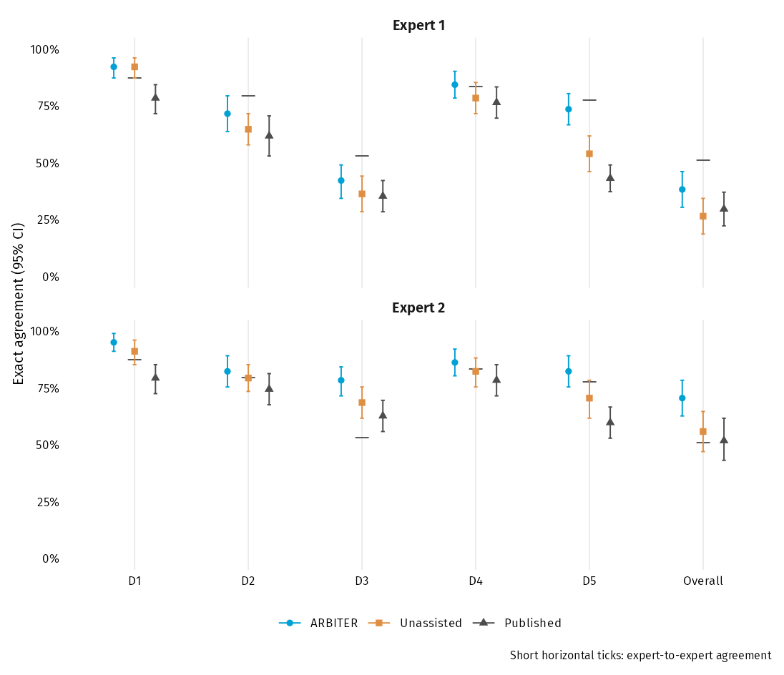
eFigure 1. Absolute agreement with independent experts by domain and derived Overall. ARBITER uses blue circles, Unassisted orange squares and Published dark-gray triangles, in that order. Short horizontal ticks show expert-to-expert agreement. Each domain has 102 cells; Overall uses 102 trials for the arms and expert reliability, and 81 for Published. Missing published Overall labels are excluded. Derived Overall against experts is exploratory. Bars show 95% percentile intervals. D1, randomisation process; D2, deviations from intended interventions; D3, missing outcome data; D4, outcome measurement; D5, selection of the reported result. CI, 95% confidence interval; 10,000 percentile bootstrap replicates, trials resampled within meta-analysis; seed 20261018.

eFigure 2. Collapsed question-level paired differences (D1 panel)
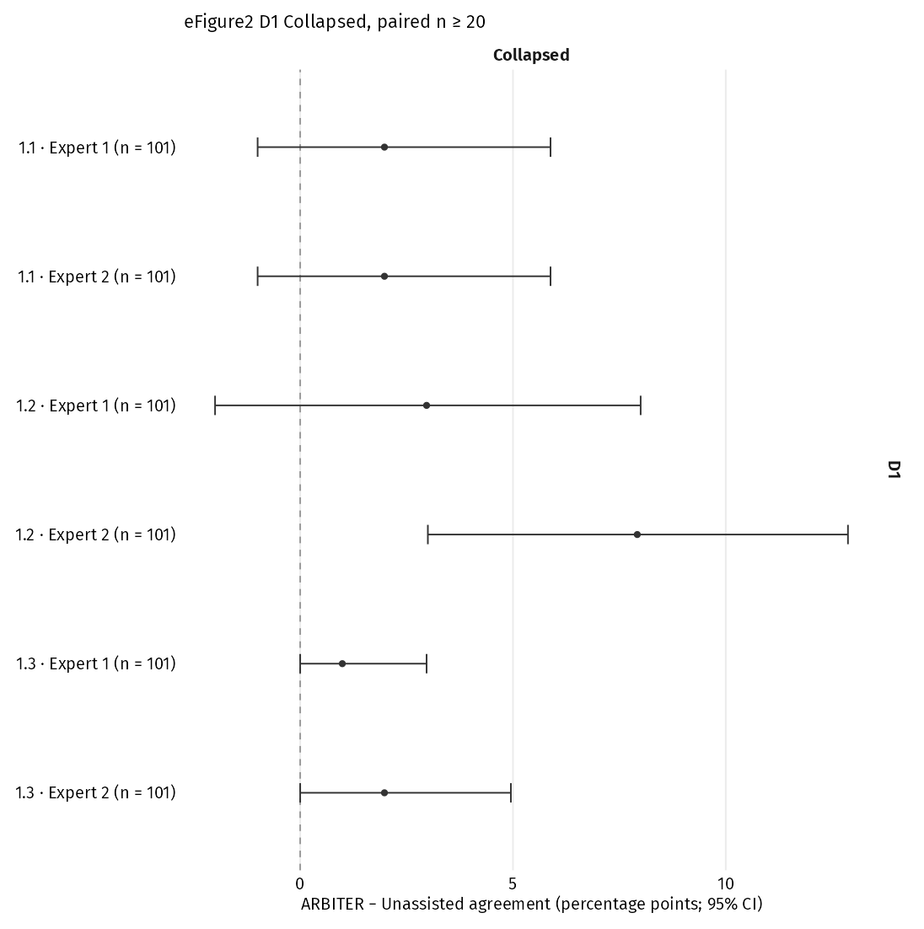
eFigure 2. Collapsed signalling-question paired differences. Rows identify the question, expert and paired denominator; only rows with at least 20 evaluable paired answers are shown. Dark circles show ARBITER − Unassisted differences with 95% percentile intervals. The complete sparse and five-level results appear in eFigure 5. D1, randomisation process; D2, deviations from intended interventions; D3, missing outcome data; D4, outcome measurement; D5, selection of the reported result. Y, yes; PY, probably yes; N, no; PN, probably no; NI, no information. Five-level coding keeps all five answers; collapsed coding combines Y/PY and N/PN, with NI separate. CI, 95% confidence interval; 10,000 percentile bootstrap replicates, trials resampled within meta-analysis; seed 20261018.

eFigure 2. Collapsed question-level paired differences (D2 panel)
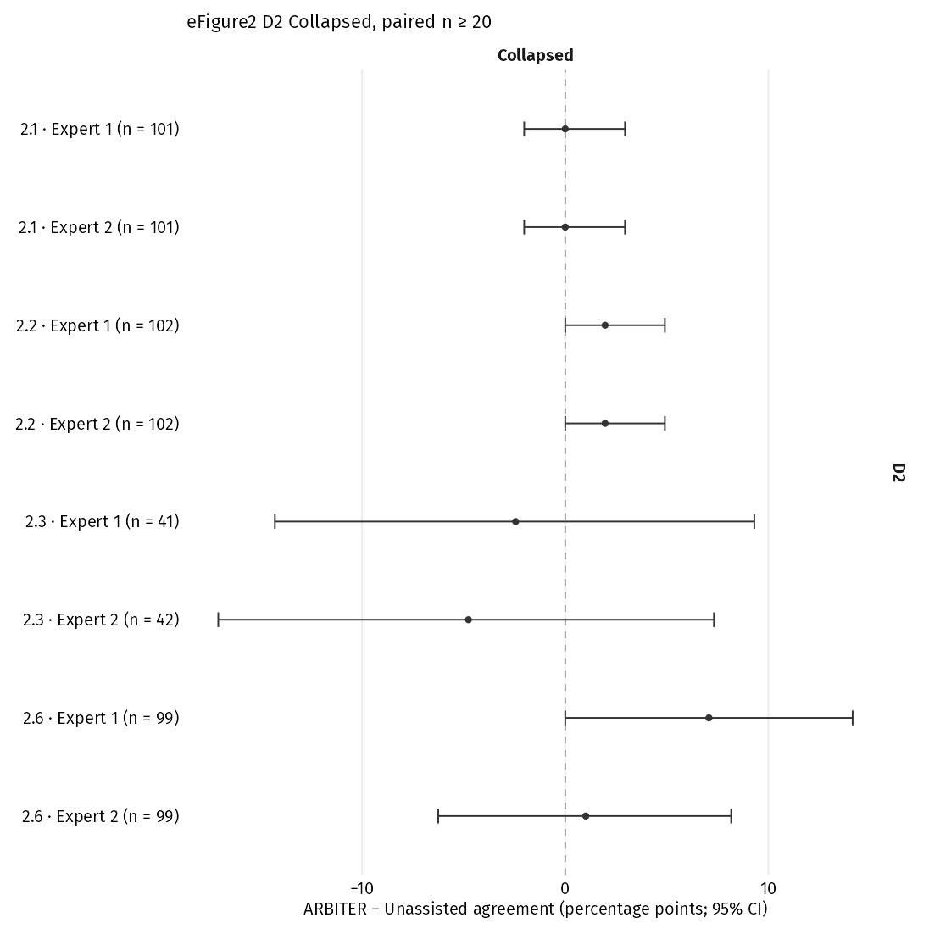
eFigure 2. Collapsed signalling-question paired differences. Rows identify the question, expert and paired denominator; only rows with at least 20 evaluable paired answers are shown. Dark circles show ARBITER − Unassisted differences with 95% percentile intervals. The complete sparse and five-level results appear in eFigure 5. D1, randomisation process; D2, deviations from intended interventions; D3, missing outcome data; D4, outcome measurement; D5, selection of the reported result. Y, yes; PY, probably yes; N, no; PN, probably no; NI, no information. Five-level coding keeps all five answers; collapsed coding combines Y/PY and N/PN, with NI separate. CI, 95% confidence interval; 10,000 percentile bootstrap replicates, trials resampled within meta-analysis; seed 20261018.

eFigure 2. Collapsed question-level paired differences (D3 panel)
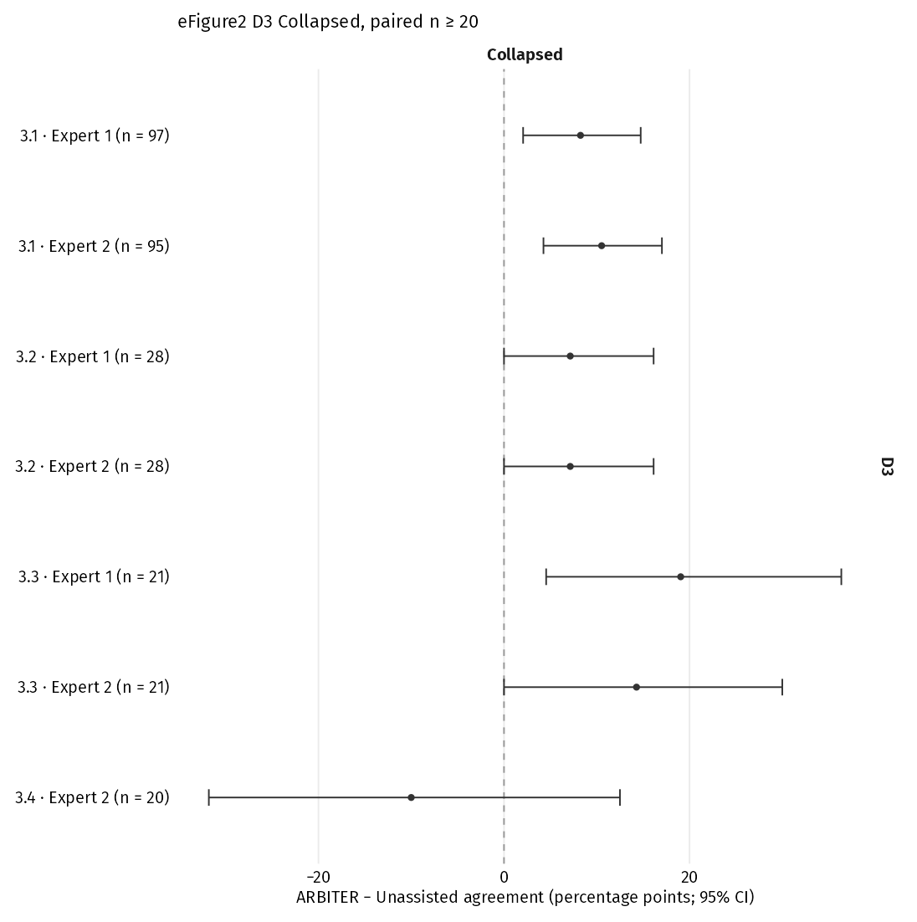
eFigure 2. Collapsed signalling-question paired differences. Rows identify the question, expert and paired denominator; only rows with at least 20 evaluable paired answers are shown. Dark circles show ARBITER − Unassisted differences with 95% percentile intervals. The complete sparse and five-level results appear in eFigure 5. D1, randomisation process; D2, deviations from intended interventions; D3, missing outcome data; D4, outcome measurement; D5, selection of the reported result. Y, yes; PY, probably yes; N, no; PN, probably no; NI, no information. Five-level coding keeps all five answers; collapsed coding combines Y/PY and N/PN, with NI separate. CI, 95% confidence interval; 10,000 percentile bootstrap replicates, trials resampled within meta-analysis; seed 20261018.

eFigure 2. Collapsed question-level paired differences (D4 panel)
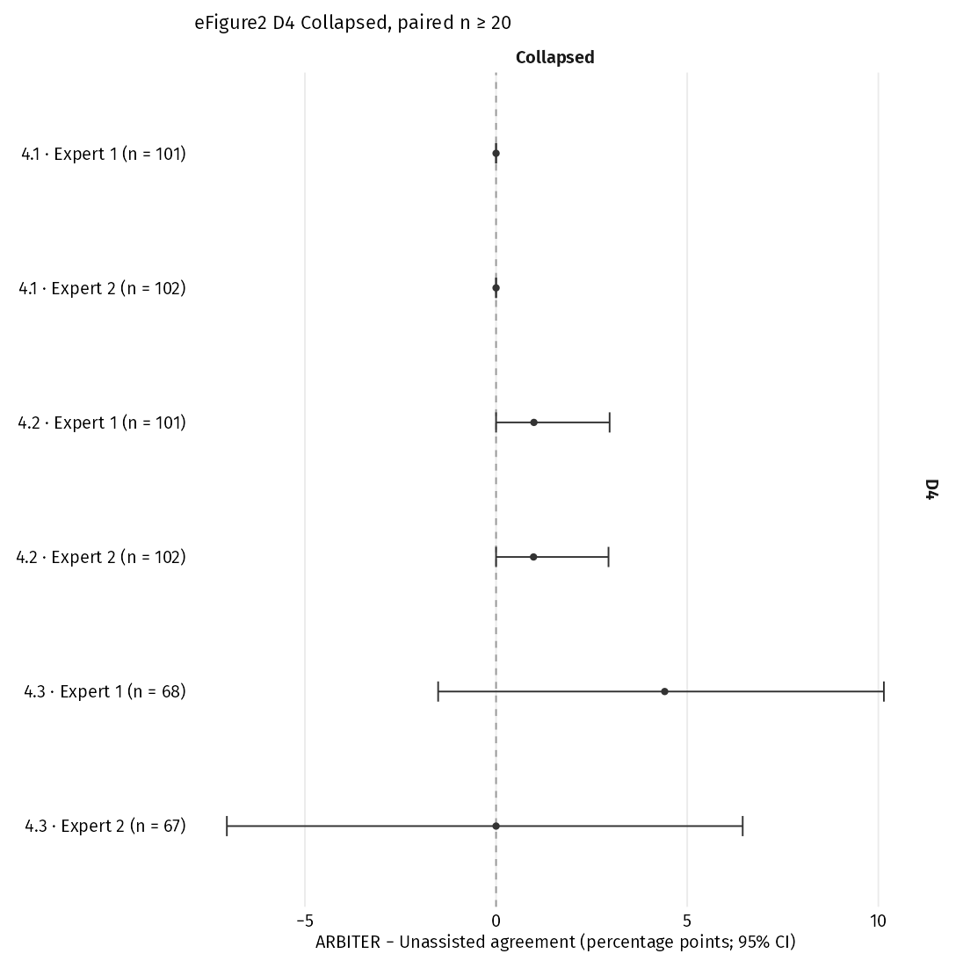
eFigure 2. Collapsed signalling-question paired differences. Rows identify the question, expert and paired denominator; only rows with at least 20 evaluable paired answers are shown. Dark circles show ARBITER − Unassisted differences with 95% percentile intervals. The complete sparse and five-level results appear in eFigure 5. D1, randomisation process; D2, deviations from intended interventions; D3, missing outcome data; D4, outcome measurement; D5, selection of the reported result. Y, yes; PY, probably yes; N, no; PN, probably no; NI, no information. Five-level coding keeps all five answers; collapsed coding combines Y/PY and N/PN, with NI separate. CI, 95% confidence interval; 10,000 percentile bootstrap replicates, trials resampled within meta-analysis; seed 20261018.

eFigure 2. Collapsed question-level paired differences (D5 panel)
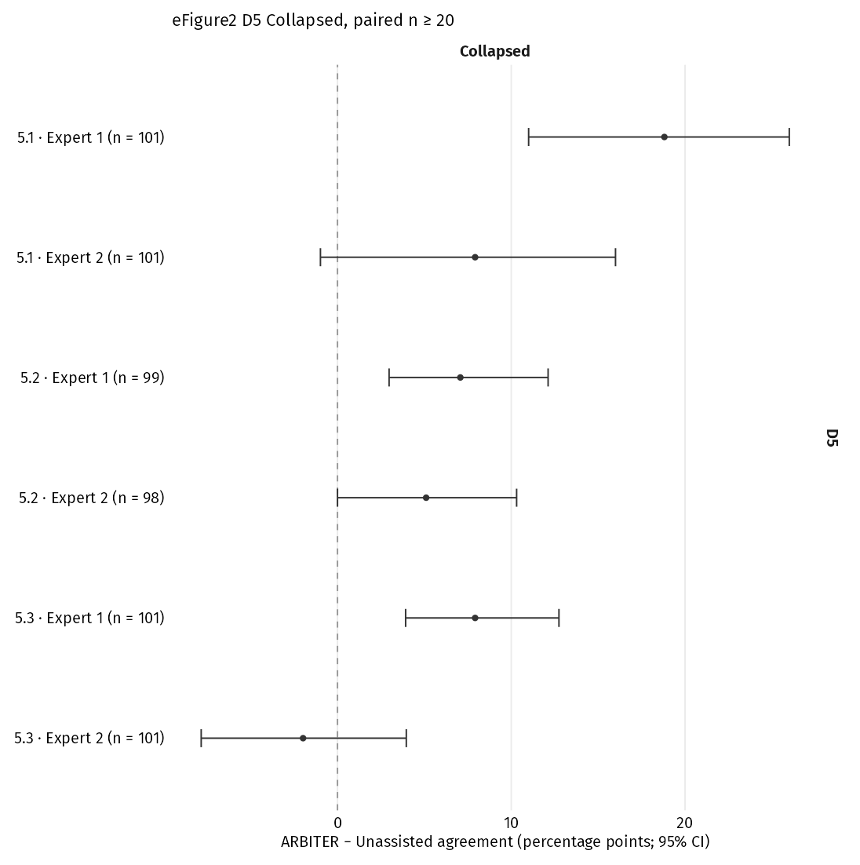
eFigure 2. Collapsed signalling-question paired differences. Rows identify the question, expert and paired denominator; only rows with at least 20 evaluable paired answers are shown. Dark circles show ARBITER − Unassisted differences with 95% percentile intervals. The complete sparse and five-level results appear in eFigure 5. D1, randomisation process; D2, deviations from intended interventions; D3, missing outcome data; D4, outcome measurement; D5, selection of the reported result. Y, yes; PY, probably yes; N, no; PN, probably no; NI, no information. Five-level coding keeps all five answers; collapsed coding combines Y/PY and N/PN, with NI separate. CI, 95% confidence interval; 10,000 percentile bootstrap replicates, trials resampled within meta-analysis; seed 20261018.

eFigure 3. Published label agreement across reviews
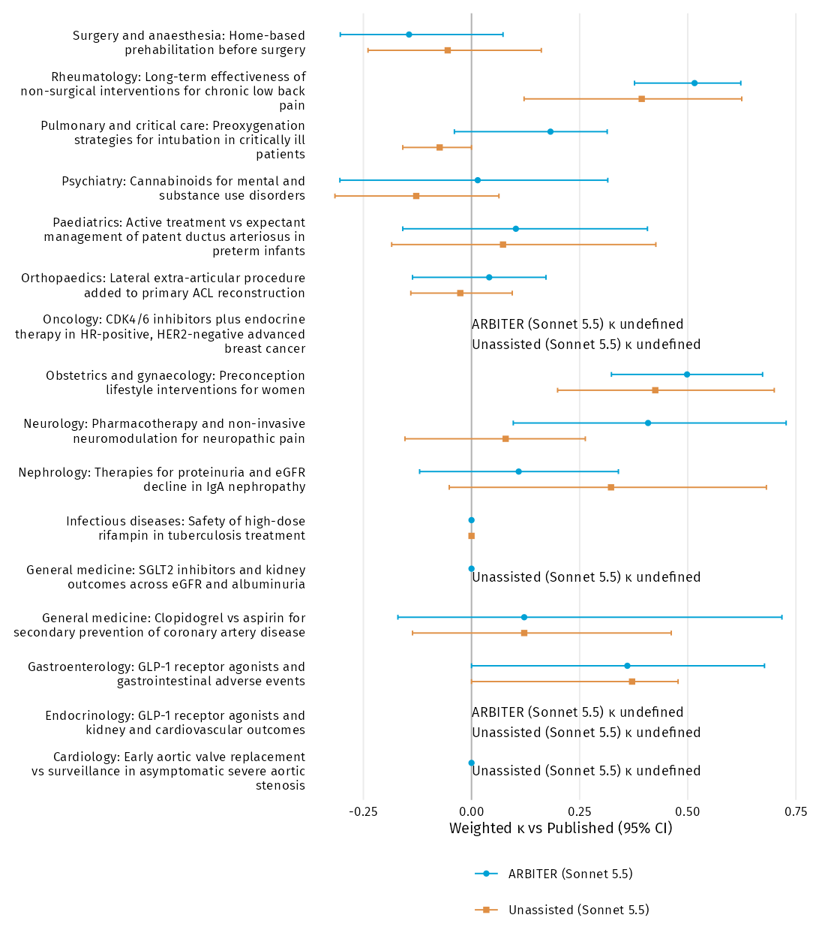
eFigure 3. Published-label agreement by source review. ARBITER uses blue circles and Unassisted orange squares. All 16 reviews remain visible; undefined κ is marked explicitly. Marks show linearly weighted κ with 95% percentile intervals, resampling the trials within reviews. CI, 95% confidence interval; 10,000 percentile bootstrap replicates, trials resampled within meta-analysis; seed 20261018.

eFigure 4. Domain-level signalling agreement
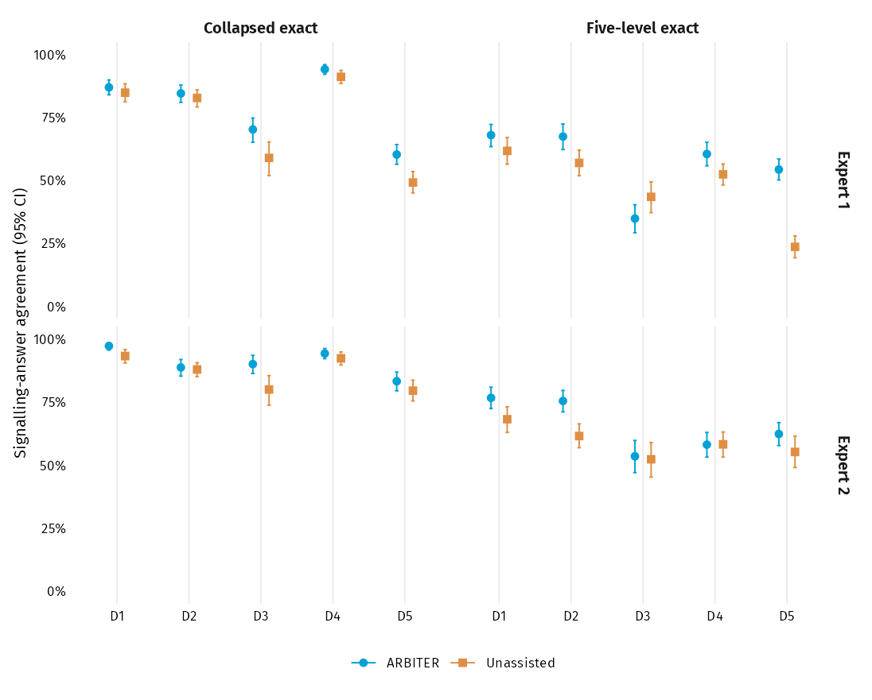
eFigure 4. Domain-level signalling agreement with each independent expert. ARBITER uses blue circles and Unassisted orange squares. Facets separate experts and five-level or collapsed answers; only evaluable source-specific answers contribute. Bars show 95% percentile intervals. Numerators and source/expert/domain-specific eligible denominators are in eTable 13, Full signalling question agreement, domain-summary rows. These denominators differ from the paired eligible intersections printed in eFigures 2 and 5. D1, randomisation process; D2, deviations from intended interventions; D3, missing outcome data; D4, outcome measurement; D5, selection of the reported result. Y, yes; PY, probably yes; N, no; PN, probably no; NI, no information. Five-level coding keeps all five answers; collapsed coding combines Y/PY and N/PN, with NI separate. CI, 95% confidence interval; 10,000 percentile bootstrap replicates, trials resampled within meta-analysis; seed 20261018.

eFigure 5. All signalling question paired differences (D1 panel)
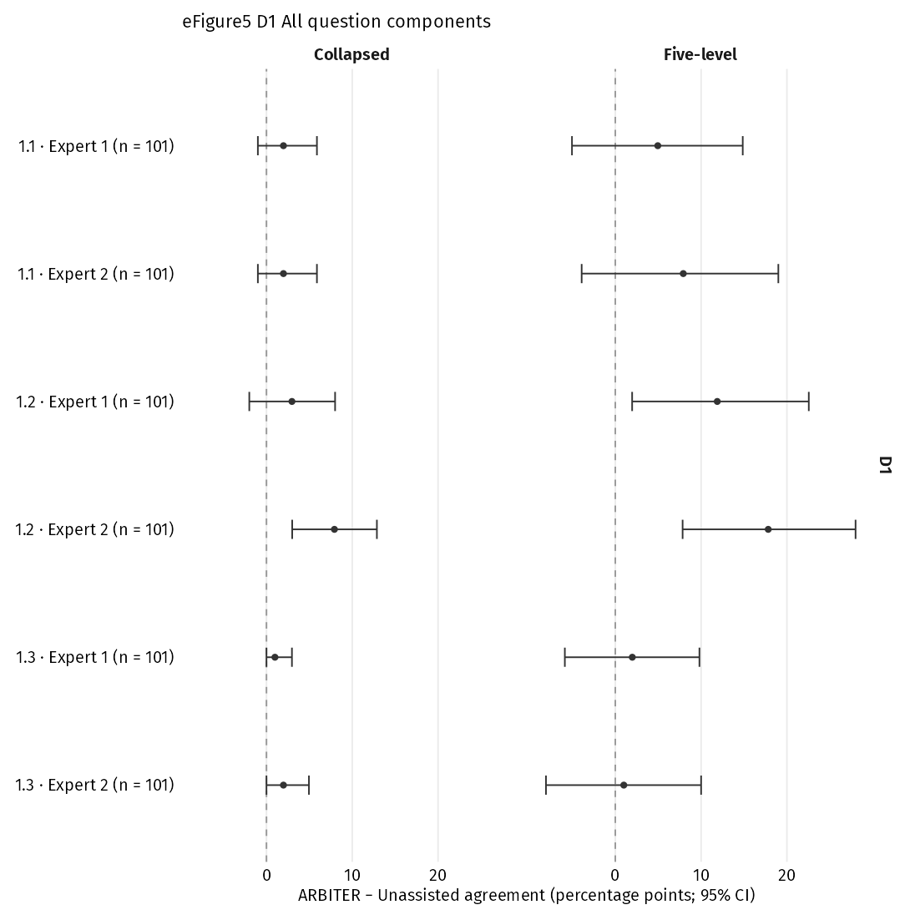
eFigure 5. All signalling-question paired differences. Facets separate collapsed and five-level answers, including sparse and zero-answer rows. Dark circles show ARBITER − Unassisted differences with 95% percentile intervals; expert identity and paired n appear on each row. D1, randomisation process; D2, deviations from intended interventions; D3, missing outcome data; D4, outcome measurement; D5, selection of the reported result. Y, yes; PY, probably yes; N, no; PN, probably no; NI, no information. Five-level coding keeps all five answers; collapsed coding combines Y/PY and N/PN, with NI separate. CI, 95% confidence interval; 10,000 percentile bootstrap replicates, trials resampled within meta-analysis; seed 20261018.

eFigure 5. All signalling question paired differences (D2 panel)
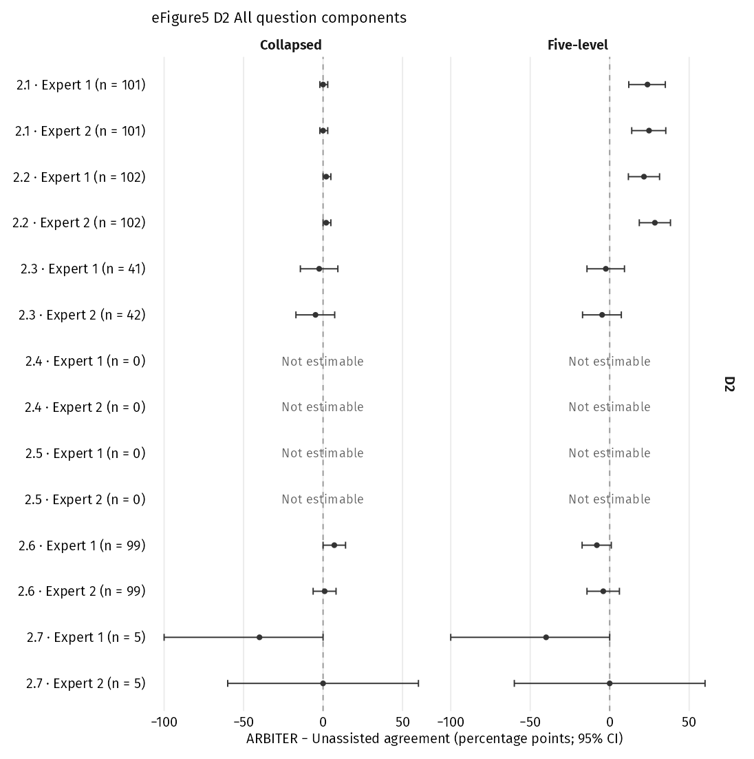
eFigure 5. All signalling-question paired differences. Facets separate collapsed and five-level answers, including sparse and zero-answer rows. Dark circles show ARBITER − Unassisted differences with 95% percentile intervals; expert identity and paired n appear on each row. D1, randomisation process; D2, deviations from intended interventions; D3, missing outcome data; D4, outcome measurement; D5, selection of the reported result. Y, yes; PY, probably yes; N, no; PN, probably no; NI, no information. Five-level coding keeps all five answers; collapsed coding combines Y/PY and N/PN, with NI separate. CI, 95% confidence interval; 10,000 percentile bootstrap replicates, trials resampled within meta-analysis; seed 20261018.

eFigure 5. All signalling question paired differences (D3 panel)
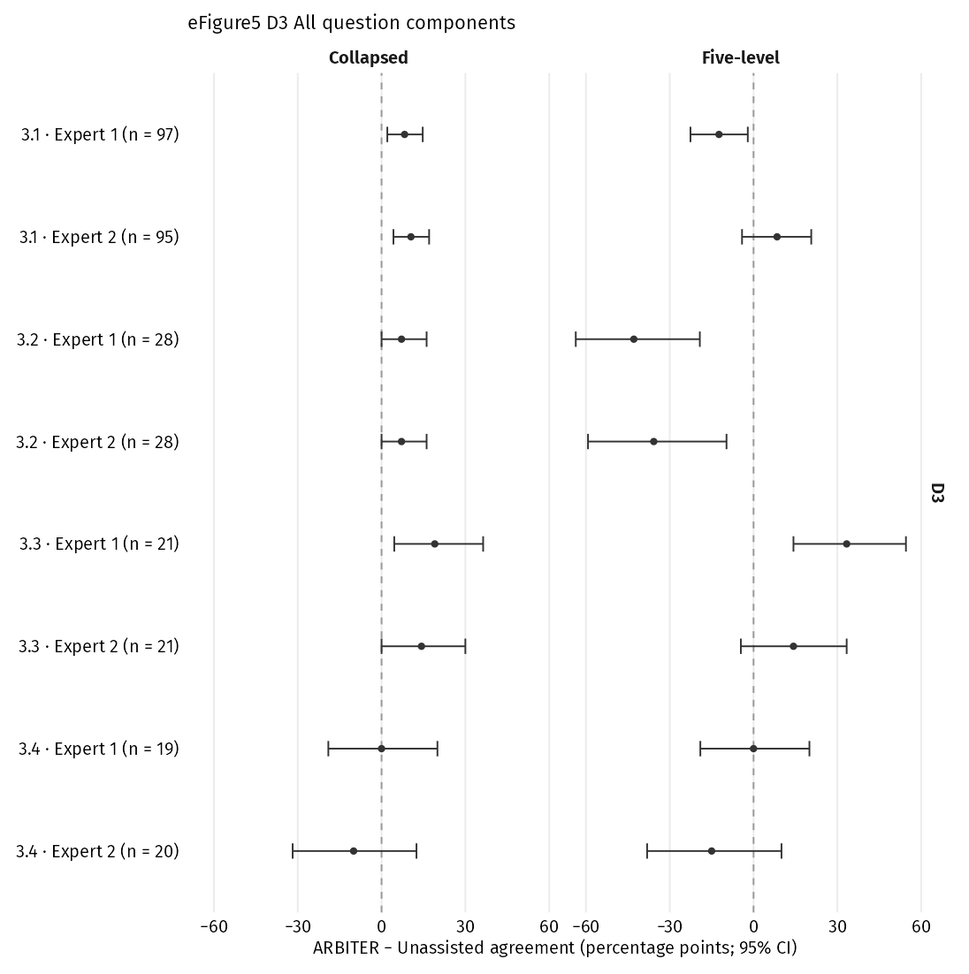
eFigure 5. All signalling-question paired differences. Facets separate collapsed and five-level answers, including sparse and zero-answer rows. Dark circles show ARBITER − Unassisted differences with 95% percentile intervals; expert identity and paired n appear on each row. D1, randomisation process; D2, deviations from intended interventions; D3, missing outcome data; D4, outcome measurement; D5, selection of the reported result. Y, yes; PY, probably yes; N, no; PN, probably no; NI, no information. Five-level coding keeps all five answers; collapsed coding combines Y/PY and N/PN, with NI separate. CI, 95% confidence interval; 10,000 percentile bootstrap replicates, trials resampled within meta-analysis; seed 20261018.

eFigure 5. All signalling question paired differences (D4 panel)
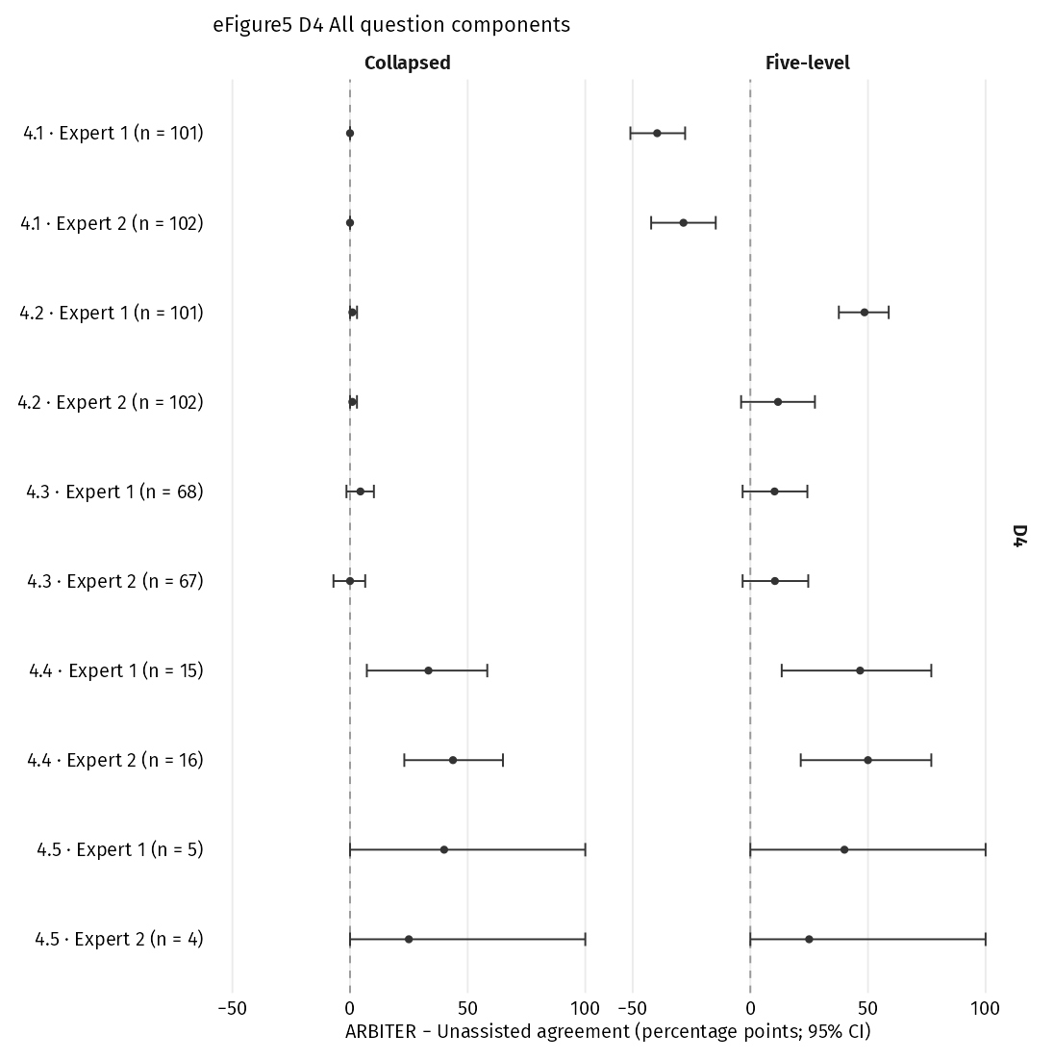
eFigure 5. All signalling-question paired differences. Facets separate collapsed and five-level answers, including sparse and zero-answer rows. Dark circles show ARBITER − Unassisted differences with 95% percentile intervals; expert identity and paired n appear on each row. D1, randomisation process; D2, deviations from intended interventions; D3, missing outcome data; D4, outcome measurement; D5, selection of the reported result. Y, yes; PY, probably yes; N, no; PN, probably no; NI, no information. Five-level coding keeps all five answers; collapsed coding combines Y/PY and N/PN, with NI separate. CI, 95% confidence interval; 10,000 percentile bootstrap replicates, trials resampled within meta-analysis; seed 20261018.

eFigure 5. All signalling question paired differences (D5 panel)
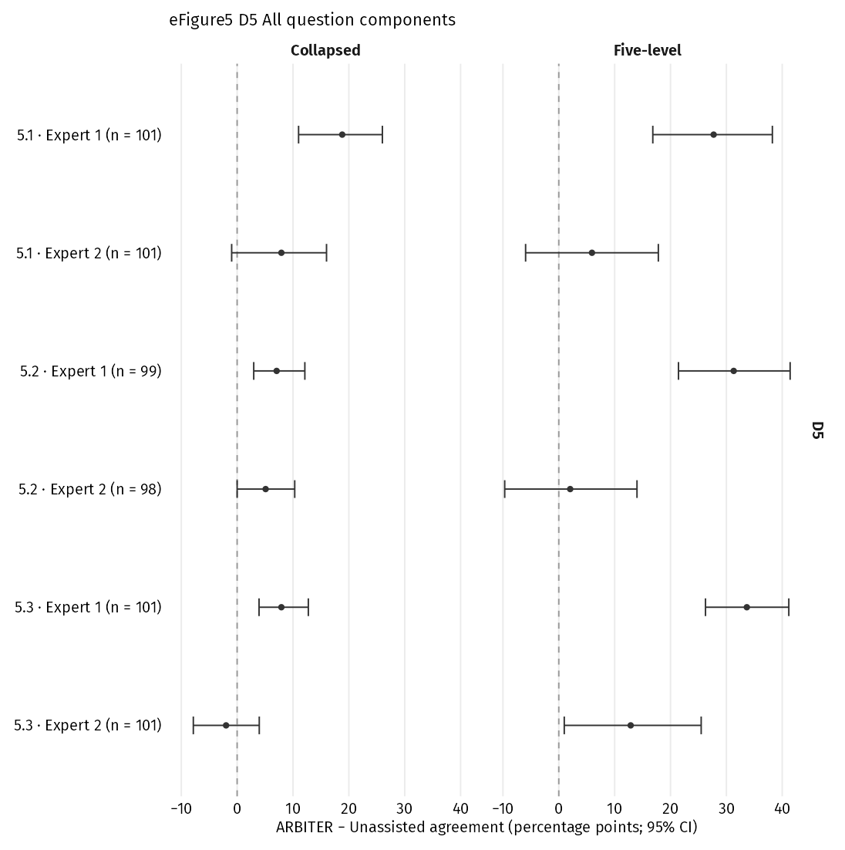
eFigure 5. All signalling-question paired differences. Facets separate collapsed and five-level answers, including sparse and zero-answer rows. Dark circles show ARBITER − Unassisted differences with 95% percentile intervals; expert identity and paired n appear on each row. D1, randomisation process; D2, deviations from intended interventions; D3, missing outcome data; D4, outcome measurement; D5, selection of the reported result. Y, yes; PY, probably yes; N, no; PN, probably no; NI, no information. Five-level coding keeps all five answers; collapsed coding combines Y/PY and N/PN, with NI separate. CI, 95% confidence interval; 10,000 percentile bootstrap replicates, trials resampled within meta-analysis; seed 20261018.

AVATAR complete trace
Part A. Answers and judgements
D1 judgement / rationale
ARBITER: Proposed: Low; adopted: Low
Unassisted: Low Allocation used a computer-generated, centre-stratified permuted-block sequence delivered through a web-based interactive response system, so concealment was adequate. The baseline differences in age (P = .02) and haemoglobin (P = .01) are consistent with chance across about 25 variables.
1.1 Random allocation sequence
ARBITER: Yes
Evidence handles (type): eh_d6c269341c7d8a5d (direct support)
Justification: The original AVATAR paper states the assignment was computer-generated and stratified by centre using a permuted-block sequence with variable block size, which is a random component.
Unknowns: —
Counterevidence: —
Unassisted: Yes
1.2 Concealment until enrolment and assignment
ARBITER: Yes
Evidence handles (type): eh_d6c269341c7d8a5d (direct support)
Justification: Patients were randomized using a web-based interactive response system, a central remote allocation method independent of enrolment staff. Variable block size limits predictability of the last allocations in a block.
Unknowns: Whether the central system was run by a unit independent of enrolling staff is not stated explicitly.
Counterevidence: —
Unassisted: Yes
1.3 Preintervention imbalance suggesting a randomisation problem
ARBITER: No
Evidence handles (type): eh_92eed84c7b98e37c (direct support); eh_58abdac52262aa33 (context)
Justification: Group sizes were 78 vs 79. Of about 25 baseline comparisons in Table 2, only age (P=.02) and haemoglobin (P=.01) were nominally significant, and diabetes was P=.07. The age difference is 1 year in medians. This is compatible with chance and none approaches P<0.001.
Unknowns: —
Counterevidence: Basis 1: Diabetes was less common in early surgery (17.9% vs 29.1%), which could favour surgery, but P=.07 is compatible with chance and the 2022 paper attributes it to chance.
Unassisted: Probably no

D2 judgement / rationale
ARBITER: Proposed: Low; adopted: Low
Unassisted: Low The trial was open label, so participants and clinicians knew the assignments. Surgery in the conservative arm followed protocol-defined triggers such as symptom onset. Six of 78 early-surgery patients did not receive surgery, and some surgeries were delayed by COVID-19. These are not deviations likely to affect the outcome. The analysis was intention-to-treat.
2.1 Participants aware of assignment
ARBITER: Yes
Evidence handles (type): eh_975aac3202107531 (direct support); eh_3ce4199af9d487f3 (context)
Justification: The registry lists masking as NONE, and the comparison is surgical valve replacement versus watchful waiting, which cannot be hidden from participants.
Unknowns: —
Counterevidence: —
Unassisted: Yes
2.2 Carers or intervention providers aware of assignment
ARBITER: Yes
Evidence handles (type): eh_975aac3202107531 (direct support)
Justification: Open-label surgery versus conservative care means clinicians and surgeons delivering care knew the assignment. Allocation was concealed until assignment, but blinding afterwards was impossible.
Unknowns: —
Counterevidence: —
Unassisted: Yes
2.3 Deviations arising from trial context
ARBITER: Probably no
Evidence handles (type): eh_c8e0958840636206 (direct support); eh_22d01d9384e1a677 (context); eh_4b5761bf573cc287 (context); eh_05e667d2d41d3858 (context)
Justification: Crossover from conservative care to surgery (35/79) was driven by protocol-defined indications (symptom onset, AS progression, LVEF decline), as Table 3 and the protocol show, so it is consistent with the protocol rather than trial-context driven. Surgical delays beyond 8 weeks arose from the COVID-19 public-health emergency and were documented as an anticipated minor deviation in the SAP amendment. Four early-surgery patients did not receive surgery as assigned, for reasons like infection or declining, which could occur outside a trial.
Unknowns: Reasons for declining surgery are not described in detail.
Counterevidence: Basis 3: The authors note pandemic-related follow-up substitution by phone and lengthened AVR delays could have increased clinical risk. These arose from the pandemic, not the trial context, and no deaths occurred while awaiting scheduled surgery in the conservative group.
Unassisted: Probably no
2.4 Deviations affecting the outcome
ARBITER: Not asked (inactive; branching)
Unassisted: Not applicable
2.5 Deviations balanced across groups
ARBITER: Not asked (inactive; branching)
Unassisted: Not applicable
2.6 Appropriate analysis of assignment effect
ARBITER: Yes
Evidence handles (type): eh_30fa222ec5523dcc (direct support); eh_c8e0958840636206 (direct support)
Justification: All analyses were intention-to-treat as randomized, and all 157 patients were included. One early-surgery patient lost to follow-up was censored and still analysed.
Unknowns: —
Counterevidence: —
Unassisted: Yes
2.7 Substantial impact of analysing outside assigned groups
ARBITER: Not asked (inactive; branching)
Unassisted: Not applicable

D3 judgement / rationale
ARBITER: Proposed: Low; adopted: Low
Unassisted: Low All 157 patients were analysed. One patient lost to follow-up was censored.
3.1 Outcome data available for nearly everyone
ARBITER: Yes
Evidence handles (type): eh_e66d374e838e8c6d (direct support)
Justification: All 157 randomized patients were analysed and median follow-up was 63 months. Only one patient (early-surgery arm) was lost to follow-up and censored at last contact, so 1/157 (0.6%) has incomplete outcome data. This is far fewer than the observed deaths, so any outcome for that patient could not materially change the HR of 0.44.
Unknowns: —
Counterevidence: —
Unassisted: Yes
3.2 Evidence against bias from missing data
ARBITER: Not asked (inactive; branching)
Unassisted: Not applicable
3.3 Missingness potentially depends on true outcome
ARBITER: Not asked (inactive; branching)
Unassisted: Not applicable
3.4 Missingness likely depends on true outcome
ARBITER: Not asked (inactive; branching)
Unassisted: Not applicable

D4 judgement / rationale
ARBITER: Proposed: Low; adopted: Low
Unassisted: Low Death is an objective outcome. Assessors were not blinded to allocation, but this cannot plausibly bias an all-cause death count.
4.1 Inappropriate measurement method
ARBITER: Probably no
Evidence handles (type): eh_3ce4199af9d487f3 (direct support)
Justification: All-cause death is a pre-specified, objective event ascertained through scheduled follow-up (6-monthly in year 1, then yearly), phone contact when in-person visits were not possible, and review of medical records for any registered event. Nothing suggests an insensitive method or an instrument with poor validity.
Unknowns: —
Counterevidence: —
Unassisted: No
4.2 Measurement differs across groups
ARBITER: Probably no
Evidence handles (type): eh_3ce4199af9d487f3 (direct support)
Justification: Both arms followed the same protocol schedule, and COVID-related phone follow-up applied to patients regardless of arm. Death is hard to miss, so any difference in contact opportunities (e.g. surgery visits) is unlikely to change ascertainment of death.
Unknowns: Whether vital status was verified from registries in both arms is not stated.
Counterevidence: —
Unassisted: No
4.3 Assessors aware of received intervention
ARBITER: Yes
Evidence handles (type): eh_3ce4199af9d487f3 (direct support)
Justification: The trial was open-label (registry masking: none), and the report states that DSMB members were not blinded to allocation when reviewing events. Site investigators recording deaths were also aware of the allocation.
Unknowns: —
Counterevidence: —
Unassisted: Not applicable
4.4 Assessment potentially influenced by awareness
ARBITER: Probably no
Evidence handles (type): eh_3ce4199af9d487f3 (inference)
Justification: All-cause death is an observer-reported outcome that involves no judgement, so knowledge of the intervention is unlikely to influence its assessment, even though the assessors were aware of the allocation.
Unknowns: —
Counterevidence: —
Unassisted: Not applicable
4.5 Assessment likely influenced by awareness
ARBITER: Not asked (inactive; branching)
Unassisted: Not applicable

D5 judgement / rationale
ARBITER: Proposed: Some concerns; adopted: Some concerns
Unassisted: Low Time to death was a prespecified secondary endpoint with a registered 5-year time frame. It was analysed with a single Cox model, and the SAP amendment only addresses COVID-19 delays. I found no sign of selective reporting. A small concern is that the extended follow-up was a later analysis, but it matches the registered time frame.
5.1 Analysis plan finalised before unblinding
ARBITER: No information
Evidence handles (type): eh_d54a2600ddc753b3 (context); eh_7ad155913c1c5826 (context); eh_30fa222ec5523dcc (context); eh_7961ea6680167af2 (context)
Justification: The registry entry (first submitted 30 Apr 2015, before enrolment began in June 2015) names all-cause death only as a component of composite outcomes. It does not list time to all-cause death as a separate outcome. The Circulation 2022 and EHJ 2024 reports describe 'time to death' as a prespecified secondary end point analysed with Kaplan-Meier and Cox models, citing a published protocol. That protocol is not among the captured Sources, and the report statements are not date-stamped before unblinded data. The only SAP-type document is an amendment dated 4 Jan 2021 about COVID surgical delays. No dated source therefore specifies this measurement and analysis.
Unknowns: Whether the published protocol listed time to all-cause death and its Cox analysis, and its date relative to unblinded data.
Counterevidence: —
Unassisted: Probably yes
5.2 Result selected from eligible outcome measurements
ARBITER: Probably no
Evidence handles (type): eh_30fa222ec5523dcc (direct support); eh_d54a2600ddc753b3 (context)
Justification: All-cause death is a single, unambiguous event, so there is essentially one way to measure the outcome domain. The registered time frames were 36 months and 5 years. The 2024 report states that all-cause death was analysed over the full follow-up and also restricted to 3 years, so no eligible time point appears to have been omitted in favour of a more favourable one.
Unknowns: —
Counterevidence: —
Unassisted: Probably no
5.3 Result selected from eligible analyses
ARBITER: Probably no
Evidence handles (type): eh_30fa222ec5523dcc (direct support); eh_f625637d366df2a0 (context)
Justification: Time-to-event secondary outcomes were analysed with the same Kaplan-Meier, log-rank and Cox model (treatment only) used for the primary outcome, and the same method was used in the 2022 paper. No covariate-adjusted or alternative models are described, and the long-term and 3-year analyses are both reported.
Unknowns: —
Counterevidence: —
Unassisted: Probably no
Overall
ARBITER: Proposed: Some concerns; adopted: Some concerns
Justification: Any domain Some concerns, with no High domain: Overall Some concerns.
Unassisted: Low
Part B. Evidence records
eh_05e667d2d41d3858
Source: AVATAR long-term follow-up report
Page: 9
Lines: 76–83
Source-version hash: a890f771fd05
Full verbatim quote: follow-up and lengthening AVR delays. Pre-defined physical visits were substituted by phone follow-up. Such surveillance within the watchful waiting may hypothetically impact timely detection of symptoms conse quently leading to increased clinical risk, including sudden death. Nevertheless, in the conservative group, none of the patients experi enced MACE or died while awaiting the scheduled surgery. It is of note that in the small number of patients undergoing TAVR, delays ap peared shorter as compared with the surgical intervention.
eh_22d01d9384e1a677
Source: Current registry-linked statistical analysis plan
Page: 2
Lines: 1–12
Source-version hash: ba0a93294998
Full verbatim quote: Amendmen to statystical analysis 1. Patients randomized to AVR surgery who received delayed surgery (more than 8 weeks after randomization) due to COVID -19 public health emergency will be documented and this delay will be defined as an anticipated minor deviation from the clinical protocol 2. Appropriate statistical procedures will be performed and results will be published according to the FDA guidance "Conduct of Clinical Trials of Medical Products During the COVID-19 Public Health Emergency Guidance for Industry, investigators, and Institutional Review Boards"
eh_30fa222ec5523dcc
Source: AVATAR long-term follow-up report
Page: 5
Lines: 13–24
Source-version hash: a890f771fd05
Full verbatim quote: Statistical analysis We conducted all analyses according to the intention-to-treat principle, where all patients were included in the analysis as they were randomized. For the analysis of the primary outcome, we built a Kaplan-Meier graph with a log rank P-value to test for a difference between early surgery and control intervention at a two-sided α value of 0.05 and used a Cox propor tional hazards model to derive hazard ratios (HRs) with 95% confidence in tervals (CIs) for treatment effect estimation. Time-to-event secondary outcomes were analysed using the same meth ods applied for the analysis of the primary outcome. For MACE, all-cause death, HF hospitalization, and cardiovascular death, we repeated the ana lysis as described above restricted to a 3-year follow-up, with complete
eh_3ce4199af9d487f3
Source: AVATAR long-term follow-up report
Page: 3
Lines: 1–116
Source-version hash: a890f771fd05
Full verbatim quote: Introduction Aortic stenosis (AS) is the single most common valvular heart disease re quiring intervention in developed countries and is projected to double by 2050 in both the USA and Europe.1 The approach to symptomatic pa tients with severe AS is straightforward. Surgical aortic valve replacement (AVR) and, more recently, transcatheter aortic valve implantation (TAVI) procedures are Class I recommendation to relieve symptoms and im prove survival in symptomatic patients with severe AS.2,3 Conversely, the question of when and how to treat truly asymptom atic patients with severe AS and normal left ventricular (LV) systolic function is still subject to debate and ongoing research. To date, two randomized trials have demonstrated benefit of early AVR in compari son with conservative strategy in asymptomatic patients with severe and very severe AS patients.4,5 In addition, there are
Context: eh_3ce4199af9d487f3 (quote continued)
several ongoing randomized trials investigating the role of early TAVI and/or early sur gical AVR in asymptomatic AS. The Aortic Valve Replacement Versus Conservative Treatment in Asymptomatic Severe Aortic Stenosis (AVATAR) trial is an investigator- initiated, prospective, multinational, randomized, controlled, parallel-group, event-driven trial that compared the safety and efficacy of early surgery in the treatment of truly asymptomatic patients with severe AS and LV ejec tion fraction (LVEF) ≥ 50% vs. conservative treatment with watchful wait ing strategy and AVR only after symptom onset, or other guidelines directed Class I or II indications for AVR.3,6 In the primary analysis of the AVATAR trial, asymptomatic AS patients randomized to early surgery had a lower incidence of the composite primary outcome comprising all- cause death, acute myocardial infarction, stroke, or unplanned
Context: eh_3ce4199af9d487f3 (quote continued)
hospitaliza tion for heart failure (HF), compared with patients who were randomized to conservative treatment.5 We now report the results of the AVATAR trial after extended follow-up at 5 years. Methods Study design and oversight The AVATAR trial (ClinicalTrials.gov identifier NCT02436655) protocol and protocol update were designed by the first co-authors and steering committee co-chairmen and was approved by the steering committee of the AVATAR trial.7,8 The clinical and outcomes data were collected by per sonnel at the participating sites and were sent directly to the data coordinat ing centre at the University Clinical Center of Serbia. No extramural funding was used to support this work. The authors, members of the steering com mittee, and investigators are solely responsible for the design and conduct of this trial, all analyses, drafting and editing of the article, and its final
Context: eh_3ce4199af9d487f3 (quote continued)
contents. Independent statistician conducted the long-term data analyses. The trial was conducted in accordance with the Declaration of Helsinki. All participants provided written informed consent. An independent data and safety monitoring board (DSMB) adjudicated all serious adverse events and oversaw the safety of the trial. The article was prepared by the first author and steering committee co-chairmen and was reviewed and edited by mem bers of the steering committee and authors. All authors reviewed the article, approved its submission for publication, and vouched for the accuracy and completeness of the data and for the fidelity of the trial to the protocol. Study population The study inclusion and exclusion criteria are shown in Table 1; trial flowchart is shown in Figure 1. Briefly, a total of 157 patients with severe AS according to the guidelines were enrolled in the trial: 79
Context: eh_3ce4199af9d487f3 (quote continued)
were randomized to conservative treatment and 78 were randomized to early surgery. To prove truly asymp tomatic status, exercise testing was performed in all candidates to evaluate symptom status according to a standardized protocol using treadmill or semi- supine ergo-bicycle. To consider exercise testing negative, which was manda tory for inclusion, all candidates needed to reach a projected submaximal heart rate. Positive exercise test included onset of AS-related symptoms, fall in systolic blood pressure (≥20 mmHg from the baseline values), or Electrocardiography (ECG) or stress echocardiography signs of myocardial ischaemia.9 Follow-up and trial endpoints Patients were followed according to the protocol every 6 months for the first year and then yearly with the in-person visits at the participating study centre. As the trial was affected by the Covid-19 pandemic, contact with
Context: eh_3ce4199af9d487f3 (quote continued)
patients who could not come in person was made by phone. For any event that was registered, the medical records were asked for and reviewed. Adverse clinical events were adjudicated by the DSMB per protocol defini tions.7,8 Data and safety monitoring board members were not blinded to the treatment allocation during events review. They adjudicated the events by consensus. Table 1 Eligibility inclusion/exclusion criteria Inclusion criteria • Men and women of any ethnic origin aged ≥18 years • Written informed consent • Vmax across the aortic valve > 4 m/s or P mean ≥ 40 mmHg and AVA ≤ 1 cm2 or AVAi ≤ 0.6 cm2/m2 at rest • Without reported symptoms • Society of Thoracic Surgeons score < 8% Exclusion criteria Participation in another clinical trial within 30 days prior to randomization • Pregnant or nursing women • Mental condition rendering the patient unable to understand the nature,
Context: eh_3ce4199af9d487f3 (quote continued)
scope, and possible consequences of the study or to follow the protocol • Positive stress-test defined as follows: (a) Anginal chest pain during testing (b) Syncope or dizziness during testing (c) Decrease in systolic blood pressure during exercise ≥ 20 mmHg (d) Malignant arrhythmia during exercise testing (VT or VF) • Left ventricular ejection fraction < 50% at rest • Very severe AS defined as Vmax > 5.5 m/s at rest • Significant disease of other valves: mitral stenosis with Pmean > 5 mg, or any significant regurgitation ≥ 3+ • Recent previous myocardial infarction (<1 year) • Need for additional aortic root replacement (i.e. Bentall) or ascending aorta surgery in asymptomatic patients undergoing AVR • Previous coronary bypass surgery • Previous any heart valve surgery • Impaired renal function, i.e. creatinine > 200 μmol/L or glomerular filtration rate < 30 mL/min/1.73 m2 •
Context: eh_3ce4199af9d487f3 (quote continued)
Significant pulmonary hypertension at rest (systolic pulmonary artery pressure > 50 mmHg) • Uncontrolled hypertension at rest (systolic blood pressure > 180 mmHg and diastolic blood pressure > 100 mmHg) • Significant comorbidity with reduced life expectancy (<3 years) • Uncontrolled diabetes mellitus (HbA1c > 9%) • Significant chronic obstructive pulmonary disease (FEV1 < 70% of predicted value)
eh_4b5761bf573cc287
Source: AVATAR original trial report
Page: 4
Lines: 8–15
Source-version hash: 592b9a6c531c
Full verbatim quote: Patients in the conservative treatment group were referred for surgery in case of onset of AS-related symptoms, if the LVEF decreased to <50%, or if the peak aortic jet velocity increased each year by >0.3 m/s on follow-up echocardiog- raphy, according to European Society of Cardiology guide- lines on valvular disease at the time the study was designed.11 Conservative treatment included the treatment of risk factors and comorbidities.
eh_58abdac52262aa33
Source: AVATAR long-term follow-up report
Page: 5
Lines: 47–50
Source-version hash: a890f771fd05
Full verbatim quote: Diabetes mellitus 14 (17.9%) 23 (29.1%) .07
eh_7961ea6680167af2
Source: Current registry-linked statistical analysis plan
Page: 1
Lines: 1–8
Source-version hash: ba0a93294998
Full verbatim quote: Avatar trial protocol -Amendment to surgical delays- Aortic Valve Replacement Versus Conservative Treatment in Asymptomatic Severe Aortic Stenosis (AVATAR trial) NCT number : NCT02436655. Date of amendment: 04.01.2021
eh_7ad155913c1c5826
Source: AVATAR original trial report
Page: 4
Lines: 16–35
Source-version hash: 592b9a6c531c
Full verbatim quote: Trial End Points The primary end point was a composite of all-cause mortality or major adverse cardiovascular events (MACEs) composed of acute myocardial infarction, stroke, and unplanned HF hospital- ization needing intravenous treatment with diuretics or inotro- pes. Prespecified secondary end points included the following: • In-hospital and 30-day postoperative mortality in oper- ated patients in both groups • Repeat aortic valve surgery in operated patients in both groups • Repeated MACEs, including stroke, acute myocardial infarction, or unplanned HF hospitalization needing IV diuretic treatment • Major bleeding defined as types 3, 4, and 5 according to the consensus report from the Bleeding Academic Research Consortium13 • Thromboembolic complications on the basis of clinical symptoms, signs, and imaging studies • Time to death • Time to first HF hospitalization
eh_92eed84c7b98e37c
Source: AVATAR long-term follow-up report
Page: 5
Lines: 26–136
Source-version hash: a890f771fd05
Full verbatim quote: Table 2 Selected baseline characteristics of the study population Early surgery group (n = 78) Conservative treatment group (n = 79) P-value Demographics and comorbidities Age, years, median (IQR) 68 (63-73) 69 (64-75) .02 Sex (female) 32 (41.0%) 35 (44.3%) .67 STS score, median (IQR) 1.6 (1.1-2.2) 1.8 (1.2-2.7) .67 Days from randomization to surgery, median (IQR) 55 (36-79) 476 (226-1098) <.001 Diabetes mellitus 14 (17.9%) 23 (29.1%) .07 Hypertension 69 (88.4%) 70 (88.6%) .44 History of PCI 1 (1.3%) 2 (2.5%) .44 History of stroke 2 (2.5%) 2 (2.5%) .92 Peripheral arterial disease 0 (0%) 1 (1.36%) .80 Laboratory parameters BNP, pg/mLa, median (IQR) 83 (53-127) 89 (58-149) .61 NT-proBNP, pg/mLa, median (IQR) 381 (153-660) 347 (186-722) .45 Haemoglobin, g/L, median (IQR) 141 (131-150) 134 (128-141) .01 Creatinine, μmol/L, median (IQR) 80 (66-94) 76 (67-92) .27 Blood glucose, mmol/L, median
Context: eh_92eed84c7b98e37c (quote continued)
(IQR) 5.6 (5.3-6.7) 5.6 (5.1-6.8) .70 Echocardiography LVESV, mL, median (IQR) 28 (20-41) 33 (22-42) .96 LVEDV, mL, median (IQR) 113 (89-142) 113 (96-126) .54 LV mass index, g/m2, median (IQR) 152 (133-175) 160 (139-183) .67 Left atrium, cm 4.1 (3.8-4.4) 4.2 (3.9-4.4) .68 SVi, mL/m2, median (IQR) 39 (33-48) 42 (34-51) .58 PA systolic pressure, mmHg, median (IQR) 30 (26-36) 30 (27-37) .82 Vmax, m/s, median (IQR) 4.5 (4.3-4.8) 4.5 (4.2-4.7) .13 Pmean, mmHg, median (IQR) 51 (44-58) 50 (43-59) .16 Pmax, mmHg, median (IQR) 82 (74-90) 79 (70-90) .18 AVA, cm2, median (IQR) 0.73 (0.55-0.84) 0.74 (0.59-0.89) .29 AVAi, cm2/m2, median (IQR) 0.37 (0.3-0.42) 0.37 (0.31-0.46) .08 E/eʹ, median (IQR) 12.2 (9.6-16.3) 12.2 (8.8-18.1) .54
eh_975aac3202107531
Source: ClinicalTrials.gov NCT02436655
Page: 1
Lines: 67–68
Source-version hash: d32e23eb2a1e
Full verbatim quote: #### Masking info - Masking: NONE
eh_af1340e6c28a70eb
Source: AVATAR long-term follow-up report
Page: 7
Lines: 1–148
Source-version hash: a890f771fd05
Full verbatim quote: group was 67.9 years, while the mean age of patients in the early surgery group was 65.4 years (P = .19). Four patients in the conservative treat ment group underwent TAVI procedure. Indications for surgery in the conservative treatment group are shown in Table 3. Median time to sur gery upon establishing the indication was 123 days (IQR 90-297 days). There were no significant baseline differences between the patients in the conservative group who remained AVR-free during follow-up and those who later underwent AVR (see Supplementary data online, Table S1). Patients in the conservative group on the watchful waiting, in cluding those undergoing valve surgery, experienced a progressive increase in the aortic valve severity associated with a significant decline in LVEF over time (see Supplementary data online, Tables S2 and S3, respectively). In total, 57/107 (53.3%) patients received a
Context: eh_af1340e6c28a70eb (quote continued)
bioprosthetic valve and 50/107 received a mechanical valve (46.7%). In the early surgery group, 34/72 (47.2%) received a bioprosthetic valve, while 23/35 (65.7%) pa tients received a bioprosthetic valve in the conservative treatment group (P = .32). Three patients in early surgery group (3/78; 3.8%) and four pa tients in the conservative treatment group (4/35; 11.4%) have undergone concomitant coronary artery bypass grafting. No peri-procedural myo cardial infarction has been noticed. The intraoperative mortality was low in both groups (1.3% in the early surgery vs. 2.5% in the conservative group; P = .54). There was no difference in length of hospitalization in the early surgery group vs. operated patients in the conservative treatment group (8.8 vs. 9.1 days; P = .87). Details of post-operative aortic valve function, procedural time, and mean hospitalization length between both groups
Context: eh_af1340e6c28a70eb (quote continued)
are shown in Supplementary data online, Table S4. Three pa tients (3/78, 3.8%) in the early surgery group, and 1/35 (2.86%) patient in the conservative treatment group underwent redo AVR procedure (P = .79; Supplementary data online, Table S5. Outcomes There were a total of 55 primary outcome events comprising a com posite of all-cause mortality or acute myocardial infarction, stroke, and unplanned HF hospitalization. A primary outcome event occurred in 18/78 patients (23.1%) in the early surgery group and in 37/79 pa tients (46.8%) in the conservative treatment group (HR with early sur gery vs. conservative treatment 0.42; 95% CI 0.24-0.73, P = .002; Figure 2). Forty patients died during follow-up: 13/78 (16.7%) in the early surgery group and 27/79 (34.17%) in the conservative treatment group. In the early surgery group, 11/72 patients died after valve surgery at median of 362 days
Context: eh_af1340e6c28a70eb (quote continued)
(IQR 116-1211), of which 8 were cardiovascular deaths. In the conservative group, 8/35 patients died after surgery at shorter median of 131 days (IQR 47.8-603), of which 5 were cardiovas cular deaths. Mortality causes for individual subjects are detailed in Supplementary data online, Tables S6A and S6B. Kaplan-Meier estimates of the individual endpoints of all-cause death and HF hospitalization were significantly lower in the early surgery compared with the conservative group (HR 0.44; 95% CI 0.23-0.85, P = .012, for all-cause death and HR 0.21; 95% CI 0.06-0.73, P = .007, for HF hospitalizations) (Figure 3 and Table 4). The risk of repeated MACE was significantly higher in the conservative treatment group (Table 4). Sudden cardiac death occurred in 9/79 patients (11.4%) in the con servative group compared with 4/78 patients (5.1%) in the early surgery group (P = .17; Table 4). The
Context: eh_af1340e6c28a70eb (quote continued)
annual rate of sudden cardiac death was twice higher in the conservatively treated group as compared with early surgery group (2.2% vs. 1%; P = .32). If not considering symptomatic pa tients in the watchful waiting group who died suddenly at home, the an nual rate of sudden cardiac death in the conservative group reached 1.48%. One patient randomized to the early surgery group died sud denly while awaiting the surgery. There was a trend for higher rates of cardiovascular deaths in the conservative treatment group over time (19.3% vs. 11.6%; P = .1; Figure 4). The incidence of serious adverse events was also significantly higher in the conservative treatment group (49.4% vs. 26.4%; P = .013) (Table 4). No difference between groups was observed in the safety outcomes including major bleeding and thromboembolic complications (5.1% vs. 3.8%; P = .69; and 5.1% vs. 3.8%; P = .69;
Context: eh_af1340e6c28a70eb (quote continued)
respectively; Table 4). In a post hoc heterogeneity analysis in the study population, no signifi cant interaction for heterogeneity was noted for any of the analysed parameters (see Supplementary data online, Figure S1) indicating that results are consistent across different patients' subgroups. Discussion The main findings from the extended follow-up of the AVATAR trial can be summarized as follows: (i) the primary composite outcome comprising of all-cause death, acute myocardial infarction, stroke, and HF hospitalizations was significantly and consistently lower with the early surgery approach compared with the conservative treatment ap proach; (ii) patients on conservative strategy appeared at almost 50% p = 0.01 HR = 0.44 (95% CI 0.23 to 0.85) 0% 10% 20% 30% 40% 50% 60% All-cause death incidence 79 71 61 39 14 Control 78 72 71 52 15 Early surgery Participants, n 0 20 40 60 80 Time
Context: eh_af1340e6c28a70eb (quote continued)
(Months) Early surgery Conservative treatment p = 0.007 HR = 0.21 (95% CI 0.06 to 0.73) 0% 10% 20% 30% 40% 50% 60% HF hospitalization incidence 79 65 55 32 11 Control 78 71 70 51 15 Early surgery Participants, n 0 20 40 60 80 Time (Months) Early surgery Conservative treatment Figure 3 Cumulative incidence of all-cause death (upper panel) and heart failure hospitalization (lower panel) (intention-to-treat population) 4532 Banovic et al. Downloaded from academic.oup.com/eurheartj/article/45/42/4526/7742145 by guest on 03 October 2026
eh_c8e0958840636206
Source: AVATAR long-term follow-up report
Page: 6
Lines: 1–99
Source-version hash: a890f771fd05
Full verbatim quote: 3-year follow-up information available for all patients. For binary outcomes, we used a generalized linear model assuming a binomial distribution with a log link function to report risk ratios and 95% CI. We conducted subgroup analyses accompanied by a P for interaction to assess the consistency of the treatment effect on the primary outcome according to the following pre- defined variables: age (<65 vs. ≥65), sex, baseline ejection fraction (<60% vs. ≥60%), and country of trial site. P-values and 95% CI for secondary out comes and secondary analyses of the primary outcome were not adjusted for multiple testing and are considered exploratory. For the post hoc ana lyses of echocardiography readouts of valve severity and LVEF in patients in the conservative group, we calculated the mean change from baseline to 12-month follow-up for all patients in the conservative group with avail able
Context: eh_c8e0958840636206 (quote continued)
data and the mean change from baseline to final follow-up for all pa tients in the conservative group that underwent surgery and had available data. We conducted paired t-tests to derive P-values and 95% CI for the mean changes from baseline.11 This analysis was repeated for patients in the conservative group that underwent AVR. Analyses were performed using Stata, version 18.0. Results Patients and follow-up Main patient characteristics at baseline are summarized in Table 2. The average age of enrolled patients was 67 years, 57% were men, the ma jority of patients had a degenerative aetiology of AS (84.7%), and the median estimated operative mortality according to the Society of Thoracic Surgeons predicted risk of mortality score was 1.7%. No sig nificant heterogeneity between both groups was noted. All patients were included in the analysis. Median follow-up for all patients was 63
Context: eh_c8e0958840636206 (quote continued)
months [interquartile range (IQR) 48-75). Median follow-up in sur vivors was 68 months (IQR 58-79). One patient, who was randomized to early surgery, has been lost to follow-up, and this patient was cen sored when the last follow-up information was available and included in the intention-to-treat analysis (Figure 1). Aortic valve replacement procedures In the early surgery group, AVR was performed in 72 of the 78 patients (92.3%). Among the six patients that did not undergo AVR per random ization, one patient, as above mentioned, was lost to follow-up, and one died prior to valve surgery. Four patients were available for the extended follow-up. Among them, one patient died unoperated after 2113 days; two became symptomatic and underwent intervention after 691 and 791 days, respectively; and one remained asymptomatic and AVR free throughout the entire follow-up (Figure 1). The median
Context: eh_c8e0958840636206 (quote continued)
time from ran domization to AVR in the early surgery group was 55 days (IQR 36-79). Thirty-five out of the 79 patients (44.3%) in the conservative treatment group had surgery during follow-up. Median time from randomization to surgery in the conservative treatment group was 476 days (IQR 226-1098). At the time of AVR, the mean age of patients in the control p = 0.002 HR = 0.42 (95% CI 0.24 to 0.73) 0% 10% 20% 30% 40% 50% 60% Primary composite endpoint incidence 79 61 52 29 11 Control 78 69 67 48 13 Early surgery Participants, n 0 20 40 60 80 Time (Months) Early surgery Conservative treatment Figure 2 Cumulative incidence of primary composite outcome (intention-to-treat population) Table 3 Indications for aortic valve replacement in the conservative treatment group Symptom onset (including increased fatigue) 18 (51.4%) AS progression 6 (17.1%) Decrease in LVEF 3 (8.6%) Combination of
Context: eh_c8e0958840636206 (quote continued)
factors 8 (22.9%) AS, aortic stenosis; LVEF, left ventricular ejection fraction. Aortic valve replacement vs. conservative treatment 4531 Downloaded from academic.oup.com/eurheartj/article/45/42/4526/7742145 by guest on 03 October 2026 [Extracted table 1] |Symptom onset (including increased fatigue) 1|8 (51.4%)| |---|---| |AS progression 6 (17.1%)|| |Decrease in LVEF|3 (8.6%)| |Combination of factors 8 (22.9%)||
eh_d54a2600ddc753b3
Source: ClinicalTrials.gov NCT02436655
Page: 1
Lines: 95–101
Source-version hash: d32e23eb2a1e
Full verbatim quote: ### Primary outcome 1: all cause death, Major Adverse Cardiac Event (MACE) including: ( Acute Myocardial Infarction - AMI, Stroke - CVI, unplanned hospitalization for Heart failure (HF) needing intravenous treatment - Measure: all cause death, Major Adverse Cardiac Event (MACE) including: ( Acute Myocardial Infarction - AMI, Stroke - CVI, unplanned hospitalization for Heart failure (HF) needing intravenous treatment - Time frame: 36 months ### Primary outcome 2: all cause death, Major Adverse Cardiac Event (MACE) including: ( Acute Myocardial Infarction - AMI, Stroke - CVI, unplanned hospitalization for Heart failure (HF) needing intravenous treatment - Measure: all cause death, Major Adverse Cardiac Event (MACE) including: ( Acute Myocardial Infarction - AMI, Stroke - CVI, unplanned hospitalization for Heart failure (HF) needing intravenous treatment - Time frame: 5 years
eh_d6c269341c7d8a5d
Source: AVATAR original trial report
Page: 3
Lines: 46–50
Source-version hash: 592b9a6c531c
Full verbatim quote: randomly assigned to early surgery or conservative treatment using a web-based interactive response system. The assign- ment to each treatment group was computer-generated and stratified according to the participating centers by means of a permuted-block sequence with variable block size. Details
eh_e66d374e838e8c6d
Source: AVATAR long-term follow-up report
Page: 6
Lines: 26–32
Source-version hash: a890f771fd05
Full verbatim quote: nificant heterogeneity between both groups was noted. All patients were included in the analysis. Median follow-up for all patients was 63 months [interquartile range (IQR) 48-75). Median follow-up in sur vivors was 68 months (IQR 58-79). One patient, who was randomized to early surgery, has been lost to follow-up, and this patient was cen sored when the last follow-up information was available and included in the intention-to-treat analysis (Figure 1).
eh_f625637d366df2a0
Source: AVATAR original trial report
Page: 4
Lines: 62–69
Source-version hash: 592b9a6c531c
Full verbatim quote: were compared by using 2-sample t tests. A Kaplan-Meier estimator was used to estimate the distribution of time to pri- mary and time-to-event secondary end points (eg, survival and time to first HF hospitalization) and a log-rank test to compare them between the 2 treatment groups. A Cox proportional- hazards regression model that included treatment was used to estimate the hazard ratio comparing the early surgery and the conservative treatment groups. For dichotomous second-

Prompt templates and run provenance
ARBITER template
/arbiter-assess Assess risk of bias for {outcome} defined as {definition} in {trial}.
ARBITER example
/arbiter-assess Assess risk of bias for Adverse events graded by CTCAE v4.0; 'Grade 3 (severe AEs)' row of Table 3; patients with grade 3 events in Table 4 defined as Table 3 Grade 3 (severe AEs) number of AEs: 600 mg 6, 900 mg 5, 1,200 mg 9 (all subjects 20); Grade 4: 0; Grade 5 (death): 1 per arm. Table 4 total no. of patients with grade 3 events: 2, 4, 5. Abstract: 'Grade 3 adverse events occurred in only 2 patients in the 600-mg arm, 4 patients in the 900-mg arm, and 5 patients in the 1,200-mg arm.' in aarnoutse-2017.
Unassisted template
Assess risk of bias for {outcome} defined as {definition} in {trial}.
Unassisted output-format instruction
When you have finished, give your answers in this format: a table with one row per signalling question (columns: domain, question number, answer as Y, PY, PN, N, NI or NA), and then a final line exactly like "FINAL: D1=<judgement>; D2=<judgement>; D3=<judgement>; D4=<judgement>; D5=<judgement>; Overall=<judgement>", where each judgement is Low, Some concerns or High.
Model claude-sonnet-5-5, medium effort; Claude Code 2.1.278; ARBITER 1.0.0 public commit 2f549ae30f056ff441ea61a04b719968716f2219. Each trial ran once per arm. Runs used a subscription; costs are frozen-rate API list-price equivalents. The reproducibility records include the R and package versions.

