ARBITER main manuscript analysis
ARBITER separates model interpretation from executable rules for the Cochrane risk-of-bias tool for randomised trials (RoB 2) and retains sources, answers and evidence for inspection. We compared its complete workflow with minimal prompting using the same reported model identifier and identical supplied files for 102 trials from 16 reviews. Two human reviewers independently rated all 510 domain cells before viewing labels. Their assessments are labeled Human Review 1 and Human Review 2. A separate conditional label-choice analysis used 60 agreed choices among 80 arm disagreements; 20 choices split.

Results
The benchmark included 102 trials from 16 reviews and 510 domain cells after exclusion of three unsupported designs (Figure 3; Table 2). Both human reviewers independently assessed every cell.
Against Published across all 510 cells, exact agreement is 386/510 (75.7%) for ARBITER versus 395/510 (77.5%) for Direct prompting, a paired difference of −1.8 points (95% CI, −5.1 to 1.6).
Human Review 1: ARBITER 371/510 (72.7%) versus Direct prompting 332/510 (65.1%); paired gain 7.6 (5.1–10.2) percentage points. Human Review 2: ARBITER 433/510 (84.9%) versus Direct prompting 400/510 (78.4%); paired gain 6.5 (3.5–9.4) percentage points. Figure 4 shows absolute levels and paired gains, with the largest observed gains in D5. D3 remains strongly reference-dependent: ARBITER matches 43/102 ratings from Human Review 1 and 80/102 from Human Review 2. The human reviewers agree on 54/102 D3 cells.
Conditional blinded-label choices favored ARBITER in 53/60 agreed choices (88%; 95% CI, 80–96%). These 60 agreed choices arose from 80 arm-cells where the two arms disagreed, with 20 split choices. Review-specific and split-loss sensitivities are in Table 4.
Figure 5 distinguishes five-level from collapsed signalling-answer agreement on paired eligible components. In D3 against Human Review 1, the five-level difference is −10.3 points (95% CI, −17.2 to −3.2), whereas the collapsed difference is +8.5 (3.5–13.7), both on 165 components. D5 collapsed gains are +11.3 points for Human Review 1 and +3.7 (−0.3 to 7.4) for Human Review 2. eTable 5 retains source-specific domain summaries, eligibility accounting and complete paired question contrasts for both codings, including sparse and unfavorable results.
Table 3 reports process conformance and computational resources. All 510 ARBITER domain outputs reproduce from the rule engine; Direct prompting has 65/509 evaluable rule breaks (26 contradictory ratings and 39 required-question omissions). In separate structural checks, all 1538 active required answers cite evidence; 1407/1407 text spans and 14 image records are source-bound, and 102 bundles pass structural verification. These checks do not establish semantic support.
Median (IQR) runtime is 7.6 (6.1–10.5) versus 0.5 (0.4–0.5) minutes per trial, with a paired mean difference of 11.0 (95% CI, 8.4–14.1) minutes. API list-price equivalents are US$3.78 (3.46–4.10) versus US$0.09 (0.07–0.13), with a paired mean difference of US$3.68 (3.61–3.75). Human time and expenditure were not measured.

Figures

Figure 1
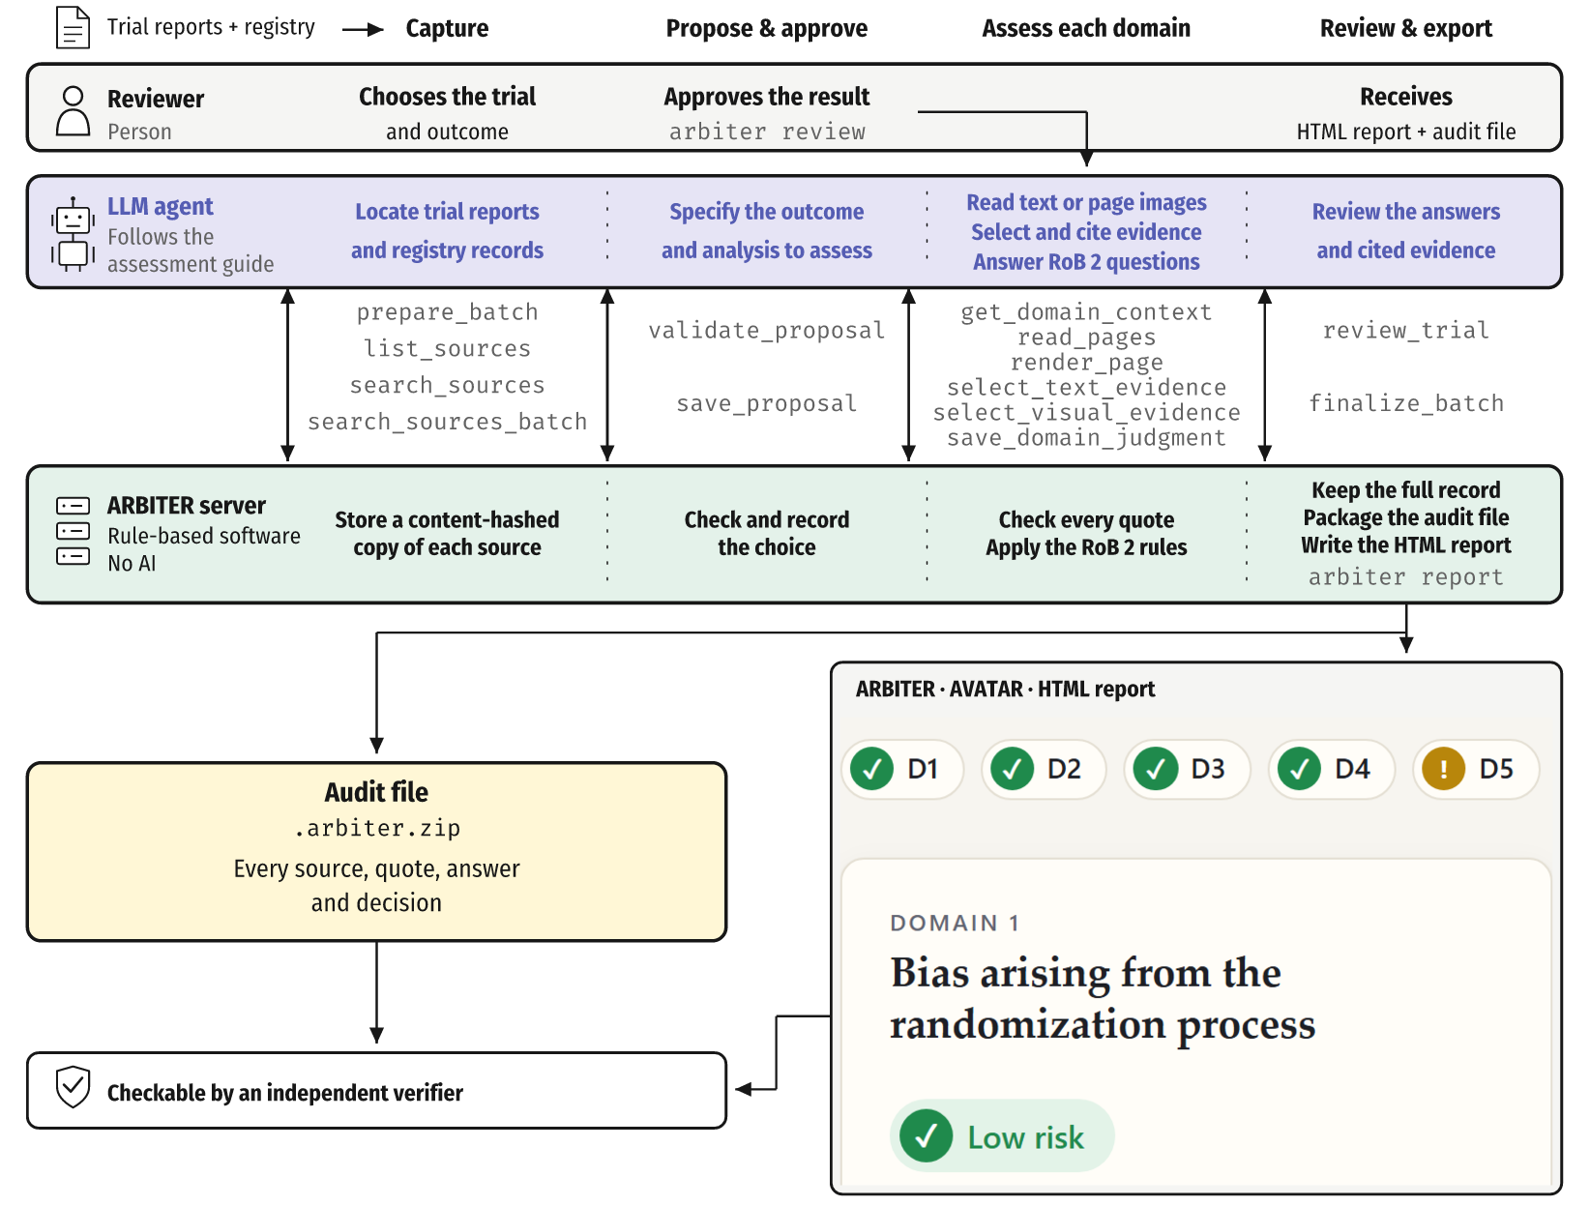
Figure 1. ARBITER splits the work: an AI model reads and answers; rule-based software checks quotes, applies RoB 2 rules and records everything. Lanes show the reviewer, AI model, ARBITER server and audit file across capture, approval, domain assessment and export. Plain labels show actions; gray text names the underlying tool calls. The reviewer receives the HTML report and audit file, both checkable by an independent verifier. RoB 2 is the Cochrane risk-of-bias tool for randomised trials.

Figure 2
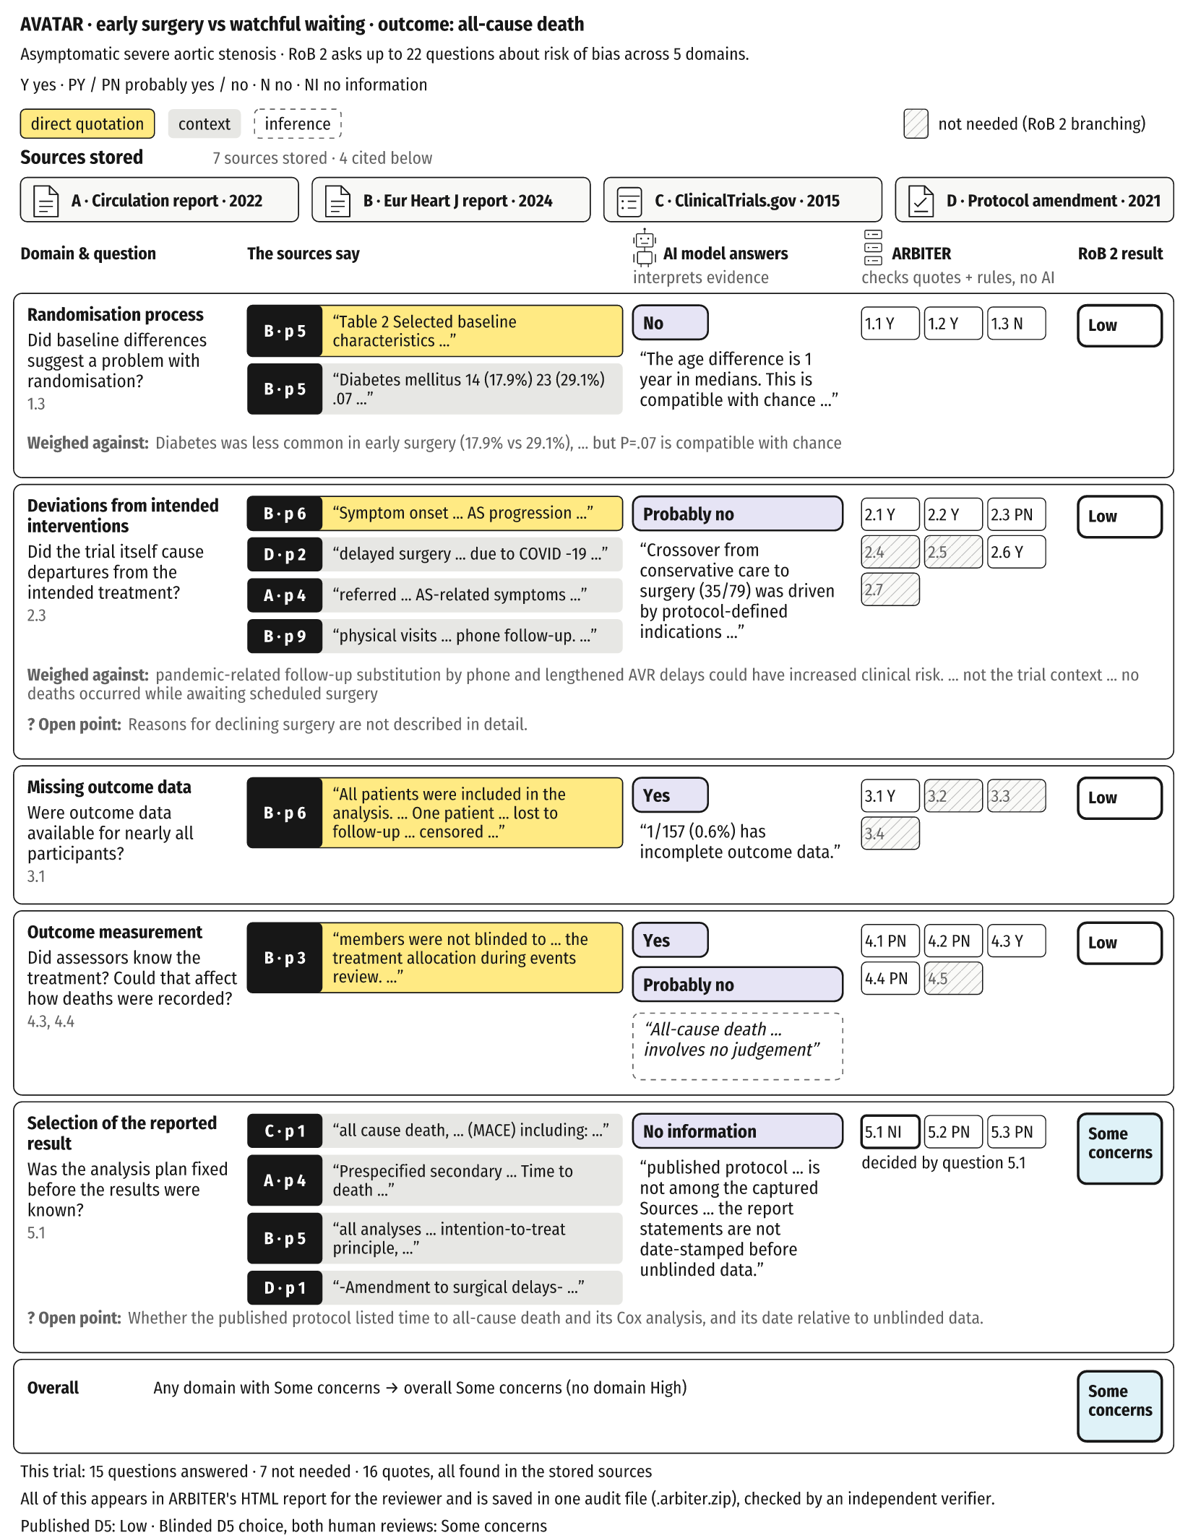
Figure 2. Each answer is tied to stored sources, and RoB 2 rules compute the rating across every domain. AVATAR compares early surgery with watchful waiting in asymptomatic severe aortic stenosis; the outcome is all-cause death. This trial was chosen to illustrate the process, not as representative. Rows link paraphrased questions, source excerpts, AI answers, software checks and domain ratings. Letter/page tabs identify sources; “Weighed against” and “Open point” give counter-evidence and unknowns. A missing dated analysis plan leads to Some concerns overall. Full answers and official question wording appear in the linked repository AVATAR answer and evidence records. Y, yes; PY, probably yes; PN, probably no; N, no; NI, no information. The footer compares the Published D5 label with the subsequent blinded D5 choices from both human reviews; it does not report independently rated Overall judgments.
Complete AVATAR answers · Complete AVATAR evidence and quotations

Figure 3
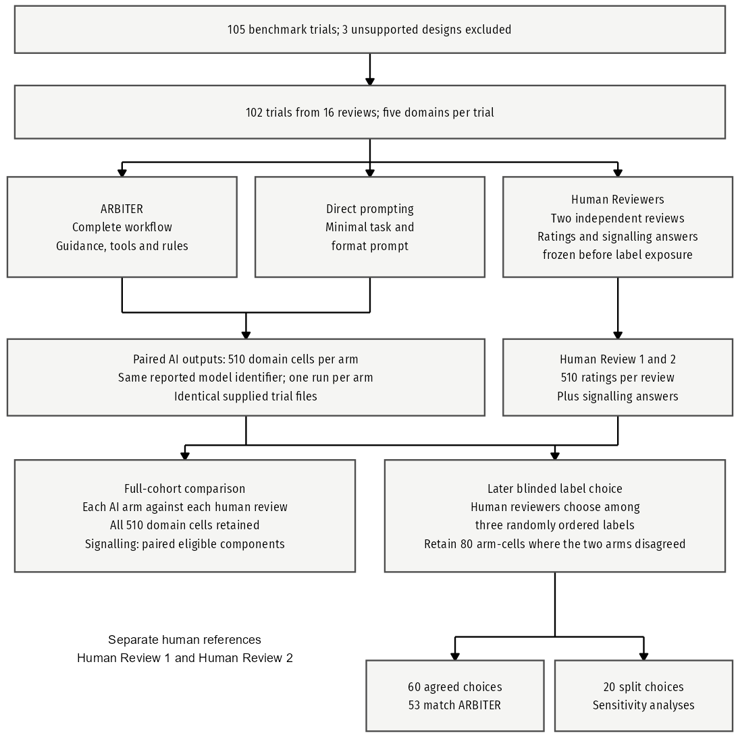
Figure 3. Parallel assessment lanes and conditional blinded-label choices. ARBITER, Direct prompting and Human Reviewers assess the same benchmark. Both AI arms assessed the same 102 trials using the same reported model identifier and supplied documents. Two human reviewers independently recorded ratings and signalling answers for all 510 trial-domain cells before viewing labels. In a separate stage, each chose among three labels presented in random order without rationales. The conditional choice estimate uses 60 agreed choices from 80 arm-cells where the two arms disagreed; 20 split choices enter sensitivities. The all-cell human reviewer comparisons are not restricted to that conditional population. Counts are trials or cells as indicated; no interval applies.

Figure 4
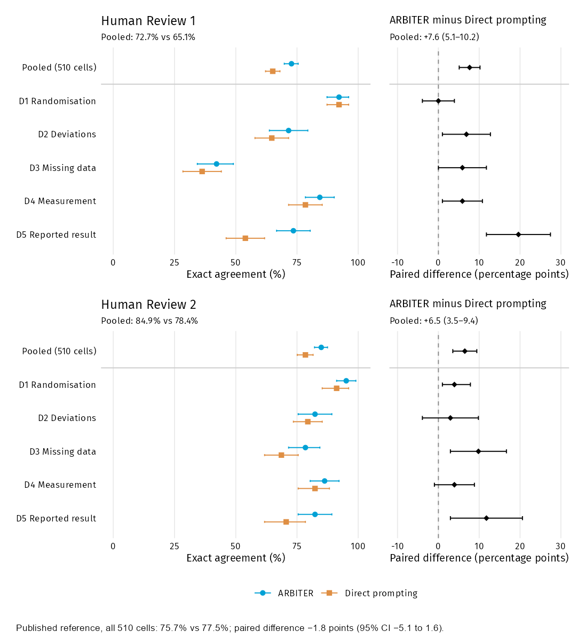
Figure 4. Absolute and paired domain agreement with each independent human reviewer. Blue circles denote ARBITER and orange squares Direct prompting. Left panels show exact agreement with 95% intervals on a 0–100% scale; right panels show paired ARBITER minus Direct prompting differences in percentage points, with neutral diamonds and zero lines. Each human reviewer contributes 510 pooled cells and 102 per domain. Between human reviews agreement is 388/510 (76.1%; weighted κ 0.59), context rather than a performance ceiling. The compact Published comparison retains all 510 cells. D1: randomisation process; D2: deviations from intended interventions; D3: missing outcome data; D4: outcome measurement; D5: selection of the reported result. CI, 95% confidence interval; 10,000 percentile bootstrap replicates, trials resampled within meta-analysis; seed 20261018.

Figure 5
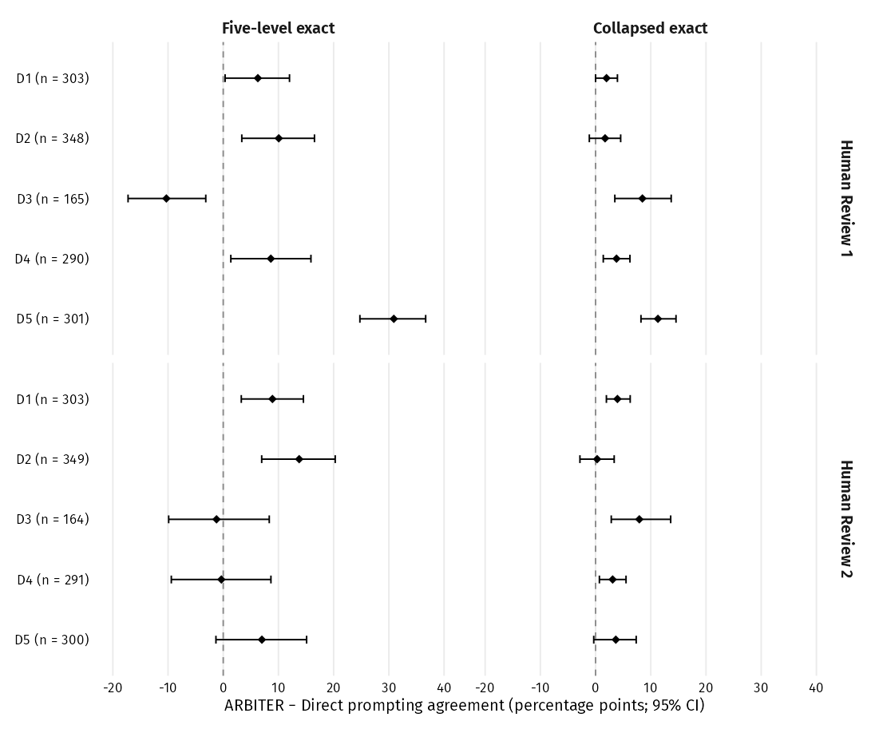
Figure 5. Paired signalling-answer diagnostics. Rows cover all five domains against each human reviewer; n is the number of question components evaluable in both arms. Diamonds and bars show ARBITER minus Direct prompting exact agreement and 95% intervals. Five-level matching distinguishes yes, probably yes, no, probably no and no information. Collapsed matching combines yes/probably yes and no/probably no, leaving no information separate. These are different estimands. D1: randomisation process; D2: deviations from intended interventions; D3: missing outcome data; D4: outcome measurement; D5: selection of the reported result. D3 and D5 illustrate reference dependence and the effect of coding. eTable 5 contains source-specific domain summaries, complete paired question contrasts and eligibility accounting for both codings. CI, 95% confidence interval; 10,000 percentile bootstrap replicates, trials resampled within meta-analysis; seed 20261018.

Tables

Table 2. Benchmark and reference context
Characteristic | Value
Trials | 102
Meta-analyses | 16
Specialties | 15
Trials with protocol | 26/102 (25.5%)
Trials with registry | 73/102 (71.6%)
Trials with SAP | 22/102 (21.6%)
Trials with supplement | 69/102 (67.6%)
D1–D5: Human Review 1 | Low: 277/510 (54.3%); Some concerns: 163/510 (32.0%); High: 70/510 (13.7%)
D1–D5: Human Review 2 | Low: 346/510 (67.8%); Some concerns: 131/510 (25.7%); High: 33/510 (6.5%)
D1–D5: Published | Low: 427/510 (83.7%); Some concerns: 69/510 (13.5%); High: 14/510 (2.7%)
D1–D5: ARBITER | Low: 375/510 (73.5%); Some concerns: 114/510 (22.4%); High: 21/510 (4.1%)
D1–D5: Direct prompting | Low: 407/510 (79.8%); Some concerns: 80/510 (15.7%); High: 23/510 (4.5%)
Rating categories are Low, Some concerns and High; each source contributes 510 domain cells. Document counts are trials with each role recorded in the source inventory among 102 trials; roles can overlap. SAP, statistical analysis plan. Source distributions and separate human reviewer agreement appear in the compact supplement.
Download editable Word table

Table 3. Process checks and computational resources
Measure | ARBITER | Direct prompting | Paired mean difference (95% CI)
A. Rule conformance
Domain outputs reproduced from proposals | 510/510 (100.0%) | Not available | —
Rating contradicts its own answers | 0 by design | 26/509 (5.1%; 3.3–6.9) | —
Required question skipped | 0 by design | 39/509 (7.7%; 5.7–10.0) | —
Any rule break | 0 by design | 65/509 (12.8%; 10.0–15.6) | —
B. Computational resources
Runtime (minutes/trial), median (IQR) | 7.6 (6.1–10.5) | 0.5 (0.4–0.5) | 11.0 (8.4–14.1)
API list-price equivalent (US$/trial), median (IQR) | 3.78 (3.46–4.10) | 0.09 (0.07–0.13) | 3.68 (3.61–3.75)
C. Evidence records (ARBITER only)
Active required answers citing evidence | 1,538/1,538 (100.0%) | Not available | —
Text spans with complete binding fields | 1,407/1,407 (100.0%) | Not available | —
Image records with complete fields | 14/14 (100%) | Not available | —
Exported records passing verification | 102/102 (100.0%) | Not available | —
Direct prompting rule-break cells show No./total (%; 95% CI); CI bounds are percentages. Domain rules use evaluable ratings (ARBITER 510; Direct prompting 509); one Direct prompting cell is unevaluable. ARBITER has no recorded domain overrides; one Overall escalation is permitted. Runtime and API list-price equivalents use 102 paired trials; source summaries are median (IQR), contrasts are paired mean differences. Cost is a frozen-rate equivalent, not expenditure. Evidence-record checks do not assess whether evidence supports an answer. — means not applicable; Not available means not measured. CI, 95% confidence interval; 10,000 percentile bootstrap replicates, trials resampled within meta-analysis; seed 20261018.
Download editable Word table

Table 4. Conditional blinded-label choices and sensitivities
Population | ARBITER, No./total (%) (95% CI)
Agreed choices | 53/60 (88%; 80–96)
Human Review 1 | 63/80 (79%; 70–87)
Human Review 2 | 61/80 (76%; 68–85)
All splits counted against ARBITER | 53/80 (66%; 58–75)
Conditional blinded-label choice evaluation includes 80 arm-cells where the two arms disagreed and the 60 for which the human reviewers made an agreed choice; 20 choices split. Review-specific sensitivities use all 80. The final row counts all 20 splits against ARBITER by assumption, without assigning Direct prompting wins. Human Review 1 chose neither arm in 4/80 cells; this is distinct from the split-loss assumption. CI, 95% confidence interval; 10,000 percentile bootstrap replicates, trials resampled within meta-analysis; seed 20261018.
Download editable Word table

Reproduction
The study repository contains the analysis pipeline, test suite, numerical exports and output verifier. Supplementary methods and results provide supporting estimates, complete paired question results, prompts, reporting locations and links to the complete worked-example records. Trial PDFs are not redistributed.

