clinical failure: fixed-effect meta-analysis (odds ratio)
Comparison: Intervention / Control

Methods
Odds ratios were pooled using a fixed-effect model. A continuity correction of 0.5 was applied to individual study estimates only; the pooled Mantel-Haenszel estimate uses the original counts. Heterogeneity was assessed with Cochran's Q and I². Analyses were performed in RC MetaStudio 0.5.1. R packages loaded for this analysis: metafor 5.0.1, meta 8.5-0.

Results
19 studies were included (1097 participants in Intervention, 1080 in Control). The pooled odds ratio was 0.712 (95% CI [0.543, 0.934], z = -2.455, p = .014). The confidence interval excludes 1, with lower odds of the outcome in Intervention than in Control. Heterogeneity: Q = 33.492, df = 18, p = .006. I² = 52.2%, which may represent moderate to substantial heterogeneity (Cochrane Handbook ranges).
Table 1. Pooled effect
Effect | Estimate | 95% CI | SE | z | p
Odds ratio | 0.712 | 0.543 to 0.934 | 0.138 | -2.455 | .014

Table 2. Model fit
Statistic | Value
Studies (k) | 19
Participants in Intervention | 1097
Participants in Control | 1080
Cochran’s Q | 33.492
Heterogeneity degrees of freedom | 18
Heterogeneity p | .006
I² | 52.2%

Table 3. Study results
Study | Effect | 95% CI | Weight
Gonzalez | 0.571 | 0.170 to 1.916 | 5.6%
Prins | 0.436 | 0.107 to 1.772 | 5.1%
Giamarellou | 0.076 | 0.004 to 1.441 | 4.0%
Maller | 1.401 | 0.667 to 2.945 | 9.6%
Sturm | 0.189 | 0.009 to 4.080 | 1.6%
Marik | 0.395 | 0.229 to 0.680 | 33.8%
Muijsken | 1.611 | 0.491 to 5.289 | 3.4%
Vigano | 2.878 | 0.115 to 71.821 | 0.0%
Hansen | 0.140 | 0.028 to 0.704 | 7.8%
De Vries | 1.973 | 0.475 to 8.188 | 2.3%
Mauracher | 0.073 | 0.004 to 1.311 | 4.8%
Nordstrom | 0.663 | 0.134 to 3.282 | 3.0%
Rozdzinski | 1.018 | 0.464 to 2.236 | 9.9%
Ter Braak | 1.356 | 0.501 to 3.666 | 5.4%
Tulkens | Not estimable | — to — | 0.0%
Van der Auwera | 0.187 | 0.009 to 4.062 | 1.6%
Klastersky | 5.762 | 1.363 to 24.362 | 1.3%
Vanhaeverbeek | Not estimable | — to — | 0.0%
Hollender | 0.316 | 0.013 to 7.928 | 0.8%

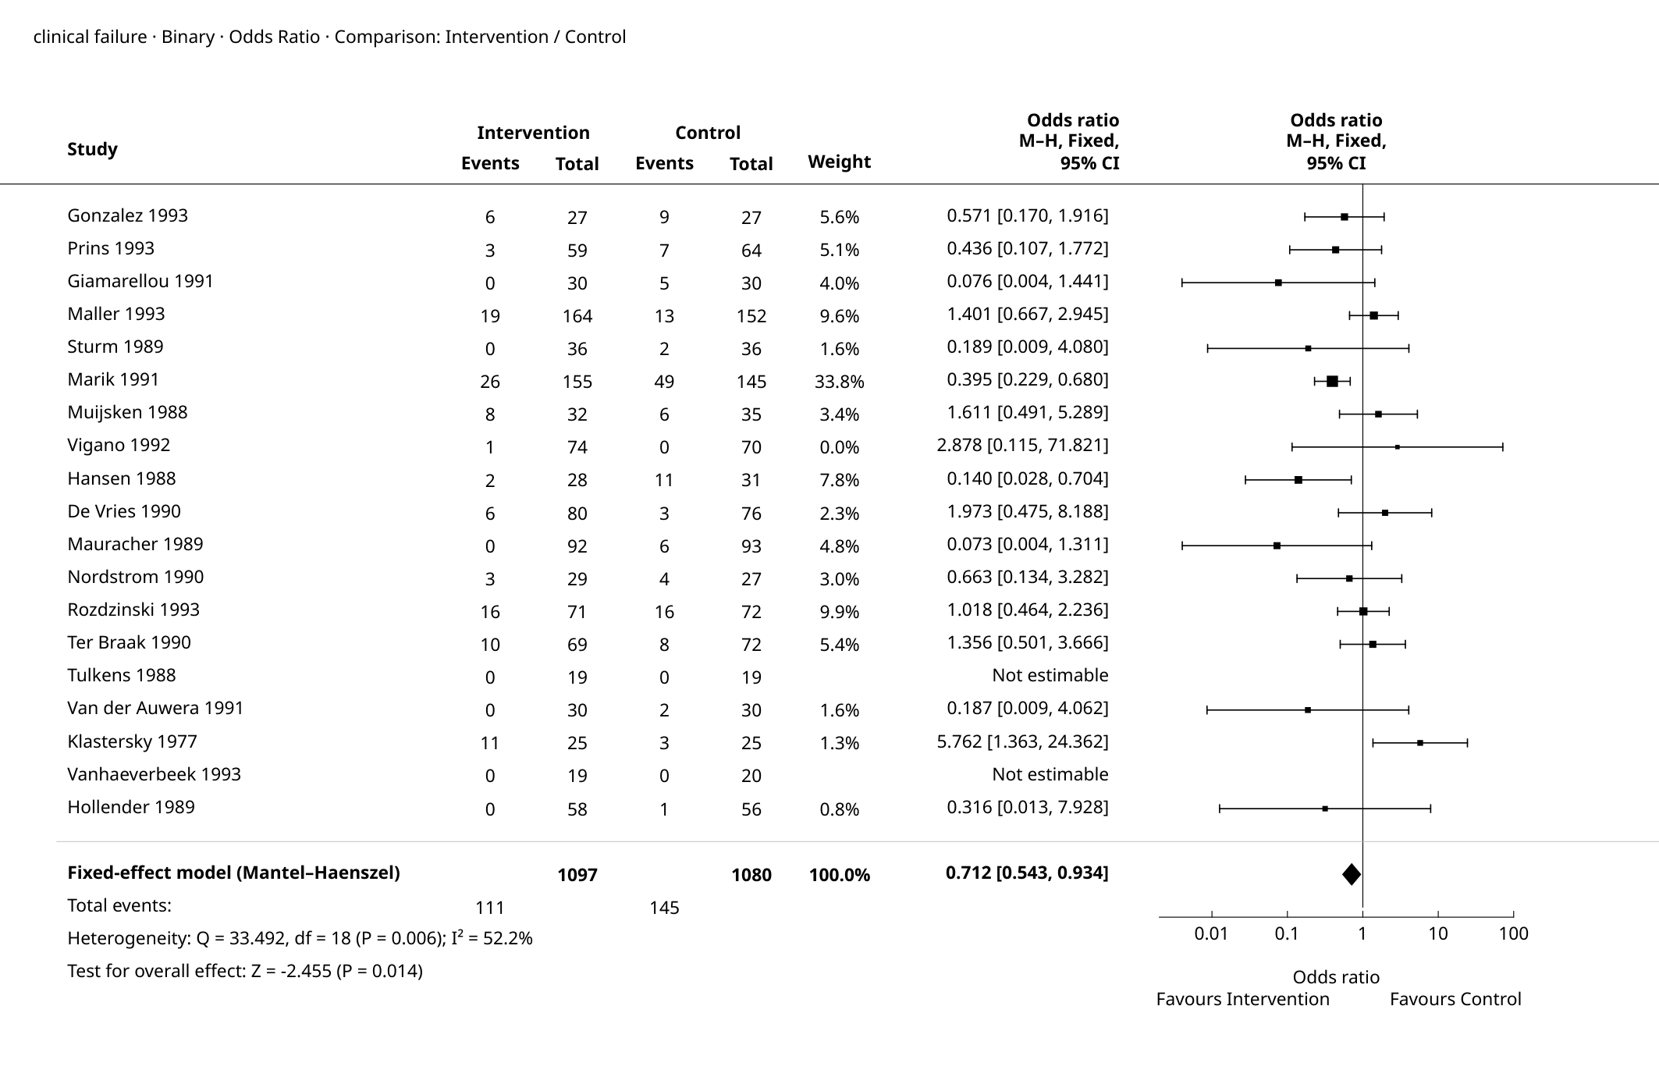
Figure 1. Forest Plot

Supplementary details
Table 4. Full-precision results
Source | Results
Summary — Model Results | Estimate: 0.712  Lower bound (95% CI): 0.543  Upper bound (95% CI): 0.934  p-value: 0.014
Summary — Heterogeneity | Q: 33.492  df: 18  p-value: 0.006  I²: 52.2%
Summary — Test for overall effect | Z: -2.455  p-value: 0.014
Summary — Calculation scale (log) | Estimate: -0.340  Lower bound (95% CI): -0.611  Upper bound (95% CI): -0.069  SE (log scale): 0.138
Weights — Study weights | Study: Gonzalez  Effect: 0.571  Lower bound: 0.170  Upper bound: 1.916  Weight (%): 5.6%
Weights — Study weights | Study: Prins  Effect: 0.436  Lower bound: 0.107  Upper bound: 1.772  Weight (%): 5.1%
Weights — Study weights | Study: Giamarellou  Effect: 0.076  Lower bound: 0.004  Upper bound: 1.441  Weight (%): 4.0%
Weights — Study weights | Study: Maller  Effect: 1.401  Lower bound: 0.667  Upper bound: 2.945  Weight (%): 9.6%
Weights — Study weights | Study: Sturm  Effect: 0.189  Lower bound: 0.009  Upper bound: 4.080  Weight (%): 1.6%
Weights — Study weights | Study: Marik  Effect: 0.395  Lower bound: 0.229  Upper bound: 0.680  Weight (%): 33.8%
Weights — Study weights | Study: Muijsken  Effect: 1.611  Lower bound: 0.491  Upper bound: 5.289  Weight (%): 3.4%
Weights — Study weights | Study: Vigano  Effect: 2.878  Lower bound: 0.115  Upper bound: 71.821  Weight (%): 0.0%
Weights — Study weights | Study: Hansen  Effect: 0.140  Lower bound: 0.028  Upper bound: 0.704  Weight (%): 7.8%
Weights — Study weights | Study: De Vries  Effect: 1.973  Lower bound: 0.475  Upper bound: 8.188  Weight (%): 2.3%
Weights — Study weights | Study: Mauracher  Effect: 0.073  Lower bound: 0.004  Upper bound: 1.311  Weight (%): 4.8%
Weights — Study weights | Study: Nordstrom  Effect: 0.663  Lower bound: 0.134  Upper bound: 3.282  Weight (%): 3.0%
Weights — Study weights | Study: Rozdzinski  Effect: 1.018  Lower bound: 0.464  Upper bound: 2.236  Weight (%): 9.9%
Weights — Study weights | Study: Ter Braak  Effect: 1.356  Lower bound: 0.501  Upper bound: 3.666  Weight (%): 5.4%
Weights — Study weights | Study: Tulkens  Effect: Not estimable  Lower bound: —  Upper bound: —  Weight (%): 0.0%
Weights — Study weights | Study: Van der Auwera  Effect: 0.187  Lower bound: 0.009  Upper bound: 4.062  Weight (%): 1.6%
Weights — Study weights | Study: Klastersky  Effect: 5.762  Lower bound: 1.363  Upper bound: 24.362  Weight (%): 1.3%
Weights — Study weights | Study: Vanhaeverbeek  Effect: Not estimable  Lower bound: —  Upper bound: —  Weight (%): 0.0%
Weights — Study weights | Study: Hollender  Effect: 0.316  Lower bound: 0.013  Upper bound: 7.928  Weight (%): 0.8%

Pooled Odds Ratio: 0.712 (95% CI 0.543 to 0.934).

References
1. Mantel-Haenszel meta-analysis: Mantel, N., & Haenszel, W. (1959). Statistical aspects of the analysis of data from retrospective studies of disease. Journal of the National Cancer Institute, 22(4), 719-748. doi:10.1093/jnci/22.4.719.
2. Common-effect sparse-data estimation: Greenland, S., & Robins, J. M. (1985). Estimation of a common effect parameter from sparse follow-up data. Biometrics, 41(1), 55-68. doi:10.2307/2530643.
3. Implementation reference: Viechtbauer, W. (2010). Conducting meta-analyses in R with the metafor package. Journal of Statistical Software, 36(3), 1-48. doi:10.18637/jss.v036.i03.

