blood pressure: random-effects meta-analysis (standardized mean difference)
Comparison: Intervention / Control

Methods
Standardized mean differences were pooled using a random-effects model with the DerSimonian–Laird estimator of between-study variance. Confidence intervals (95%) used the normal approximation. Heterogeneity was assessed with Cochran's Q and I². Analyses were performed in RC MetaStudio 0.5.1. R packages loaded for this analysis: metafor 5.0.1, meta 8.5-0.

Results
6 studies were included (500 participants in Intervention, 495 in Control). The pooled standardized mean difference was 0.358 (95% CI [0.152, 0.565], z = 3.400, p < .001). The confidence interval excludes 0, with higher mean values in Intervention than in Control. Heterogeneity: Q = 11.914, df = 5, p = .036. I² = 58.0%, which may represent moderate to substantial heterogeneity (Cochrane Handbook ranges). Between-study variance was τ² = 0.037. The 95% prediction interval was -0.072 to 0.789.
Table 1. Pooled effect
Effect | Estimate | 95% CI | SE | z | p
Standardized mean difference | 0.358 | 0.152 to 0.565 | 0.105 | 3.400 | < .001

Table 2. Model fit
Statistic | Value
Studies (k) | 6
Participants in Intervention | 500
Participants in Control | 495
Cochran’s Q | 11.914
Heterogeneity degrees of freedom | 5
Heterogeneity p | .036
I² | 58.0%
Between-study variance (τ²) | 0.037
95% prediction interval | -0.072 to 0.789

Table 3. Study results
Study | Effect | 95% CI | Weight
Carroll | 0.095 | -0.264 to 0.453 | 15.8%
Grant | 0.277 | -0.068 to 0.623 | 16.3%
Peck | 0.367 | -0.075 to 0.808 | 12.6%
Donat | 0.664 | 0.463 to 0.866 | 23.3%
Stewart | 0.462 | 0.054 to 0.870 | 13.8%
Young | 0.185 | -0.116 to 0.486 | 18.3%

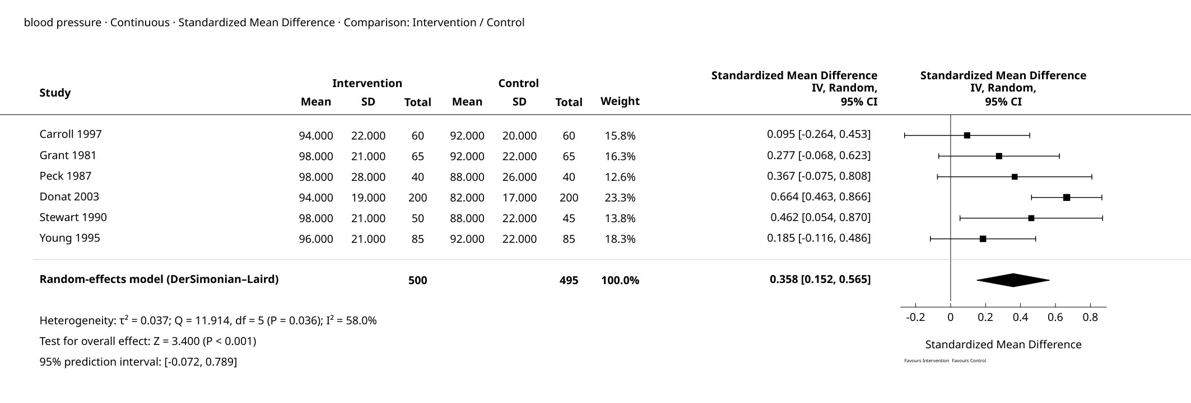
Figure 1. Forest Plot

Supplementary details
Table 4. Full-precision results
Source | Results
Summary — Model Results | Estimate: 0.358  Lower bound (95% CI): 0.152  Upper bound (95% CI): 0.565  SE (standardized scale): 0.105  p-value: < 0.001
Summary — Heterogeneity | Q: 11.914  df: 5  p-value: 0.036  I²: 58.0%  τ²: 0.037
Summary — Test for overall effect | Z: 3.400  p-value: < 0.001
Summary — Prediction interval | Lower bound (95% PI): -0.072  Upper bound (95% PI): 0.789
Weights — Study weights | Study: Carroll  Effect: 0.095  Lower bound: -0.264  Upper bound: 0.453  Weight (%): 15.8%
Weights — Study weights | Study: Grant  Effect: 0.277  Lower bound: -0.068  Upper bound: 0.623  Weight (%): 16.3%
Weights — Study weights | Study: Peck  Effect: 0.367  Lower bound: -0.075  Upper bound: 0.808  Weight (%): 12.6%
Weights — Study weights | Study: Donat  Effect: 0.664  Lower bound: 0.463  Upper bound: 0.866  Weight (%): 23.3%
Weights — Study weights | Study: Stewart  Effect: 0.462  Lower bound: 0.054  Upper bound: 0.870  Weight (%): 13.8%
Weights — Study weights | Study: Young  Effect: 0.185  Lower bound: -0.116  Upper bound: 0.486  Weight (%): 18.3%

Pooled Standardized Mean Difference: 0.358 (95% CI 0.152 to 0.565).
95% prediction interval: the underlying effect in a new study; this is not the confidence interval of the pooled estimate.

References
1. Random-effects meta-analysis: DerSimonian, R., & Laird, N. (1986). Meta-analysis in clinical trials. Controlled Clinical Trials, 7(3), 177-188. doi:10.1016/0197-2456(86)90046-2.
2. Random-effects meta-analysis: Hedges, L. V. (1983). A random effects model for effect sizes. Psychological Bulletin, 93(2), 388-395. doi:10.1037/0033-2909.93.2.388.
3. Implementation reference: Viechtbauer, W. (2010). Conducting meta-analyses in R with the metafor package. Journal of Statistical Software, 36(3), 1-48. doi:10.18637/jss.v036.i03.

