clinical failure: fixed-effect meta-analysis (odds ratio)
Comparison: Intervention / Control

Methods
Odds ratios were pooled using a fixed-effect model. A continuity correction of 0.5 was applied to individual study estimates only; the pooled Peto estimate uses the original counts. Heterogeneity was assessed with Cochran's Q and I². Analyses were performed in RC MetaStudio 0.5.1. R packages loaded for this analysis: metafor 5.0.1, meta 8.5-0.

Results
19 studies were included (1097 participants in Intervention, 1080 in Control). The pooled odds ratio was 0.710 (95% CI [0.541, 0.930], z = -2.482, p = .013). The confidence interval excludes 1, with lower odds of the outcome in Intervention than in Control. Heterogeneity: Q = 41.000, df = 18, p = .002. I² = 56.1%, which may represent moderate to substantial heterogeneity (Cochrane Handbook ranges).
Table 1. Pooled effect
Effect | Estimate | 95% CI | SE | z | p
Odds ratio | 0.710 | 0.541 to 0.930 | 0.138 | -2.482 | .013

Table 2. Model fit
Statistic | Value
Studies (k) | 19
Participants in Intervention | 1097
Participants in Control | 1080
Cochran’s Q | 41.000
Heterogeneity degrees of freedom | 18
Heterogeneity p | .002
I² | 56.1%

Table 3. Study results
Study | Effect | 95% CI | Weight
Gonzalez | 0.581 | 0.178 to 1.889 | 5.3%
Prins | 0.460 | 0.127 to 1.668 | 4.4%
Giamarellou | 0.163 | 0.031 to 0.865 | 2.2%
Maller | 1.394 | 0.672 to 2.894 | 13.8%
Sturm | 0.254 | 0.026 to 2.519 | 0.9%
Marik | 0.405 | 0.240 to 0.682 | 26.9%
Muijsken | 1.597 | 0.496 to 5.148 | 5.4%
Vigano | 2.592 | 0.160 to 41.886 | 0.5%
Hansen | 0.198 | 0.058 to 0.671 | 4.9%
De Vries | 1.914 | 0.500 to 7.326 | 4.1%
Mauracher | 0.172 | 0.038 to 0.775 | 2.8%
Nordstrom | 0.669 | 0.139 to 3.220 | 3.0%
Rozdzinski | 1.018 | 0.465 to 2.229 | 12.0%
Ter Braak | 1.352 | 0.504 to 3.624 | 7.6%
Tulkens | 1.000 | 0.020 to 50.397 | 0.0%
Van der Auwera | 0.252 | 0.025 to 2.516 | 0.9%
Klastersky | 4.738 | 1.396 to 16.084 | 4.9%
Vanhaeverbeek | 1.050 | 0.021 to 52.979 | 0.0%
Hollender | 0.352 | 0.022 to 5.700 | 0.5%

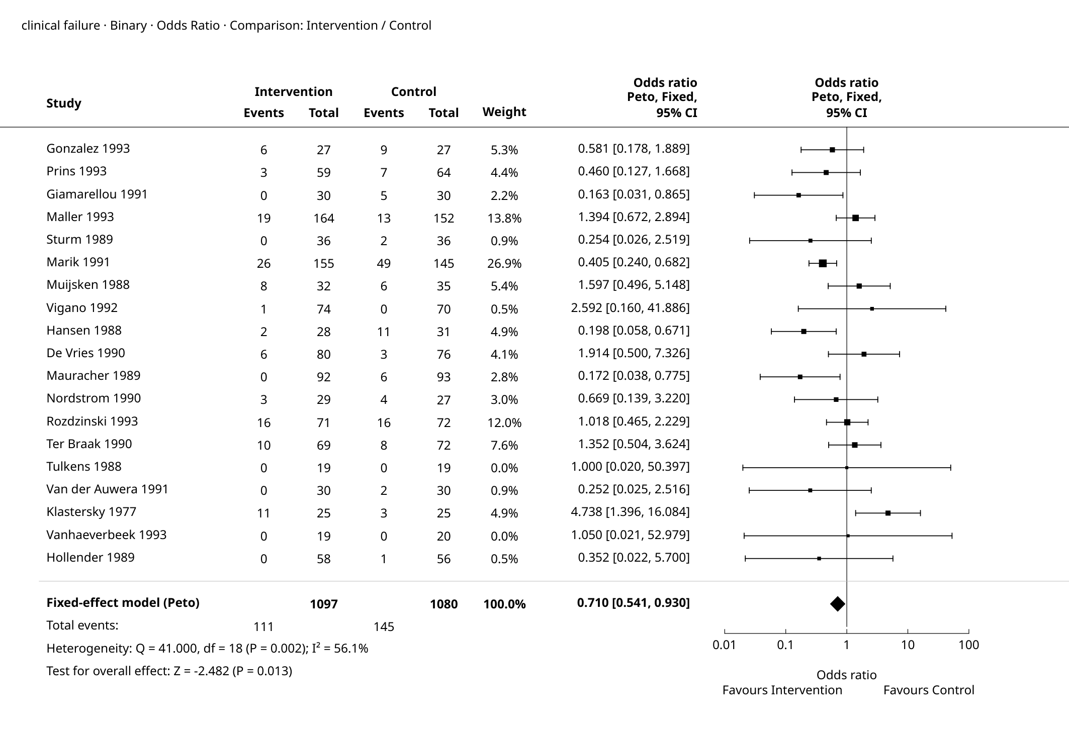
Figure 1. Forest Plot

Supplementary details
Table 4. Full-precision results
Source | Results
Summary — Model Results | Estimate: 0.710  Lower bound (95% CI): 0.541  Upper bound (95% CI): 0.930  p-value: 0.013
Summary — Heterogeneity | Q: 41.000  df: 18  p-value: 0.002  I²: 56.1%
Summary — Test for overall effect | Z: -2.482  p-value: 0.013
Summary — Calculation scale (log) | Estimate: -0.343  Lower bound (95% CI): -0.614  Upper bound (95% CI): -0.072  SE (log scale): 0.138
Weights — Study weights | Study: Gonzalez  Effect: 0.581  Lower bound: 0.178  Upper bound: 1.889  Weight (%): 5.3%
Weights — Study weights | Study: Prins  Effect: 0.460  Lower bound: 0.127  Upper bound: 1.668  Weight (%): 4.4%
Weights — Study weights | Study: Giamarellou  Effect: 0.163  Lower bound: 0.031  Upper bound: 0.865  Weight (%): 2.2%
Weights — Study weights | Study: Maller  Effect: 1.394  Lower bound: 0.672  Upper bound: 2.894  Weight (%): 13.8%
Weights — Study weights | Study: Sturm  Effect: 0.254  Lower bound: 0.026  Upper bound: 2.519  Weight (%): 0.9%
Weights — Study weights | Study: Marik  Effect: 0.405  Lower bound: 0.240  Upper bound: 0.682  Weight (%): 26.9%
Weights — Study weights | Study: Muijsken  Effect: 1.597  Lower bound: 0.496  Upper bound: 5.148  Weight (%): 5.4%
Weights — Study weights | Study: Vigano  Effect: 2.592  Lower bound: 0.160  Upper bound: 41.886  Weight (%): 0.5%
Weights — Study weights | Study: Hansen  Effect: 0.198  Lower bound: 0.058  Upper bound: 0.671  Weight (%): 4.9%
Weights — Study weights | Study: De Vries  Effect: 1.914  Lower bound: 0.500  Upper bound: 7.326  Weight (%): 4.1%
Weights — Study weights | Study: Mauracher  Effect: 0.172  Lower bound: 0.038  Upper bound: 0.775  Weight (%): 2.8%
Weights — Study weights | Study: Nordstrom  Effect: 0.669  Lower bound: 0.139  Upper bound: 3.220  Weight (%): 3.0%
Weights — Study weights | Study: Rozdzinski  Effect: 1.018  Lower bound: 0.465  Upper bound: 2.229  Weight (%): 12.0%
Weights — Study weights | Study: Ter Braak  Effect: 1.352  Lower bound: 0.504  Upper bound: 3.624  Weight (%): 7.6%
Weights — Study weights | Study: Tulkens  Effect: 1.000  Lower bound: 0.020  Upper bound: 50.397  Weight (%): 0.0%
Weights — Study weights | Study: Van der Auwera  Effect: 0.252  Lower bound: 0.025  Upper bound: 2.516  Weight (%): 0.9%
Weights — Study weights | Study: Klastersky  Effect: 4.738  Lower bound: 1.396  Upper bound: 16.084  Weight (%): 4.9%
Weights — Study weights | Study: Vanhaeverbeek  Effect: 1.050  Lower bound: 0.021  Upper bound: 52.979  Weight (%): 0.0%
Weights — Study weights | Study: Hollender  Effect: 0.352  Lower bound: 0.022  Upper bound: 5.700  Weight (%): 0.5%

Pooled Odds Ratio: 0.710 (95% CI 0.541 to 0.930).

References
1. Peto one-step odds-ratio method: Yusuf, S., Peto, R., Lewis, J., Collins, R., & Sleight, P. (1985). Beta blockade during and after myocardial infarction: An overview of the randomized trials. Progress in Cardiovascular Disease, 27(5), 335-371. doi:10.1016/S0033-0620(85)80003-7.
2. Sparse-data comparison: Bradburn, M. J., Deeks, J. J., Berlin, J. A., & Localio, A. R. (2007). Much ado about nothing: A comparison of the performance of meta-analytical methods with rare events. Statistics in Medicine, 26(1), 53-77. doi:10.1002/sim.2528.
3. Implementation reference: Viechtbauer, W. (2010). Conducting meta-analyses in R with the metafor package. Journal of Statistical Software, 36(3), 1-48. doi:10.18637/jss.v036.i03.

