clinical failure: random-effects meta-analysis (odds ratio)
Comparison: Intervention / Control

Methods
Odds ratios were pooled using a random-effects model with the DerSimonian–Laird estimator of between-study variance. Confidence intervals (95%) used the normal approximation. A continuity correction of 0.5 was applied to studies with any zero cell. 2 studies with no events in either arm were retained with this correction. Heterogeneity was assessed with Cochran's Q and I². Analyses were performed in RC MetaStudio 0.5.1. R packages loaded for this analysis: metafor 5.0.1, meta 8.5-0.

Results
19 studies were included (1097 participants in Intervention, 1080 in Control). The pooled odds ratio was 0.770 (95% CI [0.485, 1.222], z = -1.111, p = .267). The confidence interval includes 1, so these data do not show a clear difference between Intervention and Control. Heterogeneity: Q = 33.360, df = 18, p = .015. I² = 46.0%, which may represent moderate heterogeneity (Cochrane Handbook ranges). Between-study variance was τ² = 0.378. The 95% prediction interval was 0.212 to 2.799.
Table 1. Pooled effect
Effect | Estimate | 95% CI | SE | z | p
Odds ratio | 0.770 | 0.485 to 1.222 | 0.236 | -1.111 | .267

Table 2. Model fit
Statistic | Value
Studies (k) | 19
Participants in Intervention | 1097
Participants in Control | 1080
Cochran’s Q | 33.360
Heterogeneity degrees of freedom | 18
Heterogeneity p | .015
I² | 46.0%
Between-study variance (τ²) | 0.378
95% prediction interval | 0.212 to 2.799

Table 3. Study results
Study | Effect | 95% CI | Weight
Gonzalez | 0.571 | 0.170 to 1.916 | 7.3%
Prins | 0.436 | 0.107 to 1.772 | 6.2%
Giamarellou | 0.076 | 0.004 to 1.441 | 2.1%
Maller | 1.401 | 0.667 to 2.945 | 10.7%
Sturm | 0.189 | 0.009 to 4.080 | 2.0%
Marik | 0.395 | 0.229 to 0.680 | 12.2%
Muijsken | 1.611 | 0.491 to 5.289 | 7.5%
Vigano | 2.878 | 0.115 to 71.821 | 1.8%
Hansen | 0.140 | 0.028 to 0.704 | 5.3%
De Vries | 1.973 | 0.475 to 8.188 | 6.1%
Mauracher | 0.073 | 0.004 to 1.311 | 2.2%
Nordstrom | 0.663 | 0.134 to 3.282 | 5.3%
Rozdzinski | 1.018 | 0.464 to 2.236 | 10.3%
Ter Braak | 1.356 | 0.501 to 3.666 | 8.7%
Tulkens | 1 | 0.019 to 52.977 | 1.2%
Van der Auwera | 0.187 | 0.009 to 4.062 | 2.0%
Klastersky | 5.762 | 1.363 to 24.362 | 6.0%
Vanhaeverbeek | 1.051 | 0.020 to 55.627 | 1.2%
Hollender | 0.316 | 0.013 to 7.928 | 1.8%

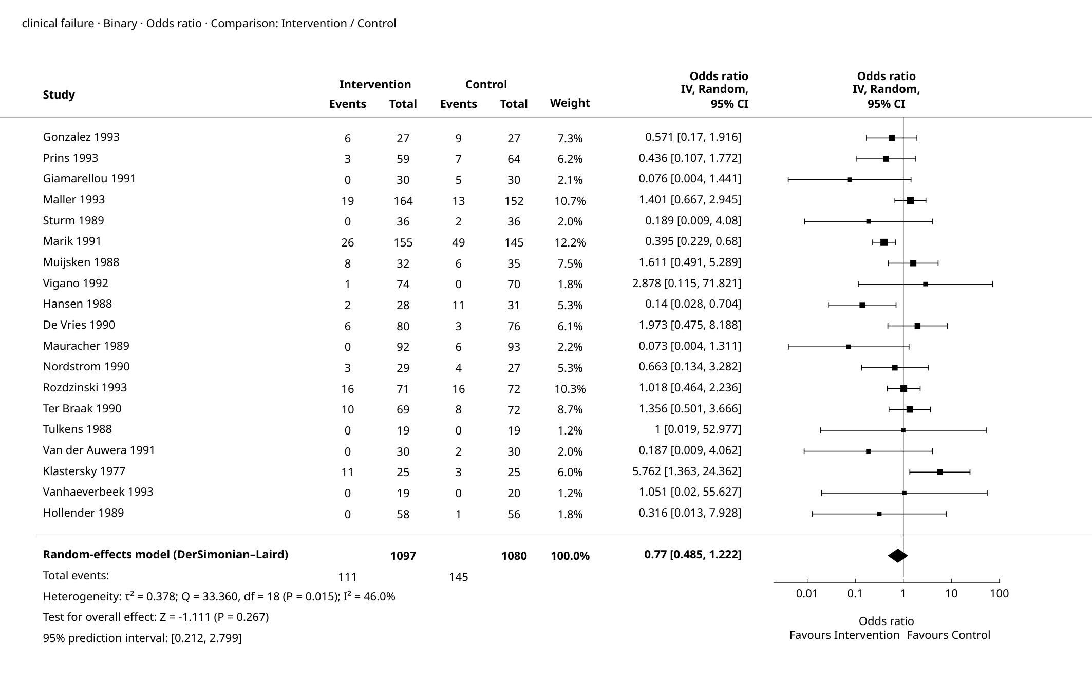
Figure 1. Forest plot

Supplementary details
Table 4. Full-precision results
Source | Results
Summary — Model Results | Estimate: 0.77  Lower bound (95% CI): 0.485  Upper bound (95% CI): 1.222  p-value: 0.267
Summary — Heterogeneity | Q: 33.360  df: 18  p-value: 0.015  I²: 46.0%  τ²: 0.378
Summary — Test for overall effect | Z: -1.111  p-value: 0.267
Summary — Prediction interval | Lower bound (95% PI): 0.212  Upper bound (95% PI): 2.799
Summary — Calculation scale (log) | Estimate: -0.262  Lower bound (95% CI): -0.724  Upper bound (95% CI): 0.200  SE (log scale): 0.236
Weights — Study weights | Study: Gonzalez  Effect: 0.571  Lower bound: 0.17  Upper bound: 1.916  Weight (%): 7.3%
Weights — Study weights | Study: Prins  Effect: 0.436  Lower bound: 0.107  Upper bound: 1.772  Weight (%): 6.2%
Weights — Study weights | Study: Giamarellou  Effect: 0.076  Lower bound: 0.004  Upper bound: 1.441  Weight (%): 2.1%
Weights — Study weights | Study: Maller  Effect: 1.401  Lower bound: 0.667  Upper bound: 2.945  Weight (%): 10.7%
Weights — Study weights | Study: Sturm  Effect: 0.189  Lower bound: 0.009  Upper bound: 4.08  Weight (%): 2.0%
Weights — Study weights | Study: Marik  Effect: 0.395  Lower bound: 0.229  Upper bound: 0.68  Weight (%): 12.2%
Weights — Study weights | Study: Muijsken  Effect: 1.611  Lower bound: 0.491  Upper bound: 5.289  Weight (%): 7.5%
Weights — Study weights | Study: Vigano  Effect: 2.878  Lower bound: 0.115  Upper bound: 71.821  Weight (%): 1.8%
Weights — Study weights | Study: Hansen  Effect: 0.14  Lower bound: 0.028  Upper bound: 0.704  Weight (%): 5.3%
Weights — Study weights | Study: De Vries  Effect: 1.973  Lower bound: 0.475  Upper bound: 8.188  Weight (%): 6.1%
Weights — Study weights | Study: Mauracher  Effect: 0.073  Lower bound: 0.004  Upper bound: 1.311  Weight (%): 2.2%
Weights — Study weights | Study: Nordstrom  Effect: 0.663  Lower bound: 0.134  Upper bound: 3.282  Weight (%): 5.3%
Weights — Study weights | Study: Rozdzinski  Effect: 1.018  Lower bound: 0.464  Upper bound: 2.236  Weight (%): 10.3%
Weights — Study weights | Study: Ter Braak  Effect: 1.356  Lower bound: 0.501  Upper bound: 3.666  Weight (%): 8.7%
Weights — Study weights | Study: Tulkens  Effect: 1  Lower bound: 0.019  Upper bound: 52.977  Weight (%): 1.2%
Weights — Study weights | Study: Van der Auwera  Effect: 0.187  Lower bound: 0.009  Upper bound: 4.062  Weight (%): 2.0%
Weights — Study weights | Study: Klastersky  Effect: 5.762  Lower bound: 1.363  Upper bound: 24.362  Weight (%): 6.0%
Weights — Study weights | Study: Vanhaeverbeek  Effect: 1.051  Lower bound: 0.02  Upper bound: 55.627  Weight (%): 1.2%
Weights — Study weights | Study: Hollender  Effect: 0.316  Lower bound: 0.013  Upper bound: 7.928  Weight (%): 1.8%

Pooled Odds ratio: 0.77 (95% CI 0.485 to 1.222).
95% prediction interval: the underlying effect in a new study; this is not the confidence interval of the pooled estimate.

References
1. Random-effects meta-analysis: DerSimonian, R., & Laird, N. (1986). Meta-analysis in clinical trials. Controlled Clinical Trials, 7(3), 177-188. doi:10.1016/0197-2456(86)90046-2.
2. Random-effects meta-analysis: Hedges, L. V. (1983). A random effects model for effect sizes. Psychological Bulletin, 93(2), 388-395. doi:10.1037/0033-2909.93.2.388.
3. Implementation reference: Viechtbauer, W. (2010). Conducting meta-analyses in R with the metafor package. Journal of Statistical Software, 36(3), 1-48. doi:10.18637/jss.v036.i03.

