clinical failure: fixed-effect meta-analysis (risk difference)
Comparison: Intervention / Control

Methods
Risk difference estimates were pooled using a fixed-effect model. A continuity correction of 0.5 was applied to individual study estimates only; the pooled Mantel-Haenszel estimate uses the original counts. Heterogeneity was assessed with Cochran's Q and I². Analyses were performed in RC MetaStudio 0.5.1. R packages loaded for this analysis: metafor 5.0.1, meta 8.5-0.

Results
19 studies were included (1097 participants in Intervention, 1080 in Control). The pooled risk difference was -0.030256 (95% CI [-0.055844, -0.004668], z = -2.317520, p = .020). The confidence interval excludes 0, with lower risk in Intervention than in Control. Heterogeneity: Q = 43.705892, df = 18, p < .001. I² = 65.7%, which may represent substantial heterogeneity (Cochrane Handbook ranges).
Table 1. Pooled effect
Effect | Estimate | 95% CI | SE | z | p
Risk difference | -0.030256 | -0.055844 to -0.004668 | 0.013055 | -2.317520 | .020

Table 2. Model fit
Statistic | Value
Studies (k) | 19
Participants in Intervention | 1097
Participants in Control | 1080
Cochran’s Q | 43.705892
Heterogeneity degrees of freedom | 18
Heterogeneity p | < .001
I² | 65.7%

Table 3. Study results
Study | Effect | 95% CI | Weight
Gonzalez | 0.000000 | -0.069371 to 0.069371 | 2.5%
Prins | -0.058528 | -0.153339 to 0.036284 | 5.6%
Giamarellou | -0.161290 | -0.302893 to -0.019688 | 2.8%
Maller | 0.030327 | -0.035823 to 0.096478 | 14.5%
Sturm | -0.054054 | -0.143077 to 0.034969 | 3.3%
Marik | -0.170189 | -0.267077 to -0.073301 | 13.8%
Muijsken | 0.078571 | -0.116617 to 0.273759 | 3.1%
Vigano | 0.012958 | -0.024221 to 0.050136 | 6.6%
Hansen | -0.283410 | -0.476977 to -0.089844 | 2.7%
De Vries | 0.035526 | -0.036915 to 0.107967 | 7.2%
Mauracher | -0.063773 | -0.117171 to -0.010375 | 8.5%
Nordstrom | -0.044700 | -0.218599 to 0.129199 | 2.6%
Rozdzinski | 0.003130 | -0.133496 to 0.139756 | 6.6%
Ter Braak | 0.033816 | -0.076496 to 0.144128 | 6.5%
Tulkens | 0.000000 | -0.096765 to 0.096765 | 1.7%
Van der Auwera | -0.064516 | -0.170128 to 0.041096 | 2.8%
Klastersky | 0.320000 | 0.087432 to 0.552568 | 2.3%
Vanhaeverbeek | 0.001190 | -0.093327 to 0.095708 | 1.8%
Hollender | -0.017841 | -0.065527 to 0.029845 | 5.2%

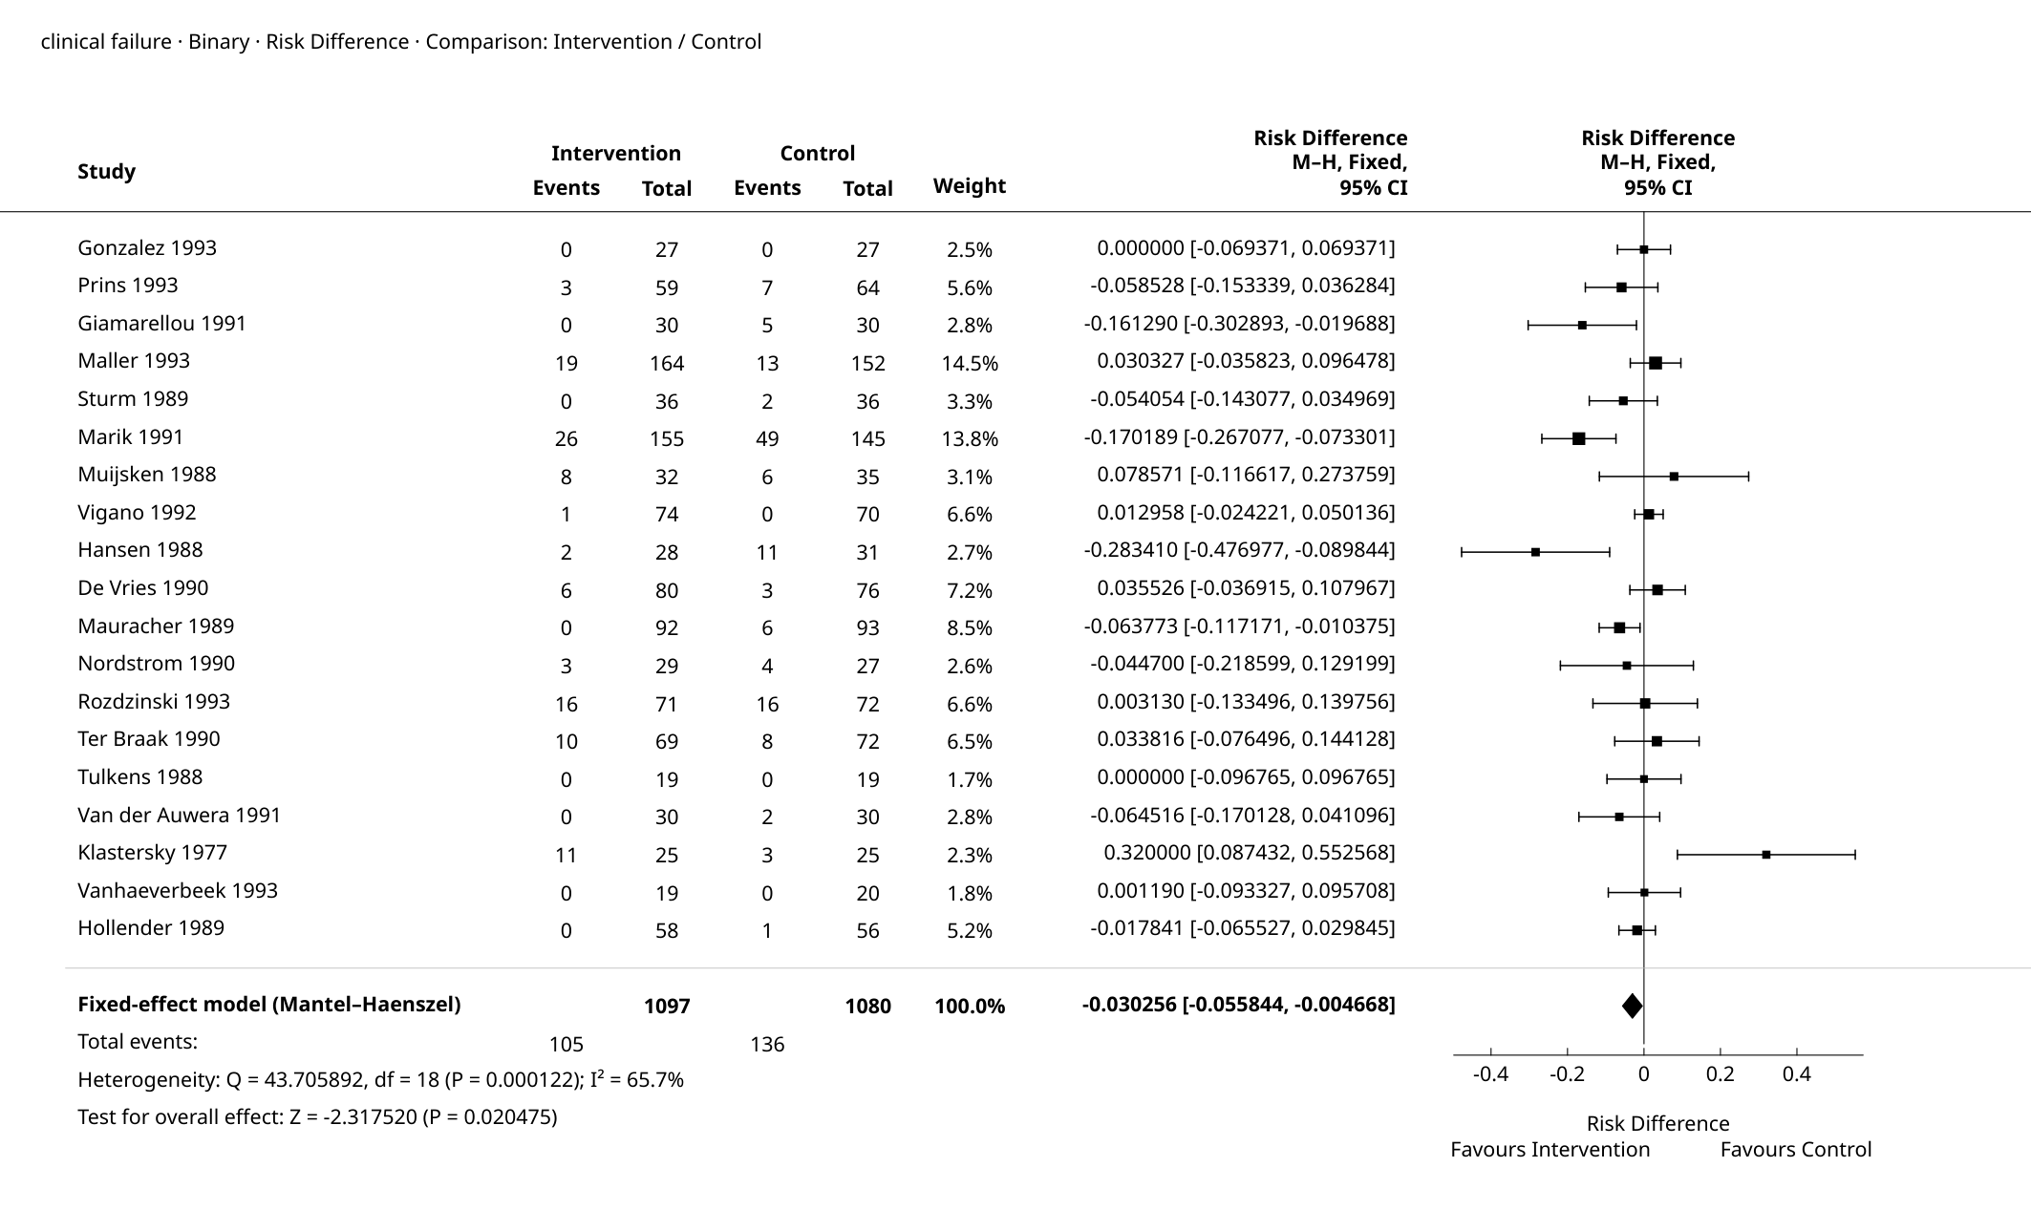
Figure 1. Forest Plot

Supplementary details
Table 4. Full-precision results
Source | Results
Summary — Model Results | Estimate: -0.030256  Lower bound (95% CI): -0.055844  Upper bound (95% CI): -0.004668  SE (outcome scale): 0.013055  p-value: 0.020475
Summary — Heterogeneity | Q: 43.705892  df: 18  p-value: 0.000122  I²: 65.7%
Summary — Test for overall effect | Z: -2.317520  p-value: 0.020475
Weights — Study weights | Study: Gonzalez  Effect: 0.000000  Lower bound: -0.069371  Upper bound: 0.069371  Weight (%): 2.5%
Weights — Study weights | Study: Prins  Effect: -0.058528  Lower bound: -0.153339  Upper bound: 0.036284  Weight (%): 5.6%
Weights — Study weights | Study: Giamarellou  Effect: -0.161290  Lower bound: -0.302893  Upper bound: -0.019688  Weight (%): 2.8%
Weights — Study weights | Study: Maller  Effect: 0.030327  Lower bound: -0.035823  Upper bound: 0.096478  Weight (%): 14.5%
Weights — Study weights | Study: Sturm  Effect: -0.054054  Lower bound: -0.143077  Upper bound: 0.034969  Weight (%): 3.3%
Weights — Study weights | Study: Marik  Effect: -0.170189  Lower bound: -0.267077  Upper bound: -0.073301  Weight (%): 13.8%
Weights — Study weights | Study: Muijsken  Effect: 0.078571  Lower bound: -0.116617  Upper bound: 0.273759  Weight (%): 3.1%
Weights — Study weights | Study: Vigano  Effect: 0.012958  Lower bound: -0.024221  Upper bound: 0.050136  Weight (%): 6.6%
Weights — Study weights | Study: Hansen  Effect: -0.283410  Lower bound: -0.476977  Upper bound: -0.089844  Weight (%): 2.7%
Weights — Study weights | Study: De Vries  Effect: 0.035526  Lower bound: -0.036915  Upper bound: 0.107967  Weight (%): 7.2%
Weights — Study weights | Study: Mauracher  Effect: -0.063773  Lower bound: -0.117171  Upper bound: -0.010375  Weight (%): 8.5%
Weights — Study weights | Study: Nordstrom  Effect: -0.044700  Lower bound: -0.218599  Upper bound: 0.129199  Weight (%): 2.6%
Weights — Study weights | Study: Rozdzinski  Effect: 0.003130  Lower bound: -0.133496  Upper bound: 0.139756  Weight (%): 6.6%
Weights — Study weights | Study: Ter Braak  Effect: 0.033816  Lower bound: -0.076496  Upper bound: 0.144128  Weight (%): 6.5%
Weights — Study weights | Study: Tulkens  Effect: 0.000000  Lower bound: -0.096765  Upper bound: 0.096765  Weight (%): 1.7%
Weights — Study weights | Study: Van der Auwera  Effect: -0.064516  Lower bound: -0.170128  Upper bound: 0.041096  Weight (%): 2.8%
Weights — Study weights | Study: Klastersky  Effect: 0.320000  Lower bound: 0.087432  Upper bound: 0.552568  Weight (%): 2.3%
Weights — Study weights | Study: Vanhaeverbeek  Effect: 0.001190  Lower bound: -0.093327  Upper bound: 0.095708  Weight (%): 1.8%
Weights — Study weights | Study: Hollender  Effect: -0.017841  Lower bound: -0.065527  Upper bound: 0.029845  Weight (%): 5.2%

Pooled Risk Difference: -0.030256 (95% CI -0.055844 to -0.004668).

References
1. Mantel-Haenszel meta-analysis: Mantel, N., & Haenszel, W. (1959). Statistical aspects of the analysis of data from retrospective studies of disease. Journal of the National Cancer Institute, 22(4), 719-748. doi:10.1093/jnci/22.4.719.
2. Common-effect sparse-data estimation: Greenland, S., & Robins, J. M. (1985). Estimation of a common effect parameter from sparse follow-up data. Biometrics, 41(1), 55-68. doi:10.2307/2530643.
3. Implementation reference: Viechtbauer, W. (2010). Conducting meta-analyses in R with the metafor package. Journal of Statistical Software, 36(3), 1-48. doi:10.18637/jss.v036.i03.

