clinical failure: random-effects meta-analysis (odds ratio)
Comparison: Intervention / Control

Methods
Odds ratios were pooled using a random-effects model with the DerSimonian–Laird estimator of between-study variance. Confidence intervals (95%) used the normal approximation. A continuity correction of 0.5 was applied to studies with any zero cell. 2 studies with no events in either arm were retained with this correction. Heterogeneity was assessed with Cochran's Q and I². Analyses were performed in RC MetaStudio 0.5.1. R packages loaded for this analysis: metafor 5.0.1, meta 8.5-0.

Results
19 studies were included (1097 participants in Intervention, 1080 in Control). The pooled odds ratio was 0.77 (95% CI [0.48, 1.22], z = -1.11, p = .267). The confidence interval includes 1, so these data do not show a clear difference between Intervention and Control. Heterogeneity: Q = 33.36, df = 18, p = .015. I² = 46.0%, which may represent moderate heterogeneity (Cochrane Handbook ranges). Between-study variance was τ² = 0.38. The 95% prediction interval was 0.21 to 2.80.
Table 1. Pooled effect
Effect | Estimate | 95% CI | SE | z | p
Odds ratio | 0.77 | 0.48 to 1.22 | 0.24 | -1.11 | .267

Table 2. Model fit
Statistic | Value
Studies (k) | 19
Participants in Intervention | 1097
Participants in Control | 1080
Cochran’s Q | 33.36
Heterogeneity degrees of freedom | 18
Heterogeneity p | .015
I² | 46.0%
Between-study variance (τ²) | 0.38
95% prediction interval | 0.21 to 2.80

Table 3. Study results
Study | Effect | 95% CI | Weight
Gonzalez | 0.57 | 0.17 to 1.92 | 7.3%
Prins | 0.44 | 0.11 to 1.77 | 6.2%
Giamarellou | 0.08 | 0.004 to 1.44 | 2.1%
Maller | 1.40 | 0.67 to 2.94 | 10.7%
Sturm | 0.19 | 0.0088 to 4.08 | 2.0%
Marik | 0.39 | 0.23 to 0.68 | 12.2%
Muijsken | 1.61 | 0.49 to 5.29 | 7.5%
Vigano | 2.88 | 0.12 to 71.82 | 1.8%
Hansen | 0.14 | 0.03 to 0.70 | 5.3%
De Vries | 1.97 | 0.48 to 8.19 | 6.1%
Mauracher | 0.07 | 0.004 to 1.31 | 2.2%
Nordstrom | 0.66 | 0.13 to 3.28 | 5.3%
Rozdzinski | 1.02 | 0.46 to 2.24 | 10.3%
Ter Braak | 1.36 | 0.50 to 3.67 | 8.7%
Tulkens | 1.00 | 0.02 to 52.98 | 1.2%
Van der Auwera | 0.19 | 0.0086 to 4.06 | 2.0%
Klastersky | 5.76 | 1.36 to 24.36 | 6.0%
Vanhaeverbeek | 1.05 | 0.02 to 55.63 | 1.2%
Hollender | 0.32 | 0.01 to 7.93 | 1.8%

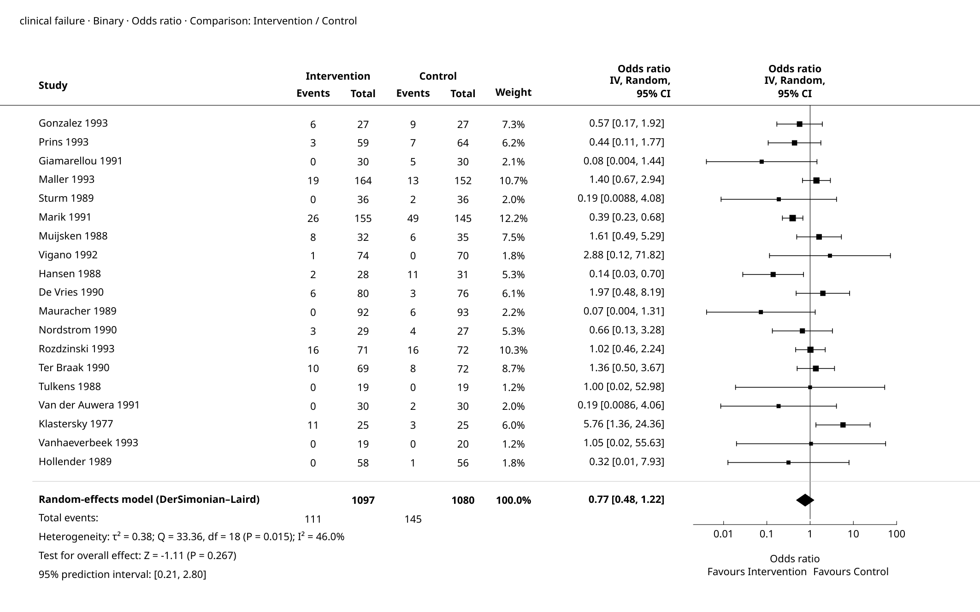
Figure 1. Forest plot

Supplementary details
Table 4. Full-precision results
Source | Results
Summary — Model Results | Estimate: 0.77  Lower bound (95% CI): 0.48  Upper bound (95% CI): 1.22  p-value: 0.267
Summary — Heterogeneity | Q: 33.36  df: 18  p-value: 0.015  I²: 46.0%  τ²: 0.38
Summary — Test for overall effect | Z: -1.11  p-value: 0.267
Summary — Prediction interval | Lower bound (95% PI): 0.21  Upper bound (95% PI): 2.80
Summary — Calculation scale (log) | Estimate: -0.26  Lower bound (95% CI): -0.72  Upper bound (95% CI): 0.20  SE (log scale): 0.236
Weights — Study weights | Study: Gonzalez  Effect: 0.57  Lower bound: 0.17  Upper bound: 1.92  Weight (%): 7.3%
Weights — Study weights | Study: Prins  Effect: 0.44  Lower bound: 0.11  Upper bound: 1.77  Weight (%): 6.2%
Weights — Study weights | Study: Giamarellou  Effect: 0.08  Lower bound: 0.004  Upper bound: 1.44  Weight (%): 2.1%
Weights — Study weights | Study: Maller  Effect: 1.40  Lower bound: 0.67  Upper bound: 2.94  Weight (%): 10.7%
Weights — Study weights | Study: Sturm  Effect: 0.19  Lower bound: 0.0088  Upper bound: 4.08  Weight (%): 2.0%
Weights — Study weights | Study: Marik  Effect: 0.39  Lower bound: 0.23  Upper bound: 0.68  Weight (%): 12.2%
Weights — Study weights | Study: Muijsken  Effect: 1.61  Lower bound: 0.49  Upper bound: 5.29  Weight (%): 7.5%
Weights — Study weights | Study: Vigano  Effect: 2.88  Lower bound: 0.12  Upper bound: 71.82  Weight (%): 1.8%
Weights — Study weights | Study: Hansen  Effect: 0.14  Lower bound: 0.03  Upper bound: 0.70  Weight (%): 5.3%
Weights — Study weights | Study: De Vries  Effect: 1.97  Lower bound: 0.48  Upper bound: 8.19  Weight (%): 6.1%
Weights — Study weights | Study: Mauracher  Effect: 0.07  Lower bound: 0.004  Upper bound: 1.31  Weight (%): 2.2%
Weights — Study weights | Study: Nordstrom  Effect: 0.66  Lower bound: 0.13  Upper bound: 3.28  Weight (%): 5.3%
Weights — Study weights | Study: Rozdzinski  Effect: 1.02  Lower bound: 0.46  Upper bound: 2.24  Weight (%): 10.3%
Weights — Study weights | Study: Ter Braak  Effect: 1.36  Lower bound: 0.50  Upper bound: 3.67  Weight (%): 8.7%
Weights — Study weights | Study: Tulkens  Effect: 1.00  Lower bound: 0.02  Upper bound: 52.98  Weight (%): 1.2%
Weights — Study weights | Study: Van der Auwera  Effect: 0.19  Lower bound: 0.0086  Upper bound: 4.06  Weight (%): 2.0%
Weights — Study weights | Study: Klastersky  Effect: 5.76  Lower bound: 1.36  Upper bound: 24.36  Weight (%): 6.0%
Weights — Study weights | Study: Vanhaeverbeek  Effect: 1.05  Lower bound: 0.02  Upper bound: 55.63  Weight (%): 1.2%
Weights — Study weights | Study: Hollender  Effect: 0.32  Lower bound: 0.01  Upper bound: 7.93  Weight (%): 1.8%
Inference method | Normal approximation

Pooled Odds ratio: 0.77 (95% CI 0.48 to 1.22).
95% prediction interval: the underlying effect in a new study; this is not the confidence interval of the pooled estimate.

References
1. Random-effects meta-analysis: DerSimonian, R., & Laird, N. (1986). Meta-analysis in clinical trials. Controlled Clinical Trials, 7(3), 177-188. doi:10.1016/0197-2456(86)90046-2.
2. Random-effects meta-analysis: Hedges, L. V. (1983). A random effects model for effect sizes. Psychological Bulletin, 93(2), 388-395. doi:10.1037/0033-2909.93.2.388.
3. Implementation reference: Viechtbauer, W. (2010). Conducting meta-analyses in R with the metafor package. Journal of Statistical Software, 36(3), 1-48. doi:10.18637/jss.v036.i03.

