**Software Requirements Specification**

**for**

**Cab Share**

**Version 1.0 approved**

1. **ALISHAH RAHIM 1912176**
2. **ALIMOHAMMAD KARIM 1912177**

**SZABIST**

**10th Nov 2022**

**Table of Contents**

**Table of Contents ii**

**Revision History ii**

**1. Introduction 1**

1.1 Purpose 1

1.2 Document Conventions 1

1.3 Intended Audience and Reading Suggestions 1

1.4 Product Scope 1

1.5 References 1

**2. Overall Description 2**

2.1 Product Perspective 2

2.2 Product Functions 2

2.3 User Classes and Characteristics 2

2.4 Operating Environment 2

2.5 Design and Implementation Constraints 3

2.6 User Documentation 3

2.7 Assumptions and Dependencies 3

**3. External Interface Requirements 3**

3.1 User Interfaces 3

3.2 Hardware Interfaces 6

3.3 Software Interfaces 6

3.4 Communications Interfaces 6

**4. System Features 6**

4.1 System Feature 1 6

4.2 System Feature 2 7

4.3 System Feature 3 7

4.4 System Feature 4 8

4.5 System Feature 5 8

4.6 System Feature 6 9

4.7 System Feature 7 10

**5. Other Nonfunctional Requirements 10**

5.1 Performance Requirements 10

5.2 Safety Requirements 10

5.3 Security Requirements 11

5.4 Software Quality Attributes 11

5.5 Business Rules 11

**6. Other Requirements 11**

**Appendix A: Glossary 11**

**Appendix B: Analysis Models 11**

**Appendix C: To Be Determined List 12**

**Revision History**

| **Name** | **Date** | **Reason For Changes** | **Version** |
| --- | --- | --- | --- |
|  |  |  |  |
|  |  |  |  |

# **Introduction**

## **Purpose**

The purpose of our project as we can clearly see that petrol prices as gone up to highs. And to afford that in student life has been a major problem for the young generation.

Our app can solve this problem easily. Students can search other students registered on app. And fix their route according to their class timings. This can also improve communication between the students. And solve out their expenses by pitching in with each other.

## **Document Conventions**

* Regular – Times New Roman – font size 12
* Sub – Sub – Headings – Times New Roman – font size 12 (bold)
* Sub – Headings – Times New Roman – font size 14 (bold)
* Headings – Times New Roman – font size 18 (bold)

## **Intended Audience and Reading Suggestions**

This project is for SZABIST students and faculty members.

## **Product Scope**

The scope of this App is within the SZABIST and can be used by students and faculties. Users will be able to login with their SZABIST ID. The App will ask if the user is a driver or a passenger. Both driver and passenger will be able to share the schedule, starting and destination points which will help to find a suitable partner.

## **References**

<https://medium.com/move-forward-blog/carpooling-benefits-to-society-employers-and-individuals-e676d30388ff>

# **Overall Description**

## **Product Perspective**

As we can clearly see that petrol prices have gone up to highs. And to afford that in student life has been a major problem for the young generation.

Our app can solve this problem easily. Students can search other students registered on app. And fix their route according to their class timings. This can also improve communication between the students. And solve out their expenses by pitching in with each other.

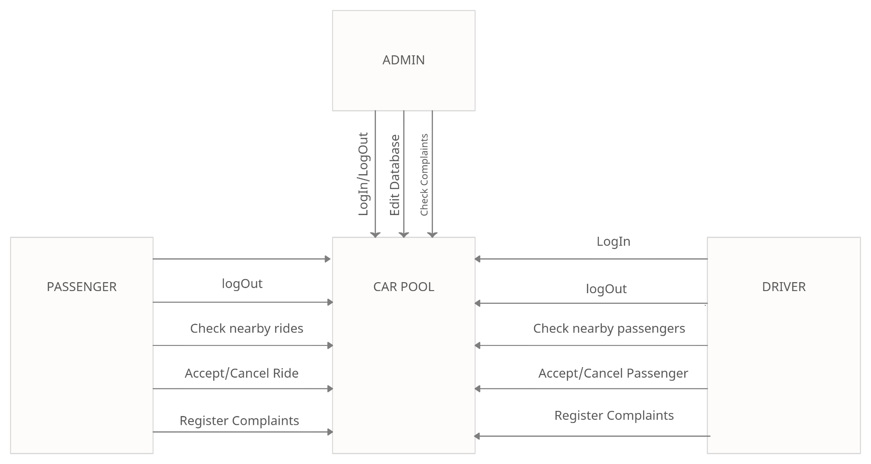

## **Product Functions**

* Sign In
* Sign Out
* Book a ride
* Accept a ride
* Select if user is a driver or a passenger
* Complain

## **User Classes and Characteristics**

This application is suitable for SZABIST students and faculties who are willing to share rides due to high fare of transportation, and also for the users who own a car and willing to share their vehicle with other mates so that everyone can have easy and low-cost transportation.

## **Operating Environment**

Software Preference: A stable internet connection is required to run this application.

Hardware Preference: A smart phone is required to run this application.

## **Design and Implementation Constraints**

The project will be created on Visual Studio Code. For the front-end we will use React Native and Java Script. For the back-end we will use Node.js.

The limitations of this application are we cannot include an e-wallet in our applications because we do not have permission to collect money from anyone else’s bank account.

Another limitation of this application is that the amount is fixed by the owner of vehicle which cannot be bargained.

## **User Documentation**

Software Requirement Specification (SRS) and Software Design Specifications (SDS) will be included.

## **Assumptions and Dependencies**

Since this is a mobile application some UI features may differ on android and IOS phones.

We will be using google sign in and google map in our application.

firebase database will be used in our application.

# **External Interface Requirements**

## **User Interfaces**

**Page1:**

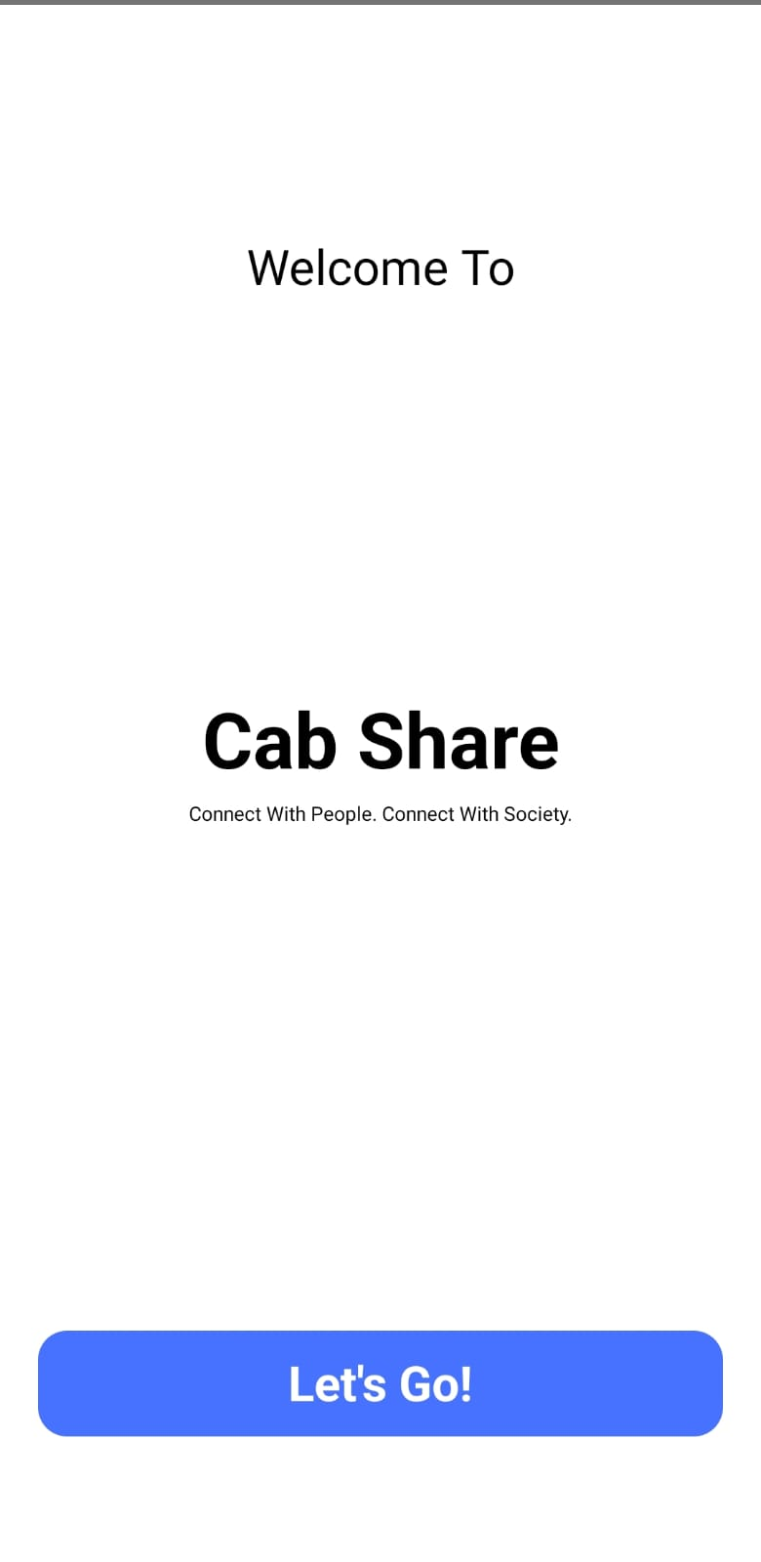

**Page2:**

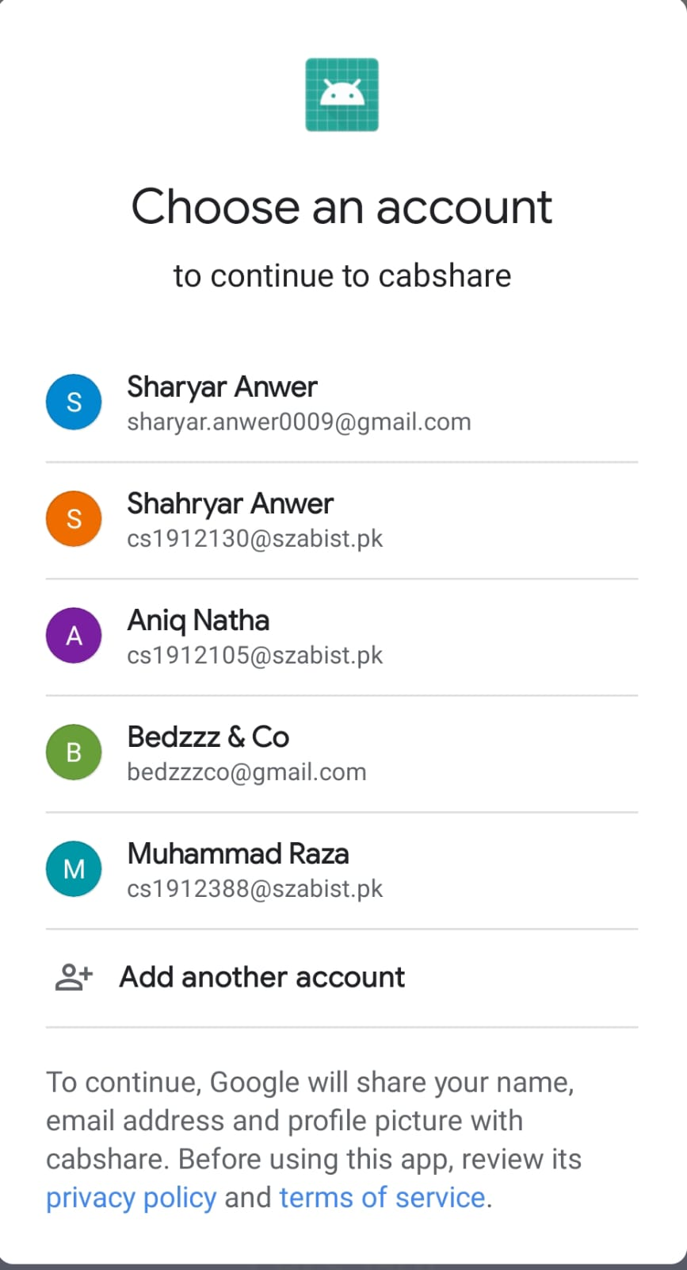

**Page3:**

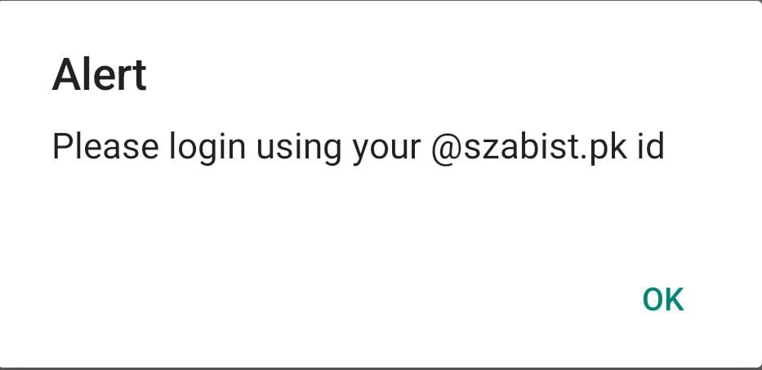

**Page4:**

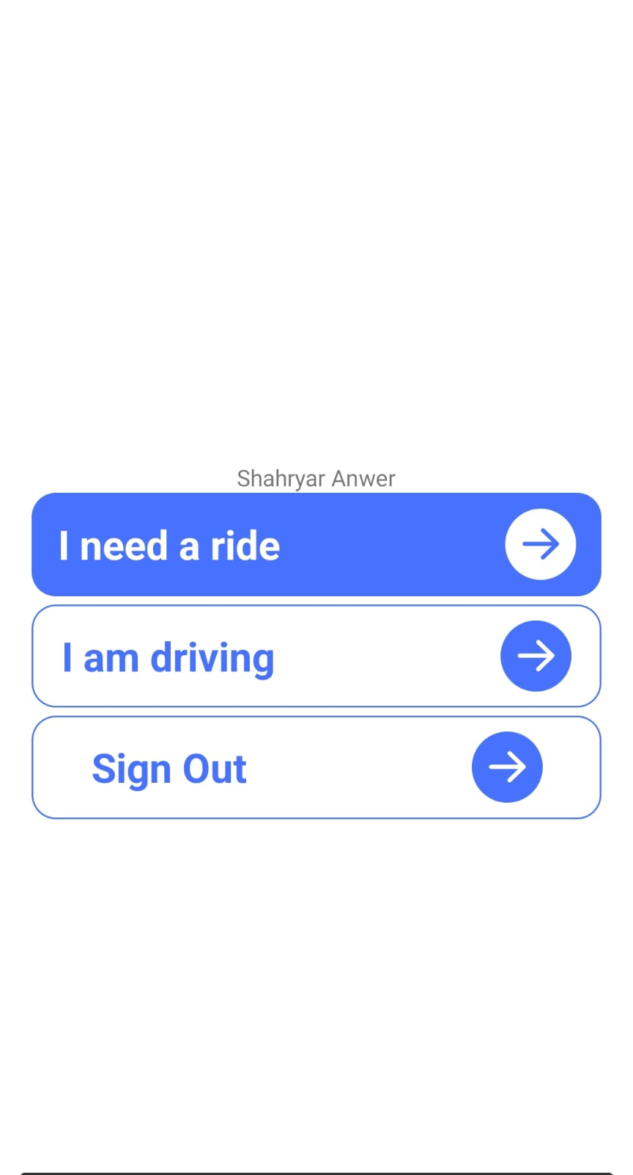

## **Hardware Interfaces**

Only requires a mobile phone with a stable internet connection.

## **Software Interfaces**

**OS:** android and IOS

**Database**: firebase

**Tools:** VS Code

**Library:** React Native and NodeJS. Node.js is an open-source, cross-platform, back-end,

JavaScript runtime environment that executes JavaScript code outside a web browser.

**Integrated commercial components:** google sign in and google map

## **Communications Interfaces**

A good internet connection is required to run this project on smartphones with SZABIST official email ID.

# **System Features**

The below are the use cases of our project:

**4.1 Login**

| **Use Case ID** | 1 | |
| --- | --- | --- |
| **Actors** | User | |
| **Pre-Condition** | A SZABIST Email is required to login. | |
| **Scenario** |  | |
| **Step#** | **Action** | **Software Reaction** |
| **1** | Take Inputs | Check Validations |
| **2** | Login | User gets logged in and proceeds to next page |
| **Post Condition** | | |
| **Step#** | **Description** | |
| **1** | User provide valid credentials | |
| **2** | User gets logged in | |
| **Use Case**  **Cross**  **Reference** | NA | |

**4.2 Select if user is a passenger**

| **Use Case ID** | 2 |  |
| --- | --- | --- |
| **Actors** | User |  |
| **Features** |  |  |
| **Pre-Condition** | User must be signed in |  |
| **Scenario** |  |  |
| **Step#** | **Action** | **Software Reaction** |
| **1** | User clicks “I need a ride” button | User is guided to ride booking interface |
| **2** |  |  |
|  |  |  |
| **Post Condition** |  |  |
| **Step#** | **Description** |  |
| **1** | User input details about pickup and drop-off location, timing etc. |  |
| **Use Case**  **Cross**  **Reference** | NA |  |

**4.3 Select if user is a driver**

| **Use Case ID** | 3 |  |
| --- | --- | --- |
| **Actors** | User |  |
| **Features** |  |  |
| **Pre-Condition** | User must be signed in |  |
| **Scenario** |  |  |
| **Step#** | **Action** | **Software Reaction** |
| **1** | User clicks “I am driving” button | User is guided to select passenger interface |
| **2** |  |  |
|  |  |  |
| **Post Condition** |  |  |
| **Step#** | **Description** |  |
| **1** | User input details about pickup and drop-off location, timing etc. |  |
| **Use Case**  **Cross**  **Reference** | NA |  |

**4.4 Book a ride**

| **Use Case ID** | 4 |  |
| --- | --- | --- |
| **Actors** | User |  |
| **Features** |  |  |
| **Pre-Condition** | User must be signed in |  |
| **Scenario** |  |  |
| **Step#** | **Action** | **Software Reaction** |
| **1** | User inputs the pickup and drop off location. |  |
| **2** | User inputs the time at which they want the ride. | The software shows all the available drivers. |
| **3** | User selects a driver and press ‘Book’ button. | A message is displayed “Your ride is booked” |
| **Post Condition** |  |  |
| **Step#** | **Description** |  |
| **1** | User clicks on Ok |  |
| **2** | User goes to homepage. Will be reminded 20 mins before the booking. |  |
| **Use Case**  **Cross**  **Reference** | NA |  |

**4.5 Accept a ride**

| **Use Case ID** | 5 |  |
| --- | --- | --- |
| **Actors** | User |  |
| **Features** |  |  |
| **Pre-Condition** | User must be signed in |  |
| **Scenario** |  |  |
| **Step#** | **Action** | **Software Reaction** |
| **1** | User inputs the pickup and drop off location. |  |
| **2** | User inputs the time at which they will be driving | The software shows all the available passengers |
| **3** | User selects a passenger and press ‘accept’ button. | A message is displayed “Your cab share partner is booked” |
| **Post Condition** |  |  |
| **Step#** | **Description** |  |
| **1** | User clicks on Ok |  |
| **2** | User goes to homepage. Will be reminded 20 mins before the booking. |  |
| **Use Case**  **Cross**  **Reference** | NA |  |

**4.6 Logout**

| **Use Case ID** | 6 |  |
| --- | --- | --- |
| **Actors** | User |  |
| **Features** |  |  |
| **Pre-Condition** | User must be signed in |  |
| **Scenario** |  |  |
| **Step#** | **Action** | **Software Reaction** |
| **1** | User clicks Log Out Button | User gets logged out |
| **2** |  |  |
|  |  |  |
| **Post Condition** |  |  |
| **Step#** | **Description** |  |
| **1** | User clicks on Log Out |  |
| **2** | User gets logged out |  |
| **Use Case**  **Cross**  **Reference** | NA |  |

**4.7 Complain**

| **Use Case ID** | 7 |  |
| --- | --- | --- |
| **Actors** | User |  |
| **Features** |  |  |
| **Pre-Condition** | User must be signed in |  |
| **Scenario** |  |  |
| **Step#** | **Action** | **Software Reaction** |
| **1** | User clicks Complain Button | Goes to complain page |
| **2** | User posts a complain | App registers the complain |
|  |  |  |
| **Post Condition** |  |  |
| **Step#** | **Description** |  |
| **1** | User goes to home page |  |
| **Use Case**  **Cross**  **Reference** | NA |  |

# **Other Nonfunctional Requirements**

## **Performance Requirements**

* Optimized code
* Stable Internet connection

## **Safety Requirements**

The application will be updated so the users do not have to face any kind of issue such as bug in the application while using it.

## **Security Requirements**

Since the user is signed in using their google account so their information would be completely secured by google by szabist email address.

## **Software Quality Attributes**

* **Usability:** The application has a user-friendly environment so that any user can easily use it.
* **Maintainability:** The application is designed so that it can be maintained easily by any developer.
* **Security:** To keep the safety of user’s sensitive information, security has to be maintained to keep the user’s credentials and database safe.

## **Business Rules**

N/A

# **Other Requirements**

N/A

**Appendix A: Glossary**

N/A

**Appendix B: Analysis Models**

N/A

**Appendix C: To Be Determined List**

N/A