**Assignment: Daily Life Activities**

**Student name: ID Github**

**Topic : Work Force Labor Management using activity recognition**

**Introduction: Human Activity Recognition or daily life activities**

Human activity recognition, or HAR, is a challenging time series classification task. It involves predicting the movement of a person based on sensor data and traditionally involves deep domain expertise and methods from signal processing to correctly engineer features from the raw data in order to fit a machine learning model. Recently, deep learning methods such as convolutional neural networks and recurrent neural networks have shown capable and even achieve state-of-the-art results by automatically learning features from the raw sensor data.

* Activity recognition is the problem of predicting the movement of a person, often indoors, based on sensor data, such as an accelerometer in a smartphone.
* Streams of sensor data are often split into subs-sequences called windows, and each window is associated with a broader activity, called a sliding window approach.
* Many classification algorithms are used such as support vector machine, k nearest neighbors, naïve Bayes, and from deep learning these are Convolutional neural networks and long short-term memory networks, and perhaps both together, are best suited to learning features from raw sensor data and predicting the associated movement.

**Time Series Forecasting**

Time series forecasting uses information regarding historical values and associated patterns to predict future activity. Most often, this relates to trend analysis, cyclical fluctuation analysis and issues of seasonality. As with all forecasting methods, success is not guaranteed.

**Overview:**

Human activity recognition (Har) is basically a time series and signal processing problem where data is collected from different sensors by different timestamp. The frequency of the sensor can be set according to the objective requirements. Human activity recognition is consider the hot topic in the world ans many labs and countries are working on it. The use cases are listed as usser

* Sports
* Education
* Army (soldier selection)
* Work labor force management\
* Health center

During this study it is the use cases are not limited upto the above and it is also observe that many hardware devices are available in the market to do same but there are some limitation of these devices the devices include are

* Garmin vivi smart hr
* Firbit
* Misfit\
* Smart watches
* Android phone
* Iphone

**Language, tools and technology**

Python , jupyter (numpy, pandas, matplot), github, agile scrum and sprints, Machine Learning

**Hardware:**

Shimmer iot device with Two Sensors Accelerometer and Gyroscope

**Sprint-1 Data reading/loading and data visualization**

For data visualization we used matplot library a popular python library for data visualization. The dataset detail is as follows dataset is collected from 19 participants using shimmer IOT device which has two sensors Accelerometer and Gyroscope. Each of these sensors contains the tri-axial values such as x, y and in z axis.

**Data visualization graphs: Participant 1**

**Activity:** Siitting

**Sensor:** Accelerometer

**Device Location:** Wrist

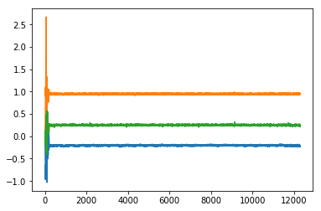

**Activity:** Siitting

**Sensor:** Gyroscope

**Device Location:** Wrist

Here blue is x-axis, green is z-axis and red or orange is y -axis

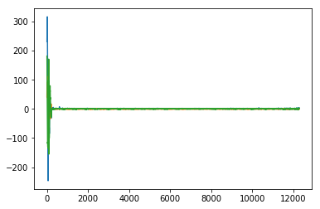

**Activity:** Siitting

**Sensor:** Accelerometer

**Device Location:** Hip

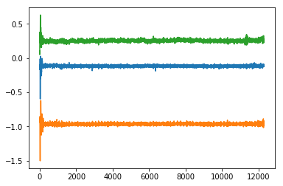

**Activity:** Sitting

**Sensor:** Gyroscop

**Device Location:** Hip

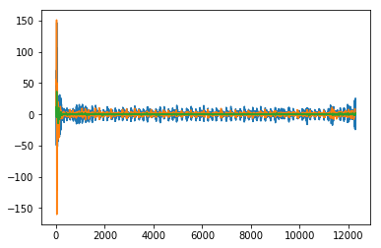

**Sprint-2 Noise Removal or Filtering**

As we know sensors data contains lot of noise we can also see in the above diagrams so it is important to remove the noise before going ahead. For this purpose we used low pass filter a signal processing technique used to remove noise from data. It is a fine filter which has the best results to remove noise from data and smoothen the output.

**Activity:** Sitting

**Sensor:** Accelerometer

**Device Location:** Wrist

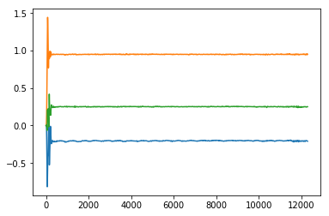

**Activity:** Sitting

**Sensor:** Accelerometer

**Device Location:** Wrist



**Gyroscope vs Accelerometer**

The difference between gyroscope and accelerometer is that the former can sense rotation, the latter cannot. A 3-axis accelerometer has the ability to gauge the orientation of a stationary platform relative to the earth’s surface. A gyroscope on the other hand has the capability of measuring the rate of rotation around a particular axis.

The 2-axis accelerometer gives you the direction of gravity on your balancing instrument. Typically, a gyroscope is used to measure angular position premised on the principle of rigidity of space of the gyroscope.

**Sprint-3 Features Engineering**

We did feature engineering in the step 3 and try to find out the four features of each of the sensor like min (), minimum value, max () maximum value, mean and std () standard deviation

At first we used two type of dataset one is wrist and second is from chest with both accelerometer and gyroscope data.so that total of 24 features are generated while in the second step we use all four positions measurements and generate 48 features such as four features from each axis of the sensor.

**Sprint-4 Build, Train and Fit the Model / Machine Learning Classification Modelling**

Classification is a method that is used to assign a label to the groups of item belongs to same category or class. We used two classification algorithms knn and svm both are popular machine learning classification techniques. To implement these classifier a very popular machine learning library is used to build the model, fit the model, predict the model and for confusion matrix that is model evalution.,

**KNN results Wrist and Chest 24 Features:**

**Accuracy:** 0.8119001919385797

**Confusion Matrix**

[[ 47 2 0 0 0 0 1 0 0 0 5 2 0]

[ 3 53 1 0 0 0 0 0 0 0 0 0 0]

[ 1 2 50 1 0 0 1 0 0 0 2 0 0]

[ 0 0 2 94 1 0 1 0 0 0 0 1 0]

[ 0 0 0 3 40 9 3 2 0 0 0 0 0]

[ 0 1 1 7 29 32 6 4 3 0 0 2 0]

[ 0 0 4 1 1 7 206 0 0 0 0 0 0]

[ 0 0 0 0 0 1 12 26 0 0 0 0 0]

[ 0 0 0 1 0 3 2 2 30 0 0 0 0]

[ 0 0 0 0 0 0 0 0 0 96 0 0 0]

[ 0 0 0 0 0 7 3 0 0 0 66 24 0]

[ 1 0 1 1 0 1 0 0 0 0 27 69 0]

[ 0 0 0 0 0 1 0 0 0 0 0 0 37]]

**SVM results Wrist and Chest 24 Features:**

**Accuracy:** 0.8272552783109405

**Confusion Matrix**

[[ 47 3 0 1 0 0 0 0 0 0 3 3 0]

[ 5 49 0 0 0 2 0 0 0 0 0 0 1]

[ 2 2 50 1 0 0 1 0 0 0 1 0 0]

[ 0 1 2 92 0 3 1 0 0 0 0 0 0]

[ 0 0 0 1 42 12 1 0 0 0 0 1 0]

[ 1 0 0 3 16 56 4 2 1 0 0 0 2]

[ 0 0 3 0 1 6 204 3 1 0 0 0 1]

[ 0 0 0 1 0 1 11 26 0 0 0 0 0]

[ 0 0 0 0 0 3 2 1 31 0 0 0 1]

[ 0 0 0 0 0 0 0 0 0 95 0 0 1]

[ 1 0 0 0 0 8 2 0 0 0 70 18 1]

[ 0 0 0 0 0 1 0 0 0 0 37 62 0]

[ 0 0 0 0 0 0 0 0 0 0 0 0 38]]

**KNN results Wrist ,Chest, Hip and Ankle 48 Features:**

**Accuracy:** 0.9069097888675623

**Confusion Matrix**

[[ 56 0 0 1 0 0 0 0 0 0 0 0 0]

[ 0 57 0 0 0 0 0 0 0 0 0 0 0]

[ 4 0 50 1 0 0 1 0 0 0 1 0 0]

[ 0 0 0 97 0 0 1 0 0 0 1 0 0]

[ 0 0 1 1 51 3 0 0 0 0 0 1 0]

[ 0 0 0 1 14 67 2 1 0 0 0 0 0]

[ 0 0 0 1 3 1 209 4 1 0 0 0 0]

[ 0 0 1 0 0 0 7 31 0 0 0 0 0]

[ 0 0 0 0 0 0 2 1 35 0 0 0 0]

[ 0 0 0 0 0 0 0 0 0 96 0 0 0]

[ 0 0 0 1 2 4 0 0 0 0 75 18 0]

[ 0 0 0 1 0 0 0 0 0 0 16 83 0]

[ 0 0 0 0 0 0 0 0 0 0 0 0 38]]

**SVM results Wrist ,Chest, Hip and Ankle 48 Features:**

**Accuracy:** 0.9126679462571977

**Confusion Matrix**

[[ 55 0 0 1 0 1 0 0 0 0 0 0 0]

[ 0 57 0 0 0 0 0 0 0 0 0 0 0]

[ 4 0 52 1 0 0 0 0 0 0 0 0 0]

[ 0 0 1 96 0 0 0 0 0 0 2 0 0]

[ 0 0 2 2 44 8 0 0 0 0 0 1 0]

[ 0 0 0 3 8 74 0 0 0 0 0 0 0]

[ 0 0 1 1 3 5 206 2 1 0 0 0 0]

[ 1 0 0 0 0 1 4 33 0 0 0 0 0]

[ 0 0 0 0 0 1 1 0 36 0 0 0 0]

[ 0 0 0 0 0 1 0 0 0 95 0 0 0]

[ 1 0 0 1 0 3 0 0 0 0 82 13 0]

[ 0 0 0 0 0 0 0 0 0 0 17 83 0]

[ 0 0 0 0 0 0 0 0 0 0 0 0 38]]

**Discussion and Results:**

Human activity recognition is hot topic and very impressive research areas. Its implementations cannot be counted actually. There are many fields and areas in real life where activity recognition found very authentic. In this work study we used two machine learning algorithms to classify the activities with four features of each axis of each sensor. Accuracy goes more than 80 percent which sounds good. Previous study also shows the accuracy above 80 percent with the help of other sensor devices. This work can be implemented in the real world use cases with shimmer hardware.

**Limitations:**

Through this whole work we found few limitations like if we collect the data then it seems to be very difficult to collect the data in true, because there are many difficulties in the research work found. It is also noted that a deep learning algorithms name as LSTM can be very handy classifier to classify the activities of human because it do not need manual feature engineering and manual feature engineering is a long hectic procedure.

**Summary:**

Human activity recognition commonly known as Har is very authentic way to track the activities in real life like in health sectors we can track heartbeat, walking, standing, sitting, lying, distance cover, calories burnt, running etc, these are the few ones but its implication are increasing day by day in every field of real life work environment by using different sensors like pedometer, barometer, accelerometer, gyroscope, camera, sound sensors etc.

This human activity recognition project is based on the shimmer hardware which includes two sensors first is accelerometer and second is gyroscope. Each of these axis contains the tri-axial information such as x, y and z axis. The phenomenon behind these sensors is signal processing, so it is time series problem that is solved with help of machine learning classification algorithms. One is **k-nearest neighbor** (knn) and second is **support vector machine (svm)**. All the work is done through general purpose programming language known as Python. The entire work is divided into different parts described as below

* 1. Importing libraries and reading dataset
  2. Visualization of participant activities with accelerometer and Gyroscope data
  3. Applying low pass filter
  4. Feature engineering
  5. Model building and fitting the model
  6. Testing the model
  7. Classification report

**Conclusion**

By this study, research and implementation we can conclude that we can track and predict the activities of human through different sensors or separate sensor device, but the key is data. How best, reliable and normalized data and the procedure of data collection must be clearer in each aspect. All this work could be move towards success if the data is collected in authentic way and true data is collected with carefully that is the worst part of this project and will always remain. We implemented algorithms in two ways first we got accuracy above 80 and then from all dataset with 48 features we got accuracy above 90 which sounds impressive.

**References:**

[1] ACCELEROMETER SIGNAL PRE-PROCESSING INFLUENCE ON HUMAN ACTIVITY RECOGNITION, Przemyslaw Maziewski, Adam Kupryjanow, Katarzyna Kaszuba, Andrzej Czyzewski, *Gdansk University of Technology, Multimedia Systems Department, Gdansk, Poland*

[2] APPLICATIONS AND CHALLENGES OF HUMAN ACTIVITY RECOGNITION USING SENSORS IN A SMART Environment , Jubil T Sunny, Sonia Mary George,  *Department of Computer Science and Engineering, St. Joseph’s College of Engineering and Technology, Palai, Kerala, India*

[3] MONITORING HUMAN ACTIVITY THROUGH PORTABLE DEVICES, G. Sebestyen, A. Tirea and R. Albert, *Technical University of Cluj-Napoca/Computers Dep., Cluj-Napoca, Romania,*

[4] WEARABLE SENSORS FOR HUMAN ACTIVITY MONITORING: A REVIEW, Subhas Chandra Mukhopadhyay, *Fellow, IEEE*

[5] ACTIVITY RECOGNITION USING CELL PHONE ACCELEROMETERS, Jennifer R. Kwapisz, Gary M. Weiss, Samuel A. Moore, *Department of Computer and Information Science*

*Fordham University*