**AL-Hussein Technical University**

**“TechRocket”**

**By**

**Ali Sammour**

**Table of Contents**

Introduction 4

The project scenario 4

Dataset 4

**Requirements 5**

Solution design 5

Solution component 5

Dataflow6

ERD 6

ETL using SSIS 7

Power BI 9

Reports 9

App 13

References 14

**Table of Figures**

**Figure 1: Project Dataflow6**

**Figure 2: ERD 6**

**Figure 3: ETL teams, country and tournament tables 7**

**Figure 4: ETL city table 7**

**Figure 5: ETL tournament city table 8**

**Figure 6: ETL matches table 8**

**Figure 7: main page 9**

**Figure 8: Matches distribution over time 10**

**Figure 9: Mondial mode 10**

**Figure 10: Drill through 11**

**Figure 11: Mondial details 11**

**Figure 12: One-on-One mode 12**

**Figure 13: teams list 12**

**Figure 14: App 13**

**Figure 15: Data Gateway 13**

# **Introduction**

## The project scenario:

A sports channel asked TeckRocket to analyze some international football match information as a preparatory step for the FIFA World Cup Qatar 2022.

## Dataset

**International football results from 1872 to 2020 from Kaggle[1]**

* This dataset includes more than **40,000** results of international football matches in different tournaments.
* Data does not include Olympic Games or matches where at least one of the teams was the nation's B-team, U-23 or a league select team.
* contains nine columns:

Date, Home team, Away team, Home score, Away score, Tournament, City, Country, and Neutral

# **Requirement**

* Which team has played the most number matches?
* Which team has won the most number matches?
* Is the Home team dominated or the Away team dominated?
* The football matches distributed over time
* Average goals in the tournament
* One-on-One mode (statistical view of the matches between two different teams)
* Mondial mode (statistical view of FIFA world cup tournaments)

# **Solution design**

## Solution components

* SQL Server

Create a Database and manage it.

* SQL Server Integration Services (SSIS)

Extract, Transform and Load (ETL process) the data from (CSV) file into tables in the database.

* Power BI

Use Power BI desktop to create reports and publish them into Power BI service.

Use Power BI service to create an app.

Use data gateway in Power BI service to make sure the dataset is up-to-date.

## Dataflow

**Figure 1:** Project Dataflow

## Entity Relational Diagram (ERD)

An Entity Relationship (ER) Diagram is a type of flowchart that illustrates how “entities” such as people, objects or concepts relate to each other within a system. **[2]**

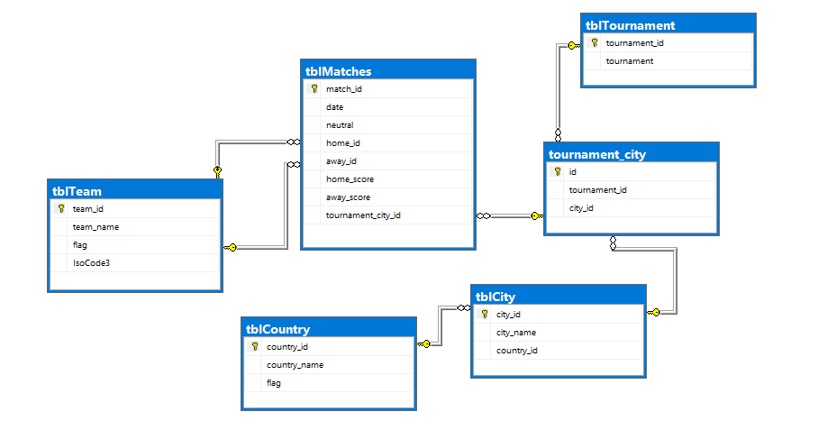

**Figure 2:** ERD

## Extract Transform Delete (ETL) using SSIS

**Figure 4:** ETL city table

**Figure 3:** ETL teams, country and tournament tables

**Figure 6:** ETL matches table

**Figure 5:** ETL tournament city table

## Power BI

This project contains one report and one app.

The report consists of one main page, and three subpages can arrive at it using buttons.

The app in power BI provides some user interface and can make you manage the content and grant permissions to different users.

## Reports

A Power BI report is a multi-perspective view into a dataset, with visuals that represent different findings and insights from that dataset. A report can have a single visual or pages full of visuals. **[3]**

In the following some screenshots.

**Figure 7:** main page

On this page, we found a lot of visualization such as average goals per tournament, and winner distribution over time this visual provides an answer to one of the requirements and we say here the home teams are dominated over away teams.

And provide some facts such as total goals, the most playing teams, and the most winning teams, and more.

We can notice there are 3 buttons on the left bottom: the first one is Mondial mode, the second one is the one-on-one mode, and the last one is to switch view to view matches distribution over time.

**Figure 8:** Matches distribution over time

**Figure 9:** Mondial mode

This mode provides some facts, for example, the total goals and the top three places in each tournament.

The visualization here provides a year-based 'drill through' to view more information about a specific tournament.

**Figure 11:** Mondial details

**Figure 10:** Drill through

**Figure 12:** One-on-One mode

In one-on-one mode, it gives you the ability to choose teams from list and provides you with some facts such as the number of matches, and when they happened, and a pie chart that gives your perspective on how matches between the two teams ended.

**Figure 13:** teams list

## App

An app is a Power BI content type that combines related dashboards and reports, all in one place. An app can have one or more dashboards and one or more reports, all bundled together. Apps are created by Power BI designers who distribute and share the apps with their colleagues. **[4]**

**Figure 14:** App

In the end to make the data up to date (reflect the data in the database), I used Data Gateway.

**Figure 15:** Data Gateway

# **References**

**[1]** Kaggle, “International football results from 1872 to 2020 from Kaggle”, [*https://www.kaggle.com/martj42/international-football-results-from-1872-to-2017*](https://www.kaggle.com/martj42/international-football-results-from-1872-to-2017)

**[2]** Lucidchart, <https://www.lucidchart.com/pages/er-diagrams>

**[3]** Microsoft,” Reports in Power BI”, <https://docs.microsoft.com/en-us/power-bi/consumer/end-user-reports>

**[4]** Microsoft,” App in Power BI”, <https://docs.microsoft.com/en-us/power-bi/consumer/end-user-apps>