
University of Central Punjab
Faculty of IT & CS
Department of Applied Computing & Technologies
__________________________________________
Title: Dynamic Surge Pricing Engine for Ride-Sharing Services Using Big Data Analytics
__________________________________________
Semester Project
Course Name: Big Data Analytics
Course Instructor: Dr. Rabbia Alamdar
Date: 25/5/26
Group Members
Name | Reg#
Ahmad Munir Sheikh | L1F23BSDS0005
Ali Akbar | L1F23BSDS0016
Ali Sufyyan | L1F23BSDS0003

Contents
No table of contents entries found.

Problem Definition
Dynamic Surge Pricing Engine is a real-time data pipeline that predicts ride-sharing price multipliers based on demand, supply, time, and location. The system uses historical NYC Taxi data to train a machine learning model and Apache Kafka to simulate live ride requests, replicating how companies like Uber and Lyft dynamically adjust prices during peak hours.

Dataset
Property | Detail
Source | NYC Yellow Taxi Trip Records (Kaggle)
File | yellow_tripdata_2016-01.csv
Total Rows | 12,210,952 (12 million records)
Size | Large-scale Big Data dataset
Format | CSV with header

Columns Used:
Column | Type | Description
tpep_pickup_datetime | Timestamp | Trip start time
tpep_dropoff_datetime | Timestamp | Trip end time
passenger_count | Integer | Number of passengers
trip_distance | Double | Distance in miles
pickup_longitude | Double | Pickup location
pickup_latitude | Double | Pickup location
dropoff_longitude | Double | Dropoff location
dropoff_latitude | Double | Dropoff location
fare_amount | Double | Base fare in USD

System Architecture
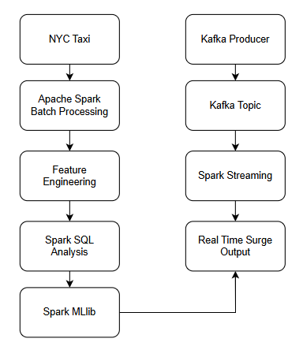

Docker Services Used:
Container | Image | Purpose
pyspark_container | jupyter/pyspark-notebook | Spark processing
kafka | confluentinc/cp-kafka:7.4.0 | Message streaming
zookeeper | confluentinc/cp-zookeeper:7.4.0 | Kafka coordination

Feature Engineering
The following features were derived from raw taxi data:
Feature | Description
hour | Hour extracted from pickup datetime
day_of_week | Day number (1=Monday, 7=Sunday)
month | Month of trip
is_weekend | 1 if Saturday/Sunday, else 0
trip_duration_min | Dropoff time − Pickup time in minutes
avg_speed_mph | trip_distance / (duration/60)
is_morning_peak | 1 if hour between 7–9 AM
is_evening_peak | 1 if hour between 5–8 PM
is_late_night | 1 if hour between 10 PM–2 AM

Surge Multiplier Label (Rule-Based):
# Paste Visuals form rule based here

Spark SQL Analysis (5 Queries)

Query 1 — Average Surge by Hour
Grouped trips by hour to identify peak surge periods throughout the day.

Query 2 — Top Pickup Areas by Demand
Grouped by pickup longitude/latitude to identify highest demand locations in NYC.

Query 3 — Weekend vs Weekday Comparison
Compared average surge, fare, distance, and duration between weekdays and weekends.

Query 4 — Surge Distribution Percentiles
Calculated P25, P50, P75, P90, P99 percentiles to understand surge distribution across all trips.

Query 5 — Peak Hour Demand Windows
Filtered peak hours (7,8,9,17,18,19,22,23,0,1) and grouped by hour and day to find highest surge combinations.

Machine Learning Model
Algorithm: Random Forest Regressor Library: Apache Spark MLlib

Input Features:
- Hour
- day_of_week
- month
- is_weekend
- trip_distance
- passenger_count
- trip_duration_min
- avg_speed_mph
- pickup_longitude
- pickup_latitude
- dropoff_longitude
- dropoff_latitude
- is_morning_peak
- is_evening_peak
- is_late_night
Train/Test Split: 80% training / 20% testing

Hyperparameters:
Parameter | Value
Number of Trees | 100
Max Depth | 8
Seed | 42

Model Evaluation Results
Metric | Value | Interpretation
RMSE | 0.0921 | Very low prediction error
R² | 0.9843 | Model explains 98.43% of surge variation
MAE | 0.0640 | Average error of only 0.06× multiplier

The R² score of 0.9843 indicates an exceptionally accurate model.

Feature Importances
Rank | Feature | Importance | Insight
1 | hour | 23.28% | Time of day is the strongest predictor
2 | is_weekend | 23.07% | Weekend vs weekday drives surge
3 | is_evening_peak | 11.64% | Evening rush significantly impacts surge
4 | avg_speed_mph | 10.72% | Traffic congestion affects pricing
5 | day_of_week | 10.71% | Specific day patterns matter
6 | is_morning_peak | 9.83% | Morning commute drives demand
7 | is_late_night | 8.95% | Late night demand creates surge
8 | passenger_count | 0.62% | Least significant factor

Key Insight: Time-based features (hour, weekend, peak periods) account for over 83% of surge prediction importance.

Kafka Streaming Results

Producer Output:

