**22K-4060 – CN – Lab 10 – C Class Subnettting and Routing Interface Protocol**

Network 1 – Configuration – CS + Router 1

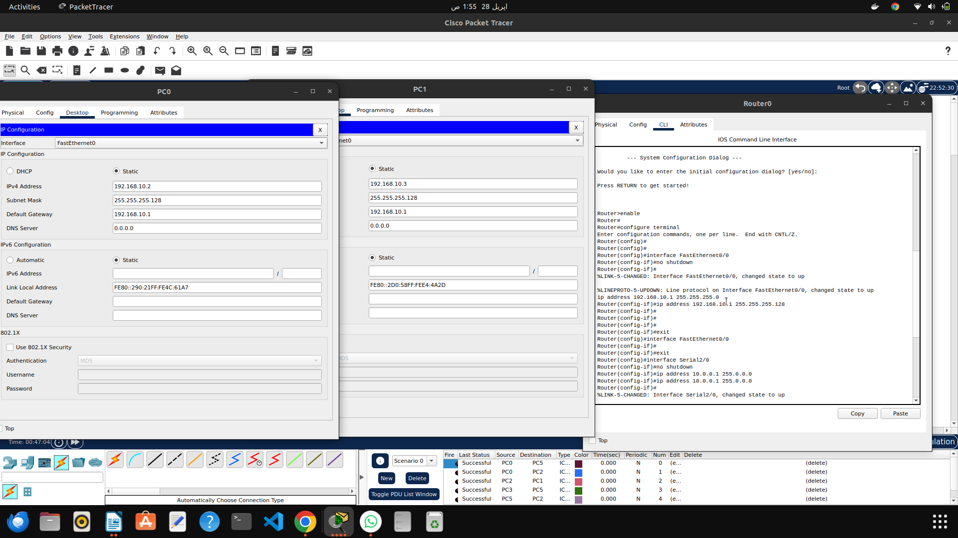

Network 2 – Config – EE

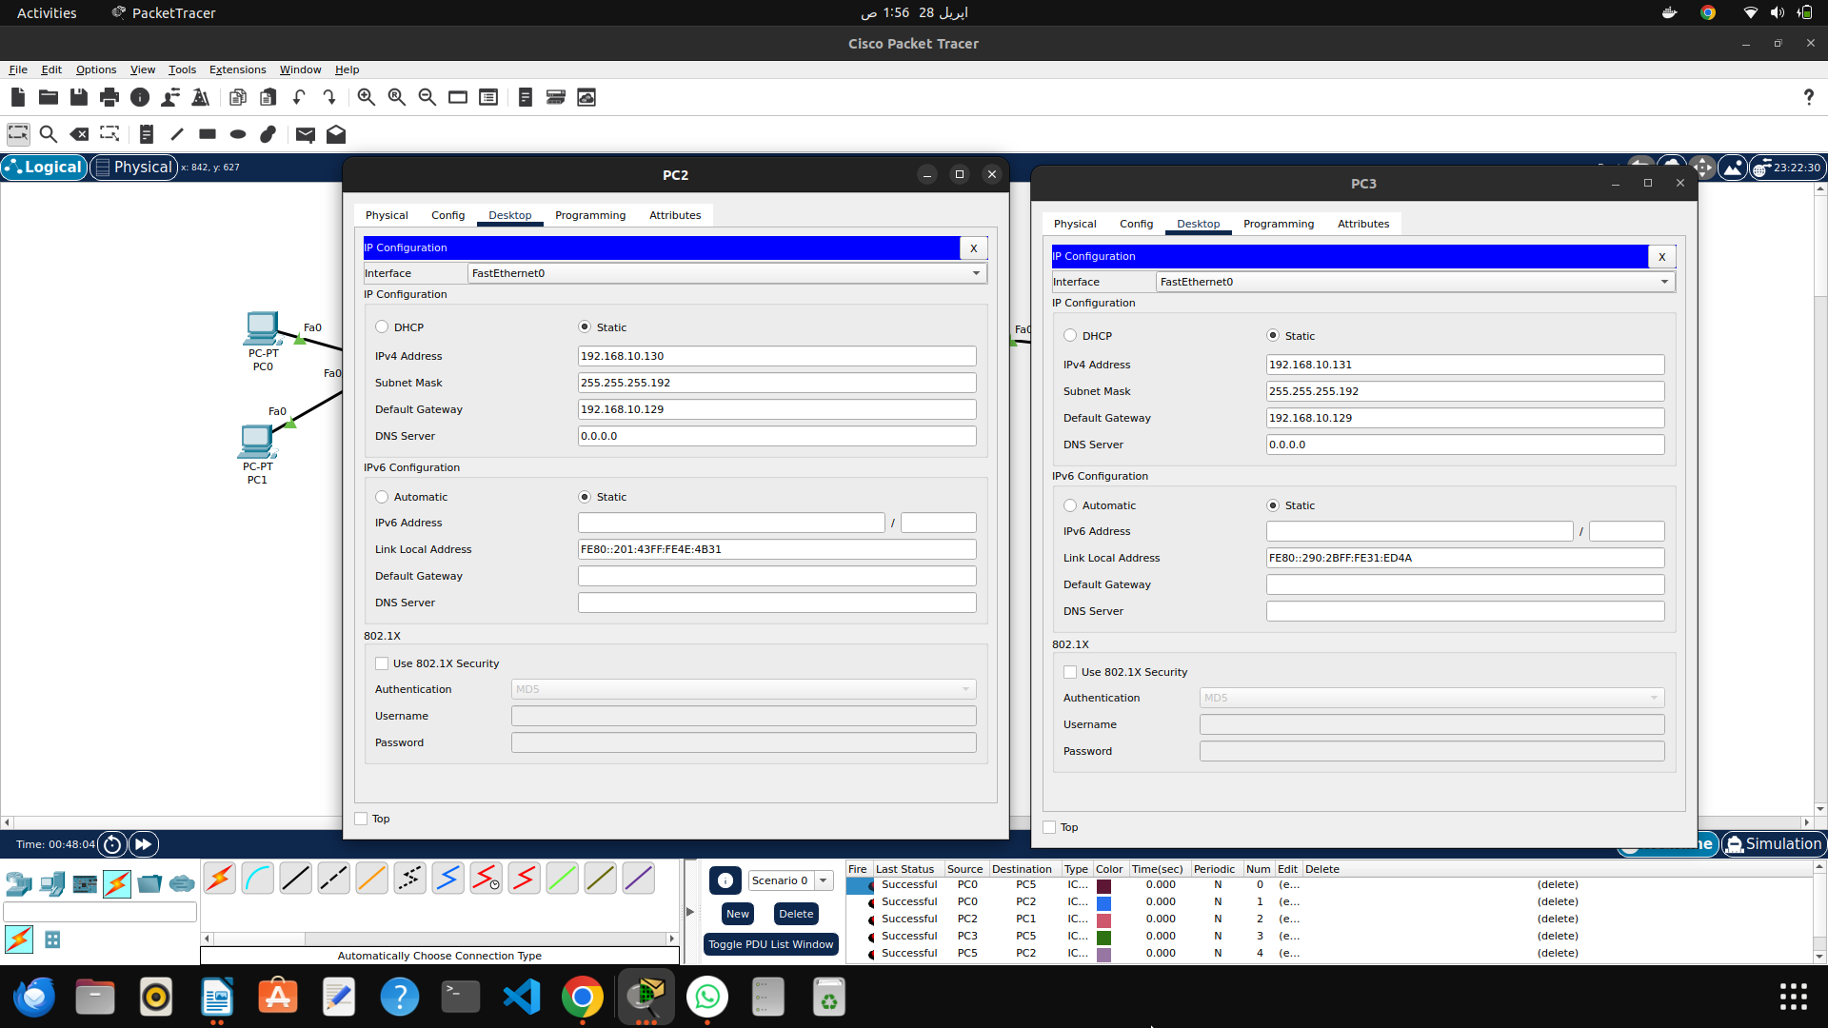

Network 3 – Config – BBA

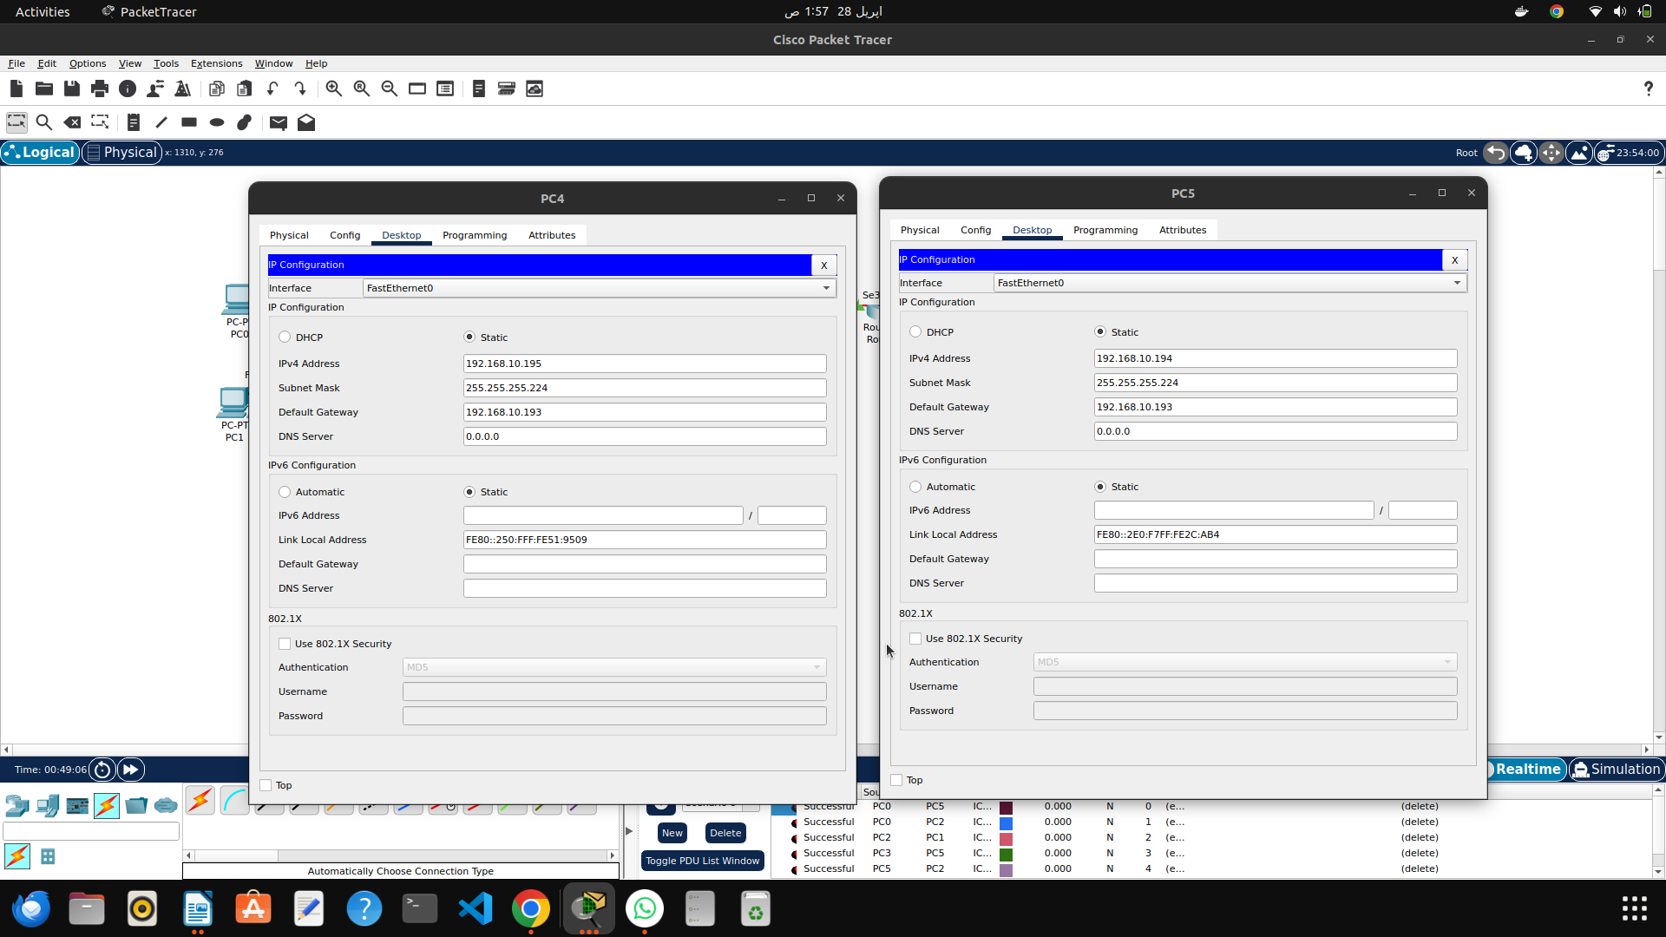

Router 1 Configuration

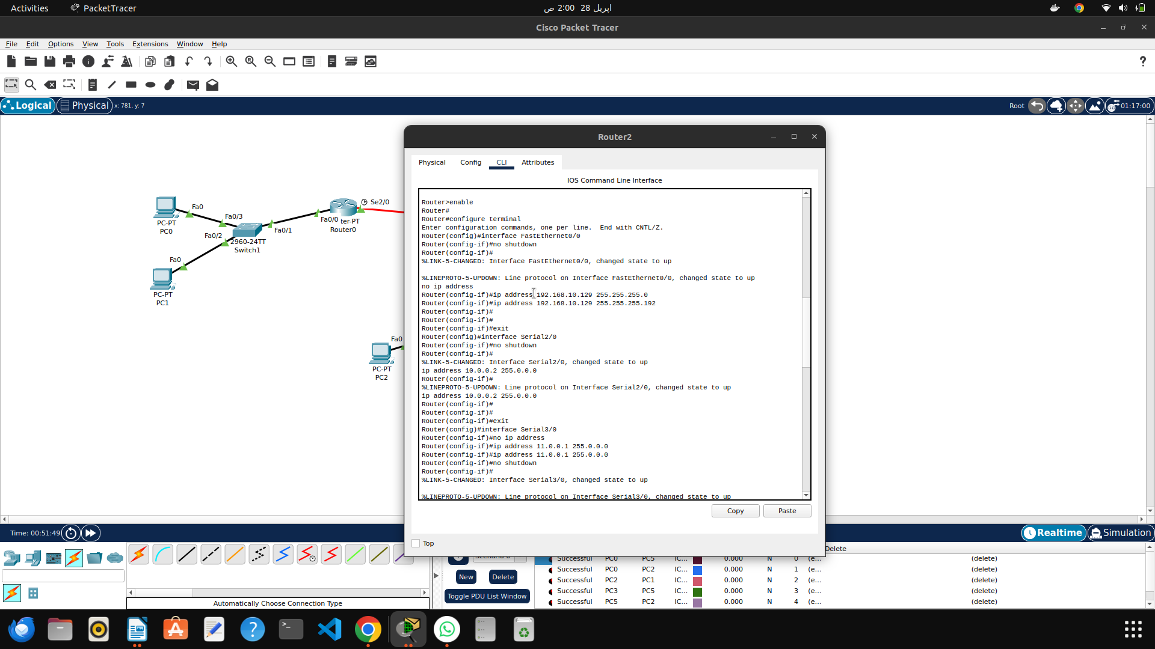

Router 2 Configuration

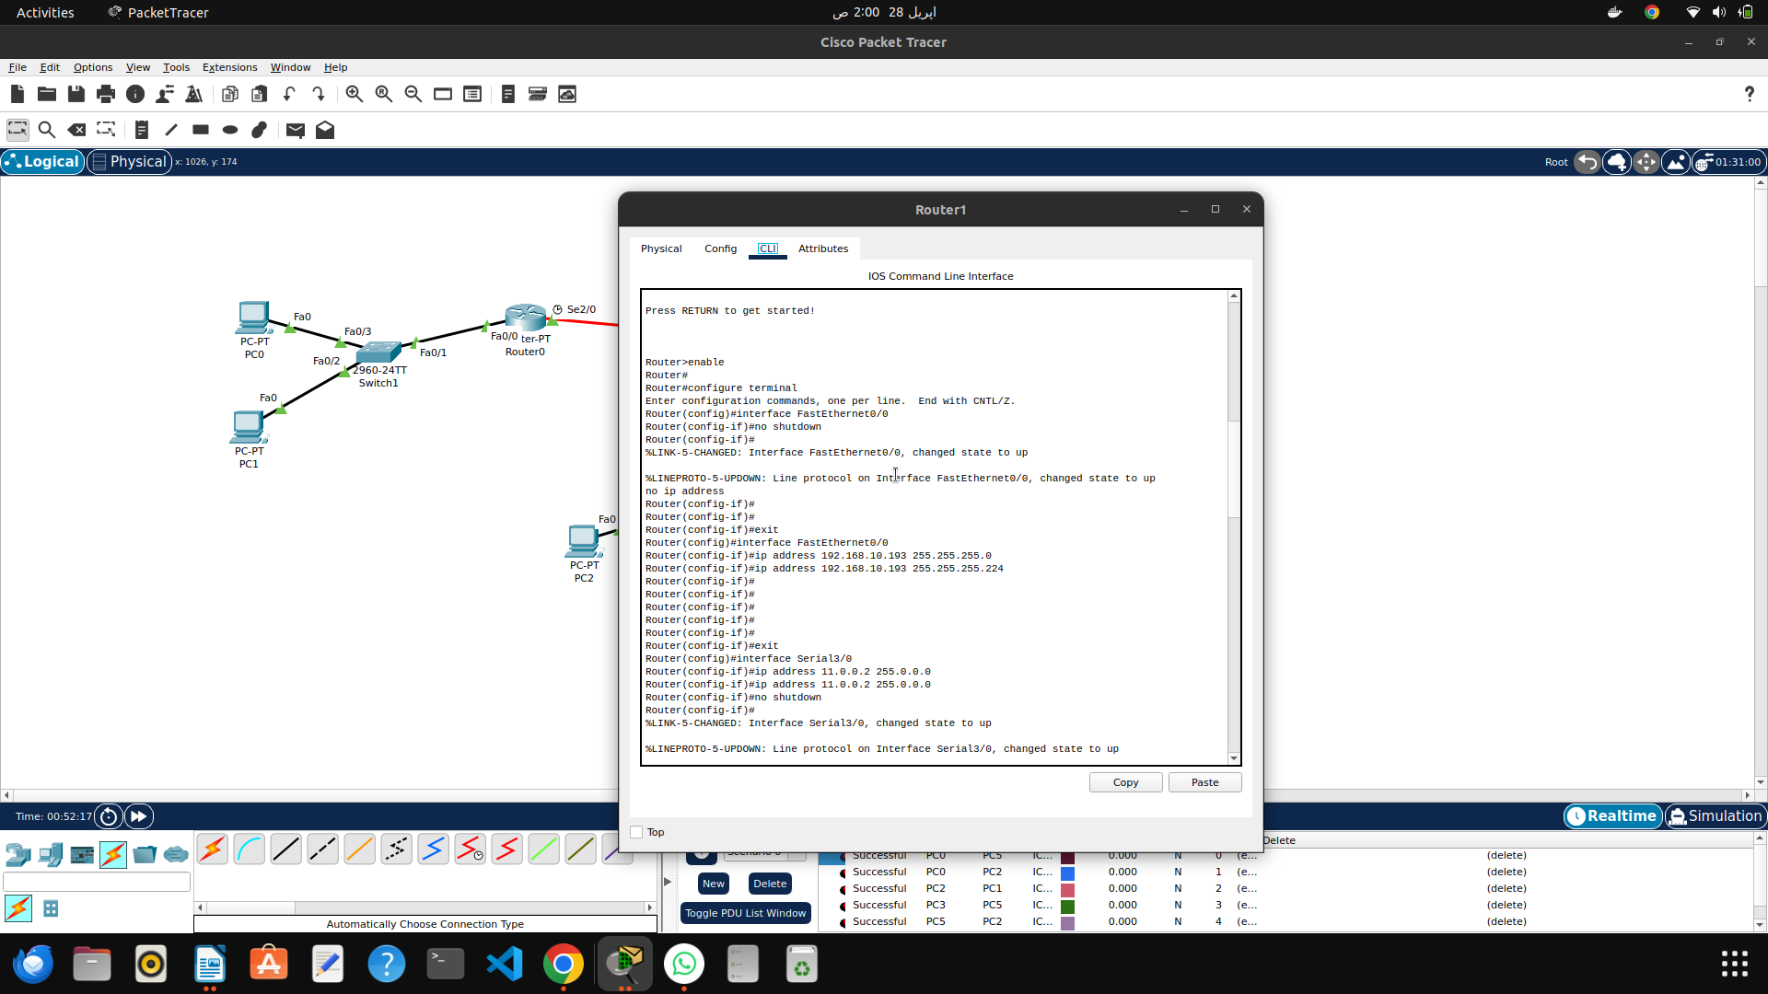**Routing Interface Protocol**

Router 0 RIP

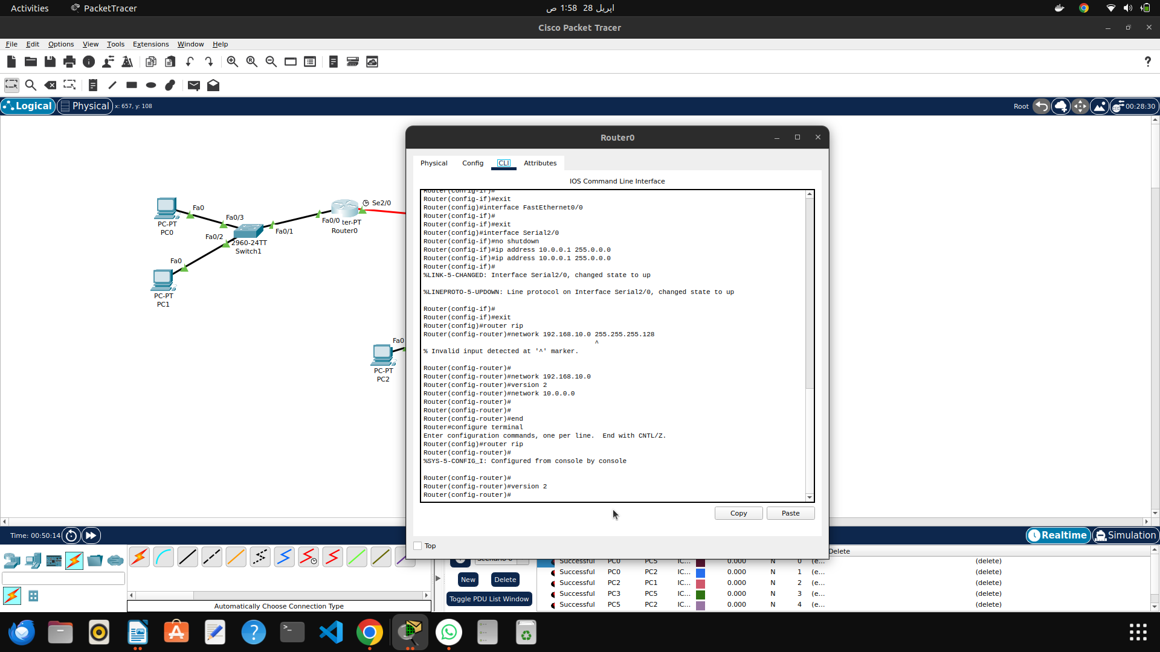

Router 1 RIP

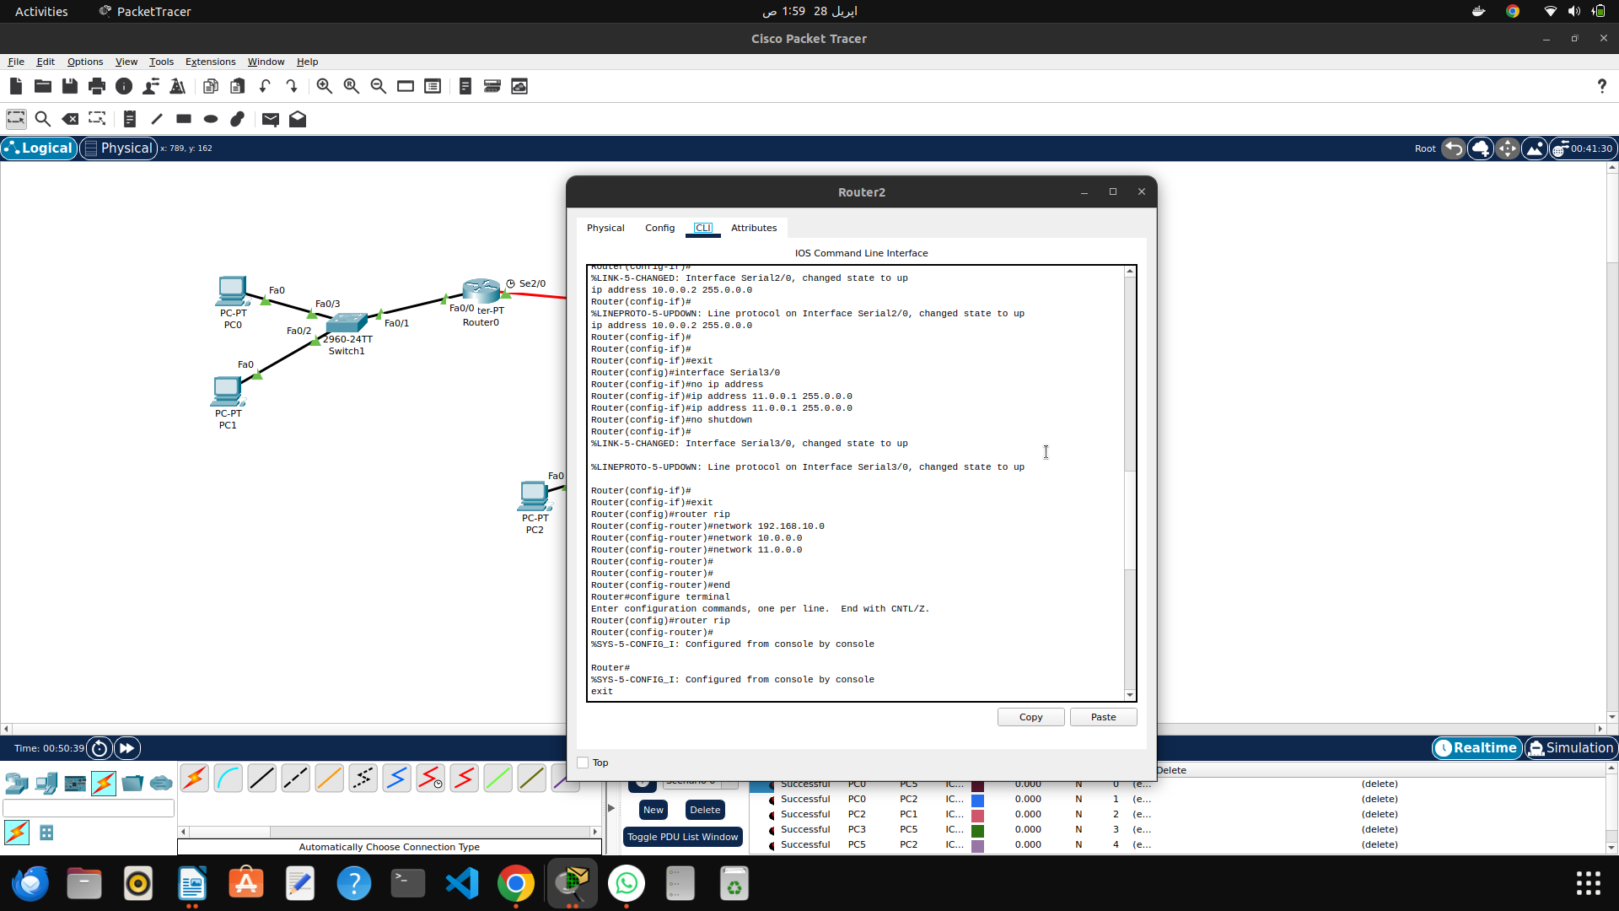

Router 2 RIP

