22K4060 – Ali Suleman – BAI6A – CN Lab 09

LOGIN

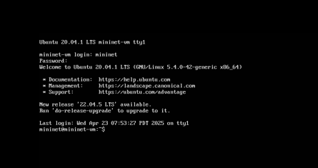

sudo mn: Creates a default minimal topology consisting of a controller, a switch, and two hosts.



help: Displays all available commands in the Mininet CLI with examples of their usage.

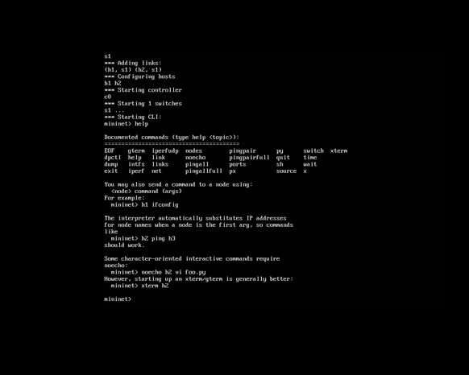

h1 ifconfig

Executes the Linux ifconfig command on host h1.

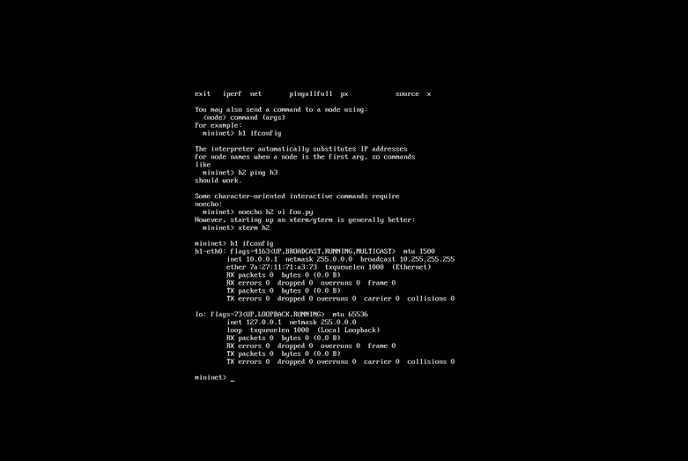

nodes: Lists all network nodes in the currently running topology.

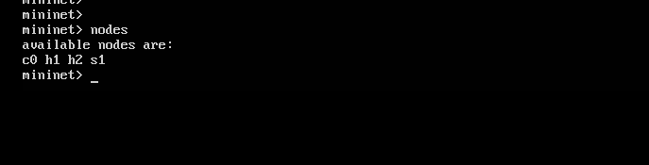

net: Displays all links between devices in the current topology.

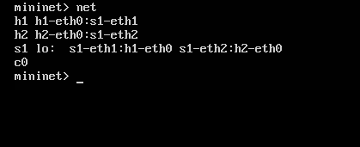

h1 ifconfig

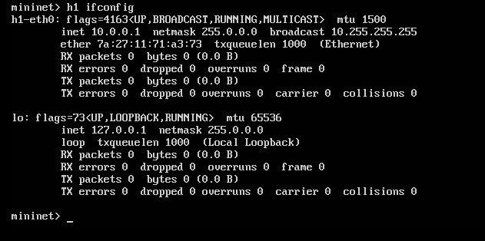

h1 ping h2: Tests connectivity between host h1 (10.0.0.1) and host h2 (10.0.0.2).

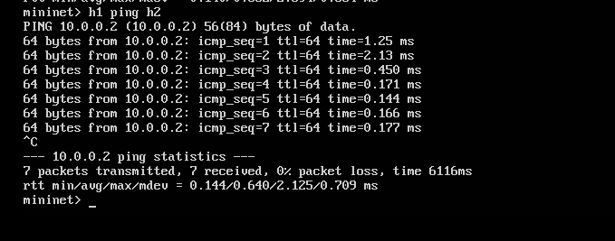

Pingpair -> tells which devices can be pinged with each other

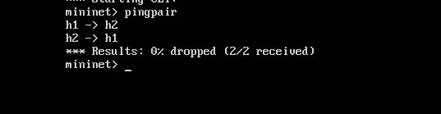

Lin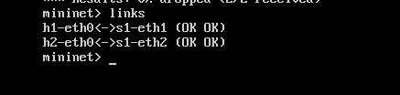ks -> shows eth connected ports