Error Reports
Accessibility testing of www.du.se · GIK2PB Lab 2 · Group 4
10 error reports (ER-01 – ER-10), one per identified error
Ali Hasan · Bilala Ahmed Adem · Karim Al hashoom

Overview
ER ID | Title | Test case | Severity
ER-01 | Visual headings in footer and sidebar are not coded as headings | TC-02, step 3 | S3 Minor/Moderate
ER-02 | Menu expand buttons all have the same name “Show/hide underpages” | TC-03, step 1 | S3 Minor/Moderate
ER-03 | Apply link text is only a URL (“student.ladok.se”) | TC-03, step 2 | S4 Low
ER-04 | Share links open a new tab without warning | TC-03, step 3 | S4 Low
ER-05 | Cookie banner does not reflow at 400% zoom – text is cut off | TC-05, step 2 | S3 Minor/Moderate
ER-06 | Expand (+) buttons get focus before their menu item | TC-09, step 3 | S4 Low
ER-07 | No visible focus on the menu, personal menu and search buttons | TC-10, step 1 (and TC-08, step 5) | S2 Major
ER-08 | Cookie banner is last in tab order and hides focused elements | TC-10, step 3 and TC-12, step 1 | S3 Minor/Moderate
ER-09 | Sub-menu (+) buttons do not respond to the Space key | TC-11, step 1 | S3 Minor/Moderate
ER-10 | Esc does not close the open main menu | TC-11, step 1 | S4 Low

Error Report ER-01 – Visual headings in footer and sidebar are not coded as headings
Error report ID | ER-01
Title | Visual headings in footer and sidebar are not coded as headings
Reported by / date | Ali Hasan / 10 Nov 2026
Test case and step | TC-02, step 3
Persona | Blind user – screen reader and keyboard
Page / URL | https://www.du.se/en/student-web/my-studies/degree-certificates-and-levels/ (same footer on all pages)
Environment | Chromium 153, axe-core 4.10.2, keyboard emulation, accessibility tree
WCAG 2.2 criterion | 1.3.1 Info and Relationships (A)
Description | The footer column titles “Shortcuts”, “About the Website” and “Contact”, and the sidebar box titles “Contact”, “Related links” and “Application forms”, are shown as headings (large bold text) but are plain text in the code. A screen reader user who jumps between headings (H key) cannot reach these sections and does not hear that they are headings. The start page has only two headings, and its H1 is just “du.se”.
Steps to reproduce | 1. Open the certificate page.  2. Open the heading list (NVDA+F7 → Headings) or inspect the accessibility tree.  3. Compare with the visual footer and sidebar.
Expected result | All visual headings are coded as headings.
Actual result | Footer and sidebar titles are exposed as plain text, not headings.
Severity | ☐ S1 Critical ☐ S2 Major ☒ S3 Minor/Moderate ☐ S4 Low
Motivation for severity | The main content has correct headings, so the user story can still be completed; the footer and sidebar are harder to navigate.
Priority | Medium
How it was found | Found manually via the accessibility tree; axe-core did not report it.
Suggested fix | Mark up the titles as <h2> (footer) and <h2>/<h3> (sidebar), and give the start page a descriptive H1.
Attachment | Screenshot below
Status | Open

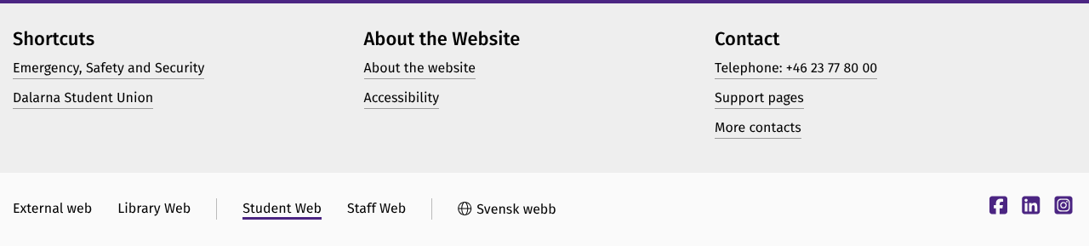

Error Report ER-02 – Menu expand buttons all have the same name “Show/hide underpages”
Error report ID | ER-02
Title | Menu expand buttons all have the same name “Show/hide underpages”
Reported by / date | Ali Hasan / 10 Nov 2026
Test case and step | TC-03, step 1
Persona | Blind user – screen reader and keyboard
Page / URL | https://www.du.se/en (main menu, all pages)
Environment | Chromium 153, axe-core 4.10.2, keyboard emulation, accessibility tree
WCAG 2.2 criterion | 2.4.6 Headings and Labels (AA)
Description | Every expand (+) control in the main menu has aria-label="Show/hide underpages". A screen reader announces the same text for each one, without saying which menu item it belongs to.
Steps to reproduce | 1. Open the main menu (Toggle navigation menu).  2. Tab through the menu items with a screen reader running.
Expected result | Every control describes its purpose, e.g. “Show/hide underpages for Student web”.
Actual result | Six or more controls are all named “Show/hide underpages”.
Severity | ☐ S1 Critical ☐ S2 Major ☒ S3 Minor/Moderate ☐ S4 Low
Motivation for severity | The user can guess from the order of the controls, but it is confusing and slows down menu navigation.
Priority | Medium
How it was found | Found manually by inspecting the markup and accessibility tree.
Suggested fix | Include the item name in the label, e.g. aria-label="Show subpages: Student web".
Attachment | Screenshot below
Status | Open

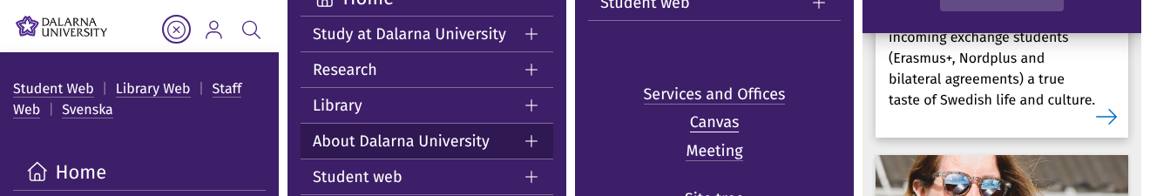

Error Report ER-03 – Apply link text is only a URL (“student.ladok.se”)
Error report ID | ER-03
Title | Apply link text is only a URL (“student.ladok.se”)
Reported by / date | Ali Hasan / 10 Nov 2026
Test case and step | TC-03, step 2
Persona | Blind user – screen reader and keyboard
Page / URL | https://www.du.se/en/student-web/my-studies/degree-certificates-and-levels/
Environment | Chromium 153, axe-core 4.10.2, keyboard emulation, accessibility tree
WCAG 2.2 criterion | 2.4.9 Link Purpose (Link Only) (AAA) – 2.4.4 (A) is met through context
Description | The most important link on the page, the one used to apply, is called “student.ladok.se”. In a links list (NVDA+F7) it does not say that this is where you apply for the degree certificate.
Steps to reproduce | 1. Open the certificate page.  2. NVDA+F7 → Links.  3. Look for the link to apply.
Expected result | The link can be identified by its name alone, e.g. “Apply for a degree certificate in Ladok”.
Actual result | The link is called “student.ladok.se”. The sentence around it gives the context.
Severity | ☐ S1 Critical ☐ S2 Major ☐ S3 Minor/Moderate ☒ S4 Low
Motivation for severity | It passes Level A because of the surrounding sentence, and the user can still find it. The issue is low.
Priority | Low
How it was found | Found manually.
Suggested fix | Rewrite the link text to “Apply for a degree certificate in Ladok (student.ladok.se)”.
Attachment | Screenshot below
Status | Open

Error Report ER-04 – Share links open a new tab without warning
Error report ID | ER-04
Title | Share links open a new tab without warning
Reported by / date | Ali Hasan / 10 Nov 2026
Test case and step | TC-03, step 3
Persona | Blind user – screen reader and keyboard
Page / URL | https://www.du.se/en/student-web/my-studies/degree-certificates-and-levels/ (Share dialog)
Environment | Chromium 153, axe-core 4.10.2, keyboard emulation, accessibility tree
WCAG 2.2 criterion | Advisory technique G201 (related to 3.2.5, AAA)
Description | The Facebook, Twitter and LinkedIn links in the Share dialog have target="_blank" but no text or label telling the user that a new tab opens.
Steps to reproduce | 1. Open the certificate page.  2. Activate “Share”.  3. Check the links’ names and their target attribute.
Expected result | The link tells the user that it opens in a new window or tab.
Actual result | The links are only named “Facebook”, “Twitter” and “LinkedIn” and open a new tab.
Severity | ☐ S1 Critical ☐ S2 Major ☐ S3 Minor/Moderate ☒ S4 Low
Motivation for severity | It does not affect the user story; the back button simply does not work in the new tab.
Priority | Low
How it was found | Found manually by inspecting the markup.
Suggested fix | Add “(opens in new tab)” to the links' accessible names.
Attachment | Screenshot below
Status | Open

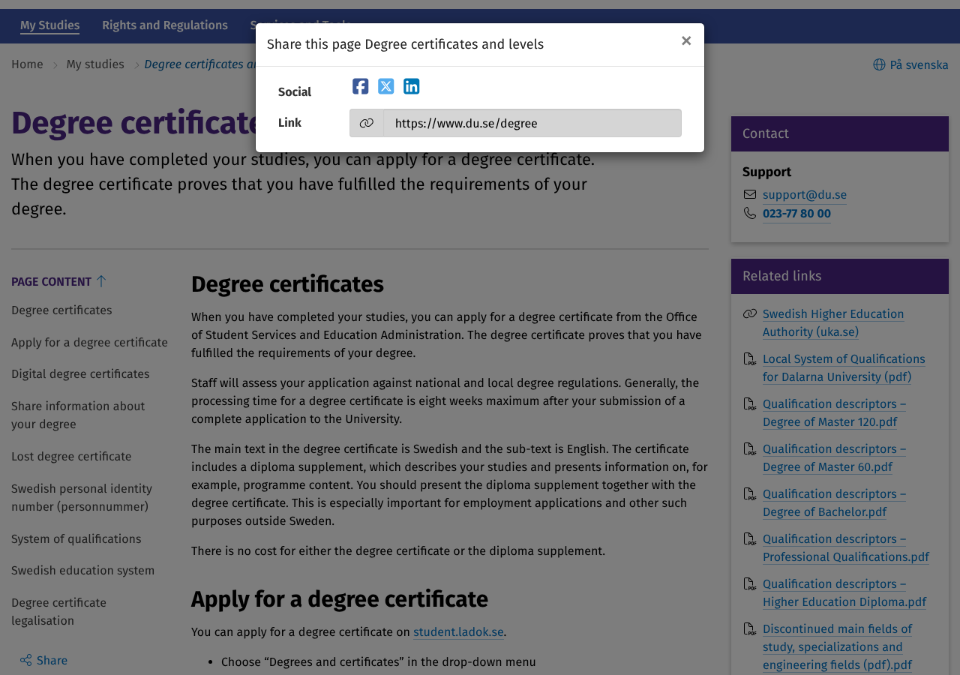

Error Report ER-05 – Cookie banner does not reflow at 400% zoom – text is cut off
Error report ID | ER-05
Title | Cookie banner does not reflow at 400% zoom – text is cut off
Reported by / date | Bilala Ahmed Adem / 10 Nov 2026
Test case and step | TC-05, step 2
Persona | User with low vision – 400% zoom
Page / URL | https://www.du.se/en and https://www.du.se/en/student-web/my-studies/degree-certificates-and-levels/
Environment | Chromium 153, axe-core 4.10.2, keyboard emulation, accessibility tree
WCAG 2.2 criterion | 1.4.10 Reflow (AA)
Description | At 400% zoom (320 CSS px wide), the fixed cookie banner is 356 px tall in a 225 px window. It covers the whole screen. The top of its text (“To improve our users’ experience, we use cookies…”) is above the visible area and cannot be scrolled, so the user cannot read what they are agreeing to.
Steps to reproduce | 1. Clear cookies.  2. Open www.du.se/en and set zoom to 400%.  3. Try to read the cookie banner and to scroll it.
Expected result | The whole banner and its buttons are visible, or it can be scrolled.
Actual result | Text cut off at the top, not scrollable; the whole page is covered until a button is pressed.
Severity | ☐ S1 Critical ☐ S2 Major ☒ S3 Minor/Moderate ☐ S4 Low
Motivation for severity | The buttons are still visible, so the user can continue, but information is lost and the page is hidden behind the banner.
Priority | High
How it was found | Found manually (zoom test); axe-core did not report it.
Suggested fix | Limit the banner height (e.g. max-height: 50vh; overflow-y: auto) and use a smaller layout on narrow screens.
Attachment | Screenshot below
Status | Open

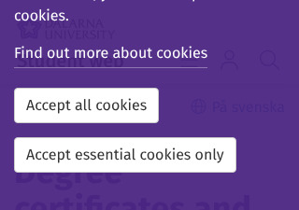

Error Report ER-06 – Expand (+) buttons get focus before their menu item
Error report ID | ER-06
Title | Expand (+) buttons get focus before their menu item
Reported by / date | Karim Al hashoom / 10 Nov 2026
Test case and step | TC-09, step 3
Persona | User with motor difficulties – keyboard only
Page / URL | https://www.du.se/en (main menu)
Environment | Chromium 153, axe-core 4.10.2, keyboard emulation, accessibility tree
WCAG 2.2 criterion | 2.4.3 Focus Order (A)
Description | In the opened main menu, each (+) button is placed to the right of its menu item, but receives focus before the item. Focus therefore jumps right and then left on every row.
Steps to reproduce | 1. Open the main menu with Enter.  2. Press Tab through the items.
Expected result | Focus moves in the visual order (item, then its + button).
Actual result | Order is “+” → item → “+” → item…, which does not match the visual layout.
Severity | ☐ S1 Critical ☐ S2 Major ☐ S3 Minor/Moderate ☒ S4 Low
Motivation for severity | The meaning is not lost and all items can be reached. It is a small inconvenience.
Priority | Low
How it was found | Found manually (scripted Tab sequence + screenshot).
Suggested fix | Place the + button after the link in the DOM.
Attachment | Screenshot below
Status | Open

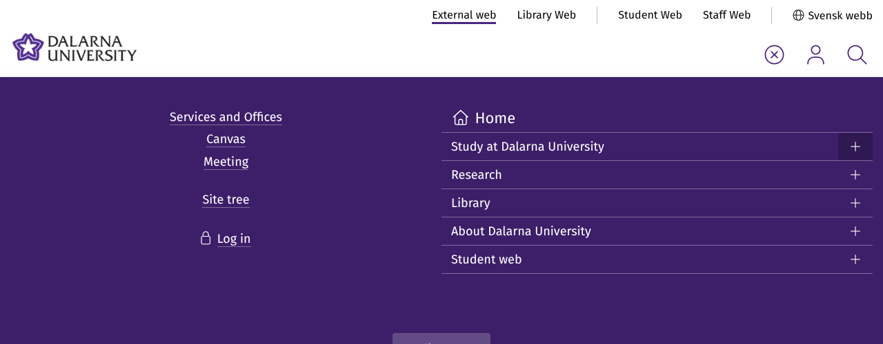

Error Report ER-07 – No visible focus on the menu, personal menu and search buttons
Error report ID | ER-07
Title | No visible focus on the menu, personal menu and search buttons
Reported by / date | Karim Al hashoom / 10 Nov 2026
Test case and step | TC-10, step 1 (and TC-08, step 5)
Persona | User with motor difficulties – keyboard only (also low vision)
Page / URL | All pages (header)
Environment | Chromium 153, axe-core 4.10.2, keyboard emulation, accessibility tree
WCAG 2.2 criterion | 2.4.7 Focus Visible (AA); 1.4.11 Non-text Contrast (AA)
Description | When the three icon buttons in the header (Toggle navigation menu, Toggle personal menu, Toggle search menu) receive keyboard focus, nothing changes visually. The only style change is a background of rgba(255,255,255,0.1) on a white background (contrast 1:1). A pixel comparison of the screenshots before and after focus showed 0 changed pixels. These are the buttons the keyboard user needs to open the menu and the search.
Steps to reproduce | 1. Open www.du.se/en.  2. Press Tab 8 times (focus on Toggle navigation menu).  3. Press Tab twice more.
Expected result | Every focused element has a clearly visible focus indicator with at least 3:1 contrast.
Actual result | No visible focus indicator on the three buttons.
Severity | ☐ S1 Critical ☒ S2 Major ☐ S3 Minor/Moderate ☐ S4 Low
Motivation for severity | The buttons are central to the user story (menu and search). The keyboard user cannot see where they are and has to guess. The task can only be completed with difficulty.
Priority | High
How it was found | Found manually (screenshots + pixel comparison); axe-core cannot detect missing focus indicators.
Suggested fix | Add a :focus-visible style, e.g. outline: 3px solid #4b2582; outline-offset: 2px.
Attachment | Screenshot below
Status | Open

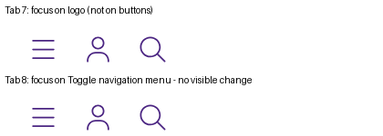

Error Report ER-08 – Cookie banner is last in tab order and hides focused elements
Error report ID | ER-08
Title | Cookie banner is last in tab order and hides focused elements
Reported by / date | Karim Al hashoom / 10 Nov 2026
Test case and step | TC-10, step 3 and TC-12, step 1
Persona | User with motor difficulties – keyboard only
Page / URL | All pages (until cookies are accepted)
Environment | Chromium 153, axe-core 4.10.2, keyboard emulation, accessibility tree
WCAG 2.2 criterion | 2.4.11 Focus Not Obscured (Minimum) (AA); 2.4.3 Focus Order (A)
Description | The cookie banner (role=dialog) is fixed at the bottom of the screen but last in the tab order: 42 Tabs on the start page and 65 on the certificate page. While it is open, footer links that receive focus are hidden behind the 95% opaque banner.
Steps to reproduce | 1. Clear cookies and open www.du.se/en.  2. Press Tab repeatedly and watch the footer links and the banner.
Expected result | Focus reaches the banner early, and a focused element is never completely hidden.
Actual result | Banner reached after 42/65 Tabs; focused footer links (e.g. “Library Web”, “Staff Web”) are hidden behind the banner.
Severity | ☐ S1 Critical ☐ S2 Major ☒ S3 Minor/Moderate ☐ S4 Low
Motivation for severity | The user can still close the banner and continue, but it takes many extra key presses and focus is lost from view.
Priority | Medium
How it was found | Found manually (scripted Tab sequence + screenshots).
Suggested fix | Move the banner first in the DOM or move focus to it on page load, and make it non-obscuring (e.g. add padding-bottom to the body).
Attachment | Screenshot below
Status | Open

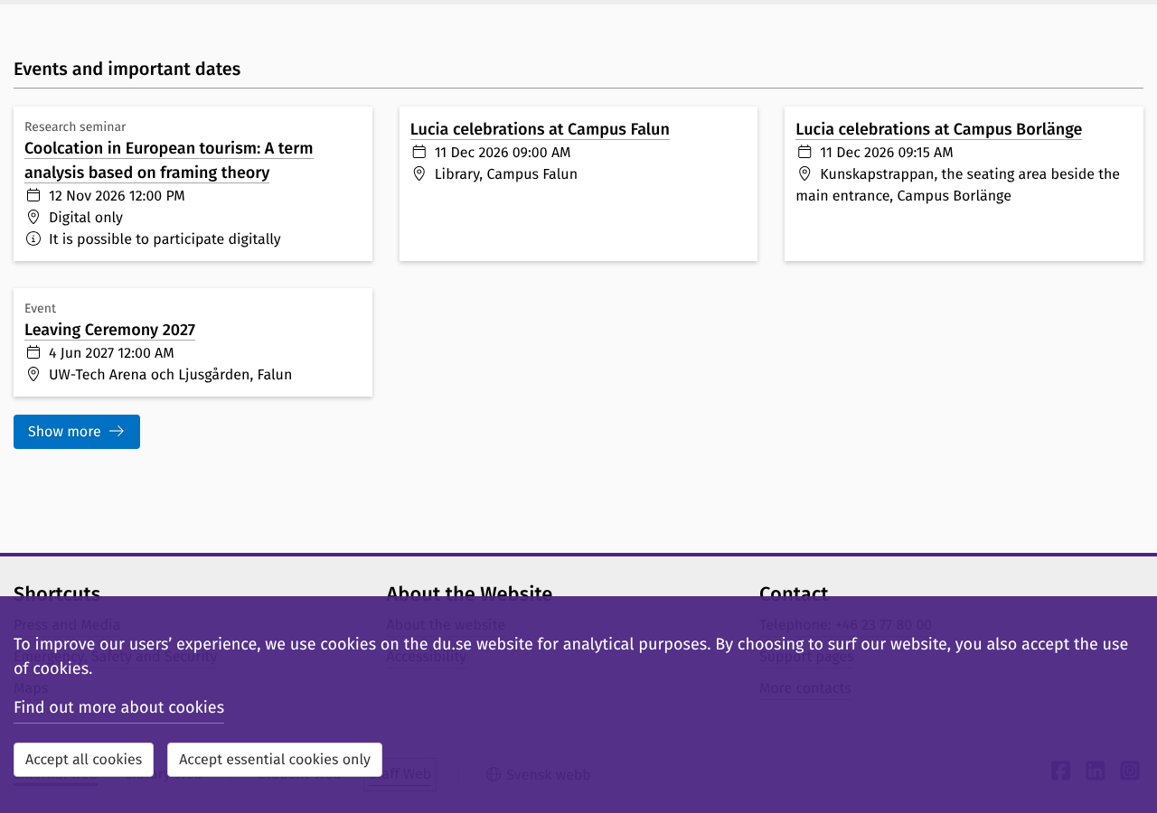

Error Report ER-09 – Sub-menu (+) buttons do not respond to the Space key
Error report ID | ER-09
Title | Sub-menu (+) buttons do not respond to the Space key
Reported by / date | Karim Al hashoom / 10 Nov 2026
Test case and step | TC-11, step 1
Persona | User with motor difficulties – keyboard only
Page / URL | https://www.du.se/en (main menu)
Environment | Chromium 153, axe-core 4.10.2, keyboard emulation, accessibility tree
WCAG 2.2 criterion | 4.1.2 Name, Role, Value (A)
Description | The (+) controls are <a href="#void" role="button">. A button should be activated with both Enter and Space. Space does nothing to the menu (aria-expanded stays “false”) and instead scrolls the page. Only Enter works.
Steps to reproduce | 1. Open the main menu.  2. Tab to the + next to “Student web”.  3. Press Space, then Enter.
Expected result | Sub-menus open with Enter and Space.
Actual result | Space scrolls the page; only Enter opens the sub-menu.
Severity | ☐ S1 Critical ☐ S2 Major ☒ S3 Minor/Moderate ☐ S4 Low
Motivation for severity | There is a workaround (Enter), but users who rely on Space for buttons will think the menu is broken.
Priority | Medium
How it was found | Found manually (keyboard test).
Suggested fix | Use a real <button> element, or handle the Space key in JavaScript.
Attachment | –
Status | Open

Error Report ER-10 – Esc does not close the open main menu
Error report ID | ER-10
Title | Esc does not close the open main menu
Reported by / date | Karim Al hashoom / 10 Nov 2026
Test case and step | TC-11, step 1
Persona | User with motor difficulties – keyboard only
Page / URL | https://www.du.se/en (main menu)
Environment | Chromium 153, axe-core 4.10.2, keyboard emulation, accessibility tree
WCAG 2.2 criterion | Not a WCAG requirement (best practice for menus)
Description | When the main menu is open, pressing Esc does nothing (aria-expanded stays “true”). The user has to Tab to “Close menu” or back to the toggle button.
Steps to reproduce | 1. Open the main menu with Enter.  2. Press Esc.
Expected result | Esc closes the menu (expected result in TC-11).
Actual result | The menu stays open.
Severity | ☐ S1 Critical ☐ S2 Major ☐ S3 Minor/Moderate ☒ S4 Low
Motivation for severity | It is only an inconvenience; the menu can be closed in other ways.
Priority | Low
How it was found | Found manually (keyboard test).
Suggested fix | Close the menu on Esc and return focus to the menu button.
Attachment | –
Status | Open

