

Statistical Analysis

Hand-Written Digits



2017/2018

Faculty of Computer and information science

Ain Shams University

Dr/ Maryam El-Bary

“Let’s have fun with data“

Made by:

Ali Taha Abd El-Salaam *sec. 11*

Mina Okaily Nateeg *sec. 18*

Mahmoud Ahmed Abd-allah  *sec. 16*

Abstract:

This report examines benefits of using structural features in recognition of handwritten digits. we will present a way to tackle the recognition of human handwritten digits using “Matlab”. The ANN proposed here is experimented on the well-known MNIST data set. Without any pre-processing of the data set, our ANN achieves quite low classification error. Combined with clustering techniques, we can build artificial intelligence system which can automatically segment individual digit from images and find its corresponding label.

Introduction:

Image recognition is important for many of the advanced technologies we use today. Handwritten digit recognition can be seen as a sub-problem of the more general OCR (Optical Character Recognition) problem. However, there are some applications that are restricted to recognizing digits but require very high accuracy and speed. In addition, handwritten digit recognition is used as a benchmark for comparing different classification techniques because digit recognition problem is hard enough to be challenging but not too complicated. While recognition of handwritten Latin digits has been extensively investigated using various techniques.

Description:

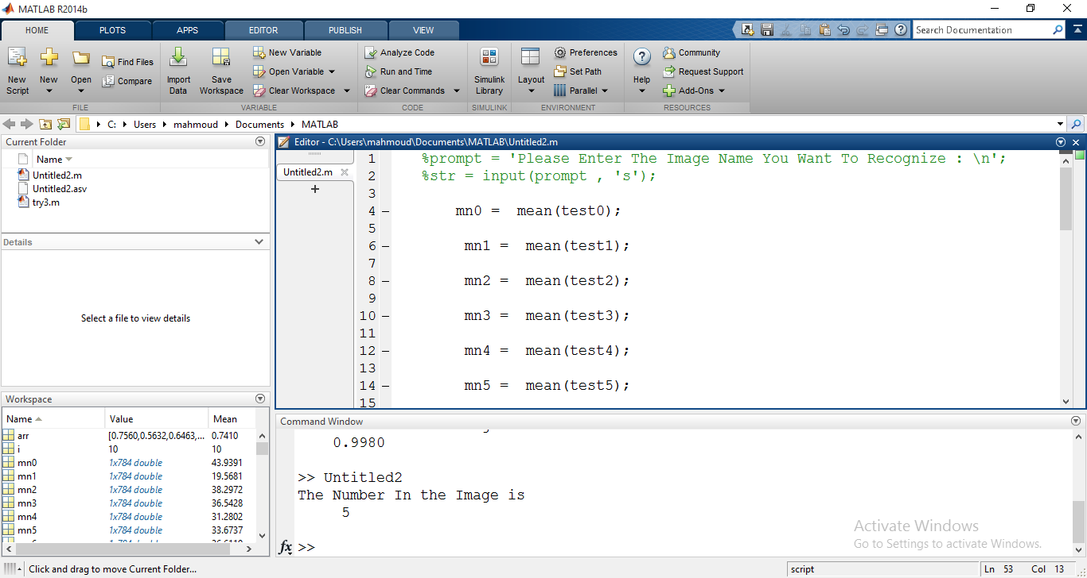

From line 1 to line 22 , we import the data to check it by the mean .Putting them in variables mn0 , mn1 , mn2 , etc.

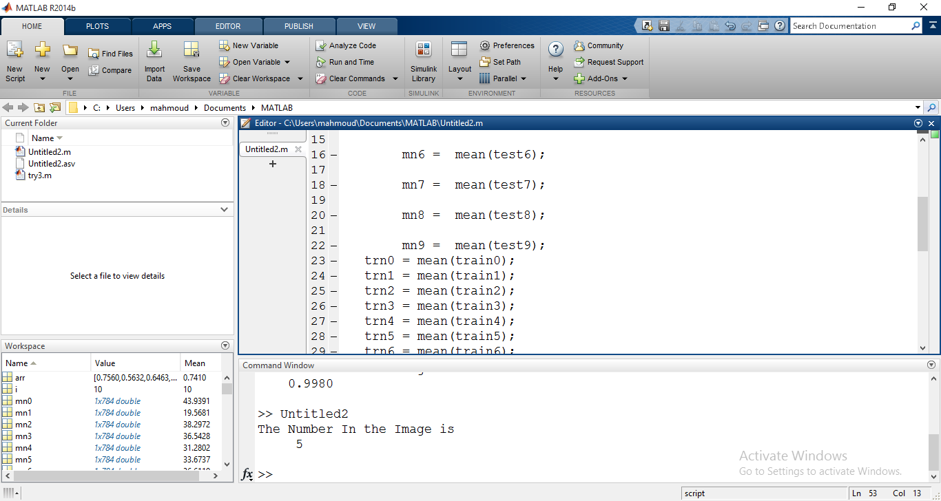

From line 23 to line 32 , we conclude the train by the mean and putting them in variables trn0,trn1,trn2, etc.

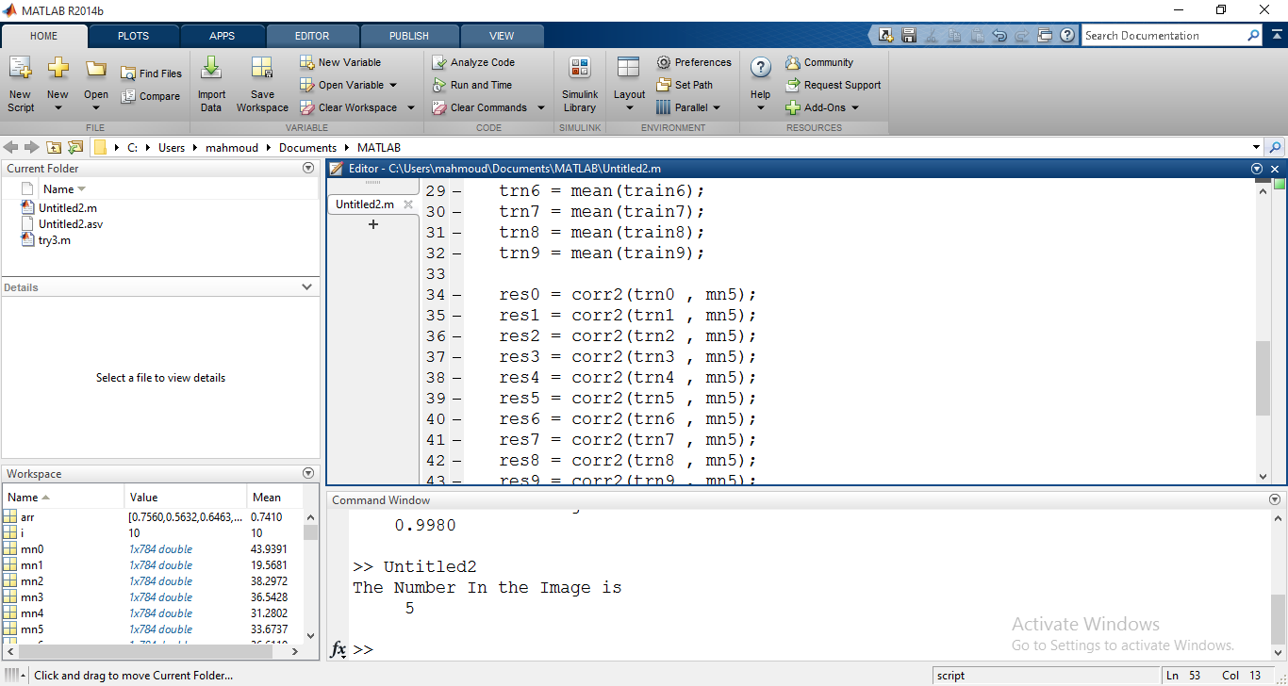

From line 33 to line 44, we take the mean for test and get the correlation with all trains by using Function called “corr2”.

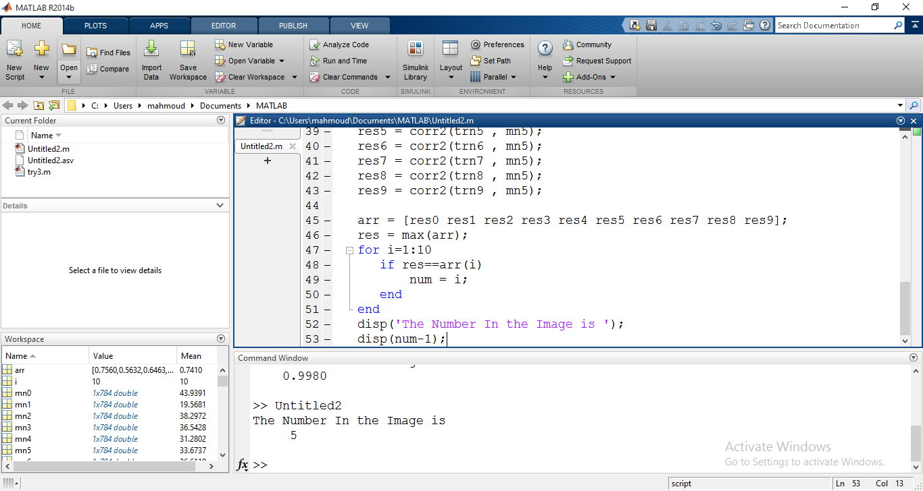

Then we get the correlation and store them in variable “res” from 0 to 9 like res0,res1,res2,etc, and we take these result and put them in an array called “arr”,then we use function called “max” to return the right value , after that we making loop to the array and compare the res with the max value then we got the final result by get (index-1) of the value .

Conclusion :

We get the result of comparing the images by the data using this simple program.