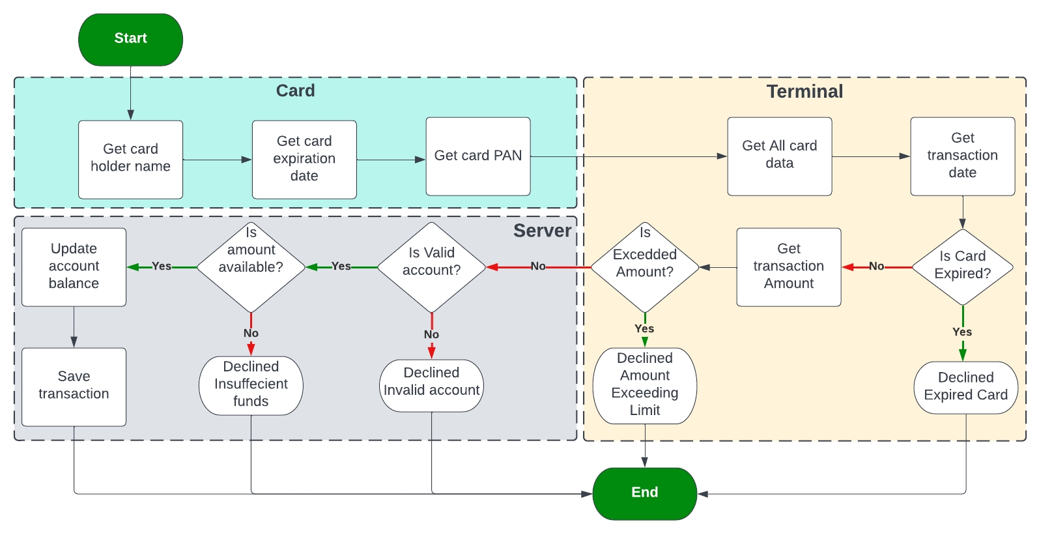**Development environment preparation**

| CRITERIA | MEETS SPECIFICATIONS |
| --- | --- |
| Create modules folders | 1. Create a new project 2. Create "Application" folder 3. Create "Card" folder 4. Create "Terminal" folder 5. Create "Server" folder   Note: To create a folder in Microsoft Visual Studio   1. In the solution explorer, right-click on the project name 2. Go to Add 3. Select Folder 4. Give a name to that folder   You should deliver a screenshot of the solution explorer that clarifies your folder structure. |
| Create .c and .h file for each module | 1. In the "Application" folder create app.c and app.h files 2. In the "Card" folder create card.c and card.h files 3. In the "Terminal" folder create terminal.c and terminal.h files 4. In the "Server" folder create server.c and server.h files   Note: To create a file into a folder in Microsoft Visual Studio   1. In the solution explorer, right-click on the folder you want 2. Go to Add 3. Select New Item 4. Select file type, .cpp or .h 5. If a .cpp is chosen, change the extension to .c 6. Give a name to that file"   You should deliver a screenshot of the solution explorer that clarifies files in each folder. |
| Add header file gaurd | 1. In the app.h file add the header file guard 2. In the card.h file add the header file guard 3. In the terminal.h file add the header file guard 4. In server.h file add the header file guard 5. You should deliver a screenshot for each .h file, file name must appear in the screenshot and the header file gaurd |

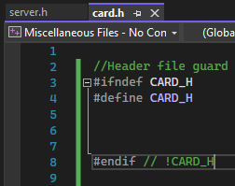 **Implement the card module**

| CRITERIA | MEETS SPECIFICATIONS |
| --- | --- |
| Fill in card.h file with functions' prototypes and typedefs | Use the following prototypes as is:   1. EN_cardError_t getCardHolderName(ST_cardData_t *cardData); 2. EN_cardError_t getCardExpiryDate(ST_cardData_t *cardData); 3. EN_cardError_t getCardPAN(ST_cardData_t *cardData);   Use the following typedef as-is: typedef struct ST_cardData_t { uint8_t cardHolderName[25]; uint8_t primaryAccountNumber[20]; uint8_t cardExpirationDate[6]; }ST_cardData_t;  typedef enum EN_cardError_t { CARD_OK, WRONG_NAME, WRONG_EXP_DATE, WRONG_PAN }EN_cardError_t;  You should deliver a screenshot for your card.h file |
| Implement getCardHolderName function | 1. This function will ask for the cardholder's name and store it into card data. 2. Card holder name is 24 alphabetic characters string max and 20 min. 3. If the cardholder name is NULL, less than 20 characters or more than 24 will return WRONG_NAME error, else return CARD_OK.   You should deliver a maximum 2min video to discuss your implementation and run different test cases on this function |
| Implement getCardExpiryDate function | 1. This function will ask for the card expiry date and store it in card data. 2. Card expiry date is 5 characters string in the format "MM/YY", e.g "05/25". 3. If the card expiry date is NULL, less or more than 5 characters, or has the wrong format will return WRONG_EXP_DATE error, else return CARD_OK.   You should deliver a maximum 2min video to discuss your implementation and run different test cases on this function |
| Implement getCardPAN function | 1. This function will ask for the card's Primary Account Number and store it in card data. 2. PAN is 20 numeric characters string, 19 character max, and 16 character min. 3. If the PAN is NULL, less than 16 or more than 19 characters, will return WRONG_PAN error, else return CARD_OK.   You should deliver a maximum 2min video to discuss your implementation and run different test cases on this function |

**Implement the terminal module**

| CRITERIA | MEETS SPECIFICATIONS |
| --- | --- |
| Fill in terminal.h file with functions' prototypes and typedefs | Use the following prototypes as is:   1. EN_terminalError_t getTransactionDate(ST_terminalData_t *termData); 2. EN_terminalError_t isCardExpired(ST_cardData_t cardData, ST_terminalData_t termData); 3. EN_terminalError_t isValidCardPAN(ST_cardData_t *cardData); 4. EN_terminalError_t getTransactionAmount(ST_terminalData_t *termData); 5. EN_terminalError_t isBelowMaxAmount(ST_terminalData_t *termData); 6. EN_terminalError_t setMaxAmount(ST_terminalData_t *termData);   Use the following typedef as is: typedef struct ST_terminalData_t { float transAmount; float maxTransAmount; uint8_t transactionDate[11]; }ST_terminalData_t;  typedef enum EN_terminalError_t { TERMINAL_OK, WRONG_DATE, EXPIRED_CARD, INVALID_CARD, INVALID_AMOUNT, EXCEED_MAX_AMOUNT, INVALID_MAX_AMOUNT }EN_terminalError_t ;  You should deliver a screenshot for your terminal.h file |
| Implement getTransactionDate function | 1. This function will ask for the transaction data and store it in terminal data. 2. Transaction date is 10 characters string in the format DD/MM/YYYY, e.g 25/06/2022. 3. If the transaction date is NULL, less than 10 characters or wrong format will return WRONG_DATE error, else return TERMINAL_OK.   Optional: The function will read the current date from your computer and store it into terminal data with the mentioned size and format.  You should deliver a maximum 2min video to discuss your implementation and run different test cases on this function |
| Implement isCardExpried function | 1. This function compares the card expiry date with the transaction date. 2. If the card expiration date is before the transaction date will return EXPIRED_CARD, else return TERMINAL_OK.   You should deliver a maximum 2min video to discuss your implementation and run different test cases on this function |
| Implement gatTransactionAmount function | 1. This function asks for the transaction amount and saves it into terminal data. 2. If the transaction amount is less than or equal to 0 will return INVALID_AMOUNT, else return OK. You should deliver a maximum 2min video to discuss your implementation and run different test cases on this function |
| Implement isBelowMaxAmount function | 1. This function compares the transaction amount with the terminal max amount. 2. If the transaction amount is larger than the terminal max amount will return EXCEED_MAX_AMOUNT, else return TERMINAL_OK.   You should deliver a maximum 2min video to discuss your implementation and run different test cases on this function |
| Implement setMaxAmount function | 1. This function sets the maximum allowed amount into terminal data. 2. Transaction max amount is a float number. 3. If transaction max amount less than or equal to 0 will return INVALID_MAX_AMOUNT error, else return TERMINAL_OK.   You should deliver a maximum 2min video to discuss your implementation and run different test cases on this function  الـ function دي هناديها في اول الـ main اللي هنعملها |

**Implement the server module**

| CRITERIA | MEETS SPECIFICATIONS |
| --- | --- |
| Fill in server.h file with functions' prototypes and typedefs | Use the following prototypes as is:   1. EN_transState_t recieveTransactionData(ST_transaction_t *transData); 2. EN_serverError_t isValidAccount(ST_cardData_t cardData, ST_accountsDB_t accountRefrence); 3. EN_serverError_t isBlockedAccount(ST_accountsDB_t *accountRefrence); 4. EN_serverError_t isAmountAvailable(ST_trminalData_t *termData); 5. EN_serverError_t saveTransaction(ST_transaction_t *transData); 6. EN_serverError_t getTransaction(uint32_t transactionSequenceNumber, ST_transaction_t *transData);   Use the following typedef as-is:  typedef enum EN_transState_t { APPROVED, DECLINED_INSUFFECIENT_FUND, DECLINED_STOLEN_CARD, FRAUD_CARD, INTERNAL_SERVER_ERROR }EN_transStat_t;  typedef struct ST_transaction_t { ST_cardData_t cardHolderData; ST_trminalData_t terminalData; EN_transState_t transState; uint32_t transactionSequenceNumber; }ST_transaction;  typedef enum EN_serverError_t { SERVER_OK, SAVING_FAILED, TRANSACTION_NOT_FOUND, ACCOUNT_NOT_FOUND, LOW_BALANCE, BLOCKED_ACCOUNT }EN_serverError_t ;  typedef enum EN_accountState_t { RUNNING, BLOCKED }EN_accountState_t;  typedef struct ST_accountsDB_t { float balance; EN_accountState_t state; uint8_t primaryAccountNumber[20]; }ST_accountsDB_t;  You should deliver a screenshot for your server.h file. |
| Implement server-side accounts' database | 1. Create a global array of ST_accountsDB_t for the valid accounts database 2. Fill in the array initially with any valid data 3. This array has a maximum of 255 element/account data 4. You can fill up to 10 different accounts for the sake of testing 5. Example of a running account: {2000.0, RUNNING, "8989374615436851"} 6. Example of a blocked account, **its card is stolen**: {100000.0, BLOCKED, "5807007076043875"}   You should deliver a screenshot of your accounts database array with a minimum of at least 5 different accounts for the different test cases, check all needed test cases in the **"Testing the application"** section |
| Implement server-side transactions' database | 1. Create a global array of ST_transaction_t 2. Fill in the array initially with 0s. 3. This array has a maximum of 255 element/transaction data   You should deliver a screenshot of your transaction database array |
| Implement recieveTransactionData function | 1. This function will take all transaction data and validate its data. 2. It checks the account details and amount availability. 3. If the account does not exist return FRAUD_CARD, if the amount is not available will return DECLINED_INSUFFECIENT_FUND, if the account is blocked will return DECLINED_STOLEN_CARD, if a transaction can't be saved will return INTERNAL_SERVER_ERROR and will not save the transaction, else returns APPROVED. 4. It will update the database with the new balance.   You should deliver a maximum 2min video to discuss your implementation and run different test cases on this function. |
| Implement isValidAccount function | 1. This function will take card data and validate if the account related to this card exists or not. 2. It checks if the PAN exists or not in the server's database (searches for the card PAN in the DB). 3. If the PAN doesn't exist will return ACCOUNT_NOT_FOUND, else will return SERVER_OK and return a reference to this account in the DB.   You should deliver a maximum 2min video to discuss your implementation and run different test cases on this function |
| Implement isAmountAvailable function | 1. This function will take terminal data and validate these data. 2. It checks if the transaction's amount is available or not. 3. If the transaction amount is greater than the balance in the database will return LOW_BALANCE, else will return SERVER_OK You should deliver a maximum 2min video to discuss your implementation and run different test cases on this function |
| Implement saveTransaction function | 1. This function will store all transaction data in the transactions database. 2. It gives a sequence number to a transaction, this number is incremented once a transaction is processed into the server, you must check the last sequence number in the server to give the new transaction a new sequence number. 3. It saves any type of transactions, APPROVED or DECLINED, with the specific reason for declining/transaction state. 4. If the transaction can't be saved, for any reason (ex: dropped connection) will return SAVING_FAILED, else will return SERVER_OK, you can simulate this by commenting on the lines you where your code writes the transaction data in the database. 5. It checks if the transaction is saved or not using the getTransaction function.   You should deliver a maximum 2min video to discuss your implementation and run different test cases on this function |
| Implement getTransaction function | 1. This function takes the sequence number of a transaction and returns the transaction data if found in the transactions DB. 2. If the sequence number is not found, then the transaction is not found, the function will return TRANSACTION_NOT_FOUND, else return transaction data as well as SERVER_OK   You should deliver a maximum 2min video to discuss your implementation and run different test cases on this function |

**Implement the application**

| CRITERIA | MEETS SPECIFICATIONS |
| --- | --- |
| Fill in application.h file with functions' prototypes | Use the following prototypes as-is: void appStart(void);  You should deliver a screenshot for your application.h file. |
| Implement appStart function | Please refere to the flow chart attached under the instructions video in order to implement this application. You should deliver:   1. All project folders and files 2. Video record where you will discuss your implementation (maximum 3min) |

**Testing the application**

| CRITERIA | MEETS SPECIFICATIONS |
| --- | --- |
| Transaction approved user story | As a bank customer have an account and has a valid and not expired card, I want to withdraw an amount of money less than the maximum allowed and less than or equal to the amount in my balance, so that I am expecting that the transaction is approved and my account balance is reduced by the withdrawn amount.  You should deliver a video for testing this user story: 1- Mention test data you are using 2- Test result must be clear - is it passed or failed |
| Exceed the maximum amount user story | As a bank customer have an account, that has a valid and not expired card, I want to withdraw an amount of money that exceeds the maximum allowed amount so that I am expecting that the transaction declined. You should deliver a video for testing this user story:  1- Mention test data you are using 2- Test result must be clear - is it passed or failed |
| Insufficient fund user story | As a bank customer have an account and has a valid and not expired card, I want to withdraw an amount of money less than the maximum allowed and larger than the amount in my balance so that I am expecting that the transaction declined. You should deliver a video for testing this user story:  1- Mention test data you are using 2- Test result must be clear - is it passed or failed |
| Expired card user story | As a bank customer have an account, have a valid but expired card, I want to withdraw an amount of money so that I expect that the transaction declined.  You should deliver a video for testing this user story: 1- Mention test data you are using 2- Test result must be clear - is it passed or failed" |
| Invalid card user story | As a bank customer have an account and has a valid and not expired stolen card, I want to block anyone from using my card so that I am expecting that any transaction made by this card is declined.  You should deliver a video for testing this user story: 1- Mention test data you are using 2- Test result must be clear - is it passed or failed" |

## Suggestions to Make Your Project Stand Out!

In getCardPAN function:

Give PAN that is a Luhn number, Luhn number generator, and checker

In terminal implement isValidCard function:

1. This function checks if the PAN is a Luhn number or not.
2. If PAN is not a Luhn number will return INVALID_CARD, else return CARD_OK.

In server isBlockedAccount function:

1. This function will take a reference to an existing account in the database.
2. It checks if the account is blocked or not.
3. If the account is blocked, will return BLOCKED_ACCOUNT, else will return SERVER_OK.

Server-side accounts DB:

1. Instead of a global array create a text file "Accounts DB.txt" that stores all account data and read this file into your application
2. Instead of a global array create a text file "Transactions DB.txt" where you will save all transactions and read if you need

Server-side transactions DB:

1. Instead of a global array create a text file "Transactions DB.txt" where you will save all transactions and read if you need

Fraud card user story:

As a bank administrator, I want to issue my own cards, so that I am expecting that any transaction made by any fraud card (failed in Luhun check) is declined.