**Lab Manual 5**

**Submitted by: Ali Rehman Qureshi**

**Class: ME-15(C)**

**ID: 459203**

**Home Task**

**Task 1:**

Write a program in C++ to find LCM of any two numbers using HCF.

#include <iostream>

using namespace std;

int main()

{

int num1;

int num2;

int temp;

int hcf;

int lcm;

cout << "Enter two numbers you want the lcm of" << endl;

cin >> num1 >> num2;

if (num2 > num1) {

temp = num1;

num1 = num2;

num2 = temp;

}

for (int i = 1; i <= num1 ; i++)

{

if (num1%i==0 && num2%i==0 ) {

hcf = i;

}

}

lcm = (num1 / hcf) * (num2 / hcf) * hcf;

cout << "The LCM of the given numbers is " << lcm;

return 0;

}

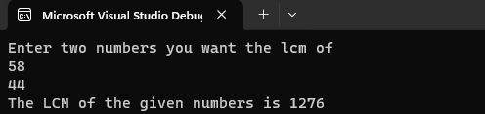

**Task 2:**

Write a program in C++ to find out the sum of an Arithmetic progression series

#include <iostream>

using namespace std;

int main()

{

int increment;

int sum = 0;

int res = 0;

cout << "Enter the increment for the arthimetic progression\n";

cin >> increment;

for (int i = 1; i <=100; i++)

{

res += increment;

sum += res;

}

cout << "The result of this series is " << sum;

return 0;

}

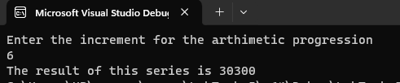

**Task 3:**

3. Write a program in C++ to create a diamond

#include <iostream>

using namespace std;

int main()

{

int spaces = 4;

int stars = 1;

for (int i = 1;i <= 5;i++)

{

for (int j = 1; j <= spaces;j++)

{

cout << " ";

}

for (int k = 1;k <= stars;k++)

{

cout << "*";

}

for (int j = 1; j <= spaces;j++)

{

cout << " ";

}

cout << endl;

stars += 2;

spaces -= 1;

}

stars -= 4;

spaces += 2;

for (int i = 1;i <= 5;i++)

{

for (int j = 1; j <= spaces;j++)

{

cout << " ";

}

for (int k = 1;k <= stars;k++)

{

cout << "*";

}

for (int j = 1; j <= spaces;j++)

{

cout << " ";

}

cout << endl;

stars -= 2;

spaces += 1;

}

return 0;

}



**Task 4:**

Write a program in C++ to convert a decimal number to a binary number.

#include <iostream>

#include <algorithm>//used for the reverse function below sir.

using namespace std;

int main()

{

int num = 0;

string result;

cin >> num;

while (num > 0)

{

if (num % 2 == 0)

{

result += "0";

num /= 2;

}

else

{

result += "1";

num = (num - 1) / 2;

}

}

std::reverse(result.begin(), result.end());//A method used for reversing a string.

cout << result;

return 0;

}

