**Lab Assignment 1**

**Submitted by: Ali Rehman Qureshi**

**Class: ME-15(C)**

**ID: 459203**

**Tasks:**

**Task 1:**

Write a C++ program to display factors of a number using for loops.

#include <iostream>

using namespace std;

int main()

{

int num = 0;

cin >> num;

for (int i = 1; i <= num; i++)

{

if (num % i == 0)

{

cout << i << " is a factor of " << num << endl;

}

}

return 0;

}

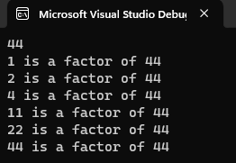

**Task 2:**

Write output to the following code.

Output: x is 5 and y is 10

**Task 3:**

Write a C++ program, take an integer value from user and check if it’s greater than 10 and less than equal to 20. Print 1 if yes and print 0 if no. Use appropriate datatype for output. 4.

#include <iostream>

using namespace std;

int main()

{

int num = 0;

cout << "Enter a number" << endl;

cin >> num;

if (num > 10 && num <= 20)

{

cout << 1;

}

else

{

cout << 0;

}

return 0;

}

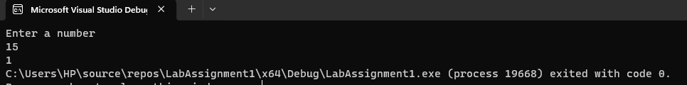

**Task 4:**

Write a C++ program that uses a while loop to find the largest prime number less than a given positive integer N. Your program should take the value of N as input from the user and then find the largest prime number less than or equal to N. You are not allowed to use any library or pre-existing functions to check for prime numbers.

#include <iostream>

using namespace std;

int main()

{

int n = 0;

cin >> n;

int count = 2;

int i = 1;

int largestPrime = 1;

bool isPrime = true;

while (count<=n)

{

isPrime = true;

i = 2;

while (i<count && isPrime==true)

{

if (!(count % i == 0))

{

isPrime = true;

}

else

{

isPrime = false;

}

i++;

}

if (isPrime==true)

{

largestPrime = count;

}

count++;

}

cout << "The largest prime number is " << largestPrime << endl;

return 0;

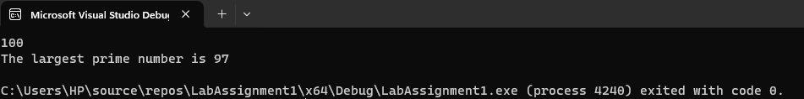

**Task 5:**

Write a C++ program, take two strings as input from the user and check if both strings are equal or not. If they are equal make them unequal by rotating string. e.g., Hello is turned into olleH, etc.

#include <iostream>

#include<algorithm>//used for reverse function

using namespace std;

int main()

{

string a;

string b;

cin >> a;

cin >> b;

if (a == b)

{

reverse(a.begin(),a.end());//reverses the function

}

cout << a<<endl;

cout << b<<endl;

return 0;

}

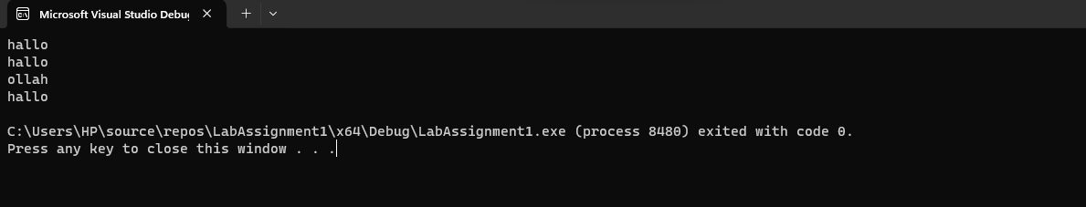

**Task 6:**

Perform division in C++ without / using for loops. You can use / only to display the final results. Your dividend must be greater than divisor.

#include <iostream>

using namespace std;

int main()

{

int num = 0;

cout << "Enter the number\n";

cin >> num;

int quotient = 0;

int divisor = 0;

cout << "Enter the divisor\n";

cin >> divisor;

while (num>=divisor)

{

num -= divisor;

quotient++;

}

cout << "The answer is " << quotient << endl;

return 0;

}

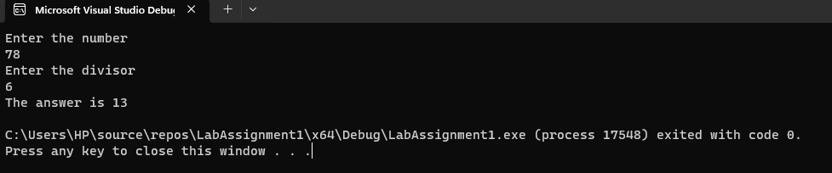

**Task 7:**

Write a C++ program for a string which may contain lowercase and uppercase characters. The task is to remove all duplicate characters from the string and find the resultant string.

**Task 8:**

Suppose an integer array a[5] = {1,2,3,4,5}. Add more elements to it and display them in C++.

#include <iostream>

using namespace std;

int main()

{

int a[10] = { 1,2,3,4,5 };

for (int i = 0; i <= 9; i++)

{

cin >> a[i];

}

for (int i = 0; i <= 9; i++)

{

cout<<a[i]<<endl;

}

}

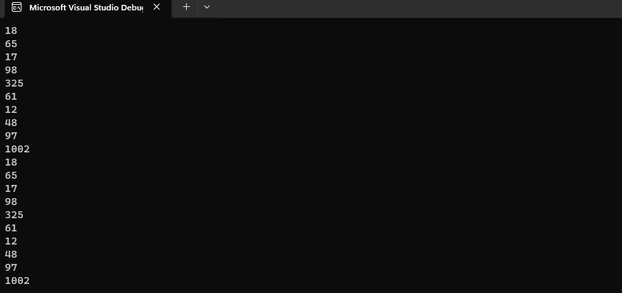

**Task 9:**

Given an integer array and an integer X. Find if there’s a triplet in the array which sums up to the given integer X.

#include <iostream>

using namespace std;

int main()

{

int a[5];

int num = 0;

bool found = false;

cout << "Enter a number\n";

cin >> num;

cout << endl;

cout << "Enter the numbers of the array\n";

for (int i = 0; i < 5; i++)

{

cin >> a[i];

}

for (int i = 0; i < 5; i++)

{

for (int j = 0; j < 5; j++)

{

for (int k = 0; k < 5; k++)

{

if (a[i]+a[j]+a[k]==num)

{

found = true;

}

}

}

}

if (!found)

{

cout << "Triplet not found" << endl;

}

else

{

cout << "Triplet found\n";

}

return 0;

}

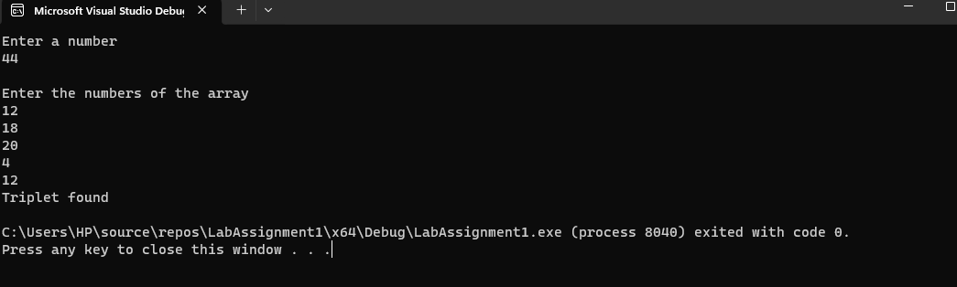

**Task 10:**

Implement Bubble Sort on an array of 6 integers.

int main()

{

int a[6];

cout << "Enter the array of 6 integers\n";

for (int i = 0; i < 6; i++)

{

cin >> a[i];

}

for (int e = 0; e <= 6; e++)

{

for (int j = 0; j < 4;j++)

{

if (a[j] > a[j + 1])

{

int temp;

temp = a[j];

a[j] = a[j + 1];

a[j + 1] = temp;

}

}

}

cout << "The sorted array is :" << endl;

for (int k = 0;k < 6;k++)

{

cout<< a[k]<<endl;

}

return 0;

}

