**Lab Manual 10**

**Submitted by: Ali Rehman Qureshi**

**Class: ME-15(C)**

**ID: 459203**

**Tasks**

**Task 1:**

**1.** Iterate Through Vector Using Iterators and print all pushed elements. Next you need to push integer 5 and remove element at that position.

#include <iostream>

#include<vector>

using namespace std;

int main()

{

vector<int> myVector;

myVector.push_back(1);

myVector.push_back(2);

myVector.push_back(3);

myVector.push_back(4);

cout << "Elements in the vector: ";

for ( auto it = myVector.begin(); it != myVector.end(); ++it) {

cout << *it << " ";

}

cout << endl;

myVector.push_back(5);

int positionToRemove = 3;

if (positionToRemove >= 0 && positionToRemove < myVector.size()) {

myVector.erase(myVector.begin() + positionToRemove);

}

cout << "Vector after pushing 5 and removing element at position 3: ";

for (const auto& element : myVector) {

cout << element << " ";

}

cout <<endl;

}

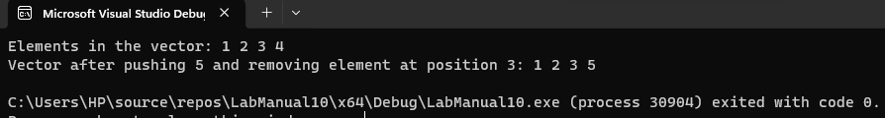

**Task 2:**

**2.** Write a complete C++ program that uses 2 vectors, 1 for names (string) and 1 for grades (int)

* 1. Ask the user for the number of name/grade pairs that will be entered.
  2. Display the mean of the grades.
  3. Display the median of the grades.
  4. Display the mode of the grades.
  5. Display the names of the students with the mode as their grade.

#include <iostream>

#include <vector>

#include <algorithm>

using namespace std;

int main() {

int numPairs;

cout << "Enter the number of name/grade pairs: ";

cin >> numPairs;

vector<string> names;

vector<int> grades;

for (int i = 0; i < numPairs; ++i) {

string name;

int grade;

cout << "Enter name #" << i + 1 << ": ";

cin >> name;

cout << "Enter grade for " << name << ": ";

cin >> grade;

names.push_back(name);

grades.push_back(grade);

}

double mean = 0.0;

for (int grade : grades) {

mean += grade;

}

mean /= grades.size();

cout << "Mean of grades: " << mean << endl;

sort(grades.begin(), grades.end());

double median;

int size = grades.size();

if (size % 2 == 0) {

median = (grades[size / 2 - 1] + grades[size / 2]) / 2.0;

}

else {

median = grades[size / 2];

}

cout << "Median of grades: " << median << endl;

int mode = grades[0];

int maxCount = 1;

int currentCount = 1;

for (int i = 1; i < size; ++i) {

if (grades[i] == grades[i - 1]) {

currentCount++;

}

else {

currentCount = 1;

}

if (currentCount > maxCount) {

maxCount = currentCount;

mode = grades[i];

}

}

cout << "Mode of grades: " << mode << endl;

cout << "Students with the mode as their grade: ";

for (int i = 0; i < size; ++i) {

if (grades[i] == mode) {

cout << names[i] << " ";

}

}

cout << endl;

return 0;

}

