SPECIFICATION

Coral Gardeners Mobile App

Introduction

Coral Gardeners is a not-for-profit organisation with the dual objectives of (1) raising awareness of the threats to coral reefs globally and (2) restoring reefs through a nursery and outplanting method.

We offer the public the option of adopting a coral, either online or during a visit to our HQ in Moorea (an Ecotour). In both cases the ‘adopter’ receives an adoption certificate.

We need a Coral Gardeners internal application to increase the efficiency of our project, specifically to save time and improve our data tracking in our restoration and adoption processes.

The app is needed for the following teams:

* Restoration Team: daily activity logging, image and data storage
* Ecotour Team : automated adoption certificate generation, data storage, image storage

Additionally, we would like a global dashboard with key statistics covering both restoration and ecotours.

The app needs to be :

* User friendly
* Simple
* Adaptable
* Written for iOS

ABOUT THE APP

The app should have three tabs: one for the Restoration Team; one for the Ecotour Team; and a global dashboard.

We would also like a Merchandise tab to record sales of merchandise on-site, but realise this may be out of the scope of this project.

GLOBAL DASHBOARD

RESTORATION

ECOTOUR

MERCHANDISING

**RESTORATION**

**What is our coral restoration process?**

1. Broken fragments of coral are collected from the lagoon. These have been broken (either by human activity (fins, anchors) or by storms). These fragments are unlikely to survive by themselves.
2. Larger corals are carefully fragmented. These fragments are then glued to a short length of bamboo collected from the island. We are currently testing a new plant-based eco-friendly glue.
3. The corals are taken to one of our nursery tables where they stay for at least three weeks.
4. Once we observe that the corals have started growing over the bamboo, we know that they are ready to be planted.
5. Corals are then planted on damaged parts of reef in the lagoon.
6. The corals are then monitored by our team. If some do not survive we try to establish why so we can improve our methodology.

**Restoration Team section of the app**

This section should include 5 sections:

* Nursery table
* Fragmentation
* Planting
* Photo capture
* Restoration dashboard

NURSERY TABLE

FRAGMENTATION

PLANTING

DASHBOARD

TAKE PHOTO

**NURSERY TABLE**

We need to be able to :   
  
1) Log the addition of a new nursery table

* Input the name of the zone
* Input the name of the table
* Input the maximum capacity of the table
* Take a photo/video of the table to have a record of the current state of the table   
  → it should automatically give the GPS position (metadata)

2) Log restoration activity

* Select table where activity took place
* Was the table cleaned? YES / NO
* How full is the table?
* Number of broken corals
* Number of bleached/dead corals
  + Specify the species

Once logged, this information needs to be saved so we can have statistics on our tables and a dynamic dashboard.

The dashboard should cover all restoration activity and must have the following information from nursery table activity:

* number of dead corals
* number of bleached corals
* the situation of the table: when last cleaned, how much available space
* we need to be able to view a record of each table and for each zone for the month and year e.g. survival rate for each table for year

**CORAL FRAGMENTATION**

We need to be able to :   
  
Log coral collection activity:

* Select name of zone where corals were collected from
* Input number of corals collected
* Input number of corals after fragmentation
* Select name of nursery table where corals are moved to (must be in the same zone that corals were collected from)

→ the app must give the number of available spaces on the tables - if there is insufficient space on one table, the app should notify us of this.

* Input status of activity - have coral fragments been moved to correct nursery table or are they in holding area.

All information is saved and linked to the restoration dashboard.

On the restoration dashboard should be the following information about coral fragmentation:

* number of corals collected
* zone where corals were collected - so we can have statistics on survival of corals collected from different zones
* number of coral cuttings made by day/week/month/year
* nursery table available space should also be updated

**Photo capture**

Additionally, we need to take a photo of every coral fragment. These photos will be used to generate adoption certificates, so must be stored on a database.

Therefore, the app must be able to use the phone’s camera to take photos and store these photos.

After photo is taken the user must confirm that the photo is good

* image with tick and cross buttons

The app should delete duplicates

The photos are then sent to a data base while waiting to be approved by the Adoption team.

All data should be saved on the phone until connected to WiFi. Then we upload to database.

**PLANTING**

We need to be able to :

Add a new ‘'patate'' - this is the coral head where we plant coral fragments

* select name of the zone
* input name of the patate
* take a photo of the patate (ID card) (photo before/after)
* It will give us the GPS position of the patate depending on the photo of it

We would like these data to be sent and linked to our Google Drive and visual tool (currently we use Google Maps).

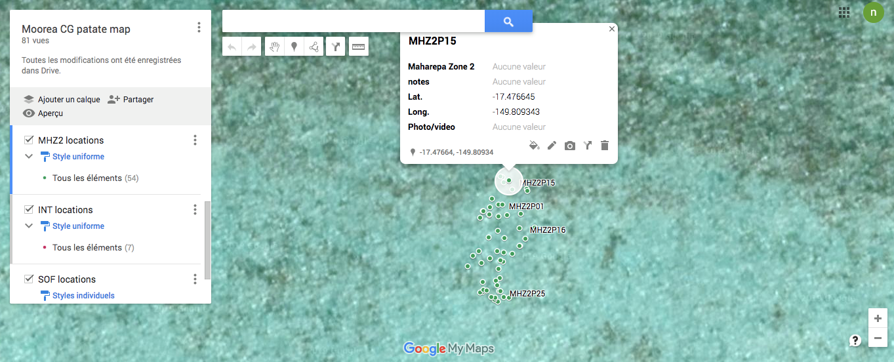

Planting activity log

- select patate ID

- was palate cleaned: YES / NO

- number of corals planted

- number of holes left

- number of broken corals

- number of bleached corals

specify the species

- number of dead corals

specify the species

On the restoration dashboard should be the following information about coral planting:

* number of corals planted by day/week/month/year
* nursery table available space should be updated

**ECOTOUR**

The app must allow our ecotour guide to:

* take a photo of the coral chosen by the customer in the water

→ allow validation of photo quality

* input the name chosen by the adopter for the coral

→ the GPS position of where the photo is taken should be automatically added

* select the language of the adoption certificate (french/english)
* choose a date to be printed on the certificate (if different from date of ecotour)

The adoption certificate can then be automatically generated either as a JPG or PDF. The certificate should look the same as website adoption certificates but for ecotour adoption the image is not randomly selected; it is a photo of the chosen coral.

The guide should able to send the adoption certificates to the customers at the end of the ecotour.

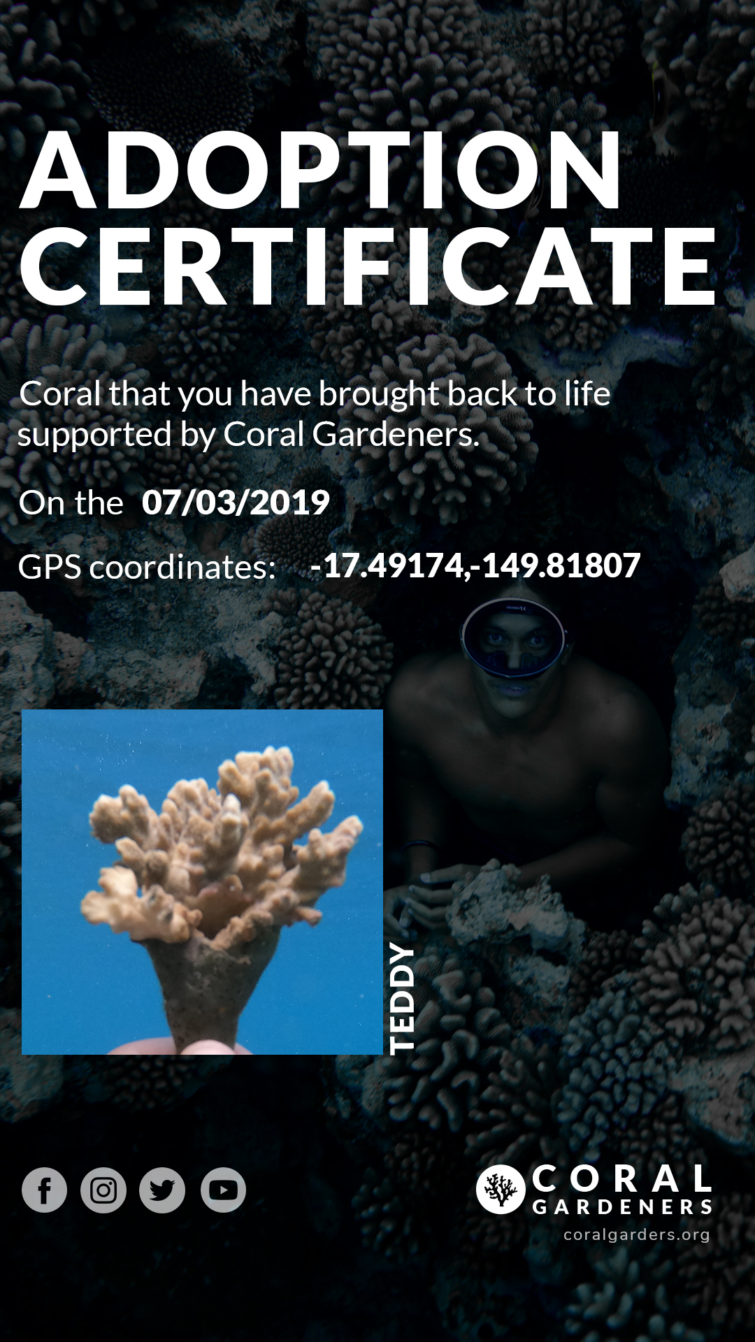

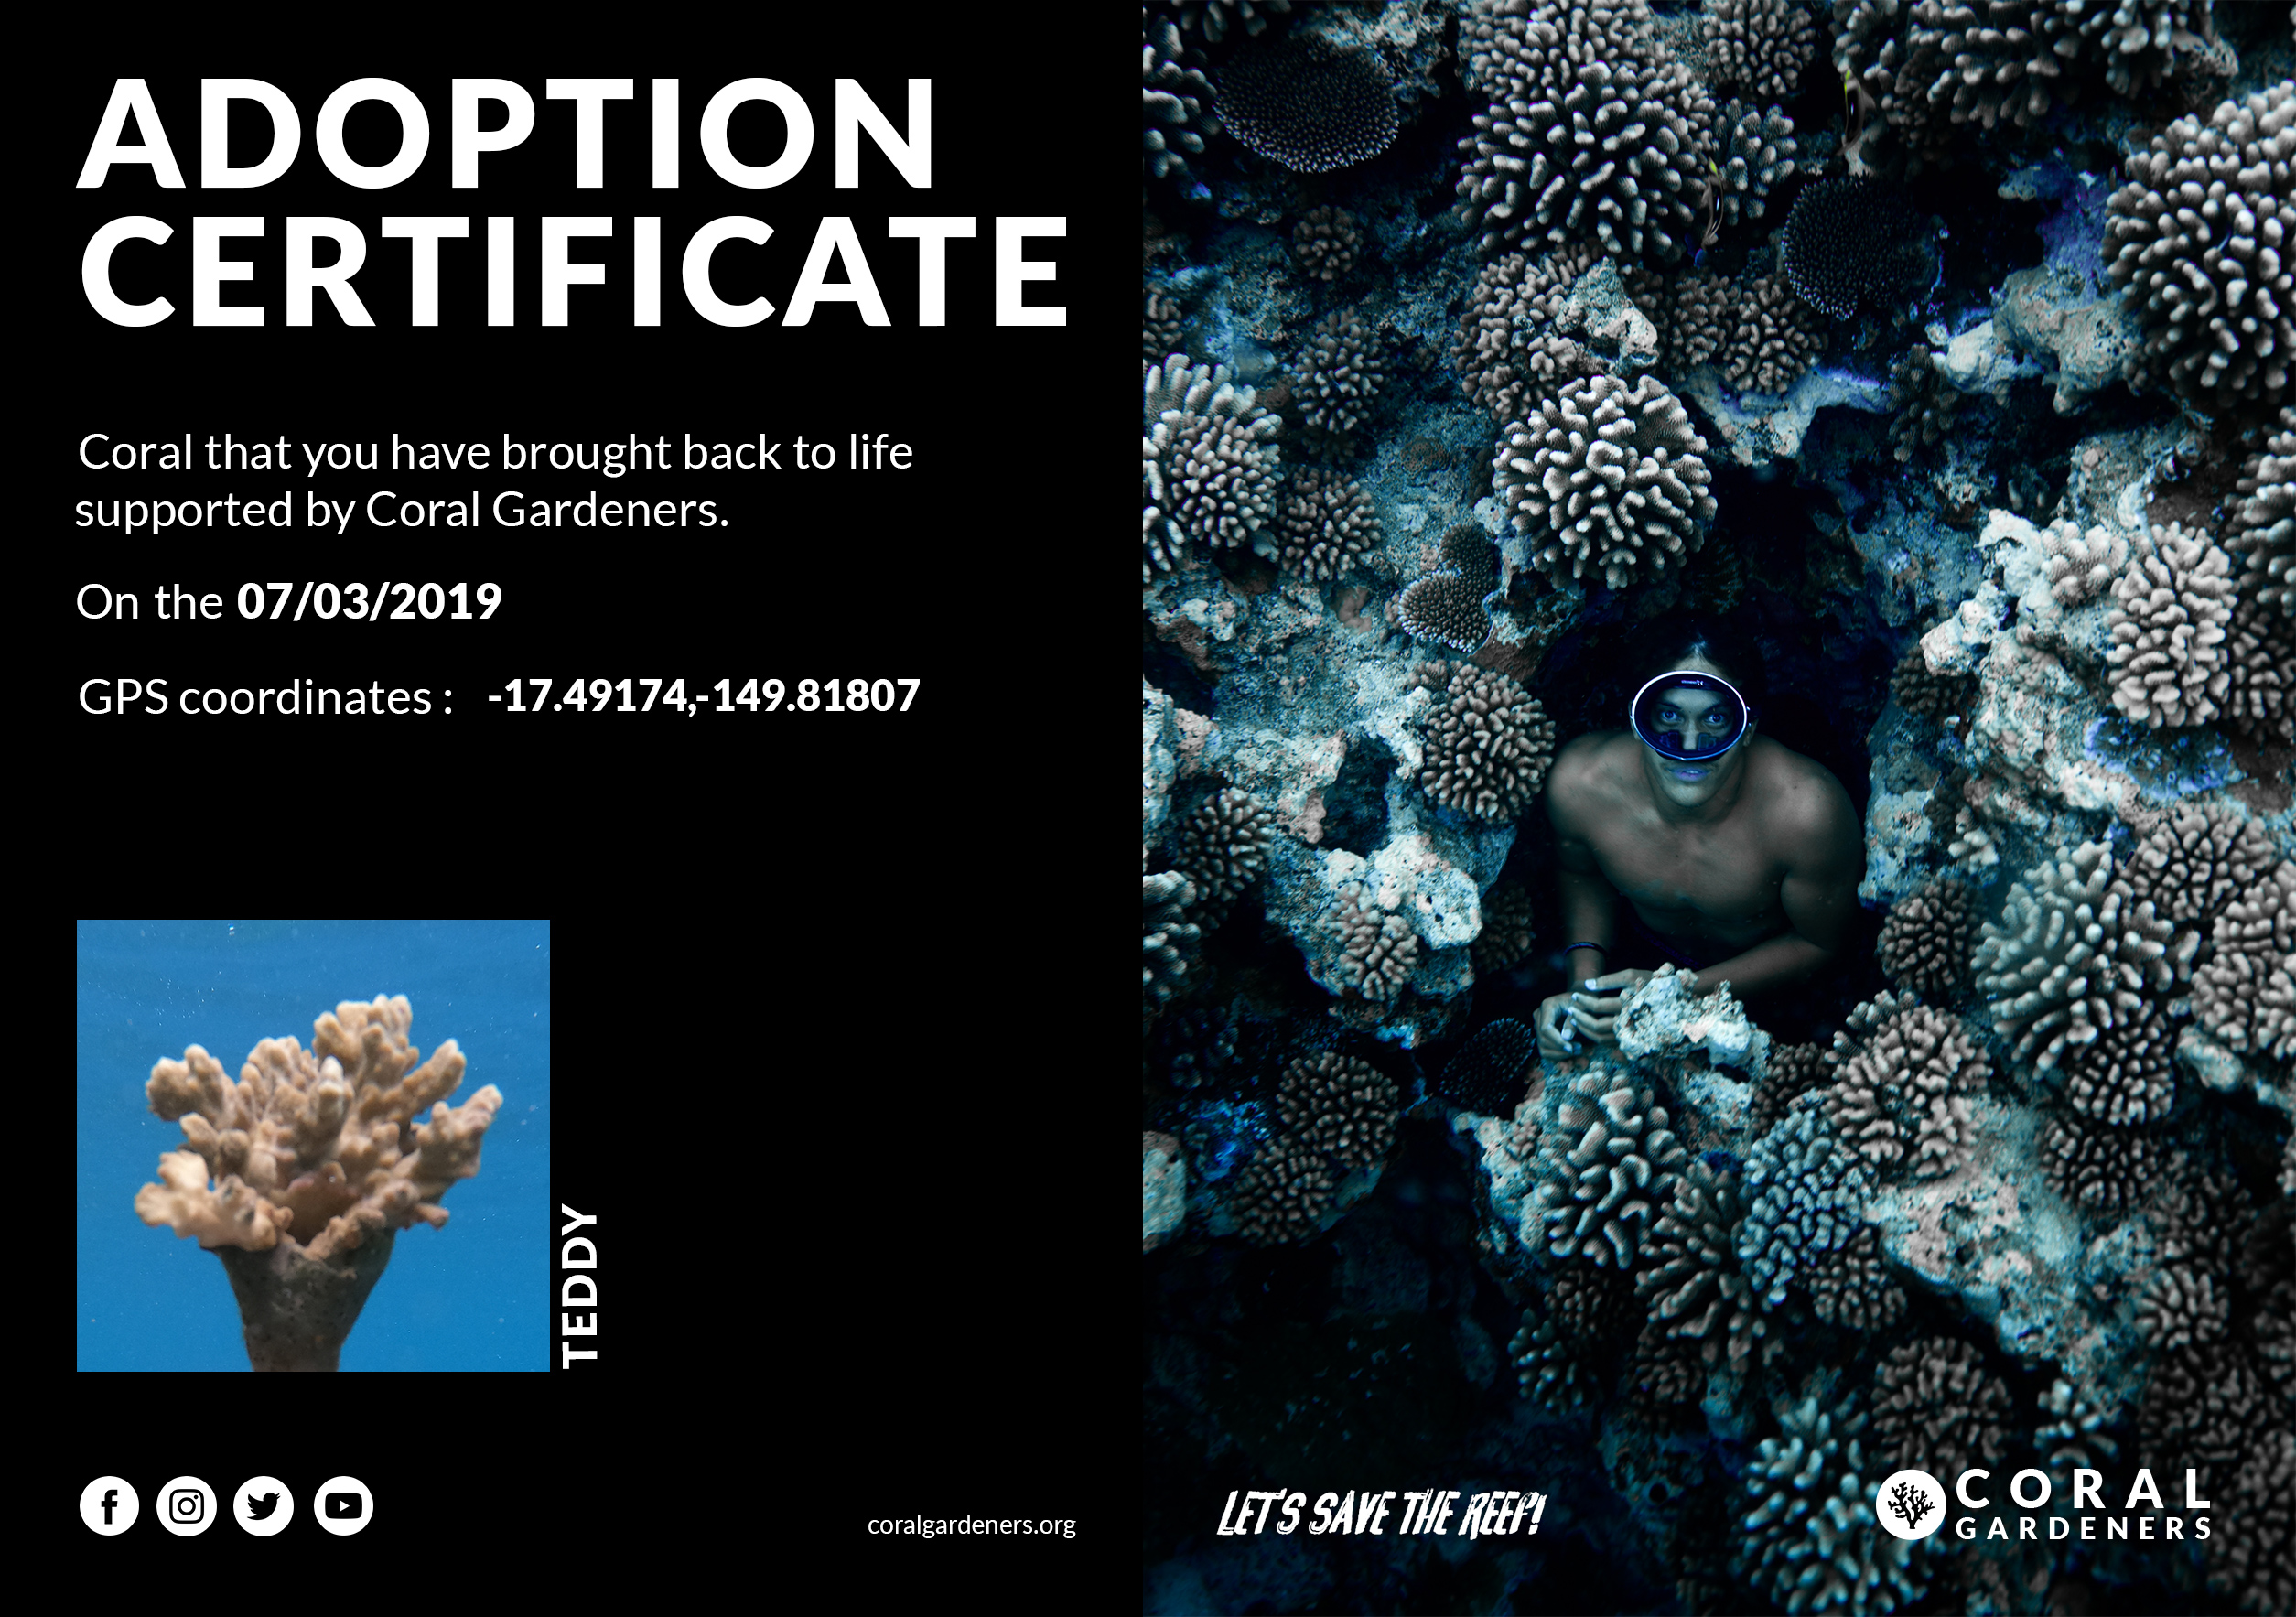

Date

GPS

Name chosen by adopter

Photo of adopted coral

**ADOPTION**

The website adoption part will not be developed during the event; a web developer is currently working on it. See technical graphic below.

When someone adopts a coral, their information should be saved in a database.

Adoption certificates should be generated automatically using this information.

The adoption certificates show :

* the name of the adopter
* image of the coral
* the name of the coral
* the adoption date
* GPS coordinates of the planting zone
* Image of coral and GPS coordinates come from app

Currently, the adoption information is stored manually in Google Sheets.

When someone adopts a coral on our website, we transfer all the information to Google Sheets. The adoption certificate is then created manually using Photoshop.

Once the adoption certificate is created, it is saved as a file under the name of the customer. Two formats of certificate exist: the horizontal and the vertical certificate. We send adopters their certificate in both of these formats.

If a customer adopts multiple corals, we create a certificate for each adoption. We record the names of the corals in a spreadsheet separated by a ''/''.   
Please find the link to the drive : [https://docs.google.com/spreadsheets/d/1KCssDxky7ksLInJIYBrziuZRDxcPGbyaerrSADQaS0A/edit#gid=0](https://docs.google.com/spreadsheets/d/1KCssDxky7ksLInJIYBrziuZRDxcPGbyaerrSADQaS0A/edit%2523gid=0)

Today, a web developer is already working on the automation of adoption certificate generation. This is the technical chart.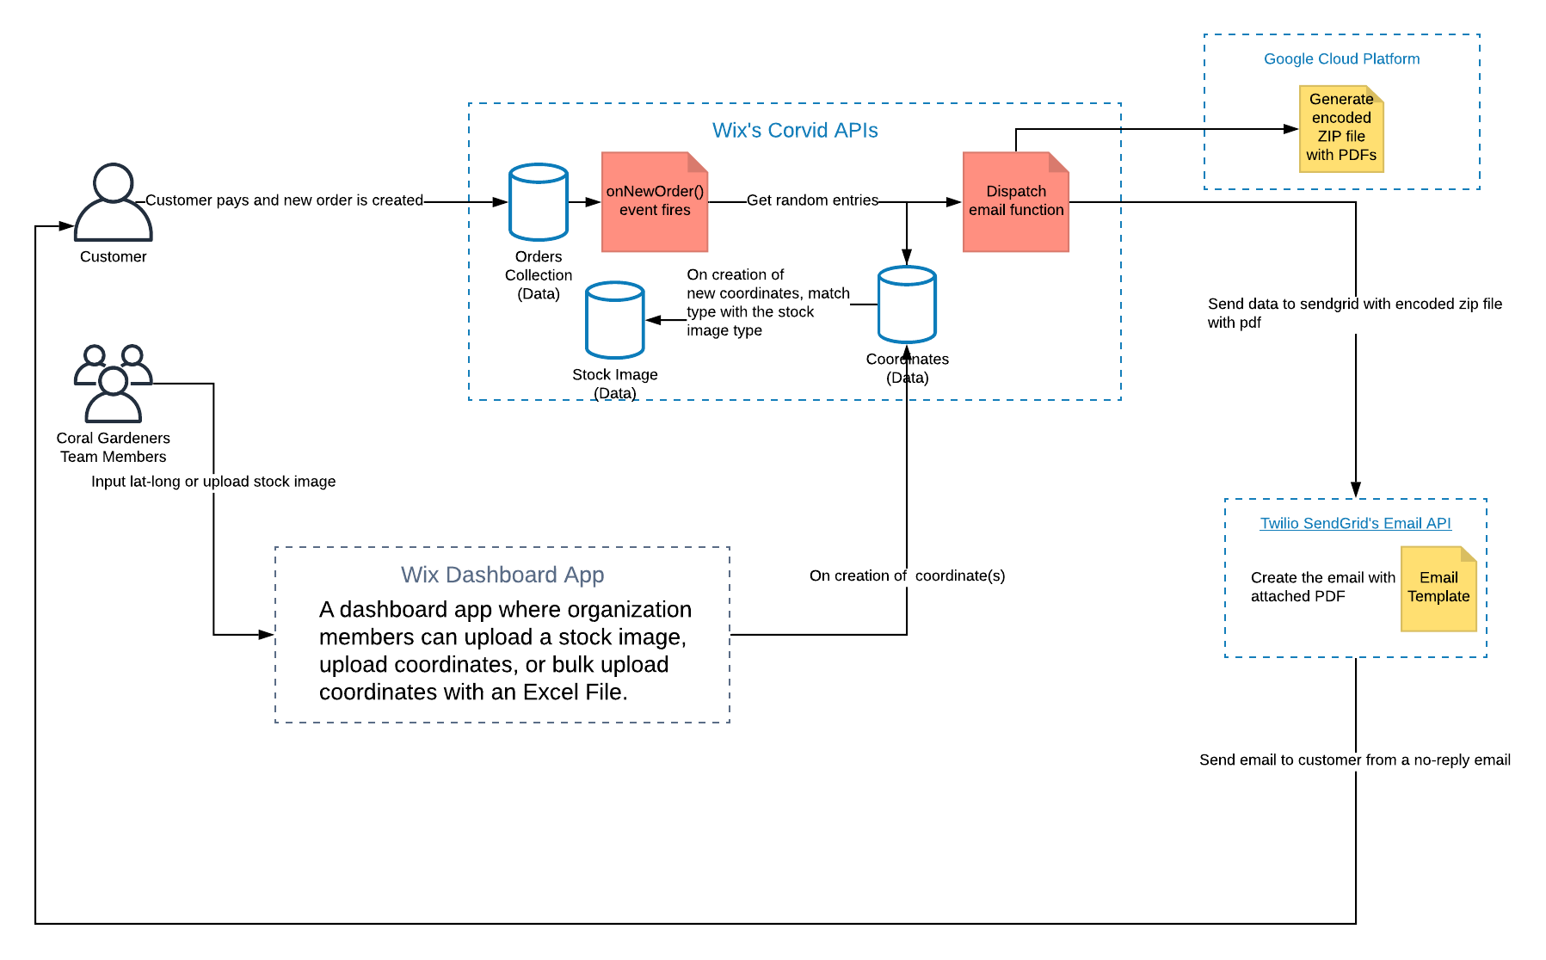

FURTHER IMPROVEMENTS

In the future, we would like to improve this app by adding further sections.

E.g. MERCHANDISING. This would allow us to sell our products to customers on an ecotour using a digital tablet.

E.g. User login for the app. It would be useful to give certain users limited access to the app and to be able to track which user has inputted data or made changes.

E.g. Calendar. To show upcoming Ecotours and other events. Show ‘what’s on today?’ on global dashboard.